**REALTIME WEATHER BASED SMART**

# SPRINKLER SYSTEM FOR GOLF COURSE USING

**IOT**

A smart sprinkler system for continuous monitoring and storage of weather and soil moisture information. Alert is generated if the soil moisture is above the threshold value. The water sprinklers can be controlled remotely using a mobile app.

# ABSTRACT

The project is based on a smart system to continuously monitor and maintain the temperature, humidity, and soil moisture levels in the Golf Course. Using the Arduino Mega microcontroller with Light-Dependent Resistor sensor, moisture sensor and temperature sensor, temperature is measured and analyzed. The soil for a certain duration, provides information related to the moisture status of the soil. The Arduino Mega will collect and process the data received from the Sensors. When a threshold moisture level of the soil is reached, the water will supply accordingly. This is essential because water must be provided to the greens at a particular time.

# INTRODUCTION

Internet of Things can be defined as the collection of two terms: one is Internet, which is defined as networks of networks which can connect billions of users with some standard internet protocols. Internet connect several different sectors and department while using different technologies. Several devices like mobile, personal systems and business organizations are connected to Internet. The second term is Thing, this term is basically mean to these devices or objects which turn into intelligent objects. Moreover this is also a part of all objects of this real world. If we want to define IOT then we can not define it precisely and concisely but Vermesan et al. defined the Internet of Things as simply an interaction between the physical and digital worlds. The digital world interacts with the physical world using a plethora of sensors and actuators .

# LITERATURE SURVEY

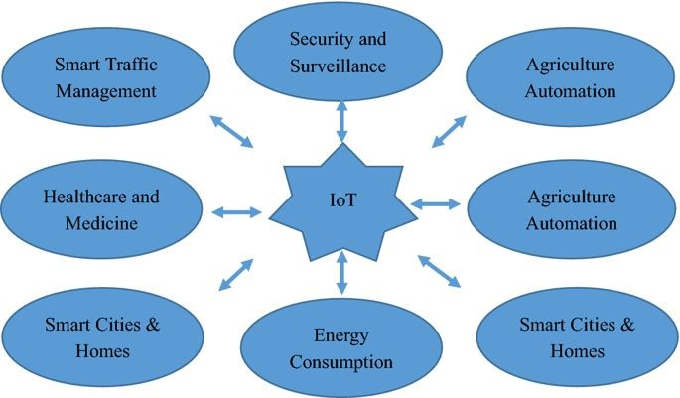

IoT has a multidisciplinary vision to provide its benefit to several domains such as environmental, industrial, public/private, medical, transportation etc. Different researchers have explained the IoT differently with respect to specific interests and aspects. The potential and power of IoT can be seen in several application domains. Illustrates few of the application domains of IoTs potentials.

# BLOCK DIAGRAM

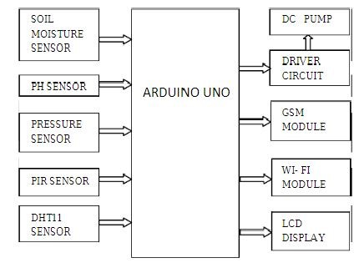

**ALGORITHM**

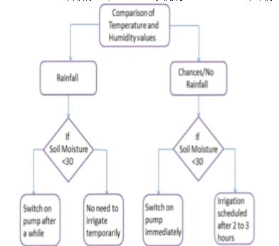

**CONCLUSION**

The soil moisture is a critical parameter for developing a smart irrigation system. The soil moisture is affected by a number of environ- mental variables, e.g., air temperature, Air humidity, UV, soil temperature, etc. With advancement in technologies, the weather forecasting accuracy has improved significantly and the weather fore- casted data can be used for prediction of changes in the soil moisture.

This paper proposes an IoT based smart irrigation architecture along with a hybrid machine learning based approach to predict the soil moisture. The proposed algorithm uses sensors’ data of recent past and the weather forecasted data for prediction of soil moisture of upcoming days. The predicted value of the soil moisture is better in terms of their accuracy and error rate.

Further, the prediction approach is integrated into a standalone system prototype. The system prototype is cost effective, as it is based on the open standard technologies. The auto mode makes it a smart system and it can be further customized for application specific scenarios. In future, we are planning to conduct a water saving analysis based on proposed algorithm with multiple nodes along with minimizing the system cost.

**FUTURE SCOPE**

The machine learning requires a mass data so our recorded meteor-logical data helps a lot in improving the performance. The region or area wise prediction can be done for giving more accurate farming suggestions of which crop can be grown by analysing the data based on the soil and weather conditions. This paper can further be industrialized with camera feeds for checking the discoloration of leaves or plants and accordingly send the results to control the disease from anywhere. The field area can be protected from the Trespassers by the deployment of AI and surveillance.