A Project Report
on
“Intelligent Customer Help Desk with Smart Document Understanding”

By

P. SAI SAVITHRU MOHAN

UNDER THE GUIDANCE OF

SMARTBRIDGE
 | CONTENTS
 |  | Page no.
 | 1. INTRODUCTION | 3
 | 2. LITERATURE SURVEY | 5
 | 3. THEORETICAL ANALYSIS | 6
 | 4. EXPERIMENTAL INVESTIGATIONS | 8
 | 5. FLOW CHART | 26
 | 6. RESULTS | 27
 | 7. ADVANTAGES & DISADVANTAGES | 29
 | 8. APPLICATIONS | 29
9. CONCLUSION 30
10. FUTURE SCOPE 30
11. BIBILOGRAPHY 30
APPENDIX 31

CHAPTER 1

INTRODUCTION

1.1 OVERVIEW

Intelligent Customer Help Desk with Smart Document Understanding is an intelligent chatbot or help desk that gives very usable and credible information to the users. It uses and integrates different Artificial Intelligence (AI) services such as Discovery, Assistant, Cloud Function and Node-RED. This project deals with the efficient way of integrating these services to develop an intelligent chatbot that can answer to most of the user queries.
- Project Requirements and Skills Required: Python, IBM Watson (Assistant, Discovery and Cloud Function) and Node-RED.
- Functional Requirements: IBM Cloud (Account).
- Technical Requirements: Python, Machine Learning (ML), IBM Watson AI Services.
- Software Requirements: IBM Services and Node-RED
- Project Category: Artificial Intelligence.
- Project Deliverables: Intelligent Customer Help Desk with Smart Document Understanding under the guidance of SmartInternz.
- Project By: P. Sai Savithru Mohan.

1.1.1 SCOPE OF WORK
- Create a customer care dialog skill in Watson Assistant.
- Use Smart Document Understanding to build an enhanced Watson Discovery collection.
- Create an IBM Cloud Functions web action that allows Watson Assistant to post queries to Watson Discovery.
- Build a web application with integration to all these services & deploy the same on IBM Cloud Platform.

1.2 PURPOSE

The existing customer care chatbots can only deliver answers or replies to questions like location, timings.... etc which are already defined in their scope. Basically, the existing customer care chatbot are only capable of answering few questions that were in the scope. But the problem arises when the user comes with a question which the chatbot has not trained for or simply, which the chatbot has never seen it. Then the most obvious and common answer it replies is either ‘could not process your request’ or ‘invalid question, please try again’.
This project serves to solve this issue with the existing limited knowledge chatbots. If the user asks a question that the chatbot is not trained for then, the question is passed to ‘Watson Discovery Service’, which has been already trained with the User manual. So, Watson Discovery Service finds an apt solution for the question in the manual and then replies it to the user with a suitable and an appropriate answer. ‘Smart Document Understanding’ is an exciting feature of Discovery Service that can train and predict which portion of text is useful and which is not useful. This increases the efficiency of and dependency on chatbot for fetching some valuable information.

CHAPTER 2

LITERATURE SURVEY

2.1 EXISTING PROBLEM

Existing chatbots generally takes questions as input from the user and delivers appropriate answers as output to the user queries. But the problem is that when user asks a question which chatbot hasn’t trained for then it replies with inappropriate answers like ‘Try again’, ‘I could not understand’, ‘Could you rephrase your words’ or ‘Would you like to talk to our agent’. But an ideal chatbot must deal maximum number of questions and thereby, reducing the involvement of a real external agent (person). Hence there is an use of intelligent chatbot which could answer maximum number of user queries and reduce the involvement of agent.

2.2 PROPOSED SOLUTION

The answer to this solution is ‘Chatbot with Smart Document Understanding (SDU)’. This can be performed or achieved by using Watson Discovery Service, which could almost answer most of the user queries. The chatbot which generally uses Watson Assistant service also uses Discovery service to answer the questions that a regular chatbot cannot. The Assistant service will be linked with the Discovery service through the Cloud Functions and Node-RED integrates all the services and provides us a user-friendly user interface (UI).

CHAPTER 3

THEORETICAL ANALYSIS

3.1 BLOCK / FLOW DIAGRAM

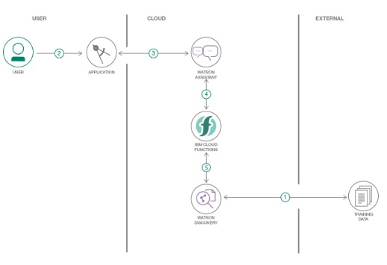

Fig. 3.1 Architecture of Intelligent Chatbot with SDU

1. The data and document is annotated using Watson Discovery SDU.
2. The user interacts with the Node-RED UI, which is an application, to get his queries answered. User Interface provides a way for the user to interact with the back-end servers. The chatbot is front-end UI to deal with the user queries.
3. The conversation and dialogs between the user and chatbot is supported by the Watson Assistant Service.
4. If the query is out of Assistant’s scope it invokes the Discovery service through Cloud Functions i.e., it sends a request to Cloud Function to wake up Discovery through webhook.
5. Cloud Function invokes the Discovery service and asks to find an appropriate answer from the pre-loaded data (manual). And this will be returned to the user.

3.2 HARDWARE / SOFTWARE DESIGNING

1. Create ‘IBM Cloud Service’ Account.
2. Configure Watson Discovery and pre-load with required manuals.
3. Create IBM Cloud Functions action.
4. Configure Watson Assistant and hook it to Discovery using Webhook.
5. Design and Create a flow in Node-RED.
6. Deploy and run the app.

CHAPTER 4

EXPERIMENTAL INVESTIGATIONS

4.1 CREATING IBM CLOUD SERVICES
IBM Cloud Services are to be created it includes the following:
- Creation of Node-RED.
- Creation of Watson Assistant.
- Creation of Watson Discovery.
- Creation of Cloud Function.

4.1.1 CREATION OF NODE-RED
1. Log in to IBM Cloud and open Catalog and search for Node-RED app in the software tab.
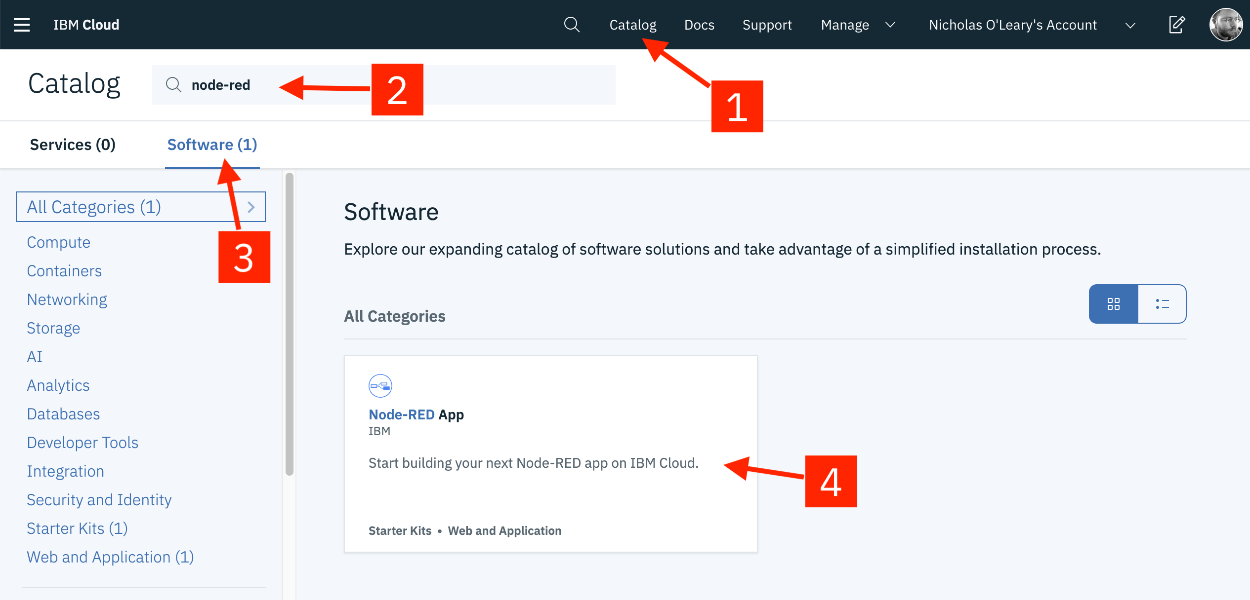
2. Click on the Create app

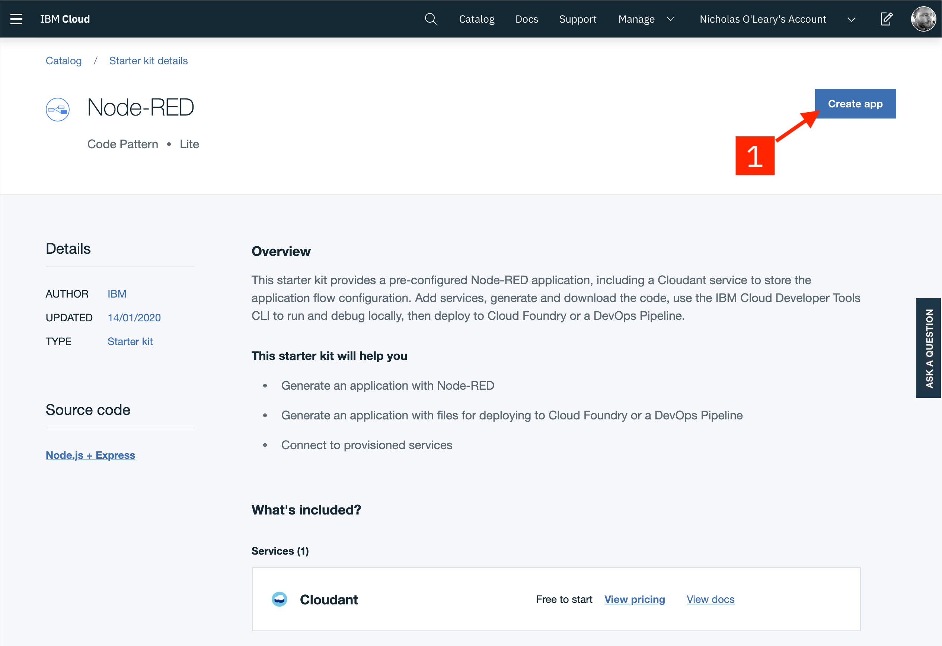
3. On the App details page, a name will be suggested for the app, accept it or modify it and name must be unique if modified.
4. Choose your Region and Service Plan and click Create.
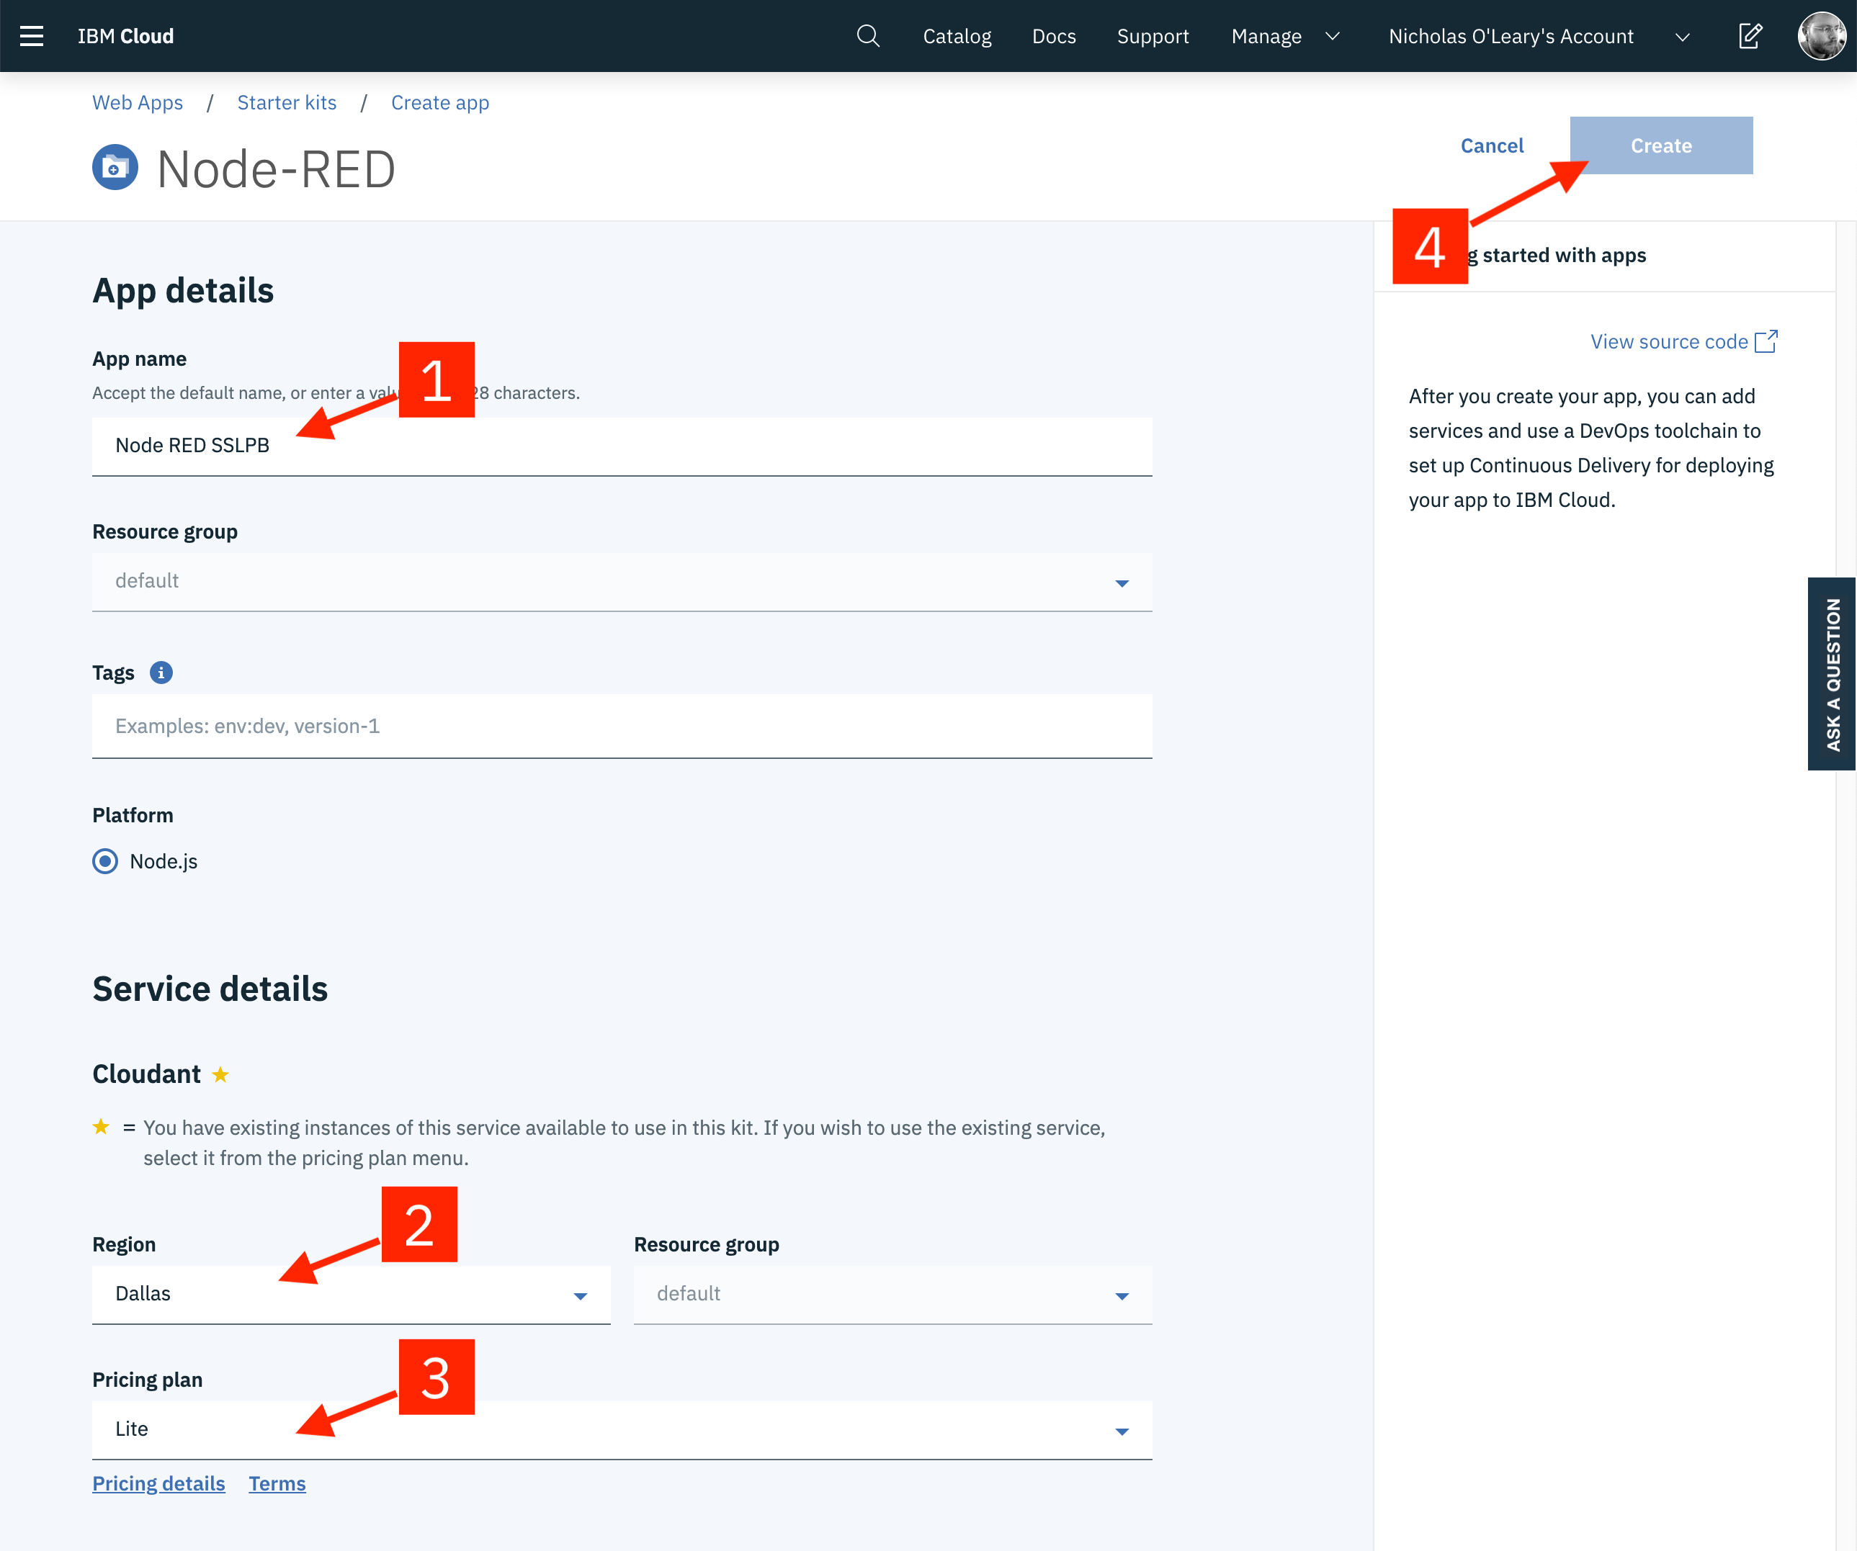
5. In the next page, click Deploy your app to enable Continuous Delivery feature.
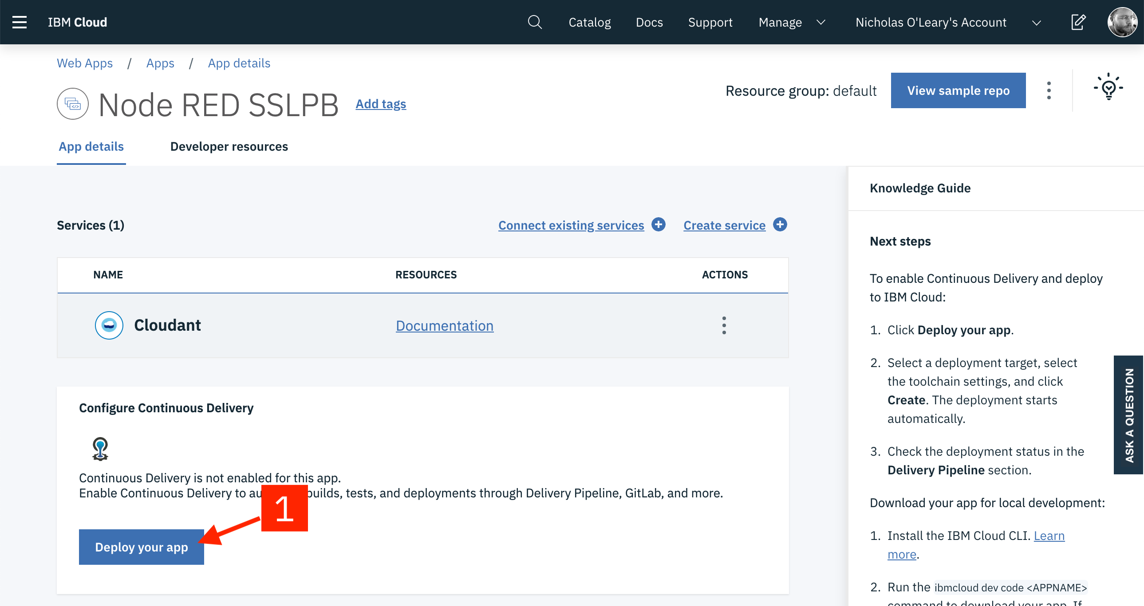
6. We need API key to access the resources, so click New in the next page under IBM Cloud API Key section and drag memory limit o 256 MB and choose region and click create.
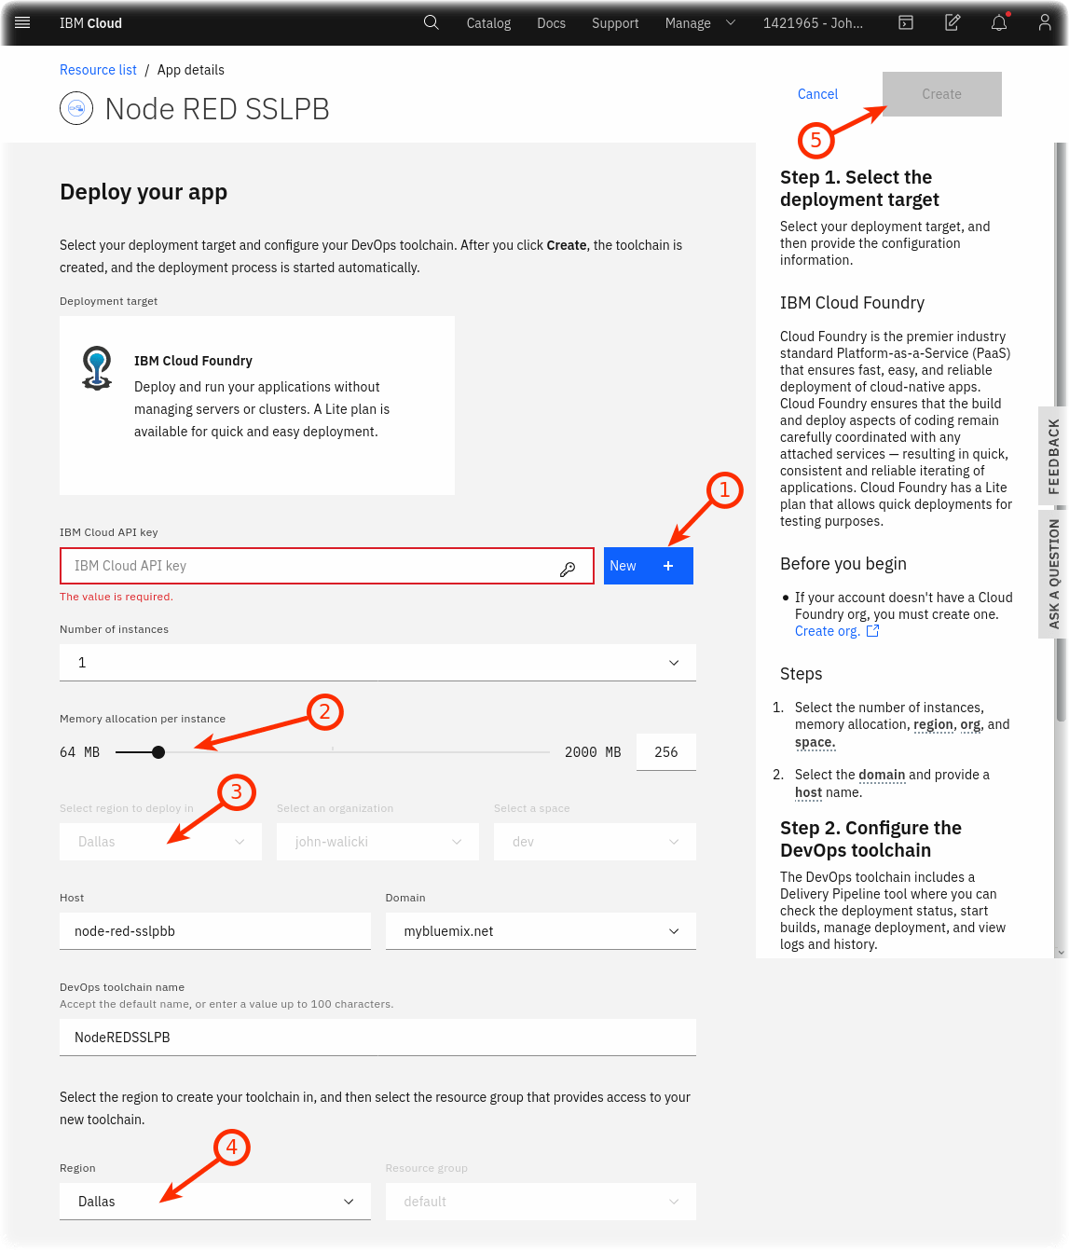
7. The page gets reloaded and shows the status of Delivery Pipeline. Click on In progress to see the full status. Here the Deploy stage takes few minutes to get passed. It means now it is ready to work.

8. Go to Resource page, and find for Node-RED in Cloud Foundry apps or app section.
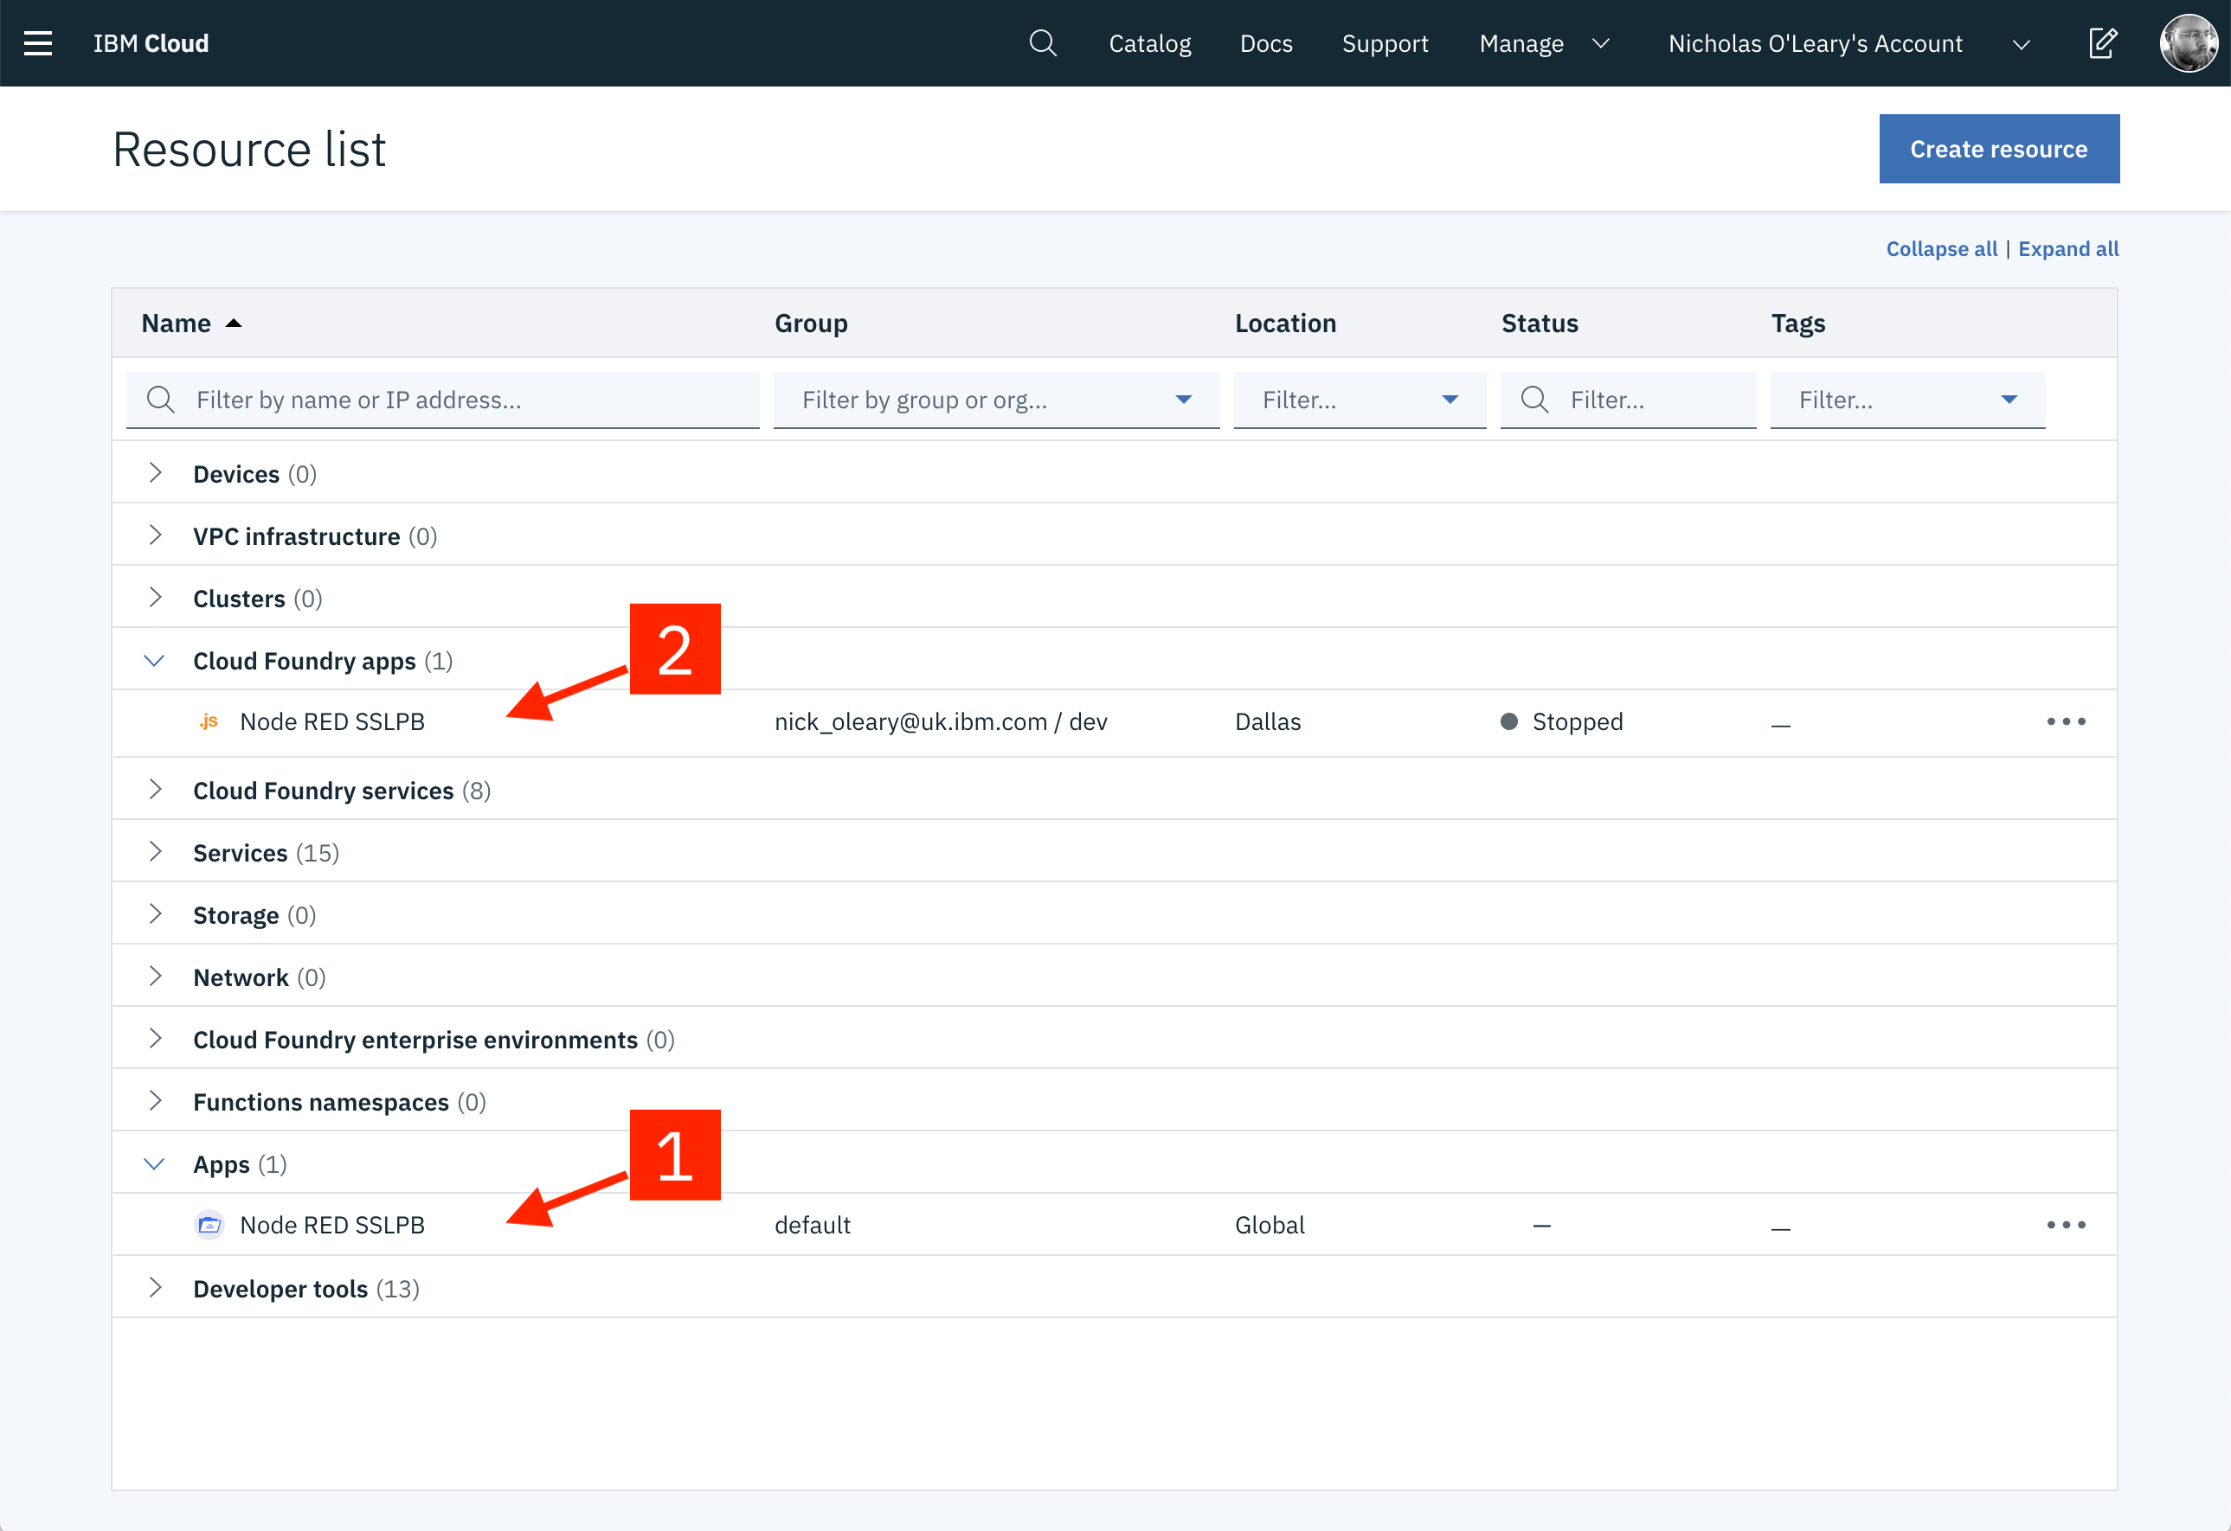9. In the next page, click on Visit App URL.
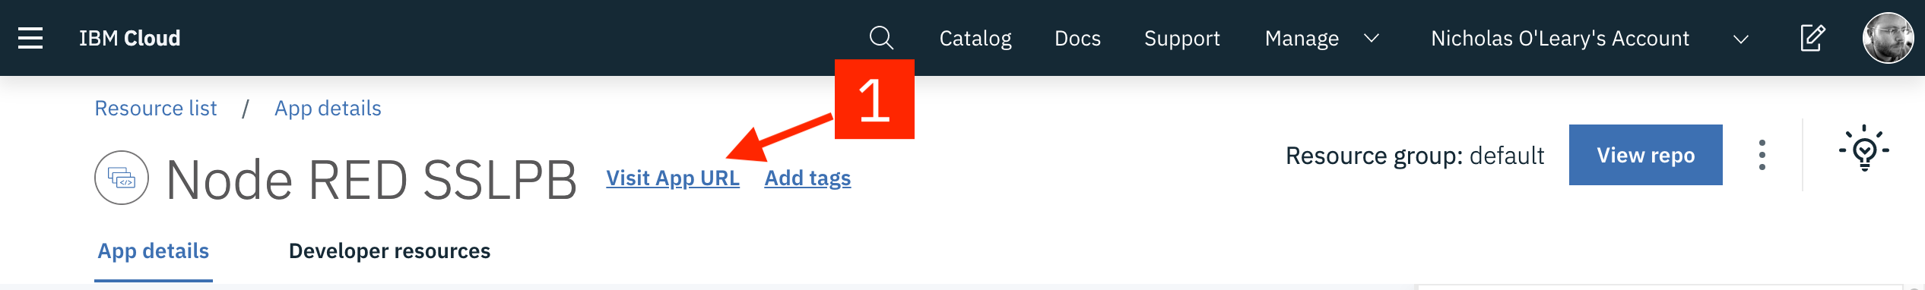
10. Configure by clicking next and then finish and the main page of Node-RED opens.
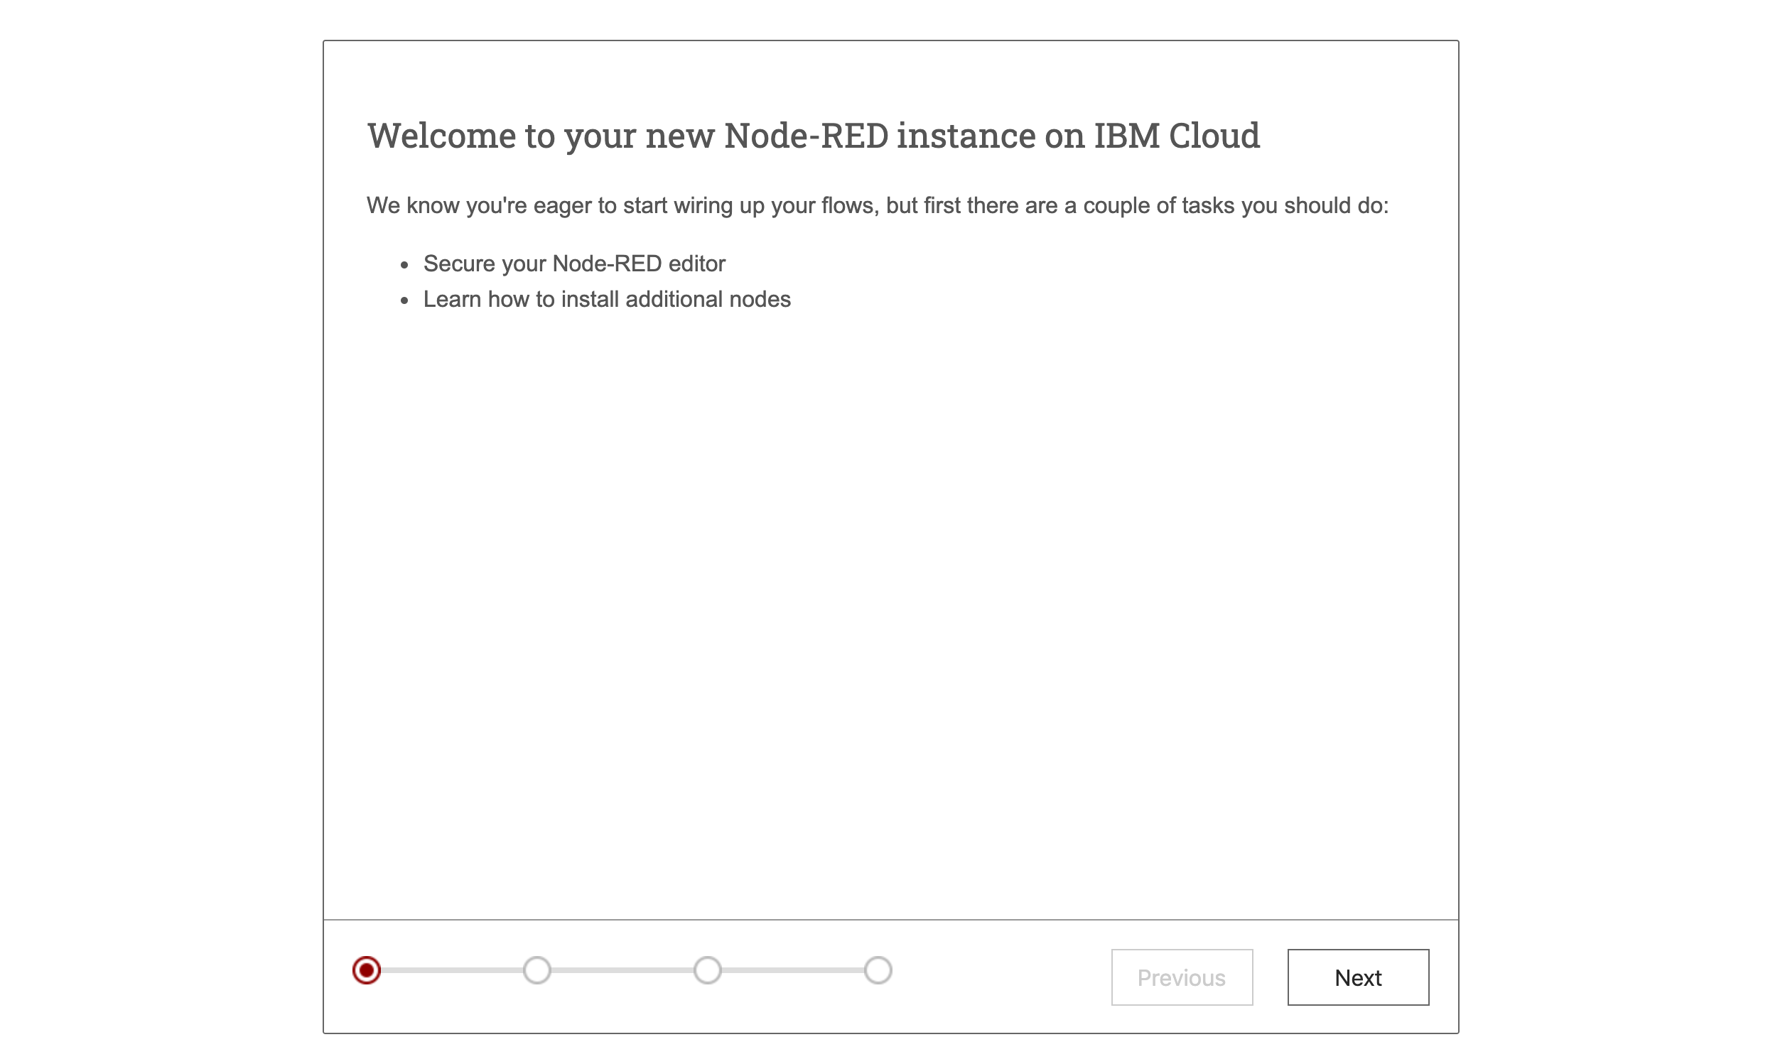

11. Click on Go to your Node-RED flow editor and then flow editor opens.
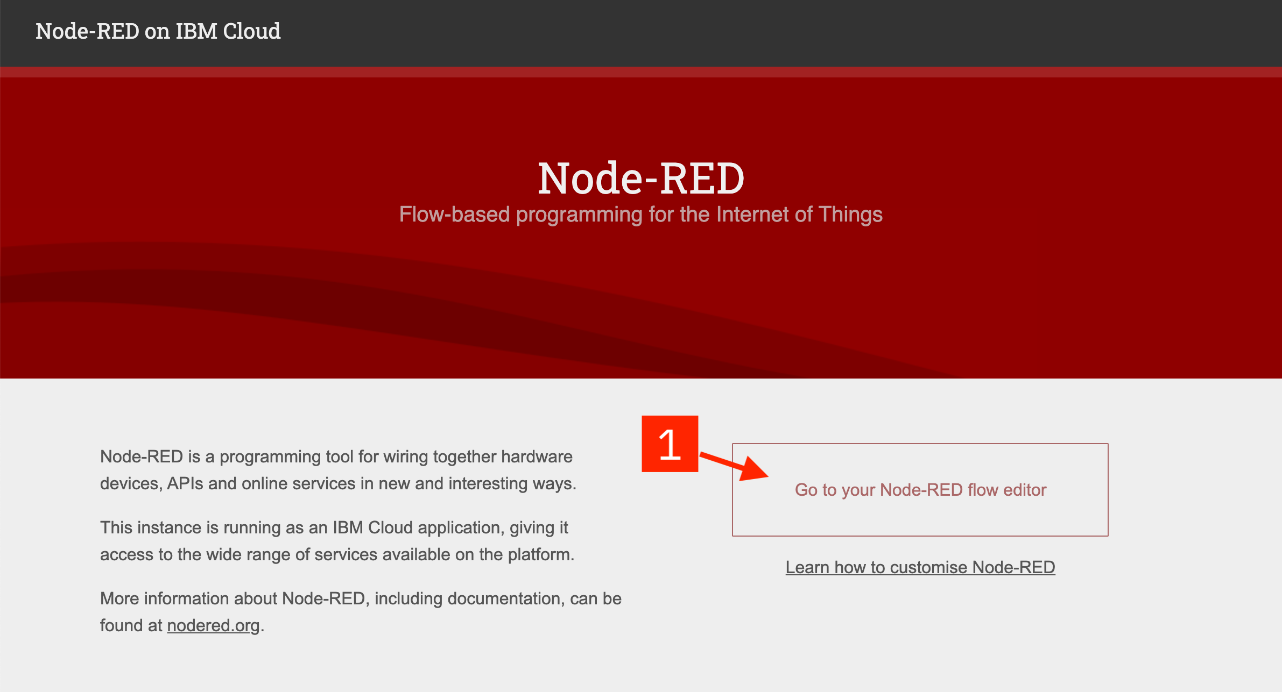

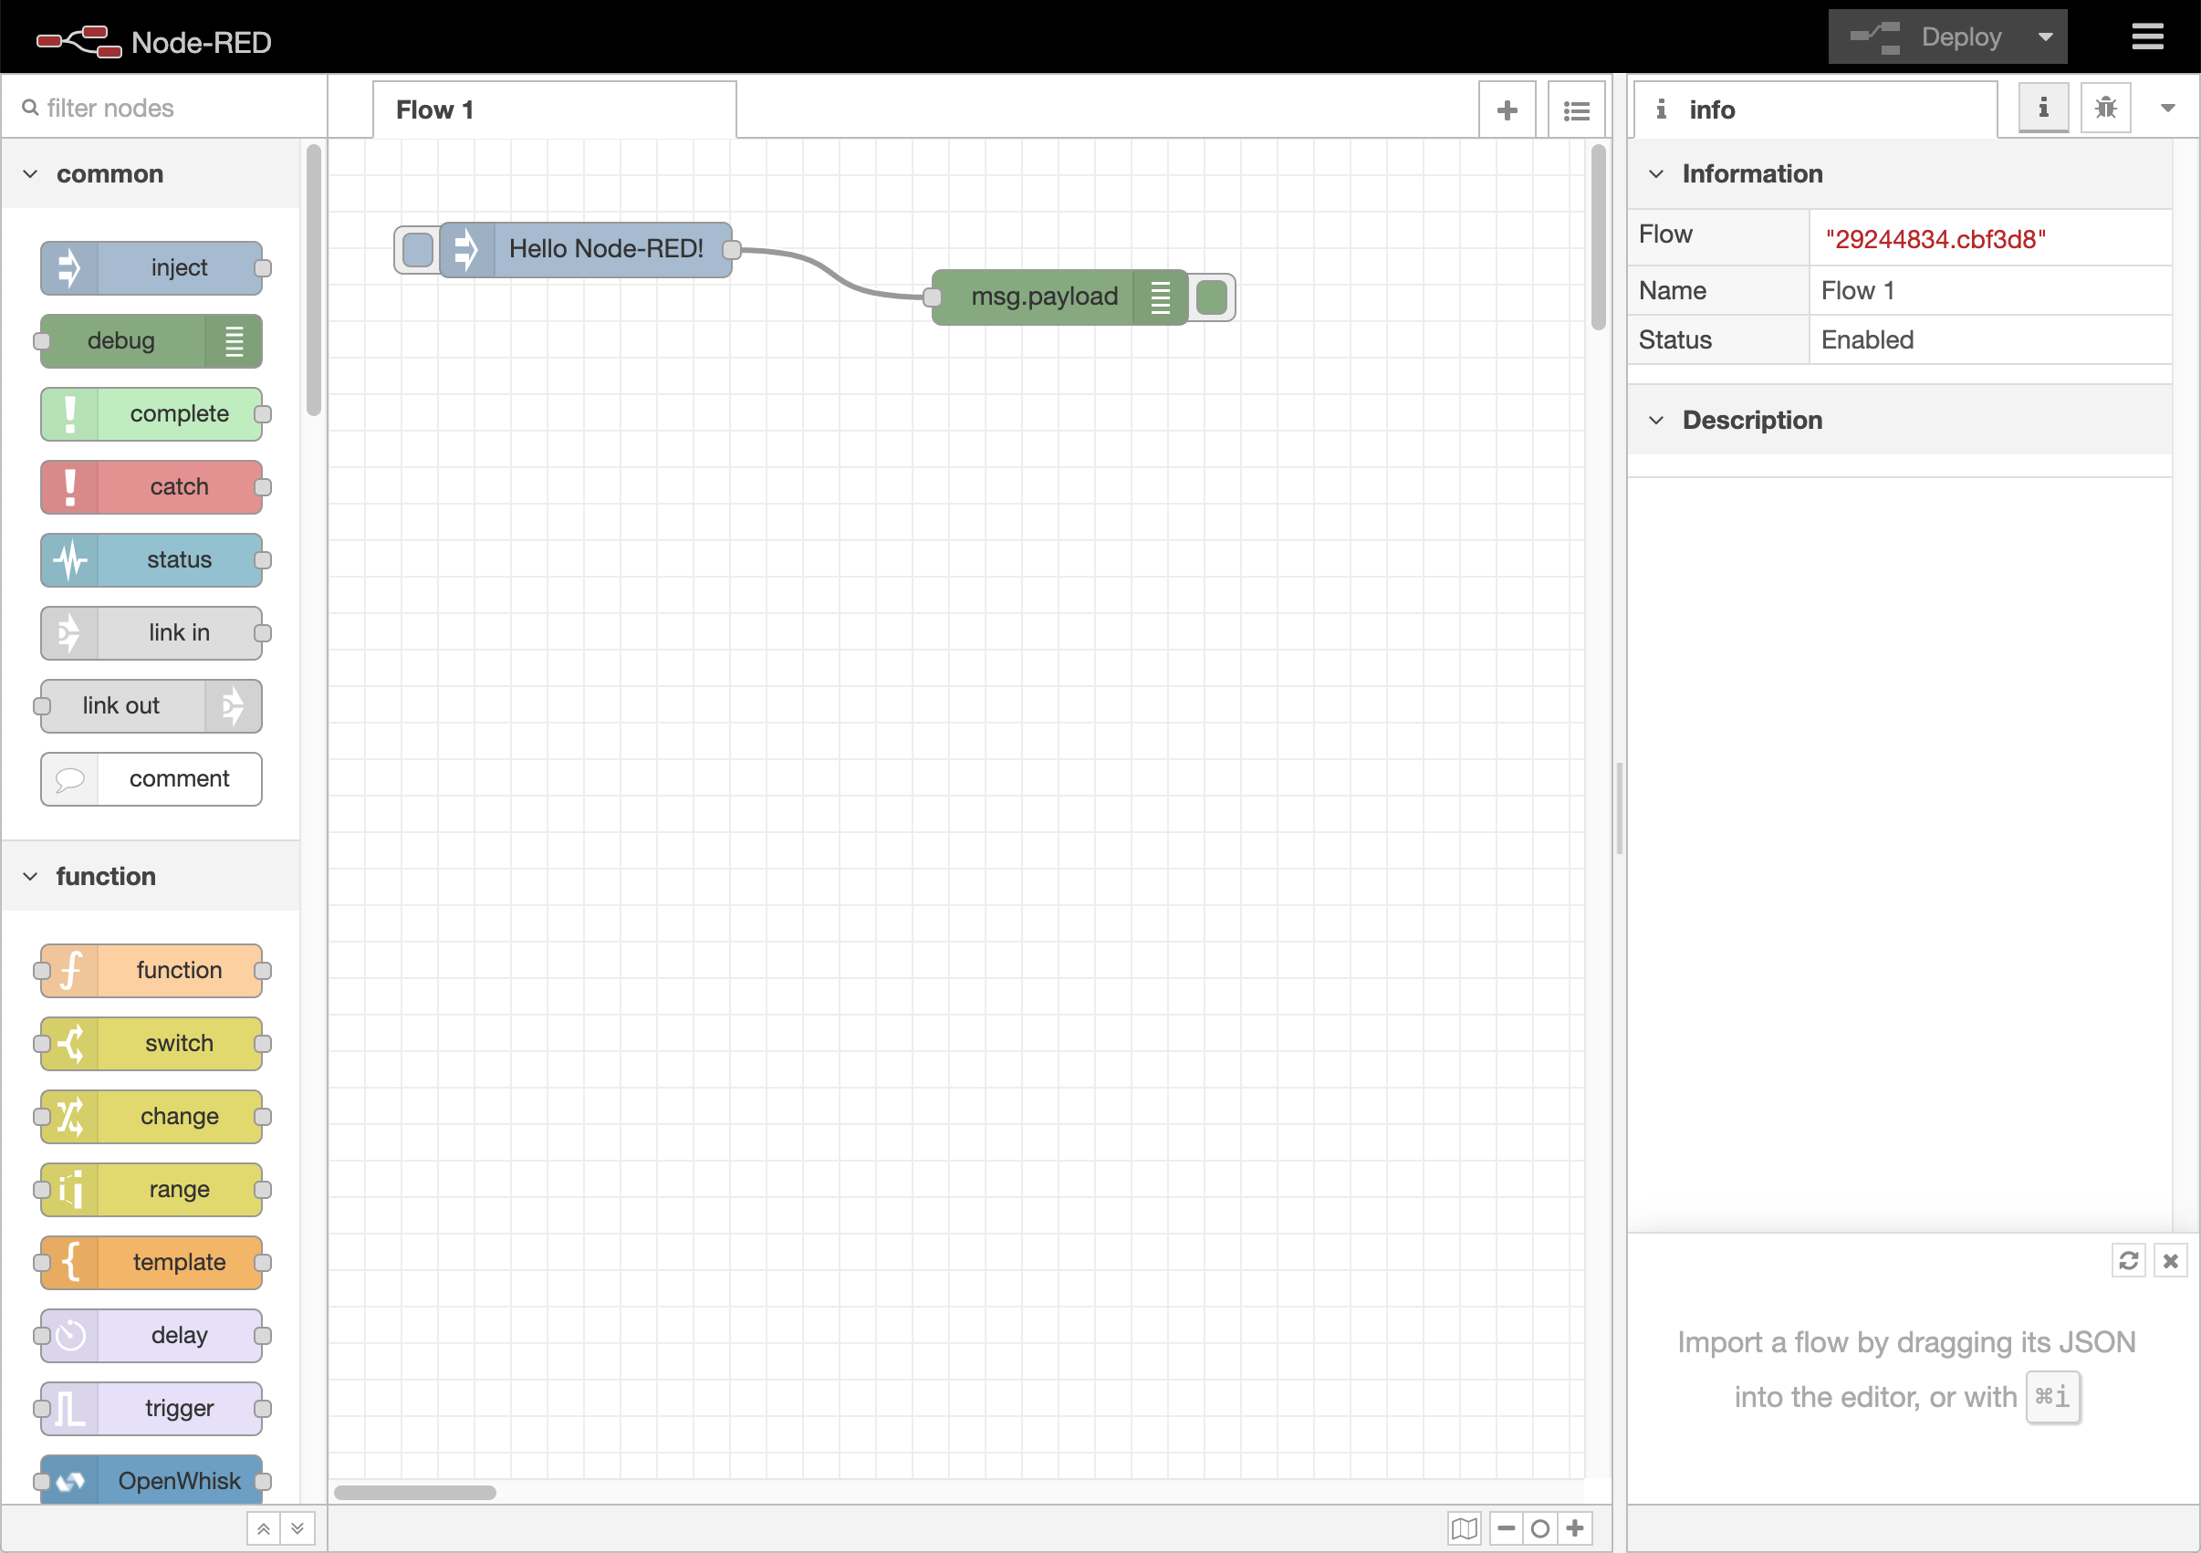

4.1.2 CREATION OF WATSON ASSISTANT
1. Open Catalog and search Watson Assistant and then click on it and then click Create.
2. In Resources, find Watson Assistant and the click on it.
3. In the Assistant page, find Launch Watson Assistant in Manage tab and click on it and note your credentials in Service credentials tab.
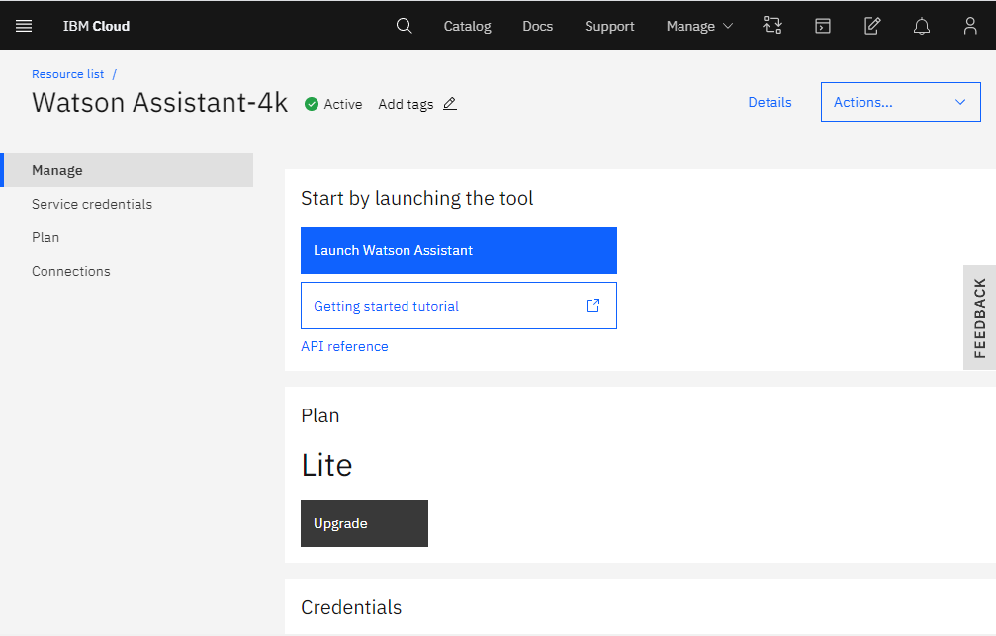

4. Click on Create Assistant and name your Assistant.
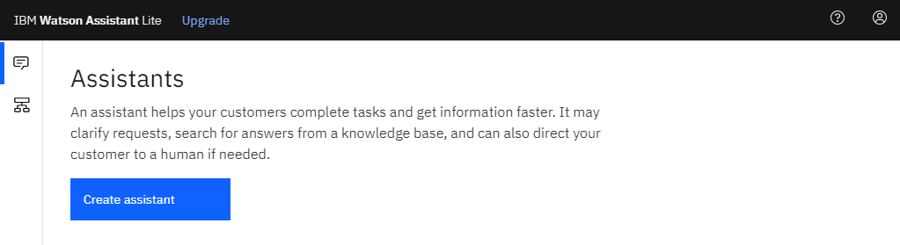
5. In the Intents tab, click Create intent.
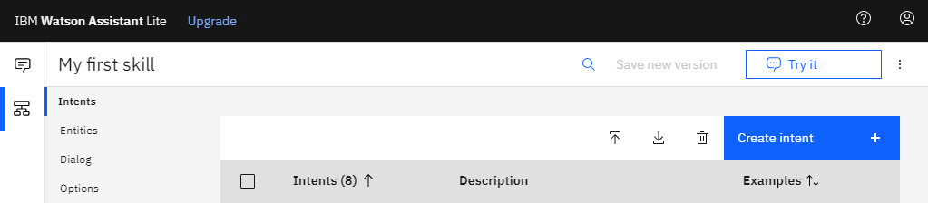

6. Name your intent accordingly and type the user examples to recognize this intent and then click Add example and do the same for entities and create required number of intents and entities.
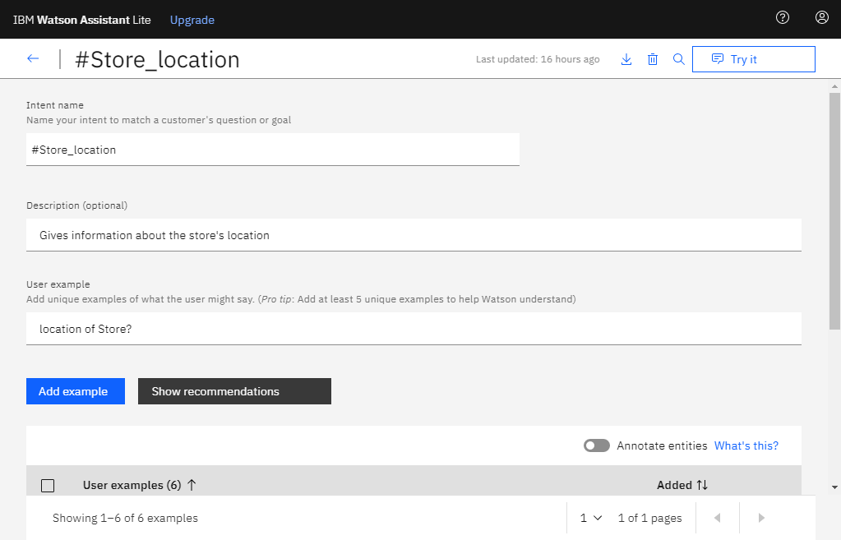

7. In the Dialog tab, click on Add node.
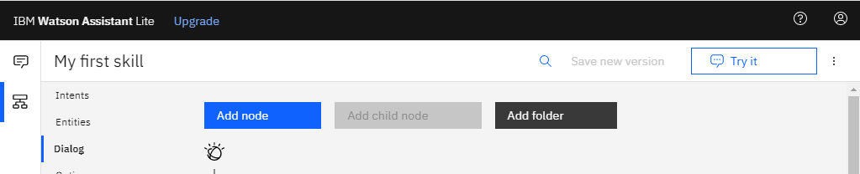

8. Name your node and choose the intent or entity (If assistant recognizes) and type what chatbot has to reply in the Assistant respond section and repeat it for required number of dialog nodes. This creates the Assistant service and can be tested by clicking on Try it (Top Right of Window).
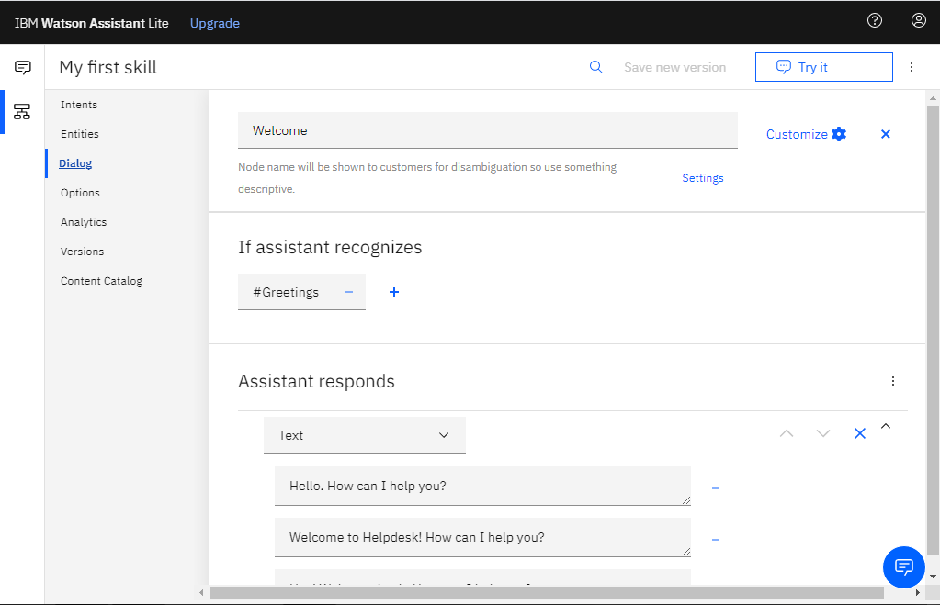

4.1.3 CREATION OF WATSON DISCOVERY
1. Open Catalog and search Watson Discovery and then click on it and then click Create.
2. In Resources, find Watson Discovery and the click on it.
3. In the Discovery page, find Launch Watson Discovery in Manage tab and click on it and note your credentials in Service credentials tab.
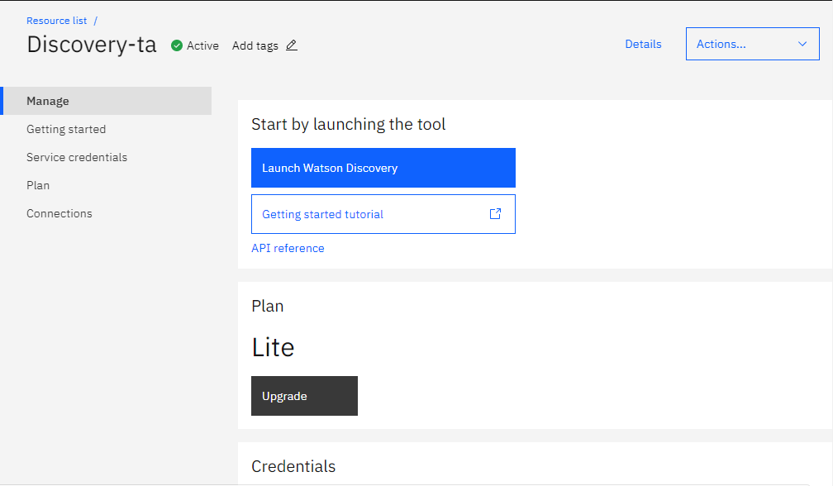

4. Click on Upload your own data and name your collection and then upload file (manual).
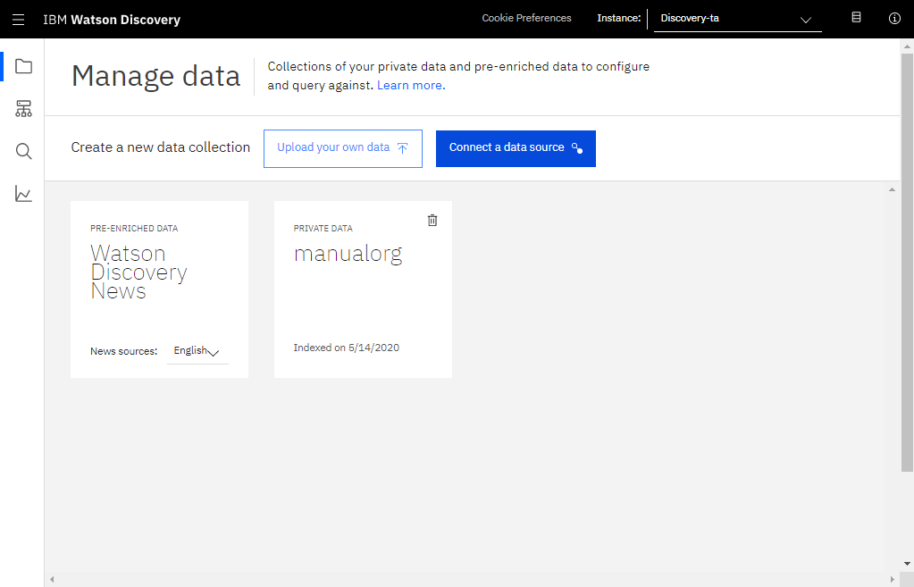
5. Click on configure data and also click on api button (highlighted) and note the environment_id and collection_id in that section.
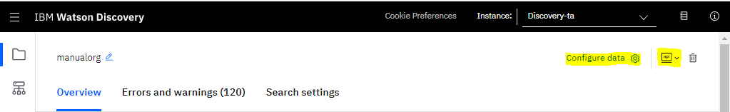
6. After clicking on configure data, in Identify fields, categorize the text in uploaded document into different categories based on the categories displayed on the palette on right side by selecting and click on Apply changes to the collection and again upload the document.
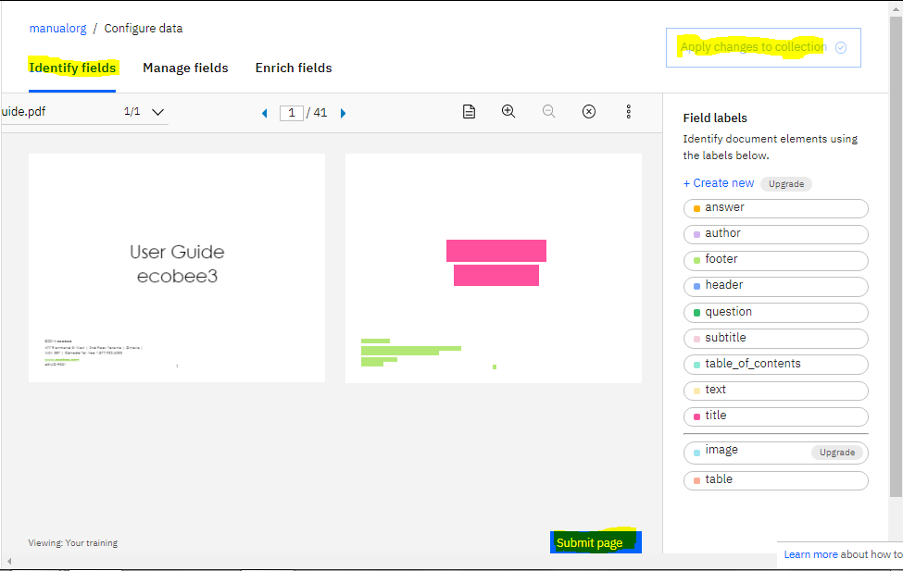
7. Now, in Manage fields, choose the fields whose content or text is important and then choose a field to split document based upon the field.
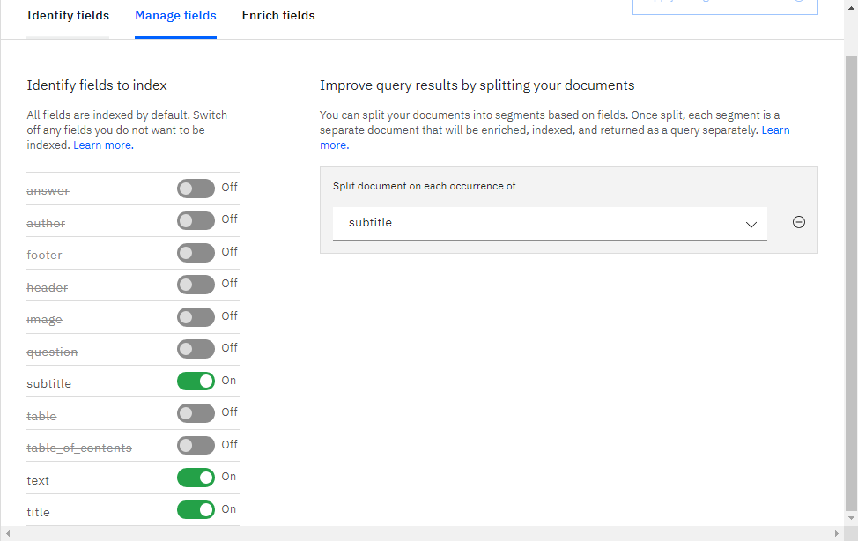
8. Now Discovery service splits the document is ready to integrate with other sources.

4.1.4 CREATION OF CLOUD FUNCTION
1. Open Catalog and search Functions and then click on it.
2. Click on Start Creating in the Getting Started tab.
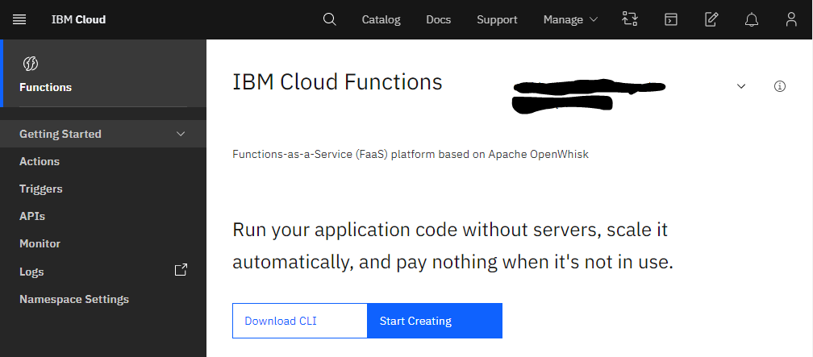
3. Click the arrow symbol (highlighted) in actions section and name the action.
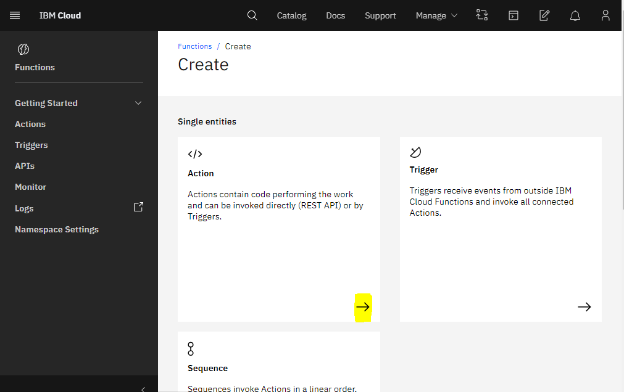
4. In the code section, type the code for integrating Discovery and Assistant and in Parameters tab, create necessary parameters like environment _id, collection_id, url and i_am_apikey and give them the values which we earlier noted in Discovery section.
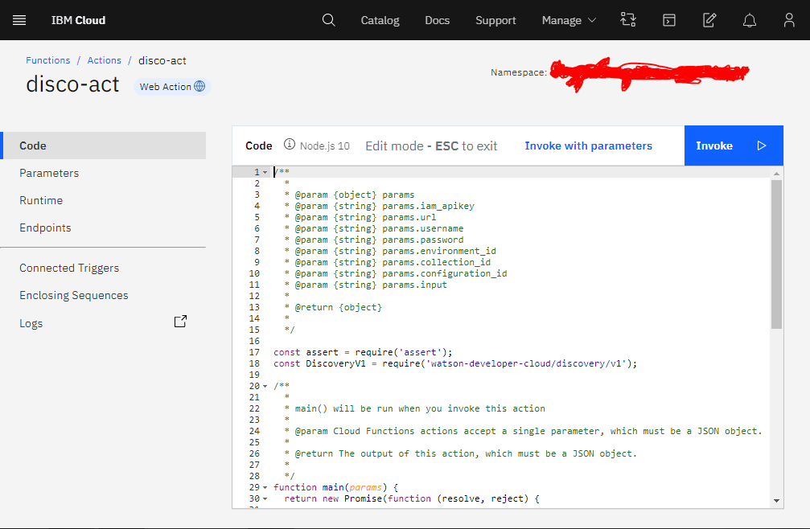
5. In the Endpoints tab, tick the Enable as Web Action to generate a URL which acts as a webhook and copy & note the URL.

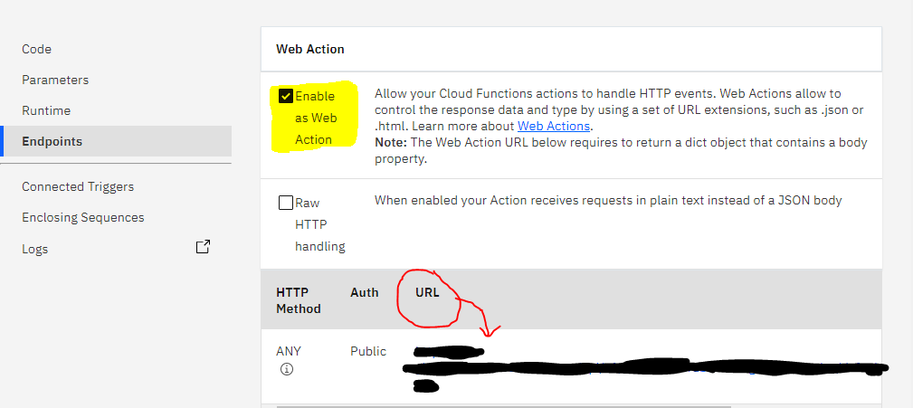

4.2 CONFIGURING AND LINKING WEBHOOK
1. Open and launch Watson Assistant, open your skill and in Options tab, under Webhooks section, paste the URL which we generated in Functions.
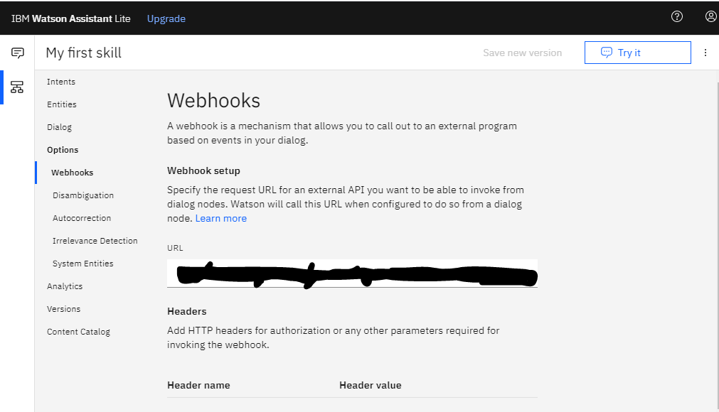
2. Create a new node in Dialog tab, to invoke the intent related to Discovery, chose that intent and click customize.
3. Switch on the Webhooks and it configures the URL and click Apply.
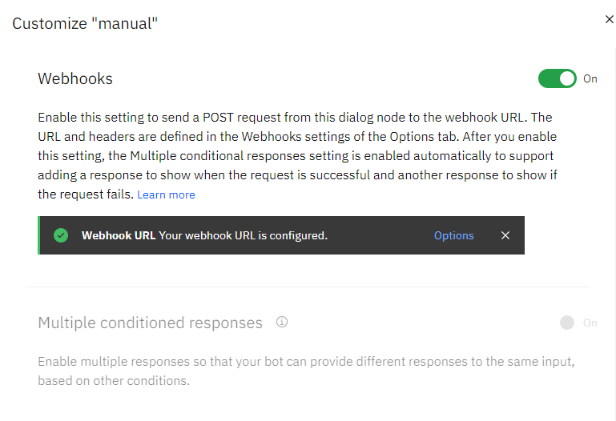
4. Now, enter the Key, Value pairs and Return variable.
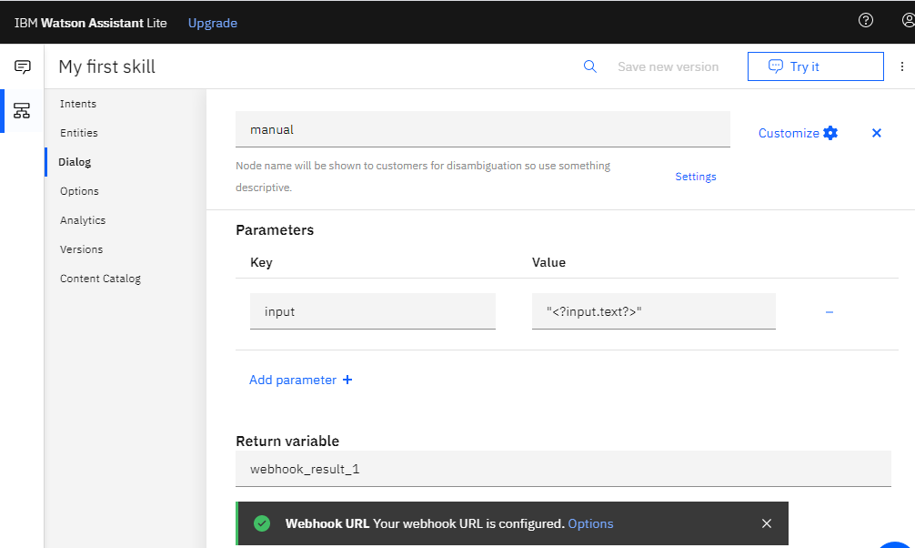
5. Enter values for what assistant has to respond with if it recognizes a particular value.

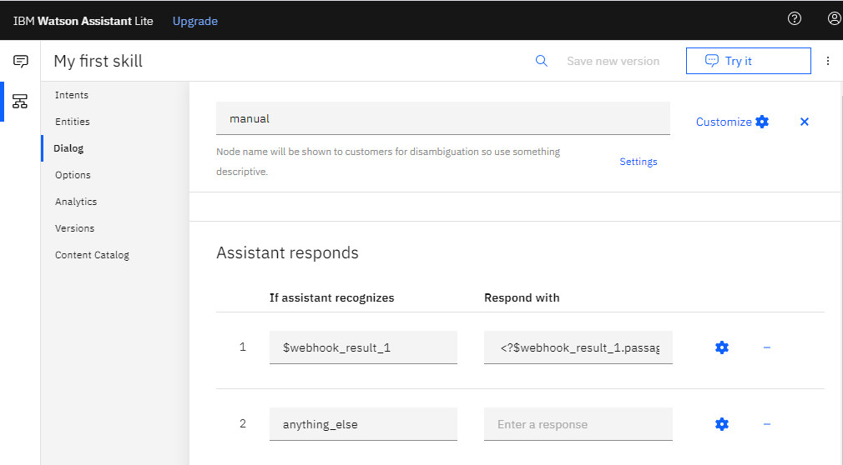
6. Assistant and Discovery are now integrated with the help of webhook of the Functions.

4.3 INTEGRATION OF ASSISTANT IN NODE-RED
1. Open Node-RED flow editor and search for assistant node, form node, function nodes (2 nodes), debug node and text node and drag them into the flow and make connections as shown.
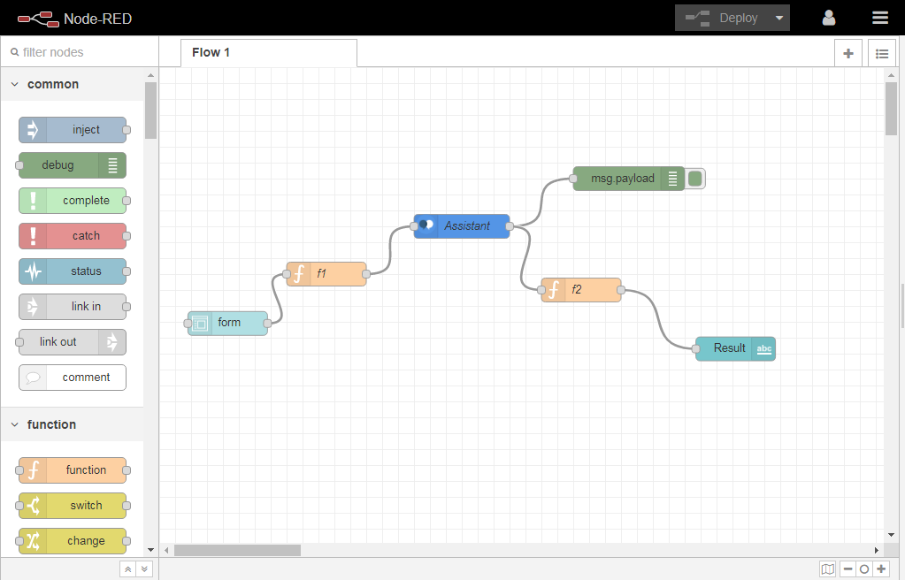

2. Click on form node and give Group name, size and Form elements and click Done.
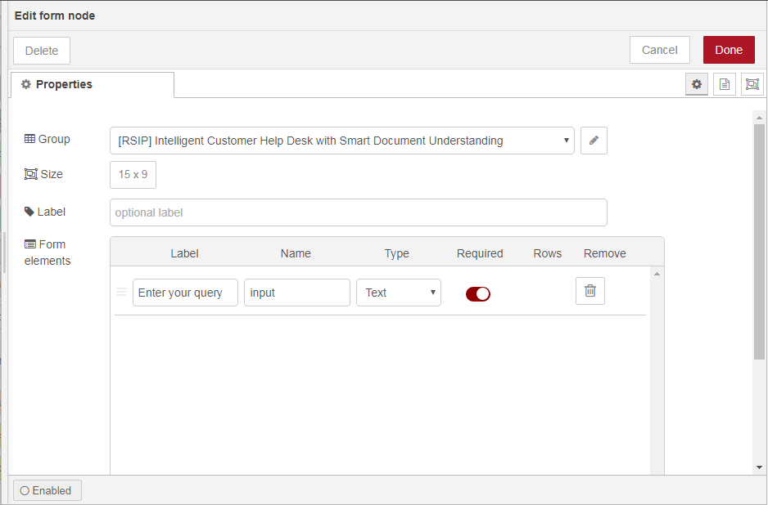
3. Click on function node and type the corresponding code in the box and click Done.
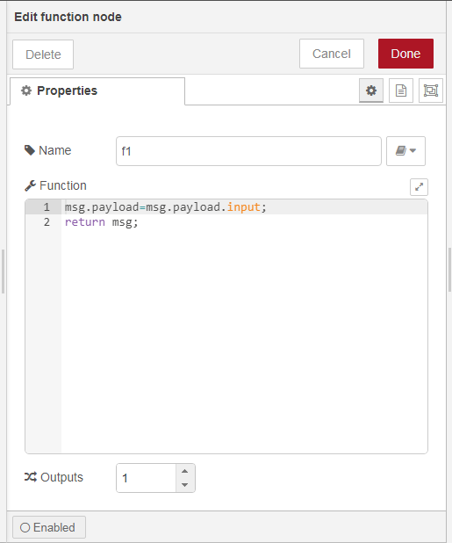
4. Now, click on assistant node and enter the API key, Service Endpoint and Workspace ID which were noted during the Assistant creation section and click Done.
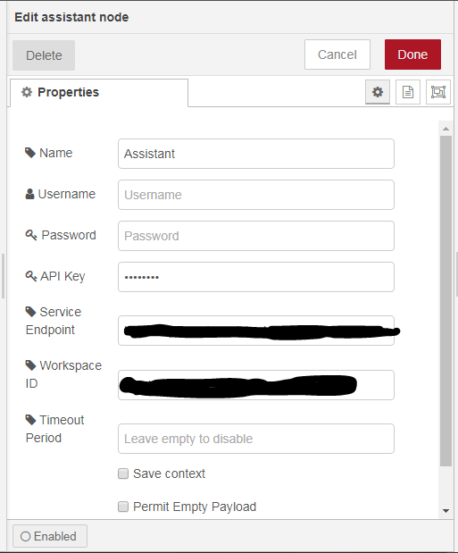
5. Click on text node, and enter Group name, size and label (as in form node) and click Done.
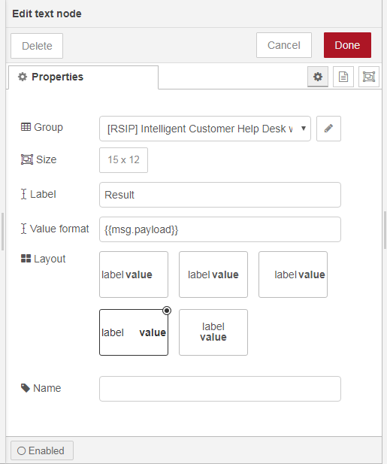
6. And the click on Deploy. And a ‘successfully deployed’ message appears if everything is perfect.
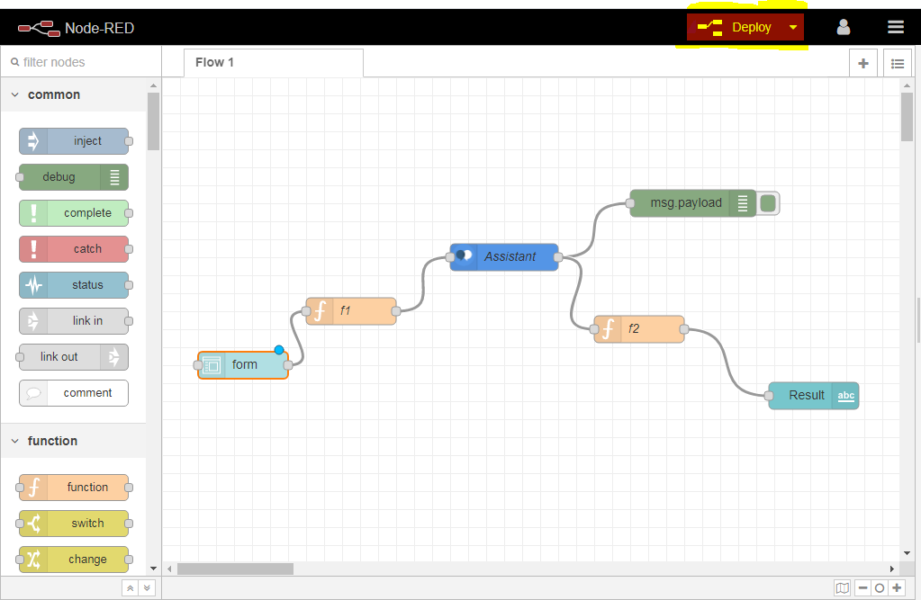
7. Copy the URL till .net/ and paste in new tab followed by ui (https://.......net/ui) and type enter.
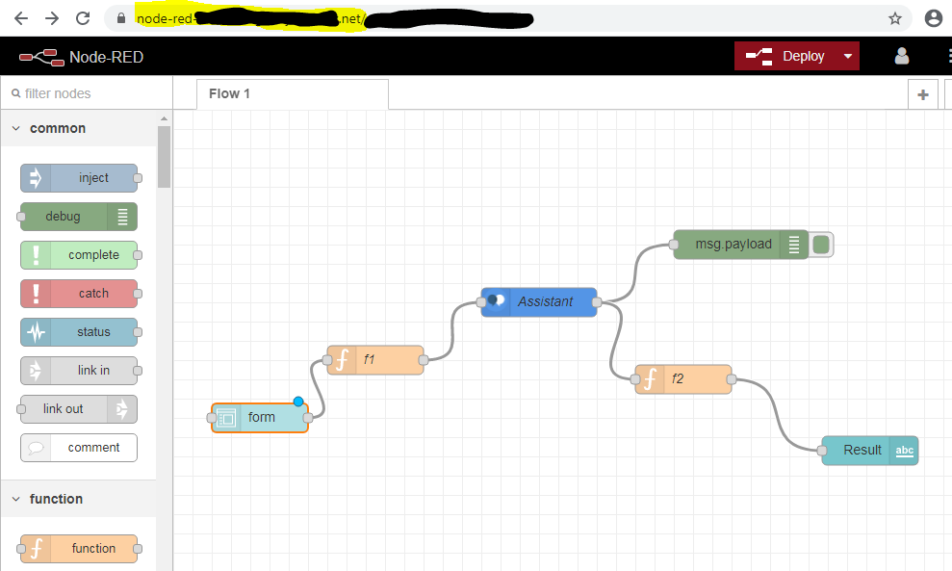
8. This is the UI that user can interact with and get his queries answered.
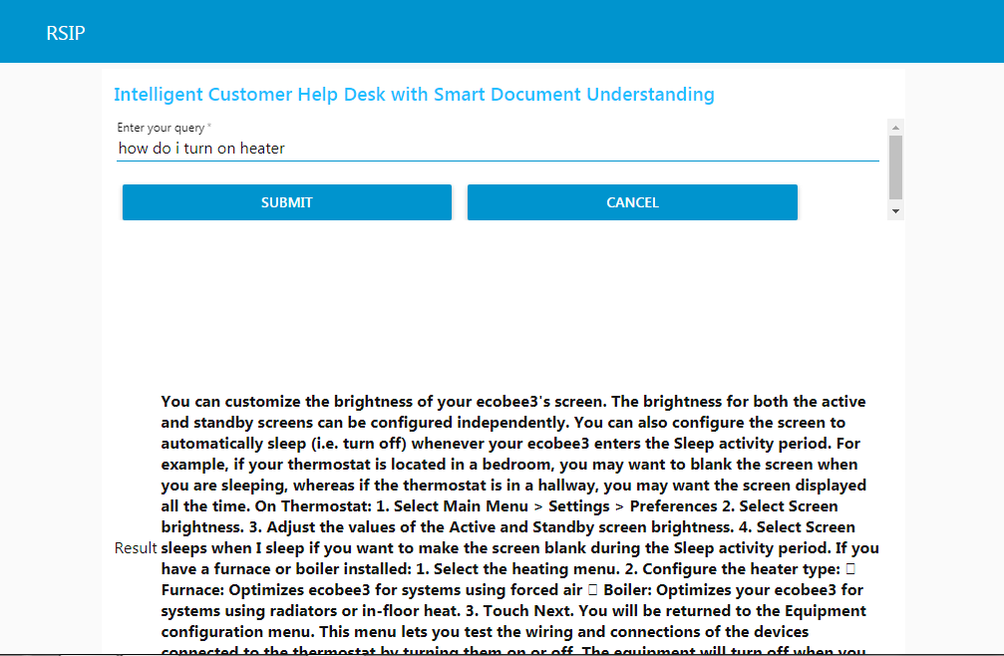

CHAPTER 5
FLOWCHART

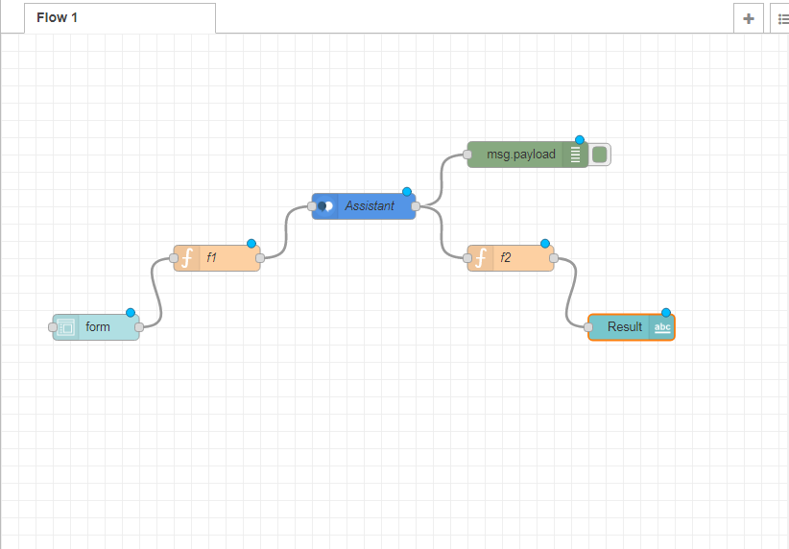
In the Node-RED flow editor, there is a palette on the left containing different nodes, draw the following nodes into the editor and make connections as shown in the figure.
- Form Node.
- Function Nodes.
- Assistant Node.
- Debug Node (msg.payload).
- Text Node.

CHAPTER 6
RESULTS
The user can interact with the UI designed in Node-RED and can ask query in the ‘Enter your query’ section and click Submit and displays the results (few results are attached below). The UI passes the query to Assistant and answers it if, it’s in the scope else it asks IBM Cloud Function to invoke the Discovery Service and respond with appropriate answer.
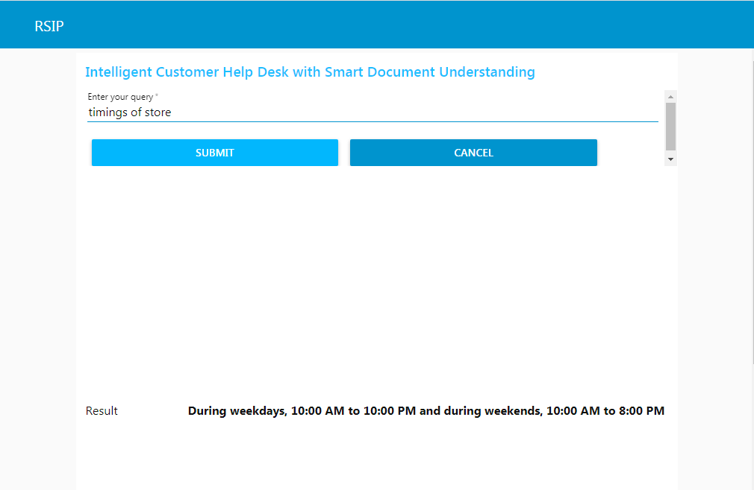

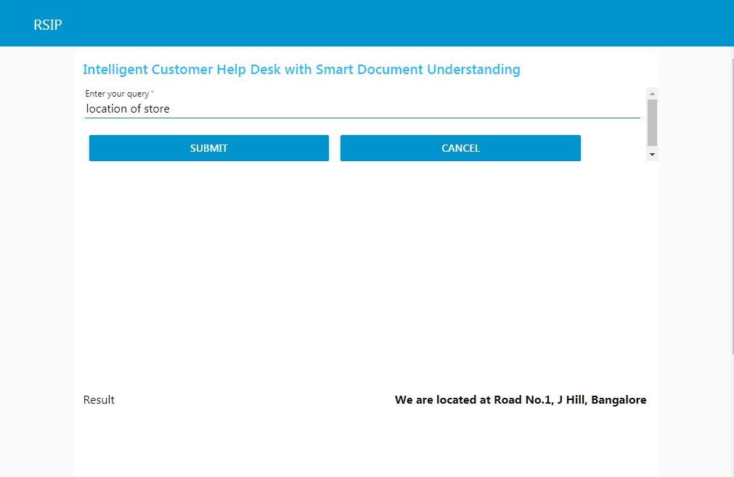
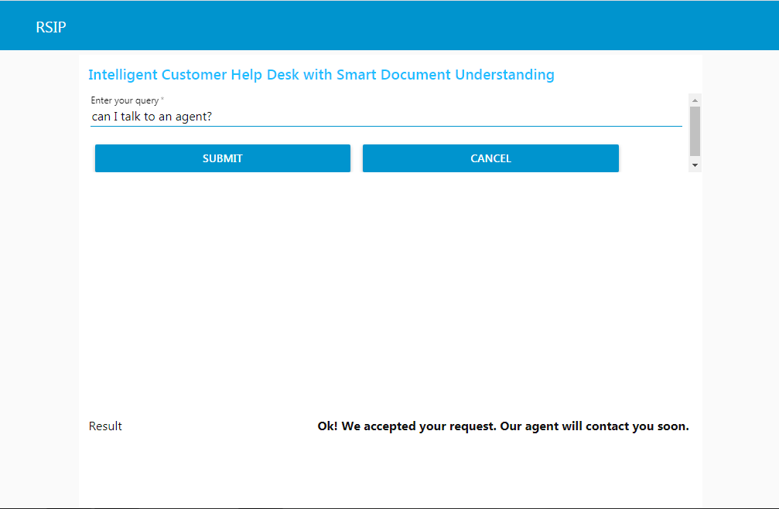
The below image outputs the result with the help of Discovery Service.
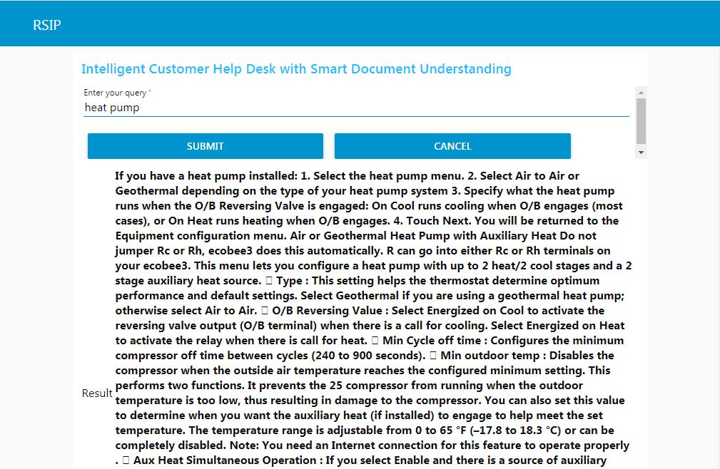

CHAPTER 7
ADVANTAGES AND DISADVANTAGES

ADVANTAGES
- It is cost-efficient.
- Reduce the involvement of external agent.
- Reduces the number of call diversions.
- Can answer most of the user queries.
- Industries, companies can deploy chatbots to help their customers explore more about their services and products.

DISADVANTAGES
- Sometimes can mislead the customers.
- Often repeats the same answer and looks like robotic.
- Does not consider human emotions.
- Sometimes does not produce required results due to clash between the words in different intents.
- Jobs for humans may be decreased or lost completely.

CHAPTER 8
APPLICATIONS
Chatbots has wide range of applications in day-to-day life. It can implemented for any kind of purpose to reduce the human effort and moreover create a best way to interact with customers and get their doubts clarified and let them explore services and products of different industries and companies more effectively, efficiently and productively. Some fields which which use chatbots commonly are:
- In websites to clarify human questions and queries.
- Social Media.
- Product developers.
- Telecommunication Services.
- Service Industries.

CHAPTER 9
CONCLUSION
Ordinary chatbots can be replaced by Intelligent Chatbot with Smart Document Understanding to increase the effectiveness and efficiency of help desks. This can be made possible using AI services like IBM Watson, Assistant, Cloud Functions and Node-RED and integrating them together. Even large documents can be split into simple and small documents with the help of Discovery’s Smart Document Understanding feature and thereby can produce results with ease.

CHAPTER 10
FUTURE SCOPE
Alexa, Google Assistant and many such similar services are almost built on this concept or model. This chatbots can be redesigned more conveniently using speech to text conversion and can be made handsfree. This eases the human efforts to ask a query and it becomes more comfortable to get users’ queries answered.

CHAPTER 11
BIBILOGRAPHY
REFERENCES
- https://cloud.ibm.com/
- https://youtube.com/ (IBM Channel)
- https://smartinternz.com/

APPENDIX
SOURCE CODE

11.1 NODE_RED CODE
[{"id":"5a7626ca.3c13a8","type":"tab","label":"Flow 1","disabled":false,"info":""},{"id":"97c4c7c9.6888f8","type":"ui_tab","z":"","name":"RSIP","icon":"dashboard","disabled":false,"hidden":false},{"id":"c757089d.88c018","type":"ui_base","theme":{"name":"theme-light","lightTheme":{"default":"#0094CE","baseColor":"#0094CE","baseFont":"-apple-system,BlinkMacSystemFont,Segoe UI,Roboto,Oxygen-Sans,Ubuntu,Cantarell,Helvetica Neue,sans-serif","edited":true,"reset":false},"darkTheme":{"default":"#097479","baseColor":"#097479","baseFont":"-apple-system,BlinkMacSystemFont,Segoe UI,Roboto,Oxygen-Sans,Ubuntu,Cantarell,Helvetica Neue,sans-serif","edited":false},"customTheme":{"name":"Untitled Theme 1","default":"#4B7930","baseColor":"#4B7930","baseFont":"-apple-system,BlinkMacSystemFont,Segoe UI,Roboto,Oxygen-Sans,Ubuntu,Cantarell,Helvetica Neue,sans-serif"},"themeState":{"base-color":{"default":"#0094CE","value":"#0094CE","edited":false},"page-titlebar-backgroundColor":{"value":"#0094CE","edited":false},"page-backgroundColor":{"value":"#fafafa","edited":false},"page-sidebar-backgroundColor":{"value":"#ffffff","edited":false},"group-textColor":{"value":"#1bbfff","edited":false},"group-borderColor":{"value":"#ffffff","edited":false},"group-backgroundColor":{"value":"#ffffff","edited":false},"widget-textColor":{"value":"#111111","edited":false},"widget-backgroundColor":{"value":"#0094ce","edited":false},"widget-borderColor":{"value":"#ffffff","edited":false},"base-font":{"value":"-apple-system,BlinkMacSystemFont,Segoe UI,Roboto,Oxygen-Sans,Ubuntu,Cantarell,Helvetica Neue,sans-serif"}},"angularTheme":{"primary":"indigo","accents":"blue","warn":"red","background":"grey"}},"site":{"name":"Node-RED Dashboard","hideToolbar":"false","allowSwipe":"false","lockMenu":"false","allowTempTheme":"true","dateFormat":"DD/MM/YYYY","sizes":{"sx":48,"sy":48,"gx":6,"gy":6,"cx":6,"cy":6,"px":0,"py":0}}},{"id":"472ccfe8.3b92c","type":"ui_group","z":"","name":"Search Result","tab":"97c4c7c9.6888f8","order":2,"disp":true,"width":"12","collapse":false},{"id":"a4ac30b5.91d3c","type":"ui_group","z":"","name":"Intelligent Customer Help Desk with Smart Document Understanding","tab":"97c4c7c9.6888f8","order":2,"disp":true,"width":"15","collapse":false},{"id":"8dcc1427.14bc08","type":"watson-conversation-v1","z":"5a7626ca.3c13a8","name":"Assistant","workspaceid":"4404fc51-e311-465e-939c-ac7f9a4bcb48","multiuser":false,"context":false,"empty-payload":false,"service-endpoint":"https://api.eu-gb.assistant.watson.cloud.ibm.com/instances/72f2647e-bc5c-4506-bdd5-7776e6e6b0ae","timeout":"","optout-learning":false,"x":420,"y":200,"wires":[["7dfe96db.b1bce8","26b5c9f2.9774b6"]]},{"id":"7dfe96db.b1bce8","type":"debug","z":"5a7626ca.3c13a8","name":"","active":true,"tosidebar":true,"console":false,"tostatus":false,"complete":"payload","targetType":"msg","x":610,"y":140,"wires":[]},{"id":"845e5947.a40eb8","type":"function","z":"5a7626ca.3c13a8","name":"f1","func":"msg.payload=msg.payload.input;\nreturn msg;","outputs":1,"noerr":0,"x":250,"y":260,"wires":[["8dcc1427.14bc08"]]},{"id":"26b5c9f2.9774b6","type":"function","z":"5a7626ca.3c13a8","name":"f2","func":"msg.payload.text=\"\";\nif(msg.payload.context.webhook_result_1){\n for(var i in msg.payload.context.webhook_result_1.results){\n msg.payload.text=msg.payload.text+\"\\n\"+msg.payload.context.webhook_result_1.results[i].text;\n }\n msg.payload=msg.payload.text;\n}\n\nelse\nmsg.payload=msg.payload.output.text[0];\nreturn msg;","outputs":1,"noerr":0,"x":590,"y":260,"wires":[["c3b53a32.0aa348"]]},{"id":"ce91d255.a95ef","type":"ui_form","z":"5a7626ca.3c13a8","name":"","label":"","group":"a4ac30b5.91d3c","order":1,"width":"15","height":"9","options":[{"label":"Enter your query","value":"input","type":"text","required":true,"rows":null}],"formValue":{"input":""},"payload":"","submit":"submit","cancel":"cancel","topic":"","x":110,"y":340,"wires":[["845e5947.a40eb8"]]},{"id":"c3b53a32.0aa348","type":"ui_text","z":"5a7626ca.3c13a8","group":"a4ac30b5.91d3c","order":1,"width":"15","height":"12","name":"","label":"Result","format":"{{msg.payload}}","layout":"row-spread","x":730,"y":340,"wires":[]}]

11.2 IBM FUNCTION CODE
/**
*
* @param {object} params
* @param {string} params.iam_apikey
* @param {string} params.url
* @param {string} params.username
* @param {string} params.password
* @param {string} params.environment_id
* @param {string} params.collection_id
* @param {string} params.configuration_id
* @param {string} params.input
*
* @return {object}
*
*/

const assert = require('assert');
const DiscoveryV1 = require('watson-developer-cloud/discovery/v1');

/**
*
* main() will be run when you invoke this action
*
* @param Cloud Functions actions accept a single parameter, which must be a JSON object.
*
* @return The output of this action, which must be a JSON object.
*
*/
function main(params) {
return new Promise(function (resolve, reject) {

let discovery;

if (params.iam_apikey){
discovery = new DiscoveryV1({
'iam_apikey': params.iam_apikey,
'url': params.url,
'version': '2019-03-25'
});
}
else {
discovery = new DiscoveryV1({
'username': params.username,
'password': params.password,
'url': params.url,
'version': '2019-03-25'
});
}

discovery.query({
'environment_id': params.environment_id,
'collection_id': params.collection_id,
'natural_language_query': params.input,
'passages': true,
'count': 3,
'passages_count': 3
}, function(err, data) {
if (err) {
return reject(err);
}
return resolve(data);
});
});
}

