Position:

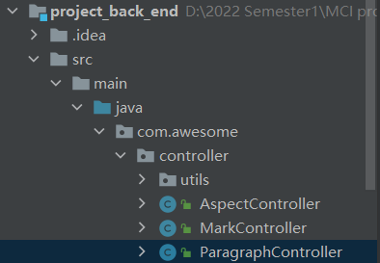

URL:

http://localhost/article/origin

Form:

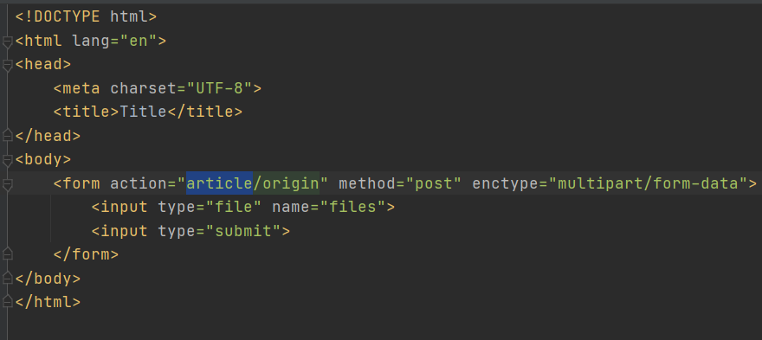

Web screenshot:

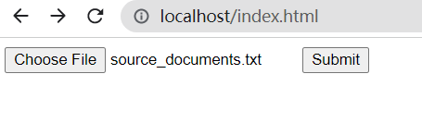

Results:

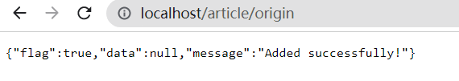

Before:

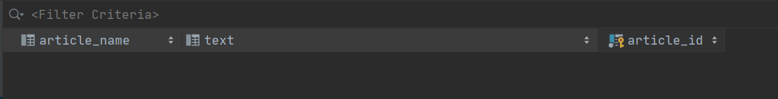

After:



URL:

<http://localhost/article/summary>

Form:

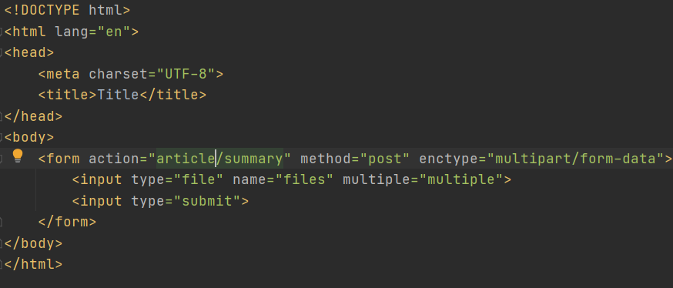

Web screenshot:

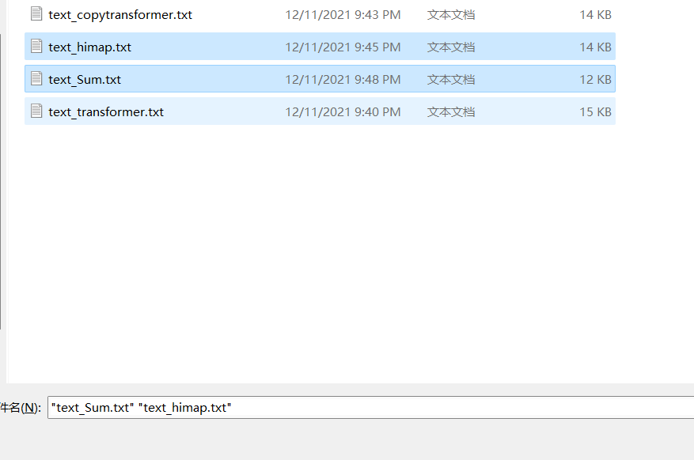

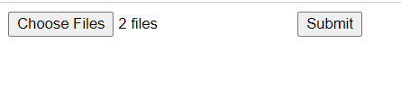

Before:



After:

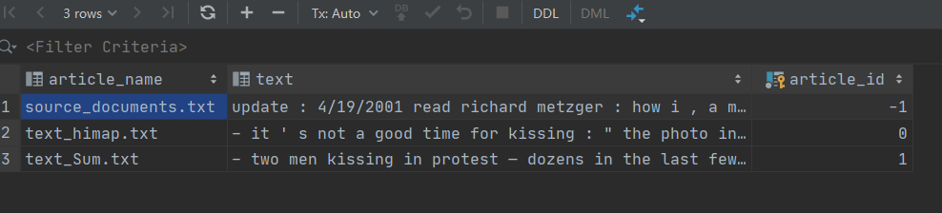

URL:

<http://localhost/paragraphs/origin>

METHOD: GET

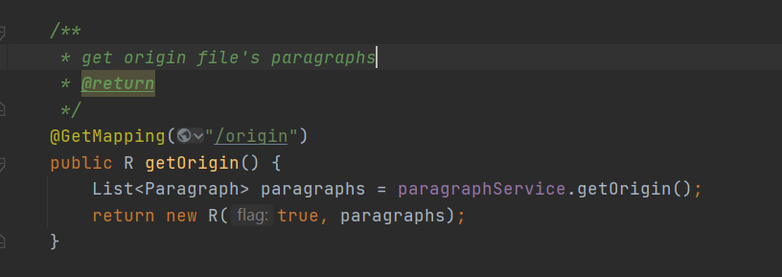

RESULTS:

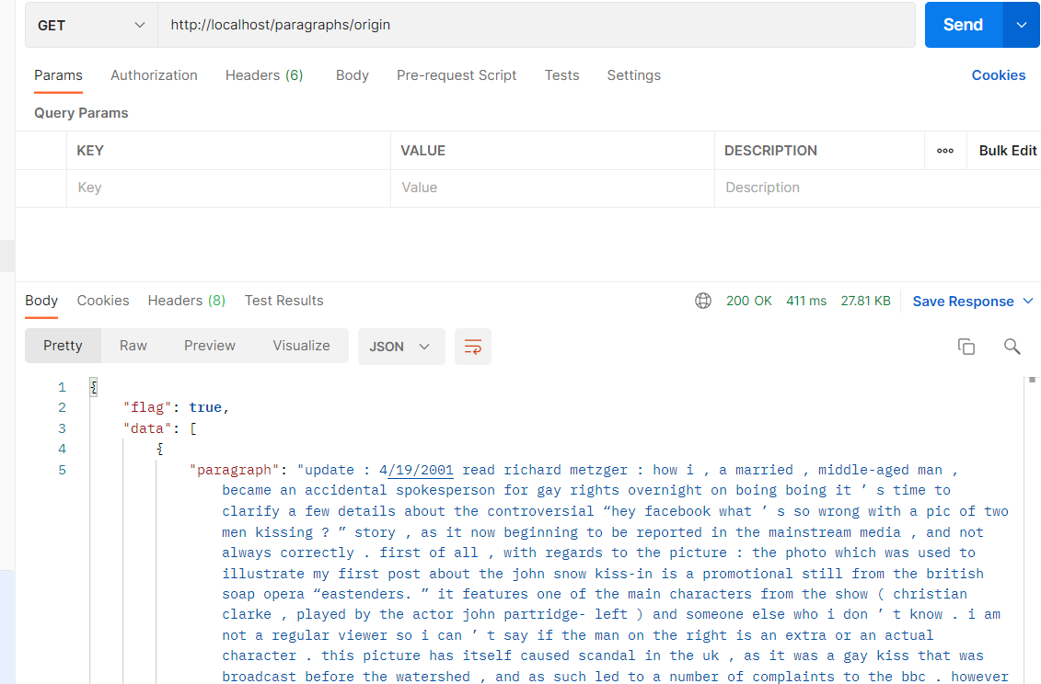

URL:

<http://localhost/paragraphs/summary>

METHOD: GET

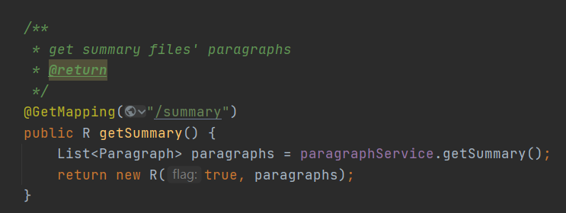

Results:

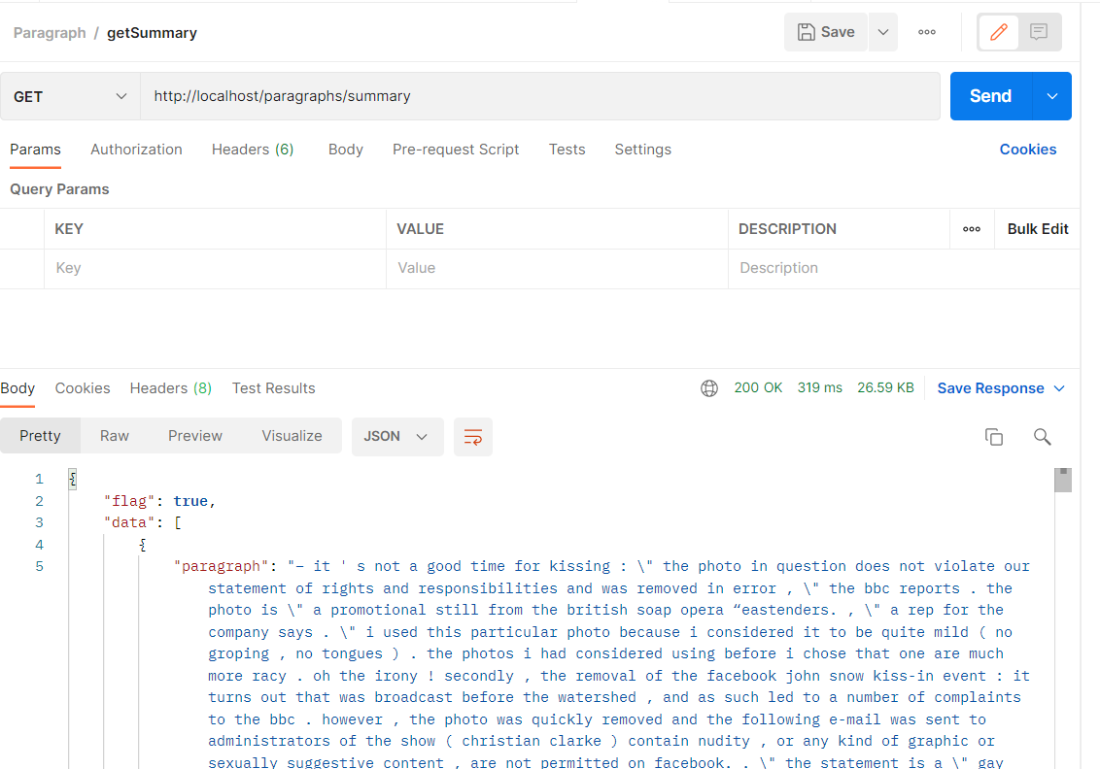

URL:

<http://localhost/paragraphs/summary>/1

METHOD: GET

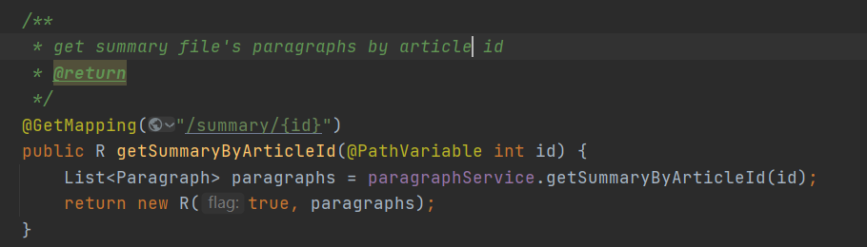

RESULT:

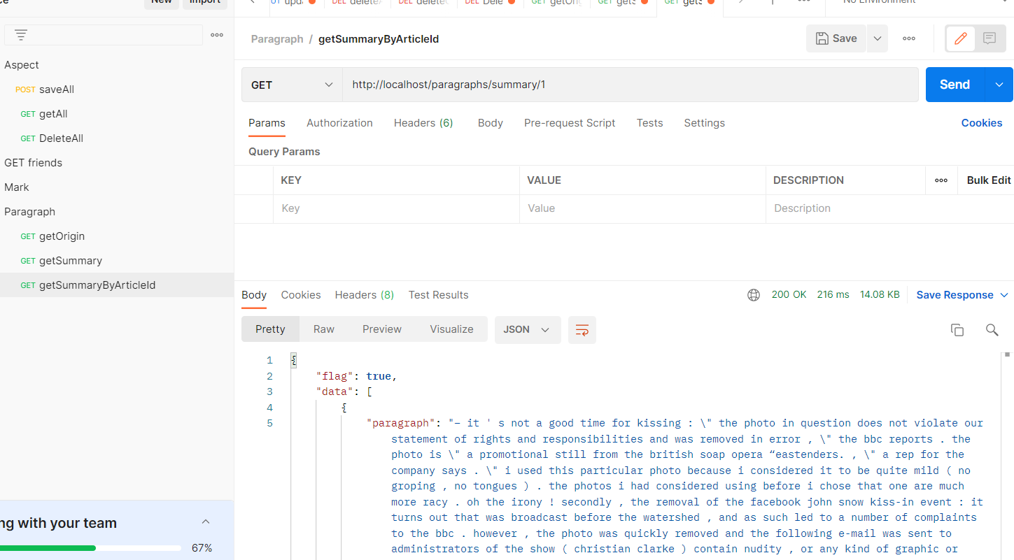

URL:

<http://localhost/paragraphs>

METHOD: DELETE

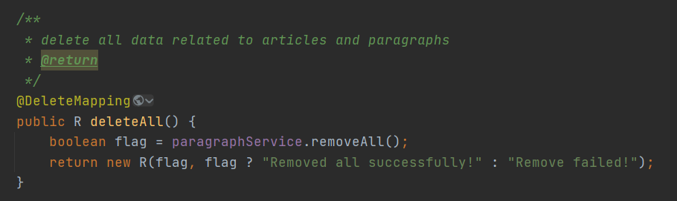

Result:

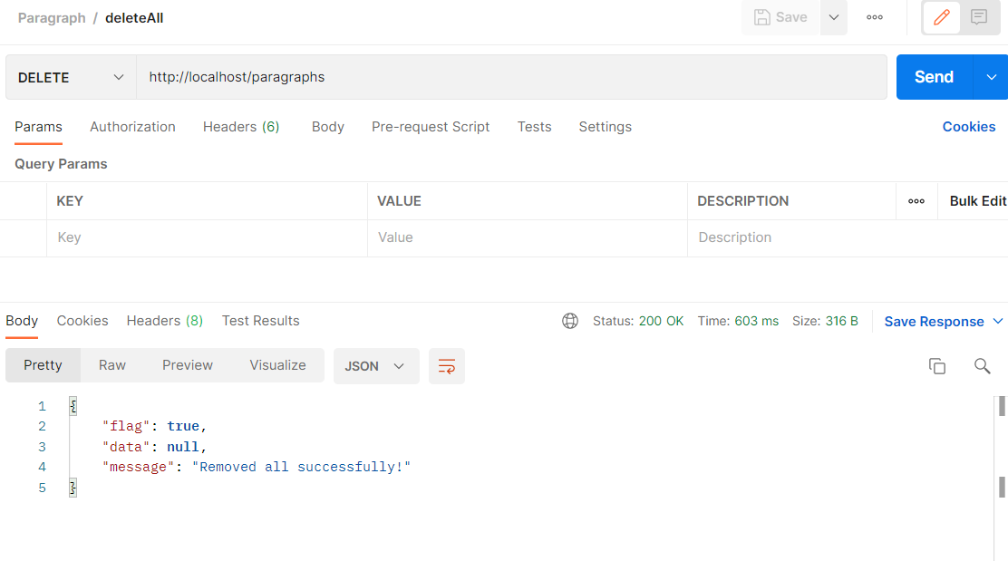

Before:

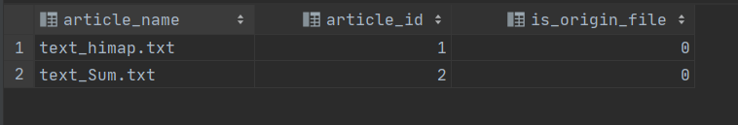

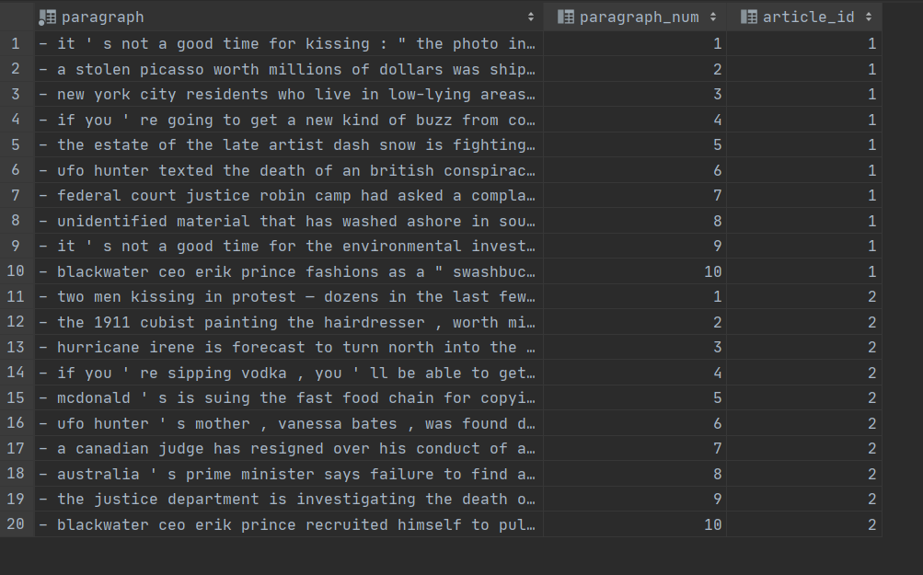

After:



