MarkController Position:

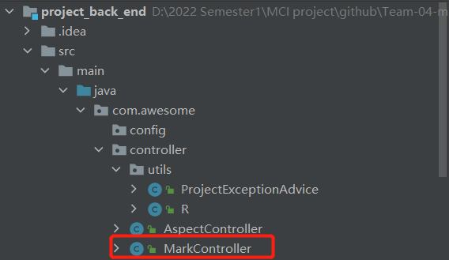

URL:

http://localhost/marks

Method: POST

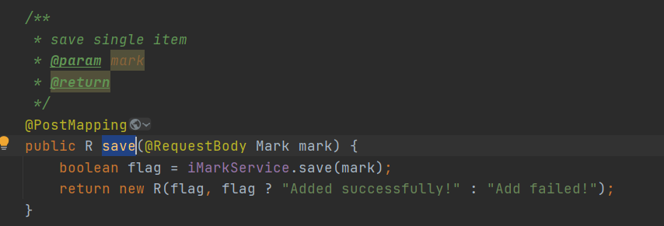

Result:

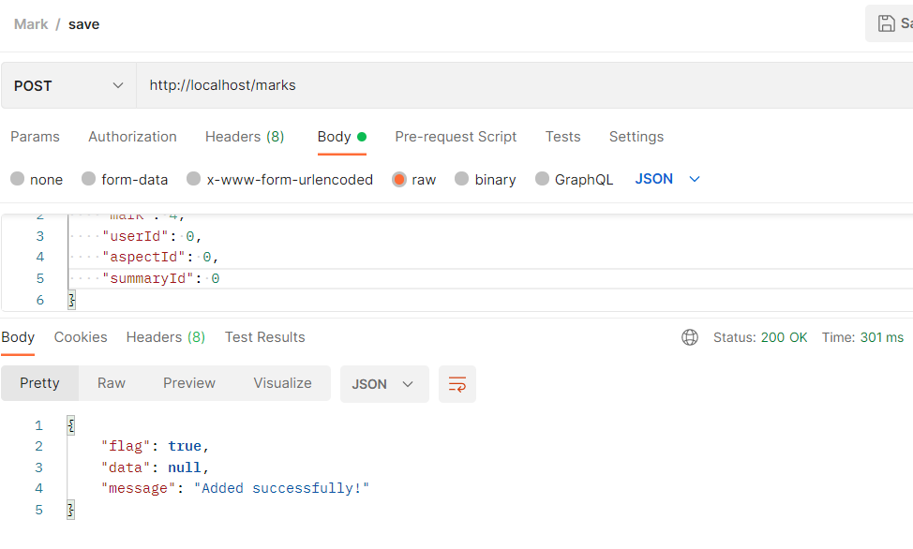

Before:

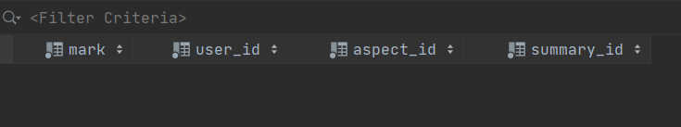

After:

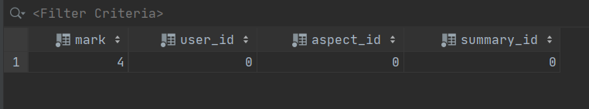

URL:

http://localhost/marks

Method: GET

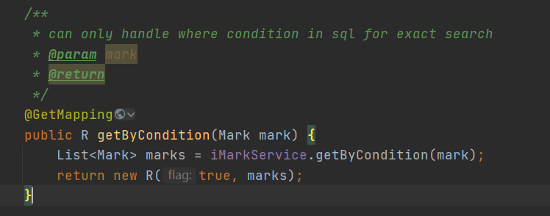

Result:

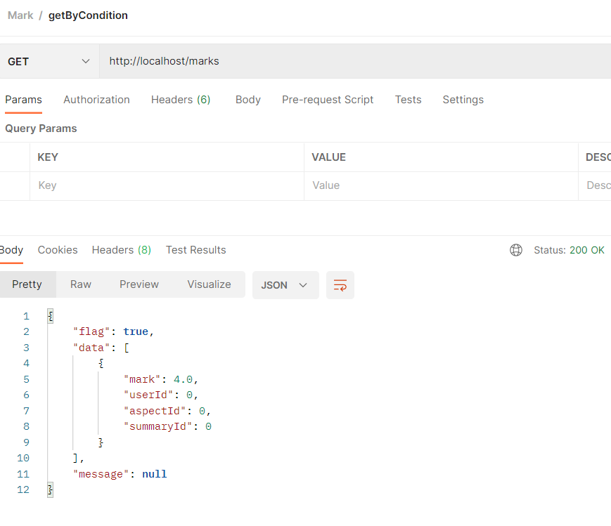

URL:

http://localhost/marks?mark=4&userId=1&aspectId=3&summaryId=2

Method: GET



Result:

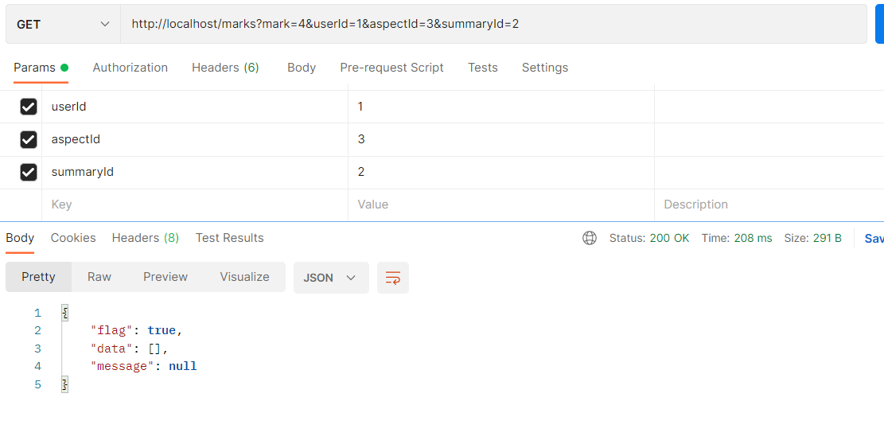

URL:

<http://localhost/marks?mark=4&userId=0>

Method: GET



Result:

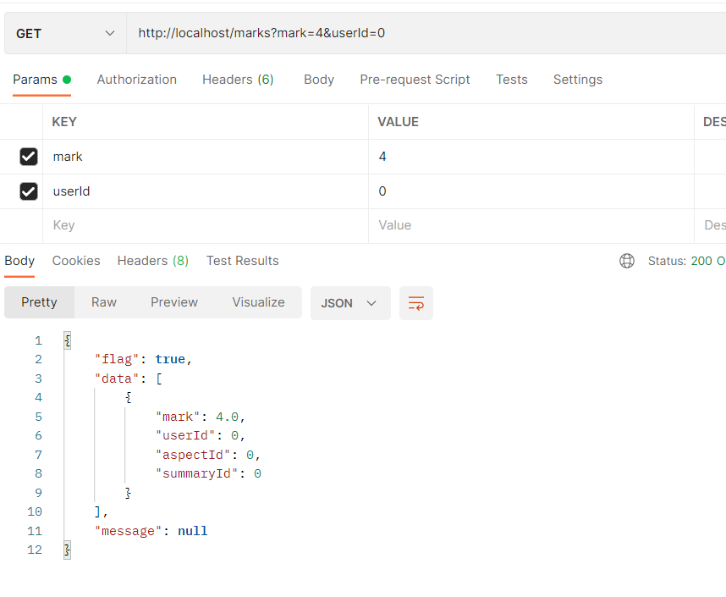

URL:

http://localhost/marks/avg_userid

Method: GET

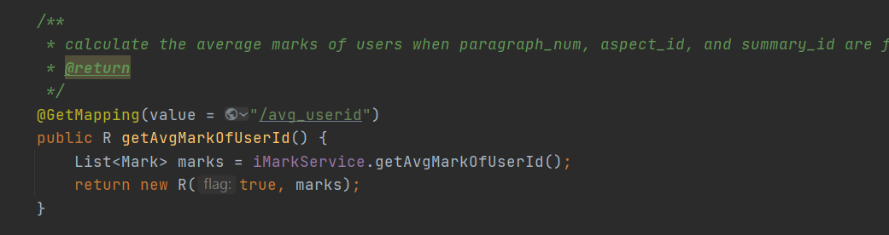

Database:

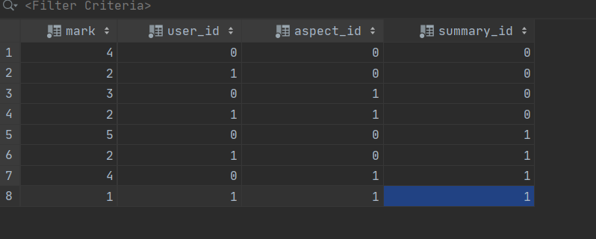

Result:

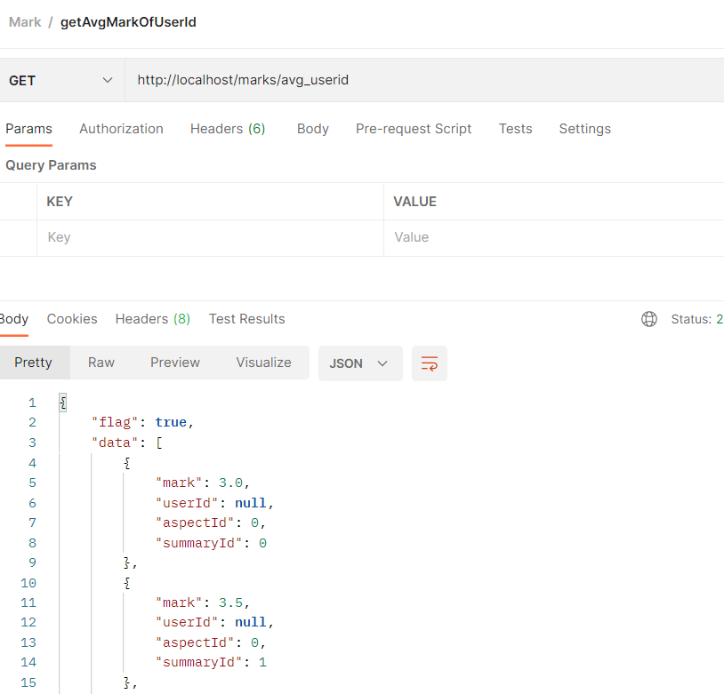

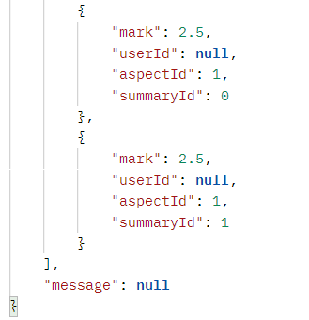

URL:

http://localhost/marks/avg_userid /1

Method: GET

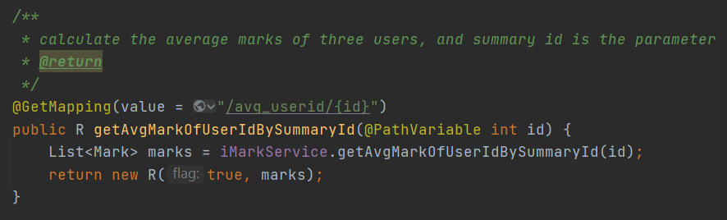

Database

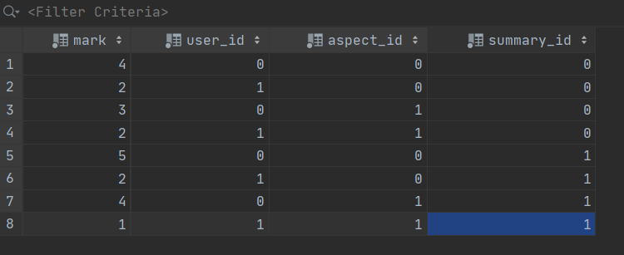

Result:

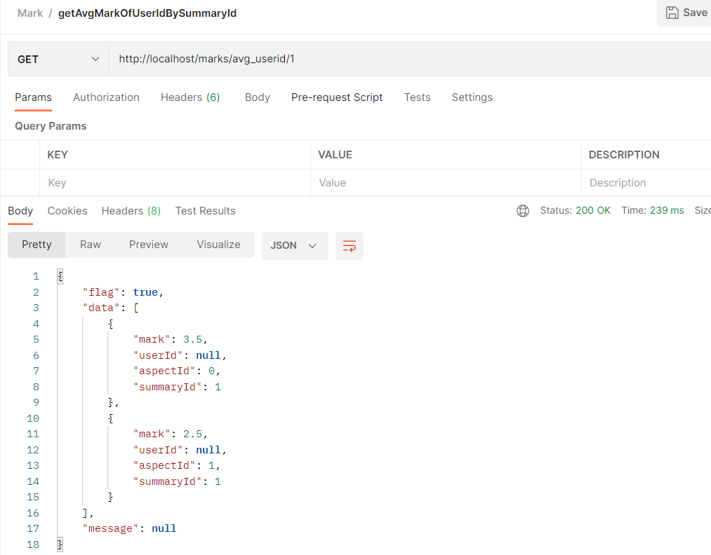

URL:

http://localhost/marks/highest_marks

Method: GET

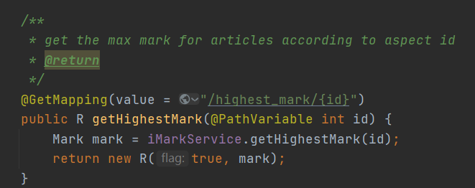

Database



Result:

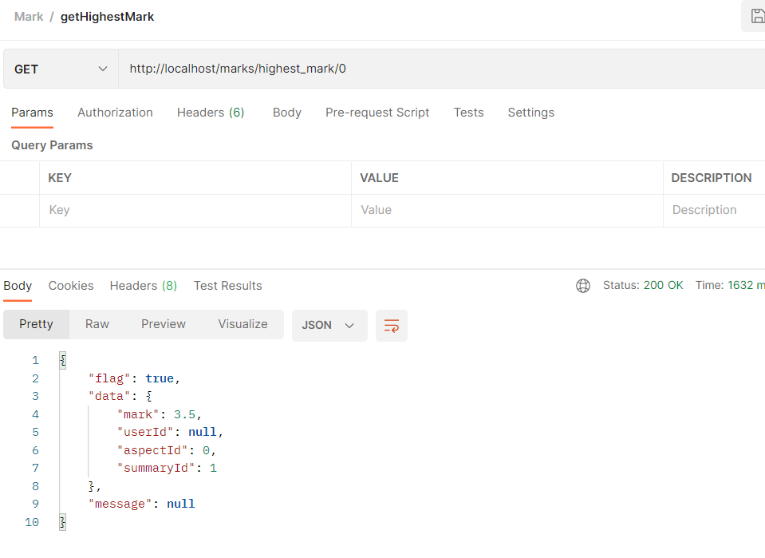

URL:

<http://localhost/marks/lowest_mark/1>

Method: GET

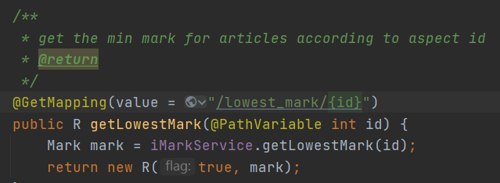

Database



Result:

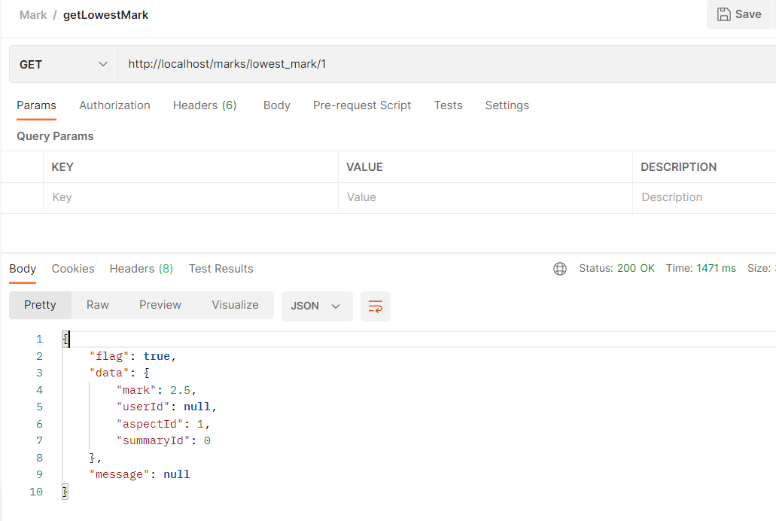

URL:

http://localhost/marks/vote

Method: GET

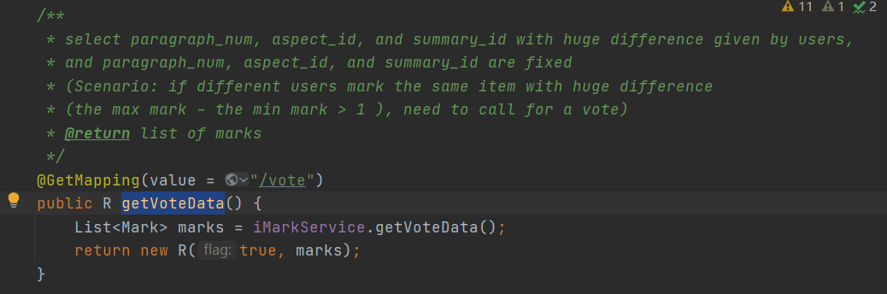

Result:

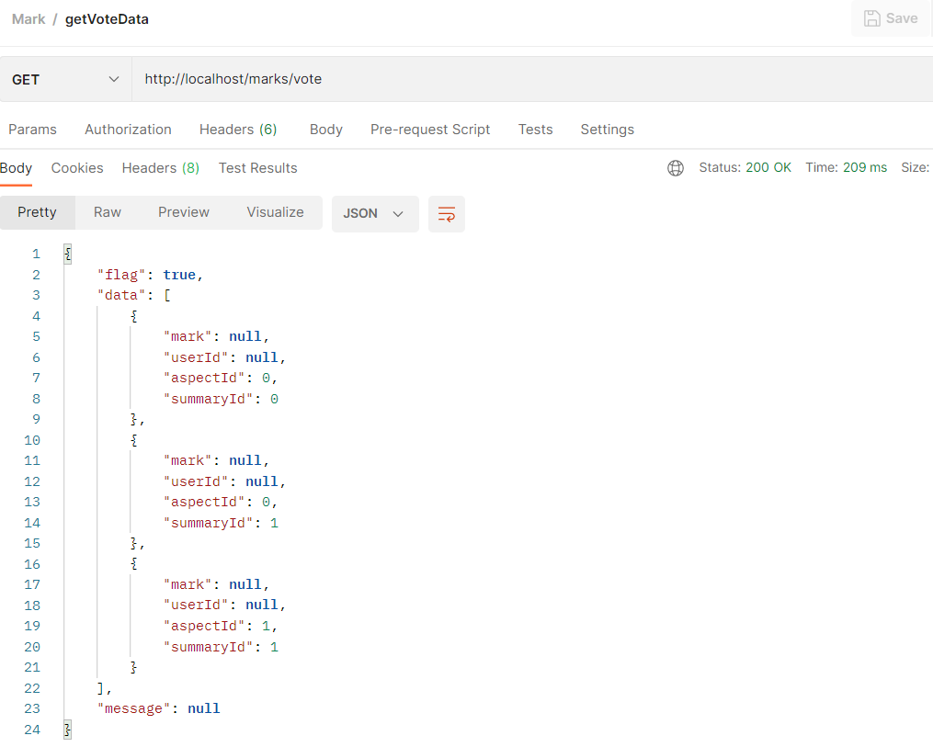

URL:

http://localhost/marks

Method: PUT

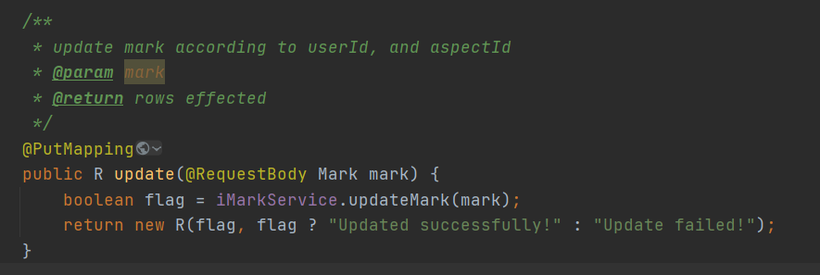

Result:

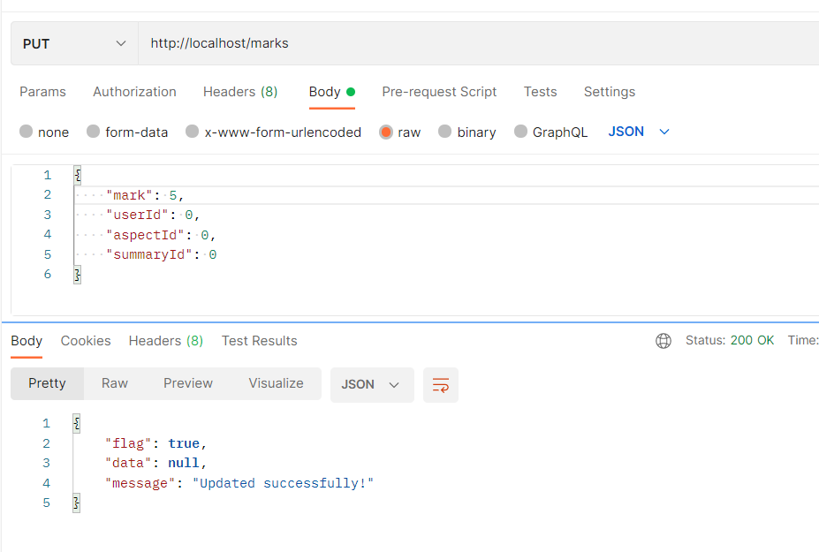

Before:



After:

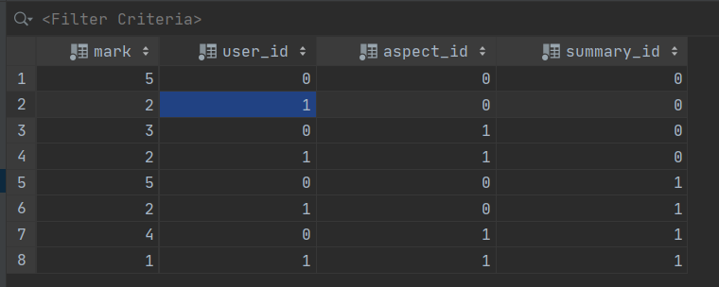

URL:

http://localhost/marks

Method: DELETE

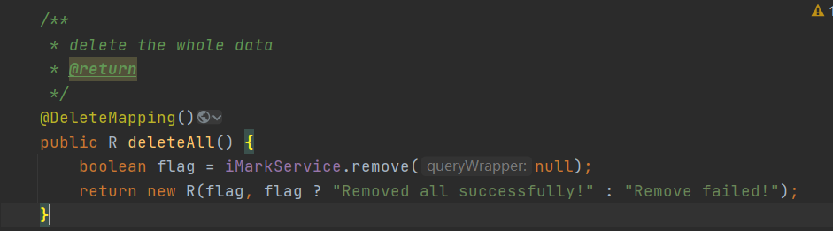

Result:

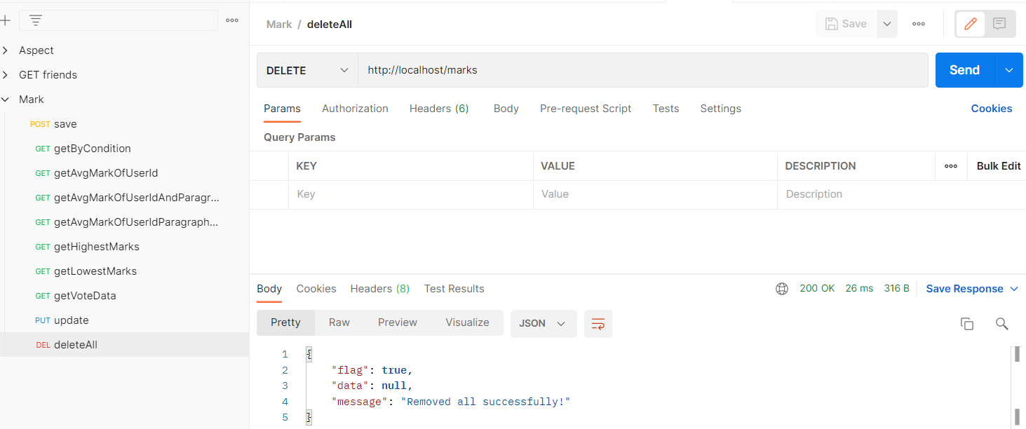

Before:

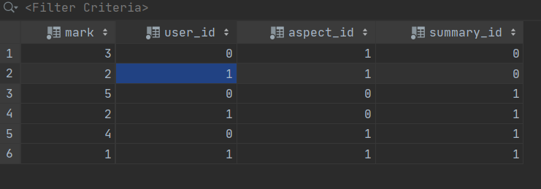

After:

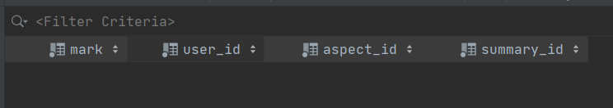

URL:

<http://localhost/marks/current_all_users>

Method: DELETE

Results:

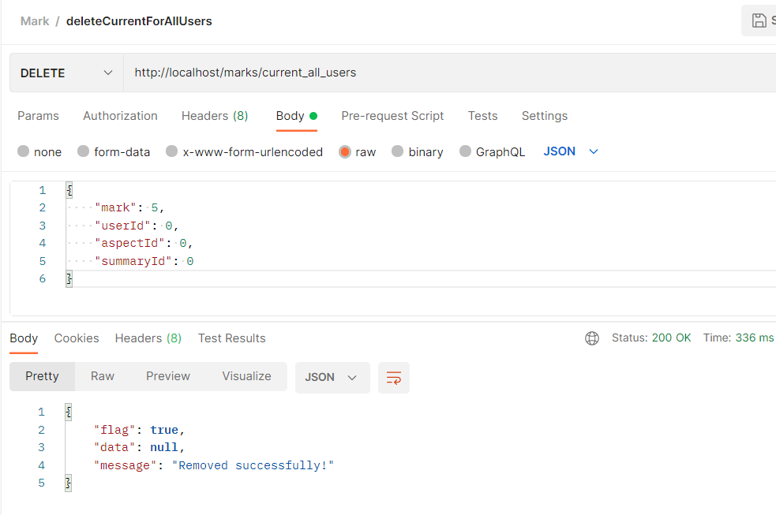

Before:



After:

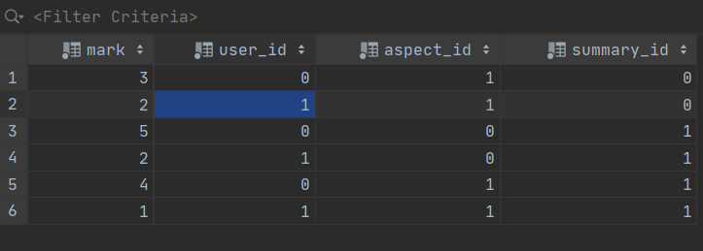

URL:

http://localhost/marks/current_all_users

Method: DELETE

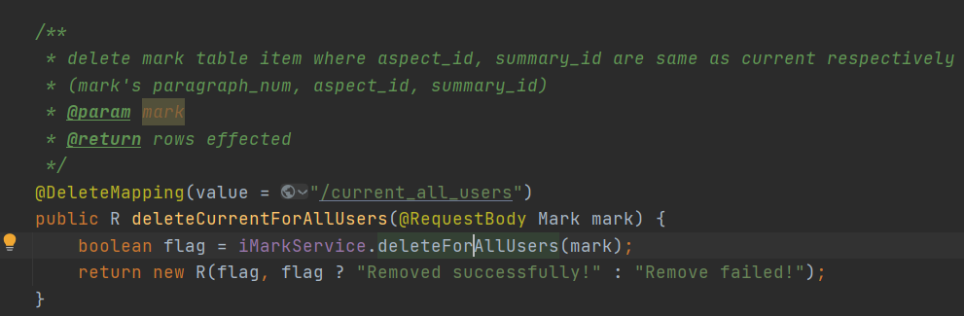

Result:

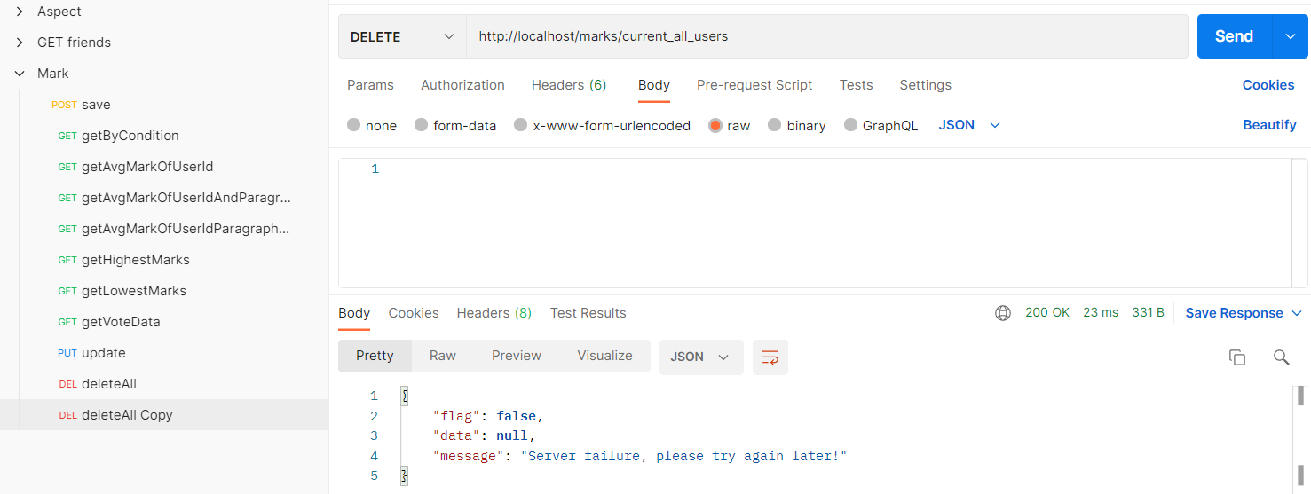

(No Request Body)