**Scanning Electrochemical Microscope (SECM)**

**Product Manual**

# Introduction

This manual helps you to get familiar with the SECM. Whether manually controlling the microscope's movement or using some of the automatic movement features, you can use the program by intuition or after some time exploring. Our software is open-access and based on Labview.

# Structure of the SECM program

Starting the program will open the main screen (Figure 1.) with two main parts. The left is the feature control, giving you access to all the features by changing through the tabs. The right screen is the camera image output, with some inbuilt features like zoom, dragging, and drawing over the image.

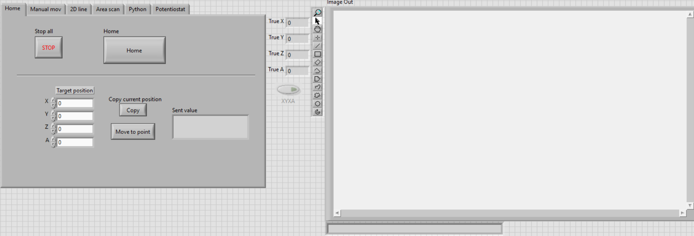

**Fig. 1. Central control panel (left) and camera image output (right)**

**Notice\*** If there is a problem with the TCP connection with the controller (Raspberry Pi) or the camera, an error notice will appear, and the program will not run.

## Home tab

The home tab aids with automatic movement, which is usually most useful when starting a run.

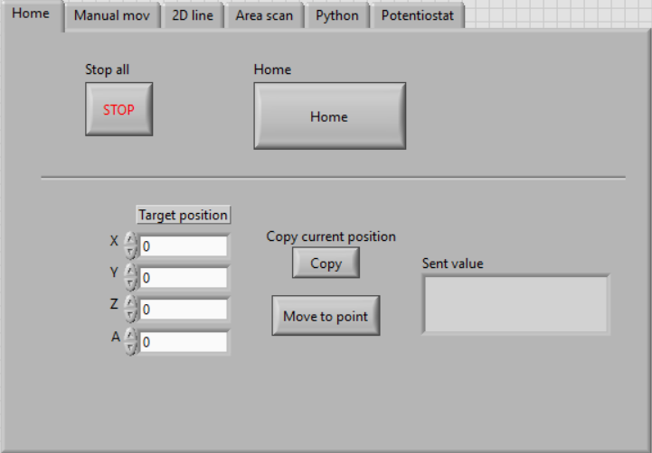

**Fig. 2. Central control panel (Home tab).**

When the program starts, and the camera image is visible, the program is running correctly, and you can push the home button.

When turning on the controller, the current position is set to 0,0,0,0, even if it is not. The home position will ensure to have a constant starting and origin point.

## Stop all.

By pressing Stop All, the currently executed command is aborted, and the program will stop shortly.

## Copy the Current position and move to point

It is helpful to use this feature when multiple axes must be changed simultaneously to a known position. It moves at maximum allowed speed, which is especially useful when moving many axes over considerable distances.

The move-to-point button will move ALL axes to the specified coordinates. Therefore, use the Copy current position feature and edit only the axes you want to move.

## Manual *mov* tab

This tab allows more effortless single-axis movement. There are two movement types: ***Step*** and ***Jog***. Use the slide switch to change between the two movement types.

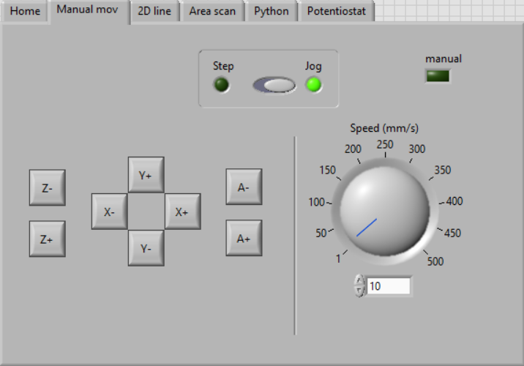

**Figure 2. Central control panel (Manual mov tab).**

## *Jog* button

***Jog*** allows you to continuously move in a specified axis if the button is pressed. The speed of this movement can be changed with the dial on the right-hand side.

After the button is released, the ***XYZA*** light will turn ON for a short duration. This means that the current position is being updated.

**Note\*** If an axis jog button is pushed while this ***XYZA*** light is ON, it may overload the connection, and an error message will appear. Make sure to press the buttons only after this light turns off. If the error message appears, you can rerun the program and continue from where you left off. If the light does not turn OFF and the coordinates do not move, you can rerun the program and continue from where you left off.

## *Step* button

Steps allow you to move a specified distance. Specify the step size for movement, and then you move any axis.

## Line Scan (*2D Line*)

This feature allows you to move in a straight line with intermediate pauses on the XY plane.

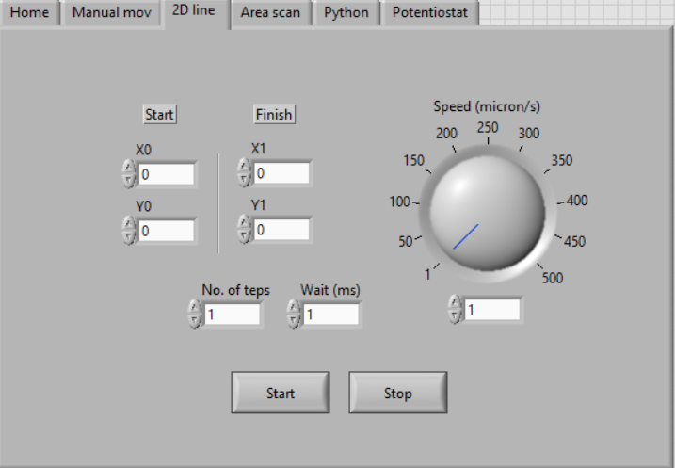

**Figure 3. Central control panel (2D line tab).**

To do so:

* Insert the initial starting coordinates of X0 and Y0. (It is faster to move to the starting position with the ***Home*** target position and then do the ***2D line***),
* Insert the ***Finish*** position,
* Insert in how many steps you want to accomplish this line. (1 step is one continuous line),
* Change the waiting time,
* Change the speed,
* Push start.

If you want to cancel the movement halfway, press ***stop***.

## *Area scan* tab

The ***area scan*** allows the scan of a fixed area and continuous displacement.

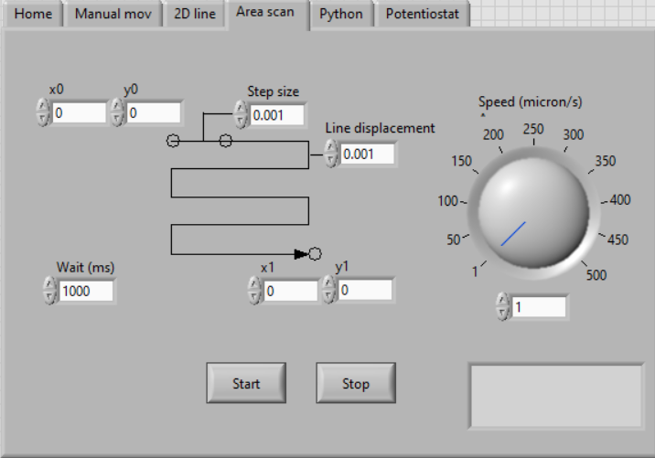

**Figure 4. Central control panel (*Area scan* tab).**

To do so:

* Choose the ***speed***,
* Choose the ***start*** and ***end*** position corners (X0, Y0, X1, Y1),
* Choose the ***step size*** and ***line displacement*** values,
* Choose the wait time ***Wait (ms)*** during every pause,
* Push ***Start***.

## Potentiostat

To use the potentiostat, Select the correct ***VISA resource name*** from the drop-down list and press ***Check port***. If the “Config Status'' bar does not fully load or the Status light turns red, rerun the program, and select the correct ***VISA resource name***.

Once the potentiostat starts reading values, other controller features can be used. The values are displayed on the ***Actual I/U*** indicator.

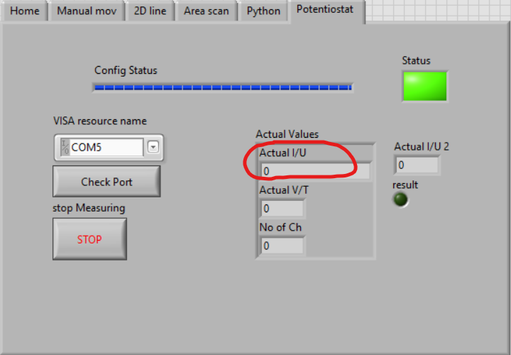

**Figure 5. Central control panel (Potentiostat tab).**

The Potentiostat will work (in the Amperometric Detection Technique) for one hour. This time can be changed in the Common Pram string array (Fig 6).

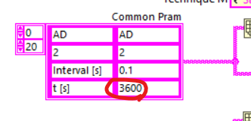

**Figure 6. Standard Pram string array in the block diagrams.**

**Note\*** The potentiostat must stop using the STOP button in the Potentiostat tab. Otherwise, it will be tasked to read values even if the emergency stop is used.

**The control interface** comprises 6 tabs (Python tab in blank), where the different movements and controls are spread. The Home Tab allows to home position the motors and to move all motors to a specific axis position.

**Figure 7. The control interface.**

**The “Manual mov” tab** allows users to move every microscope axis independently. In the Jog mode, the speed is adjustable with the dial on the right side of the controller. In the Step mode, the step size is adjustable with a numeric control on the right side of the controller.

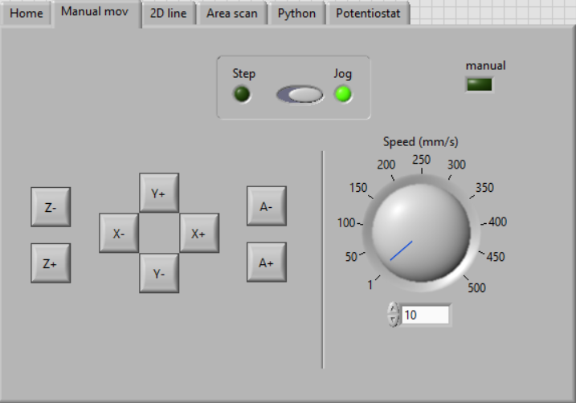

**Figure 8. The “Manual mov” tab.**

**The “2D line” tab** allows users to move the motors in a line in one or two axes. For example, it can be a line only in the X axes or a diagonal across the XY plane.

The user is required to enter:

- Initial and final position of the line,

- Speed with limits from 1 to 500μm/s,

- Number of steps (how many evenly distributed steps wanted to finish the line; if only one constant line is wanted, the number of steps must be 1).

- Wait time in between every step.

**Figure 9. The “2D line” tab**

**The “Area scan” tab** allows movement across an area. To do so, the following details are required:

Coordinates off opposing corners of the area,

* Step size,
* Line displacement,
* Wait time wanted in between every step,
* Speed with limits from 1 to 500μm/s.

**Figure 10. The “Area scan” tab**

**The “Potentiostat” tab** allows you to start the potentiostat to read values. This part of the program has been taken from the uStat400 program. The config status bar above will load after the VISA resource name is correctly selected (usually COM3), and “Check port” is pressed. If an error occurs, the Status light on the top right corner will turn red, in where the program must be restarted and resumed.

**Figure 11. The “Potentiostat” tab**

**Image Out:** The vision acquisition window displays what the camera sees. It displays a full view of the image in real time, and it has some tools that allow for some manipulation of the image such as zooming in and out, drawing among others.

**Figure 12. Image Out dialog.**

Make sure to change **the TCP address**, where the program will connect to the other computer and send commands.

**Figure 13. Block diagram with TCP address.**

**The Vision Acquisition block** is connected to a specific camera device. Meaning that its properties should be edited when connecting to a new camera.

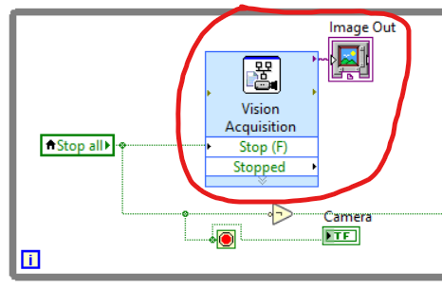

**Figure 14. The Vision Acquisition block.**

When the potentiostat is started, it will continuously work for an hour, reading values every 0.1 seconds. These values can be changed in the **Common pram string array**.

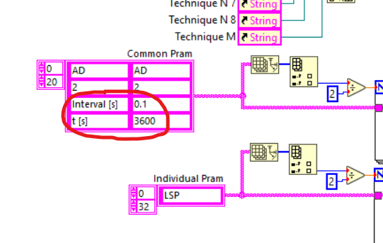

**Figure 15. Common pram string array.**

The following loop is needed to receive the axis coordinates. They turn on and off when needed, reading all values or just from one. Because of this, repeated fast manual movements might overload the connection.

**Figure 16. Loop to receive axis coordinates.**

Most functions work as a State machine, although 2D Line and Area scan do not. This is because of the repetitive nature of the process, in which loops were avoided. This is why there are separate cases for these functions.

**Figure 17. Scanning functions.**