IOT Based Smart lights And Vehicle Crossing Alert with Indication Systems in Hill Station

**Sakthi Dhasan.K1 , Dhilip Kumar.D2, Mrs. M.A. christy grace3,**

# 1,2,Fourth year, B.Tech - IT Student, Department of Information Technology, Jerusalem College of Engineering,Chennai-100

*Email: sakthidhasan778@gmailcom 3,Assistant Professor, Department of Information Technology,*

# Jerusalem College of Engineering, Chennai-100 [Email: christygrace@jerusalemengg.ac.in](mailto:%20christygrace@jerusalemengg.ac.in)

**Abstract -**The project aims to implement an IoT-based system in a hill station that integrates smart lighting control and vehicle crossing alerts using a PIR (Passive Infrared) sensor. The system will enhance safety and efficiency by automatically adjusting lighting levels and alerting vehicles about potential crossing.

project described involves an advanced lighting system that aims to reduce electricity wastage by utilizing Arduino, a Light Dependent Resistor (LDR), and a Passive Infrared (PIR) motion sensor. In this setup, the light will be activated when the LDR detects movement. The system is designed to automatically turn on the lights when a vehicle crosses the sensor, triggered by the sensor's detection. This innovative approach integrates sensor technology with Arduino to create an efficient lighting control system that responds to environmental changes, enhancing energy conservation and convenience.

We are using LDR to reduce unnecessary wastage of power during daytime and increase the efficiency of system. This project can also work as a security system. This project can also be used in smart light system.

***Key Words*:** LDR, IoT, Microcontroller, PIR Module.

## INTRODUCTION

Hairpin turns are strategically built on routes that traverse steep slopes, allowing vehicles to navigate across the slope with moderate steepness. These turns are often arranged in a zigzag pattern, facilitating safer ascents and descents on mountainous terrain compared to direct, steep climbs. While these roads require greater distances of travel and lower speed limits due to the sharpness of the turns, they are more cost-effective to construct and maintain than tunnels. Hairpin curves are essential for very steep terrains, ensuring that roadways adhere to maximum grades suitable for vehicles and trucks to navigate safely.

The zigzag component in road design, as seen in the provided sources, serves to minimize the grade or steepness of the roadway. This design feature is akin to how cyclists zigzag up steep hills to reduce the effort required. In road design, guidelines dictate the length of the radius of curves, primarily based on the design speed of the road.

The relationship between design speed and the radius of a curve is crucial in road design, especially concerning truck traffic. Truck traffic significantly influences the minimum radius of curvature in road design. Turning templates play a vital role in assessing whether a truck can navigate a turn without excessive tracking. In road design, a sharp bend with a very acute inner angle may force an oncoming vehicle to almost make a 180° turn to continue on the road.

The main reason behind accidents in Ghats is the challenging curves and bends of the roads, especially during turns, making it hard for drivers to see vehicles from the opposite lane. This situation forces drivers to assume the right of way, increasing the risk of accidents. Additionally, the limited space for only one vehicle to turn at a time in hairpin sections poses a significant risk, especially when two vehicles meet face to face during a turn. This scenario escalates the chances of accidents and makes it challenging to manage effectively

## OBJECTIVE

Driving in hilly terrains presents unique challenges, requiring drivers to maintain constant vigilance. Negotiating curves and hairpin bends in mountainous regions demands heightened attention due to the limited visibility of oncoming vehicles. This lack of visibility in bends is a significant factor contributing to accidents in such areas. Staying alert and adapting driving techniques to the specific conditions of mountain roads are crucial for safe navigation in these challenging environments..

The paper proposes a solution to prevent accidents on mountain roads

by detecting vehicles on one side of a curve using a camera,classifying

them as 'light' or 'heavy,' and alerting vehicles on the other side.

This system aims to address the increasing number of accidentsand fatalities in hilly areas due to the challenging road conditions.By utilizing image processing techniques, suchas detecting vehiclesin blind spots and alertingdrivers, this research aims to enhancesafety onmountain roads where visibility of approaching vehicles is limited due to curves and bends.

the curve using LED display board. Our specially designed LED display board consists of information such as vehicle class and traffic signals which is used to alert the driver about the upcoming opposite vehicle.

## BLOCK DIAGRAM

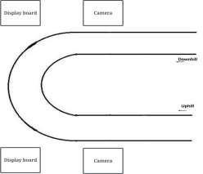

**Fig -1**: Block Diagram of Proposed System

To assist vehicles navigating hairpin turns, a proposed system is designed to detect vehicles on one side of the turn and aid those approaching from the opposite direction.

This system aims to enhance safety and efficiency on challenging road segments by providing real-time information and assistance to drivers.

safety and preventing accidents on the road by facilitating seamless communication between vehicles and centralized hubs. This innovative system aims to benefit both the vehicle and the driver by minimizing damage and ensuring safety.

The technology described in the provided sources can be adapted for use in various types of vehicles. Its design allows for integration that is accessible to everyday drivers of standard automobiles.

Automobiles have indeed evolved into a significant economic success story for humanity. The delegation of decisions related to speed and distance to vehicles through visual displays represents a pivotal advancement in automotive technology

## METHODOLOGY

**4.1 Power Supply Section**

Designing a power supply circuit is fundamental in electronics education. The linear technology-based design process involves breaking down the circuit into individual sections for efficient design. device. Actually it can be best used as a filter. It is the most inexpensive filter for our basic 5V power supply design.

Starting with a comprehensive block diagram is crucial as it allows for a systematic approach to designing each section before integrating them into a complete circuit.

The four main sub blocks are: Transformer, Rectifier Circuit, Filter and Regulator

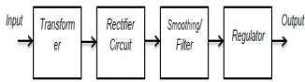

**Fig -2**: Block Diagram of Power Supply Section

## Input Transformer

o step down the incoming AC voltage from 220/120V to a lower level close to 5V (AC) for further conversion to 5V DC, a non-contact voltage tester is crucial for safety and accuracy. This device ensures that the live wire is identified correctly without direct contact, minimizing the risk of electrical shock. By using a non-contact voltage tester, you can detect the presence of voltage in wires, outlets, or circuit breakers without physical contact, providing a safe method to verify the status of electrical lines.

## Rectifier Circuit

A rectifier circuit is essential for converting AC voltage into DC voltage, ensuring a stable output. Without this conversion, achieving the desired 5V DC output is not possible. The rectifier circuit, composed of diodes arranged to convert AC to DC, plays a crucial role in this process by rectifying the voltage.

## Filter

A capacitor filter is essential in electronics to convert pulsating DC into a pure form or to eliminate distortion from a signal. In practical electronics, perfection is unattainable. While a rectifier circuit transforms AC into DC, the output remains pulsating, known as pulsating DC, which is unsuitable for powering sensitive devices due to its lack of purity. The rectified DC contains ripples, making it necessary to filter them out for voltage regulation. Ideally, DC voltage should have less than 10 percent ripples for perfect regulation. Capacitors serve as effective filters by storing and releasing charge, making them the most cost-effective option for basic 5V power supply designs

## 4.5 Regulator

A voltage regulator is crucial for maintaining a stable output voltage despite fluctuations in input voltage and load changes. It ensures a constant output voltage, independent of load variations, and minimizes the impact of line voltage fluctuations. This integrated circuit plays a vital role in providing a consistent voltage output, essential for the proper functioning of electronic devices, by effectively managing input voltage changes and load variations.

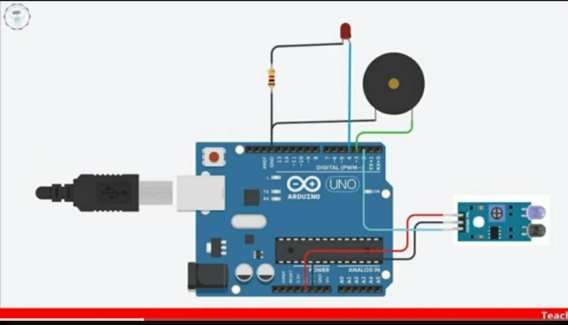



## FLOWCHART

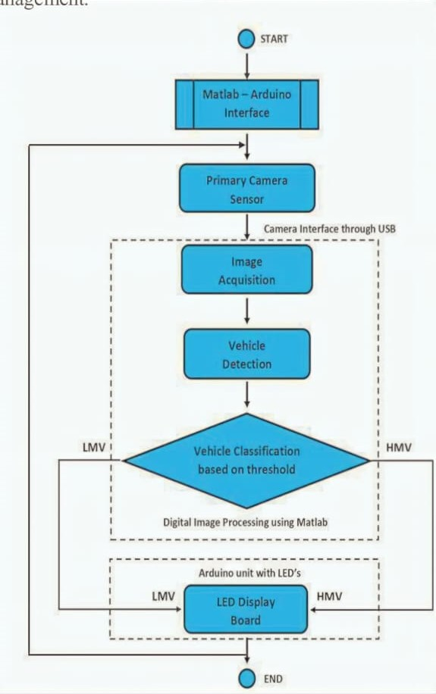

**Fig -3:** System Flowchart

Voltage cables are essential in reducing distribution network sensitivity to environmental impacts. Lighting systems, widely used in urban power networks for easy circuit connections, face challenges when faults occur. Locating faults and their nearby areas during repair processes can be complex, highlighting the critical role of voltage cables in minimizing network

So the proposed system gives confidence to the drivers about the incoming vehicles in the deep curve and they are aware of the upcoming vehicle category. The proposed system reduces accidents in hairpin bends and there is less traffic congestion.

Every human being depends on vehicles in their daily lives.In addition, high-speed and rash driving are responsible for a high number of accidents. In hilly areas, the situation is even riskier. Because of the hairpin curves, automobiles have no visibility. The proposed system prevents accidents in hairpin curves and also reduces traffic congestion. It provides a real- time solution and vehicles can easily move through the hairpin curves.

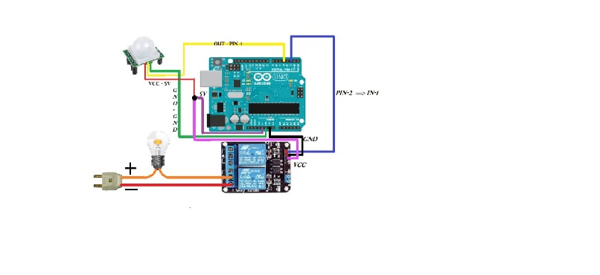



**Fig -4:** Circuit of Working Process

Accidents on roads are often attributed to violations of traffic rules, negligence, and poor road conditions. Particularly, hairpin curves pose a significant risk due to limited visibility and communication challenges, making vehicles vulnerable to accidents. To address this issue, a proposed system aims to enhance driver confidence by providing information about approaching vehicles and their category, thereby improving safety and reducing accidents in hairpin bends. This system not only enhances safety but also contributes to reducing traffic congestion in these challenging road sections.

**6. HARDWARE AND SOFTWARE COMPONENTS**

## Hardware Components

### ATmega328 Micro controller

ATmega328 is a single-chip micro controller with a modified Harvard architecture 8-bit RISC processor core. It is known for being low-powered and cost-effective. The ATmega328 features 32KB of internal built-in memory, which contributes to its efficiency. Additionally, the ATmega328 is faster compared to other micro controllers as it requires fewer clock cycles for instruction execution.

### Arduino Nano

The Arduino Nano Every is an evolution of the traditional Arduino Nano board, featuring a more powerful processor,theATMega4809, which allows for larger programs and more variables compared to the Arduino UnoIt is Arduino's 5V compatible board,

### IoT Module (ESP8266)

The ESP8266 is a cost-effective Wi-Fi microchip with MIB of built-in flash memory, enabling single-chip devices to connect to Wi-Fi networks. This module facilitates micro controllers in establishing wireless internet connectivity at a minimal cost. By integrating the ESP8266 with an Arduino, basic functions like connecting to a Wi-Fi network can be easily achieved. This small module allows for simple TCP/IP connections, making it ideal for Internet of Things (IoT) projects due to its affordability and wireless capabilities

### Other Components

Step Down Transformer, Rectifier, PIR Sensor, Voltage Regulator, Switches and Connecting Wires.

## Software Components

### Arduino IDE

The Arduino Integrated Development Environment (IDE) is a versatile cross-platform application available for Windows, mac OS, and Linux. This software, written in Java, facilitates programming in C and C++ languages, making it easier to work with micro controllers

### Embedded C

Embedded C is an extension of the C programming language designed for embedded systems, offering features like fixed-point arithmetic, named address spaces, and basic I/O hardware addressing. It maintains the syntax and semantics of standard C while providing additional functionalities tailored for embedded applications

**7. RESULTS**

The proposed system aims to enhance accident avoidance and improve traffic management in hairpin curves by utilizing two cameras and two display boards. This system employs webcams for input reading and the Python GUI library Tkinter for display purposes. It is particularly effective for vehicle classification, providing a preference for a vehicle based on its class.

## APPLICATIONS AND ADVANTAGES

## Applications

♣ Monitoring vehicle crossing.

♣ Hairpin curves indication.

♣ Hills station use smart lights.

♣ PIR sensor use detecting

* 1. **Advantages**

♣ Avoid Accident

♣ Increase Road safety

♣ Reducing the risks of people getting invoked in accidents

♣ Ensure safe work environment

♣ Any object moving sensor will be triggering.

## CONCLUSIONS

People have increasingly relied on transportation systems in recent years, facing both opportunities and limitations. As the world's population continues to grow, transportation management systems encounter significant challenges.

Vehicle moving through hairpin bends are highly susceptible to accidents due to the lack of communication and zero visibility over the curves. Drivers must exercise extreme caution while navigating these deep curves to prevent accidents.

The proposed system is designed to alleviate traffic congestion and enhance safety in hairpin curves, particularly in hilly terrains. By facilitating smoother vehicle navigation through these challenging curves, the system aims to minimize the risk of collisions and improve overall traffic flow.

Designing a system utilizing PIR sensors for motion detection is challenging task. The coding has been tailored to detect even slight movements of the human body by the sensor. To enhance the precision of detection, time delays have been incorporated, and the sampling period for the sensor output has been adjusted

## REFERENCES

[1].Soyoung Hwang and Donghui Yu, “Remote monitoring and Controlling System Based on Zigbee Networks” InternationalJournal of Software Engineering and Its Application Vol. 6, No. 3, July,2012.

[2].Richu Sam Alex, R NarcissStarbell “ Energy efficient Intelligent Street Light System using Zigbee and Sensor”, InternationalJournal of Engineering and advanced Technology (IJEAT), Vol-3, Issue 4, april 2014.

[3].Daeho Kim, Junghoon Lee, Yeongmin Jang and Jaesang Cha . “ Smart LED light system implementation using Human trackingUS/IR sensor ” 2011 IEEE (ICTC 2011).

[4].B.K Subramanyam, K Bhaskar Reddy, P. Ajay Kumar Reddy, “ Design and Development Of intelligent wireless Street lighting control and monitoring system along with GUI ”, International Journal of Engineering Research and Application (IJERA) ISSN: 2248-9622 www.ijera.com Vol. 3, Issue 4, Jul-Aug 2013.

[5].RajaR , Dr.K.Udhayakumar ” Development in Smart Sensor Network for Energy Saving” International Journal of advanced Research in Electrical, electronics and instrumentation Engineering (An ISO 3297: 2007 Certified Organization) Vol. 3, SpecialIssue 2, April 2014.

[6].Michale Mango, Tommaso Poloneli , Luca Benini “ A Low Cost and Highly Scalable Wireless Sensor Network Solution to Achieve Smart LED Light Control for Green Buildings” IEEE Senosrs Journal, VOL. 15, NO. 5, MAY 20.

[7] Anuradha A, Trupti Tagare, Vibha T. G and Priyanka N, “Implementation of Critical Intimation System for Avoiding Accidents in Hairpin Curves & Foggy Areas”, International Journal of Science Technology & Engineering, Volume: 05, Issue: 05, November 2018.

[8] Avinash Shetty, Bhavish Bhat, RameshaKarantha and Srinivasa Hebbar, “Smart Transport System Signalling Sensor System Near Hairpin Bends”, International Journal of Scientific & Engineering Research, Volume: 09, Issue: 04, April 2018.

[9] V.Ramachandran, R.Ramalakshmi and K. Mathankumar, “Accident Prevention and Traffic Pattern Analysis System for Hilly Regions”, International Journal of Innovative Technology and Exploring Engineering, Volume: 09, Issue: 02, December 2019