

**UNIVERSITY OF GREENWICH**  
COMP 1682 – Final Year Project

Coursework

|  |  |
| --- | --- |
| Student name | Tran Minh Hieu |
| ID number (00xxxxxxx) | 001391650 |
| Lecturer/Tutor name | Tran Thi Kim Khanh |
| Student submission date | 30/04/2024 |

**Table of Contents**

1. Overview 4

2. Aim 4

3. Related works / Literature review 5

4. Objectives 9

4.1. Comprehensive Research Documentation and Analysis 9

4.2. Game Design Planning and Documentation Process 9

4.3. Game Development and Asset Creation Phase 10

4.4. Testing and Quality Assurance Procedures 10

4.5. Project Framework and Methodology 10

5. Legal, Social, Ethical and Professional 11

5.1. Introduction: 11

5.2. Legal 11

5.3. Social 12

5.4. Ethical 12

5.5. Professional 12

6. Planning (see appendix A) 13

7. Initial References 17

Appendix A 18

**List of Figures**

Figure 1. All phases of the project 14

Figure 2. Phase 1 - Comprehensive Research Documentation and Analysis 14

Figure 3. Phase 2 - Game Design Planning and Documentation Process 15

Figure 4. Phase 3 - Game Development and Asset Creation Phase 15

Figure 5. Phase 4 - Testing and Quality Assurance Procedures 16

Figure 6. Phase 1 - Comprehensive Research Documentation and Analysis 18

Figure 7. Phase 2 - Game Design Planning and Documentation Process 18

Figure 8. Phase 3 - Game Development and Asset Creation Phase 19

Figure 9. Phase 4 - Testing and Quality Assurance Procedures 19

**COMP1682.1 Project Proposal**

**Game 2D Metroidvania: Sanctaria - The First Sin**

**TRAN MINH HIEU**

**Final Year Entry**

**001391650**

# **Overview**

Wolfe (2021) explores the harmful effects of fanaticism on society, including violence and the erasure of cultural identities, by analyzing historical examples. This study highlights the importance of understanding fanaticism's ideological origins (Wolfe, 2021). Inspired by this research, my game project aims to stimulate reflection on the nuanced aspects of fanaticism and its impact on society, emphasizing the value of critical historical awareness. This exploration of historical instances underlines the critical need for understanding fanaticism's ideological roots to prevent chaos and destruction. Building on Wolfe's insights, the proposed project is a 2D Action-Platformer game developed in Unity, designed to engage with the theme of fanaticism's consequences. Through combat, storytelling, and interaction with NPCs, the game aims to educate players on the dangers of unchecked belief and the importance of thoughtful decision-making, reflecting on how faith shapes human nature and the repercussions of our actions.

Keywords: [Faith, Fanaticism, Unity, 2D game, Action-Platformer, Metroidvania, Combat game, Storytelling]

# **Aim**

The project creates a 2D action-platformer game that combines action gameplay and thoughtful storytelling in ancient settings to explore and critique social issues, aiming to engage players in reflecting on ethical dilemmas.

# **Related works / Literature review**

* **Game Development Methodologies, Technologies and Educational**

Roedavan et al. (2021) present an innovative framework for serious game development that leverages the Game-Based Learning Foundation to create educational games with a deeper impact on learners. Their model is meticulously designed to incorporate educational content ideation, art and technology development, learning mechanics, and assessment mechanisms within a structured developmental lifecycle. By adopting an iterative approach, this model allows for flexibility in development, accommodating changes and refinements to enhance educational effectiveness. The integration of affective, behavioral, cognitive, and social/cultural engagement as foundational layers underscores the multifaceted approach to engaging players deeply in learning processes. Particularly compelling is the model's emphasis on emotional engagement and behavioral motivation, which are critical for sustaining player interest and facilitating meaningful learning experiences (Roedavan et al., 2021). The nuanced understanding of game mechanics and their potential to represent complex educational content in an accessible and engaging manner offers valuable insights for my project's development. This model not only aligns with but also enriches the development process of a 2D Action-Platformer game by ensuring that educational objectives are seamlessly integrated into the gaming experience.

The comprehensive review by Payandeh et al. (2024) delves into the integration of Model-Driven Engineering (MDE) with game development, advocating for a methodology that enhances the development process through abstraction and automation. This study illuminates the potential of using environments like the Unity Engine, augmented by graphical syntax for game specifications, to streamline the creation of complex game systems. The discussion on the challenges associated with model-driven game development (MDGD) provides a balanced view, offering strategies to overcome these hurdles while maximizing the benefits of MDE principles. The endorsement of MDE in the game development context, particularly its utility in simplifying complex design and development tasks, offers a compelling argument for incorporating these methodologies into the creation of a Metroidvania-style game (Payandeh et al., 2024). The insights derived from this review could significantly influence the project's design and development phases, suggesting a structured yet flexible approach to incorporating educational content within the game mechanics. This systematic review is instrumental in shaping the methodological foundation of my project, advocating for an innovative approach to game development that leverages the strengths of MDE to achieve educational and entertainment objectives concurrently.

In their evaluation of game engines for serious game development, Sharif and Ameen (2022) provide a critical analysis of various platforms, focusing on their applicability in educational contexts. This study stands out for its meticulous comparison of game engines based on essential criteria such as visual fidelity, functionality, development features, heterogeneity, and user accessibility. The recognition of engines like Unreal, Unity, and Godot as superior platforms for developing high-quality educational games highlights the importance of choosing the right engine to support the specific needs of serious game development. The emphasis on engines that facilitate emotional engagement, offer efficient learning mechanics, and enable social interaction is particularly relevant to my project, aligning with the objectives of creating an engaging and educationally meaningful Metroidvania game (Sharif and Ameen, 2021). The detailed evaluation presented in this study not only aids in the selection of an appropriate game engine but also underscores the necessity of integrating educational content with immersive gaming experiences. This analysis is invaluable to my literature review, providing a clear direction for selecting the Unity engine, which is renowned for its versatility and robust support system, as the foundation for my game development project.

* **Unity Engine Technology evolution in Game Development:**

Hussain et al. (2020) provide a detailed analysis of the Unity game development engine, presenting it as a transformative tool that transcends traditional gaming applications to impact various sectors such as education, film, and automotive. The authors laud Unity for its unparalleled cross-platform support, enabling developers to efficiently create and deploy applications across more than twenty platforms. This flexibility not only democratizes the development process but also broadens the audience reach, a critical factor in the modern digital landscape (Hussain et al., 2020). However, Hussain et al. don't shy away from discussing Unity's limitations, notably its sometimes outdated documentation and the necessity for significant investment to unlock the engine's full capabilities. Despite these hurdles, the paper underscores Unity's potential for career development within the IT sector, backed by a robust community and a rich ecosystem of development tools (Hussain et al., 2020). From my perspective, the balanced exploration of Unity's advantages and challenges by Hussain et al. provides a grounded framework for leveraging Unity in game development. Their insights are invaluable in formulating a strategy for my project, guiding the integration of educational content within a game that is both engaging and accessible, leveraging Unity's expansive capabilities.

Singh and Kaur (2022) offer an in-depth exploration of Unity's comprehensive suite of features, focusing on its asset management, scripting language, and the engine's overall contribution to creating immersive gaming experiences. They highlight Unity's capacity for simulating physical effects and rendering complex 2D and 3D scenes, positioning it as a versatile solution for developers aiming to push creative boundaries. Despite recognizing Unity's broad applicability, Singh and Kaur (2022) acknowledge the steep learning curve associated with the engine. They argue, however, that the wealth of resources provided by Unity—including detailed documentation and a supportive online community—significantly mitigates this challenge, facilitating a smoother development process for both novices and experts alike (Singh and Kaur, 2022). Their thorough examination of Unity's features and workflow is directly relevant to my project, providing a roadmap for employing Unity's full potential in the development of a game that is not only aesthetically appealing but also rich in educational value. The focus on Unity's multi-platform support underscores the engine's ability to make educational games more accessible, reinforcing my decision to choose Unity as the foundation for development.

In "The Process of Using Unity to Create a 2D Video Game" Tammelleo (2023) delves into a deeply personal exploration of the Unity game development environment, chronicling the myriad challenges and rich learning experiences encountered along the way. The narrative is densely packed with valuable insights on maneuvering through Unity's robust suite of features, achieving a harmonious blend of technical prowess and creative ingenuity, and highlighting the indispensability of adaptability throughout the game creation process. Tammelleo underlines the critical importance of persistence and the benefits of an ongoing commitment to learning as key strategies for surmounting the hurdles presented by Unity and achieving proficiency in game development. This account resonates strongly with the objectives of my project, showcasing the ways in which Unity's expansive toolset can be employed to transcend individual artistic and technical barriers (Tammelleo, 2023). Through Tammelleo's experiences, I gain insight into Unity's significant potential to revolutionize game development for committed creators, especially in terms of weaving educational elements seamlessly into engaging and dynamic gameplay.

* **Exploration Mechanics and Player Engagement in Metroidvania Games Genre**

Mawhorter et al. (2022) provide a groundbreaking examination of exploration dynamics within the Metroidvania genre, emphasizing its pivotal role in player experience. Their research introduces an open-source Python library specifically designed to model Metroidvania games' exploration processes. This tool captures the genre’s hallmark of intricate spatial relationships and progression barriers through an abstract topological lens, rather than relying on conventional spatial or grid-based models (Mawhorter et al., 2022). The authors argue that this methodological innovation not only aids in understanding player navigation and discovery within these games but also presents a novel framework for game design and research. By leveraging a graph-based representation, they address unique challenges and opportunities in depicting Metroidvania exploration, enriching the dialogue on level design and player engagement (Mawhorter et al., 2022). This approach resonates with my project's objectives to delve into the mechanics of exploration and progression that define the Metroidvania genre. The insights and tools provided by Mawhorter et al. offer a comprehensive framework for analyzing and designing game levels that captivate and challenge players, guiding my endeavor to craft a game that embodies the essence of exploration and discovery.

Imbert's thesis (2023) meticulously explores the factors contributing to player engagement in video games, with a keen eye on the action-platformer and Metroidvania genres. Through a blend of qualitative analysis and quantitative research, including sales data and gameplay metrics, Imbert identifies core mechanics such as building, exploration, combat, and problem-solving as key engagement drivers (Imbert, 2023). His analysis extends to the significance of narrative depth, competitive elements, and the creation of immersive worlds through art and sound, offering a holistic perspective on what makes games compelling. Imbert highlights the interplay between technology, demographics, design, and marketing in shaping player experiences, providing case studies that illustrate successful implementation of engaging mechanics (Imbert, 2023). This thesis underlines the importance of a multifaceted approach to game development, where mechanical excellence is harmonized with narrative and aesthetic richness to foster deep player investment. Imbert’s findings echo my aspirations for developing a Metroidvania game that not only challenges players mechanically but also immerses them in a rich narrative and vibrant world, offering insightful strategies for enhancing player engagement through thoughtful game design.

In "Wizard Adventure Game" Sells (2021) narrates the journey of developing a Metroidvania-style game from conception through to completion. This capstone project offers an intimate look at the trials and triumphs of game development, covering the gamut from gameplay scripting and level design to the integration of artistic elements. Sells discusses the iterative nature of development, the challenges of aligning game mechanics with player experience, and the critical role of team dynamics and agile methodologies like Scrum in navigating the project lifecycle (Sells, 2021). His reflections on the need for scope adjustment, the value of community resources, and the importance of polishing existing features rather than overextending on new ones provide a practical roadmap for game development. Sells’ account is particularly instructive for my project, highlighting the necessity of flexibility, continuous improvement, and the integration of feedback in creating a game that balances ambitious design with playability and engagement. His insights into overcoming developmental hurdles and achieving a cohesive game experience are invaluable for anyone venturing into the Metroidvania or action-platformer genres.

# **Objectives**

## **Comprehensive Research Documentation and Analysis**

* + 1. Compile relevant documents. [5 days]
    2. Conduct a literature review. [3 days]
    3. Analyze findings and extract key insights. [3 days]
    4. Synthesize research into a comprehensive report. [3 days]

**Outcome:** Key insights from extensive literature review and analysis were synthesized into a foundational report, informing the game's thematic and mechanical framework.

## **Game Design Planning and Documentation Process**

* + 1. Create detailed game design documentation. [5 days]
    2. Define game concept and scope. [3 days]
    3. Develop gameplay mechanics and level design concepts. [5 days]
    4. Draft design documentation including storyline, characters, and gameplay features. [5 days]

**Outcome:** Developed comprehensive game design documentation, setting a clear blueprint for storyline, characters, and gameplay mechanics.

## **Game Development and Asset Creation Phase**

* + 1. Design and assemble interactive game environments using assets and layouts. [7 days]
    2. Code the game mechanics and implement narrative elements. [20 days]
    3. Create graphical assets including characters, environments, and UI elements. [7 days]
    4. Integrate sound effects and background music. [7 days]

**Outcome:** Translated game design into code and visual/sound assets, crafting a playable game with engaging mechanics and immersive environments.

## **Testing and Quality Assurance Procedures**

* + 1. Test Case Development and Unit Testing develops scenarios and tests individual components. [3 days]
    2. Integration and System Testing verifies module integration and overall system functionality. [5 days]
    3. User Acceptance Testing and Feedback gathers player feedback to ensure game satisfaction. [5 days]
    4. Cross-Platform Validation and Gameplay Balance checks platform compatibility and adjusts gameplay balance. [5 days]
    5. Narrative and Exploration Evaluation evaluates story coherence and exploration depth. [7 days]
    6. Performance Optimization boosts game performance and makes stakeholder-informed adjustments. [5 days]
    7. Security and Compliance Finalization meets all legal and platform requirements for launch. [3 days]

**Outcome:** Executed a series of tests to ensure functionality, balance, and player satisfaction, refining the game based on feedback for a polished final product.Top of Form

## **Project Framework and Methodology**

* + 1. Use Scrum to organize game development into efficient sprints, fostering team collaboration and rapid adaptation through regular reviews and feedback cycles.
    2. Utilize Unity Engine to streamline game creation with its robust tools and assets, while its cross-platform capabilities enhance deployment efficiency across multiple systems.

# **Legal, Social, Ethical and Professional**

## **Introduction:**

The proposed project aims to develop a 2D platformer pixel game with a combat mechanism involving violence and bloodshed, alongside a system of non-playable characters (NPCs) to portray the storyline. It seeks to address social issues such as fanaticism and religious extremism, emphasizing the importance of critical thinking and empathy among players. Through the game, players are encouraged to reflect on the consequences of past actions, particularly in the context of extremism, with the ultimate goal of fostering greater societal understanding and tolerance.

## **Legal**

**Intellectual Property Rights:** Copyrights and trademarks protect the game’s identity and prevent unauthorized use.

**Licensing Agreements:** Adhering to Unity and third-party licenses ensures compliance with legal and revenue-sharing standards.

**Data Privacy and Protection:** GDPR-compliant measures protect user data, building trust and regulatory compliance.

**Third-party Software and Dependencies:** Maintaining accurate records and regular license reviews prevent legal issues and ensure content standards.

**Software Development Agreements:** Define roles, responsibilities, and timelines to prevent disputes and ensure smooth project flow.

**Confidentiality Agreements:** Legally bind parties to keep proprietary information secret, enhancing security for collaborative innovation.

**Compliance with industry standards:** Age restrictions and content warnings ensure the game reaches suitable audiences, supporting ethical development practices.

## **Social**

**Global Impact and Cultural Sensitivity:** The game is designed with cultural sensitivity to influence perceptions on morality and societal issues, using engaging storylines to educate and provoke thought.

**User accessibility:** Features like easy gameplay and a deep storyline make the game accessible to a broad audience, maximizing its reach and effectiveness.

**Digital divide:** The game is designed exclusively for PC to leverage specific platform capabilities, enhancing the gaming experience for PC users.

**Diversity:** Incorporating diverse perspectives and contexts in the game’s content enriches the experience and encourages inclusive player engagement.

## **Ethical**

**User Privacy and Consent:** The game secures explicit consent for data collection and communicates mature themes clearly, ensuring players are well informed and agree to the terms of engagement.

**Transparency:** Accessibility of detailed information on the game's handling of sensitive themes and data practices enhances transparency and player trust.

**Reliability and Safety:** Rigorous content review and testing guarantee the game's safety and reliability, preventing harmful impacts on players.

**Bias and Discrimination:** Engaging diverse communities and consulting experts ensure the narrative is free from bias and promotes a fair representation of all groups.

## **Professional**

**Quality (Testing and Quality Assurance):** Rigorous testing of gameplay, storylines, sound, and visuals ensures the game meets high standards, with quality assurance processes in place to identify and rectify any issues for a polished, reliable product.

**Professionalism:** Maintaining professionalism through ethical practices, adherence to deadlines, and clear communication, particularly in resolving challenges, ensures the project's integrity and success.

**Collaboration:** Collaborating with Unity for technical support and resources boosts the efficiency and effectiveness of the development process.

**Competency:** The developer’s comprehensive skill set in creating engaging gameplay, compelling storylines, immersive sound, and appealing graphics demonstrates proficiency with Unity’s platform and a commitment to quality.

**Applying Scrum:** Utilizing Scrum methodologies facilitates a structured yet adaptable development process, enhancing project management and responsiveness to change.

**Model for Game:** The game will be developed using a Model-Driven Engineering (MDE) approach, which simplifies complex design tasks through abstraction and automation.

**Design Patterns:** The Singleton design pattern will be applied to manage global game states efficiently, while the Observer pattern will be used to handle events and notifications within the game system.

# **Planning (see appendix A)**

For this game development project, I'll adopt the Scrum framework, tailored for a one-person team. This approach allows me to leverage Scrum's flexibility and iterative nature while addressing the unique challenges of working alone. By organizing work into sprints, I can maintain a structured yet adaptable schedule, focusing on small, manageable increments of work that enable frequent reassessment and adjustment based on evolving project needs and feedback. This method ensures that development remains on track and responsive to change, crucial for a solo developer who must juggle multiple roles. Regular sprint retrospectives, adapted for self-review, will help in identifying improvements in workflow and efficiency, ensuring that the project progresses smoothly towards its goals.

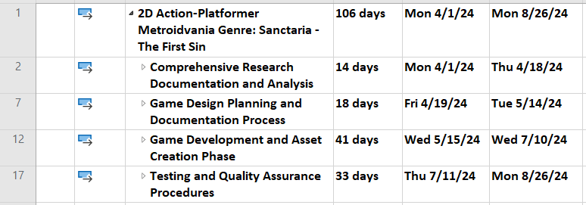My game project has 4 main phases shown in the images below:

Figure 1. All phases of the project

The game build progresses through four phases: research and analysis, planning, development, and testing. These stages involve thorough investigation, design creation, game construction, and quality assurance, respectively.

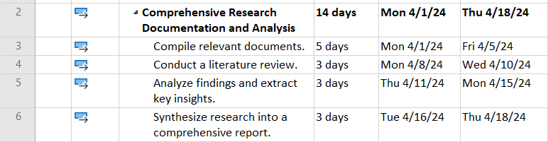

Figure 2. Phase 1 - Comprehensive Research Documentation and Analysis

During the "Comprehensive Research Documentation and Analysis" phase, relevant documents are compiled, a literature review is conducted, findings are analyzed, and key insights are extracted. Finally, the research is synthesized into a comprehensive report, laying the foundation for subsequent design and development decisions.

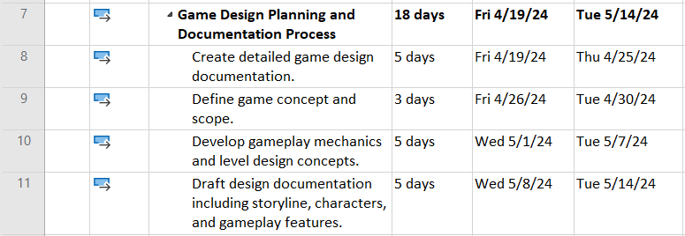During the "Game Design Planning and Documentation Process" phase, detailed game design documentation is created. Narrative concepts and plotlines are brainstormed, and gameplay mechanics and level design concepts are developed. Design documentation, including storyline, characters, and gameplay features, is drafted to establish the blueprint for the game's structure and content.

Figure 3. Phase 2 - Game Design Planning and Documentation Process

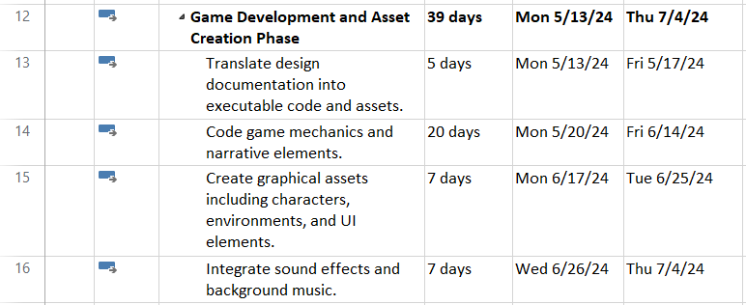In the "Game Development and Asset Creation Phase," design plans are turned into code and assets. Mechanics and narrative elements are programmed, while characters, environments, and UI elements are created graphically. Sound effects and music are also integrated. This phase brings the game design to life through coding, art creation, and audio implementation.

Figure 4. Phase 3 - Game Development and Asset Creation Phase

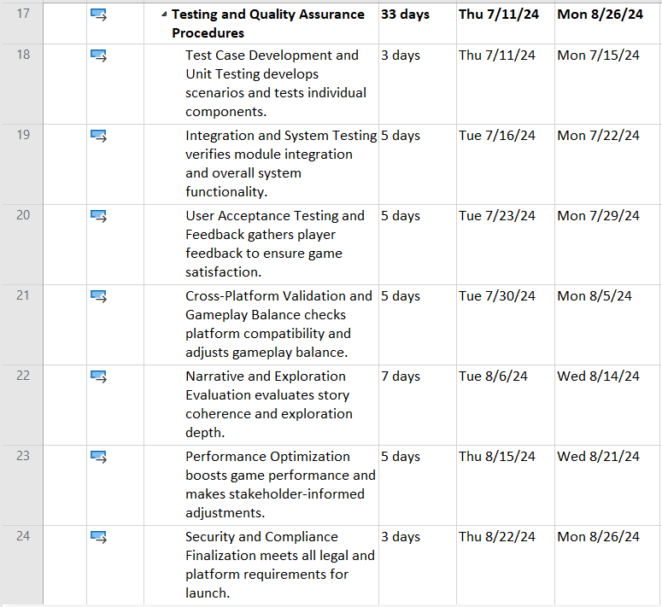During the "Testing and Quality Assurance Procedures" phase, tests are conducted to ensure functionality and quality. This includes developing test cases and unit testing, verifying integration and system functionality, gathering player feedback, checking platform compatibility and gameplay balance, evaluating narrative coherence and exploration depth, optimizing performance, and finalizing security and compliance.

Figure 5. Phase 4 - Testing and Quality Assurance Procedures

# **Initial References**

Hussain, A., Shakeel, H., Hussain, F., Uddin, N., Ghouri, T.L., 2020. Unity game development engine: A technical survey. Univ. Sindh J. Inf. Commun. Technol 4, 73–81.

Imbert, D., 2023. What Makes Video Games Engaging: deep dive into the design, mechanics and psychology of games.

Mawhorter, P., Ruslanova, I., Mawhorter, R., 2022. Representing Exploration in Metroidvania Games. Presented at the Proceedings of the FDG workshop on Procedural Content Generation.

Payandeh, A., Sharbaf, M., Rahimi, S.K., 2024. A Systematic Review of Model-Driven Game Development Studies. IEEE Transactions on Games.

Roedavan, R., Pudjoatmodjo, B., Siradj, Y., Salam, S., Hardianti, B., 2021. Serious Game Development Model Based on the Game-Based Learning Foundation. Journal of ICT Research & Applications 15.

Sells, E., 2021. Wizard Adventure Game.

Sharif, K.H., Ameen, S.Y., 2021. Game engines evaluation for serious game development in education. Presented at the 2021 International Conference on Software, Telecommunications and Computer Networks (SoftCOM), IEEE, pp. 1–6.

Singh, S., Kaur, A., 2022. Game Development using Unity Game Engine. Presented at the 2022 3rd International Conference on Computing, Analytics and Networks (ICAN), IEEE, pp. 1–6.

Tammelleo, S., 2023. The Process of Using Unity to Create a 2D Video Game.

Wolfe, S., 2021. THE RISE OF FANATICISM AND THE IMPACT ON SOCIETY.

# **Appendix A**

Figure 6. Phase 1 - Comprehensive Research Documentation and Analysis

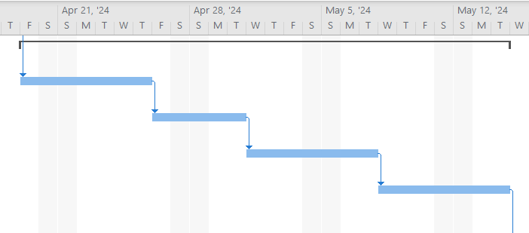

Figure 7. Phase 2 - Game Design Planning and Documentation Process

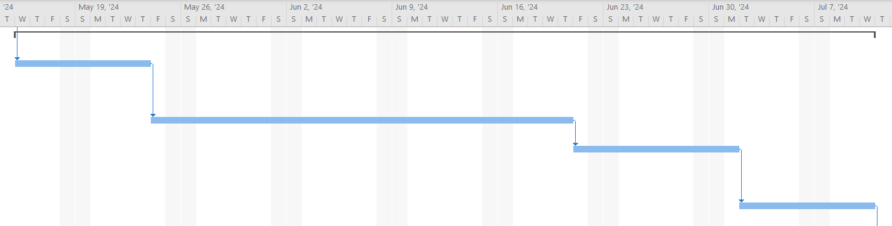

Figure 8. Phase 3 - Game Development and Asset Creation Phase

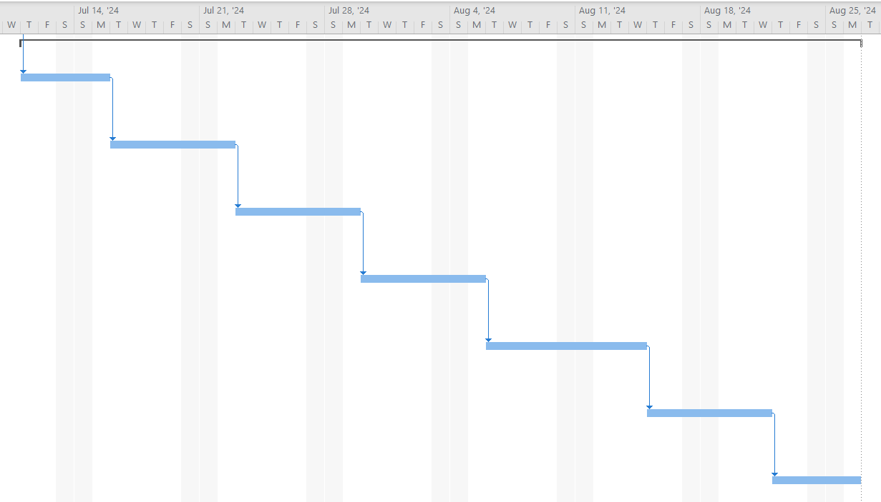

Figure 9. Phase 4 - Testing and Quality Assurance Procedures