|  |
| --- |
| Smart CV App  version 1.0 |
|  |
| SBP Bungalowparken |
| SmartThermo App |

Millions of customers count on them. They count on us.

CGI brings four decades of IT services experience and expertise to our partnership with clients. Our professionals in hundreds of locations around the world work side-by-side with our clients each day to help them satisfy their customers, reduce risks and achieve top-to-bottom-line results. Visit cgi.com and experience the commitment.

Smart CV App

SmartThermo release manual v1

#### The customer:

SBP bungalow parken: Al meer dan veertig jaar is SBP onbetwist marktleider in de markt voor korte vakanties in ruim opgezette parken middenin de natuur. Als koploper in de recreatiebranche investeert het bedrijf voortdurend in vernieuwing om elk jaar een aanbod te bieden dat perfect aansluit op de wensen van haar gasten. De kwaliteitseisen van het concern zijn in alle opzichten toonaangevend in de recreatiebranche.

#### Development team:

Adolfo Roman Sanchez

Erik Thissen

Arnold Slotboom

Table of contents

1 Smart CV App 5

1.1 Introduction 5

1.1.1 Heading 3 5

1.1.1.1 Heading 4 5

1.1.1.1.1 Heading 5 5

1.1.1.1.1.1 Heading 6 5

1.1.1.1.1.1.1 Heading 7 5

2 User Manual 7

2.1 Heading 2 7

3 Installation manual 8

# Smart CV App

## Introduction

How nice would it be to be able to control the temperature in your holiday bungalow with your smart device? The CGI development team Adolfo Roman Sanchez, Erik Thissen & Arnold Slotboom made the Smart CV App to upgrade the temperature controller and ready for the future.

The Smart CV App user interface is web based and accessible with all your smart devices.

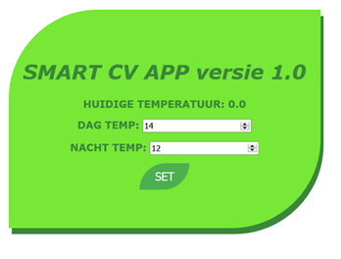

The Development Team is happy to introduce you to the new Smart CV App release 1.0.

Enjoy the easiness of controlling the temperature of your bungalow with your smart device.

If you do have any questions about the use, installation, or if you just like to tell us how happy you are with the new Smart CV App please contact us.

Enjoy,

Adolfo, Erik & Arnold.

SmartCVApp@cgi.com

# Installation manual

## The package

The Smart CV App contains only 2 files:

* Smartcvapp-1.0-RELEASE.jar
* Startup – smartcvapp.bat

File Smartcvapp-1.0-RELEASE.jar is the main program in Java 8 programming language.

Startup – smartcvapp.bat is used for quick starting the Smartcvapp-1.0-RELEASE.jar.

Both files need to be in the same folder.

The user interface is accessible with any web browser.

## Installation

* Unzip 20180508-SmartThermo-JAR-DEMO.zip
* Make sure “Smartcvapp-1.0-RELEASE.jar” and “Startup – smartcvapp.bat” are in the same folder
* “20180508-SmartThermo-JAR-DEMO.zip” is programmed to be used only for CV with access token 123456.
* When files are unpacked the Smart CV App is ready to start-up / use.

## Running

* To start-up the Smart CV App run / double click “Startup – smartcvapp.bat”.
* Start your web browser and surf to <http://localhost:8080/>
* The user interface will show up:

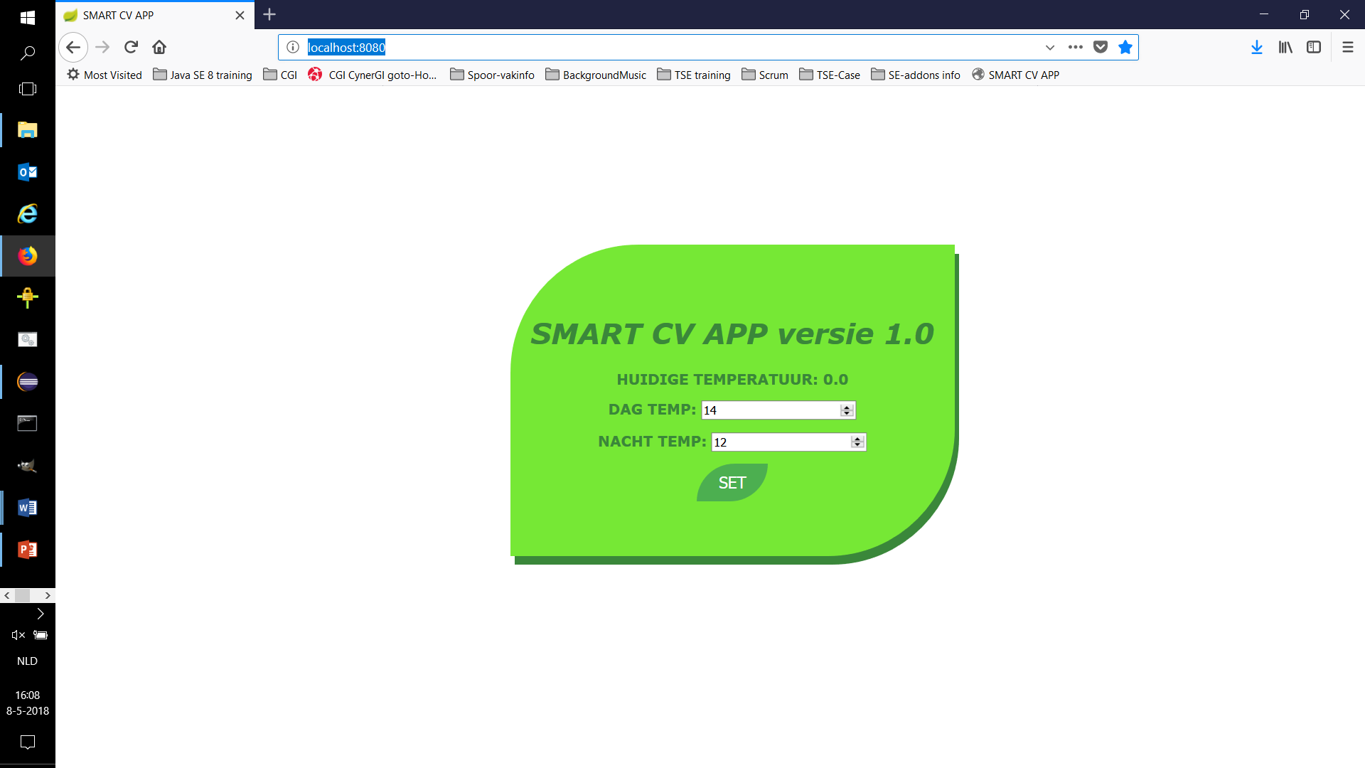

* When the CV is not connected / off line the “Huidige temperatuur” will show 0.0.
* Reboot your CV or for simulation run “startup CVEmulator.bat”.
* Your CV will indicate a green LED when Smart CV App is connected to the CV.
* When green LED is shown the “Huidige temperatuur” will show the latest setting, which is 14°C for the simulator.
* Now your Smart CV App is ready for use. Please refer to the User Manual.

# User Manual

## User interface

The Smart CV App user interface is web based and accessible with all your smart devices.



Your content goes here, using the Body Text style. Please note that this template includes all the styles that you will use to create a document consistent with the CGI brand. Please view the Styles pane to access the styles available for your use.

* Your content goes here, using the List Bullet style.
* Your content goes here, using the List Bullet 2 style.
* Your content goes here, using the List Bullet style.
* Your content goes here, using the List Bullet 2 style.
* Your content goes here, using the List Bullet 3 style.

Your content goes here, using the Body Text style. Please note that this template includes all the styles that you will use to create a document consistent with the CGI brand. Please view the Styles pane to access the styles available for your use.

Appendix contents

Appendix A 10

Technical Details 10

1. Appendix A
   1. Technical Details

* Program: Smart CV App version 1.0 Release
* Programming language: Java 8, Java runtime environment 1.8
* Framework: Spring boot 2.0.1.
* Server: maven.apache 4.0.0.
* Compatible browsers: Firefox Version 59.0.3, Chrome 66.0.3359.139, Internet Explorer 11
* Hosting: localhost, standard port 8080, web address: http://localhost:8080/
* CV access token 123456
* Start time of day temperature: 07:00
* Start time of night temperature: 22:00
* Switch point temperature difference of set point 0.5 °C
* Waiting time/ update interval ~ 4 seconds.
* Status request of CV: "#ACT-OK"
* Logging of set day temperature: settemp.txt
* Logging of set night temperature: settempnight.txt
* Logging of CV status: data.txt

|  |  |  |  |
| --- | --- | --- | --- |
| Table Heading | Table Heading | Table Heading | Table Heading |
| Table Sub Title | Table Sub Title | Table Sub Title | Table Sub Title |
| Table Text | Table Text | Table Text | Table Text |
| Table Text | Table Text | Table Text | Table Text |
| Table Text | Table Text | Table Text | Table Text |
| Table Text | Table Text | Table Text | Table Text |
| Table Text | Table Text | Table Text | Table Text |

Your content goes here, using the Note style. Please note that this template includes all the styles that you will use to create a document consistent with the CGI brand. Please view the Styles pane to access the styles available for your use.

|  |
| --- |
| cgi.com |