

# SIFT ICO Reveals Trading Algorithms in Action High-yield ICO reveals the effectiveness of its trading algorithms on crypto pairs

**FOR IMMEDIATE RELEASE**

London, United Kingdom, July 27th, 2017 – [Smart Investment Fund Token (SIFT)](https://smartift.com) is an ICO that opens on August 1st and runs until September 15th that is raising funds to trade cryptocurrency pairs using proprietary algorithms that have been developed over the last decade. With proven experience in the forex markets the company claim that their combination of volume analysis and artificial intelligence to determine what the “big money” in the market is doing works well in crypto markets. But how well does it work – especially during these particularly turbulent market times?

A recent post on [SIFT’s telegram group](https://t.me/smartift) showed some analysis of charts during trades that were taken. Any bar which is coloured in the top main trading area indicates a potentially valid trade whilst the blue bars at the bottom indicate that the AI system also agreed this was a recommended trade. The colours that the bars on top are filled in indicates the type of signal that the system detected. This shows whether to make a buy or sell move and what the expected profit range and win rate will be.

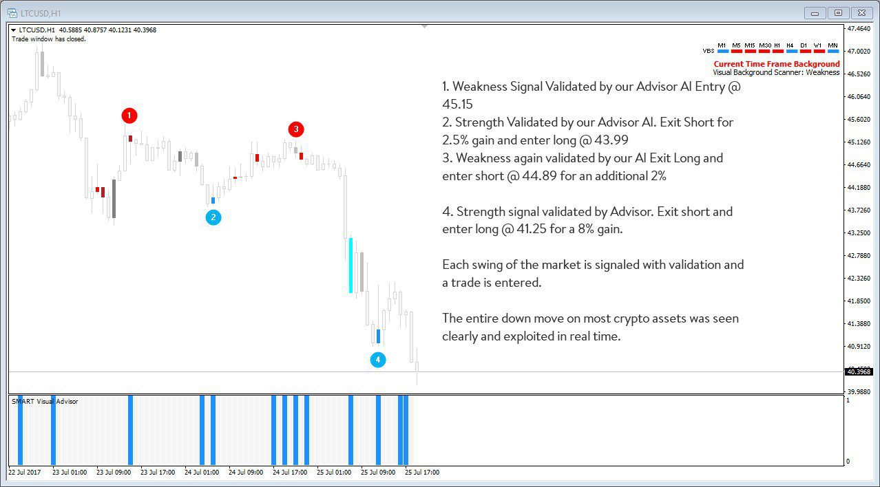  
Figure 1: LTCUSD Chart (<https://smartift.com/media-kit/sift-chart-01.jpg>)

When looking at the LTCUSD chart above SIFT’s algorithms detect an opportunity to enter a sell trade at the point labelled 1, to then get out and switch to a buy order at point 2 before entering another sell order at point 3 and switching to another buy order at point 4. Across just a few hours the validated trades that were taken show that their signal and AI detection systems work as well for crypto pairs as they do for forex and commodities.

SIFT also shared these trading patterns across DASH, BTC and ETH charts with similar levels of accuracy. Examples were also shared of projected trades where the AI system advised not investing so that investors were given a greater indication of SIFT’s risk model.

SIFT plans to publicly open up their books and begin trading a fresh account once the ICO opens. This account will relay the trades live during the ICO period so that investors can confirm that the projected ROIs are accurate.

**Press Contact**Name: Guy Powell  
Mobile: +44 7743 421 467  
Email: [guy@smartift.com](mailto:guy@smartift.com)

**Notes to Editors**

* The SIFT ICO opens on August 1st 2017 and runs until September 17th 2017
* SIFT’s algorithms come from Smart Trader, a well-established forex trading analysis suite that has existed for a decade
* Further chart analysis images are available from the [media kit](https://smartift.com/media-kit) (<https://smartift.com/media-kit>)
* Realtime trading to validate these trades will commence shortly using MyFXBook to verify trades
* SIFT is not open to US residents
* Dividends are paid to investors monthly in Ether
* Investors are estimated a 40% ROI spread across dividends and NAV of each SIFT
* SIFT itself is an ERC-20 compliant token running on the Ethereum network
* At launch five smart contracts make up SIFT’s presence on the Ethereum network
* A desktop application is available to aid investors in purchasing SIFT at <http://SmartIFT.com/sift-win>
* Investors can send ether to the ICO wallet at 0xf8Fc0cc97d01A47E0Ba66B167B120A8A0DeAb949 to be awarded SIFT
* Relevant URLs:
  + Bitcoin Talk Thread: <https://bitcointalk.org/index.php?topic=2037464.msg20268019>
  + Twitter: <https://twitter.com/SmartIFT>
  + Telegram: <https://t.me/smartift>
  + Reddit: <https://www.reddit.com/r/SmartIFT>
  + Whitepaper: <https://smartift.com/sift_whitepaper.pdf>