IDEAS FOR THE LOGO

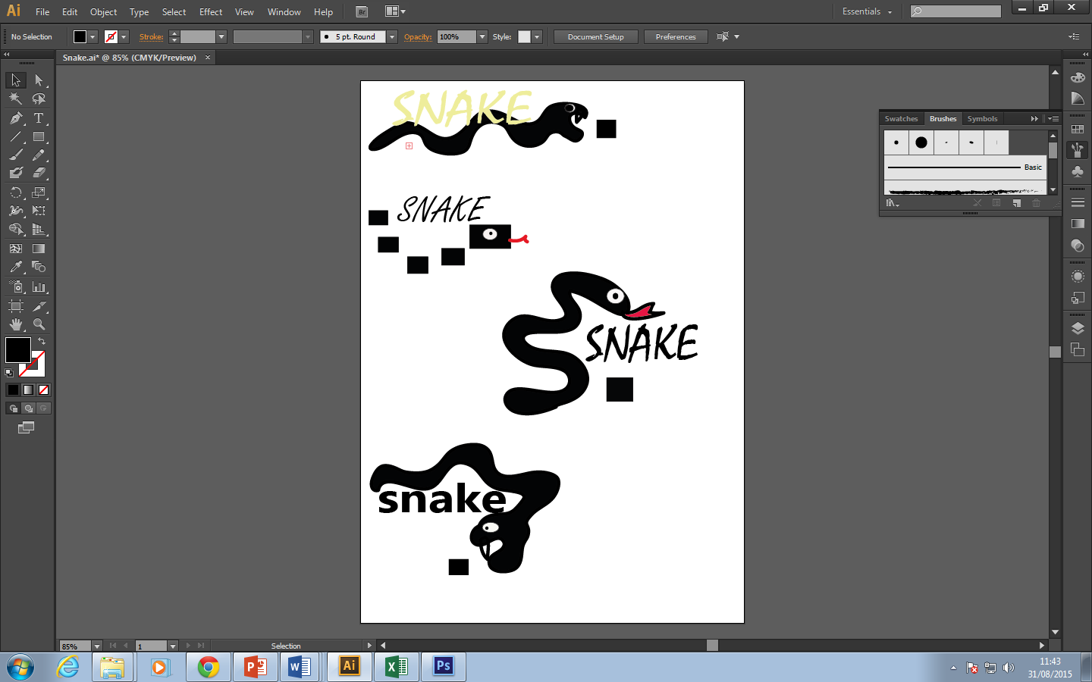

Webpages

Countdown, Homepage, About, Play the Game, Contact