### Research with solid fill6.3 Hands-on Case Study:

Neural Network Classification

*Download Source Data Set from GitHub link* : <https://github.com/Smartbrain2024/Mastering_AI_2.git>

**Chapters/Chp_06/6.3/Hands_on/Test_Data.csv**

**Context**

People are always confused about their medical insurance and do not know the cost of insurance at different ages and conditions. This data is useful for these people and is useful to make predictions of the insurance cost they will have to pay.

Step 1 : Configure Source data set : insurance charges.csv.

Step 2: Perform EDA

Data Explorer

Step 3 : Data Preprocessing

Step 4: Partitioning and Normalization

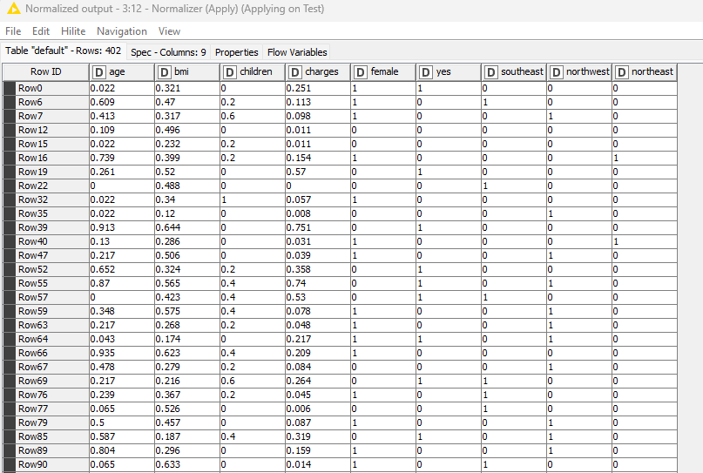

Step 5 : Model building Unpruned NN Vs Pruned NN Modeling

Unpruned NN Model Statistics Pruned NN Model Statistics

