

**Smarter Balanced**

**Assessment Consortium:**

**Test Authoring User Guide**

**2015-2016**

**Published May, 2016**

***Prepared by the American Institutes for Research®***



**Table of Contents**

© Smarter Balanced Assessment Consortium, 2014   
Descriptions of the operation of the Test Delivery System, Test Information Distribution Engine, and related systems are property of the American Institutes for Research® (AIR) and are used with permission of AIR.

Introduction to This User Guide 8

Section I. Overview of the Test Authoring System 9

Inter-relation between the Test Authoring System and other Smarter Balanced Systems 9

User Roles and Access 9

Section II. Getting Started with the Test Authoring System 11

Logging in to the Test Authoring System 11

Understanding the Test Authoring System Layout 12

Header 12

Task Bar 13

Task Icons 13

Task Screens 14

Search Screen 14

Add/Edit Screen 16

Section III. Managing Settings 17

Subjects 18

Search for a Subject 18

Add a Subject 19

Filter Tenants 20

Edit a Subject 20

Deactivate a Subject 21

Standards Publications 22

Search for a Publication 22

Add a Publication 22

Select Subjects 23

Edit a Publication 24

Delete a Publication 24

Computation Rules 25

Search for a Computation Rule 25

Add a Scoring Function 26

Scoring Function Parameters 27

Edit a Scoring Function 27

Delete a Scoring Function 28

Item Selection Algorithms 28

Search for an Item Selection Algorithm 29

Add an Item Scoring Algorithm 29

Item Selection Algorithm Parameters 31

Edit an Item Selection Algorithm 32

Delete an Item Selection Algorithm 33

Section IV. Managing Test Creation Tasks 34

Test 35

Search for a Test 35

Add a Test 36

View a Test’s Summary 38

Edit a Test 38

Copy a Test 39

Delete a Test 40

Test Segments 40

Search for a Test Segment 41

Add a Test Segment 42

Specify Item Selection Parameters for a Test Segment 44

Edit a Test Segment 45

Update Test Segment Positions 46

Delete a Test Segment 46

Blueprints 47

Manage Blueprints 47

Features of the Blueprints Screen 48

Search Blueprints 50

Edit Blueprint Standard Elements 51

Blueprint Validation Errors 52

Blueprint Widgets 54

Search for an Affinity Group 58

Add an Affinity Group 59

Edit an Affinity Group 59

Segment Pools 61

Manage Item Pools 61

Features of the Item Pool Screen 62

Search Item Pool 64

Search and Import Items from TIB 65

Edit Item Attributes 66

Move Items 67

Delete Items 68

Manage Item Groups 69

Search for an Item Group 70

Add an Item Group 71

Edit an Item Group 71

Delete an Item Group 72

View Standards Summary 72

Manage Enemy Lists 74

Search for an Enemy 75

Add an Enemy 75

Edit an Enemy Record 76

Delete an Enemy 77

Forms 77

Manage Forms 77

Add a Form 78

Edit a Form 79

Delete a Form 79

Manage Form Partitions 80

Add a Form Partition 80

Edit a Form Partition 81

Delete a Form Partition 82

Manage Items 82

Features of the Item Search Screen 83

Search for Form Partition Items 85

Search and Import Form Partition Items from TIB 85

Edit Form Item Attributes 86

Move Form Items 86

Delete Form Items 86

Manage Form Item Groups 86

Reorder Form Items 87

Scoring Rules 88

Add a Scoring Rule 89

Edit a Scoring Rule 92

Reorder Scoring Rules 92

Delete a Scoring Rule 93

Performance Levels 93

Search for a Performance Level 94

Add a Performance Level 94

Set Up Level Values for Performance Levels 95

Edit a Performance Level 96

Delete a Performance Level 97

Reporting 97

Search for a Reporting Measure 98

Add a Reporting Measure 98

Edit a Reporting Measure 99

Delete a Reporting Measure 100

Section V. Managing Post Test-Creation Tasks 101

Simulate 102

Publish 104

Submitting a Test 105

Approving a Test 105

Modifying a Published Test 106

Viewing a Test’s Approval History 107

Uploading Psychometric Information 108

Change Log 111

**Table of Figures**

Figure 1. Login Screen 11

Figure 2. Test Authoring System Home Screen 12

Figure 3. Header 12

Figure 4. Task Bar 13

Figure 5. Test Creation Task Icons 13

Figure 6. Sample Search Screen 14

Figure 7: Sample Add/Edit Screen 16

Figure 8: Error Message 16

Figure 9: Settings Drop-down List 17

Figure 10. Subject Search Screen 18

Figure 11: Add Subject Screen 19

Figure 12: Tenant Filter Pop-up Window 20

Figure 13. View/Edit Subject Screen 20

Figure 14. Publication Search Screen 22

Figure 15. Add Publication Screen 23

Figure 16: View/Edit Publication Screen 24

Figure 17. Scoring Function Search Screen 25

Figure 18: Add Scoring Function Screen 26

Figure 19: View Scoring Function Screen 28

Figure 20. Item Selection Algorithm Search Screen 29

Figure 21: Add Item Selection Algorithm Screen 30

Figure 22: Edit Item Selection Algorithm Screen 33

Figure 23. Assessment Search Screen 35

Figure 24. Assessment Details Screen 36

Figure 25: Assessment Summary Screen 38

Figure 26: View/Edit Assessment Screen 39

Figure 27. Segment Search Screen 41

Figure 28: Add Segment Screen 42

Figure 29: Segment Item Selection Parameters Section 44

Figure 30: View/Edit Segment Screen 45

Figure 31. Blueprints Screen 48

Figure 32: Blueprint Standards Screen in Edit Mode 51

Figure 33: Blueprint Widgets Pop-up Window 54

Figure 34: Pop-up Window with Widget Selected 54

Figure 35. Affinity Group Search Screen 58

Figure 36. Segment Pools: Item Pool Screen 61

Figure 37: TIB Search Pop-up Window 65

Figure 38: Item Pool Screen in Edit Mode 66

Figure 39: Item Pool Screen with Move Selected Items Pop-up Window 67

Figure 40: Item Pool Screen with Move Selected Items Pop-up Window 68

Figure 41. Item Group Search Screen 70

Figure 42. Add Item Group Screen 71

Figure 43: View/Edit Item Group Screen 72

Figure 44. Standards Summary Screen 73

Figure 45. Enemy List Search Screen 74

Figure 46. Add Enemy Screen 75

Figure 47: View/Edit Enemy Screen 76

Figure 48: Form Search Screen 78

Figure 49. Add Form Screen 78

Figure 50: View/Edit Form Screen 79

Figure 51: Form Partitions Search Screen 80

Figure 52. Add Form Partition Screen 80

Figure 53: View/Edit Form Partition Screen 81

Figure 54. Item Search Screen 82

Figure 55. Form Item Group Search Screen 86

Figure 56. Reorder Form Items Screen 87

Figure 57. Scoring Screen 88

Figure 58. Add Scoring Rule Screen 89

Figure 59: View/Edit Scoring Rule Screen 92

Figure 60. Performance Levels Search Screen 93

Figure 61. Add Performance Levels Screen 94

Figure 62: View/Edit Performance Level Screen 96

Figure 63. Reporting Measures Search Screen 97

Figure 64. Add Reporting Measure Screen 98

Figure 65: View/Edit Reporting Measure Screen 99

Figure 66: Post Test-Creation Tasks 101

Figure 67: Viewing Post Test-Creation Tasks 101

Figure 68: Viewing Post-Test Creation Tasks in the Menu 101

Figure 69: Simulation Documents Screen 102

Figure 70: Add Simulation Documents Screen 102

Figure 71: Simulation Records Table 103

Figure 72. Edit Simulation Documents Screen 103

Figure 73: Publishing Screen 104

Figure 74: Approving a Test 105

Figure 75: Creating a New Version 106

Figure 76: Approval History 107

Figure 77: Psychometric Documents Screen 108

Figure 78: Add Psychometric Documents Screen 108

Figure 79: Psychometric Records Table 109

Figure 80. Edit Psychometric Documents Screen 109

**Table of Figures**

Table 1. Key Icons and Elements 8

Table 2. User Roles and Permissions 9

Table 3. Search Screen Action Buttons 15

Table 4. Item Selection Algorithm Parameter Types 31

Table 5. Test Detail Fields 36

Table 6. Test Segment Details 42

Table 7. Master Blueprint Standards Table Columns 49

Table 8. Blueprint Standards Tools 49

Table 9. Blueprint Search Filters 51

Table 10. Blueprint Business Rules 53

Table 11. Affinity Group Search Filters 59

Table 12. Item Details Table Columns 62

Table 13. Item Attributes Table Columns 63

Table 14. Item Pool Tools 63

Table 15. Item Pool Search Filters 64

Table 16. Item Group Detail Fields 71

Table 17. Standards Summary Table 73

Table 18. Item Details Table Columns 83

Table 19. Item Attributes Table Columns 84

Table 20. Form Item Tools 84

Table 21. Item Search Filters 85

Table 22. Scoring Rule Details 89

Table 23. Test Specification Packages 105

# Introduction to This User Guide

This user guide supports individuals using the Test Authoring System to create and manage test specifications and test packages. This introduction describes the contents of this document and includes a key for identifying icons and elements.

This user guide provides information about the Test Authoring System in a series of five sections, as follows:

* **Section I, Overview of the Test Authoring System**, provides an overview of the system, its inter-relation with other Smarter Balanced systems, and the user roles for accessing the system.
* **Section II, Getting Started with The Test Authoring System**, explains how to log in to the Test Authoring System and describes the overall layout of the Test Authoring System Interface.
* **Section III. Managing Settings**, explains how to manage the test metadata required for creating tests.
* **Section IV: Managing Test Creation Tasks**, describes how to create and manage a test and the different elements constituting a test, such as test segments, blueprints, item pools, and forms.
* **Section V. Managing Post Test Creation Tasks**, describes how to perform actions, such as storing simulations or publishing a test, once the test has been created.

Table 1. Key Icons and Elements

|  |  |
| --- | --- |
| Icon | Description |
|  | **Warning:** This symbol appears with text that contains extremely important information regarding actions that may cause errors. |
|  | **Caution:** This symbol appears with text that contains important information regarding a task. |
|  | **Note:** This symbol appears next to text that contains helpful information or reminders. |
|  | Text that appears in gray boxes provides instructions relevant to the task described.   * Numbered (ordered) lists provide step-by-step instructions. * Bulleted lists provide instructions that do not need to be done in a specific order. |
| [Text] | Text in brackets is used to indicate a link or button that is clickable. |
| Text | Text in italics indicates field names or labels. |
| “Text” | Text in quotation marks indicates the value specified for a field. |

# Section I. Overview of the Test Authoring System

The Test Authoring System is a web-based system, which facilitates the creation, management, and workflow of test specification data and test packages for the purpose of assessing students. It is a multi-tenanted system that maintains test data for each tenant or client separately. The Test Authoring System allows you to create and manage tests, test segments, blueprint specifications, item pools, test forms, scoring specifications, performance levels, and reporting measures for each tenant. It also allows you to publish the test and manage simulation documents and psychometric evaluations.

## Inter-relation between the Test Authoring System and other Smarter Balanced Systems

To manage the test package creation and workflow, the Test Authoring System needs to interact with a number of systems. The different systems are described below.

* **Single Sign On (SSO)**: This system is responsible for user authentication and authorization and allows you to log in to the Smarter Balanced systems provided by the American Institutes for Research (AIR). After logging in, you can switch between systems without having to log in and out of each system.
* **Program Management**: This system stores information about the tenants who have subscribed to the Smarter Balanced systems. When logging in to the Test Authoring System, only users who are associated with tenants in good standing are allowed access.
* **Permissions**: This system stores the list of roles that have permissions to access the Test Authoring System and provides a mapping between these roles and Test Authoring System permissions. When logging in to the Test Authoring System, only users with a valid role are allowed access.
* **Core Standards**: This system stores standards publications for each tenant. The Test Authoring System uses these standard publications to create test blueprints.
* **Test Item Bank**: This system stores items that are ready for operational or field test use on an assessment. The Test Authoring System performs queries on the Test Item Bank for items based on various search criteria that can be included in an adaptive item pool or a fixed test form.

## User Roles and Access

The Test Authoring System is a role-based system. Users can access the data stored in the Test Authoring System and perform tasks based on the permissions the user’s role is authorized to access. Table 2 lists the standard roles in the Test Authoring System. The Test Authoring System administrator can add additional roles to accommodate an individual state’s policies and procedures.

Table 2. User Roles and Permissions

| Permissions | Test  Viewer | Test Author | Test Authoring Administrator | Content Lead | Psychometric Lead | Data Quality Management Lead |
| --- | --- | --- | --- | --- | --- | --- |
| Test Read | ✓ | ✓ | ✓ | ✓ | ✓ | ✓ |
| Test Modify |  | ✓ | ✓ | ✓ | ✓ | ✓ |
| Test Segment Read | ✓ | ✓ | ✓ | ✓ | ✓ | ✓ |
| Test Segment Modify |  | ✓ | ✓ | ✓ | ✓ | ✓ |
| Blueprint Read | ✓ | ✓ | ✓ | ✓ | ✓ | ✓ |
| Blueprint Modify |  | ✓ | ✓ | ✓ | ✓ | ✓ |
| Item Pool Read | ✓ | ✓ | ✓ | ✓ | ✓ | ✓ |
| Item Pool Modify |  | ✓ | ✓ | ✓ | ✓ | ✓ |
| Form Read | ✓ | ✓ | ✓ | ✓ | ✓ | ✓ |
| Form Modify |  | ✓ | ✓ | ✓ | ✓ | ✓ |
| Scoring Rule Read | ✓ | ✓ | ✓ | ✓ | ✓ | ✓ |
| Scoring Rule Modify |  | ✓ | ✓ | ✓ | ✓ | ✓ |
| Performance Level Read | ✓ | ✓ | ✓ | ✓ | ✓ | ✓ |
| Performance Level Modify |  | ✓ | ✓ | ✓ | ✓ | ✓ |
| Reporting Measure Read | ✓ | ✓ | ✓ | ✓ | ✓ | ✓ |
| Reporting Measure Modify |  | ✓ | ✓ | ✓ | ✓ | ✓ |
| Approval Read | ✓ | ✓ | ✓ | ✓ | ✓ | ✓ |
| Approval Modify |  |  |  | ✓ | ✓ | ✓ |
| Result Upload Read | ✓ | ✓ | ✓ | ✓ | ✓ | ✓ |
| Result Upload Create |  | ✓ | ✓ | ✓ | ✓ | ✓ |
| Settings Read |  |  | ✓ |  |  |  |
| Settings Modify |  |  | ✓ |  |  |  |

# Section II. Getting Started with the Test Authoring System

This section provides information about:

* Logging in to the Test Authoring System
* Understanding the Test Authoring System Layout

## Logging in to the Test Authoring System

To access the Test Authoring System, you must have an authorized username and password. Since the Test Authoring System is an open-source system, your system administrator will be responsible for setting up your user account and providing you the login credentials.

To log into the Test Authoring System:

|  |  |
| --- | --- |
| 1. Open your Web browser and navigate to the Test Authoring System using the URL provided to you. 2. You will be directed to the Single Sign On Login screen. 3. In the Username field, enter your username. 4. In the Password field, enter your password. 5. Click the [**Log In**] button. You will be directed to the Test Authoring System Home screen, provided your login is authenticated. | Figure 1. Login Screen |

## Understanding the Test Authoring System Layout

You can access the different features of the Test Authoring System from the Home screen that appears when you first log in to the system.

|  |  |
| --- | --- |
|  | Use the on-screen tools and buttons to navigate within the system. Do not use your web browser’s back button. |

Figure 2. Test Authoring System Home Screen

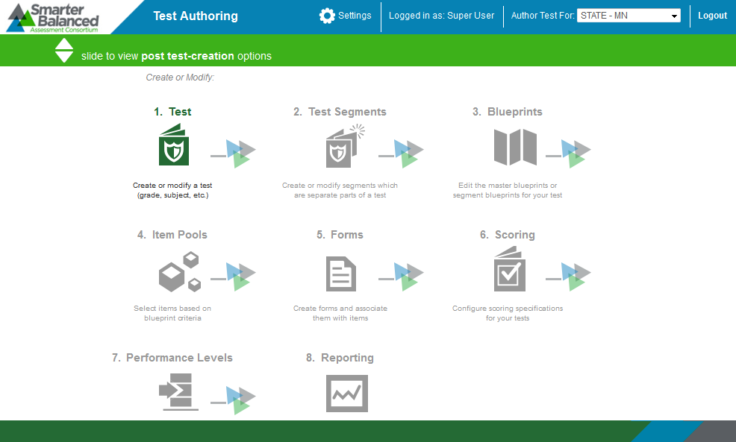

The Test Authoring System layout includes the features described below.

### Header

The Header that appears on every screen provides information about the user logged in to the system and includes tools and buttons to perform different tasks.

Figure 3. Header



The features of the Header are:

* User Identification: When you log in to the system, your name and the user role with which you are logged in is displayed on the Header. If you have multiple user roles, you can switch between the different user roles without having to log out of the system.

|  |  |
| --- | --- |
|  | The Test Authoring System maintains test data for each tenant separately and uses a role-specific design to restrict access to data and tasks based on the user’s designated role. It is important to ensure that you are logged in with the correct user role before performing any task.  For example, if you log in with a Test Author role for the tenant Minnesota, you will only be able to access test data for Minnesota and perform tasks that you are authorized to do. |

* [**Logo**]: The Smarter Balanced Assessment Consortium logo acts as a button that brings you back to the Home screen.
* Settings: The **Settings** drop-down menu allows authorized users to set up test metadata or pre-requisites. While some of the prerequisites are tenant-specific, others are common to all tenants. For more information, refer to Section III. Managing Settings.
* [**Logout**]: This button enables you to log out of the system.

### Task Bar

The Task Bar enables you to switch between “test-creation” and “post test-creation” tasks. By default, the Home screen displays the “test-creation” tasks. To view the “post test-creation” tasks, click the arrows encircled in the figure below.

Figure 4. Task Bar



|  |  |
| --- | --- |
|  | The Task Bar is not available on all the screens and may appear in a different location on screens other than the Home screen. For example, the Task Bar is not available when you are on task search screens. For more information, refer to Task Screens. |

### Task Icons

The test-creation and post test-creation tasks are displayed as icons on the Home screen. Each task icon acts as a link that takes you to the specified task screen. When you first log in to the system, the test-creation task icons are displayed. You can view the post test-creation task icons using the Task Bar.

Figure 5. Test Creation Task Icons

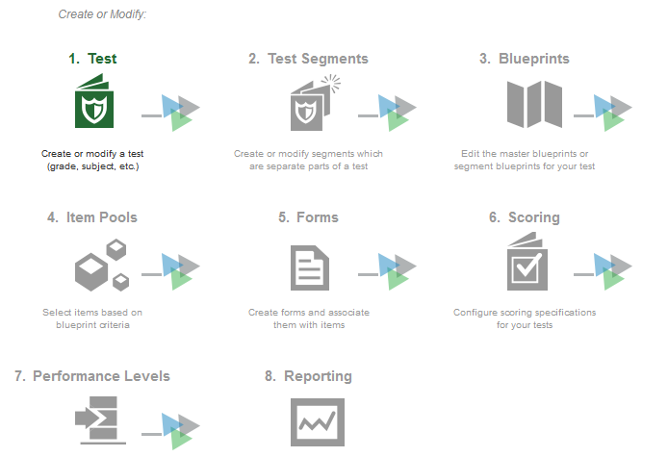

The task icons are displayed in a hierarchical order. When you first log in to the system, all the task icons except for [**Test**] are disabled. This is because all the tasks that you can perform in the Test Authoring System, with the exception of setting up test metadata, are all referenced to a particular test. Once you create a test or select the test that you wish to work on, the other task icons are enabled.

|  |  |
| --- | --- |
|  | Although you can access the other tasks out of order, it is recommended that you maintain the workflow. This is because a task is often dependent on a previous task. For example, once you create or select a test, you can access the Reporting task category. However, you will not be able to create any reporting measures until you have established scoring rules. Again, you cannot create scoring rules until blueprint element categories, such as test segments, and blueprint standards, are created. |

When you select a task, a Menu is displayed on the screen. You can navigate through the different tasks using the menu. To return to the Home screen and view the task icons, click the logo on the header.

### Task Screens

For ease of use, the Test Authoring System is designed to primarily use two types of screen layouts, which are described below.

#### Search Screen

When you first access a task, you are taken to the task’s search screen by default.

Figure 6. Sample Search Screen

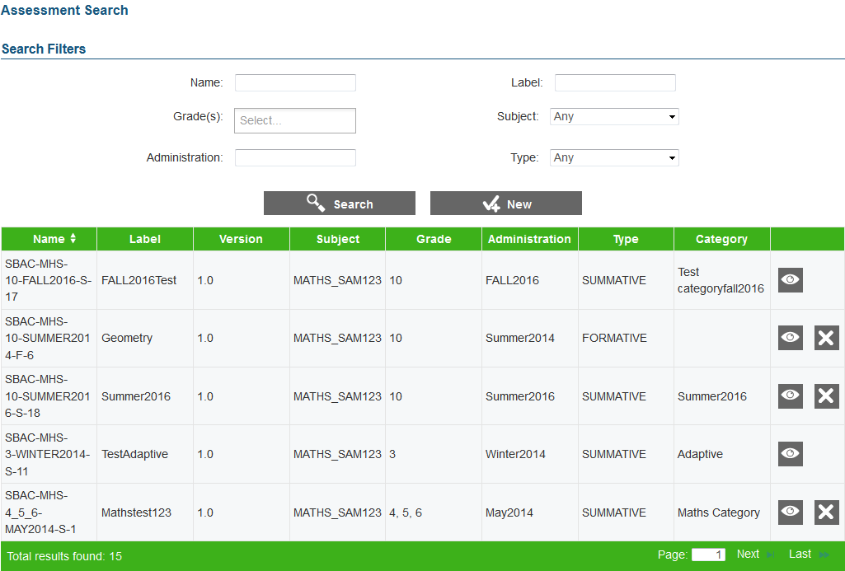

The search screen consists of the following two sections:

* Search Filters Section: This section allows you to search for records that have been created for the selected task. It consists of the following:
  + Search criteria fields applicable to the task that you are viewing, where you can specify the required search criteria.
  + [**Search**] button that enables you to search for records based on the specified criteria.

|  |  |
| --- | --- |
|  | The Search Filters section also consists of a [**New**] button that takes you to the Add/Edit/View Screen where you can create a new record for the task. However, the button may not be available for all task categories. |

* Table of Records: The table of records displays the records that have been created for the selected task based on the search filter specifications. While some screens display all the records existing for a task, others may display records for a specific blueprint element type. You can search for and filter the records using the search filters. The features of the table are:
  + You can sort the data displayed in the columns by clicking the column header. Not all columns can be sorted. If a column can be sorted, arrows will be displayed when you hover over the column header. The column by which the data is sorted will display the arrows by default.
  + A navigation panel is displayed at the bottom of the table, which enables you to navigate through the retrieved records. It also displays the number of records that matched the specified search criteria.
  + Each record is displayed in a separate row.
  + Action icons are displayed next to each record, which allow you to view or delete a record. The different action icons are listed in the following table.

Table 3. Search Screen Action Buttons

| **Button** | **Description** |
| --- | --- |
|  | **View**: Enables you to view the record details. |
|  | **Delete**: Enables you to delete the record. |
|  | **Move Down**: Enables you to move a record to the position below. |
|  | **Move Up**: Enables you to move a record to the position above. |

|  |  |
| --- | --- |
|  | All action icons may not be available or applicable for all records. For example, if a record cannot be deleted, the delete [] button will not be displayed next to the record. |

#### Add/Edit Screen

When you add, view, or edit a record, the same screen with slight variations is displayed to you.

Figure 7: Sample Add/Edit Screen

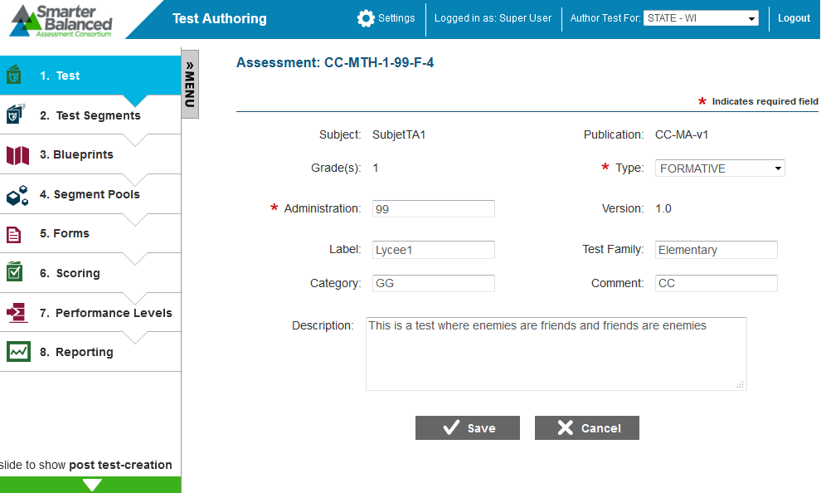

The features of this screen are:

* Menu: Displays a Menu that enables you to access the different tasks for the selected test. When you select a record from the search screen, the Menu is filtered to display records pertaining to the selected test for all the task categories.

|  |  |
| --- | --- |
|  | To view the details of another test, go back to the search screen for the Test task category and select a different test. |

* Consists of task specific fields where you can add or edit values.
* Buttons: [**Edit**], [**Save**], [**Cancel**], and [**Back**] buttons may be provided for a task. Additional task-specific buttons may also be displayed. For example, buttons to add parameters are displayed for the Scoring Rules task category.
* Error message: Any errors that may occur while performing a task are displayed on the top of the screen. Click the [+] button to expand and view the errors. Additionally, the errors may also be displayed next to the field itself.

Figure 8: Error Message



# Section III. Managing Settings

To create tests for a tenant, you need to set up some pre-requisites in the Test Authoring System. The pre-requisites include setting up subjects for which tests can be created, specifying the content standards that can be used for the test blueprints, creating scoring functions that can be associated to a test, and establishing item selection algorithms.

You can create and manage the pre-requisites from the **Settings** drop-down list on the Header. This drop-down list consists of the following four options:

* Subjects
* Standard Publications
* Computation Rules
* Item Selection Algorithms

Figure 9: Settings Drop-down List

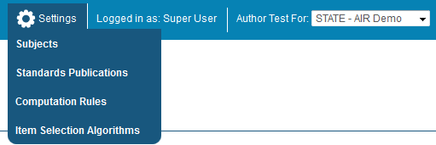

|  |  |
| --- | --- |
|  | **About users who can manage test metadata:**  Establishing test metadata is a highly specialized task and is generally performed for new tenants. Only authorized users can create and manage test metadata. Currently, only users with Test Author Administrator user role can create and manage test metadata. An error message will be displayed for other users who attempt to access the Settings options. |

## Subjects

All tests must be associated with a subject. From the Subject Search screen, a Test Author Administrator can manage subjects for all tenants established in the Program Management System.

To view the Subject Search screen:

|  |
| --- |
| 1. From the **Settings** drop-down list (see Figure 9), select **Subjects**. The Subject Search screen appears. |

Figure 10. Subject Search Screen

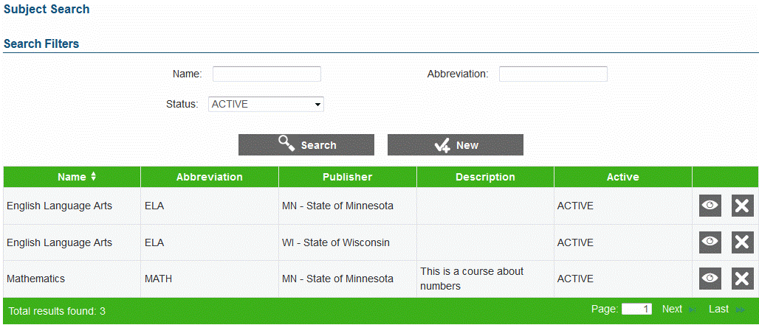

### Search for a Subject

The Subject Search screen allows you to search for existing subjects by the subject’s name, abbreviation, or status.

|  |  |
| --- | --- |
|  | By default, the Subject Search screen displays existing subjects that have a status of “Active.” |

To search for subjects:

|  |
| --- |
| 1. On the Subject Search screen, enter any search criteria you want to include. 2. Click the [**Search**] button. The screen will display the search results table containing the subjects that match the search criteria. |

### Add a Subject

The Add Subject screen allows you to add subjects for the different tenants.

Figure 11: Add Subject Screen

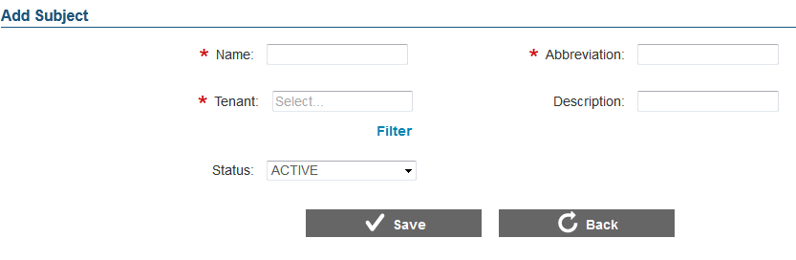

|  |  |
| --- | --- |
|  | **About adding subjects:**  Subjects are tenant-specific. When creating a test for a tenant, such as a state, you can only select subjects that have been established for that state. Thus, you may need to add the same subject more than once. For example, if you need to create Mathematics tests for both Demo State 1 and Demo State 2, you need to add the subject Mathematics twice.  You cannot create the same subject for the same tenant twice. |

To add a subject:

|  |
| --- |
| 1. On the Subject Search screen (see Figure 10), click the [**New**] button. The Add Subject screen (see Figure 11) appears. 2. In the Name field, enter the subject’s name. 3. In the Abbreviation field, enter an abbreviation for the subject. For example, the abbreviation for “English Language Arts” can be “ELA.” The abbreviation cannot be more than three characters and can only contain letters or numbers. 4. From the **Tenant** drop-down list, select the tenant for whom the subject is being created. The list displays only after you start typing. For example, if you enter “c,” a list of all tenants whose name contains the letter “c” appears. You can also filter the tenants displayed in the drop-down list by tenant type. For more information, refer to Filter Tenants. 5. Optional: In the Description field, enter the subject’s description. 6. From the **Status** drop-down list, select the subject’s status. When associating subjects with tests or standards publications, you can only select subjects that are “Active” 7. Click the [**Save**] button. 8. To return to the Subject Search screen, click the [**Back**] button. Verify that the subject is listed on the Subject Search screen. |

#### Filter Tenants

You can filter the tenants listed in Tenant drop-down lists by tenant type. This is especially useful when there are a large number of tenants.

To filter tenants by tenant type:

|  |
| --- |
| 1. On the Add Subject screen (see Figure 11), click the [**Filter**] link underneath the **Tenant** drop-down list. This will open a pop-up window.   Figure 12: Tenant Filter Pop-up Window     1. From the **Tenant Type Filter** drop-down list, select the tenant type by which you wish to filter the records. For example, select “Institution” to view only those tenants whose name contains the letter “c” and who are of the institution type. 2. Click the [**Filter**] button. The Tenant field on the Add Subject screen will display the tenant type by which the field is being filtered. |

### Edit a Subject

The View/Edit Subject screen allows you to edit the details for a subject.

|  |  |
| --- | --- |
|  | You can only edit subjects that are not associated with published tests. |

Figure 13. View/Edit Subject Screen

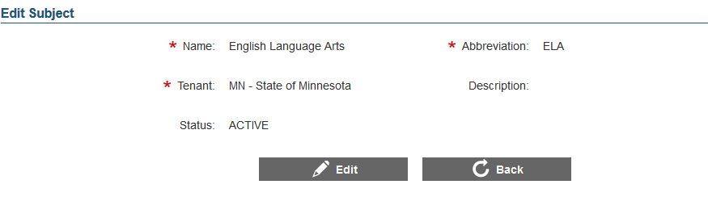

To edit a subject:

|  |
| --- |
| 1. On the Subject Search screen (see Figure 10), search for the subject you want to edit. 2. Click the view [] button next to the subject. The View/Edit Subject screen (see Figure 13) appears. 3. Click the [**Edit**] button. The button is available only for subjects that can be edited. 4. Update the information as necessary. All fields are editable. 5. Click the [**Save**] button. 6. To return to the Subject Search screen, click the [**Back**] button. |

### Deactivate a Subject

You can deactivate subjects from the Subject Search screen.

|  |  |
| --- | --- |
|  | Currently, the system prevents you from deleting subjects. In the future, you will be allowed to delete subjects that are not associated with published tests. However, for a subject associated with a published test, you can deactivate the subject by changing its status to “Inactive.” This will prevent users from creating new tests associated with the subject. |

To deactivate a subject:

|  |
| --- |
| 1. On the Subject Search screen (see Figure 10), search for the subject you want to deactivate. 2. Click the delete [] button next to the subject. A pop-up message will appear that asks if you are sure you want to deactivate the subject. 3. To deactivate the subject, click the [**OK**] button. The subject will display a status of “Inactive.” The subject will no longer be displayed on subject lists in other areas of the system. |

## Standards Publications

All test blueprints must be associated with a standards publication. Standards publications are stored in the Core Standards System. From the Publication Search screen, a Test Author Administrator can create and manage references to these standards publications.

To view the Publication Search screen:

|  |
| --- |
| 1. From the **Settings** drop-down list (see Figure 9), select “Standards Publication.” The Publication Search screen appears. |

Figure 14. Publication Search Screen

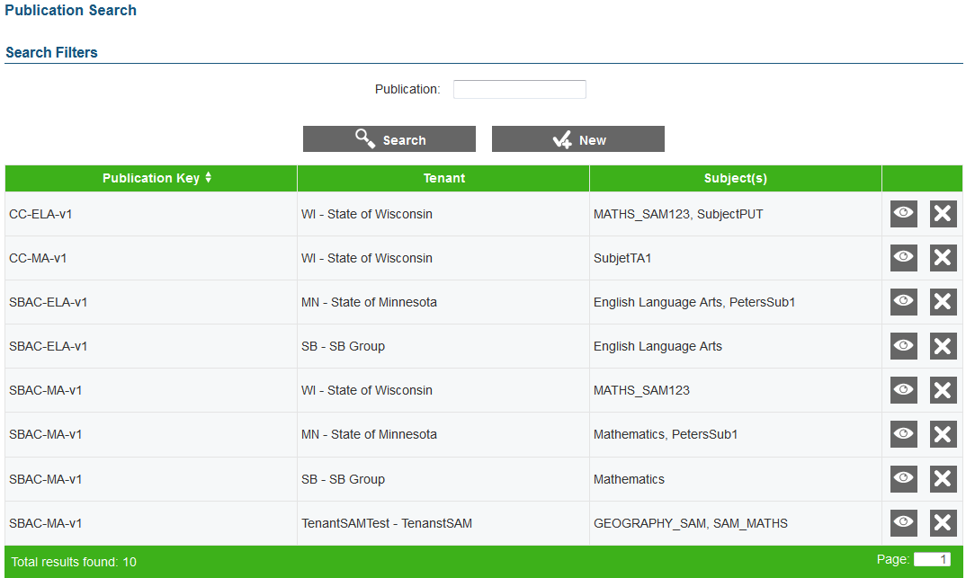

### Search for a Publication

The Publication Search screen allows you to search for existing standards publications associations by the publication key. The publication key is a combination of the publisher, subject, and publication that is assigned by the system when you add a standards publication.

To search for publications:

|  |
| --- |
| 1. On the Publication Search screen, enter any search criteria you want to include. 2. Click the [**Search**] button. The screen will display the search results table containing the publications that match the search criteria. |

### Add a Publication

The Add Publication screen enables you to create references to standards publications existing in the Core Standards System and associate them with tenants and subjects in the Test Authoring System. When selecting a standards publication for a test, you can only select standards publications that have been associated with the test subject for the specified tenant.

Figure 15. Add Publication Screen

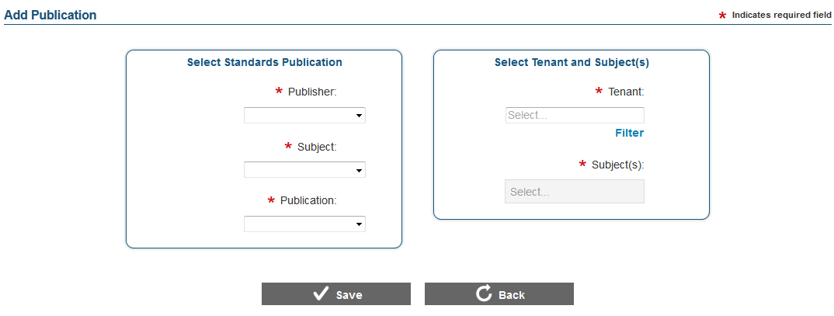

|  |  |
| --- | --- |
|  | You can associate a standards publication with a tenant only once. However, you can associate multiple subjects created for that tenant with the same standards publication. For example, you cannot associate the AIR Demo State subject English Language Arts with the AIR ELA Standards publication twice. However, you can associate the AIR Demo State subjects Algebra II and Geometry with the AIR Mathematics Standards publication. |

To add a standards publication:

|  |
| --- |
| 1. On the Publication Search screen (see Figure 14), click the [**New**] button. The Add Publication screen (see Figure 15) appears. 2. From the Select Standards Publication section, specify the following:    1. From the **Publisher** drop-down list, select the publisher whose standards you wish to include. The list displays all the publishers existing in the Core Standards System.    2. From the **Subject** drop-down list, select the subject whose standards you wish to include. The list displays all the subjects for which standards have been published by the selected publisher.    3. From the **Publication** drop-down list, select the standards publication that you wish to include. The list displays all the publications existing for the selected publisher and subject. 3. From the Select Tenant and Subject(s) section, specify the following:    1. From the **Tenant** drop-down list, select the tenant with whom the standards publication will be associated. You can select the tenant in the same process as described in Add a Subject.    2. From the **Subject(s)** drop-down list, select the subjects that you wish to associate with the standards publication. For information on how to select or remove a subject, refer to Select Subjects. 4. Click the [**Save**] button. 5. To return to the Publication Search screen, click the [**Back**] button. Verify that the publication is listed with the publication key. |

#### Select Subjects

To select a subject or subjects from the Subject(s) drop-down list:

|  |
| --- |
| 1. Place your cursor in the text area to view the list of subjects created for the tenant. 2. Select a subject. The selected subject will appear as a button in the text area. 3. Repeat the above steps until you have selected all required subjects. |

To deselect or remove a subject from the Subject(s) drop-down list:

|  |
| --- |
| 1. Select the subject from the Subject(s) text area. The subject button will appear a shade darker than the other subjects. 2. Press the [**Delete**] button on your keyboard. |

### Edit a Publication

The View/Edit Publication screen enables you to edit standards publication associations.

|  |  |
| --- | --- |
|  | Once a publication is associated with a test, you will not be able to change the publication. You will also not be able to change the tenant associated with the publication or the subject for which the test has been created. You will only be able to associate new subjects or remove subjects that are not associated with tests referring to the publication. |

Figure 16: View/Edit Publication Screen

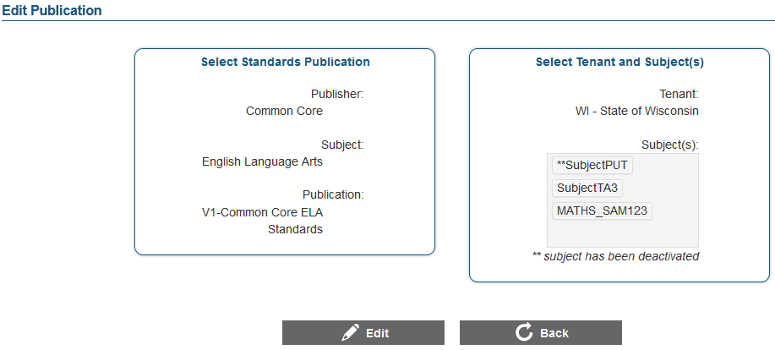

To edit a publication:

|  |
| --- |
| 1. On the Publication Search screen (see Figure 14), search for the publication you want to edit. 2. Click the view [] button next to the publication. The View/Edit Publication screen appears. 3. Click the [**Edit**] button. 4. Update the details for fields that can be edited. 5. Click the [**Save**] button. 6. To return to the Publication Search screen, click the [**Back**] button. |

### Delete a Publication

You can delete a publication association if required. To delete a publication:

|  |
| --- |
| 1. Go to the Publication Search screen and search for the publication you wish to edit. 2. Click the delete[] button next to the publication. The publication will no longer be listed. |

## Computation Rules

This feature allows Test Author administrators to set up test scoring functions. When establishing scoring rules for a test, users can select a scoring function set up by Test Author Administrators and customize it according to the test requirements.

|  |  |
| --- | --- |
|  | **About computation rules**:  The Test Authoring System does not allow you to create the actual function. The scoring function is created in the Test Scoring Engine. The Test Authoring System allows you to create signatures for the scoring functions established for a tenant in the Test Scoring Engine. You will not be able to score a test unless the signature of the selected scoring function matches the scoring function set up in the Test Scoring Engine. |

From the Scoring Function Search screen, a Test Author Administrator can create and manage scoring functions.

To view the Scoring Function Search screen:

|  |
| --- |
| 1. From the **Settings** drop-down list (see Figure 9), select “Computation Rules.” The Scoring Function Search screen appears. |

Figure 17. Scoring Function Search Screen

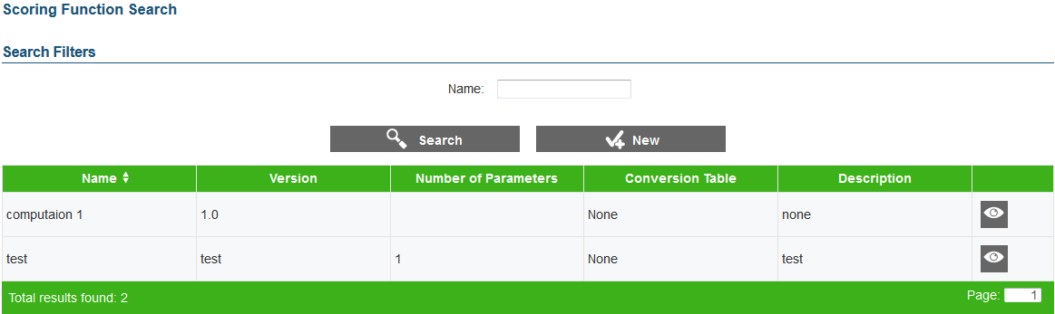

### Search for a Computation Rule

The Scoring Function Search screen allows you to search for existing scoring functions by name.

To search for computation rules:

|  |
| --- |
| 1. On the Scoring Function Search screen, enter the name of the scoring function. 2. Click the [**Search**] button. The screen will display the scoring functions that match the name, along with the version number, the number of parameters established for the scoring function, whether it uses a conversion table, and description. |

### Add a Scoring Function

The Add Scoring Function screen enables you to set up scoring functions that are available to all tenants. When setting up scoring rules for a test, you can assign any scoring function set up in the system.

|  |  |
| --- | --- |
|  | **About scoring functions**:  You can create multiple versions of the same scoring function to accommodate new rules. However, the name and version number combination of the scoring function must be unique.  While the scoring functions are available to all tenants, only those functions that match the scoring functions set up in the tenant’s Test Scoring Engine will work. |

Figure 18: Add Scoring Function Screen

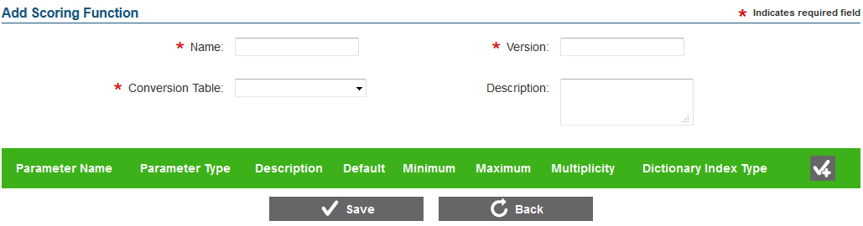

To add a scoring function:

|  |
| --- |
| 1. On the Scoring Function Search screen (see Figure 17), click the [**New**] button. The Add Scoring Function screen (see Figure 18) appears. 2. In the Name field, enter the name of the scoring function. The name must match the name of the scoring rule in the Test Scoring Engine. 3. In the Version field, enter the version number for the scoring function. The version number must be entered in the format 0.0, where the number before the decimal point indicates the major revision number and the number after the decimal point indicates the minor revision number. 4. From the **Conversion Table** drop-down list, specify whether you want to use a conversion table and the type of conversion table you want to use. The available options are:    * None: Indicates that the scoring function does not use a conversion table.    * Value: Indicates that the scoring function uses a value-based conversion table.    * Value and Standard Error: Indicates that the scoring function uses both value-based and standard error conversion table. 5. Optional: In the Description field, enter a description of the scoring function. 6. Optional: Create one or more scoring function parameters. For information on managing parameters, refer to Scoring Function Parameters. 7. Click the [**Save**] button. 8. To return to the Scoring Function Search screen, click the [**Back**] button. Verify that the scoring function is listed on the screen. |

#### Scoring Function Parameters

A scoring function may or may not consist of a parameter.

To create a parameter:

|  |
| --- |
| 1. On the Parameters header, click the Add [] button (this button is only displayed when you are creating or editing a scoring function). A new row appears. 2. In the Parameter Name field, enter the name of the parameter. 3. From the **Parameter** **Type** drop-down list, specify whether the parameter is a string, float, or integer value. 4. Optional: In the Description field, enter the parameter description. 5. Optional: In the Default field, enter the default parameter value. 6. Optional: In the Minimum field, enter the minimum parameter value. This is only applicable for integer and float type parameters. 7. Optional: In the Maximum field, enter the maximum parameter value. This is only applicable for integer and float type parameters. 8. From the **Multiplicity** drop-down list, specify whether the parameter is a scalar value or a dictionary. A dictionary indicates a compound value with indexes and values.    1. From the **Dictionary Index Type** drop-down list, select the dictionary index type to use. This is only required if the parameter is a dictionary value. 9. Repeat the above steps until you have entered the required parameters. 10. To save the parameters, click the [**Save**] button. |

To switch positions or order of a parameter:

|  |
| --- |
| 1. On the View/Edit Scoring Function screen, click the [**Edit**] button. 2. Select the parameter that you want to reorder and drag it to the required position. |

To delete a parameter:

|  |
| --- |
| 1. On the View/Edit Scoring Function screen, click the [**Edit**] button. 2. Click the delete[] button next to the parameter. |

### Edit a Scoring Function

The View/Edit Scoring Function screen enables you to edit existing scoring functions.

|  |  |
| --- | --- |
|  | You can only edit scoring functions that have not been assigned to a test. If required, you can create a new version of the scoring function with the required configurations. This maintains compatibility of scoring functions that are being used by existing tests. |

Figure 19: View Scoring Function Screen

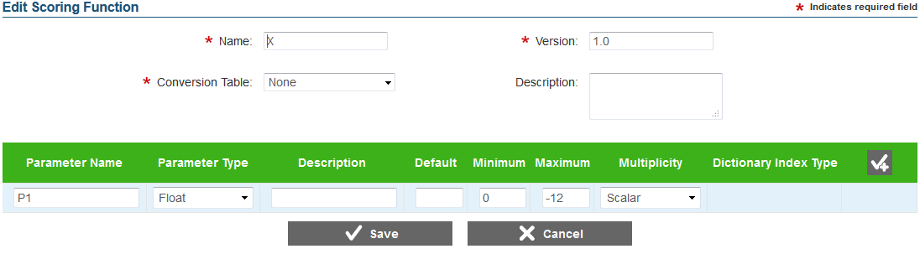

To edit a scoring function:

|  |
| --- |
| 1. On the Scoring Function Search screen (see Figure 17), search for the scoring function you want to edit. 2. Click the view [] button next to the scoring function. The View/Edit Scoring Function screen appears. 3. Click the [**Edit**] button. 4. Update the details for the different scoring function fields and parameters. 5. Click the [**Save**] button. 6. To return to the Scoring Function Search screen, click the [**Back**] button. |

### Delete a Scoring Function

The Scoring Function Search screen allows you to delete a scoring function.

|  |  |
| --- | --- |
|  | You can only delete scoring functions that have not been assigned to a test. |

To delete a scoring function:

|  |
| --- |
| 1. On the Scoring Function Search screen, search for the scoring function you want to delete. 2. Click the delete [] button, if available, next to the scoring function. A pop-up message will appear that asks if you are sure you want to delete the scoring function. 3. To delete the scoring function, click the [**OK**] button. The scoring function will no longer be listed on the screen and will not be displayed in scoring function lists in other areas of the system. |

## Item Selection Algorithms

This feature allows Test Author administrators to set up algorithms for selecting items. When creating a test segment, test authors can select an algorithm and configure the algorithm parameters as required. From the Item Selection Algorithm Search screen, a Test Author Administrator can create and manage item selection algorithms.

|  |  |
| --- | --- |
|  | The Test Authoring System merely allows you to set up signatures of Item Selection Algorithms that are configured in the Test Delivery System. The algorithms will not function unless the signatures match the specifications in the Test Delivery System. |

To view the Item Selection Algorithm Search screen:

|  |
| --- |
| 1. From the **Settings** drop-down list (see Figure 9), select “Item Selection Algorithm.” The Item Selection Algorithm Search screen appears. |

Figure 20. Item Selection Algorithm Search Screen

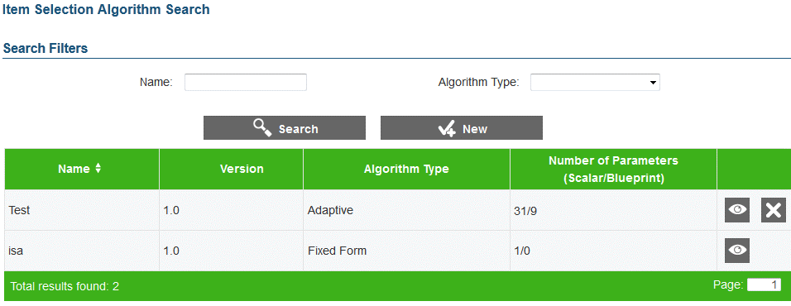

### Search for an Item Selection Algorithm

The Item Selection Algorithm Search screen allows you to search for existing algorithms by name and algorithm type.

To search for item selection algorithms:

|  |
| --- |
| 1. On the Item Selection Algorithm Search screen, enter any search criteria you want to include. 2. Click the [**Search**] button. The screen will display the algorithms that match the search criteria along with the version number and the number of parameters established for the algorithm. |

### Add an Item Scoring Algorithm

The Add Item Selection Algorithm screen enables you to set up item selection algorithm signatures for tenants. When setting up a test segment, you can select any of the item selection algorithms that are set up in the system.

|  |  |
| --- | --- |
|  | **About item selection algorithms**:  While the selection algorithms are available to all tenants, only those algorithms that match the algorithms set up in the tenant’s Test Delivery System will function.  You can create multiple versions of the same algorithm to accommodate new configurations. However, the name and version number combination of the selection algorithm must be unique. |

Figure 21: Add Item Selection Algorithm Screen

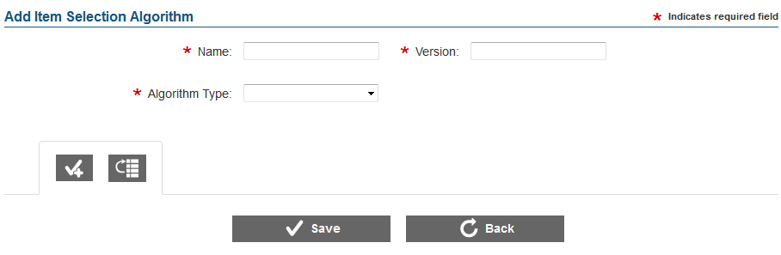

To add an item scoring algorithm:

|  |
| --- |
| 1. On the Item Selection Algorithm Search screen (see Figure 20), click the [**New**] button. The Add Item Selection Algorithm screen (see Figure 21) appears. 2. In the Name field, enter the name of the selection algorithm. 3. In the Version field, enter the version number for the selection algorithm. The version number must be entered in the format 0.0, where the number before the decimal point indicates the major revision number and the number after the decimal point indicates the minor revision number. 4. From the **Algorithm Type** drop-down list, specify the type of algorithm you want to use. The available options are:    * FixedForm: Indicates that the items included on a form are fixed and are selected by the user.    * Adaptive: Indicates that the items in a segment are not fixed and are selected by the Test Delivery System from a pool of items created by the user. 5. Create item selection algorithm parameters, if required. Currently, the system requires you to set up at least one parameter. For more information, refer to Item Selection Algorithm Parameters. 6. Click the [**Save**] button. 7. To return to the Item Selection Algorithm Search screen, click the [**Back**] button. Verify that the item selection algorithm is listed on the screen. |

#### Item Selection Algorithm Parameters

Currently, an item selection algorithm must consist of a parameter. To create a parameter:

|  |
| --- |
| 1. Click the Add [] button (this button is only displayed when you are creating or editing an item selection algorithm). The “New Parameter” details tab appears. 2. In the Parameter Name field, enter the name of the parameter. 3. From the **Purpose** drop-down list, specify whether the parameter is going to be applied globally to scalar test segments or whether it will be applied to a test segment blueprint. 4. From the **Type** drop-down list, specify the parameter type. Depending on the selected parameter type, additional fields will be displayed. 5. Specify details for the additional fields. For information on the different fields, refer to Table 4. Item Selection Algorithm Parameter Types. 6. Optional: In the Description field, enter a description of the parameter. 7. Repeat the above steps until you have entered the required parameters. 8. Click the [**Save**] button to save the parameters. The parameters will be listed as tabs on the View Item Selection Algorithm screen. |

Table 4. Item Selection Algorithm Parameter Types

| **Type** | **Description** |
| --- | --- |
| **Boolean** | When you select this type, the following field is displayed:   * **Default Value**: Drop-down list that allows you to specify whether the parameter value should be defaulted to true or false. |
| **Integer** | When you select this type, the following fields are displayed:   * Default Value: Text field where you can enter a default integer value. The value must be within the minimum and maximum values specified for the parameter. * Min Value: Text field where you can enter the minimum integer value allowed for the parameter. The value must be less than the maximum value specified for the parameter. * Max Value: Text field where you can enter the maximum integer value allowed for the parameter. |
| **Float** | When you select this type, the following fields are displayed:   * Default Value: Text field where you can enter a default float value. The value must be within the minimum and maximum values specified for the parameter. * Min Value: Text field where you can enter the minimum float value allowed for the parameter. The value must be less than the maximum value specified for the parameter. * Max Value: Text field where you can enter the maximum float value allowed for the parameter. |
| **List** | When you select this type, the following fields and buttons are displayed:   * Default Value: Text field where you can enter the default parameter value. The value must be included in the list of values that you create for the parameter. Therefore, you can only specify the default value after creating the list. * Add [] button to add a value. * Re-order [] button to re-order the list values.   **To create a list of values**:   1. From the List Values section, click the Add [] button. 2. In the text field that appears, enter the required value. 3. Repeat the steps until you have added all the list values.   **To remove a value from the list**:   1. Click the delete [] button next to the value.   **To reorder list values**:   1. Click the re-order list values [] button. The list values will be listed in rows. 2. Select the list value that you wish to reorder and drag it to the required position 3. To exit the re-order feature, click the [**Done**] button. |

To re-order or change positions of parameters:

|  |
| --- |
| 1. On the View/Edit Item Selection Algorithm screen, click the [**Edit**] button. 2. Click the re-order parameters [] button. The parameters will be listed in rows. 3. Select the parameter that you wish to reorder and drag it to the required position. 4. To exit the re-order feature, click the [**Done**] button. 5. To save the new parameter orders, click the [**Save**] button. |

To delete a parameter:

|  |
| --- |
| 1. On the View/Edit Item Selection Algorithm screen, click the [**Edit**] button. 2. Click the delete [] button next to the parameter that you wish to delete. The parameter tab will be removed. 3. Click the [**Save**] button. |

### Edit an Item Selection Algorithm

The View/Edit Item Selection Algorithm screen enables you to edit existing item selection algorithms.

|  |  |
| --- | --- |
|  | You can only edit item selection algorithms that have not been assigned to a test. If required, you can create another version of the item selection algorithm with the new configurations. This allows the item selection algorithms to remain compatible with existing tests. |

Figure 22: Edit Item Selection Algorithm Screen

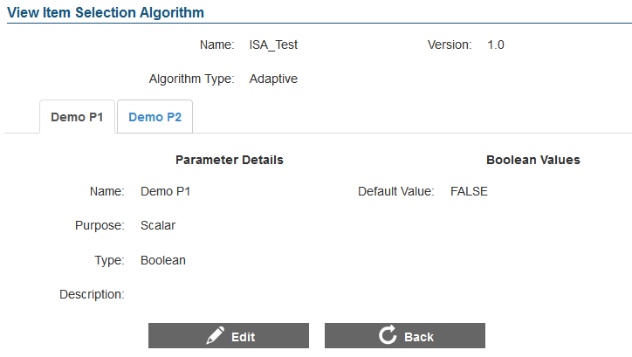

To edit an item selection algorithm:

|  |
| --- |
| 1. On the Item Selection Algorithm Search screen (see Figure 20), search for the item selection algorithm you want to edit. 2. Click the view [] button next to the item selection algorithm. The View/Edit Item Selection Algorithm screen appears. 3. Click the [**Edit**] button. 4. Update the details for the different item selection algorithm fields and parameters. 5. Click the [**Save**] button. 6. To return to the Item Selection Algorithm Search screen, click the [**Back**] button. |

### Delete an Item Selection Algorithm

The Item Selection Algorithm Search screen allows you to delete an item selection algorithm.

|  |  |
| --- | --- |
|  | You can only delete item selection algorithms that have not been assigned to a test. |

To delete an item selection algorithm:

|  |
| --- |
| 1. On the Item Selection Algorithm Search screen, search for the algorithm you want to delete. 2. Click the delete [] button, if available, next to the algorithm. A pop-up message will appear that asks if you are sure you want to delete the algorithm. 3. To delete the algorithm, click the [**OK**] button. The item selection algorithm will no longer be listed on the screen and will not be displayed in item selection algorithm lists in when setting up a test segment. |

# Section IV. Managing Test Creation Tasks

The core functionality of the Test Authoring System is to create tests. Creating a test involves a number of steps. The Test Authoring System presents these different steps as individual tasks. You can access the tasks from the Test Authoring System Home screen (see Figure 2).

|  |  |
| --- | --- |
|  | **About test-creation tasks:**  Tests are tenant-specific. You can only view and create tests for the tenant you are logged in as. Please verify that you have logged in with the correct user role before performing any task.  You can only create tests after Test Author Administrators have established tenant-specific test metadata. For information on the test metadata, refer to Section III. Managing Settings. |

The different test creation tasks involve the creation and management of:

* Test
* Test Segments
* Blueprints
* Item Pools
* Forms
* Scoring
* Performance Levels
* Reporting

|  |  |
| --- | --- |
|  | **About test-creation task workflow:**  You can perform test-creation tasks for one test at a time. When you log in to the system, only the [**Test**] icon is enabled. The other task icons are only enabled after you have created or selected the test that you want to work on.  Although the other task icons are enabled once you have selected a test, it is advisable to perform the tasks in a chronological order. This is because tasks are hierarchical and you may not be able to perform a task completely unless the previous task has been completed. For example, you will be able to establish the Master blueprint for an assessment without creating test segments, but you will not be able to create test segment blueprints. |

## Test

The first step in creating a test is to establish the test identity that consists of details, such as the test name, the grades to which the test will be administered, and the test subject. All other test creation tasks, such as creating test segments, blueprints, item pools, and forms can only be performed after the test identity has been established. From the Assessment Search screen, authorized users can search for, create, and manage tests for a specific tenant.

Figure 23. Assessment Search Screen

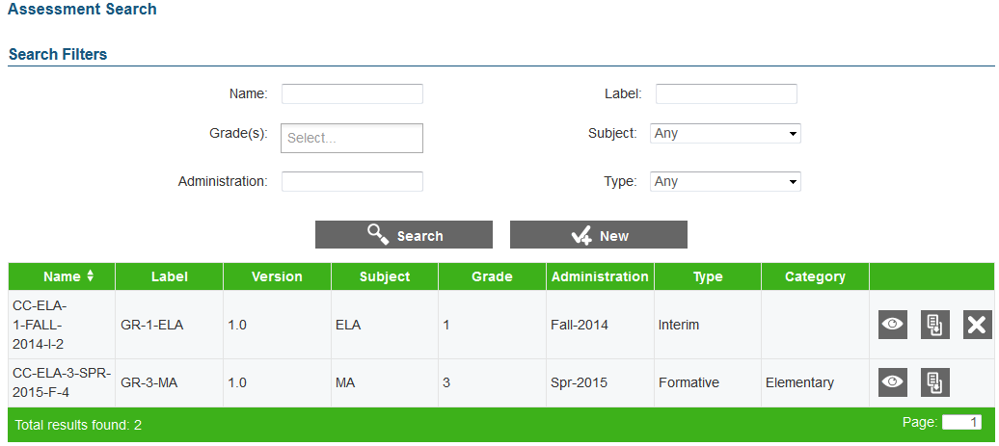

To view the Assessment Search screen:

|  |
| --- |
| 1. On the Home screen (see Figure 2), click the test [] icon. The Assessment Search screen appears listing the tests that have been created for the tenant. |

### Search for a Test

The Assessment Search screen allows users to search for tests that have been created for a tenant using the available search filters.

|  |  |
| --- | --- |
|  | All the search filters, with the exception of the Name field, correspond to the test details specified by the user when creating a test. For information on the detail fields, refer to Table 6. The name is a concatenation of the standards publication, test subject, grade, type, administration, and system-generated test number that is assigned by the system when the test is created. |

To search for tests:

|  |
| --- |
| 1. On the Assessment Search screen, enter any search criteria you want to include. 2. Click the [**Search**] button. The screen will display the search results table containing the test records that match the search criteria. |

### Add a Test

The Assessment Details screen allows you to add tests for a specific tenant.

|  |  |
| --- | --- |
|  | You can only add a test for a tenant after Test Author Administrators have:   * + set up the subject that you want to create the test for   + associated the subject with standards publications |

Figure 24. Assessment Details Screen

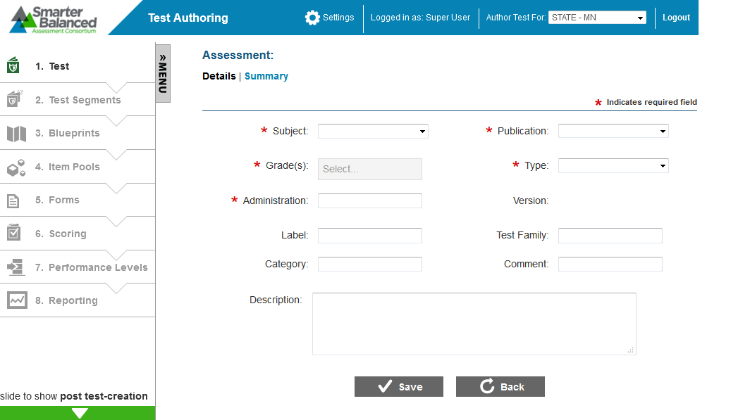

To add a test:

|  |
| --- |
| 1. On the Assessment Search screen (see Figure 23), click the [**New**] button. The Assessment Details screen appears. 2. Specify the test details. Fields marked with asterisks are mandatory fields for which details must be provided. The fields comprising the Assessment Details screen are described in Table 5. 3. Click the [**Save**] button. The system-generated test name will be displayed on the top of the screen. 4. To return to the Assessment Search screen, click the [**Back**] button. To continue with subsequent test creation tasks for the created test, select the next task from the Menu. |

Table 5. Test Detail Fields

| **Field** | **Description** |
| --- | --- |
| Subject | Refers to the test subject. You can select the subject from the drop-down list that displays all the subjects set up for the tenant. |
| Publication | Refers to the standards publication that you want to associate with the test. You can select the publication from the drop-down list that displays all the publication associations set up for the selected tenant and subject. |
| Grade(s) | Indicates the grade or grades to which the test will be administered. You can select the required grade or grades one at a time from the drop-down list that displays all the grades applicable to the selected publication. |
| Type | Refers to the purpose or goal of the test. You can select the assessment type from the drop-down list, which displays the following options:   * Interim: Indicates a mid-term assessment that is administered to students to gauge their level of understanding and determine if they are on track to perform well on future summative assessments. * Formative: Indicates a diagnostics assessment that is administered during an ongoing course to identify student strengths and weaknesses and thereby determine areas that need improvement. * Summative: Indicates an end-of-course assessment that is intended to evaluate student learning by comparing it against standards or benchmarks. |
| Administration | Refers to the time frame when the test will be administered. The administration can only consist of letters, numbers, and hyphens. An example of an administration is Fall-2014. |
| Version | Refers to the version number of the test. The version number is displayed in x.x format where the number before the decimal point indicates the major revision number and the number after the decimal point indicates the minor version number. The version is system-generated and cannot be modified. Once a test has been published and approved, authorized personnel can create a new major or minor version of the test. For more information, refer to Section V. Managing Post Test Creation Tasks. |
| Label | Refers to a user-specified test name that can be used to easily identify the test on the Assessment Search screen, as opposed to the system-generated test name. The label can only consist of letters, numbers, and hyphens. An example of a label is Grade3-ELA. |
| Test Family | Refers to the name of the assessment group to which the test belongs. An example of a test family is the Oregon Assessment of Knowledge and Skills (OAKS). |
| Category | Refers to a type of grouping that can be used to filter tests. An example of a test category is the educational stage for which the test is applicable, such as Elementary, Middle, or High School. |
| Comment | Refers to any comment pertaining to the test. |
| Description | Refers to a description of the test. |

### View a Test’s Summary

The Assessment Summary screen allows you to view a summary of the test configuration.

|  |  |
| --- | --- |
|  | This feature is useful once the child elements of the test, such as test segment, blueprints, forms, and item pools, have been established. |

Figure 25: Assessment Summary Screen

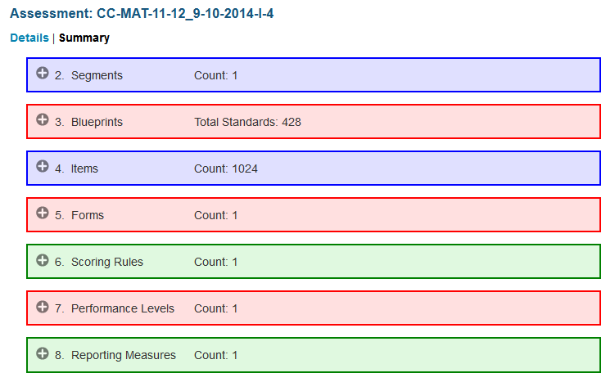

To view test summary:

|  |
| --- |
| 1. On the Assessment Search screen (see Figure 23), search for the test you want to view. 2. Click the view [] button next to the test. The Assessment Details screen appears. 3. Click the [**Summary**] link underneath the test name. The Assessment Summary screen appears, displaying the number of records existing for each child task category. 4. To view additional details about the records existing for a particular task category, click the expand [] button next to the task. |

### Edit a Test

The View/Edit Assessment screen allows you to edit test details.

|  |  |
| --- | --- |
|  | **About editing test details:**  You cannot edit tests that have been published.  For tests that have not been published, you will be prevented from modifying the subject, publication, and grade. However, you will be able to update other details. If you need to modify the subject, publication, or grade, then you should delete the test and create a new one. |

Figure 26: View/Edit Assessment Screen

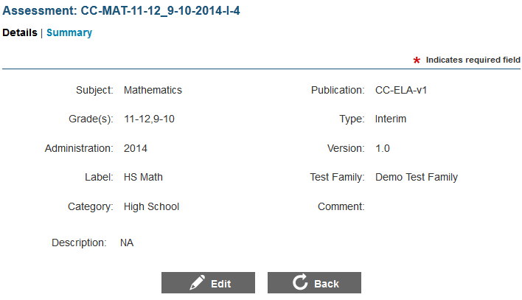

To edit a test:

|  |
| --- |
| 1. On the Assessment Search screen (see Figure 23), search for the test you want to edit. 2. Click the view [] button next to the test. The View/Edit Assessment screen appears. 3. Click the [**Edit**] button. The button is only available for unpublished tests. 4. Update the information as necessary. Only certain detail fields can be edited. 5. To save the updates, click the [**Save**] button. |

### Copy a Test

The Assessment Search screen allows you to copy a test along with all of its child elements. After copying the test, you can modify the test and its child elements as necessary. This is an efficient and time-conserving way of creating a test that shares similar characteristics with an existing test. For example, to create a Grade 3 Mathematics test that can be administered in 2015, you can copy an existing Grade 3 Mathematics test and make necessary modifications, such as modifying the administration details and items that are included in the test.

|  |  |
| --- | --- |
|  | **About copying a test:**  This feature is especially useful after the child elements, such as test segment, blueprints, forms, and item pools, have been established.  When copying a test, any records existing for the post test-creation tasks are not copied as these records are specific to a particular test. |

To copy a test:

|  |
| --- |
| 1. On the Assessment Search screen (see Figure 23), search for the test you want to copy. 2. Click the copy [] button next to the test. A pop-up message will appear that asks if you are sure you want to copy the test. 3. To copy the test and all of its child elements, click the [**OK**] button. Once the action is completed, the Assessment Details screen appears, listing the copied test. The Label field displays the original label followed by the word “COPY” to indicate that the test is a copy. 4. Update the test details as required. |

### Delete a Test

The Assessment Search screen allows you to delete a test along with its existing child elements.

|  |  |
| --- | --- |
|  | You can only delete tests that are not published. |

To delete a test:

|  |
| --- |
| 1. On the Assessment Search screen (see Figure 23), search for the test you want to delete. 2. Click the delete [] button next to the test. The button is only available for unpublished tests. A pop-up message that asks if you are sure you want to delete the test will appear. 3. To delete the test and all of its child elements, click the [**OK**] button. The test will no longer be listed on the Assessment Search screen. |

## Test Segments

Once the test identity has been established, you can proceed to creating test segments. Test segments refer to sections within a test that are presented to a student in a specified sequence or order.

Dividing a test into test segments can be beneficial, as you can specify different characteristics for each individual segment.

*These may include:*

* The item selection algorithm to use for each test segment, such as fixed form or adaptive.
* The minimum and maximum number of operational and field test items to present for each section.

From the Segments Search screen, authorized users can view, create, and manage test segments for the selected test.

|  |  |
| --- | --- |
|  | **About test segments:**  While a test may or may not be multi-segmented, it must always consist of at least one test segment.  You can only add, edit, or delete segments for tests that are not published. |

Figure 27. Segment Search Screen

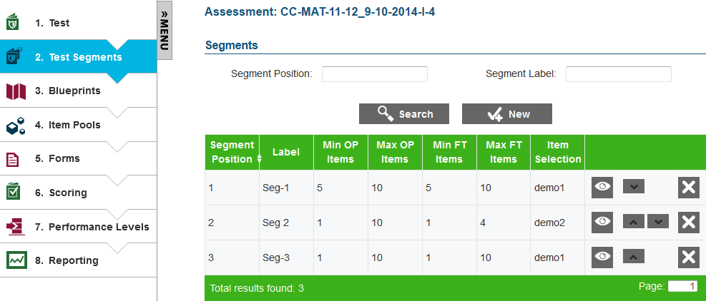

To view the Segment Search screen:

|  |
| --- |
| 1. On the Home screen (see Figure 2), click the test [] button. The Assessment Search screen (see Figure 26) appears. 2. Click the view [] button next to the test for which you want to view or create segments. The View Assessment screen (see Figure 23) appears. 3. From the Menu, select “Test Segments.” The Segment Search screen for the selected test appears listing all the test segments created for the test in sequential order. |

### Search for a Test Segment

The Segment Search screen allows users to search for test segments that have been created for a test using the available search filters. For information on the search filters, refer to Table 6.

To search for test segments:

|  |
| --- |
| 1. On the Segment Search screen, enter any search criteria you want to include. 2. Click the [**Search**] button. The screen will display the search results table containing the test segment records that match the search criteria. |

### Add a Test Segment

The Add Segment screen allows you to add test segments for the selected test.

|  |  |
| --- | --- |
|  | You can only add a test segment after Test Author Administrators have set up Item Selection Algorithms in the system. |

Figure 28: Add Segment Screen

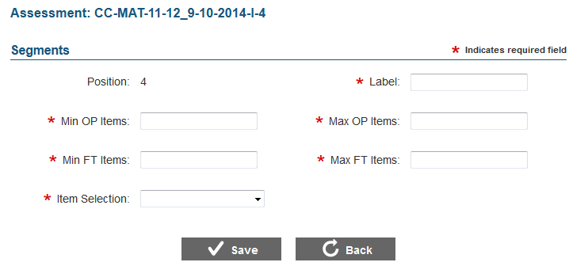

To add a test segment:

|  |
| --- |
| 1. On the Segment Search screen (see Figure 27), click the [**New**] button. The Add Segment screen appears. 2. Specify the test segment details. Fields marked with asterisks are mandatory fields for which details must be provided. The fields comprising the Add Segment screen are described in Table 6. 3. To save the test segment, click the [**Save**] button. 4. To return to the Segment Search screen, click the [**Back**] button. The segment will be listed at the specified position. |

Table 6. Test Segment Details

| Field | Description |
| --- | --- |
| Position | This is a system-generated value that indicates the position of the segment. By default, a new segment is added to the end of existing segments. You can change a segment’s position after it has been added from the Segment Search screen. For information on how to change segment positions, refer to Update Test Segment Positions. |
| Label | Refers to the segment name. The segment name must be unique. |
| Min OP Items | Refers to the minimum number of operational items that must be included on the test segment. You can enter a value that is   * Between 0-999999999 * Less than or equal to the value specified for Max OP Items |
| Max OP Items | Refers to the maximum number of operational items that can be included on the test segment. You can enter a value that is   * Between 0-999999999 * Greater than or equal to the value specified for Min OP Items |
| Min FT Items | Refers to the minimum number of field test items that must be included on the test segment. You can enter a value that is   * Between 0-999999999 * Less than or equal to the value specified for Max FT Items |
| Max FT Items | Refers to the maximum number of field test items that can be included on the test segment. You can enter a value that is   * Between 0-999999999 * Greater than or equal to the value specified for Min FT Items |
| Item Selection | Refers to the item selection algorithm that will be used for selecting the items on the test segment. You can select the item selection algorithm from the drop-down list that displays all the algorithms set up by the Test Author Administrator.  When you select an item selection algorithm, all the scalar parameters that may have been set up for the selected algorithm are displayed along with the default values set up for the parameters. You can change the parameter values for the test segment if required. For more information, refer to Specify Item Selection Parameters for a Test Segment. |

#### Specify Item Selection Parameters for a Test Segment

When setting up an item selection algorithm, Test Author Administrators specify default values for all the parameters created for the algorithm. When you select a particular item selection algorithm for a test segment, all the parameters display the default value. You can change the parameter value if required.

To specify a different item selection algorithm parameter value for a test segment:

|  |
| --- |
| 1. From the **Item Selection** drop-down list, select the item selection algorithm that you want to use for the segment. The Item Selection Parameters section will display all the scalar parameters set up for the selected algorithm along with their default values. For example, if an algorithm has three scalar parameters, three parameter rows will be displayed.   Figure 29: Segment Item Selection Parameters Section     1. Select or enter the required values for the parameters. For Boolean parameters, you can select either “true” or “false.” For Integer or Float parameters, you can specify a value within the range specified underneath the parameter name. For List parameters, you can select a value from the parameter drop-down list. 2. To save the parameter values, click the [**Save**] button. |

### Edit a Test Segment

The View/Edit Segment screen allows you to edit the details for a test segment.

Figure 30: View/Edit Segment Screen

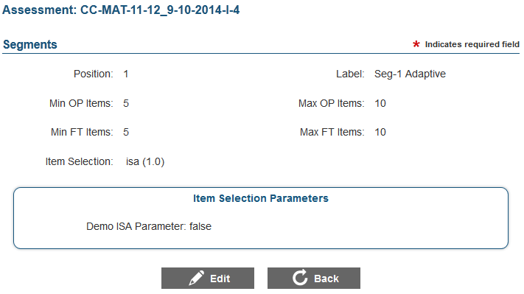

To edit a test segment:

|  |
| --- |
| 1. On the Segment Search screen (see Figure 27), search for the test segment you want to edit. 2. Click the view [] button next to the test segment. The View/Edit Segment screen appears. 3. Click the [**Edit**] button. The button is available only for test segments that can be edited. 4. Update the information as necessary. All fields except for the Position field are enabled. You can modify the segment position from the Segment Search screen, if required. For more information, refer to Update Test Segment Positions. 5. To save the changes, click the [**Save**] button. |

### Update Test Segment Positions

The Segment Search screen allows you to update test segment positions. The test segment positions determine the order in which the segments are presented to a student during a test.

To update test segment positions:

|  |
| --- |
| 1. On the Segment Search screen (see Figure 27), search for the segment whose position you want to change. 2. To move the segment, click the move [] button in the Action column and drag the segment to the required position. |

### Delete a Test Segment

The Segment Search screen allows you to delete test segments if required.

To delete a test segment:

|  |
| --- |
| 1. On the Segment Search screen (see Figure 27), search for the test segment you want to delete. 2. Click the delete [] button next to the test segment. The button is only available for test segments that can be deleted. A pop-up message will appear that asks if you are sure you want to delete the test segment. 3. To delete the test segment, click the [**OK**] button. The test segment will no longer be listed on the Segment Search screen. |

## Blueprints

This feature of the Test Authoring System allows you to establish the number of items that should be presented to a student for the different standards and affinity groups constituting the standards publication associated with the test. The Test Delivery System uses these specifications to select and present items for a test.

Read on to learn how to:

* Manage Blueprints
* Manage Affinity Groups

### Manage Blueprints

Blueprints allow you to balance the items that are included in a test and test segment. This is especially true for test segments that use an adaptive algorithm for selecting items. The blueprint allows you to establish the minimum and maximum number of operational and field test items that are to be presented for each level of the standards publication.

When generating a test, the Test Delivery System uses the blueprint specifications to select the items that are presented to a student. Blueprints can also be useful for fixed form test segments, as you can document the standards covered by the items included on a form.

The Test Scoring Engine uses the blueprint specifications of both adaptive and fixed form test segments for generating reports.

The Blueprints screen displays the standards constituting the standards publication associated with the test and allows authorized users to view, edit, and manage master and segment blueprints.

|  |  |
| --- | --- |
|  | **About Blueprints**:  You must create a master blueprint for the entire test and segment blueprints for each test segment.  You can only create or edit blueprints for tests that have not been published. |

Figure 31. Blueprints Screen

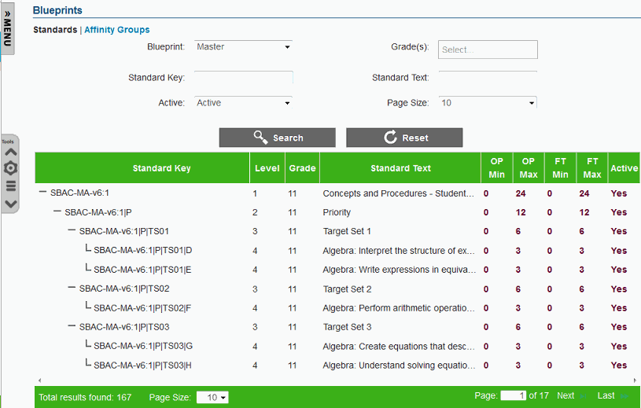

To view the Blueprint Standards screen:

|  |
| --- |
| 1. On the Home screen (see Figure 2), click the test [] button. The Assessment Search screen appears, listing all the tests that have been created for the tenant. 2. Click the view [] button next to the test for which you want to view or create blueprints. The View Assessment screen (see Figure 26) appears. 3. From the Menu, select “Blueprints.” The Blueprints screen for the selected test appears. For more information, refer to Features of the Blueprints Screen. |

#### Features of the Blueprints Screen

The Blueprints screen displays standards from the standards publication associated with a test. Some of the features of the Blueprints screen are:

* **Standards Synchronization**: The Test Authoring System enables Test Author Administrators to associate tenant and tenant-specific subjects with standards publications stored in the Core Standards System. When you view the Blueprints screen, a message appears on the screen to notify you that the blueprint is being synchronized with the Core Standards System. This is to ensure that changes made to the standards publication in the Core Standards system are reflected on the Blueprints screen.
* **Search Filters**: By default, this screen displays the active standards existing for the Master blueprint. You can search for other standards using the available search filters. For information on how to search for blueprint standards, refer to Search Blueprints.
* **Standards Table**: All the standards that match the selected search criteria are displayed in a table.
  + A navigation bar that displays the total number of retrieved standards and allows you to browse through the standards is displayed at the bottom of the page. If all the columns cannot be viewed on the screen simultaneously, scrollbars are available at the top and bottom of the table to allow you to view the columns.
  + A search [] button is displayed next to the standard key, which allows you to filter the standards displayed on the screen by the selected standard key. For example, if you click the search [] button for a Level 1 standard, only that standard and its sub-levels will be displayed. The Standard Key search filter on the top of the screen is automatically updated to indicate which standard you are viewing.
  + The standards table for a test segment blueprint contains all the columns that are available for the Master blueprint. The Master blueprint standards table columns are described in Table 7.

|  |  |
| --- | --- |
|  | The standards table for segment blueprints may also contain columns for item selection algorithm parameters for segments using algorithms that have blueprint parameters. The columns vary depending on the number of blueprint parameters set up for the item selection algorithm. |

* **Tool Bar**: A Tool Bar is displayed on the screen that enables you to perform different actions on the blueprint standards. The available tools are described in Table 8.

Table 7. Master Blueprint Standards Table Columns

| Column | Description |
| --- | --- |
| Standard Key | Displays the key used to identify a standard in the standards publication. |
| Level | Displays the level to which the standard belongs. |
| Grade | Indicates the grade or grade band for which the standard is applicable. |
| Standard Text | Displays the description of the standard. You can hover over the text to read the full description. |
| OP Min | Indicates the minimum number of operational items to be included for the standard. |
| OP Max | Indicates the maximum number of operational items to be included for the standard. |
| FT Min | Indicates the minimum number of field test items to be included for the standard. |
| FT Max | Indicates the maximum number of field items to be included for the standard. |
| Active | Indicates whether the standard is active or enabled on the test blueprint. |

Table 8. Blueprint Standards Tools

| **Tool** | **Description** |
| --- | --- |
|  | **Top of Page**: Button that allows you to navigate to the top of the screen without having to use the scrollbar. This button is only available when there are at least 25 standards displayed on the screen. |
|  | **Bottom of Page**: Button that allows you to navigate to the bottom of the screen without having to use the scrollbar. This button is only available when there are at least 25 standards displayed on the screen. |
|  | **Edit Blueprint Elements**: Button that allows you to edit and set up blueprint standard elements, such as the minimum and maximum number of operational items, for a standard. For more information, refer to Edit Blueprint Standard Elements. This tool is not available for the Master blueprint. |
|  | **Save**: Button that allows you to save the edits made to blueprint elements. This button only appears when you are editing blueprint elements. |
|  | **Cancel**: Button that allows you to cancel any edits made to blueprint elements and return to viewing the blueprint standards. This button only appears when you are editing blueprint elements. |
|  | **Widgets**: Button that allows you to perform additional actions on the blueprints. When you click the [**Widget**] button, a pop-up window displays, listing the action items you can perform. For more information, refer to Blueprint Widgets. |
|  | **Errors**: Allows you to view any validation errors that have been generated as a result of the edits made to the blueprint elements. This button is only displayed if validation errors exist after you have saved edits. When you click the [**Errors**] button, a pop-up window displays, listing the existing validation errors. For more information, refer to Blueprint Validation Errors. |
|  | **Informational Statistics**: Button that provides information about the number of blueprint standards that are active and the number of blueprint standards that have been retrieved based on the specified search criteria. When you click the [**Informational Statistics**] button, a pop-up window appears, listing the information. |

#### Search Blueprints

The Blueprints screen allows you to search for and view blueprint standards existing for the selected publication using the search filters available on the top of the screen.

To search for blueprint standards:

|  |
| --- |
| 1. Table 9 Table 9. 2. If you have entered or selected criteria other than the blueprint that you want to view, click the [**Search**] button. The screen will display the search results table containing the blueprint standards that match the search criteria. To reset the search filters and return to the default view, click the [**Reset**] button. |

|  |  |
| --- | --- |
|  | When you select a blueprint from the **Blueprint** drop-down list, the screen automatically displays the standards for the selected blueprint. You do not need to click the [**Search**] button. |

Table 9. Blueprint Search Filters

| Field | Description |
| --- | --- |
| Blueprint | Drop-down list that enables you to select the blueprint that you want to view. The drop-down list includes the Master blueprint and blueprints for each existing segment. |
| Grade | Drop-down list that enables you to search for standards appropriate to the selected grade or grades. |
| Standard Key | Text field that enables you to enter the standard key of the standard you want to view. |
| Standard Text | Text field that enables you to enter the descriptive text associated with the standard that you want to view. |
| Active | Drop-down list that enables you to search for standards based on their status. The available options are:   * Active: Displays standards that are active in the selected blueprint. * Inactive: Displays standards that are inactive in the selected blueprint. * Any: Displays both active and inactive standards for the selected blueprint. |
| Page Size | Drop-down list that enables you to select the number of standards to display on the screen. |

#### Edit Blueprint Standard Elements

For each standard displayed on the test segment blueprints, the Blueprints screen allows you to edit the blueprint standard elements, such as the item count values, status, and applicable item selection algorithm parameters.

|  |  |
| --- | --- |
|  | The Tool Bar on the Blueprints screen also consists of widgets that allow you to efficiently manage item counts and the status of standards. For information on the widgets, refer to Blueprint Widgets. |

Figure 32: Blueprint Standards Screen in Edit Mode

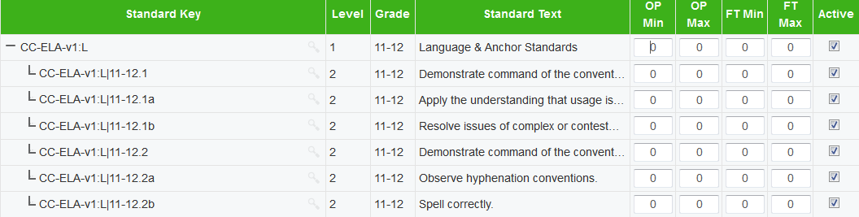

To edit blueprint standard elements:

|  |
| --- |
| 1. From the **Blueprint** drop-down list on the Blueprint Standards screen (see Figure 31), select the blueprint you want to edit. 2. On the Tool Bar, click the edit blueprint elements [] button. The blueprint standard element fields that can be edited will be enabled (see Figure 32). 3. Update the information as necessary. The following fields can be edited:    * OP Min, OP Max, FT Min, FT Max: You can enter values between 0 and 999.    * Active: You can check the box to activate or inactivate a standard and its sub-levels.    * Blueprint Item Selection Algorithm Parameters: You can enter or select the required parameter values from the parameter fields. The fields can vary in number and are only displayed for test segment blueprints that use an item selection algorithm consisting of blueprint parameters. 4. To save the updates, click the save [] button. To cancel any updates you have made to the blueprint standard elements, click the cancel [] button. The blueprint standard element fields will be disabled. |

|  |  |
| --- | --- |
|  | **About blueprint validation errors:**  If the blueprint values you have specified conflict with existing blueprint business rules, the errors [] button will appear on the Tool Bar. You will be prevented from publishing a test that has blueprint validation errors. For information on fixing the errors, refer to Blueprint Validation Errors. |

|  |  |
| --- | --- |
|  | **Tips for setting up test blueprints:**  Setting up blueprints for a test is a complex process and requires thorough planning, as well as understanding of the items that need to be presented on a test and existing blueprint business rules.  To simplify the process of setting up blueprints without generating too many errors:   * 1. Once the first segment blueprint is set up and is free of errors, use the “Copy Values from Segment” widget from the Tool Bar to copy the values from this segment blueprint to any additional segment blueprints.   2. Adjust the copied values on the segment blueprint to specify the number of items that should be included on the segment.   3. If a test consists of more segments, repeat step 2 until all blueprints have been set up. |

#### Blueprint Validation Errors

When specifying blueprint values, the values must conform to blueprint business rule established in the system. An error will be generated if the specified values conflict with these rules.

To view and fix blueprint validation errors:

|  |
| --- |
| 1. On the Tool Bar, click the errors [] button. This button is only displayed if conflicts exist. A pop-up window will appear listing the errors. For information on the different blueprint business rules, refer to Blueprint Business Rules. 2. To close the pop-up window, click the [**Close**] button. 3. To fix the errors, edit the blueprint elements in the same process as described in Edit Blueprint Elements. The button disappears after you save the fixes. |

##### Blueprint Business Rules

There are different categories of blueprint business rules established in the Test Authoring System. While some of the rules are applicable at the standard level, other rules are applicable across standard levels and across blueprints. The different rules are described in Table 10.

|  |  |
| --- | --- |
|  | The rules below are described in reference to operational items. However, the same rules are applicable for field test items as well.  Validation rules related to sums of item counts are only checked against standards that are active. |

Table 10. Blueprint Business Rules

| Business Rule | Error Example |
| --- | --- |
| The operational item minimum value specified for each standard must be less than or equal to the operational item maximum value for that standard. | A standard has a minimum of 10 operational items, but it has a maximum of 6 operational items. |
| The sum of the operational item minimum values specified for active children standards must be less than or equal to the operational item maximum value specified for the parent standard. | A standard has two active children and the minimum items specified for the two children standards add up to 7, but the operational item maximum value specified for the parent standard indicates that only a maximum of 5 items can be included for that standard. |
| The sum of the operational item maximum values specified for active children standards must be more than or equal to the operational item minimum value specified for the parent standard. | A standard has two active children and the maximum items specified for the two children standards add up to 10, but the operational item minimum value specified for the parent standard indicates that at least 15 items must be included for that standard. |
| The sum of the operational item minimum values specified for a particular standard in all the test segment blueprints must be less than or equal to the operational item maximum value specified for that standard in segment associated with the master blueprint. | A test has two adaptive test segments and the minimum items specified for a standard in both the segments add up to 10, but the operational item maximum value specified for that standard in the master blueprint is 6. |
| The sum of the operational item maximum values specified for a particular standard in all the test segment blueprints must be more than or equal to the operational item minimum value specified for that standard in the segment associated with the blueprint. | A test has two adaptive test segments and the maximum items specified for a standard in both the segments add up to 10, but the operational item minimum value specified for that standard in the master blueprint is 12. |
| The item counts must be non-negative integers between 0-999 | A standard has a minimum operational item value of 0.5 |

#### Blueprint Widgets

The Widgets tool consists of a number of widgets or action items that you can use to efficiently manage master and test segment blueprints. The widgets can be categorized into:

* Widgets for Managing Item Counts
* Widgets for Managing Standards

When you click the widgets [] button on the Tool Bar, a pop-up window is displayed, where you can select the widget or action item you want to use. Once you select the widget, additional fields appropriate for the selected widget are displayed, which allow you to perform the required action.

|  |  |
| --- | --- |
| Figure 33: Blueprint Widgets Pop-up Window | Figure 34: Pop-up Window with Widget Selected |

##### Widgets for Managing Item Counts

The widgets tool consists of widgets that allow you to manage the item count values specified for the OP Min, OP Max, FT Min and FT Max fields. The different widgets for managing item counts are:

* Zero Out Segment Values
* Copy Values from Segment

**Zero Out Segment Values**

This widget enables you to reset the values specified for all the item count fields on the selected blueprint back to 0. This can be useful if the specified values result in a large number of validation errors, as it allows you to start afresh without having to manually delete the values.

To zero out segment values:

|  |
| --- |
| 1. On the Tool Bar, click the widgets [] button. A pop-up window appears. 2. From the **Action** drop-down list, select “Zero Out Segment Values.” 3. From the **Segment** drop-down list, select the blueprint that you wish to reset. The drop-down list includes all the segment blueprints. 4. To reset the values, click the [**Save**] button. A message appears to inform you that the values of the selected blueprint have been successfully removed. 5. To close the pop-up window, click the [**Ok**] button. The OP Min, OP Max, FT Min, and FT Max columns on the Blueprint Standards screen will display “0” for the selected blueprint. |

**Copy Values from Segment**

This widget enables you to copy the values specified for one blueprint to another blueprint. For example, if you want two test segments to use the same item counts, you can copy values from one test segment to the other.

To copy values from one blueprint to another:

|  |
| --- |
| 1. On the Tool Bar, click the widgets [] button. A pop-up window appears. 2. From the **Action** drop-down list, select “Copy Values from Segment.” 3. From the **From** drop-down list, select the blueprint whose item count values you want to copy. The drop-down list includes all the segment blueprints. 4. From the **To** drop-down list, select the blueprint to which you want to copy the values. The drop-down list includes all the segment blueprints. 5. To copy the values, click the [**Save**] button. A message appears to inform you that the values have been successfully copied. 6. To close the pop-up window, click the [**Ok**] button. |

##### Widgets for Managing Standards

The widgets tool also consists of widgets that allow you to activate or deactivate standards on a blueprint. When selecting items to present on a test, the Test Delivery System does not include items for inactive standards.

|  |  |
| --- | --- |
|  | When you are editing a blueprint, you can also activate or deactivate a standard individually by checking or unchecking the checkbox that is displayed in the Active column. For information on editing blueprints, refer to Edit Blueprint Elements.  However, using the widgets may be more efficient since:   * + They allow you to conserve time by activating or deactivating multiple standards simultaneously.   + They may result in fewer errors. |

The different widgets for managing standards are:

* Activate Grade
* Deactivate Grade
* Activate Standard
* Deactivate Standard

|  |  |
| --- | --- |
|  | When you activate or deactivate a standard, the standard is activated or deactivated across all the blueprints existing for the test. For example, if you deactivate a standard on a test segment blueprint, the standard will be deactivated on the master blueprint and any other test segment blueprints that may exist. |

**Activate Grade**

This widget enables you to activate standards belonging to a grade other than the grade or grades being tested. By default, the standards associated with the tested grade or grades are activated. However, you can activate standards for higher or lower grades if you want to include items for those standards.

To activate all the standards for a selected grade or grades:

|  |
| --- |
| 1. On the Tool Bar, click the widgets [] button. A pop-up window appears. 2. From the **Action** drop-down list, select “Activate Grade.” 3. From the **Grade** drop-down list, select the grade or grades whose standards you want to activate. The drop-down list includes all the grades associated with the publication. 4. To activate the standards for the selected grades, click the [**Save**] button. A message appears to inform you that the standards for the selected grades have been successfully activated. 5. To close the pop-up window, click the [**Ok**] button. The Active column on the Blueprints screen will display “Yes” for the standards associated with the selected grade or grades. |

**Deactivate Grade**

This widget enables you to deactivate standards associated with a grade or multiple grades.

To deactivate all the standards for the selected grade(s):

|  |
| --- |
| 1. On the Tool Bar, click the widgets [] button. A pop-up window appears. 2. From the **Action** drop-down list, select “Deactivate Grade.” 3. From the **Grade** drop-down list, select the grade or grades whose standards you want to deactivate. The drop-down list includes all the grades associated with the publication. 4. To deactivate the standards for the selected grades, click the [**Save**] button. A message appears to inform you that the standards for the selected grades have been successfully deactivated. 5. To close the pop-up window, click the [**Ok**] button. The Active column on the Blueprints screen will display “No” for the standards associated with the selected grade or grades. |

**Activate Standard**

This widget enables you to activate a standard along with all its sub-levels simultaneously. This is especially useful when you want to activate all levels of a standard, as you do not have to check the checkbox in the Active column for each of the sub-level standards individually.

To activate a standard:

|  |
| --- |
| 1. On the Tool Bar, click the widgets [] button. A pop-up window appears. 2. From the **Action** drop-down list, select “Activate Standard.” 3. From the **Grade** drop-down list, select the grade with which the standard that you want to activate is associated. The drop-down list includes all the grades associated with the publication. 4. From the **Standard Key** drop-down list, select the standard that you want to activate. The drop-down list includes all the standards existing for the selected grade. 5. To activate the standard along with any sub-level standards that may exist, click the [**Save**] button. A message appears to inform you that the standard has been successfully activated. 6. To close the pop-up window, click the [**Ok**] button. The Active column on the Blueprints screen will display “Yes” for the activated standard and its sub-levels. |

**Deactivate Standard**

This widget enables you to deactivate a standard along with all its sub-levels simultaneously. A standard cannot be active if its parent is inactive. If you manually deactivate a standard by unchecking the checkbox in the Active column without deactivating all its children, validation errors will be generated. Thus, using this widget is especially useful when you need to deactivate a standard that has multiple sub-levels.

To deactivate a standard:

|  |
| --- |
| 1. On the Tool Bar, click the widgets [] button. A pop-up window appears. 2. From the **Action** drop-down list, select “Deactivate Standard.” 3. From the **Grade** drop-down list, select the grade with which the standard that you want to deactivate is associated. The drop-down list includes all the grades associated with the publication. 4. From the **Standard Key** drop-down list, select the standard that you want to deactivate. The drop-down lists all the standards existing for the selected grade. 5. To deactivate the standard along with any sub-level standards that may exist, click the [**Save**] button. A message appears to inform you that the standard has been successfully deactivated. 6. To close the pop-up window, click the [**Ok**] button. The Active column on the Blueprints screen will display “No” for the deactivated standard and its sub-levels. |

Manage Affinity Groups

In addition to managing the items in a blueprint by standard, you can also manage blueprint items by affinity groups. Affinity groups are categories containing related items that exist separately from the standard publication. An affinity group may be an existing SOCK (Some Other Category of Knowledge) or an ad hoc group created for a particular test.

Figure 35. Affinity Group Search Screen

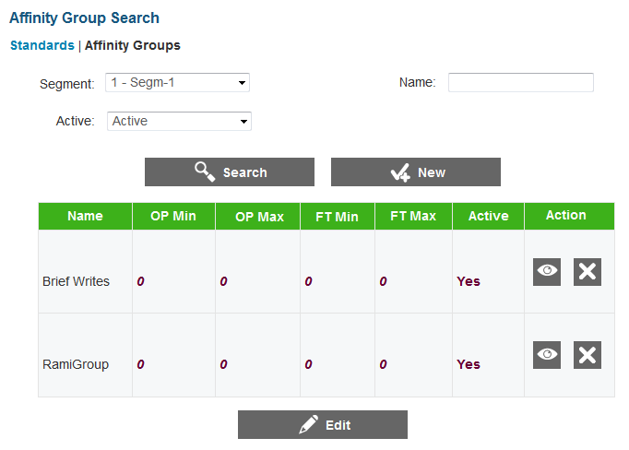

The Affinity Group Search screen displays the existing affinity groups associated with the test. You can add new affinity groups and manage the settings for existing affinity groups.

To view the Affinity Group Search screen:

|  |
| --- |
| 1. On the Blueprints screen (see Figure 31), click the [**Affinity Groups**] link. The Affinity Group Search screen appears, listing any existing affinity groups. |

#### Search for an Affinity Group

The Affinity Group Search screen allows users to search for affinity groups associated with a test using the available search filters. By default all the active and inactive affinity groups in the master blueprint are displayed on the screen.

To search for an affinity group:

|  |
| --- |
| 1. On the Affinity Groups screen, enter any search criteria you want to include. The available search filters are described in . 2. Click the [**Search**] button. The screen will display the affinity groups that match the search criteria. |

Table 11. Affinity Group Search Filters

| Filter | Description |
| --- | --- |
| Segment | Drop-down list that enables you to select the set of affinity groups that you want to view. The drop-down list includes the Master affinity groups and affinity groups for each test segment. |
| Name | Refers to the name of the affinity group. |
| Active | Refers to the status of the affinity group. The three available options are:   * Active: Filter that lets you search for active affinity groups * Inactive: Filter that lets you search for inactive affinity groups * Any: Filter that lets you search for all the affinity groups existing for the test |

#### Add an Affinity Group

You can associate ad hoc affinity groups and SOCK affinity groups with a test.

To add an affinity group:

|  |
| --- |
| 1. On the Affinity Group Search screen, click the [**New**] button. The Affinity Group screen appears. 2. From the **Type** drop-down list, select the type of affinity group you want to add:    * To add a new group specifically for the test, select **Ad Hoc** and then enter a name for the group in the Group Name field.    * To add an existing SOCK affinity group, select **SOCK** and then select the SOCK you want to add from the **SOCK** drop-down list. 3. To save the new group, click the [**Save**] button. |

#### Edit an Affinity Group

You can edit the elements for each affinity group, such as the item count values, status, and applicable item selection algorithm parameters. You can also make an affinity group active or inactive.

|  |  |
| --- | --- |
|  | You cannot edit affinity groups when viewing the master version of the blueprint. In order to edit an affinity group, you must select a segment from the **Segment** drop-down list. |

To edit an affinity group:

|  |
| --- |
| 1. On the Affinity Groups Search screen, select the appropriate segment from the **Segment** drop-down list and click the [**Search**] button. 2. Click the [**Edit**] button. The editable affinity group element fields activate. 3. Update the information as necessary. The following fields can be edited:    * OP Min, OP Max, FT Min, FT Max: You can enter values between 0 and 999.    * Active: You can check the box to activate or inactivate an affinity group.    * Blueprint Item Selection Algorithm Parameters: You can enter or select the required parameter values from the parameter fields. The fields can vary in number and are only displayed for test segment blueprints that use an item selection algorithm consisting of blueprint parameters. 4. To save the updates, click the [**Save**] button. To cancel any updates you have made to the blueprint affinity group elements, click the [**Cancel**] button. The blueprint affinity group element fields deactivate. 5. To save the changes, click the [**Save**] button. |

## Segment Pools

This feature of the Test Authoring System allows you to create and manage item pools for test segments that use an adaptive item selection algorithm. When presenting items for an adaptive test segment, the Test Delivery System selects items from the item pool established for that segment. You can also create groups of items, specify items that should not be presented together, and view a standards summary displaying the items represented for each standard.

|  |  |
| --- | --- |
|  | The Test Authoring System does not allow you to create or store items. The Test Item Bank (TIB) stores all operational and field test items that can be included in an item pool. The Test Authoring System retrieves item IDs from the Test Item Bank(TIB) based on your specified search criteria and allows you to perform different actions on them, such as include items in item pools and create item groups. |

Read on to learn how to:

* Manage Item Pools
* Manage Item Groups
* View the Standards Summary
* Manage Enemy Lists

### Manage Item Pools

The Item Pool screen allows authorized users to view, create, edit, and manage item pools for adaptive test segments. Each adaptive test segment must consist of one item pool.

|  |  |
| --- | --- |
|  | You can only create or edit item pools for test segments that use an adaptive algorithm and for tests that have not been published. |

Figure 36. Segment Pools: Item Pool Screen

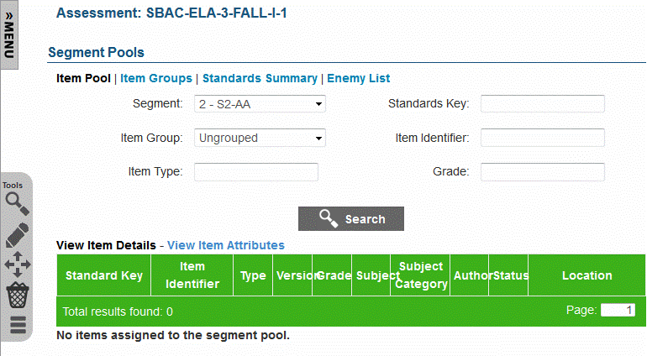

To view the Item Pool screen:

|  |
| --- |
| 1. On the Home screen (see Figure 2), click the test [] button. The Assessment Search screen appears listing all the tests that have been created for the tenant. 2. Click the view [] button next to the test for which you want to view or create item pools. The View Assessment screen (see Figure 26) appears. 3. From the Menu, select “Segment Pools.” The Item Pool screen for the selected test appears. For information on the features of the Item Pool screen, refer to Features of the Item Pool Screen. |

#### Features of the Item Pool Screen

The Item Pool screen displays the items existing in the item pool for an adaptive test segment. If a test does not consist of any adaptive test segments or if no item pools have been created, no items will be displayed on the screen. Some of the features of the Item Pool screen are:

* **Search Filters**: By default, the screen displays the items included in the item pool for the first adaptive test segment. You can search for specific items in the pool or item pools created for other test segments using the available search filters. For information on how to search for items existing in an item pool, refer to Search Item Pool.
* **Item Pool Table**: All the items that match the selected search criteria are displayed in a table.
  + A navigation bar that displays the total number of retrieved items and allows you to browse through the items is displayed at the bottom of the page.
  + Two different views of the retrieved items are available. To choose the type of item information that you want to view, click the [**View Item Details**] link or [**View Item Attributes**] link available above the table. By default, the Item Details table is displayed on the screen. The Item Details table columns are described in Table 12 and the Item Attributes table columns are described in Table 13.
* **Tool Bar**: A Tool Bar is displayed on the screen that enables you to perform different actions, such as creating an item pool, deleting items from an item pool, and editing item attributes. The available tools are described in Table 14.

Table 12. Item Details Table Columns

| Column | Description |
| --- | --- |
| Standard Key | Displays the standard key of the standard with which the item is associated. |
| Item Identifier | Displays the unique item ID. |
| Type | Indicates the type of the item. Examples of some item types are grid items, selected-response items, and constructed-response items. |
| Version | Displays the item version number. |
| Grade | Indicates the grade or grade band for which the item has been created. |
| Subject | Indicates the subject for which the item has been created. For example, “Algebra II.” |
| Subject Category | Indicates the subject category for which the item has been created. An example of a subject category for an Algebra II item is Mathematics. |
| Author | Refers to the name of the author who created the item. |
| Status | Indicates whether the item is a field test item or an operational item. |
| Location | Refers to the location of the item in the Test Authoring System. The location indicates the name of the segment with which the item is associated and the name of the group to which the item belongs, if applicable. If an item is not part of a group, the location will display “Ungrouped.” |

Table 13. Item Attributes Table Columns

| Column | Description |
| --- | --- |
| Standard Key | Displays the standard key of the standard with which the item is associated. |
| Item Identifier | Displays the unique item ID. |
| Type | Indicates the type of the item. Examples of some item types are grid items, selected-response items, and constructed-response items. |
| Admin Required | Indicates whether the item must be presented to the student. |
| Response Required | Indicates whether the student must provide a response to the item if the item is presented. |
| Active | Indicates whether the item is active and can be presented in a test. |
| Field Test Item | Indicates whether the item is a field test item. |
| Block ID | Indicates the item group block to which the item belongs. When selecting items to include on a test, items from only one block can be presented. |
| Location | Refers to the location of the item in the Test Authoring System. The location indicates the name of the segment with which the item is associated and the name of the group to which the item belongs, if applicable. If an item is not part of a group, the location will display “Ungrouped.” |

Table 14. Item Pool Tools

| Column | Description |
| --- | --- |
|  | **TIB Search**: Button that allows you to search for items existing in the Test Item Bank and include them in the item pool. For information on how to search for and include items in item pools, refer to Search and Import Items from TIB. |
|  | **Edit Items**: Button that allows you to edit the item attributes of items included in the pool. For more information, refer to Edit Item Attributes. |
|  | **Move Items**: Button that allows you to move items from a segment or group to another segment or group. For more information, refer to Move Items. |
|  | **Save**: Button that allows you to save the edits made to item attributes. This button only appears after you click the [**Edit Items**] button. |
|  | **Cancel**: Button that allows you to cancel any edits made to item attributes and return to viewing the item attributes. This button only appears after you click the [**Edit Items**] button. |
|  | **Delete Items**: Button that allows you to delete the items from the item pool. For more information, refer to Delete Items. |
|  | **Missing Items**: Provides information about the items that are missing for a particular standard. When you click the [**Missing Items**] button, a pop-up window displays, listing the information. |

#### Search Item Pool

The Item Pool screen allows you to search for and view items existing in the item pool for the selected segment using the search filters available on the top of the screen.

|  |  |
| --- | --- |
|  | This feature allows you to search for items that have already been included in the item pool. It does not allow you to search for items existing in the Test Item Bank. To search for items in the Test Item Bank that can be included to the item pool, refer to Search and Import Items from TIB. |

To search for items existing in an item pool:

|  |
| --- |
| 1. On the Item Pool screen, enter any search criteria you want to include. The available search filters are listed in Table 15. 2. Click the [**Search**] button. The screen will display the search results table containing the items that match the search criteria. |

Table 15. Item Pool Search Filters

| Field | Description |
| --- | --- |
| Segment | Drop-down list that enables you to select the adaptive test segment whose item pool you want to view. The drop-down displays all the adaptive test segments created for the test. |
| Standards Key | Text field that enables you to enter the standard key of the standard with which an item is associated. |
| Item Group | Drop-down list that enables you to search for items that belong to the selected group or groups. The drop-down list includes:   * Existing item groups: Displays items existing for the selected item group. When items are imported from the TIB, you can automatically group items by the passage with which they are associated. The item group is named after the passage. You can also create custom item groups. For more information, refer to Manage Item Groups. * “Ungrouped”: Displays all items that are not included in a group. If a passage only contains one item, an item group is not created at the time of importing the item. |
| Item Identifier | Text field that enables you to enter the item ID of the item that you want to search for. |
| Item Type | Text field that enables you to enter the item type of the item or items that you want to search for. |
| Grade | Drop-down list that enables you to search for items belonging to the specified grade or grades. |

#### Search and Import Items from TIB

|  |  |
| --- | --- |
| The TIB search [] button on the Item Pool screen allows you to search for items existing in the Test Item Bank and add them to a test segment’s item pool.  **The actual items are not imported into the Test Authoring System**. The items are stored in the TIB. The Test Authoring System merely stores references to these items. | Figure 37: TIB Search Pop-up Window |

To search for and import items:

|  |
| --- |
| 1. On the Tool Bar displayed on the Item Pool screen (see Figure 36), click the TIB search [] button. A pop-up window appears (see Figure 37). 2. Optional: Specify the required item search criteria. Two search filters, “Publication Key” and “Grade,” that enable you to search for items that match the standards publication and grade or grades specified for the test are displayed by default. You can add, edit, or delete search criteria, if required. For more information, refer to Manage TIB Search Criteria. 3. Click the [**Search**] button. The popup window displays the total number of retrieved items. 4. Optional: To view the item details, click the [**Preview**] button. The item details, such as the item ID, status, type, standard and grade associated with the item, are displayed in a table.    * To view additional item details, click the expand [] button for the item. To hide the details, click the hide [] button.    * To close the preview and return to the filter view on the pop-up window, click the [**Filter**] button. To close the pop-up window and return to the Item Pool screen, click the [**Close**] button. 5. Click the [**Import**] button. Additional fields and buttons that allow you to specify where the items are to be imported are displayed. 6. From the **Segment** drop-down list, select the segment pool to which the items should be added. The drop-down list displays all the adaptive test segments. 7. From the **Item Group** drop-down list, select the item group to which the items should be added. The drop-down list is defaulted to “Auto assign group,” whereby the system automatically groups items based on the passage with which they are associated. You can select a different item group if required. If the required item group has not been created, you can import the items and move them to the required item group later. For information, refer to Manage Item Groups. 8. Click the [**Import**] button. A progress bar appears to indicate that the action is underway. Once the action is completed, details about the import are displayed. 9. To return to the filter view on the pop-up window and search for other items, click the [**Filter**] button. To close the pop-up window and return to the Item Pool screen, click the [**Close**] button. |

##### Manage TIB Search Criteria

By default, the TIB Search pop-up window displays two search filters, “Publication Key” and “Grade.” You can add, edit, or delete search criteria if required.

To add a search filter:

|  |
| --- |
| 1. On the TIB Search pop-up window, click the [**Add Filter**] button. A new search filter row will be added. 2. From the drop-down list, select the search filter that you want to search by. For example, you can search by subject, item difficulty, item author, and passage name. 3. In the text field, enter the required search criteria for the specified filter. |

To edit a search filter:

|  |
| --- |
| 1. On the TIB Search pop-up window, update the available filters or search criteria as required. |

To delete a search filter:

|  |
| --- |
| 1. On the TIB Search pop-up window, click the delete [] button next to the filter you want to remove. |

#### Edit Item Attributes

The edit items [] button on the Item Pool screen allows you to edit the item attributes of the items listed on the screen. For example, you can change the block on which the item is included or change the status of the item.

|  |  |
| --- | --- |
|  | Any edits made to an item are applicable to the Test Authoring System alone. The edits do not affect the item’s attributes in the Test Item Bank. |

Figure 38: Item Pool Screen in Edit Mode

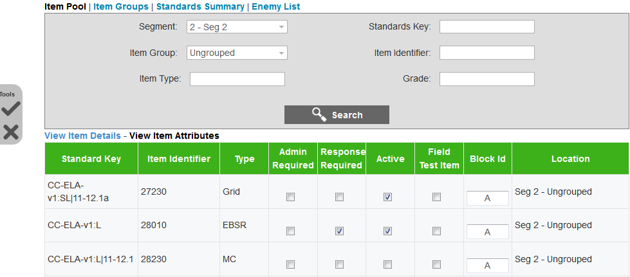

To edit the item attributes:

|  |
| --- |
| 1. From the Item Pool screen (see Figure 36), search for the items that you want to edit. 2. On the Tool Bar, click the edit items [] button. The item attribute fields that can be edited will be enabled (see Figure 38). 3. Update the information as necessary. The following fields can be edited:    * Admin Required, Response Required, Active, and Field Test Item: You can check or uncheck the applicable checkboxes to indicate whether an item needs to be administered, needs to be responded to, is active, or is a field test item.    * Block ID: You can enter the required block ID. 4. To save the updates, click the save [] button. To cancel any updates you have made to the item attributes, click the cancel [] button. The item attribute fields will be disabled. |

#### Move Items

You can move items from one item group to another or from one test segment to another.

Figure 39: Item Pool Screen with Move Selected Items Pop-up Window

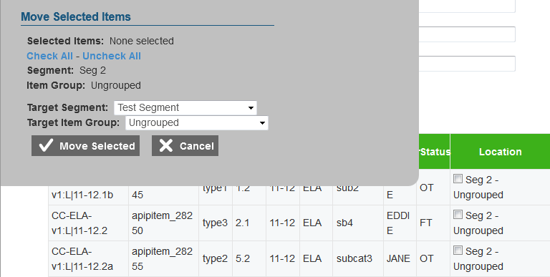

To move items:

|  |
| --- |
| 1. From the Item Pool screen (see Figure 36), search for the items that you want to move. 2. On the Tool Bar, click the move items [] button. A pop-up window appears and the Location column on the Item Details table or the Item Attributes table displays checkboxes for each item (see Figure 39). 3. In the Location column, check the boxes for the items that you want to move. To select all the items displayed on the screen, click the [**Check All**] link on the pop-up window. The item IDs of all the selected items will be displayed on the pop-up window. 4. From the **Target Segment** drop-down list on the pop-up window, select the test segment to which you want to move the selected items. The drop-down list displays all the adaptive test segments. 5. From the **Target Item Group** drop-down list on the pop-up window, select the item group to which you want to move the selected items. The drop-down list displays all the item groups existing for the selected segment. 6. To move the items, click the [**Move Selected**] button on the pop-up window. |

#### Delete Items

You can delete items from an item pool.

|  |  |
| --- | --- |
|  | The items are merely removed from the item pool created in the Test Authoring System. The items are not deleted from the TIB. |

Figure 40: Item Pool Screen with Move Selected Items Pop-up Window

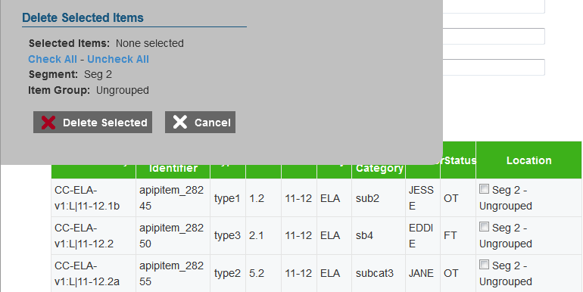

To delete items:

|  |
| --- |
| 1. From the Item Pool screen (see Figure 36), search for the items that you want to delete. 2. On the Tool Bar, click the delete items [] button. A pop-up window appears and the Location column on the Item Details table or the Item Attributes table displays checkboxes for each item (see Figure 40). 3. In the Location column, check the boxes for the items that you want to delete. To select all the items displayed on the screen, click the [**Check All**] link on the pop-up window. The item IDs of all the selected items will be displayed on the pop-up window. 4. To delete the items, click the [**Delete Selected**] button on the pop-up window. The deleted items will no longer be listed on the screen. |

### Manage Item Groups

The Item Group Search screen allows authorized users to view, create, edit, and manage item groups for adaptive test segments. An item group is a collection of items that are selected and administered to a student as one entity. However, all items in an item group do not need to be administered simultaneously. For example, any inactive items in the item group will not be administered.

|  |  |
| --- | --- |
|  | **About Item Groups**:   * When items are imported from the TIB, you can automatically group items by the passage with which they are associated. When automatically grouping items, the Test Authoring System uses the following rules   + All items associated with a passage are included in a group. The item group is named after the passage.   + An item that is not associated with any passage is imported as an ungrouped item.   + A single item that is associated with a passage is imported as a group of one item. This is to ensure that if other items associated with that passage are retrieved from the TIB at a later point of time, the items can be included in the existing group. * You can add items to a custom user-created group at any point of time. * The same item group containing the same or different items may be included on different segments or form partitions. |

Figure 41. Item Group Search Screen

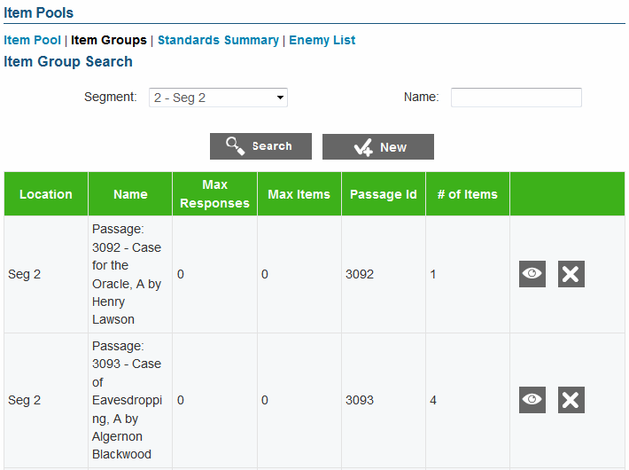

To view the Item Group Search screen:

|  |
| --- |
| 1. On the Item Pool screen (see Figure 36), click the [**Item Groups**] link. The Item Group Search screen appears, listing the available item groups. |

#### Search for an Item Group

The Item Group Search screen allows users to search for item groups that have been created for a test segment using the available search filters.

|  |  |
| --- | --- |
|  | All the search filters correspond to the item group details specified by the user when creating an item group. For information on the detail fields, refer to Table 17. |

To search for an item group:

|  |
| --- |
| 1. On the Item Group Search screen, enter any search criteria you want to include. 2. Click the [**Search**] button. The screen will display the search results table containing the item groups that match the search criteria. The table also displays the segment to which an item group belongs and the number of items existing in the item pool for that item group. |

|  |  |
| --- | --- |
|  | The Item Group Search screen or the View/Edit Item Group screen does not allow you to view the items that are included in the group. To view the items that are included in an item group, you must search for that item group from the Item Pool screen. |

#### Add an Item Group

The Add Item Group screen allows you to create item groups for an adaptive test segment.

Figure 42. Add Item Group Screen

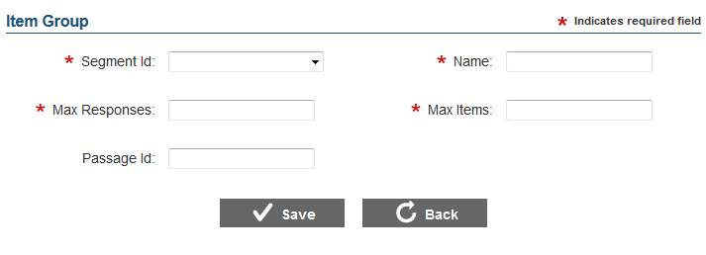

To add an item group:

|  |
| --- |
| 1. On the Item Group Search screen (see Figure 41), click the [**New**] button. The Add Item Group screen appears. 2. Specify the item group details. Fields marked with asterisks are mandatory fields for which details must be provided. The fields comprising the Add Item Group screen are described in Table 16. 3. To add the item group, click the [**Save**] button. 4. To return to the Item Group Search screen, click the [**Back**] button. |

Table 16. Item Group Detail Fields

| Field | Description |
| --- | --- |
| Segment ID | Refers to the segment to which the item group will be added. The drop-down lists all the adaptive test segments created for the test. |
| Name | Refers to the name of the item group. |
| Max Responses | Refers to the maximum number of responses that the student needs to provide. For example, a student may be required to respond to 2 items out of the 5 items presented for that item group in order to continue testing. |
| Max Items | Refers to the maximum number of items that can be presented for the item group. |
| Passage ID | Refers to the unique identifier of the passage with which the items in the group are associated |

#### Edit an Item Group

The View/Edit Item Group screen allows you to edit item group details.

|  |  |
| --- | --- |
|  | You cannot edit item groups for tests that have been published. |

Figure 43: View/Edit Item Group Screen

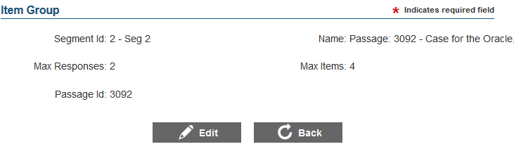

To edit an item group:

|  |
| --- |
| 1. On the Item Group Search screen (see Figure 41), search for the item group you want to edit. 2. Click the view [] button next to the item group. The View/Edit Item Group screen appears. 3. Click the [**Edit**] button. The button is only available for unpublished tests. 4. Update the information as necessary. 5. To save the updates, click the [**Save**] button. |

#### Delete an Item Group

The Item Group Search screen allows you to delete item groups if required.

To delete an item group:

|  |
| --- |
| 1. On the Item Group Search screen (see Figure 41), search for the item group you want to delete. 2. Click the delete [] button next to the item group. The button is only available for item groups that can be deleted. A pop-up message will appear that asks if you are sure you want to delete the item group. 3. To delete the item group from the segment, click the [**OK**] button. |

### View Standards Summary

The Standards Summary screen allows authorized users to compare operational and field test item counts specified on a test segment’s blueprint with the item pool established for the test segment to ensure that an adequate number of items exist for the required standards. For example, the Test Delivery System will not be able to generate a test if a segment blueprint specifies that a minimum of 5 items need to be presented for a standard, but the segment item pool only contains 2 items associated with that standard.

Figure 44. Standards Summary Screen

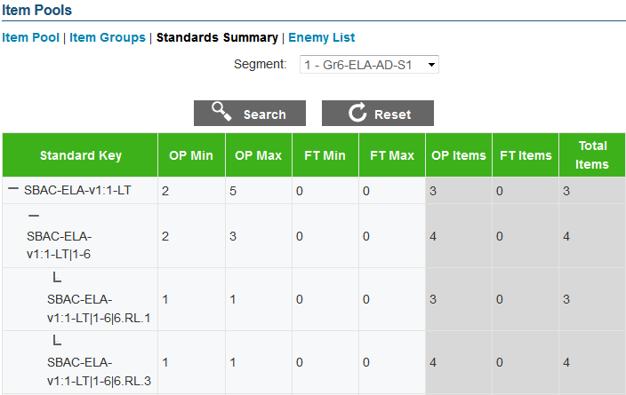

To view the Standards Summary screen:

|  |
| --- |
| 1. On the Item Pool screen (see Figure 36), click the [**Standards Summary**] link. The Standards Summary screen appears, displaying the standards summary table for the selected test segment. The constituent columns of the standards summary table are described in Table 17. |

|  |  |
| --- | --- |
|  | **To view the standards summary for another test segment**:   1. From the **Segment** drop-down list, select the test segment. 2. Click the [**Search**] button. |

Table 17. Standards Summary Table

| Column | Description |
| --- | --- |
| Standard Key | Refers to the key used to identify a standard in the standards publication. |
| OP Min | Refers to the minimum number of operational items that must be included for the standard, as specified in the selected test segment’s blueprint. |
| OP Max | Refers to the maximum number of operational items that can be presented for the standard, as specified in the selected test segment’s blueprint. |
| FT Min | Refers to the minimum number of field test items that must be included for the standard, as specified in the selected test segment’s blueprint. |
| FT Max | Refers to the maximum number of field test items that can be presented for the standard, as specified in the selected test segment’s blueprint. |
| OP Items | Refers to the number of operational items existing in the test segment’s item pool for the standard. |
| FT Items | Refers to the number of field test items existing in the test segment’s item pool for the standard. |
| Total Items | Refers to the total number of operational and field test items existing in the test segment’s item pool for the standard. |

### Manage Enemy Lists

The Enemy List Search screen allows authorized users to view, create, edit, and manage enemy lists of items and item groups. An item is considered to be an enemy of another item or item group if the item gives away the answer for the other item or item group. If an item is declared to be an enemy of an item or item group, the Test Delivery System ensures that both are not presented to the student in an assessment simultaneously.

|  |  |
| --- | --- |
|  | Enemies are applicable to the whole test and are not segment- or form-specific. If an item is declared to be an enemy of another item, only one of the items may be presented in the entire test. |

Figure 45. Enemy List Search Screen

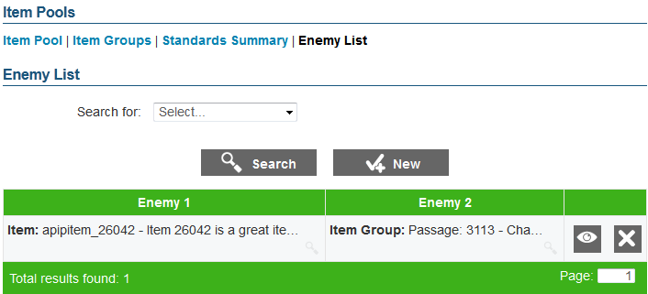

To view the Enemy List Search screen:

|  |
| --- |
| 1. On the Item Pool screen (see Figure 36), click the [**Enemy List**] link. The Enemy List Search screen appears, listing the existing enemy items and item groups. |

|  |  |
| --- | --- |
|  | A details [] button is displayed next to each item or item group that allows you to view details about the item or item group. The button is only displayed when you hover over the item or item group.  To view the details:   1. Click the details [] button for the required item or item group. A pop-up window appears listing details, such as the segment or form on which an item group is included and the maximum number of items that can be selected from the item group. 2. To close the details window, click the [**Close**] button. |

#### Search for an Enemy

The Enemy List Search screen allows users to search for item and item groups that are enemies of other items or item groups. By default, the screen lists all the enemies that have been set up for the test.

To search for an enemy:

|  |
| --- |
| 1. From the Search for field on the Enemy List Search screen, select the entity that you want to search for. The two options are:    * Item: Allows you to search for a particular item    * Item Group: Allows you to search for a particular item group 2. From the **Item or Item Group** drop-down list that is displayed, select the item or item group that you want to search for. The drop-down list displays all the items and item groups included in the item pools established for all the test segments. 3. Click the [**Search**] button. The screen will display the item or item group that matches the search criteria. |

#### Add an Enemy

The Add Enemy screen allows you to establish enemies of items and item groups included on both adaptive test segments and fixed form test segments.

|  |  |
| --- | --- |
|  | An item can be an enemy of an item or item group. |

Figure 46. Add Enemy Screen

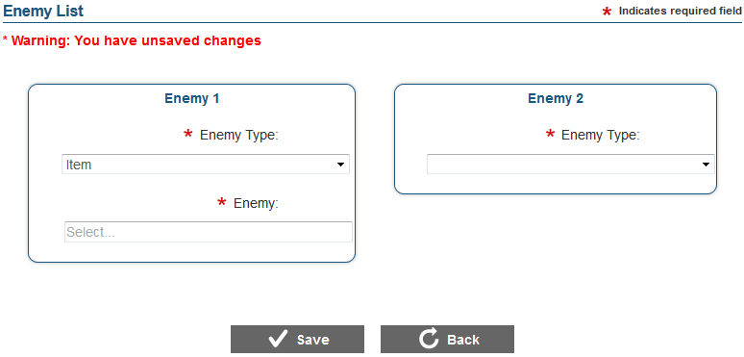

To add an enemy:

|  |
| --- |
| 1. On the Enemy List Search screen, click the [**New**] button. The Add Enemy screen appears. 2. From the Enemy 1 section, specify the following:    1. From the **Enemy Type** drop-down list, specify whether you are creating an enemy record for an item or item group.    2. From the **Enemy** drop-down list that is displayed after you specify the enemy type, select the required item or item group as applicable. The drop-down lists all the items or item groups included in item pools and form partitions. Since the same item group containing different items may be included on different segments or forms, the location of the item group is also listed. 3. From the Enemy 2 section, specify the following:    1. From the **Enemy Type** drop-down list, specify whether an item or item group is an enemy of the entity selected for Enemy 1.    2. From the **Enemy** drop-down list that is displayed after you specify the enemy type, select the required item or item group as applicable. The drop-down lists all the items or item groups included in item pools and form partitions. Since the same item group containing different items may be included on different segments or forms, the location of the item group is also listed. 4. To save the enemy record, click the [**Save**] button. 5. To return to the Item Group Search screen, click the [**Back**] button. |

#### Edit an Enemy Record

The View/Edit Enemy screen allows you to edit enemy records.

|  |  |
| --- | --- |
|  | You cannot edit enemies for tests that have been published. |

Figure 47: View/Edit Enemy Screen

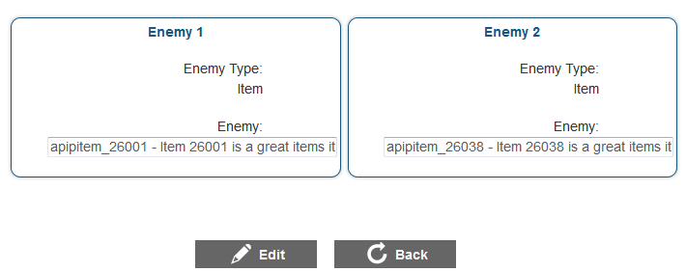

To edit an enemy record:

|  |
| --- |
| 1. On the Enemy List Search screen (see Figure 45), search for the enemy item or item group you want to edit. 2. Click the view [] button next to the record. The View/Edit Enemy List screen appears. 3. Click the [**Edit**] button. The button is only available for unpublished tests. 4. Update the information as necessary. 5. To save the updates, click the [**Save**] button. |

#### Delete an Enemy

The Enemy List Search screen allows you to delete enemies if required.

To delete an enemy:

|  |
| --- |
| 1. On the Enemy List Search screen (see Figure 45), search for the enemy item or item group you want to delete. 2. Click the delete [] button next to the record. The button is only available for unpublished tests. A pop-up message will appear that asks if you are sure you want to delete the record. 3. To delete the record, click the [**OK**] button. |

## Forms

This feature of the Test Authoring System allows you to create and manage forms for test segments that use a fixed form item selection algorithm. Fixed form segments are test segments where the items that are presented to a student are pre-determined. Authorized users select the items that need to be presented to a student and the Test Delivery System presents exactly those items.

Read on to learn how to:

* Manage Forms
* Manage Form Partitions
* Manage Items
* Manage Form Item Groups
* Sort Form Items

### Manage Forms

The Form Search screen allows authorized users to view, create, edit, and manage forms for test segments that use fixed form item selection algorithm. Each fixed form test segment must consist of at least one form. If a fixed form test segment consists of multiple forms, the Test Delivery System presents one of the forms created for the test segment.

|  |  |
| --- | --- |
|  | You can only create or edit forms for test segments that use a fixed form item selection algorithm and for tests that have not been published. |

Figure 48: Form Search Screen

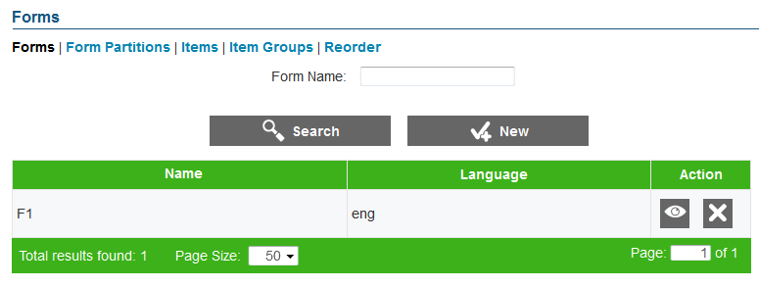

To view the Form Search screen:

|  |
| --- |
| 1. On the Home screen (see Figure 2), click the test [] icon. The Assessment Search screen appears listing the tests that have been created for the tenant. 2. Click the view [] button next to the test for which you want to view or create forms. The View Assessment screen (see Figure 23) appears. 3. From the Menu, select “Forms.” The Form Search screen for the selected test appears listing any existing forms. You can search for existing forms by name. |

#### Add a Form

The Add Form screen allows you to create forms for the existing fixed form test segments.

|  |  |
| --- | --- |
|  | You can only add forms for unpublished tests. |

Figure 49. Add Form Screen

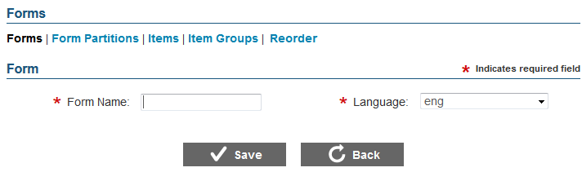

To add a form:

|  |
| --- |
| 1. On the Form Search screen (see Figure 48), click the [**New**] button. The Add Form screen appears. 2. In the Form Name field, enter the name of the form. 3. From the **Language** drop-down list, select the language in which the items will be presented. 4. To save the form, click the [**Save**] button. 5. To return to the Form Search screen, click the [**Back**] button. |

#### Edit a Form

The View/Edit Form screen enables you to edit existing forms.

|  |  |
| --- | --- |
|  | You can only edit forms for unpublished tests. |

Figure 50: View/Edit Form Screen

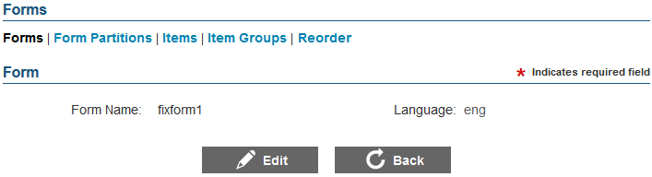

To edit a form:

|  |
| --- |
| 1. On the Form Search screen (see Figure 48), search for the form you want to edit. 2. Click the view [] button next to the form. The View/Edit Form screen appears. 3. Click the [**Edit**] button. 4. Update the name or language of the form as required. 5. Click the [**Save**] button. 6. To return to the Form Search screen, click the [**Back**] button. |

#### Delete a Form

The Form Search screen allows you to delete a form.

|  |  |
| --- | --- |
|  | You can only delete forms for unpublished tests. |

To delete a form:

|  |
| --- |
| 1. On the Form Search screen, search for the form you want to delete. 2. Click the delete [] button, if available, next to the form. A pop-up message will appear that asks if you are sure you want to delete the form. 3. To delete the form, click the [**OK**] button. The form will no longer be listed on the screen. |

### Manage Form Partitions

The Form Partitions Search screen allows authorized users to view, create, edit, and manage form partitions for forms created for test segments that use fixed form item selection algorithm. Each form must consist of one form partition. The items that need to be presented to a student for a form are included in the form partition. If a fixed form test segment consists of multiple forms, the Test Delivery System presents one of the forms created for the test segment.

Figure 51: Form Partitions Search Screen

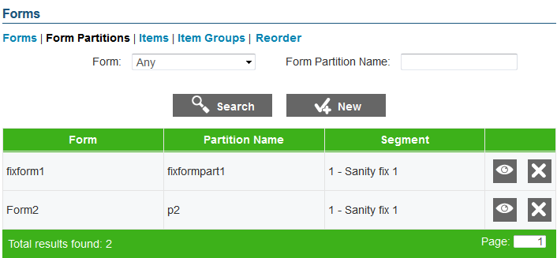

To view the Form Partitions Search screen:

|  |
| --- |
| 1. On the Form Partitions Search screen (see Figure 51), click the [**Form Partitions**] link. The Form Partitions Search screen appears listing any existing form partitions. You can search for form partitions by name or by the form to which it belongs. |

#### Add a Form Partition

The Add Form Partition screen allows you to create form partitions for the existing forms.

|  |  |
| --- | --- |
|  | You can only create one form partition per test form set up for a fixed form test segment. You can only add form partitions for unpublished tests. |

Figure 52. Add Form Partition Screen

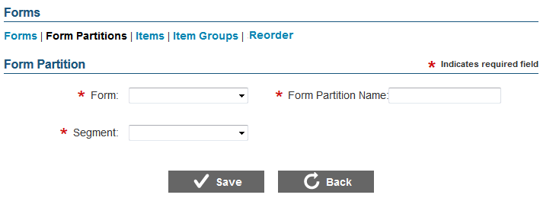

To add a form partition:

|  |
| --- |
| 1. On the Form Partition Search screen (see Figure 51), click the [**New**] button. The Add Form Partition screen appears. 2. From the **Form** drop-down list, select the form for which you want to create a form partition. 3. In the Form Partition Name field, enter the name of the form partition. 4. From the **Segment** drop-down list, select the fixed form test segment to which the form partition belongs. 5. To save the form partition, click the [**Save**] button. 6. To return to the Form Partition Search screen, click the [**Back**] button. |

#### Edit a Form Partition

The View/Edit Form Partition screen enables you to edit existing forms.

|  |  |
| --- | --- |
|  | You can only edit form partitions for unpublished tests. |

Figure 53: View/Edit Form Partition Screen

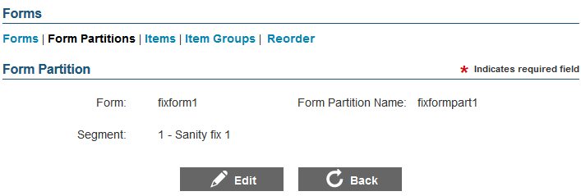

To edit a form partition:

|  |
| --- |
| 1. On the Form Partition Search screen (see Figure 51), search for the form partition you want to edit. 2. Click the view [] button next to the form partition. The View/Edit Form Partition screen appears. 3. Click the [**Edit**] button. 4. Update the details for the different form partition fields. 5. Click the [**Save**] button. 6. To return to the Form Partition Search screen, click the [**Back**] button. |

#### Delete a Form Partition

The Form Partition Search screen allows you to delete a form partition.

|  |  |
| --- | --- |
|  | You can only delete form partitions for unpublished tests. |

To delete a form partition:

|  |
| --- |
| 1. On the Form Partition Search screen, search for the form you want to delete. 2. Click the delete [] button, if available, next to the form partition. A pop-up message will appear that asks if you are sure you want to delete the form partition. 3. To delete the form partition, click the [**OK**] button. The form partition will no longer be listed on the screen. |

### Manage Items

The Item Search screen allows authorized users to view, select, edit, and manage items for test segments that use fixed form item selection algorithm.

|  |  |
| --- | --- |
|  | You can only select items to include on a fixed form test segment after form partitions have been created for the test segments. |

Figure 54. Item Search Screen

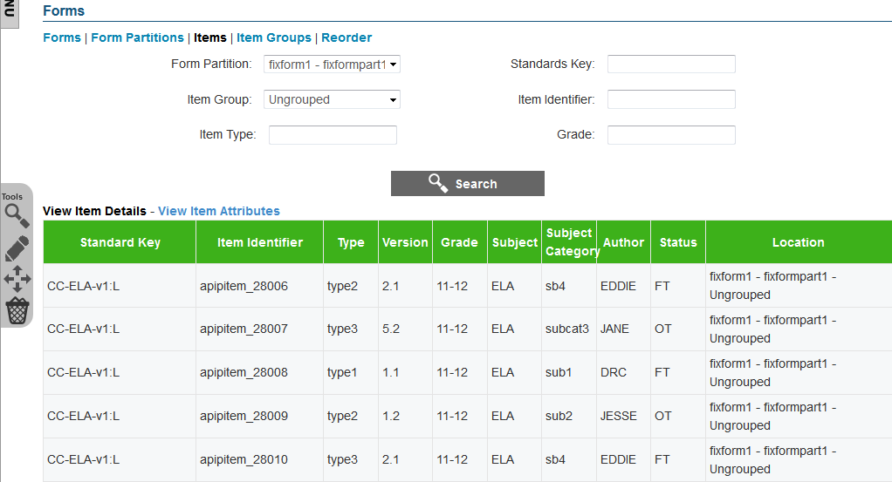

To view the Item Search screen:

|  |
| --- |
| 1. On the Form Search screen (see Figure 48), click the [**Items**] link. The Item Search screen appears listing any items that may have already been included. |

#### Features of the Item Search Screen

The Item Search screen displays the items included on a form partition for a fixed form test segment. If a test does not consist of any fixed form test segment or if no items have been selected, no items will be displayed on the screen. Some of the features of the Item Search screen are:

* **Search Filters**: By default, the screen displays the items included in the form partition for the selected fixed form segment. You can search for specific items on the form partition or item existing for other form partitions using the available search filters. For information on how to search for items included on a form partition, refer to Search for Form Partition Items.
* **Item Table**: All the items that match the selected search criteria are displayed in a table.
  + A navigation bar is displayed at the bottom of the page that displays the total number of retrieved items and allows you to browse through the items.
  + Two different views of the retrieved items are available. To choose the type of item information that you want to view, click the [**View Item Details**] link or [**View Item Attributes**] link available above the table. By default, the Item Details table is displayed on the screen. The Item Details table columns are described in Table 18and the Item Attributes table columns are described in Table 19.
* **Tool Bar**: A Tool Bar is displayed on the screen that enables you to perform different actions, such as selecting items to include on a form partition, deleting items from a form partition, and editing item attributes. The available tools are described in Table 20.

Table 18. Item Details Table Columns

| Column | Description |
| --- | --- |
| Standard Key | Displays the standard key of the standard with which the item is associated. |
| Item Identifier | Displays the unique item ID. |
| Type | Indicates the type of the item. Examples of some item types are grid items, selected-response items, and constructed-response items. |
| Version | Displays the item version number. |
| Grade | Indicates the grade or grade band for which the item has been created. |
| Subject | Indicates the subject for which the item has been created. For example, “Algebra II.” |
| Subject Category | Indicates the subject category for which the item has been created. An example of a subject category for an Algebra II item is Mathematics. |
| Author | Refers to the name of the author who created the item. |
| Status | Indicates whether the item is a field test item or an operational item. |
| Location | Refers to the location of the item in the Test Authoring System. The location indicates the name of the fixed form segment and form partition with which the item is associated and the name of the group to which the item belongs, if applicable. If an item is not part of a group, the location will display “Ungrouped.” |

Table 19. Item Attributes Table Columns

| Column | Description |
| --- | --- |
| Standard Key | Displays the standard key of the standard with which the item is associated. |
| Item Identifier | Displays the unique item ID. |
| Type | Indicates the type of the item. Examples of some item types are grid items, selected-response items, and constructed-response items. |
| Admin Required | Indicates whether the item must be presented to the student. |
| Response Required | Indicates whether the student must provide a response to the item if the item is presented. |
| Active | Indicates whether the item is active and can be presented in a test. |
| Field Test Item | Indicates whether the item is a field test item. |
| Block ID | Indicates the item group block to which the item belongs. When selecting items to include on a test, items from only one block can be presented. |
| Location | Refers to the location of the item in the Test Authoring System. The location indicates the name of the fixed form test segment and form partition with which the item is associated and the name of the group to which the item belongs, if applicable. If an item is not part of a group, the location will display “Ungrouped.” |

Table 20. Form Item Tools

| **Column** | **Description** |
| --- | --- |
|  | **TIB Search**: Button that allows you to search for items existing in the Test Item Bank and add them to the form partition. For information on how to search for and include items in form partitions, refer to Search and Import Form Partition Items from TIB. |
|  | **Edit Items**: Button that allows you to edit the item attributes of items included in the form partition. For more information, refer to Edit Form Item Attributes. |
|  | **Move Items**: Button that allows you to move items from a form partition or group to another form partition or group. For more information, refer to Move Form Items. |
|  | **Save**: Button that allows you to save the edits made to item attributes. This button only appears after you click the [**Edit Items**] button. |
|  | **Cancel**: Button that allows you to cancel any edits made to item attributes and return to viewing the item attributes. This button only appears after you click the [**Edit Items**] button. |
|  | **Delete Items**: Button that allows you to delete the items from the form partition. For more information, refer to Delete Form Items. |

#### Search for Form Partition Items

The Item Search screen allows you to search for and view items included in the selected form partition using the search filters available on the top of the screen.

|  |  |
| --- | --- |
|  | This feature allows you to search for items that have already been included in the form partition. It does not allow you to search for items existing in the Test Item Bank. To search for items in the Test Item Bank that can be included in the form partition, refer to Search and Import Form Partition Items from TIB |

To search for items included in a form partition:

|  |
| --- |
| 1. On the Item Search screen, enter any search criteria you want to include. The available search filters are listed in Table 21. Item Search Filters. 2. Click the [**Search**] button. The screen will display the search results table containing the items that match the search criteria. |

Table 21. Item Search Filters

| Field | Description |
| --- | --- |
| Form Partition | Drop-down list that enables you to select the form partition whose items you want to view. The drop-down lists all the form partitions created for the fixed form test segments. |
| Standards Key | Text field that enables you to enter the standard key of the standard with which an item is associated. |
| Item Group | Drop-down list that enables you to search for items that belong to the selected group or groups. The drop-down lists:   * Existing item groups: Displays items existing for the selected item group. When items are imported from the TIB, you can automatically group items by the passage with which they are associated. The item group is named after the passage. You can also create custom item groups. For more information, refer to Manage Form Item Groups. * “Ungrouped”: Displays all items that are not included in a group. If a passage only contains one item, an item group is not created at the time of importing the item. |
| Item Identifier | Text field that enables you to enter the item ID of the item that you want to search for. |
| Item Type | Text field that enables you to enter the item type of the item or items that you want to search for. |
| Grade | Drop-down list that enables you to search for items belonging to the specified grade or grades. |

#### Search and Import Form Partition Items from TIB

The TIB search [] button on the Form Item Search screen allows you to search for items existing in the Test Item Bank and add them to a form partition. You can search for items and add them to a form partition in the same way as adding items to an adaptive test segment item pool. For more information on searching for and importing items, refer to Search and Import Items from TIB.

|  |  |
| --- | --- |
|  | The actual items are not imported into the Test Authoring System. The items are stored in the TIB. The Test Authoring System merely stores references to these items. |

#### Edit Form Item Attributes

The edit items [] button on the Item Search screen allows you to edit the item attributes of the items listed on the screen. For example, you can change the block on which the item is included or change the status of the item. You can edit item attributes in the same way as editing item attributes of items in an item pool. For more information, refer to Edit Item Attributes.

|  |  |
| --- | --- |
|  | You can only edit item attributes that are specific to the Test Authoring System. The edits do not affect the item’s attributes in the Test Item Bank. |

#### Move Form Items

You can move items from one item group to another or from one form partition to another. You can move items in the same way as moving items included in an item pool. For more information, refer to Move Items.

#### Delete Form Items

You can delete items from a form partition. You can delete items in the same way as deleting items from an item pool. For more information, refer to Delete Items.

|  |  |
| --- | --- |
|  | The items are merely removed from the form partition and are not deleted from the Test Item Bank. |

### Manage Form Item Groups

The Form Item Group Search screen allows authorized users to view, create, edit, and manage item groups for fixed form test segments. An item group is a collection of items that are selected and administered to a student as one entity. However, all items in an item group do not need to be administered simultaneously. For example, any inactive items in the item group will not be administered.

To view the Item Group Search screen:

|  |
| --- |
| 1. On the Form Search screen (see Figure 48), click the [**Item Groups**] link. The Form Item Group Search screen appears listing the available item groups. |

Figure 55. Form Item Group Search Screen

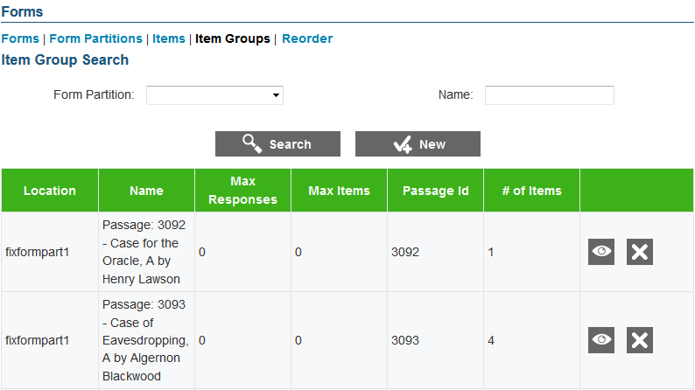

You can search for, add, edit, and delete item groups for form partitions in the same way as searching, adding, editing, and deleting item groups for adaptive test segments. For more information, refer to Manage Item Groups.

### Reorder Form Items

From the Reorder Form Items screen, authorized users can specify the order in which items included in a form partition should be presented to a student. You can specify the order in which item groups and ungrouped items should be presented as well as the order in which items within an item group should be presented.

Figure 56. Reorder Form Items Screen

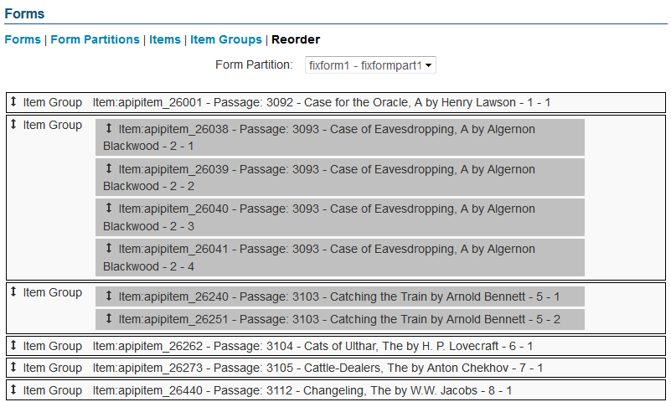

To view the Reorder Form Items screen and view the items included on a form partition:

|  |
| --- |
| 1. On the Form Search screen (see Figure 48), click the [**Reorder**] link. The Reorder Form Items screen appears. 2. From the **Form Partition** drop-down list, select the form partition whose items you want to sort. The ungrouped items and item groups included in the form partition will be displayed. |

|  |  |
| --- | --- |
|  | **About the items and item groups displayed on the** Reorder Form Items **screen**:   * Each item group and each ungrouped item is displayed in a separate block. * If an item group consists of more than one item, the items are displayed in separate rows within the item group block. * For ungrouped items, the phrase “NO_GROUP” is displayed next to the item ID. |

To reorder items within a group:

|  |
| --- |
| 1. From the required item group, select the item that you want to reorder and drag it to the desired position within that item group. |

To reorder ungrouped items and item groups:

|  |
| --- |
| 1. Select the required item group or ungrouped item and drag it to the desired position within the form partition. |

## Scoring Rules

This feature of the Test Authoring System enables you to configure the scoring rules for a test. Scoring rules may consist of a series of computation rules that are performed in a specified sequence using a particular scoring function.

Test Author Administrators set up signatures of scoring functions that correspond to scoring functions configured in the Test Scoring Engine. From the Scoring screen, authorized users can align the scoring functions established in the Test Authoring System with different blueprint element categories, such as assessment, test segment, blueprint standard, or affinity groups and they can also specify parameter values.

Figure 57. Scoring Screen

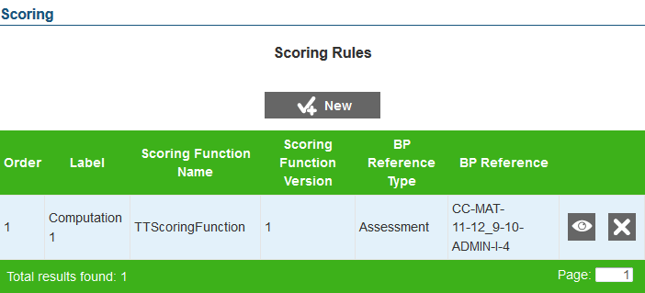

To view the Scoring Rules screen:

|  |
| --- |
| 1. On the Home screen (see Figure 2), click the test [] icon. The Assessment Search screen appears, listing the tests that have been created for the tenant. 2. Click the view [] button next to the test for which you want to view or create scoring rules. The View Assessment screen (see Figure 26) appears. 3. From the Menu, select “Scoring.” The Scoring screen for the selected test appears, listing all existing scoring rules. |

### Add a Scoring Rule

The Add Scoring Rule screen allows you to add scoring rules for different blueprint element categories.

|  |  |
| --- | --- |
|  | **About adding scoring rules**:   * You can only add scoring rules after Test Author Administrators have set up scoring rules in the system. * You can only add scoring rules for unpublished tests. |

Figure 58. Add Scoring Rule Screen

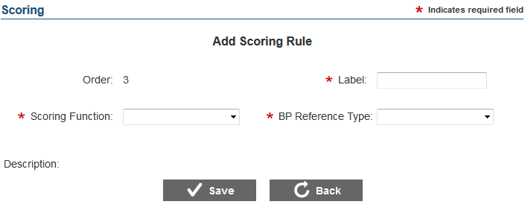

To add a scoring rule:

|  |
| --- |
| 1. On the Scoring screen (see Figure 57), click the [**New**] button. The Add Scoring Rule screen appears. 2. Specify the scoring rule details. Fields marked with asterisks are mandatory fields for which details must be provided. The fields comprising the Add Scoring Rule screen are described in Table 22. 3. To save the scoring rule, click the [**Save**] button. 4. To return to the Scoring screen, click the [**Back**] button. |

Table 22. Scoring Rule Details

| Field | Description |
| --- | --- |
| Order | This is a system-generated value that indicates the order in which the scoring rule will be performed. By default, a new scoring rule is added to the end of existing rules. You can change the order after the rule has been added. For information on how to change scoring rule order, refer to Reorder Scoring Rules. |
| Label | Refers to the scoring rule name. The scoring rule name must be unique. |
| Scoring Function | Refers to the scoring function you want to use for the scoring rule. You can select the scoring function from the drop-down list that displays all the scoring functions set up by the Test Author Administrator.  After you select a scoring function, the Description field displays all the parameters that may have been set up for the selected scoring function, including a button for uploading conversion tables (if the scoring rule uses one). |
| BP Reference Type | Refers to the blueprint element category for which you want to create scoring rules. The available options are:   * Assessment: Allows you to establish scoring rules for the entire test. * Segment: Allows you to establish scoring rules for a specific test segment. * Blueprint Affinity Group: Allows you to establish scoring rules for a specific affinity group, if available for the standards publication associated with the test. * Blueprint Standard: Allows you to establish scoring rules for a specific standard in the standards publication that is associated with the test. |
| BP Reference | Refers to the specific blueprint element for which you want to create the scoring rule. The drop-down list appears if any blueprint element other than “Assessment” is selected. The drop-down list displays all the active records existing for the selected blueprint element type. For example, if you select the category “Blueprint Standards,” all the active standards existing for the test will be displayed. |
| Description | Displays all the parameters established for the selected scoring function along with any default value that may have been set up. You can specify the required parameter values for the different fields. For more information, refer to Set up Scoring Rule Parameter Values.  For scoring function that use a configuration table, a button for uploading the conversion table is also displayed. For information on how to upload files, refer to Upload Configuration Files. |

**Set up Scoring Rule Parameter Values**

A scoring function may or may not consist of parameters. If a scoring function consists of parameters, the parameters are displayed on the Add Scoring Rule screen after you select the scoring function. To save a scoring rule, you must specify the parameter values.

Parameters can be of different types, such as integer, string, or float. Furthermore parameters can be scalar or dictionary in nature.

You can only specify parameter values when you are creating or editing scoring rules.

To specify parameter values for a scalar parameter:

|  |
| --- |
| 1. In the text field displayed for the parameter, enter the required value. If the range has been set up, the minimum and maximum values allowed for the parameter will be displayed. |

To specify parameter values a dictionary parameter:

|  |
| --- |
| 1. Click the Add [] button next to the dictionary type parameter. A new row will appear, where you can enter the values. 2. In the Key and Value fields, enter the index key and the value of the parameter. 3. Repeat the steps until all the dictionary values have been set up. |

**Upload Configuration Files**

A scoring function may or may not use a conversion table. If a scoring function uses a conversion table, a button for uploading the conversion table will appear on the Add Scoring Rule screen after you select the scoring function. To save a scoring rule, you must upload the conversion table.

|  |  |
| --- | --- |
|  | **About configuration files**:   * You can only upload files that are in a comma separated value (.csv) format. * The file can only contain two columns of data, having the headings “invalue” and “outvalue.” The “invalue” column can contain integer values and the “outvalue” column can contain string values. * If the scoring rule uses both a value conversion table and a standard error conversion table, the number of rows in both files must be an exact match. |

To upload a configuration file:

|  |
| --- |
| 1. Click the [**Add Value Conversion Table…**] button. A window to your computer will appear, from where you can select the file. 2. Select the file that you want to upload. The selected file’s name will be displayed on the screen. A [**Remove**] link also appears next to the file, which allows you to remove the file and select a new file if necessary. 3. Click the [**Upload**] button. If the file passes validation, a message displays to notify you that the file has been successfully uploaded. The file appears as a link that you can use to download the file. A delete [] button also appears next to the file, which allows you to delete the file and upload a new file if necessary. 4. If the scoring rule uses both value and standard error conversion tables, click the [**Add Standard Error Conversion Table…**] button and repeat the same process. |

### Edit a Scoring Rule

The View/Edit Scoring Rule screen enables you to edit existing scoring rules.

|  |  |
| --- | --- |
|  | You can only edit scoring rules for unpublished tests. |

Figure 59: View/Edit Scoring Rule Screen

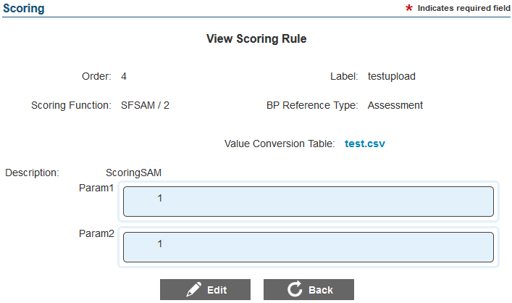

To edit a scoring rule:

|  |
| --- |
| 1. On the Scoring screen (see Figure 57), search for the scoring rule you want to edit. 2. Click the view [] button next to the scoring rule. The View/Edit Scoring Rule screen appears. 3. Click the [**Edit**] button. The button is only available for scoring rules that can be edited. 4. Update the details for the different scoring rule fields, parameters, and configuration tables, if applicable. 5. Click the [**Save**] button. 6. To return to the Scoring Rules screen, click the [**Back**] button. |

### Reorder Scoring Rules

The Scoring screen allows you to reorder scoring rules. When scoring a test, the Test Scoring Engine instantiates the scoring rules in the order in which they are set up. By default, the Test Authoring System orders the scoring rules by the sequence in which they were created. You can change the order after the scoring rules have been created.

|  |  |
| --- | --- |
|  | You can only reorder scoring rules if there are at least two scoring rules established for the test and if the test is unpublished. |

To reorder a scoring rule:

|  |
| --- |
| 1. On the Scoring screen, select the scoring rule that you want to reorder and drag it to the required position. 2. To save the new order, click the [**Save Order**] button that appears when you change the positions of the scoring rules. The scoring rules will be listed in the new order. |

### Delete a Scoring Rule

The Scoring screen allows you to delete a scoring rule.

|  |  |
| --- | --- |
|  | You can only delete scoring rules for unpublished tests. |

To delete a scoring rule:

|  |
| --- |
| 1. On the Scoring screen, search for the scoring rule you want to delete. 2. Click the delete [] button (if available) next to the scoring rule. A pop-up message will appear, asking if you are sure you want to delete the scoring rule. 3. To delete the scoring rule, click the [**OK**] button. The scoring rule will no longer be listed on the screen. |

## Performance Levels

Performance levels are a sequential set of value-ranges that provide teachers, parents and students with information about the level of skills and knowledge demonstrated by the student in an assessment.

From the Performance Levels Search screen, authorized users can establish a list of ranges for blueprint element categories, such as assessment, test segment, blueprint standard, or affinity groups.

Figure 60. Performance Levels Search Screen

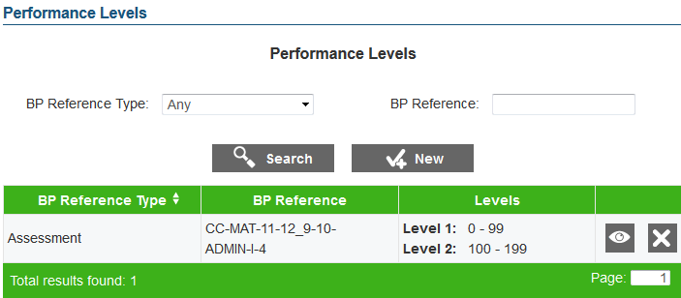

To view the Performance Levels Search screen:

|  |
| --- |
| 1. On the Home screen (see Figure 2), click the test [] icon. The Assessment Search screen appears, listing the tests that have been created for the tenant. 2. Click the view [] button next to the test for which you want to view or create performance levels. The View Assessment screen (see Figure 26) appears. 3. From the Menu, select “Performance Levels.” The Performance Levels Search screen for the selected test appears, listing any existing performance levels. |

### Search for a Performance Level

The Performance Levels Search screen allows users to search for performance levels that may have been established using the available search filters.

To search for performance levels:

|  |
| --- |
| 1. From the **BP Reference Type** drop-down list on the Performance Levels Search screen, select the blueprint element category whose performance levels you want to search for. By default, the screen displays performance levels set up for all blueprint element categories. 2. In the BP Reference field, enter the name of the blueprint element, if required. For example, enter the segment name if you have selected “Segment” from the **BP Reference Type** drop-down. 3. Click the [**Search**] button. The screen will display the search results table, displaying the records that match the search criteria. |

### Add a Performance Level

The Add Performance Level screen allows you to add performance levels for different blueprint element categories.

|  |  |
| --- | --- |
|  | You can only add performance levels for unpublished tests. |

Figure 61. Add Performance Levels Screen

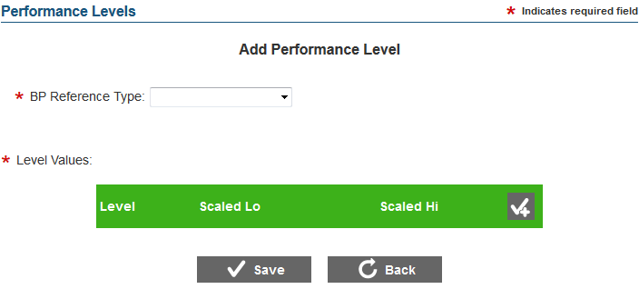

To add a performance level:

|  |
| --- |
| 1. On the Performance Levels Search screen (see Figure 60), click the [**New**] button. The Add Performance Level screen appears. 2. From the **BP Reference Type** drop-down list, select the blueprint element category for which you want to create performance levels. The available options are:    * Assessment: Allows you to establish levels for the entire test.    * Segment: Allows you to establish levels for a specific test segment.    * Affinity Group: Allows you to establish levels for a specific affinity group, if available for the standards publication associated with the test.    * Blueprint Standard: Allows you to establish levels for a specific standard in the standards publication associated with the test. 3. From the **BP Reference** drop-down list that appears when a blueprint element other than “Assessment” is selected, select the particular blueprint element for which you want to create performance levels. The drop-down list displays all the active records existing for the selected blueprint element type. For example, if you select the category “Blueprint Standards,” all the active standards existing for the test will be displayed. 4. From the Level Values section, set up the required levels. To save a performance level, you must establish at least two level values. For more information, refer to Set up Level Values for Performance Levels. 5. To save the performance level, click the [**Save**] button. 6. To return to the Performance Levels Search screen, click the [**Back**] button. |

#### Set Up Level Values for Performance Levels

Each performance level must have at least two ranges.

To set up level values:

|  |
| --- |
| 1. In the Level Values section, click the add [] button. A new row appears, where you can specify the range. The button is only displayed when you are creating or editing a performance level. 2. In the Scaled Lo field, enter the lower range of the level. 3. In the Scaled Hi field, enter the higher range of the level. 4. Repeat the above steps until at least two ranges have been established. 5. Click the [**Save**] button to save the levels. |

To switch positions or order of the level values:

|  |
| --- |
| 1. On the View/Edit Performance Level screen, click the [**Edit**] button. 2. Select the range that you want to reorder and drag it to the required position. |

To delete a level value:

|  |
| --- |
| 1. On the View/Edit Performance Level screen, click the [**Edit**] button. 2. To delete the level value, click the delete [] button. |

### Edit a Performance Level

The View/Edit Performance Level screen enables you to edit existing performance levels.

|  |  |
| --- | --- |
|  | You can only edit performance levels for unpublished tests. |

Figure 62: View/Edit Performance Level Screen

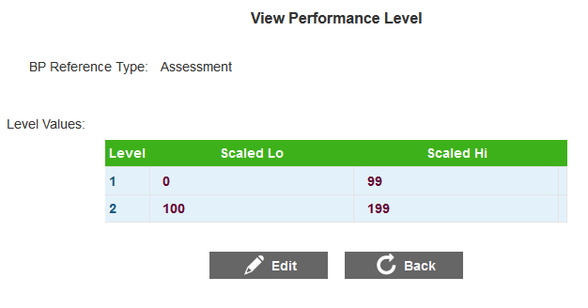

To edit a performance level:

|  |
| --- |
| 1. On the Performance Levels Search screen (see Figure 60), search for the performance level you want to edit. 2. Click the view [] button next to the performance level. The View/Edit Performance Level screen appears. 3. Click the [**Edit**] button. 4. Update the details for the different performance level fields and field values. 5. Click the [**Save**] button. 6. To return to the Performance Levels Search screen, click the [**Back**] button. |

### Delete a Performance Level

The Performance Levels Search screen allows you to delete a performance level.

|  |  |
| --- | --- |
|  | You can only delete performance levels for unpublished tests. |

To delete a performance level:

|  |
| --- |
| 1. On the Performance Levels Search screen, search for the performance level you want to delete. 2. Click the delete [] button next to the performance level (if available). A pop-up message will appear that asks if you are sure you want to delete the performance level. 3. To delete the performance level, click the [**OK**] button. The performance level will no longer be listed on the screen. |

## Reporting

This feature of the Test Authoring System enables you to set up reporting measures for the different scoring rules established for a test. The reporting measures are used by the Reporting Engine to generate test reports.

From the Reporting Measures Search screen, authorized users can set up reporting measures for different blueprint element categories, such as assessment, test segment, blueprint standard, or affinity groups.

Figure 63. Reporting Measures Search Screen

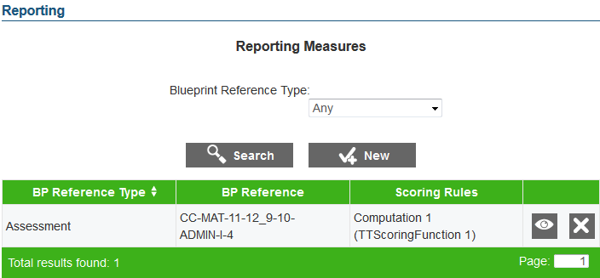

To view the Reporting Measures Search screen:

|  |
| --- |
| 1. On the Home screen (see Figure 2), click the test [] icon. The Assessment Search screen appears, listing the tests that have been created for the tenant. 2. Click the view [] button next to the test for which you want to view or create reporting measures. The View Assessment screen (see Figure 26) appears. 3. From the Menu, select “Reporting.” The Reporting Measures Search screen for the selected test appears, listing all existing reporting measures. |

### Search for a Reporting Measure

The Reporting Measures Search screen allows users to search for reporting measures existing for a blueprint element category using the available search filter. By default, the filter is set to display reporting measures existing for any blueprint element category.

To search for reporting measures existing for a particular blueprint element category:

|  |
| --- |
| 1. From the Blueprint Reference Type filter on the Reporting Measures Search screen, select the blueprint element category whose reporting measures you want to search for. 2. Click the [**Search**] button. The screen will display the search results table containing the reporting measures that match the search criteria. |

### Add a Reporting Measure

The Add Reporting Measure screen allows you to add reporting measures for different blueprint element categories.

|  |  |
| --- | --- |
|  | **About adding reporting measures**:   * You can only add reporting measures after scoring rules are established for the existing blueprint element categories, such as assessment, test segment, standards, and affinity groups. For example, you can establish a reporting measure for a test segment only if a scoring rule has been established at the test segment level. * You can only add reporting measures for unpublished tests. |

Figure 64. Add Reporting Measure Screen

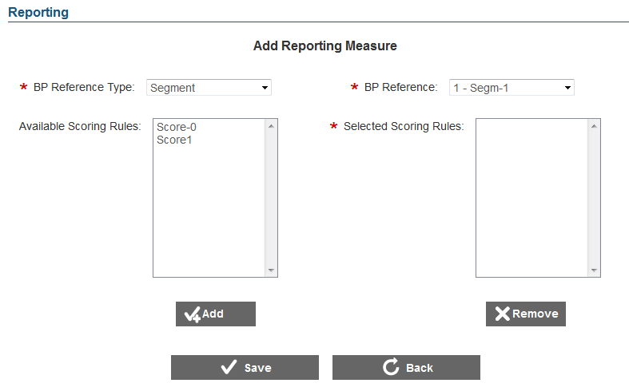

To add a reporting measure:

|  |
| --- |
| 1. On the Reporting Measures Search screen (see Figure 63), click the [**New**] button. The button is only displayed if a scoring rule has been established for the test. When you click the button, the Add Reporting Measures screen appears. 2. From the **BP Reference Type** drop-down list, select the blueprint element category for which you want to create a reporting measure, such as assessment, segment, blueprint standard, and blueprint affinity groups. The drop-down lists the categories for which scoring rules have been created. 3. From the **BP Reference** drop-down list, select the particular blueprint element for which you want to create reporting measures. The drop-down lists the blueprint elements for which scoring rules have been established. For example, if you select the category “Segment,” all the segments for which scoring rules have been set up will be displayed. 4. From the Available Scoring Rules list that displays all the scoring rules established for the selected blueprint element, select the scoring rule or rules that you want to use for reporting. The list is only displayed after you have selected the blueprint element. 5. To move the scoring rules to the Selected Scoring Rules list, click the [**Add**] button. To remove a scoring rule from the Selected Scoring Rules list, select the rule or rules and click the [**Remove**] button. 6. To save the reporting measure, click the [**Save**] button. 7. To return to the Reporting Measures Search screen, click the [**Back**] button. |

### Edit a Reporting Measure

The View/Edit Reporting Measure screen enables you to edit existing reporting measures.

|  |  |
| --- | --- |
|  | You can only edit reporting measures for unpublished tests. |

Figure 65: View/Edit Reporting Measure Screen

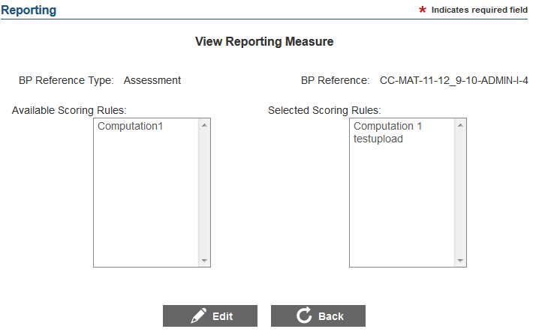

To edit a reporting measure:

|  |
| --- |
| 1. On the Reporting Measures Search screen (see Figure 63), search for the reporting measure you want to edit. 2. Click the view [] button next to the reporting measure. The View/Edit Reporting Measure screen appears. 3. Click the [**Edit**] button. The button is only available for reporting measures that can be edited. 4. Update the details for the different reporting measure fields and selected scoring rules. 5. Click the [**Save**] button. 6. To return to the Reporting Measures Search screen, click the [**Back**] button. |

### Delete a Reporting Measure

The Reporting Measures Search screen allows you to delete a reporting measure.

|  |  |
| --- | --- |
|  | You can only delete reporting measures for unpublished tests. |

To delete a reporting measure:

|  |
| --- |
| 1. On the Reporting Measures Search screen, search for the reporting measure that you want to delete. 2. Click the delete [] button, if available, next to the reporting measure. A pop-up message will appear that asks if you are sure you want to delete the reporting measure. 3. To delete the reporting measure, click the [**OK**] button. The reporting measure will no longer be listed on the screen. |

# Section V. Managing Post Test-Creation Tasks

The Test Authoring System includes three post test-creation tasks, which may be performed after the test is created and validated.

Figure 66: Post Test-Creation Tasks

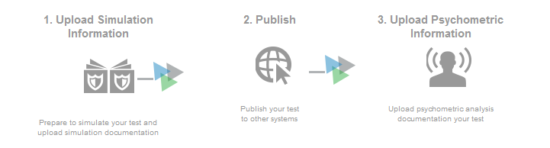

1. **Simulate**: This task allows users to store simulation records from the CAT Simulator application.
2. **Publish**: This task allows authorized users to submit and approve a completed test. Once a test has been submitted and approved, this section may be used to begin the next minor or major version of the test. This section also contains links to the various test specification packages that are automatically created for the test.
3. **Upload Psychometric Information**: This task allows users to upload and store psychometric records that are created after the administration period for a test ends.

To access post test-creation tasks:

|  |
| --- |
| * Click the [**Slide to view post test-creation options**] bar on the main screen of the Test Authoring System.   Figure 67: Viewing Post Test-Creation Tasks    **OR**   * Click the [**Slide to show post test-creation**] bar in the task menu on the left.   Figure 68: Viewing Post-Test Creation Tasks in the Menu |

## Simulate

If a test created in the Test Authoring system contains adaptive segments, users may need to run a simulation of the test to ensure that the adaptive segments are functioning according to the test blueprint. The simulation is run externally in the CAT Simulator application, which extracts simulation specifications from the Test Authoring System. The Simulation Documents screen in the Test Authoring System allows users to upload the results of these simulations.

Figure 69: Simulation Documents Screen

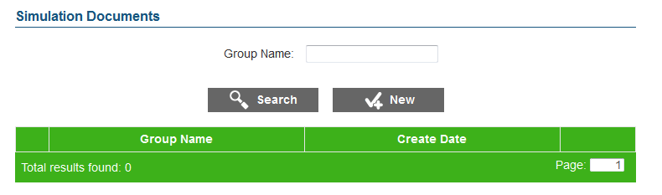

The table on the Simulation Documents screen displays the simulation records that have been uploaded to the Test Authoring System for the selected test. Authorized users can add, view, edit, download, and delete records in this table.

To upload a new simulation record:

|  |
| --- |
| 1. Click the [**New**] button on the Simulation Documents screen. The Add Simulation Documents screen will open.   Figure 70: Add Simulation Documents Screen     1. In the Group Name field, enter a group name that will be used to identify the simulation record and any information included with it. 2. Click the [**Upload Simulation Results…**] button. The operating system’s file upload interface will open. Select and upload the appropriate simulation file from your computer. 3. Click the [**Save**] button. The simulation file will be added to the table on the Simulation Documents screen. 4. To add another file to this record, click the [**Edit**] button and then repeat steps 2 through 4. |

Figure 71: Simulation Records Table

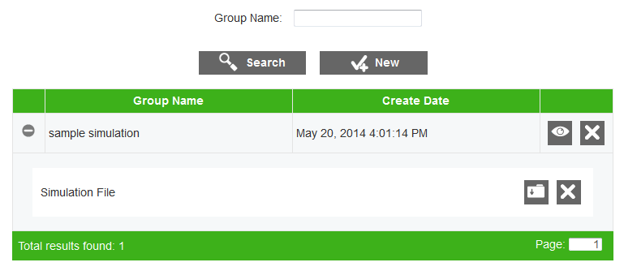

To search for a simulation record in the table:

|  |
| --- |
| 1. In the Group Name field, enter the group name for a simulation record and click the [**Search**] button. The table will update to display only simulation records associated with the entered group name. |

To view and manage the files associated with a simulation record:

|  |
| --- |
| * Click the expand [**+**] button next to a record in the table. The row for that record will expand to display the attached simulation file(s).   + To download the file, click the download [] icon.   + To delete the file, click the delete [] icon. |

Figure 72. Edit Simulation Documents Screen

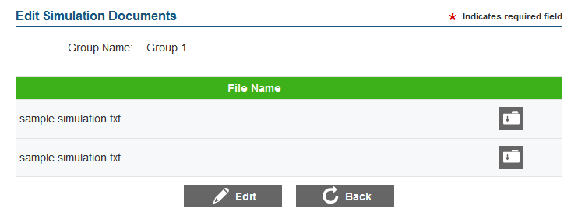

To view and edit the files associated with a simulation record:

|  |
| --- |
| 1. Click the view [] button next to a simulation record. The Edit Simulation Documents screen will load, displaying the files associated with the selected record. 2. To download a file, click the download [] button next to that file. 3. To edit the files, click the [**Edit**] button. The [**Upload Simulation Results**] and delete [] buttons will appear.    1. To upload a new file to the simulation record, click the [**Upload Simulation Results**] button and select a file from your computer.    2. To delete a file, click the delete [] button next to that file.    3. When you are finished, click the [**Save**] button. 4. To return to the Simulation Documents screen, click the [**Back**] button. |

## Publish

The Publishing screen in the Test Authoring System allows users to submit completed tests for approval. A test must be completed and validated before it can be published.

Figure 73: Publishing Screen

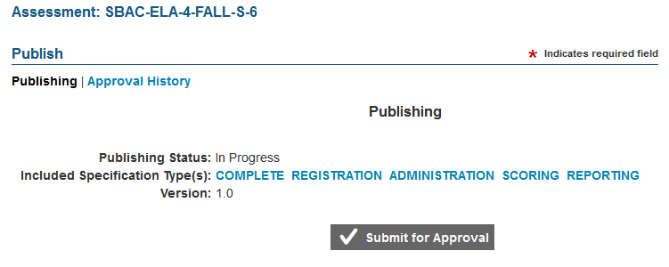

* The Publishing Status field indicates the current status of the test.
* The Included Specification Type(s) field displays links to the various test specification packages for the test. Users can click each of these specification types to download the XML data for that specification type. Each package includes data from a different combination of test elements, which are sent to different systems. These test specifications can also be used to run simulations.
* The Version field indicates the version of the test. By default, all tests begin with version 1.0.

Table 23. Test Specification Packages

| **Type** | **Description** |
| --- | --- |
| Complete | Includes data from all of the test elements as well as item content and metadata. |
| Registration | Includes data from the Test, Segment, and Form (if fixed) elements. This package is sent to the Test Registration System. |
| Administration | Includes data from the Test, Segment, Blueprint, Item Pool (if segmented), and Form (if fixed) elements, item content and item metadata. This package is sent to the Test Delivery System. |
| Scoring | Includes data from the Test, Segment, Blueprint, Item Pool (if segmented), Form (if fixed), Scoring, and Performance Level elements. This package is sent to the Scoring System. |
| Reporting | Includes data from the Test, Segment, Blueprint, Item Pool (if segmented), Form (if fixed), Performance Level, and Reporting elements. This package is sent to the Test Reporting Component. |

### Submitting a Test

To submit the test for approval:

|  |
| --- |
| 1. Click the [**Submit for Approval**] button. A message will pop up asking you to confirm this action. 2. Click [**OK**] in the popup message. The test’s status will change to “Awaiting Approval.” |

|  |  |
| --- | --- |
|  | If you attempt to submit a test that contains validation errors, an error message will display, indicating the source of the validation error. |

### Approving a Test

In order to be published, a submitted test must be approved by the Content Lead, Psychometric Lead, and QA Lead. Either the Content Lead or Psychometric Lead may approve first, but the QA Lead must always provide the final approval.

Figure 74: Approving a Test

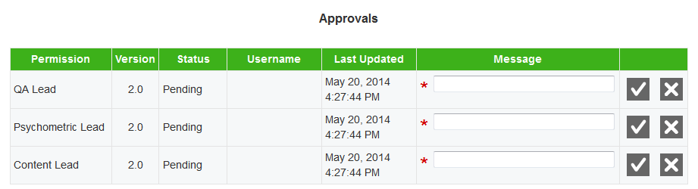

The steps for approving a test are the same for all three user types.

To approve a test:

|  |
| --- |
| 1. Enter a message in the appropriate Message text box on the Approvals table. 2. Click the approve [] button in the row for your user role and confirm your action in the dialog box that pops up. The test will proceed to the next approval level.    * To reject a test, click the reject [] button in the row for your user role and confirm your action in the dialog box that pops up. The test will revert to the “In Progress” status. Users may need to modify some aspect of the test before it can be resubmitted for approval. |

When all three user types have approved the test, the status of the test will change to “Published” and the test will be locked for editing. Tests are published to the Test Specifications Bank.

### Modifying a Published Test

In order to modify a published test, you will need to create a new version of the test. This can be done from the Publishing screen in the Test Authoring System. When making minor changes to the test, you should create a new minor version of the test (e.g. Test 1.0 would become Test 1.1). When making substantial changes to a test, you should create a new major version of the test (e.g. Test 1.0 would become Test 2.0).

Figure 75: Creating a New Version

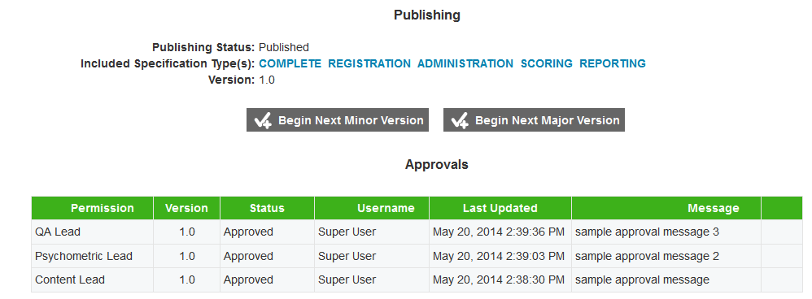

To create a new minor version of the test:

|  |
| --- |
| 1. Click the [**Begin Next Minor Version**] button. The test version will increase by .1 and the status of the test will revert to “In Progress.” You may modify the test at this point. The new minor version of the test will need to be submitted and approved in order to be published. |

|  |  |
| --- | --- |
|  | The minor version of a test cannot exceed N.9. If a test is on version N.9 and you begin the next minor version, the test will increment to the next major version level (N+1.0). |

To create a new major version of the test:

|  |
| --- |
| 1. Click the [**Begin Next Major Version**] button. The test version will increase to the next whole number and the status of the test will revert to “In Progress.” You may modify the test at this point. The new minor version of the test will need to be submitted and approved in order to be published. |

### Viewing a Test’s Approval History

The Publishing screen also allows users to view the test’s approval history. The Approval Historytable displays the user role, test version, status, username, date, and message of each event in the test’s approval history.

Figure 76: Approval History

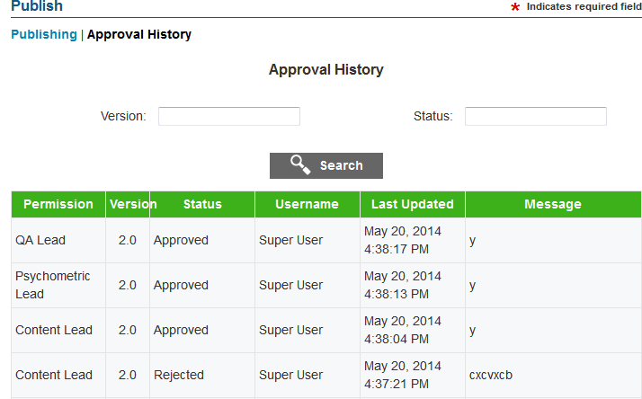

To view a test’s approval history:

|  |
| --- |
| 1. Click the [**Approval History**] link at the top of the Publishing screen. The Approval History screen will load. 2. To filter the Approval History table, enter a value in the Version or Status field and click the [**Search**] button. The table will update to display only the events that match the entered search criteria. |

## Uploading Psychometric Information

When the administration period for a test ends, the student response data undergoes psychometric analysis. The results of this analysis are used as input for any modifications the test will require for the next administration. The Test Authoring System stores these psychometric records on the Psychometric Documents screen.

Figure 77: Psychometric Documents Screen

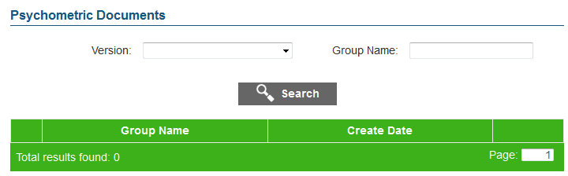

The table on the Psychometric Documents screen displays the group name and creation date associated with each psychometric record. Users can filter the table by the test version and the group name.

To upload a new psychometric record:

|  |
| --- |
| 1. Click the [**New**] button on the Psychometric Documents screen. The Add Psychometric Documents screen will open.   Figure 78: Add Psychometric Documents Screen     1. In the Group Name field, enter a group name that will be used to identify the psychometric record and any information included with it. 2. Click the [**Upload Psychometric Records…**] button. The operating system’s file upload interface will open. Select and upload the appropriate psychometric file. 3. Click the [**Save**] button. The psychometric file will be added to the table on the Psychometric Documents screen. 4. To add another file to this record, click the [**Edit**] button and then repeat steps 2 through 4. |

The table on the Psychometric Documents screen displays the psychometric records that have been uploaded to the Test Authoring System for the selected test. Authorized users can view, edit, download, and delete the records displayed in this table.

Figure 79: Psychometric Records Table

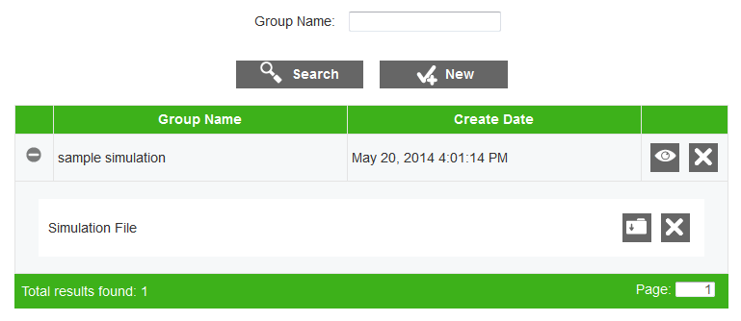

To search for a psychometric record in the table:

|  |
| --- |
| 1. In the Group Name field, enter the group name for a psychometric record and click the [**Search**] button. The table will update to display only psychometric records associated with the entered group name. |

To view and manage the files associated with a psychometric record:

|  |
| --- |
| * Click the expand [**+**] button next to a record in the table. The row for that record will expand to display the attached psychometric file.   + To download the file, click the download [] button.   + To delete the file, click the delete [] button. |

Figure 80. Edit Psychometric Documents Screen



To view and edit the files associated with a psychometric record:

|  |
| --- |
| 1. Click the view [] button next to the psychometric record. The Edit Psychometric Documents screen will load, displaying the files associated with the selected record. 2. To download a file, click the download [] button next to that file. 3. To edit the files, click the [**Edit**] button. The [**Upload Psychometric Results**] and delete [] buttons will appear.    1. To upload a new file to the psychometric record, click the [**Upload Psychometric Records**] button and select a file from your computer.    2. To delete a file, click the delete [] button next to that file.    3. When you are finished, click the [**Save**] button. 4. To return to the Psychometric Documents screen, click the [**Back**] button. |

# Change Log

|  |  |  |
| --- | --- | --- |
| **Change** | **Section** | **Date** |
|  |  |  |