**Overview of the Reporting System**

### add highlighted text to focus on interim reports only

### The Smarter Balanced Reporting System allows teachers and administrators to access detailed student performance information for Smarter Balanced assessments. This version of the User Guide focuses on interim assessments, including interim comprehensive assessments (ICAs) and interim assessment blocks (IABs). Authorized users of the system can view student data at the district, school, and grade levels. Users with the required permissions may also view, download and print individual student reports.

...

The following won't be true for all environments -- remove not if necessary

|  |  |
| --- | --- |
|  | **Note**: State users with PII will be able to view summative results only, not interim results. |

### Reporting Features in Detail

### Student Report

Not all environments will support "New Students" functionality for transfer students. The description of New Students may be to be removed.

**Student Assessment Results Report**

Same as above. Remove text about New Students if necessary.

**Creating My Groups**

When creating custom subgroups for an aggregate report, either assigned groups or accessible school can be used for selecting students. However, this functionality is targeted at teachers, who will normally only have access to assigned groups, not whole schools. The text about selecting from available schools was removed for clarity, but it can be added back as necessary.

The following section can be added after Writing Trait Scores in systems that support Percentiles.

### Percentiles

The percentile tables show the points at which a score is greater than a percentage of other student results, as shown below.

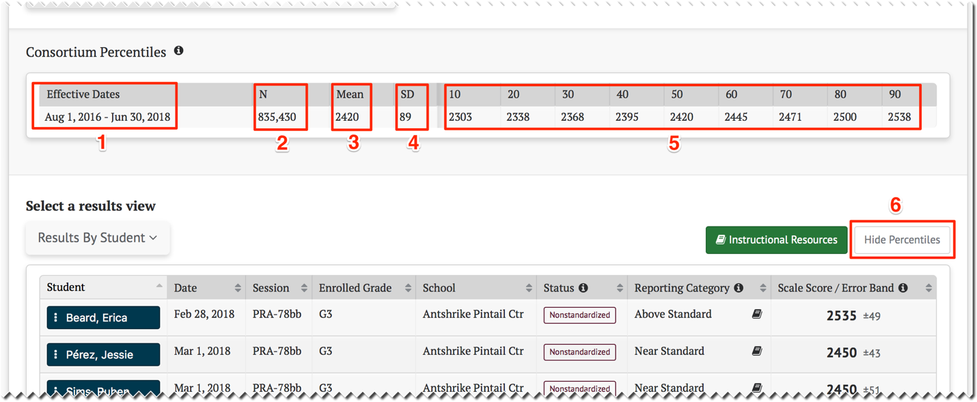

1. The Effective Dates range of test results for which these percentiles should referenced
2. The total number (N) of assessments used to generate the percentiles
3. The Mean of all assessments used to generate the percentiles
4. The standard deviation (SD) of all assessments used to generate the percentiles
5. The percentile rank (10… 90) for the listed scores, in which a score is greater than the other student results
6. The Show/Hide Percentiles toggle control. The percentiles table is either hidden with the control showing “Show Percentiles”, or the percentiles table is displayed withe the control showing “Hide Percentiles”. Selecting the button will toggle between the two states.