Software Technical Design Specification
for
CONTENT STANDARDS
AIR
Table of Contents
Table of Contents ii
Revision History ii
1. Introduction 1
1.1 Purpose 1
1.2 Document Conventions, Intended Audience and Reading Suggestions 1
1.3 References 1
2. Overall Description 1
2.1 Product Perspective 1
2.2 Product Functions 1
2.3 Design, Implementation Constraints, Assumptions and Dependencies 2
3. Design 2
3.1 Design Criteria 2
3.2 Design 2
4. Database Schema 3
4.1 Database’s and Table’s Overview 3
4.2 Table Description 3
4.3 Stored Procedures 4
4.4 Database Schema 4
5. Functional Requirements and Enhancements 5
5.1 ITS 5
5.2 Learning Point Navigator 5
5.3 Online Reporting 5
6. Other Nonfunctional Requirements 6
6.1 Performance and Security Requirements 6
6.2 Software Quality Metrics and Test Cases 6

Revision History
Name | Date | Reason For Changes | Version

Introduction

Purpose
The Purpose of this document is to describe the Content Standards module for the Content Standards Repository product. The scope of this document is limited to the Content Standards module only

Document Conventions, Intended Audience and Reading Suggestions
The document is intended primarily for describe the design of the Content Standards module. It is intended for software engineers to describe the design of the document. It is also intended for the client’s of the Content Standards module to understand how to communicate with the Content Standards module

It is also useful for product managers, technical writers and senior management to gain an insight into the inner working of this module.

References
Reference list is provided below <TBD>

Overall Description

Product Perspective
Content standards are loosely described in multiple systems’ across AIR. The content standards module acts a single point of contact for querying content standards. The primary goal of this effort is to have a system that contains a single set of Content standards that is adopted across assessment and to have a mean to query it.

The ability to query Content standards is required by the following system’s across assessment

- ITS
- Scoring
- Online Reporting
- Learning Point Navigator
- TDS

Product Functions
The Content Standards module performs the following functions

- Provides the interface for the ITS system to query Content Standards
- Provides the interface for the Scoring system to query Content Standards
- Provides the interface for the Online Reporting system to query Content Standards
- Provides the interface for the Learning Point Navigator system to query Content Standards
- Provides the interface for Administrative users to import, export, and modified existing publications

Design, Implementation Constraints, Assumptions and Dependencies
The platform constraint is MySQL database server and the programming language constraint Java. An active database connection to the standards repository is required.

Design

Design Criteria
The Content Standards API needs to be exposed to diverse systems across Assessment. The following technologies were considered for exposing the Content Standards API

- REST
- HTTP Handlers

The technologies were evaluated based on the following criteria
- Efficiency
- Ease of implementation of service
- Standards Compliance [So that multiple systems can work together]
- Ability to consume the service across different platforms
- Maintainability

REST is currently considered the prime candidate based on the above criteria.

All available REST APIs

Get Publishers

Summary
Called to get a publisher or a list of publishers

Request Parameters
Parameter | Type | Description
publisherKey | String | Publisher Key, this is optional

Response Parameters (on Success)
Parameter | Type | Description
Publisher or Publishers | Publisher or List<Publisher> | A publisher or a list of publishers object. A Publisher object includes Key, and Name
Sample: see attachments dtd and xml files

Response Parameters (on Failure)
Parameter | Type | Description
status | String | “success” or “failed”
reason | String | The actual error message
Sample: see attachments dtd and xml files

Get Publications

Summary
Called to get a publication or a list of publications

Request Parameters
Parameter | Type | Description
publicationKey | String | Publication Key, this is optional
publisherKey | String | Publisher Key, this is optional
subjectKey | String | Subject Key, this is optional

Response Parameters (on Success)
Parameter | Type | Description
Publication or Publications | Publication or List< Publication > | A Publication or a list of Publications object. A Publication object includes Key, Description, SubjectName, SubjectKey, Version, DateChanged, Status
Sample: see attachments dtd and xml files

Response Parameters (on Failure)
Parameter | Type | Description
status | String | “success” or “failed”
reason | String | The actual error message
Sample: see attachments dtd and xml files

Get Subjects

Summary
Called to get a subject or a list of subjects

Request Parameters
Parameter | Type | Description
subjectKey | String | Subject Key, this is optional

Response Parameters (on Success)
Parameter | Type | Description
Subject or Subjects | Subject or List< Subject > | A Subject or a list of Subjects object. A Subject object includes Key, Name, Code, and Description
Sample: see attachments dtd and xml files

Response Parameters (on Failure)
Parameter | Type | Description
status | String | “success” or “failed”
reason | String | The actual error message
Sample: see attachments dtd and xml files

Get Grade Levels

Summary
Called to get a grade level or a list of grade levels

Request Parameters
Parameter | Type | Description
gradeKey | String | Grade Key, this is optional
publicationKey | String | Publication Key, this is optional

Response Parameters (on Success)
Parameter | Type | Description
Grade or Grades | Grade or List< Grade> | A Grade or a list of Grades object. A Grade object includes Key, and Name
Sample: see attachments dtd and xml files

Response Parameters (on Failure)
Parameter | Type | Description
status | String | “success” or “failed”
reason | String | The actual error message
Sample: see attachments dtd and xml files

Get Standards

Summary
Called to get a list of Standards

Request Parameters
Parameter | Type | Description
publicationKey | String | Publication Key, this is required

Response Parameters (on Success)
Parameter | Type | Description
Standards | List< Standards > | A list of Standards object. A Standard object includes Key, Name, PubKey, ParentKey, TreeLevel, ShortName, GradeLevel, and Description
Sample: see attachments dtd and xml files

Response Parameters (on Failure)
Parameter | Type | Description
status | String | “success” or “failed”
reason | String | The actual error message
Sample: see attachments dtd and xml files

Add a Publisher

Summary
Called to add a publisher

Request Parameters
Parameter | Type | Description

Response Parameters (on Success)
Parameter | Type | Description
Sample: see attachments dtd and xml files

Response Parameters (on Failure)
Parameter | Type | Description
status | String | “success” or “failed”
reason | String | The actual error message
Sample: see attachments dtd and xml files

Add a Subject

Summary
Called to add a Subject

Request Parameters
Parameter | Type | Description

Response Parameters (on Success)
Parameter | Type | Description
Sample: see attachments dtd and xml files

Response Parameters (on Failure)
Parameter | Type | Description
status | String | “success” or “failed”
reason | String | The actual error message
Sample: see attachments dtd and xml files

Add a Grade

Summary
Called to add a Grade

Request Parameters
Parameter | Type | Description

Response Parameters (on Success)
Parameter | Type | Description
Sample: see attachments dtd and xml files

Response Parameters (on Failure)
Parameter | Type | Description
status | String | “success” or “failed”
reason | String | The actual error message
Sample: see attachments dtd and xml files

Validation a Publication XML

Summary
Called to validation a publication xml before import

Request Parameters
Parameter | Type | Description

Response Parameters (on Success)
Parameter | Type | Description
Sample: see attachments dtd and xml files

Response Parameters (on Failure)
Parameter | Type | Description
status | String | “success” or “failed”
reason | String | The actual error message
Sample: see attachments dtd and xml files

Import a Publication XML

Summary
Called to import a publication xml

Request Parameters
Parameter | Type | Description

Response Parameters (on Success)
Parameter | Type | Description
Sample: see attachments dtd and xml files

Response Parameters (on Failure)
Parameter | Type | Description
status | String | “success” or “failed”
reason | String | The actual error message
Sample: see attachments dtd and xml files

Export a Publication XML

Summary
Called to export a publication to xml

Request Parameters
Parameter | Type | Description

Response Parameters (on Success)
Parameter | Type | Description
Sample: see attachments dtd and xml files

Response Parameters (on Failure)
Parameter | Type | Description
status | String | “success” or “failed”
reason | String | The actual error message
Sample: see attachments dtd and xml files

Delete a Publication

Summary
Called to delete a publication, can ONLY do this if the publication is not used by any systems

Request Parameters
Parameter | Type | Description

Response Parameters (on Success)
Parameter | Type | Description
Sample: see attachments dtd and xml files

Response Parameters (on Failure)
Parameter | Type | Description
status | String | “success” or “failed”
reason | String | The actual error message
Sample: see attachments dtd and xml files

Inputs and Outputs
The list of DTDs, see attachments

Administrative Console Interface
See attachments

Database Schema

Database’s and Table’s Overview
Standards repository tables
- Publication
- Publisher
- Standard
- Standard_Grade
- Standard_Relationship
- StandardCategory
- GradeLevel
- Subject
- SOCK_Drawer
- SOCK_Relationship
- RelationshipType
- Loader_BenchmarkGrades
- Loader_Categories
- Loader_Publication
- Loader_SOCKs
- Loader_Standard_Relationship
- Loader_Standards

Table Description
Publisher holds the information of a publisher of content standards, it could be a state or an independent body.
- _key: key
- Name: Name of the publisher
- URL: URL of the publisher

Publication is used to hold the publication standards and has the following columns
- _key: key
- _fk_Publisher: foreign key to the publisher table
- _date: date
- version: version
- isCannonical: checks to see if the user is currently active
- Description: entity key of living entities
- _fk_Subject: foreign key to the subject table
- SubjectLabel:
- URL:

Standard maintains the hierarchy of strands, benchmarks and indicators
- _key: key of the element
- Name: name of the strand, benchmark or indicator
- _fk_parent: contains a key to the parent node in the hierarchy
- _fk_publication: foreign key to the associated publication
- Description: Description of the standard
- TreeLevel: The tree level in the hierarchy

Standard_Grade maintains the associative relationship between the standard and grade level
- _fk_Standard: foreign key to the standard
- _fk_GradeLevel: foreign key to the grade level

Code Name table follow the following format
- Key:
- Code:
- Name:
- Description:

Subject is a code name table that maintains the subject information
Grade Level is a code name table that maintains the grade level information

RelationshipType holds information about relationships between standards
- _key: relationship type key
- Name: name of the relationship
- Description: description of the relationship

Stored Procedures
The stored procedures used for this module are as follows
- _Initialize
- _InitializePublications
- _LoadPublicationFromConfigs
- _SetTestDefaults
- AddStandardRelationship
- AddPublisher
- AddSubject
- AddGrade
- CreatePublication
- ExportPublication
- GetGradeLevel
- GetPublication
- GetPublisher
- GetStandard
- GetStandardRelationships
- GetSubject
- GetSubjectByPublisher
- ModifyPublicationStatus
- RemoveStandardRelationship
- Loader_Clear
- Loader_Main
- Loader_Main_Partial
- Loader_Validate

Database Schema
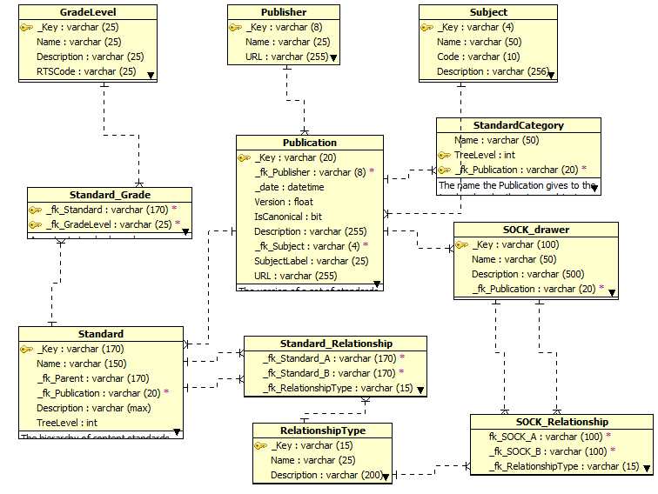

Functional Requirements and Enhancements

The functional requirements are organized as use cases. Each subsection corresponds to a use case scenario or a new enhancement request

General use cases:
5.1.1 Description and Priority

5.1.2 Stimulus/Response Sequences

TDS
6.1.1 Description and Priority
The use case describes interactions of TDS with Content Standards.
6.1.2 Stimulus/Response Sequences

6.1.3 Functional Requirements and user case

- Invokes web service call to get content standards

ITS
6.1.1 Description and Priority
The use case describes interactions of ITS with Content Standards.
6.1.2 Stimulus/Response Sequences

6.1.3 Functional Requirements and user case

- Invokes web service call to get content standards

Learning Point Navigator
6.1.1 Description and Priority
The use case describes interactions of LPN with Content Standards.
6.1.2 Stimulus/Response Sequences

6.1.3 Functional Requirements and user case

- Invokes web service call to get content standards

Online Reporting
6.1.1 Description and Priority
The use case describes interactions of LPN with Content Standards.
6.1.2 Stimulus/Response Sequences

6.1.3 Functional Requirements and user case

- Invokes web service call to get content standards

Other Nonfunctional Requirements

Performance and Security Requirements
Authentication requirements for Content Standard modules clients are
- WS Security
- Triple DES Encryption

Software Quality Metrics and Test Cases

