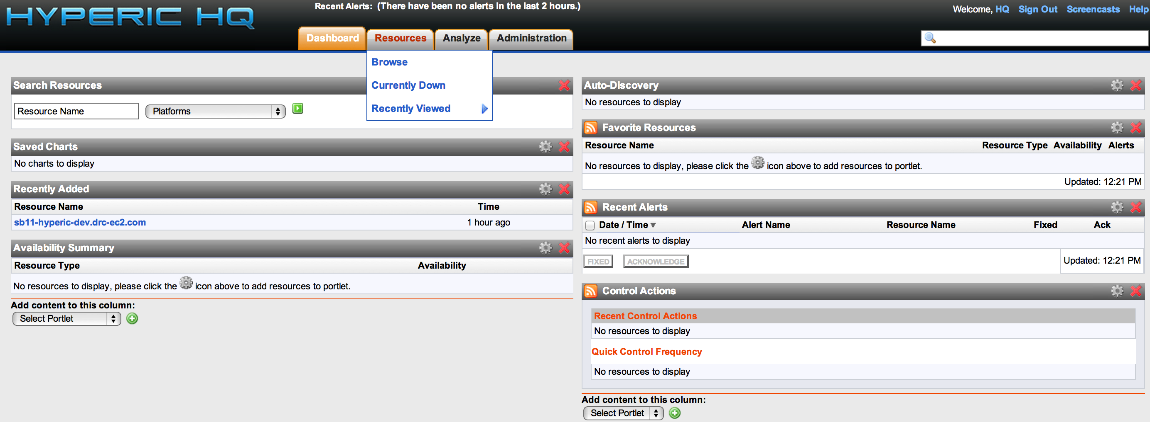
Creating an Alert from a Metric

Here is the Hyperic Dashboard. Hover on the Resources tab and choose Browse to browse all resources added to Hyperic.

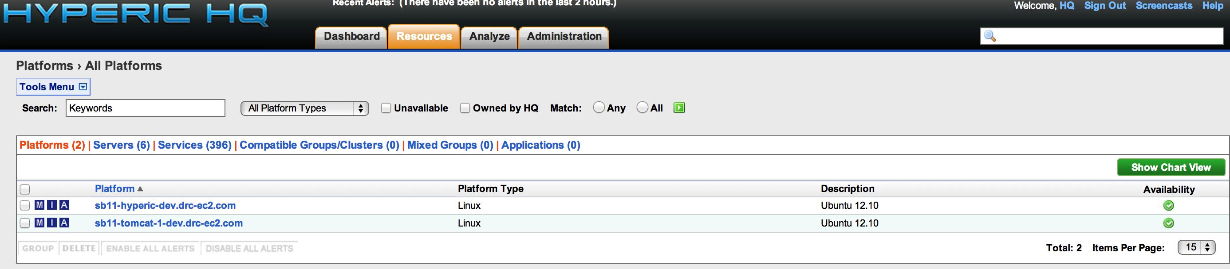
The resources view defaults to show all of the added Platforms. A Platform is equivalent to a server that is running a Hyperic Agent. In this example, we will click on the platform sb11-tomcat-1-dev.drc-ec2.com.

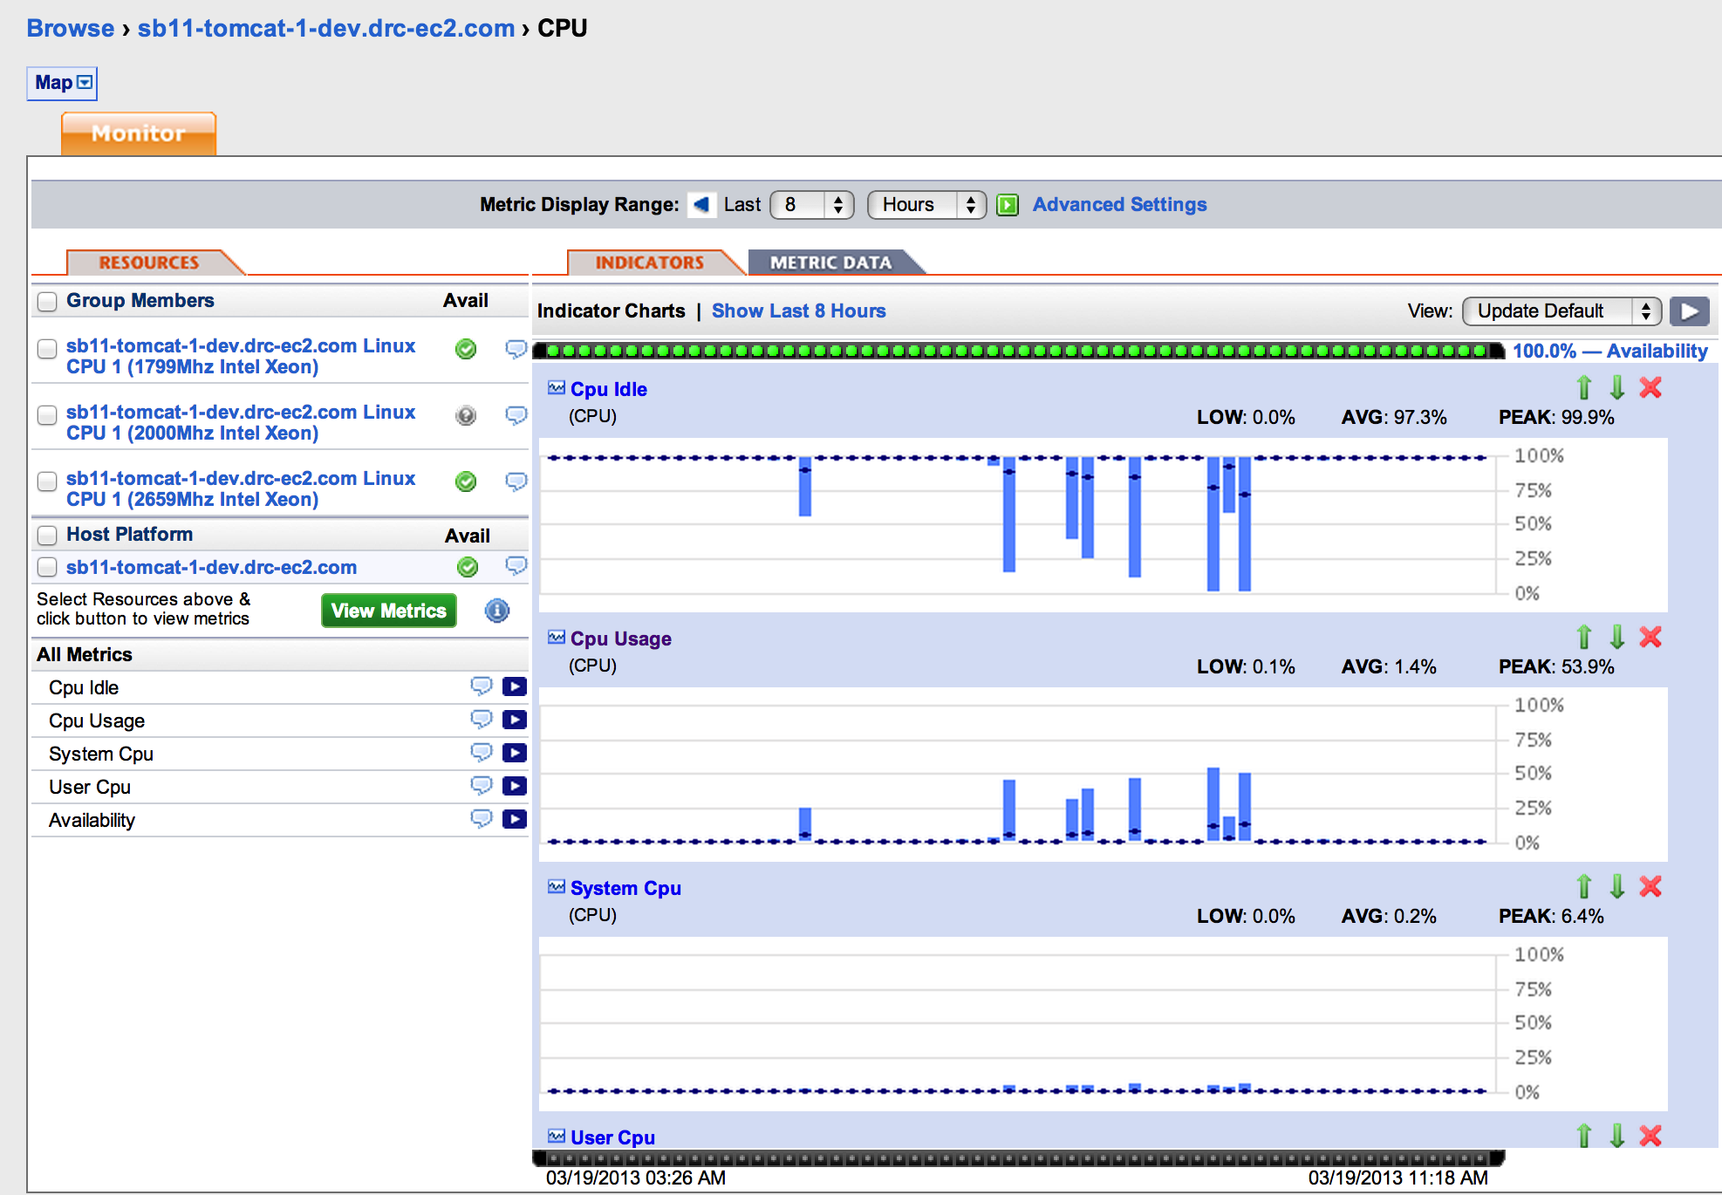
Here are the CPU metrics for a Platform. We click on the Group Member on the left hand side titled sb11-tomcat-1-dev.drc-ec2.com Linux CPU 1(1799Mhz Intel Xeon).

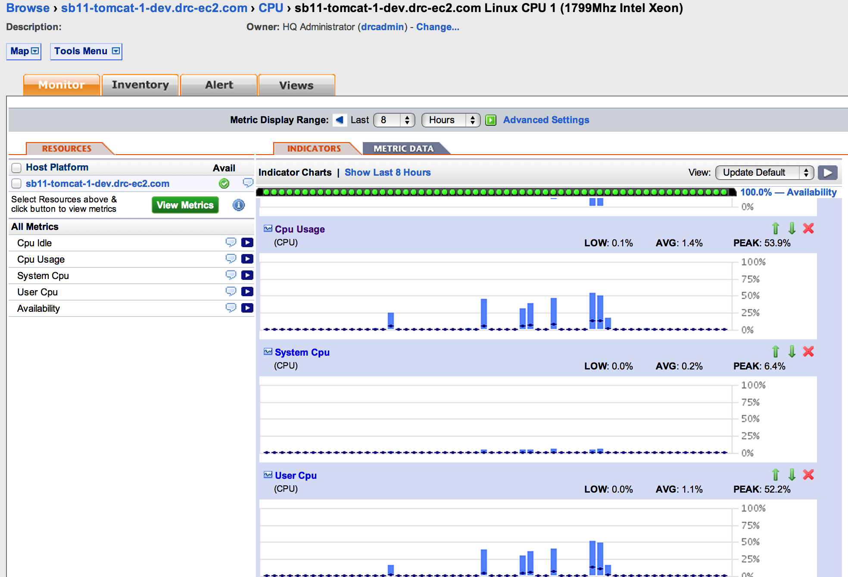
Now we're viewing the metrics specific to that CPU. Click on the CPU Usage title on the metric graph on the right side.

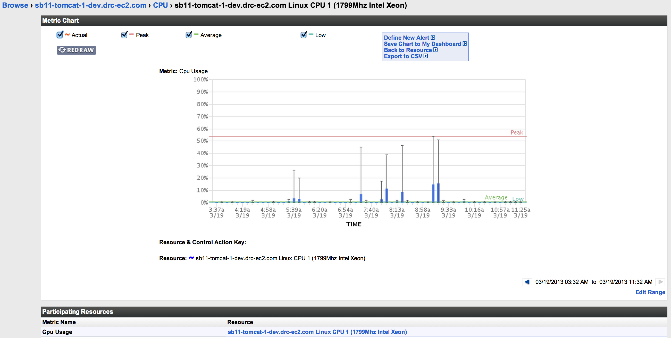
Now we see a bit more detailed graph of the metric along with nice lines to indicate Low, Average, and Peak values over the time period graphed. Click on Define New Alert to create an alert on this metric.

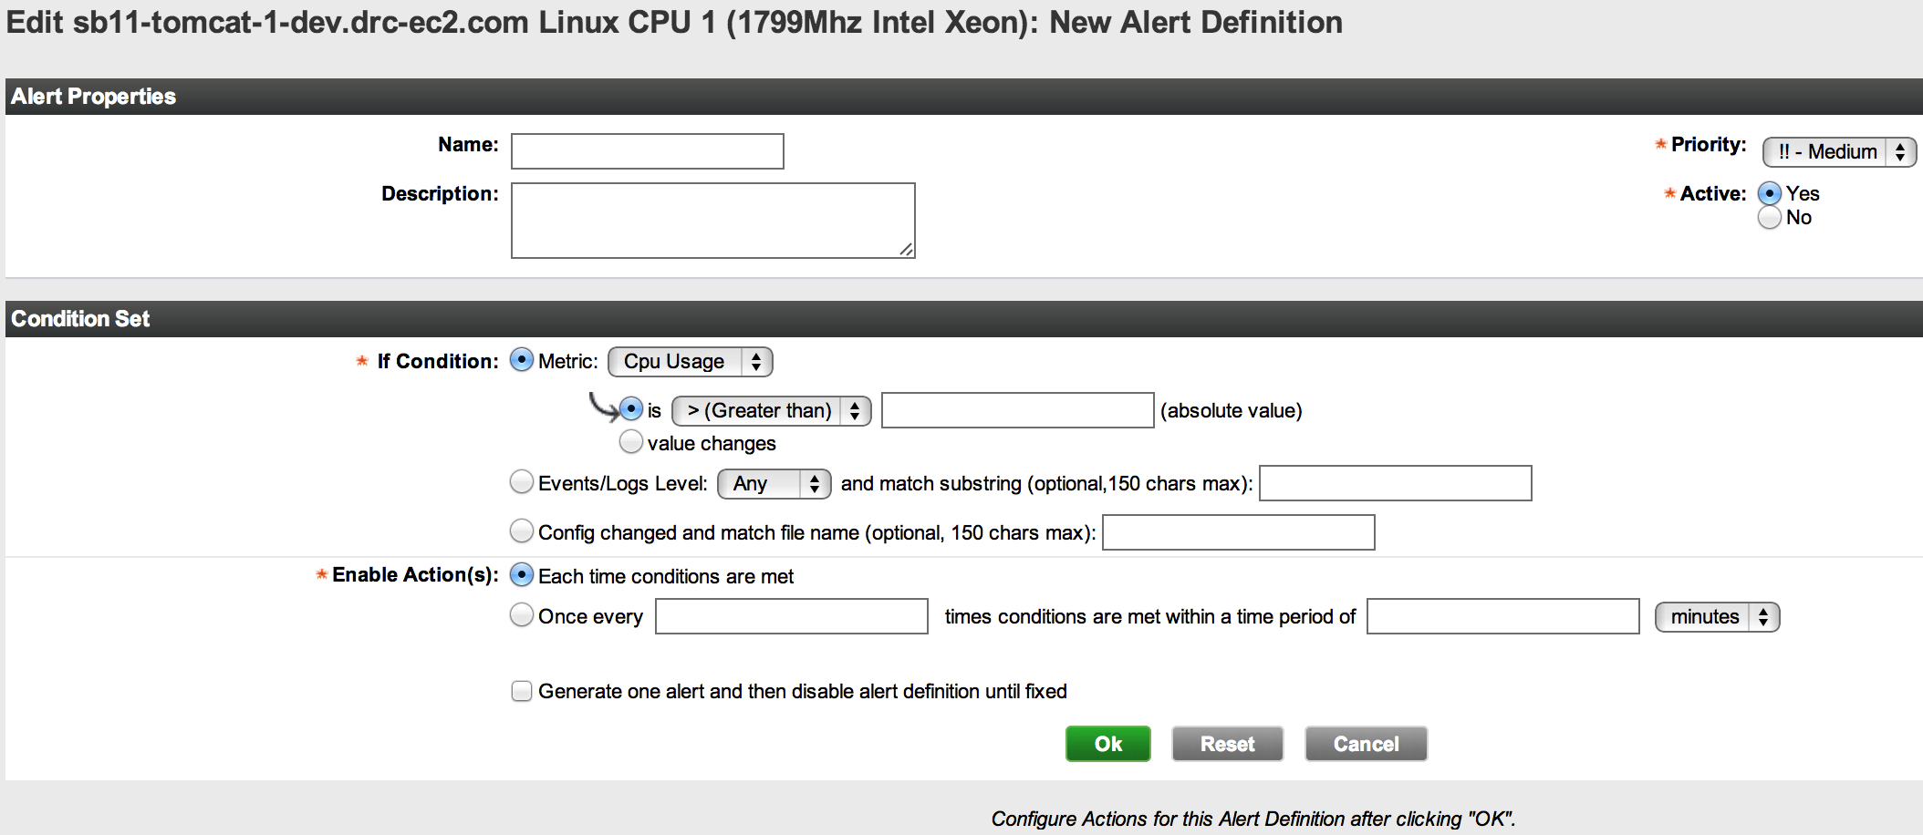
This is the create New Alert page.
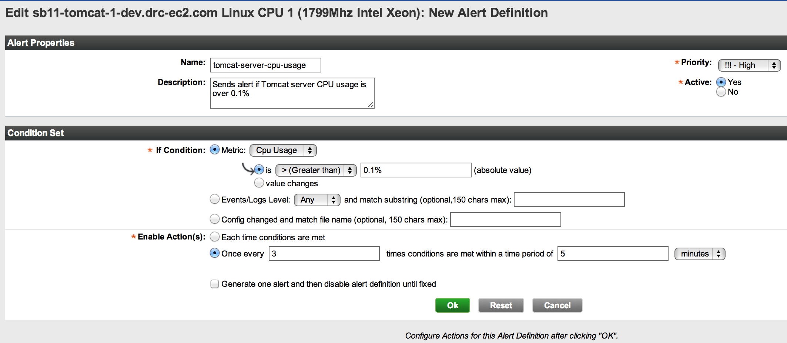
This is an example of how to create an alert. This alert will fire if the CPU Usage is greater than 0.1% 3 times over 5 minutes.

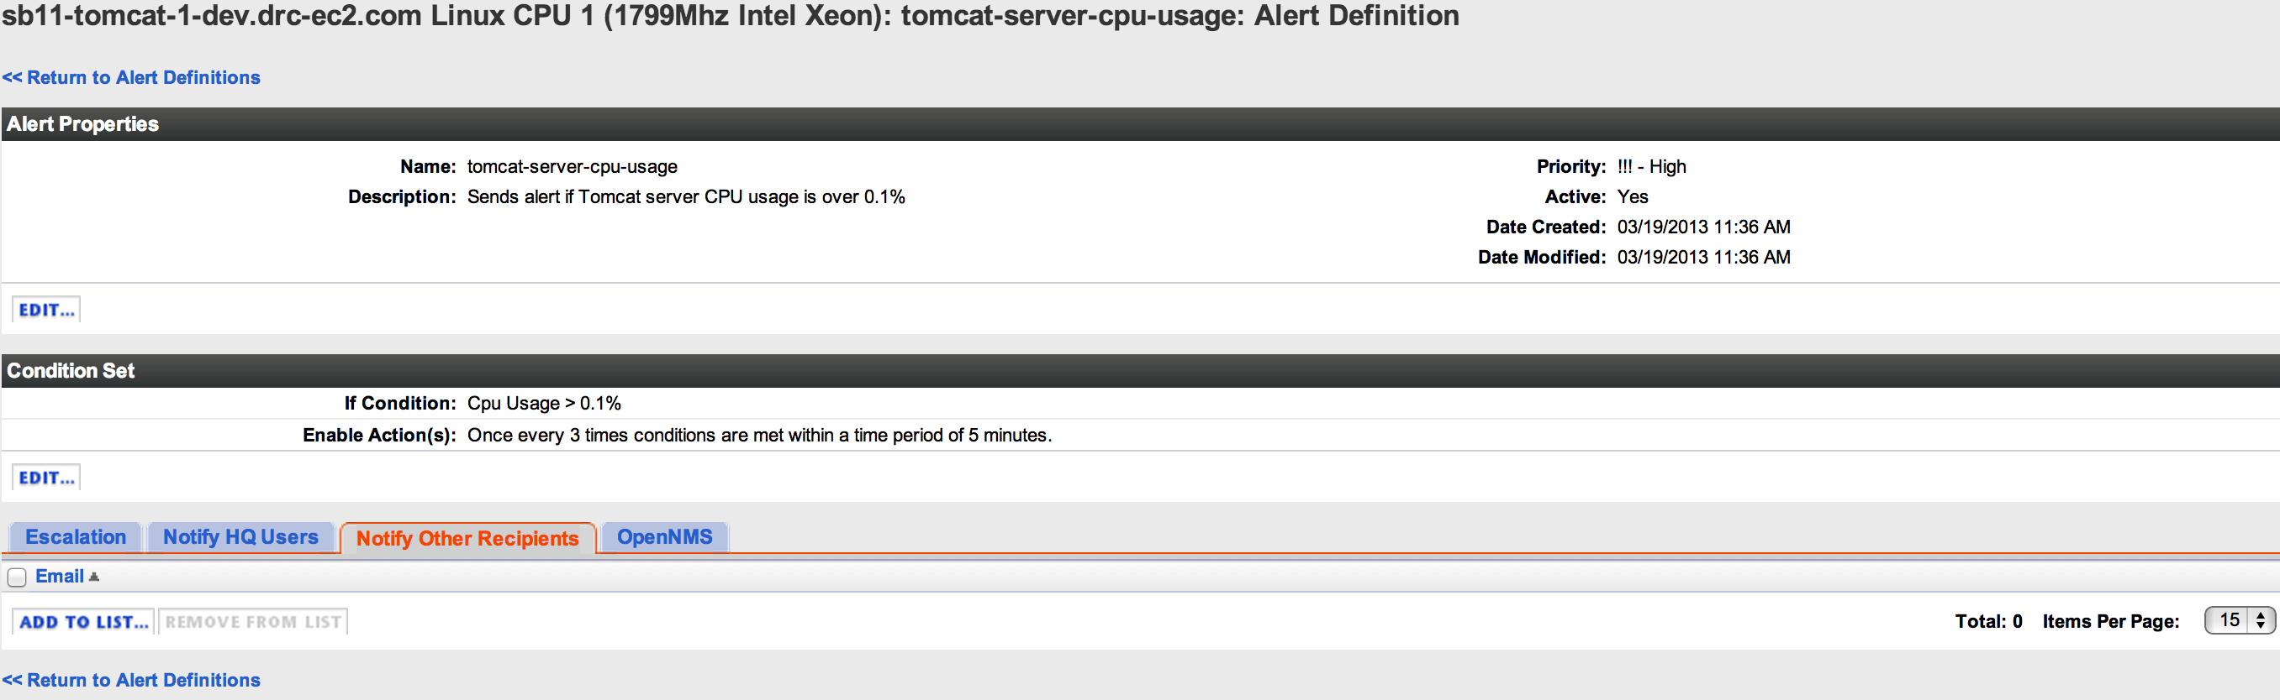
Completed Alert Definition. The tabs at the bottom are for notifying users about the alert. To send an email to any email address choose Notify Other Recipients and click ADD TO LIST...

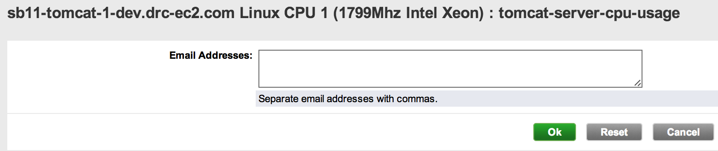
Enter in whichever email addresses are necessary to notify the correct individuals about the alert.
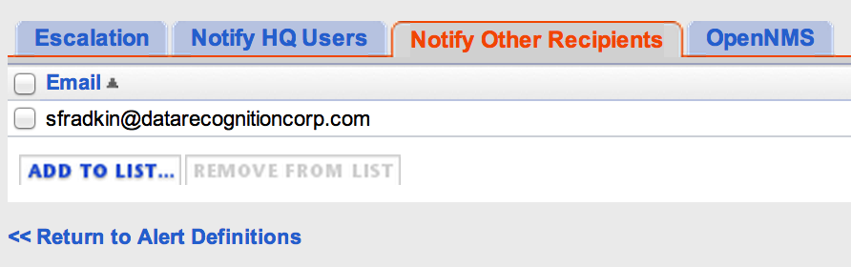
One email address will be sent an alert email.

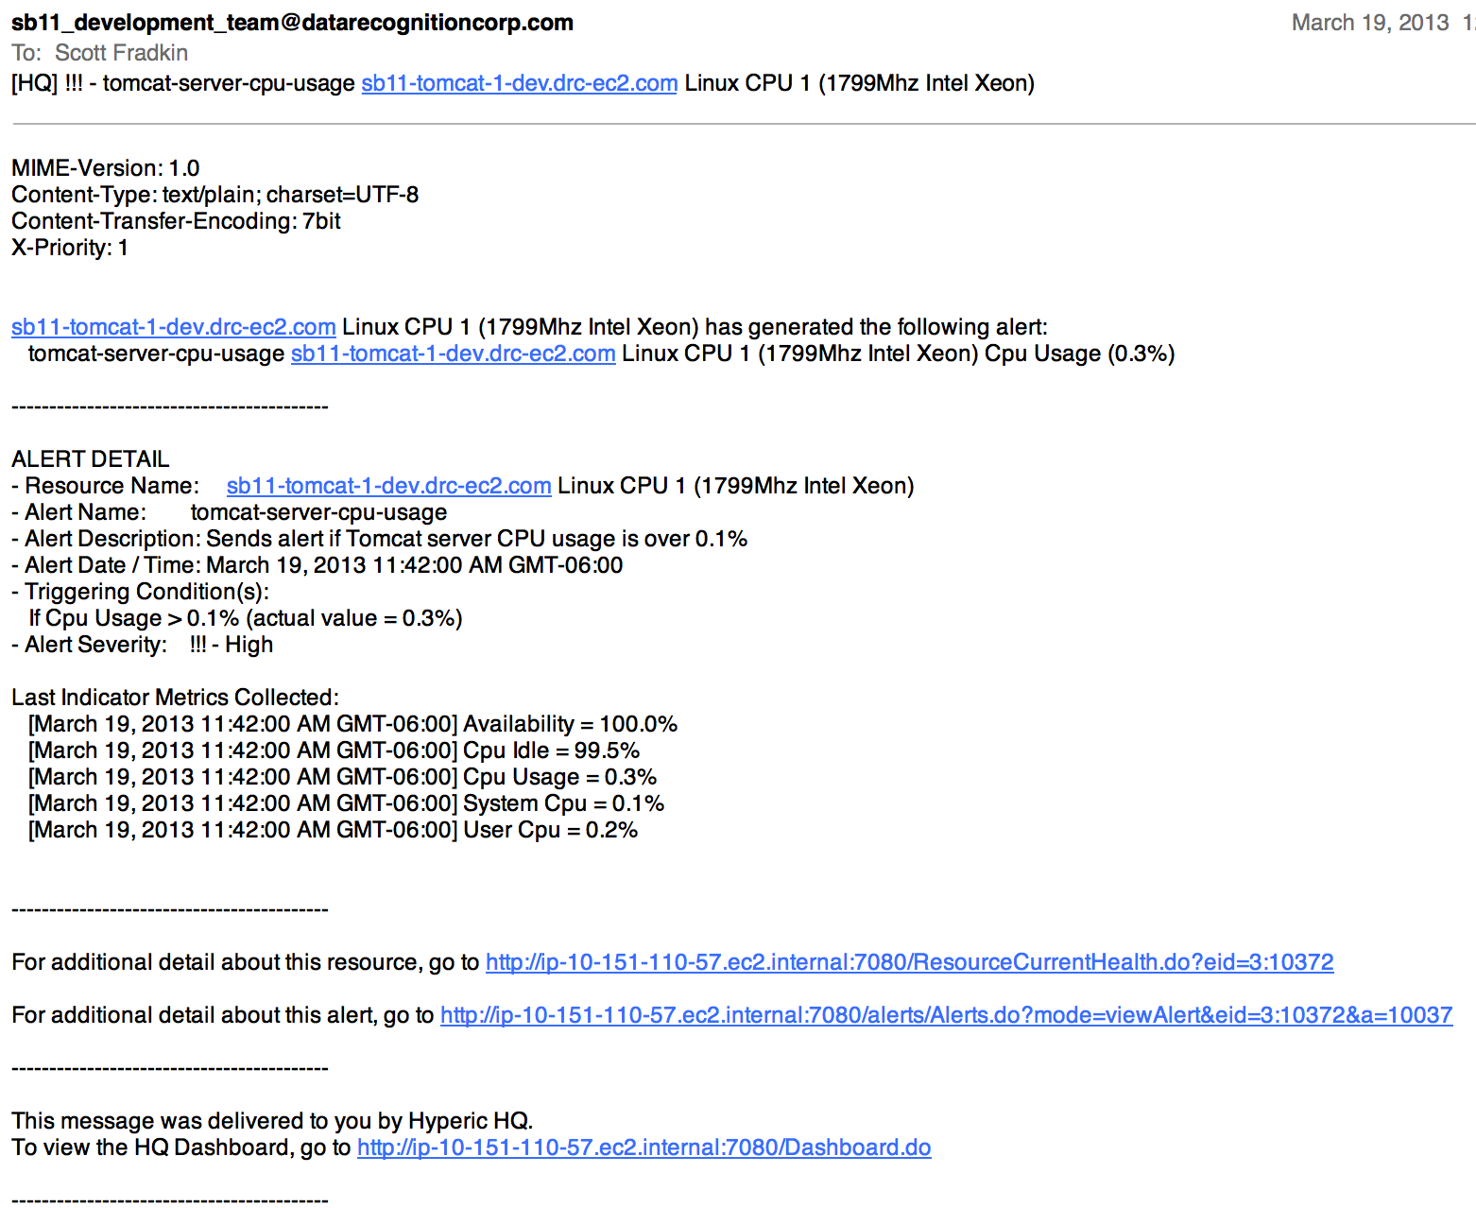
Here is an example of the email that is sent out when an alert fires.
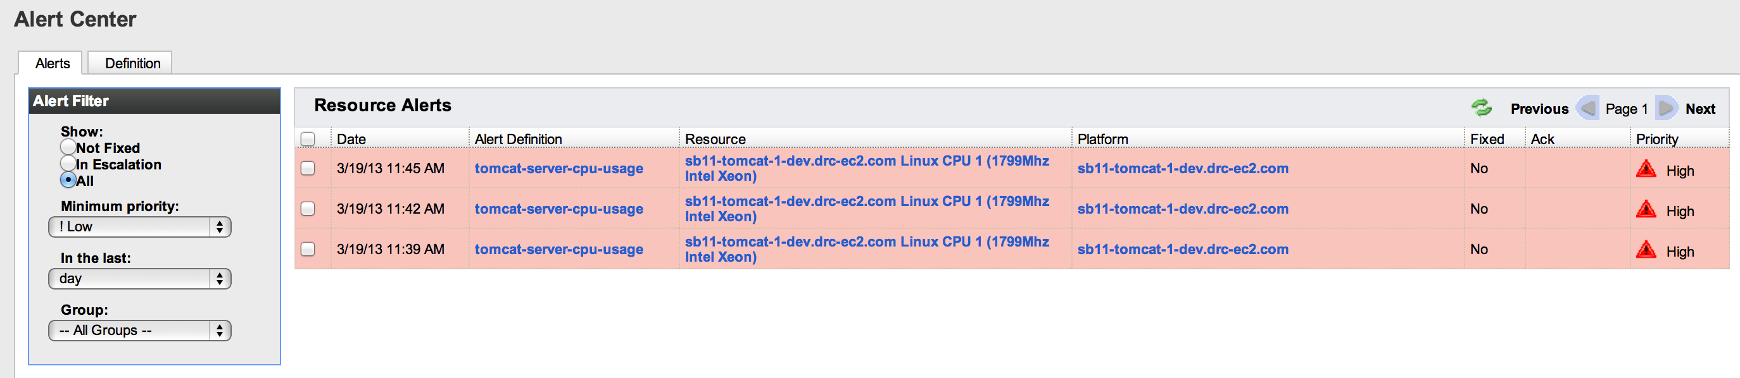
At the top of the screen is an Analyze tab with a choice called Alert Center. The Alert Center displays all alerts based on the filter defined.
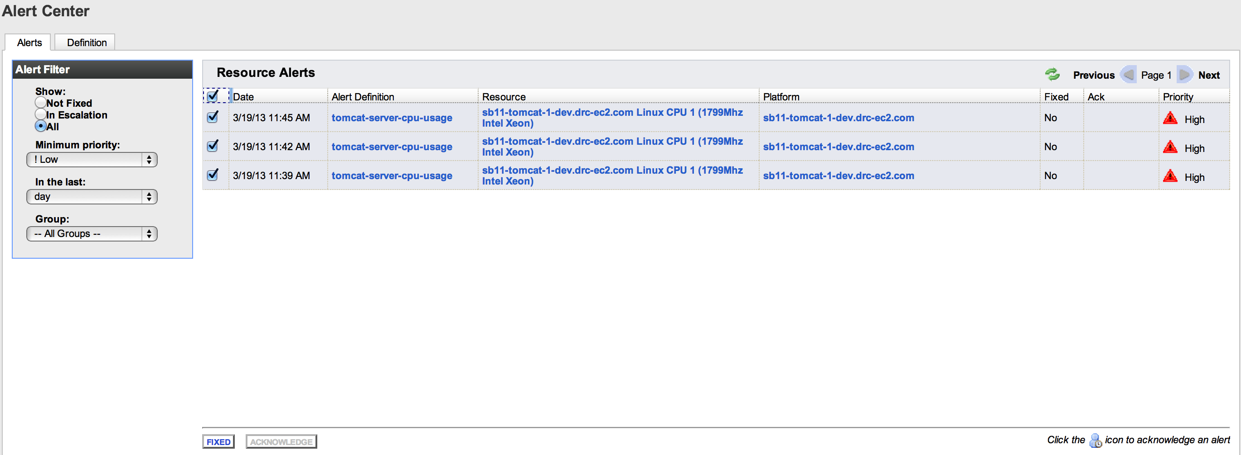
All the alerts can be checked and marked as Fixed.

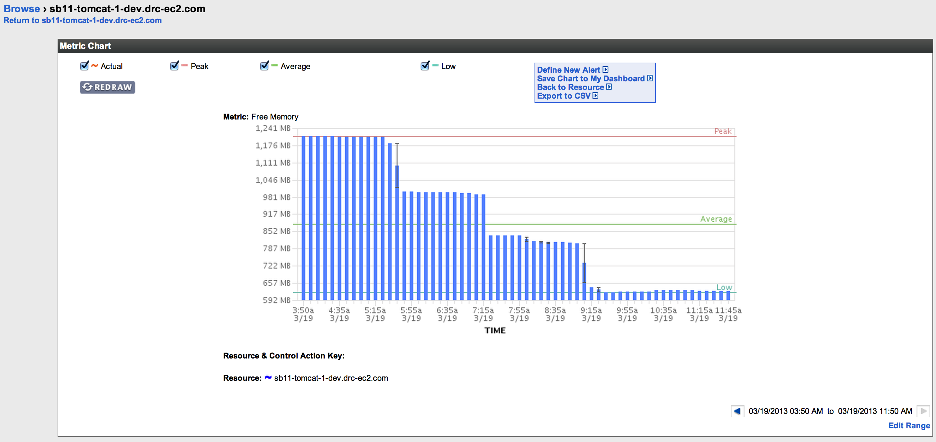
Another example of a metric along with Low, Average, and Peak indicators. Baselining is only available in the paid version of Hyperic.

