**A Guide to the Open Source Portal**

**Part 1: Set Up**

1. **Install Wordpress**

For information on installing and setting up Wordpress please refer to <http://wordpress.org/> or contact your hosting provider.

1. **Settings**
   1. Site Title

The site title is used to display the name of the site on the browser tab as well as other locations on the site. To set this got to Settings > General and edit the Site Title option.

* 1. Permalinks <http://codex.wordpress.org/Using_Permalinks>

In the wp-admin go to Settings > Permalinks and selct the Post name option. Permalinks are how Wordpress knows what content to display when a user enters the url

1. **Activate Theme**
2. Once you have installed Wordpress on your server, add the provided theme to the themes folder located at:

Your root directory/wp-content/themes/

1. In the wp-admin go to Appearance > Themes and choose to activate the theme named ‘smarterbalanced’.
2. For more information about using themes in Wordpress please refer to <http://codex.wordpress.org/Using_Themes>
3. **Install Types Plugin**
4. For this site to work properly you must install this plugin
5. In the wp-admin go to Plugins > Add New
6. Search for ‘Types’
7. Install and activate **‘Types - Custom Fields and Custom Post Types Management’, it should be the first result on the search**
8. **Import the provided Types data file**
   1. **In the wp-admin go to Types > Import/Export**
   2. **Select ‘browse’ under the Import Types data file heading**
   3. **Find the provided file named ‘typesImport.xml’**
   4. **Choose Import File**
9. **Install SAML 2.0 Single Sign-On Plugin**
   1. This plugin will allow you to connect your portal to the SSO database so your users can login with out creating a new account
   2. Upload the SAML 2.0 folder (made available by AIR) to the wp-content/plugins folder on your server.
   3. Install and activate ‘SAML 2.0 Single Sign-On’
   4. Set up
      1. Go to Settings > Single Sign-On
      2. General Tab
         * enable ‘Allow SSO Bypass’
         * enable ‘SAML authentication’
      3. Identity Provider Tab
         * In the URL to IdP Metadata field enter
         * <http://drc-dev.opentestsystem.org:8080/auth/saml2/jsp/exportmetadata.jsp?realm=sbac>
         * Select ‘Fetch Metadata’
      4. Service Provider Tab
         * Set the NameID Policy to ‘Transient’
         * Check the box to ‘generate a new certificate and private key’
         * Set the attribute values as follows

|  |  |
| --- | --- |
| **Attribute** | **Value** |
| Username | sbacUUID |
| First Name | givenName |
| Last Name | sn |
| E-mail | mail |
| Groups | groups |

* + - * Set the subscriber groups value to ‘users’
      * Enable ‘Allow Unlisted Users

1. **Other plugins that are recommended**
   1. Intuitive Custom Post Order – Allows posts to be ordered by dragging and dropping
   2. Admin Menu Editor – Customize the order of the options in the WP-Admin menu
   3. TinyMCE Advanced – Adds extra features to the WYSIWYG editor

**Part 2: Adding Content**

1. **Pages -** [**http://codex.wordpress.org/Pages**](http://codex.wordpress.org/Pages)
   1. Front-page
      1. The home page of the site is generated by front-page.php
      2. You do not have to create the home page in wordpress, it automatically knows what to display.
      3. The content on front page will change based upon whether or not the user is logged in (see II.E)
   2. In the wp-admin go to Pages > Add New
   3. There are 6 templates available in the theme
      1. Default Template – This template will display the page title as a header, and the content that is entered in the WYSIWYG of the page editor.
      2. Announcements – This template is used to create an archive of all announcements that do not fit on the home page (5)
      3. Resources – This template will show any resources that are added to the portal in a table. It also has the capability to add multiple tables to organize resources into different sections.
      4. Secure Browsers – This template is used to create a page to display information and links to download the secure browsers used to take tests. The top of the page is created from the content of the WYSIWYG of the page.
      5. Private Announcements ­– Just like the announcements template, but the content will only be displayed if the user is logged in.
      6. Private Resources – Just like the resources template, but the content will only be displayed if the user is logged in.
   4. Page Slugs
      1. The page slug is used in creating the URL for each page
      2. The slug for the archived announcements page must be ‘announcements’
      3. The slug for the private archived announcements page must be ‘private-announcements’
   5. Add pages to the forms for creating Cards and Quick Links
      1. In the wp-admin go to Types > Custom Fields
      2. Select Edit on the Cards group
      3. Under the Fields expand the Internal Link section
      4. Choose ‘Add option’
         * Under ‘Display text’ enter the page name
         * Under ‘Custom field content’ enter the permalink for the corresponding page
      5. Save
2. **Posts -** [**http://codex.wordpress.org/Post_Types**](http://codex.wordpress.org/Post_Types)
   1. Posts are how individual nodes of content are created in Wordpress
   2. This theme is set up to use custom post types for creating specific types of content
      1. Cards – Links to navigate around the portal or to other sites

* A library of images to use on cards has been provided
* Custom images should be 130px by 85px
* The post title is the text displayed on the card
  + 1. Quick Links – Same as cards but located in the side bar
* A library of images to use on quick links has been provide
* Custom images should be 47px by 48px
* The post title is the text display on the quick link
  + 1. Announcements – News that is important for users to see
* The bullet will display as ‘New’ for the first 3 days after an announcement has been posted
* If you have created a page titled ‘Archived Announcements’ then a link to the archived announcements page will be displayed at the end of the list
* The content added to the WYSIWYG editor is what is displayed
  + 1. Messages – Welcome text for the home page
* The post title will be displayed as the section header
* The content added to the WYSIWYG editor is what is displayed as the message
  + 1. Resources – Documents or links that users can use
* Resource Groups – allow for multiple tables to be displayed on the resources page
* If you do not assign any resource groups all resources will be displayed in one table
  + 1. Secure Browsers – Information on how to download and install the secure browser used for taking tests.
    2. Browser Information – General information about the secure browsers
    3. Private Portal URL – Creating this post will display a link in the header to allow users to login to the private application that provides them with links to all the systems they have access to
  1. Each Custom Post type has a unique form to fill out that will gather the data needed to create that type of content
  2. To create a new post select the name of the post type in the menu then Add New
  3. Private vs. Public
     1. Security Taxonomy
* Make sure there are two values available
* Public, slug must be exactly ‘public’
* Private, slug must be exactly ‘private’
  + 1. If you want a post to display when users are not logged in choose ‘Public’ for the Security value
    2. To display a post only for logged in users choose ‘Private’ for the Security value
    3. To display a post for both logged in and not logged in users select both ‘Public’ and ‘Private’

1. **Templates**
   1. You can create your own custom templates to add page layouts that have not been included
   2. To learn more about creating templates visit <http://codex.wordpress.org/Stepping_Into_Templates>
   3. Using the types Plugin
      1. <http://wp-types.com/home/types-manage-post-types-taxonomy-and-custom-fields/>
      2. Types allows you to create custom post types and fields for creating specific types of content that need more control than a WYSIWYG allows
      3. This API explains how to use the different fields that are available through Types <http://wp-types.com/documentation/functions/>

**Part 3: Branding**

1. **Color Scheme**
   1. Edit via Wordpress Admin
2. Go to Appearance > Editor
3. On the right hand side under Styles, select branding.css
4. All of the styles in this document are the colors of the site
5. Change the hexadecimal values to those of the colors you wish to brand your site with
   1. Edit via FTP
6. In the theme folder there is a style sheet named branding.css
7. Open this file in a text editor
8. All of the styles in this document are the colors of the site
9. Change the hexadecimal values to those of the colors you wish to brand your site with
10. **Images**
    1. All images on the site are located in the images folder inside the theme folder
    2. To change any of these just replace them with you own image using the same file name

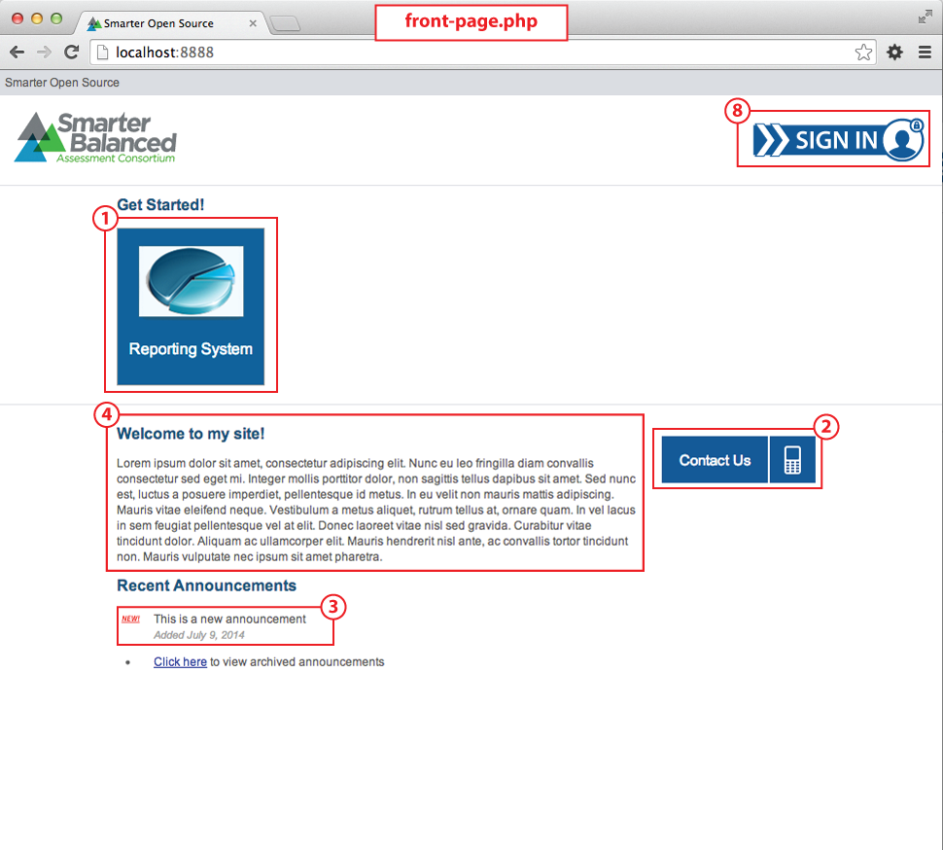dsfsd

