Smarter Balanced Assessment Consortium

TDS Admin User Guide

Published 5/25/2016

Prepared by the American Institutes for Research®



Contents

Introduction to this User Guide 1

Section I. Accessing TDS Admin 2

About User Roles 2

Section II. Overview of TDS Admin 3

About the TDS Admin Actions 3

About the TDS Admin Layout 4

Section III. Using TDS Admin 7

Searching for Test Opportunities 7

Performing TDS Admin Actions 7

Extending Grace Periods 7

Resetting Opportunities 8

Restoring Opportunities 8

Extending Expiration Dates 8

Reopening Opportunities 9

Invalidating Opportunities 9

Changing Segment Permeability 9

Viewing Action Results 10

Appendix A. User Support 11

List of Figures

Figure 1. Login Page 2

Figure 2. TDS Admin Layout (After Search) 5

Figure 3. TDS Admin Search Filters 7

Figure 4. Action Results 10

Introduction to this User Guide

This user guide provides information about using the TDS Admin application. TDS Admin allows authorized users to search for and perform basic administrative actions on student test opportunities that were administered in TDS.

This user guide includes the following sections:

* Section I, Accessing TDS Admin, explains how to log in to TDS Admin.
* Section II, Overview of TDS Admin, explains the layout of TDS Admin and provides an overview of the actions you can perform on student test opportunities.
* Section III, Using TDS Admin, provides instructions for performing actions on student test opportunities.

Table 1 describes icons and typographical elements that appear in this user guide.

Table 1. Key Icons and Elements

| Icon | Description |
| --- | --- |
|  | **Note:** This symbol appears next to text that contains helpful information or reminders. |
| **Text** | Text in bold indicates a clickable link or button. |
| Text | Text in bold italics indicates a page name. |
| Text | Text in italics indicates field names or labels. |

# Accessing TDS Admin

This section contains information about logging in to TDS Admin. To access TDS Admin, you must have an authorized username and password. Your system administrator sets up your user account and provides you with the login credentials.

To log in to TDS Admin:

1. Open your web browser and navigate to TDS Admin using the URL provided to you. You will be directed to the login page.

Figure 1. Login Page

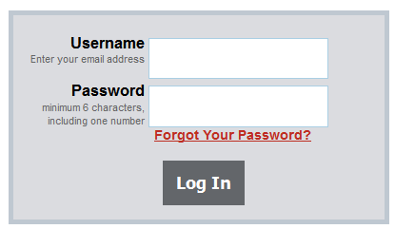

1. In the Username field, enter your username.
2. In the Password field, enter your password.
3. Click **Log In**.

|  |  |
| --- | --- |
|  | **Note**: If a user is already logged into the proctor application when trying to log in as the TDS Administrator, and the proctor session times out, the TDS Admin app will time out as well. We recommend the proctor application and TDS Admin Tool application be opened separately, and at different times. |

## About User Roles

The following user roles may access TDS Admin:

* **TDS Administrator**—Users with this role may search for student test opportunities and perform all of the available administrative actions on them.
* **TDS Admin Viewer**—Users with this role may search for student test opportunities, but they cannot perform any administrative actions on them.

|  |  |
| --- | --- |
|  | **Note**: All users in TDS Admin can access any opportunity available in the associated TDS session database, regardless of the users’ hierarchy level. Since TDS is associated with one tenant at a time, users cannot access any opportunities for other tenants. |

# Overview of TDS Admin

This sections provides overviews of the actions you can perform in TDS Admin and the layout of the application.

## About the TDS Admin Actions

Table 2 provides descriptions of the actions you can perform on student test opportunities.

Table 2. Overview of Administrative Actions

|  |  |
| --- | --- |
| Action | Description |
| Extend Grace Period | The grace period refers the length of time a student can pause a test and still be allowed to review previously-answered items. If a student exceeds the grace period, this action allows the student to review those items that would otherwise be prohibited. For information about performing this action, see the section Extending Grace Periods. |
| Reset Opportunity | This action removes a student’s opportunity record, allowing that student the chance to use the opportunity again. For more information about performing this action, see the section Resetting Opportunities. |
| Restore Opportunity | This action reverses the Reset Opportunity action. For information about performing this action, see the section Restoring Opportunities. |
| Extend Expiration Date | This action changes the expiration date for an expired opportunity, allowing the student to continue answering and viewing items in the test. For information about performing this action, see the section Extending Expiration Dates. |
| Reopen Opportunity | This action allows students to continue answering and viewing items in a test that was expired, completed, or invalidated. For information about performing this action, see the section Reopening Opportunities. |
| Invalidate Opportunity | If a student is suspected of cheating on a test, this action sets that student’s opportunity to an invalid state. For information about performing this action, see the section Invalidating Opportunities. |
| Change Segment Permeability | Some test segments can be impermeable, meaning that students cannot return to them once they have proceeded to the next segment in the test. This action allows students to return to an impermeable segment to review and modify answers. For more information about performing this action, see the section Changing Segment Permeability. |

Table 3 provides descriptions of the actions you can perform on student test opportunities based on the status of a student’s test.

Table 3. Available Administrative Actions by Test Status

|  |  |  |  |  |  |  |  |
| --- | --- | --- | --- | --- | --- | --- | --- |
| **Opportunity Status** | **Extend Grace Period** | **Reset a Test** | **Restore a Test** | **Extend Expiration Date** | **Reopen a Test** | **Invalidate a Test** | **Change Segment Permeability** |
| Completed | ✓ |  |  |  | ✓ | ✓ | ✓ |
| Expired | ✓ |  |  | ✓ | ✓ | ✓ | ✓ |
| Invalidated | ✓ | ✓ |  |  | ✓ |  | ✓ |
| Paused | ✓ |  |  | ✓ | ✓ | ✓ | ✓ |
| Reset | ✓ |  | ✓ |  |  |  | ✓ |

## About the TDS Admin Layout

TDS Admin consists of a single page on which you search for test opportunities and perform actions on those opportunities.

When you first log in to TDS Admin, only the search filters are available. After you perform a search, the table of retrieved opportunities appears below the filters, along with a Reason field and **Execute Procedure on Selected Opportunities** button.

Figure 2 displays the layout of the TDS Admin site after performing a search.

Figure 2. TDS Admin Layout (After Search)

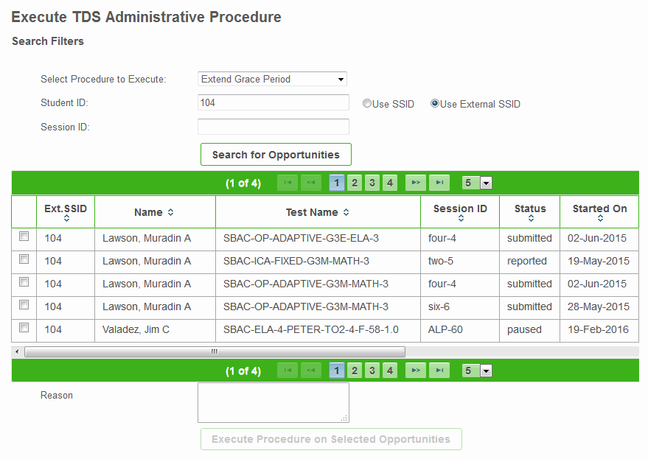

The table of retrieved opportunities is paginated. You can use the navigation buttons above or below the table to move between the pages. You can also select options from the drop-down list to the right of the navigation buttons to specify the number of opportunities that display on each page.

You can sort the retrieved opportunities by any column in the table except columns with user-changeable fields. Click the required column header once to sort in ascending order, and click it again to sort in descending order.

The table of retrieved opportunities displays a row for each retrieved opportunity (or each retrieved segment, in the case of the Change Segment Permeability action). Most columns in this table appear for all actions, but some only appear for specific actions. Table provides descriptions of the columns in this table.

Table 4. Columns in the Table of Retrieved Opportunities

| Column | Description |
| --- | --- |
| Ext. SSID | Student’s external State Student Identifier |
| Name | Student’s last and first name |
| Test Name | Name of the test |
| Session ID | ID for the most recent session in which the student accessed the opportunity |
| Status | Current status of the test opportunity |
| Started On | Date on which student first accessed the opportunity |
| Expired On | Opportunity’s expiration date |
| Completed On | Date on which the student completed the opportunity |
| Paused On | Date on which the student paused the opportunity |
| Restarts | Number of times the opportunity has been reset |
| Selected Sitting a | Number of times student logged in to the opportunity, where the first login attempt is 0 and each attempt afterward increments that number by one |
| Day Increment b | Number of days by which to extend the opportunity’s expiration date |
| Segment Name c | Name of the segment within the opportunity |
| Segment Position c | Order in which the segment appears in the opportunity |
| Permeable c | Indicates whether student can return to the segment after completing it |
| Restore On c | State in which a segment restores its default permeability setting |
| Result | Displays Success or Failed depending on the outcome of the administrative action performed on an opportunity |
| Column appears for Extend Grace Period actions  Column appears for Extend Expiration Date actions  Column appears for Change Segment Permeability actions | |

# Using TDS Admin

This section explains how to search for student test opportunities and perform actions on them in TDS Admin.

## Searching for Test Opportunities

This section describes the procedure for searching for opportunities. When searching for test opportunities in TDS Admin, you can search by one or both of the following:

* Session ID
* Student ID (either the student’s SSID or External SSID)

Figure 3. TDS Admin Search Filters

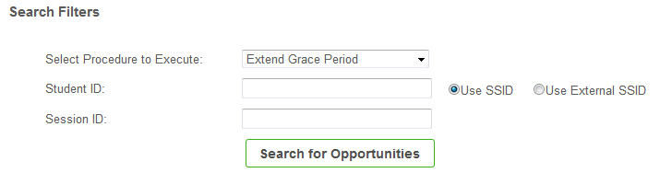

To search for student test opportunities:

1. From the **Select Procedure to Execute** drop-down list, select the type of administrative action you need to perform. For an explanation of these actions, see Table 2.
2. If you wish to search by the student’s ID, do the following in the Student ID field:
   * Enter the student’s SSID and mark the **Use SSID** radio button.
   * Enter the student’s external SSID and mark the **Use External SSID** radio button.
3. If you wish to search by Session ID, enter the required ID in the Session ID field.
4. Click **Search for Opportunities**. The retrieved opportunities appear in a table below the search filters. For a description of the columns in this table, see Table 4.

For instructions for performing actions on the retrieved opportunities, see the section Performing TDS Admin Actions.

## Performing TDS Admin Actions

This section provides instructions for performing each of the actions available in TDS Admin.

### Extending Grace Periods

If students paused a test past the grace period through no fault of their own, you can follow these instructions to extend the grace period for an opportunity.

To extend the grace period for an opportunity:

1. From the **Select Procedure to Execute** drop-down list, select **Extend Grace Period**.
2. Search for opportunities by following the procedure in the section Searching for Test Opportunities.
3. Mark the checkbox for the opportunity whose grace period you need to extend.
   1. In the Selected Sitting column for that opportunity, enter an appropriate value.
4. Repeat steps 3–3.a for each additional opportunity whose grace period you need to extend.
5. Optional: In the Reason text box, enter a comment explaining why you are performing this action.
6. Click **Execute Procedure on Selected Opportunities**.

### Resetting Opportunities

If you need to erase a student’s existing opportunity so that the student may use the opportunity again, you can follow these instructions to reset the opportunity.

To reset an opportunity:

1. From the **Select Procedure to Execute** drop-down list, select **Reset Opportunity**.
2. Search for opportunities by following the procedure in the section Searching for Test Opportunities.
3. Mark the checkbox for each opportunity you need to reset.
4. Optional: In the Reason text box, enter a comment explaining why you are performing this action.
5. Click **Execute Procedure on Selected Opportunities**.

### Restoring Opportunities

If you reset an opportunity accidentally, you can follow these instructions to restore the opportunity.

To restore an opportunity:

1. From the **Select Procedure to Execute** drop-down list, select **Restore Opportunity**.
2. Search for opportunities by following the procedure in the section Searching for Test Opportunities.
3. Mark the checkbox for each opportunity you need to restore.
4. Optional: In the Reason text box, enter a comment explaining why you are performing this action.
5. Click **Execute Procedure on Selected Opportunities**.

### Extending Expiration Dates

If students need to access an opportunity after its expiration date, you should follow these instructions to extend the opportunity’s expiration date.

To extend the expiration date for an opportunity:

1. From the **Select Procedure to Execute** drop-down list, select **Extend Expiration Date**.
2. Search for opportunities by following the procedure in the section Searching for Test Opportunities.
3. Mark the checkbox for the opportunity whose expiration date you need to extend.
   1. In the Day Increment column for that opportunity, enter the number of days by which you need to extend the opportunity. Be sure to calculate the number of days you’d like incremented based on the date in the expired on column.
4. Repeat steps 3–3.a for each additional opportunity whose expiration date you need to extend.
5. Optional: In the Reason text box, enter a comment explaining why you are performing this action.
6. Click **Execute Procedure on Selected Opportunities**.

### Reopening Opportunities

If students need to access an opportunity that is in a closed state, you should follow these instructions to reopen the opportunity.

To reopen an opportunity:

1. From the **Select Procedure to Execute** drop-down list, select **Reopen Opportunity**.
2. Search for opportunities by following the procedure in the section Searching for Test Opportunities.
3. Mark the checkbox for each opportunity you need to reopen.
4. Optional: In the Reason text box, enter a comment explaining why you are performing this action.
5. Click **Execute Procedure on Selected Opportunities**.

### Invalidating Opportunities

If a student is suspected of cheating on an opportunity, you can follow these instructions to invalidate that opportunity.

To invalidate an opportunity:

1. From the **Select Procedure to Execute** drop-down list, select **Invalidate Opportunity**.
2. Search for opportunities by following the procedure in the section Searching for Test Opportunities.
3. Mark the checkbox for each opportunity you need to invalidate.
4. Optional: In the Reason text box, enter a comment explaining why you are performing this action.
5. Click **Execute Procedure on Selected Opportunities**.

### Changing Segment Permeability

If a student needs to return to an impermeable segment in an opportunity, you can follow these instructions to modify the segment’s permeability.

To change a segment’s permeability:

1. From the **Select Procedure to Execute** drop-down list, select **Change** **Segment Permeability**.
2. Search for opportunities by following the procedure in the section Searching for Test Opportunities.
3. Mark the checkbox for the segment whose permeability you need to change.
   1. In the Permeable column for that opportunity, mark the checkbox.
   2. From the drop-down list in the Restore On column, select the state in which the segment’s default permeability setting should be restored:
   * **Segment**—The segment’s original permeability setting is restored when student navigates to the next segment in the test.
   * **Paused**—The segment’s original permeability setting is restored when student pauses the test.
   * **Completed**—The segment’s original permeability setting is restored after completing the test.

|  |  |
| --- | --- |
|  | **Note**: When an impermeable segment’s default permeability setting is restored, the student will not be able to return to that segment to review or modify answers. |

1. Repeat steps 3–3.b for each additional segment whose permeability setting you need to change.
2. Optional: In the Reason text box, enter a comment explaining why you are performing this action.
3. Click **Execute Procedure on Selected Opportunities**.

## Viewing Action Results

After you perform an action in TDS Admin, a results counter in the upper-left corner of the table indicates how many of the executions succeeded and how many failed. The Result column in the table also shows you the outcome for each selected opportunity. If the action failed for an opportunity, you can hover over Failed in the Result column to view a message explaining the reason for the failure.

Figure 4. Action Results

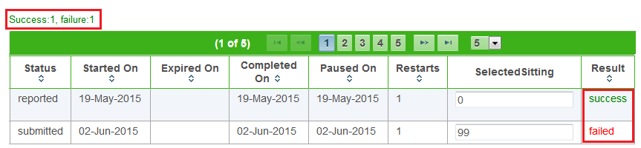

If the action failed for an opportunity, you can hover over *Failed* in the Result column to view a message explaining the reason for the failure.

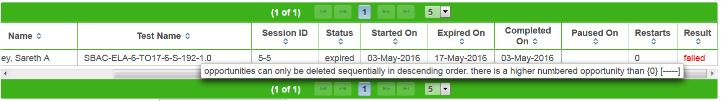

Appendix A. User Support

|  |  |
| --- | --- |
| Contact Information | |
| **Questions about state policies** | **Questions about technology and the overall administration procedures** |
| STATE  **Accommodations, Test Policy, Testing Irregularities**  {Blanks to fill in with your specific state information}   |  |  | | --- | --- | | Name: |  | | Phone: |  | | Email: |  |   **Your Smarter Balanced State Lead Contact (in the event of a security breach or irregularity)**  {Blanks to fill in with your specific state information}   |  |  | | --- | --- | | Name: |  | | Phone: |  | | Email: |  | | Assessment Program Name  Monday–Friday from 6:30 a.m. to 6:30 p.m. Eastern Time  800-555-5555  [demoHelpDesk@air.org](mailto:demoHelpDesk@air.org) |