***TDS Admin Sequence Diagram***

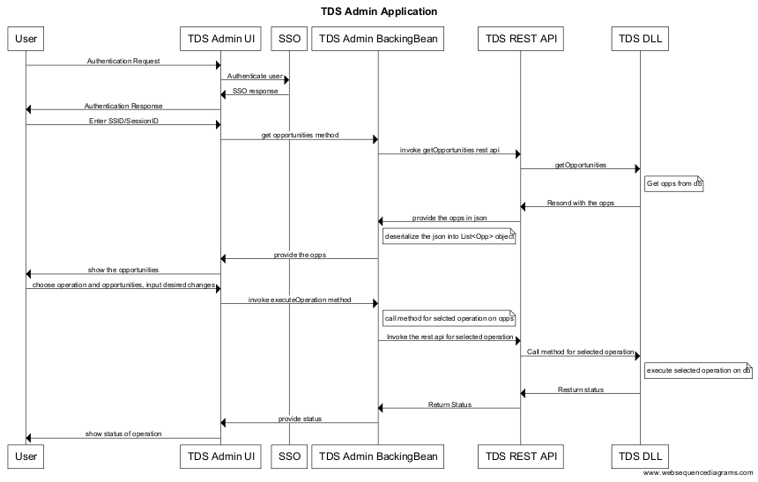

Figure 1: Sequence diagram for fetching opportunities and execute operations

Components:

1. TDS Admin UI : This will be one jsf page providing the interface to user for fetching opportunities, select database operations and modify opportunities.
2. TDS Admin Backing Bean: This is the java code working behind the UI
3. TDS REST API: These are the rest web service called from TDS Admin Backing Bean to interact with the database layer. TDS Admin can’t call the database layer directly.
4. TDS DLL: This component provides the api to execute database operation in raw level.
5. SSO: This manages user authentication
6. MNA: This manages logging of all sorts of activities within the TDS Admin application. (Not available in the diagram yet)