­Smarter Balanced Assessment Consortium

Administration and Registration Tools User Guide

Updated April 21, 2020

Contents

Overview of the Administration and Registration Tools System 4

Inter-relation between the Administration and Registration Tools System and other Smarter Balanced Systems 4

User Roles and Permissions 4

Understanding the Smarter Balanced Hierarchy 4

About Microsoft Excel Files 5

Introduction to This User Guide 6

Accessing and Understanding the ART Interface 7

Logging on to ART 7

ART Home Screen 7

ART Banner 8

Task Bar. 9

Edit Profile 9

Creating Records in ART 11

File Uploads. 11

Download File Templates 12

Creating an Upload File. 13

Uploading Files. 14

Creating/Modifying Individual Records. 18

About Data Columns and Edit Fields. 20

Managing Records 22

Managing State Groups. 22

Create or modify state groups. 22

Upload state groups. 23

Managing Districts. 24

Create or modify a district. 24

Upload districts. 25

Managing Institution Groups. 27

Create or modify institution groups. 27

Upload institution groups. 28

Managing Institutions. 30

Create or modify an institution. 30

Upload Institutions. 31

Managing Users. 33

Create or modify a user record. 33

List of Figures

Figure 1. Simple Smarter Balanced Hierarchy 5

Figure 2. Login Screen 7

Figure 3. ART Home Screen for the Client Role 8

Figure 4. Task Bar 9

Figure 5. Edit Profile Screen 10

Figure 6. Download Templates Screen 12

Figure 7. Sample Template for District Records 13

Figure 8. Step 1: Upload File 14

Figure 9. Step 2: Preview Records 15

Figure 10. Step 3: Successful Validation 16

Figure 11. Failed Validation 16

Figure 12. Sample Error Message 17

Figure 13. Failed Validation 17

Figure 14. Upload File, Step 4: Confirmation 18

Figure 15. Sample Create/Modify [Record Type] Screen 18

Figure 16. Comparison Between Labels for Edit Fields and Data Columns 21

Figure 17. Group of States Search Screen 22

Figure 18. District Search Screen 24

Figure 19. Institution Group Search Screen 27

Figure 20. Institution Search Screen 30

Figure 21. User Search Screen 33

# Overview of the Administration and Registration Tools System

The Administration and Registration Tools (ART) system allows authorized users to create and manage records, users, and entities such as states, districts, and institutions. You can upload records in groups or manage them individually in ART.

## Inter-relation between the Administration and Registration Tools System and other Smarter Balanced Systems

ART has connections to the following Smarter Balanced systems.

* **Single Sign-On (SSO)**: This system is responsible for user authentication and authorization, and allows you to log in to the Smarter Balanced systems. After logging in, you can switch between systems without logging in and out of each system. Users added through ART are automatically added to SSO, and permissioned users added to SSO can log in to ART.
* **Reporting Data Warehouse**: This system stores student groups and results for assessments.

## User Roles and Permissions

ART restricts access to certain tasks based on your designated role. You can access the data stored in ART and perform tasks based on your permissions. Table 1 lists the standard roles in ART.

Table 1. Standard ART User Roles

| User Role | Description |
| --- | --- |
| **State Coordinator** | State Coordinators can create other State Coordinator accounts as well as District Coordinator, School Coordinator, and Test Administrator accounts. They can upload data across all districts and institutions within their states. |
| **District Coordinator** | District Coordinators can create other District Coordinator accounts as well as School Coordinator and Test Administrator accounts. They can upload data across all institutions within their districts. |
| **School Coordinator** | School Coordinators can create other School Coordinator and Test Administrator accounts. They can upload data for their institution only. |

## Understanding the Smarter Balanced Hierarchy

The Smarter Balanced hierarchy organizes entities. For this user guide, the term “entity” refers to institutions, groups of institutions, districts, groups of districts, and states. Figure 1 provides a simple hierarchy, please note that it is not representative of the entire available structure. In this case, a teacher is associated with an institution, the institution is in a group of institutions, the group of institutions is in a district, the district is in a group of districts, the group of districts is in a state, and the state is a member of the Smarter Balanced consortium. You may construct hierarchies with different structures as well.

|  |  |
| --- | --- |
|  | You can rename any of these entity levels. For example, you may choose to rename “Institution” and “Group of Institutions” as “School” and “Group of Schools,” respectively. |

Figure 1. Simple Smarter Balanced Hierarchy

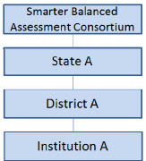

* All relationships are limited by permissions. For example, a user at the institution level cannot add users or entities to the district level, but a user at the district level can add users to institutions within that district.
* An entity or must have only one “parent.” The parent is the entity to which another entity or user belongs. For example, an institution can be in only one district, and a district can be in only one state.

## About Microsoft Excel Files

The Administration and Registration Tools system allows you to upload files in one of two formats: .csv and .xlsx. Your version of Excel impacts the file format you should select or use.

CSV (comma-separated values):

If you have Excel 2003 or earlier, Smarter Balanced recommends that you download exported records in .csv format. CSV files do not automatically preserve leading zeros (numbers that begin with at least one zero at the beginning, e.g., 0001234).

Excel:

Microsoft Excel 2007 and later .xlsx files automatically preserve leading zeros. These files cannot be opened using an earlier version of Excel.

# Introduction to This User Guide

This user guide provides information about using ART to create and manage assessment registrations and schedules. This introduction describes the contents of this document and includes a key for identifying icons and elements.

This user guide includes the following sections:

* Accessing and Accessing and Understanding the ART Interface explains how to log in to ART and describes the overall layout of the ART interface.
* Creating Records in ART explains how to create records and upload records using the ART interface.
* Managing Records explains how to create and modify institutions and organization hierarchies.

Table 2 describes icons and typographical elements that appear in this user guide.

Table 2. Key Icons and Elements

| Icon | Description |
| --- | --- |
| Red hazzard sign | **Warning:** This symbol appears with text that contains extremely important information regarding actions that may cause errors. |
| Hazzard sign | **Caution:** This symbol appears with text that contains important information regarding a task. |
| Notebook | **Note:** This symbol appears next to text that contains helpful information or reminders. |
| Text graphic | Text that appears in gray boxes provides instructions relevant to the task described.   * Numbered (ordered) lists provide step-by-step instructions. * Bulleted lists provide instructions that do not need to be done in a specific order. |
| [**Text**] | Text in brackets is used to indicate a link or button that is clickable. |
| Text | Text in bold italics indicates a screen name. |
| Text | Text in italics indicates field names or labels. |

# Accessing and Understanding the ART Interface

This section contains information about how to log on to ART, how to reset a forgotten password, and navigate the ART user interface.

## Logging on to ART

To access the Administration and Registration Tools System, you must have an authorized username and password. Since the Administration and Registration Tools System is an open-source system, your system administrator will be responsible for setting up your user account and providing you the login credentials.

To log in to the Administration and Registration Tools System:

|  |  |
| --- | --- |
| 1. Open your web browser and navigate to the Administration and Registration Tools System using the URL provided to you. You will be directed to the Single Sign-On Login screen. 2. In the *Username* field, enter your username. 3. In the *Password* field, enter your password. 4. Click [**Log In**]. You will be directed to the Administration and Registration Tools System home screen, provided your login is authenticated. | Figure 2. Login Screen  Login screen |

## ART Home Screen

The first screen you see after logging in to ART is the ART home screen. You can click the button for a task to begin working on that task. The tasks that are available on the home screen depending on your user role. Figure 3 displays the home screen for the Client Coordinator role.

Figure 3. ART Home Screen for the Client Role

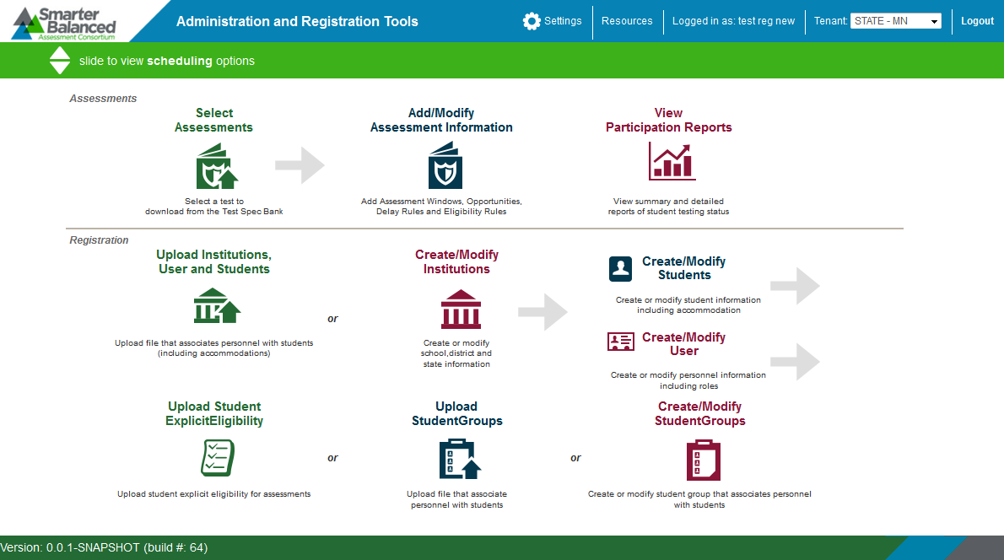

|  |  |
| --- | --- |
| Hazzard sign graphic | Do not have more than one ART browser tab or window open simultaneously. Changes made in one tab or window may overwrite changes made in another, resulting in loss of data. |

The ART home screen provides brief directions for the required workflow. The arrow (Arrow) symbols indicate precedence: you must complete a task to the left of the symbol before performing the task to the right. The “or” indicates a choice between one of the tasks. For instance, you must upload institutions before you can create users, etc.

|  |  |
| --- | --- |
| Notebook | For the Smarter Reporting System, ART’s primary use if for uploading institutions and creating users. Student Groups, for example, are managed elsewhere. Many of the tools on the home screen will not be used by Service Providers. |

## ART Banner

The ART banner at the top of the screen displays the following information and links:

* **[Smart Balanced**] logo—Click to return to the home screen at any time.
* [**Settings**]—Click to configure system-wide settings.
* [**Resources**] —Click to access the Download Templates screen or view the user guide.
* **[Your user name]** – Click to **Edit Profile** or **Logout**
* **[Tenant**] —Your tenancy, the state or client associated with your logon.
* [**Logout**]—Click to log out of the site.

### Task Bar.

The task bar below the banner enables you to switch between registration tasks and assessment administration tasks, such as scheduling. By default, the home screen displays the registration tasks. To view the assessment administration tasks, click the arrows shown in Figure 4.

Figure 4. Task Bar

Task Bar

## Edit Profile

Users can edit/modify their profile, including:

* Change/reset password
* Change email address
* Change First and Last Name
* Change phone number
* Delete assigned roles (cannot add a role)

To edit your profile:

|  |
| --- |
| 1. On the ART banner, at the top of the screen, select your user name 2. Select *Edit Profile* 3. Modify your information 4. Click **[Save]** |

|  |  |
| --- | --- |
| Notebook graphic | When changing/resetting your password, you do not have to log out of your current session. You will be required to enter your new password the next time you log in. |

Figure 5. Edit Profile Screen

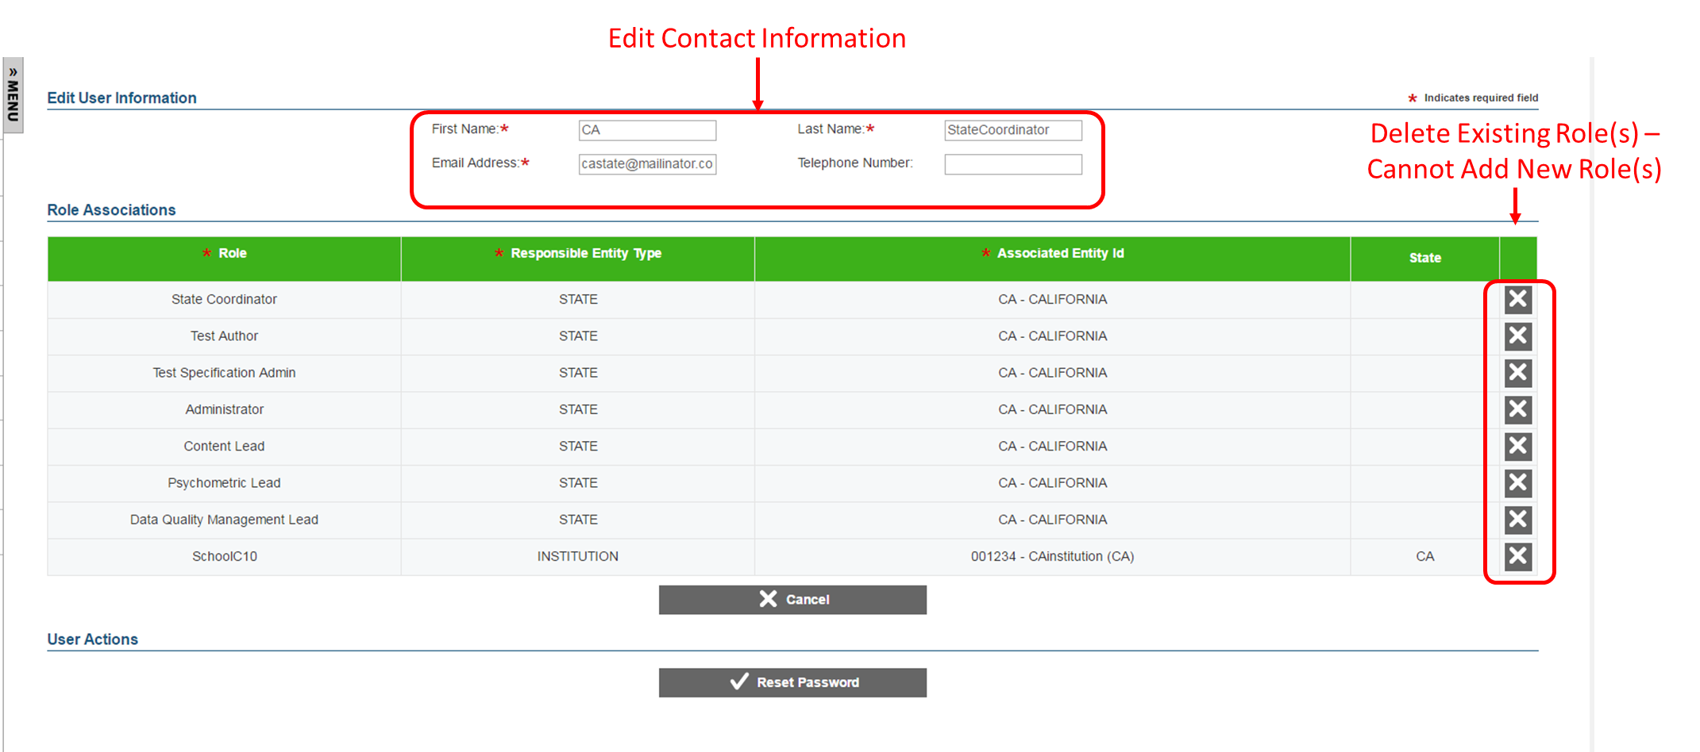

# Creating Records in ART

This section describes how to build a hierarchy of entity records from the state level to the institution level. You can upload entity and user records in groups, or create each record individually with the ART user interface. You can create or modify records using the following methods:

* **File Uploads:** This feature allows you to upload many records using predefined templates, which can be constructed in Excel. Depending on your user role, you can upload state, group of states, district, group of districts, institution, group of institutions, user, student, student group, student accommodation, and student eligibility records. In most cases, you can use file uploads to modify or delete existing records.
* **Create/Modify Records:** This feature allows you to create individual records using the forms provided on the ART user interface. Depending on your user role, you can create state, group of states, district, group of districts, institution, group of institutions, user, student, student group, and student accommodation records. You can also use the **Create/Modify** features to modify or delete existing records in ART.

### File Uploads.

The process for uploading files to ART consists of three main steps:

1. Download the appropriate file template for the record type.
2. Fill out the template by entering the information for each record in a new row.
3. Save and upload the file to ART.

#### Download File Templates

|  |  |
| --- | --- |
| The best way to create upload files for the various types of records is to use one of the available file templates. These templates organize records into tables, and you enter data into the tables—one row for each record. Using the template reduces the risk of errors, and helps to ensure that your file upload is successful.  Templates are available in CSV, XLSX, TAB, and XLS formats.  To download file templates: | Figure 6. Download Templates Screen  Download Templates Screen |
| 1. In the ART banner, select “**Download Templates**” from the Resources drop-down list. The Download Template screen opens. 2. Mark the checkboxes corresponding to the templates you want to download. For example, if you want to download templates for states or districts, mark the **State** or **District** checkbox. 3. Mark the checkboxes corresponding to the format you want to download. For example, if you want to download templates in the CSV format, mark the **CSV** checkbox. The [**Download**] button appears. 4. Click [**Download**]. Your browser downloads the files. Depending on your browser’s configuration, the files open in the appropriate application or are stored on your computer. |

#### Creating an Upload File.

Each template consists of columns appropriate for the record type you selected. The top row in the template contains the data columns for which you enter the appropriate information. You enter the information for each record in the subsequent rows.

Figure 7. Sample Template for District Records

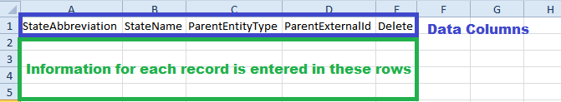

|  |  |
| --- | --- |
| Hazzard sign | **CAUTION: Validation Errors.** Editing values in the top row of a template file results in validation errors when uploading the file. Do not edit values in the top row of a template file.  **Multiple Entries in a Data Cell.**For fields in which multiple entries are permitted each entry should be separated with a semicolon. |

To create an upload file:

|  |
| --- |
| After downloading the appropriate template, open the file in Microsoft Excel or a compatible spreadsheet program.  Enter each record’s information in a separate row. Be sure to adhere to the field requirements described in the appropriate table provided in the Managing Records section.  *Note: Upload templates are case-sensitive. Data must be entered as standard text. Any formatting, such as boldface, highlighting, or italics, will be lost during the upload.*   * + To delete an existing record, enter “DELETE” in the Delete column for that record.   + To modify an existing record, enter the new information for that record. The old record will be replaced upon uploading the file. To modify the key value of a record (e.g., the email address of a user record), you must delete the original record and create a new one. The tables in the Managing Records section identify key columns with a plus (+).   Note: Some record types cannot be deleted or modified via the file upload task. You must delete or modify those records from the Create/Modify screen for that record type.  Save the upload file in one of the following file formats: CSV, XLS, XLSX, or TXT*.* After the file is saved, you can upload it to ART. |

#### Uploading Files.

The file upload process has four main steps: (1) Choose File, (2) Preview File, (3) Validate File, and (4) Confirmation. This process allows you to confirm that the correct file was uploaded and that it contains no errors. When uploading a file, you must use the correct upload screen for that record type.

Step 1: Upload File

Figure 8. Step 1: Upload File

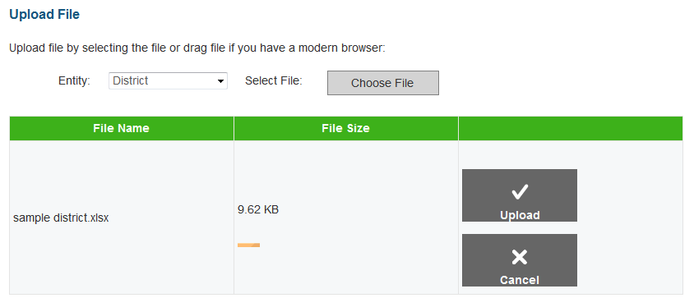

|  |
| --- |
| 1. On the home screen, navigate to the appropriate file upload screen for the record type. 2. Select the record upload type from the Entity drop-down list on the Upload File screen. 3. Click [**Choose File**] and select the saved file on your computer. The file name and file size appears in the table on the screen. Note: If you are using a modern browser, you may also click and drag the file directly into the table provided on the upload screen*.* 4. Verify that the name of the file is correct, and then click [**Upload**]. |

Step 2: Preview File

Figure 9. Step 2: Preview Records

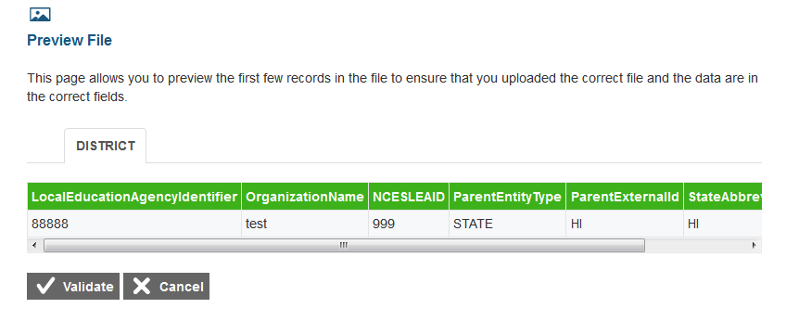

|  |
| --- |
| 1. To ensure that you uploaded the correct file, you can preview the file you selected in the table on this screen.Note: Only the first few records in the file are visible on this preview screen. 2. To begin the file validation process, click [**Validate**]. |

|  |  |
| --- | --- |
| Hazzard sign | **Caution:** If your file is large, uploading it may take a long time. DO NOT cancel the upload and try again, because ART may have already begun processing some of the records. If your file is too large to upload while you are online, you can minimize the file by separating it into smaller files. Smaller file uploads can be processed simultaneously in separate browser tabs with one upload per tab. |

|  |  |
| --- | --- |
| Step 3: Validate File  If the file passes validation, a message appears, indicating that no validation errors were found (see Figure 10). You can click [**Save**] to proceed to the final step.  If the file contains records with errors, an error message appears (see Figure 11). Depending on the severity of the error, either the entire file will fail or just the records with errors will fail.  Files with data that are not in the correct format as shown in the template will generate error messages by row, identifying the errors in the file.  The “Understanding Error Types” section in the column to the right provides a brief explanation of the three possible error types: fatal errors, record errors, and record warnings. | Figure 10. Step 3: Successful Validation  Step 3: Successful Validation |
| *Understanding Error Types*   * White box **If the entire file fails**, note the errors and the corresponding record numbers. Click [**Cancel**], update your file, and then restart the upload process from Step 1: Choose File. * Warning sign **If the file contains record errors**, these records will not be committed to ART. The records that passed validation can be committed. You may elect to fix the errors in your file and re-upload it, or to add these records individually on the appropriate Create/Modify [Record] screen. * Hazzard sign **If the file contains record warnings**, these records will be saved to ART. However, you are strongly encouraged to review the associated records. You may edit these records using the appropriate Create/Modify [Record] screen. |

Figure 11. Failed Validation

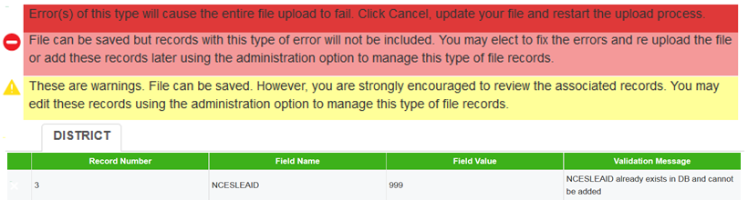

***If your file has errors***

Files with data not in the correct format as shown in the template generate error messages by row, identifying the errors by line (row) for each invalid record in the file.

Some errors prevent a record from uploading (e.g., invalid parent entity). A table of validation messages appears and contains information about the errors. *Note: A single record can have multiple errors.*

Figure 12. Sample Error Message

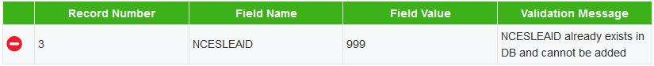

* **Record #:** The row in the file in which the error appeared
* **Field Name:** The column name that contains the error
* **Field Value:** The text that you entered in the cell
* **Validation Message:** A brief description of the error

Depending on the severity of the error(s), one of the following will occur:

* The file will fail to upload.
* The file will upload, but ART will exclude the record(s) that had errors.
* The file will upload, and ART will accept the record(s) that had errors. (These records will need to be fixed in ART or uploaded in a new file.)

Figure 13. Failed Validation

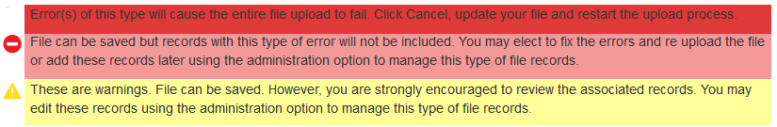

If your file included errors, you have two options:

* **Abort the upload.** Click [**Cancel**], and then click [**OK**]. You can then make edits to the upload file, save it, and begin the upload process again.
* **Proceed with the upload, and add the information to ART.** To do so, click [**Save**]. Only error-free records or records with acceptable errors (rows in yellow) will be uploaded to the system.

**These are some common errors:**

* Having blank rows between records or at the end of the file
* Inserting invalid characters (refer to appropriate user guide sections for information about accepted formats)
* Uploading a file that contains parent entities that do not already exist in ART.
* Uploading a file for users in an institution or district with which you are not associated.

Step 4: Confirmation

After you click [**Save**], the accepted records will be uploaded to ART. A table appears, confirming the type of records uploaded, the number of records deleted, and the number of records inserted.

Figure 14. Upload File, Step 4: Confirmation

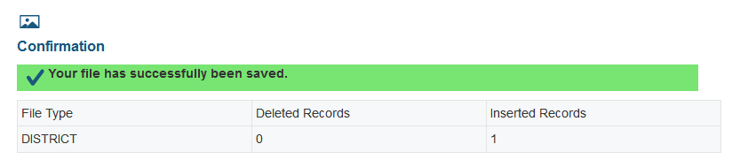

### Creating/Modifying Individual Records.

The ***Create/Modify*** screens in ART allow you to add, modify, and delete individual records. You can also use these screens to search for and export records. When working with a record, you must use the appropriate screen for that record type. Table 3 describes the available screens and the record types that they process.

Table 3. Record Management Screens

| Screen | Description |
| --- | --- |
| Create/Modify Institutions | Use this screen to manage state, district, group of districts, institution, and group of institutions records.  Note: When managing entity records, you must select the appropriate entity type from the links provided at the top of the screen. |
| Create/Modify Users | Use this screen to manage user records. |

Figure 15. Sample Create/Modify [Record Type] Screen

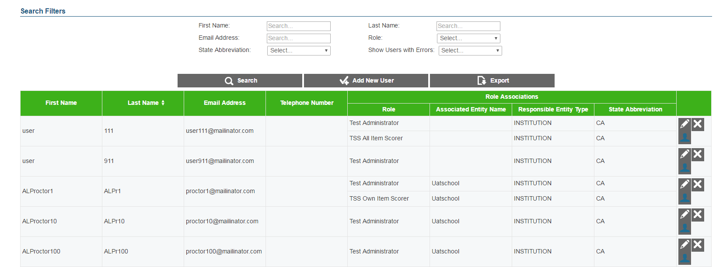

The following items are available on every ***Create/Modify*** screen:

* Filter fields and [**Search**] button used to search for records. Some Create/Modify screens also include a checkbox that filters the search results table to only display records with errors.
* [**New]** button used to create new records.
* Various [**Export**] buttons used to export data for all records or just records in the table.
* Search results table that displays existing records. By default, this table displays all existing records. The table includes action buttons used to edit or delete individual records.

|  |  |
| --- | --- |
| Notebook graphic | The actual filter fields and table columns on the Create/Modify screens vary for each record type. For more information, see the Managing Records section. |

To add a new record:

|  |
| --- |
| 1. Click [**New**]. The ***Add [Record Type] Information*** screen appears. This screen displays fields for creating a new record. 2. Enter the record’s information in the provided fields. Be sure to adhere to the field requirements described in the appropriate table provided in the Managing Records section. 3. Click [**Save**]. |

To search for records:

|  |
| --- |
| 1. On the Create/Modify screen, enter values in the filter fields and click [**Search**]. The table updates to display only the records that meet the entered criteria. |

To export records:

|  |
| --- |
| * To export all the records as an XLS file, click [**Export Search Results to Excel**]. * To export all the records as a CSV file, click [**Export Search Results to CSV**]. * To export only the filtered records included in the table as an XLS file, perform a search and click [**Export Current Page to Excel**]. * To export only the filtered records included in the table as a CSV file, perform a search and click [**Export Current Page to CSV**]. |

To modify an existing record:

|  |
| --- |
| 1. In the search results table, click [Pencil graphic] for a record. The ***Edit [Record Type] Information*** screen appears. This screen is similar to the screen used for adding new records. 2. You can modify the record’s information in the available fields. Be sure to adhere to the field requirements described in the appropriate table provided in the Managing Records section. 3. Click [**Save**]. |

To delete a record:

|  |
| --- |
| 1. In the search results table, click [X graphic] for a record. A warning message appears, asking you to verify the action. 2. In the warning dialog box, click [**OK**]. The record will be removed from ART. **Caution: This action cannot be undone.** |

|  |  |
| --- | --- |
| Hazzard sign | **Caution:** If you delete the record for a parent entity, then all the child entities that belong to that parent will also be removed from ART. For example, if you delete a district record from ART, then all the institutions that belong to that district are also deleted. |

### About Data Columns and Edit Fields.

For a given record type, the fields displayed on the ***Add [Record] Information*** and ***Edit [Record] Information*** screens correspond with the data columns included in the template used to upload that same record type. Column labels on the template use CamelCase, while fields on the ***Add [Record Type] Information*** and ***Edit [Record] Information*** screens use Title Case. Otherwise, these labels are usually identical.

For example, the ***Add District Information*** screen includes the Organization Name field. The corresponding column on the District template is “OrganizationName.” See Figure 16.

|  |  |
| --- | --- |
| Notebook graphic | The “Delete” column in upload templates does not have a corresponding field on the ***Add [Record] Information*** and ***Edit [Record] Information*** screens, because individual records are deleted directly from the search results table on their ***Create/Modify*** screen. |

Figure 16. Comparison Between Labels for Edit Fields and Data Columns

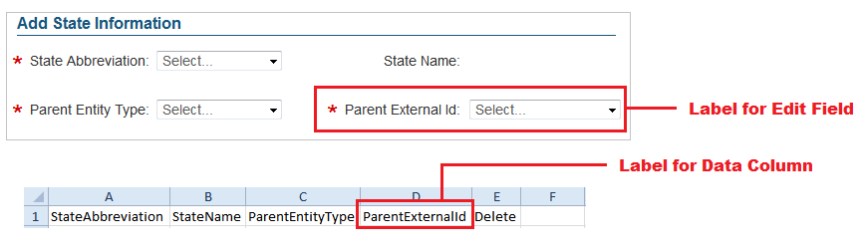

# Managing Records

The following sections provide instructions for creating or modifying the various record types, as well as detailed information about creating, modifying, or deleting records through file uploads.

### Managing State Groups.

When building the hierarchy of entities in ART, you must start at the state or state group level. A state group consists of multiple states that are associated together and belong to the same client.

Note: The actions described in this section are available to users with a client-level role.

|  |  |
| --- | --- |
| Notebook graphic | All entity group levels in the Smarter Balanced Consortium hierarchy are optional. You can configure and rename these entity group levels. |

#### Create or modify state groups.

Figure 17. Group of States Search Screen

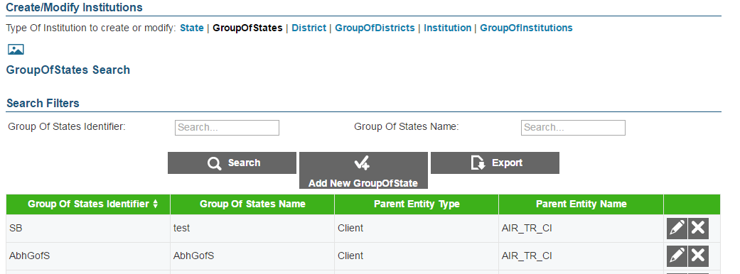

To create a state group:

|  |
| --- |
| 1. On the ART home screen, click [**Create/Modify Institutions**]. 2. On the Create/Modify Institutions screen, click the [**Group of States**] link. 3. On the Group of States Search screen, click [**Add** **New Group of State**]. 4. On the Add Group of States Information screen, enter the information for the state group in the provided fields. For an explanation of these fields, see **Error! Reference source not found.**Table 4. 5. Click [**Save**]. |

To modify a state group:

|  |
| --- |
| 1. On the ***Group of States Search*** screen, search for a state group record. 2. In the search results table, click [Pencil graphic] for a state group record. 3. On the Edit Group of States Information screen, modify the information for the state group in the provided fields as required. For an explanation of these fields, see Table 4. 4. Click [**Save**]. |

To delete a state group:

|  |
| --- |
| 1. On the ***Group of States Search*** screen, search for a state group record. 2. In the search results table, click [X graphic] for a state group record. 3. In the warning box that pops up, click [**OK**].   **Caution: If you delete a state group, all the child entities within that group will also be deleted.** |

#### Upload state groups.

You can add, modify, or delete state groups by uploading a file to ART.

To upload a state group file:

|  |
| --- |
| 1. Download the Group of States template, following the instructions provided in the Download File Templates section. 2. Using Table 4**Error! Reference source not found.** as a reference, enter a row of information for each state group you want to add, modify, or delete.    1. To update an existing state group record, enter the new information for the record in its own row. The previous record will be replaced upon uploading the file.    2. To delete an existing state group record, enter “DELETE” in the Delete column. 3. On the ART home screen, click [**Upload Institutions, Users and Students**]. 4. Upload the state group file, following the instructions provided in the Uploading Files section. |

Table 4 describes the columns in the state-group file and lists acceptable values in **bold type**. These columns also correspond with the fields on the ***Add Group of States Information*** screen. Columns marked with an asterisk (*) are required for add or modify actions; columns marked with a plus (+) are required for delete actions.

Table 4. Upload State-Group File Requirements

| Column | Description |
| --- | --- |
| GroupOfStatesIdentifier*+ | Unique identifier for a state group.  **Up to 20 characters.** |
| GroupOfStatesName* | Descriptive name of state group.  **Up to 50 characters.** |
| ParentEntityType* | State group’s parent in the Consortium’s hierarchy. Must be the following:   * **CLIENT**—Indicates the state group is a direct member of the Consortium.   For a description of the Consortium’s hierarchy in ART, see the section Understanding the Smarter Balanced Hierarchy. |
| ParentExternalId* | Parent entity’s identifier.  **Up to 20 characters of an existing client’s ID.** |
| Delete+ | Flag for deleting the state group.   * **DELETE**—Delete the state group associated with the GroupOfStatesIdentifier. * **<blank>**—Add the new state group or modify the existing one. |

### Managing Districts.

After adding district group records, you can create district records. Districts can belong to a district group, state, state group, or client.

Note: The actions described in this section are available to users with a state- or client-level role.

#### Create or modify a district.

Figure 18. District Search Screen

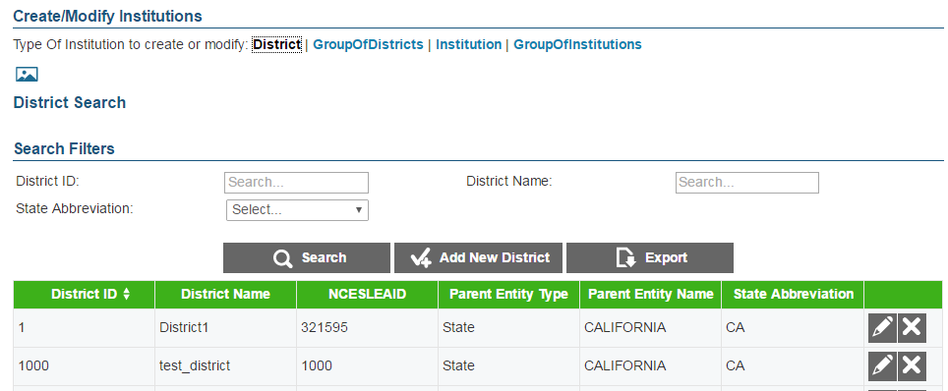

To create a district:

|  |
| --- |
| 1. On the ART home screen, click [**Create/Modify Institutions**]. 2. On the Create/Modify Institutions screen, click the [**District**] link. 3. On the District Search screen, click [**Add** **New District**]. 4. On the Add District Information screen, enter the information for the district in the provided fields. For an explanation of these fields, see Table 5**Error! Reference source not found.**. 5. Click [**Save**]. |

To modify a district:

|  |
| --- |
| 1. On the District Search screen, search for a district record. 2. In the search results table, click [Pencil graphic] for a district record. 3. On the Edit District Information screen, modify the information for the district in the provided fields. For an explanation of these fields, see Table 5. 4. Click [**Save**]. |

To delete a district:

|  |
| --- |
| 1. On the District Search screen, search for a district record. 2. In the search results table, click [X graphic] for a district record. 3. In the warning box that pops up, click [**OK**].   **Caution: If you delete a district, all of the child entities within that district will also be deleted.** |

#### Upload districts.

You can add, modify, or delete districts by uploading a file to ART.

To upload a district file:

|  |
| --- |
| 1. Download the District template, following the instructions provided in the Download File Templates section. 2. Using Table 5 as a reference, enter a row of information for each district you want to add, modify, or delete.    1. To modify an existing district record, enter the information for the new record in its own row. The old record will be replaced upon uploading the file.    2. To delete an existing district record, enter “DELETE” in the Delete column. 3. On the ART home screen, click [**Upload Institutions, Users and Students**]. 4. Upload the district file, following the instructions provided in the Uploading Files section. |

Table 5 describes the columns in the district file and lists acceptable values in **bold type**. These columns also correspond with the fields on the ***Add District Information*** screen. Columns marked with an asterisk (*) are required for add or modify actions; columns marked with a plus (+) are required for delete actions. Note: Some of the labels on the district template differ from those on the **Add District Information** screen. The unique labels from the **Add District Information** screen are provided in parentheses under the labels in the template.

Table 5. Upload District File Requirements

| Column | Description |
| --- | --- |
| LocalEducationAgencyIdentifier*+  (District ID) | A unique number or alphanumeric code assigned to a local education agency by a school system, a state, or other agency or entity.  **Up to 20 alphanumeric characters.** |
| OrganizationName*  (District Name) | District Name.  **Up to 60 characters.** |
| NCESLEAID | Unique nationwide district identifier.  **Up to 20 numbers.** |
| ParentEntityType* | District’s parent in the Consortium’s hierarchy. One of the following:   * **CLIENT**—Indicates the district is a direct member of the Consortium. * **GROUPOFSTATES**—Indicates the district is a member of a group of states. * **STATE**—Indicates the district is a member of a state. * **GROUPOFDISTRICTS**—Indicates the district is a member of a group of districts.   For a description of the Consortium’s hierarchy in ART, see the section Understanding the Smarter Balanced Hierarchy. |
| ParentExternalId* | Parent entity’s identifier.  **Up to 20 characters of an existing client’s, state group’s, state’s, or district group’s ID.** |
| StateAbbreviation*+ | * State in which the district is located. **Error! Reference source not found.** |
| Delete+ | Flag for deleting the district.   * **DELETE**—Delete the district associated with the combination of LocalEducationAgencyIdentifier and StateAbbreviation. * **<blank>**—Add the new district, or modify the existing district. |

### Managing Institution Groups.

After adding district records, you can create institution group records. Institution groups contain institutions that are associated together and belong to the same district, district group, state, state group, or client.

Note: The actions described in this section are available to users with a district-, state-, or client-level user role.

|  |  |
| --- | --- |
| Notebook graphic | All entity group levels in the hierarchy are optional. You can configure and rename these entity group levels. |

#### Create or modify institution groups.

Figure 19. Institution Group Search Screen

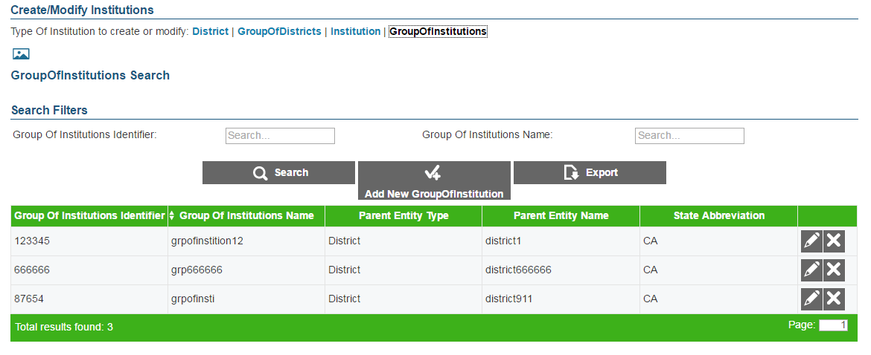

To create an institution group:

|  |
| --- |
| 1. On the ART home screen, click [**Create/Modify Institutions**]. 2. On the Create/Modify Institutions screen, click the [**Group Of Institutions**] link. 3. On the Group of Institutions Search screen, click [**Add New Group of Institution**]. 4. On the Add Group of Institutions Information screen, enter the information for the institution group in the provided fields. For an explanation of these fields, see Table 6. 5. Click [**Save**]. |

To modify an institution group:

|  |
| --- |
| 1. On the ***Group of Institutions Search*** screen, search for an institution group record. 2. On the search results table, click [Pencil graphic] for an institution group record. 3. On the Edit Group of Institutions Information screen, modify the information for the institution group in the provided fields. For an explanation of these fields, see Table 6. 4. Click [**Save**]. |

To delete an institution group:

|  |
| --- |
| 1. Perform a search for a particular institution group record on the ***Group of Institutions Search*** screen. 2. On the search results table, click [X graphic] for an institution group record. 3. In the warning box that pops up, click [**OK**].   **Caution: If you delete an institution group, all the child entities within that group will also be deleted.** |

#### Upload institution groups.

You can add, modify, or delete institution groups by uploading a file to ART.

To upload an institution group file:

|  |
| --- |
| 1. Download the GroupOfInstitutions template, following the instructions provided in the Download File Templates section. 2. Using Table 6 as a reference, enter a row of information for each institution group you want to add, modify, or delete.    1. To modify an existing institution group record, enter the information for the new record in its own column. The old record will be replaced upon uploading the file.    2. To delete an existing institution group record, enter “DELETE” in the Delete column. 3. On the ART home screen, click [**Upload Institutions, Users and Students**]. 4. Upload the institution group file, following the instructions provided in the Uploading Files section. |

Table 6 describes the columns in the institution group file and lists acceptable values in **bold type**. These columns also correspond with the fields on the ***Add Group of Institutions Information***. Columns marked with an asterisk (*) are required for add or modify actions; columns marked with a plus (+) are required for delete actions.

Table 6. Upload Institution Group File Requirements

| Column | Description |
| --- | --- |
| GroupOfInstitutionsIdentifier*+ | Unique identifier for institution group.  **Up to 20 alphanumeric characters.** |
| GroupOfInstitutionsName* | Institution group’s name.  **Up to 60 alphanumeric characters.** |
| ParentEntityType* | Institution group’s parent in the Consortium’s hierarchy. One of the following:   * **CLIENT**—Indicates the institution group is a direct member of the Consortium. * **GROUPOFSTATES**—Indicates the institution group is a member of a group of states. * **STATE**—Indicates the institution group is a member of a state. * **GROUPOFDISTRICTS**—Indicates the institution group is a member of a group of districts. * **DISTRICT**—Indicates the institution group is a member of a district.   For a description of the Consortium’s hierarchy in ART, see the section Understanding the Smarter Balanced Hierarchy. |
| ParentExternalId* | Parent entity’s identifier.  **Up to 20 characters of an existing client’s, state group’s, state’s, district group’s, or district’s ID.** |
| StateAbbreviation*+ | * State in which the institution group is located. **Error! Reference source not found.** |
| Delete+ | Flag for deleting the institution group.   * **DELETE**—Delete the institution group associated with the combination of GroupOfInstitutionsIdentifier and StateAbbreviation. * **<blank>**—Add the new institution group or modify an existing institution group. |

### Managing Institutions.

After adding institution group records, you can create institution records. Institutions can belong to an institution group, district, district group, state, state group, or client.

Note: The actions described in this section are available to users with a district-, state-, or client-level role.

#### Create or modify an institution.

Figure 20. Institution Search Screen

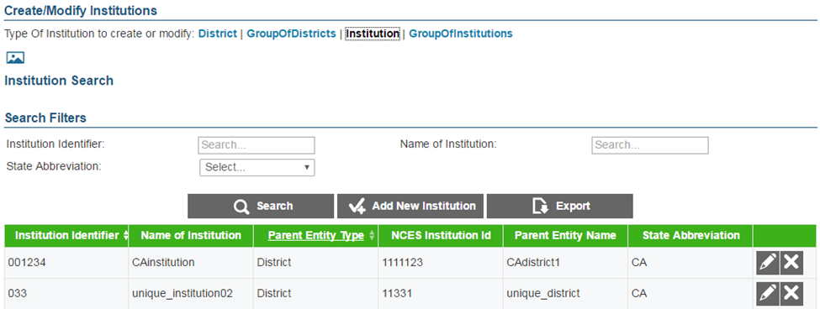

To create an institution:

|  |
| --- |
| 1. On the ART home screen, click [**Create/Modify Institutions]**. 2. On the Create/Modify Institutions screen, click the [**Institution**] link. 3. On the Institution Search screen, click [**Add New Institution**]. 4. On the Add Institution Information screen, enter the information for the institution in the provided fields. For an explanation of these fields, see Table 7. 5. Click [**Save**]. |

To modify an institution:

|  |
| --- |
| 1. On the ***Institution Search*** screen, search for an institution record. 2. In the search results table, click [Pencil graphic] for an institution record. 3. On the Edit Institution Information screen, modify the information for the institution in the provided fields. For an explanation of these fields, see Table 7. 4. Click [**Save**]. |

To delete an institution:

|  |
| --- |
| 1. On the ***Institution Search*** screen, search for an institution record. 2. In the search results table, click [X graphic] for an institution record. 3. In the warning box that pops up, click [**OK**].   **Caution: If you delete an institution, all of the child entities within that institution will also be deleted.** |

#### Upload Institutions.

You can add, modify, or delete institutions by uploading a file to ART.

To upload an institution file:

|  |
| --- |
| 1. Download the Institution template, following the instructions provided in the Download File Templates section. 2. Using Table 7 as a reference, enter a row of information for each institution you want to add, modify, or delete.    1. To modify an existing institution record, enter the information for the new record in its own row. The old record will be replaced upon uploading the file.    2. To delete an existing institution record, enter “DELETE” in the Delete column.       1. If you attempt to delete an institution record where a teacher exists, or a district where an institution exists, an error will occur. This rule, or parent-child relationship, exists up to the top of the hierarchy. 3. On the ART home screen, click [**Upload Institutions, Users and Students**]. 4. Upload the institution file, following the instructions provided in the Uploading Files section. |

Table 7**Error! Reference source not found.** describes the columns in the institution file and lists acceptable values in **bold type**. These columns also correspond with the fields on the ***Add Institution Information*** screen. Columns marked with an asterisk (*) are required for add or modify actions; columns marked with a plus (+) are required for delete actions.

Table 7. Upload Institution File Requirements

| Column | Description |
| --- | --- |
| InstitutionIdentifier*+ | Unique identifier for the institution.  **Up to 20 alphanumeric characters.** |
| NameOfInstitution* | Institution name.  **Up to 60 alphanumeric characters.** |
| ParentEntityType* | Institution’s parent in the Consortium’s hierarchy. One of the following:   * **CLIENT**—Indicates the institution is a direct member of the Consortium. * **GROUPOFSTATES**—Indicates the institution is a member of a group of states. * **STATE**—Indicates the institution is a member of a state. * **GROUPOFDISTRICTS**—Indicates the institution is a member of a group of districts. * **DISTRICT**—Indicates the institution is a member of a district. * **GROUPOFINSTITUTIONS**—Indicates the institution is a member of a group of institutions.   For a description of the Consortium’s hierarchy in ART, see the section Understanding the Smarter Balanced Hierarchy. |
| NCESInstitutionId* | Institution’s unique nationwide identifier. You can look up an NCES identifier at <http://nces.ed.gov/ccd/schoolsearch/>. |
| ParentExternalId* | Parent entity’s identifier.  **Up to 20 characters of an existing client’s, state group’s, state’s, district group’s, district’s, or institution group’s ID.** |
| StateAbbreviation*+ | * State in which the institution is located. **Error! Reference source not found.** |
| Delete+ | Flag for deleting the institution.   * **DELETE**—Delete the institution associated with InstitutionIdentifier. * **<blank>**—Add the new institution or modify an existing one. |

### Managing Users.

You can create user records that are within your entity and below your level of the hierarchy. You cannot create user records for a higher entity level or for an entity to which you do not belong. For example, if you belong to District A, you can only create user records in District A that are associated with the district level or below.

Note: The actions described in this section are available to client-, state-, district-, and institution-level users.

#### Create or modify a user record.

Figure 21. User Search Screen

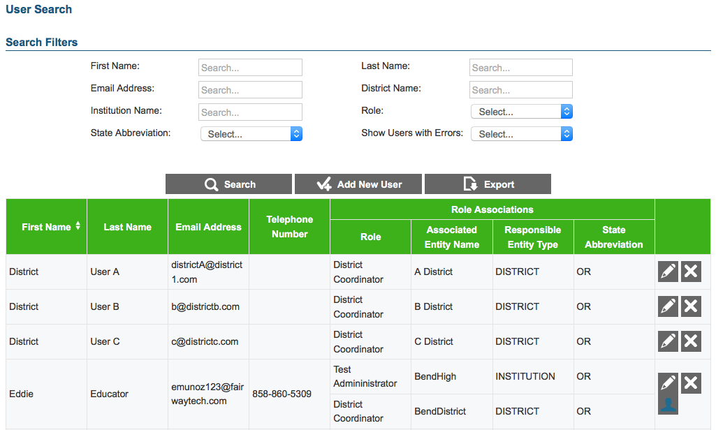

To create a user record:

|  |
| --- |
| 1. On the ART home screen, click [**Create/Modify Users**]. 2. On the User Search screen, click [**Add New User**]. 3. On the Add User Information screen, enter the information for the user record in the provided fields. For an explanation of these fields, see Table 8. 4. To associate the user with a role, do the following:    1. Click [Check plus graphic] in the *Role Associations* section.    2. Select options from the drop-down menus provided in this section.    3. Repeat steps a–b to add additional roles as necessary. 5. *Optional*: To ensure the user’s information is current across the Single Sign-On System, in the Actions section click [**Sync**]. 6. *Optional*: To reset the user’s password, click [**Reset Password**]. 7. *Optional*: To prohibit the user from logging in, click [**Lock User**] at the bottom of the screen. 8. Click [**Save**]. |

To modify a user record:

|  |
| --- |
| 1. On the User Search screen, search for a user record. 2. On the search results table, click [Pencil graphic] for a user record. 3. On the Edit User Information screen, modify the information for the user in the provided fields. For an explanation of these fields, see Table 8. 4. To associate the user with a role, do the following: 5. Click [Check plus graphic] in the *Role Associations* section.    1. Select options from the drop-down menus provided in this section.    2. To remove a role association, click [X graphic] next to that role. 6. *Optional:* To ensure the user’s information is current across the Single Sign-On System, in the Actions section click [**Sync**]. 7. *Optional:* To reset the user’s password, click [**Reset Password**]. 8. *Optional:* To prohibit the user from logging in, click [**Lock User**] at the bottom of the screen.    1. To allow a locked user to log in, click [**Unlock User**] at the bottom of the screen. 9. Click [**Save**]. |

To delete a user record:

|  |
| --- |
| 1. On the ***User Search*** screen, search for a user record. 2. On the search results table, click [X graphic] for the record you want to delete. 3. A warning box pops up, click [**OK**]. |

To delete a user role:

|  |
| --- |
| 1. On the User Search screen, search for a user record. 2. On the search results table, click [Pencil graphic] for a user record. 3. On the Edit User Information screen, click [X graphic] for the role you want to delete. |

**Error! Reference source not found.** describes the columns in the user file and lists acceptable values in **bold type**. These columns also correspond with the fields on the ***Add User Information*** screen. Columns marked with an asterisk (*) are required for add or modify actions; columns marked with a plus (+) are required for delete actions. *Note: Some of the labels on the user template differ from those on the* **Add User Information** *screen. The unique labels from the* **Add User Information** *screen are listed in parentheses below the labels from the template.*

Table 8. Upload User File Requirements

| **Column** | **Description** |
| --- | --- |
| FirstName* | User’s first name.  **Up to 35 characters.** |
| LastOrSurname*  (Last Name) | User’s last name.  **Up to 35 characters.** |
| ElectronicMailAddress*+  (Email Address) | User’s email address.  **Up to 128 characters in standard email address format.** |
| TelephoneNumber | Telephone number including the area code, and optional extension.  **Up to 24 characters in XXX‑XXX‑XXXX xNNNNNN or XXX‑XXX‑XXXX xNNNNNN format.** |
| Role* | Role assigned to the user.  **Up to 30 characters.** |
| AssociatedEntityID* | Identifier of entity associated with the user.  **Up to 20 characters.** |
| Level*  (Responsible Entity Type) | User-role combination’s parent in the Consortium’s hierarchy.   * **CLIENT** – Indicates the user is a direct member of the Consortium. * **GROUPOFSTATES** – Indicates user is a member of a group of states. * **STATE** – Indicates user is a member of a state. * **GROUPOFDISTRICTS** – Indicates user is a member of a group of districts. * **DISTRICT** – Indicates user is a member of a district. * **GROUPOFINSTITUTIONS** – Indicates user is a member of a group of institutions. * **INSTITUTION** – Indicates user is a member of a group of an institution.   For a description of the Consortium’s hierarchy in ART, see the section Understanding the Smarter Balanced Hierarchy. |
| StateAbbreviation*  (State) | * State with which the user is associated. **Error! Reference source not found.** |
| Delete+ | Flag for deleting the user-role combination.   * **DELETE**—Delete the user-role combination associated with the ElectronicMailAddress. * **<blank>**—Add the new user record or modify an existing one. |