SSO Federated Overview

Smarter Balanced Assessment Consortium

Document Date: March 22, 2024

# 1 Document Control

## Revision History

|  |  |  |  |
| --- | --- | --- | --- |
| Version | Date | Author(s) | Reason for version |
| 1.0 | April 9, 2020 | Peter Flores, Jeff Khoury | * Created and based-off document supplied from vendor (Okta) that assisted Smarter Balanced in establishing the Federated SSO solution |
| 1.1 | July 22, 2020 | Peter Flores | * Added information related to the IAIP rolename * Removed textual context related to the Digital Library and replaced with Tools for Teachers * Amended SSO Section to include better verbiage regarding Tenancy Chain information * Added SBAC Tenancy Chain Example as an appendix |
| 1.2 | March 22, 2024 | Peter Flores | * Text and grammar updates and cosmetic revisions * Deleted Section 1.2, Document References * Refined Section 2.3 Scope * Refined Role Names List and Descriptions in Section 6.2.1, Role Information * Added New Section 6.2.3, Role-Mapping Examples * Added New Section 7, Establishing Federation with Smarter Balanced |

# Introduction

## Purpose

The purpose of this document is to capture the architectural framework for implementing federation with Okta for unified single sign-on with Smarter Balanced. This document entails how the users will securely authenticate and gain access to external facing applications.

## Intended Audience

This document is intended for implementation project teams:

* Project Manager - to define tasks for phases & milestones
* Architects - to define the implementation strategy
* Developers - to define any custom applications needed
* Business Analysts - to define user experience

## Scope

Smarter Balanced Tools for Teachers (T4T), Student Reporting System (SRS, formerly RDW), and Test Item Management System (TIMS) systems have been integrated with Okta and are available to federated members.

# Solution Overview

## Business Goals and Objectives

Smarter Balanced provides an SSO solution for their members to give secured access to protected applications. The goal is to share authenticated application access that will provide different levels of secure access to Smarter Balanced members via a centralized, secure, highly available service.

## Requirements Review

High level features include:

* Just in Time User creation through Identity Provider
  + Users will be provisioned within Okta using Just in Time (JIT) provisioning once the user has been validated through the trusted Identity Provider. The Member Service Provider is responsible for maintaining an up-to-date directory of users and their associated authorization information.
  + The user will be automatically assigned to a group based upon the source IdP.
* Sign-In
  + Users from member states will sign in through their federated IdP UI.
  + Once federated, the Okta sign-in UI will direct the users to their “home” IdP for login *if it is known.*
    - Note: If the account exists and it's not known what the person's home IdP is, they will continue to operate as a standalone user in Okta. If no account exists, then they MUST log in from their "home" IdP at least once in order to be provisioned.
  + Non-federated and local account users will use the standard Okta sign-in user interface (UI).
* Application/Policy Assignment
  + Assignment by group
  + Assignment by tenancy chain

# Architecture

## Overview

Smarter Balanced provides a secure, single user data source for a federated single sign-on authentication for its members to their shared applications. Each member state must have its own IdP. Smarter Balanced employs Okta Identity Portal to be the authentication point for all applications. All applications use Okta for authentication.

Application and policy assignment are based on group assignments and the users’ tenancy chains. A user’s group assignment will be automatically assigned based on the identity provider at the time of creation using Okta’s JIT provisioning process.

Since most users will be authenticating via inbound SAML federation, passwords are not stored within the Okta Universal Directory. Any locally created Okta accounts must adhere to the University of California’s password policies (<https://its.ucsc.edu/policies/password.html>).

Okta supports a federated authentication for the web applications using the SAML / WS-Fed protocols. Each user will authenticate to Okta and will be redirected to the application using SAML authentication flow. Application assignment will be granted based on the user’s group membership and tenancy chain.

Okta requires 5 attributes per user account:

* Username (in email format)
* Email address (same as username)
* Firstname
* Lastname
* Tenancy Chain (a string array attribute)

## Target Architecture

Below is an overview diagram of the Okta architecture as it relates to the infrastructure in its final state:

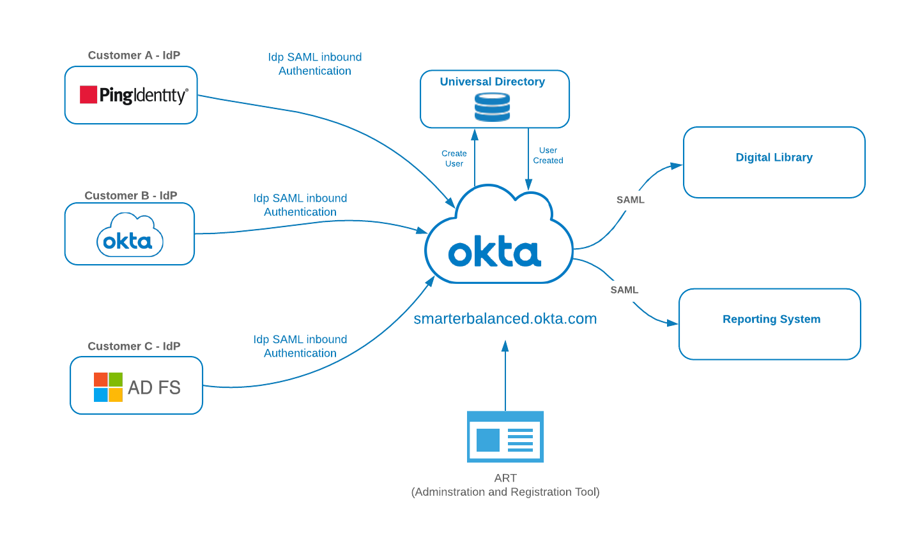

**Target State Architecture**

* Tools for Teachers and SRS instances will be configured to use Okta as their IdP

## Environments

There are two Okta environments, one for “Production” and one for “Staging” (Integration testing with applications and member states).

## Detailed Architecture Views

In this section, each requirement shall be associated with a specific implementation(s).

### Login / Username

**Email address** will be used as the consistent username across platforms. The email addresses are verified during the account activation/verification process.

Note: Okta recommends using email address as username going forward to reduce complexity.

### Just-In Time User Creation

If the user does not have profile data in Okta and they authenticate from their federated IdP, an account will be automatically provisioned based on the data in the SAML payload. The user will seamlessly have an account created, activated, added to their respective IdP group, and able to access assigned applications.

See User Attribute Section.

The User profile must contain the 4 basic attributes:

* Username (in email format)
* Email
* Firstname
* Lastname

Additional non-Okta required attributes

* sbacTenancyChain

Optional attributes

* telephone
* sbacUUID

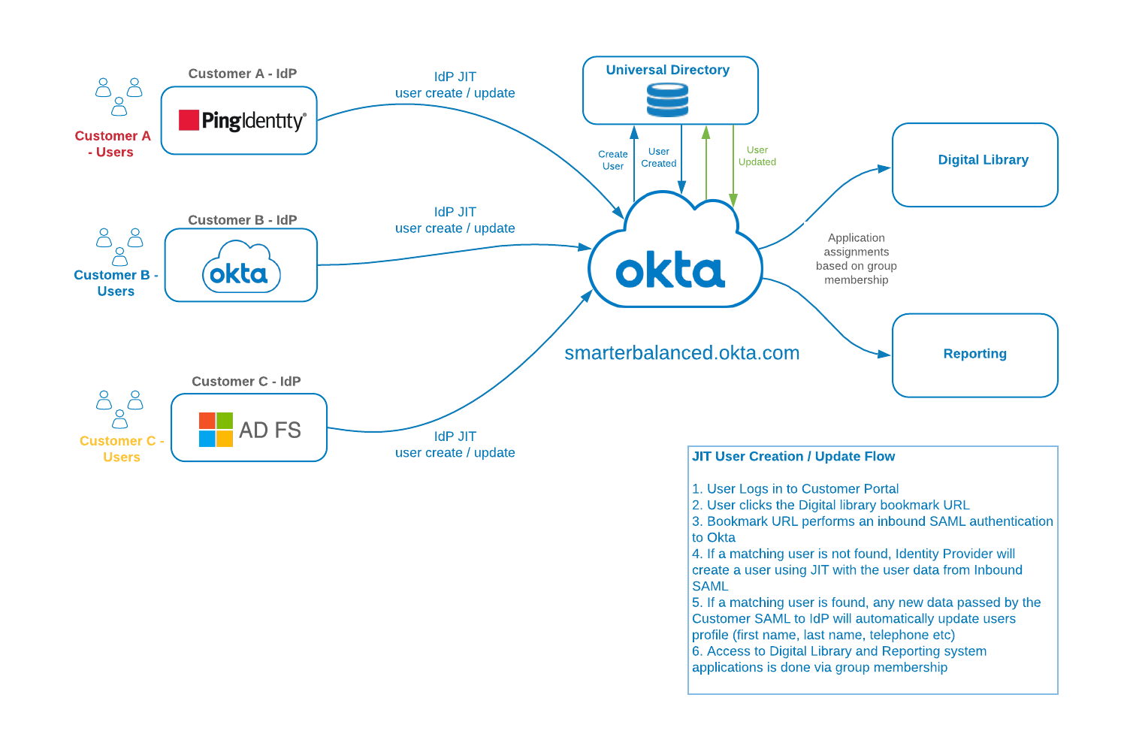

**JIT User Creation / Update**

### User Sign-In

The customer will utilize Inbound SAML to authenticate to the Okta Org. Local Users will utilize the Okta UI for standard authentications.

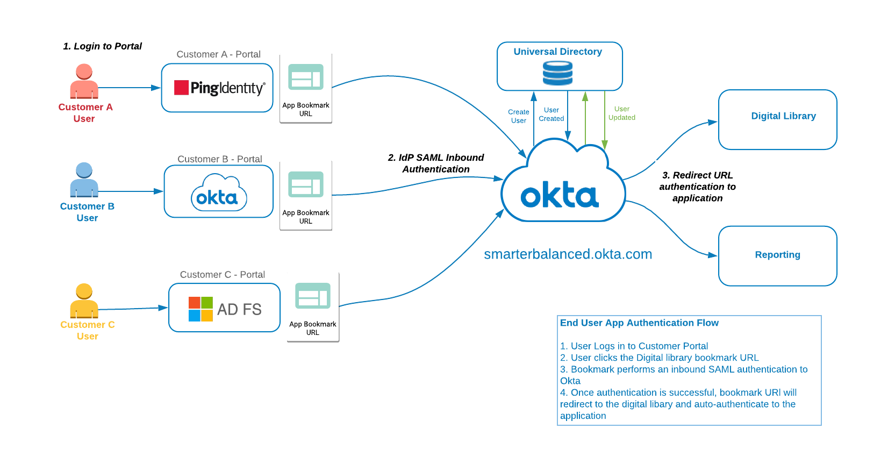

**Authentication Flow**

## Identity Provider

Each Smarter Balanced Member will have its own IdP and that will be the authoritative source for user creation/updates. From the perspective of the member’s IdP, Okta will be configured as a Service Provider. This is referred to as Inbound SAML, which allows users from external identity providers to SSO through Okta and on to their application. The matching criteria to link any existing user will be performed using the **email address**.

If no match is found, the new user will be created ‘on the fly’ in Okta Universal Directory. **All profile attributes will be mastered by the payload from the member Identity Provider**.

Below is a sample data mapping that will need to be configured for each Identity Provider.

|  |  |  |  |
| --- | --- | --- | --- |
| **Okta** | **Sample Value** | **Customer Identity Provider** | **Sample Value** |
| Username | John.Smith@gmail.com | Username | John.Smith@gmail.com |
| Email | John.Smith@gmail.com | Email | John.Smith@gmail.com |
| First Name | John | First Name | John |
| Last Name | Smith | Last Name | Smith |
| TelephoneNo |  | TelephoneNo |  |
| Institution | California |  |  |
| Okta UID | Auto generated |  |  |
| sbacUUID | 584efee2e4b0e6709dfc6aa8 | - | - |
| sbacTenancyChain | |TS101|DL_EndUser|DISTRICT|1000|ART_DL|||TS|TEST STATE|||T  S101|Test State 101||||| | - | - |

### Multi-Factor Authentication

We recommend members implment multi-factor authentication (MFA) for increased security to all their applications.

### Application Embed Link

Application bookmarks will be available to give Federated Users access to applications within the Okta org. This is accomplished through inbound SAML federation using the Identity Provider and redirecting the user (once authenticated) to the target application embed link. Each Okta application has a defined app embed link that can be used for direct access. The user must have a valid Okta session token and be assigned the application in order to properly use the link.

### SAML SSO

SAML has been widely used as the single sign-on protocol by many ISVs and is supported by many identity management solutions. Okta provides comprehensive guidance for developers to implement a proper SAML service provider.

<https://help.okta.com/en/prod/Content/Topics/Security/Identity_Providers.htm>

Additional reference resrouce: <https://www.oasis-open.org/standards#samlv2.0>

#### SAML Sequence

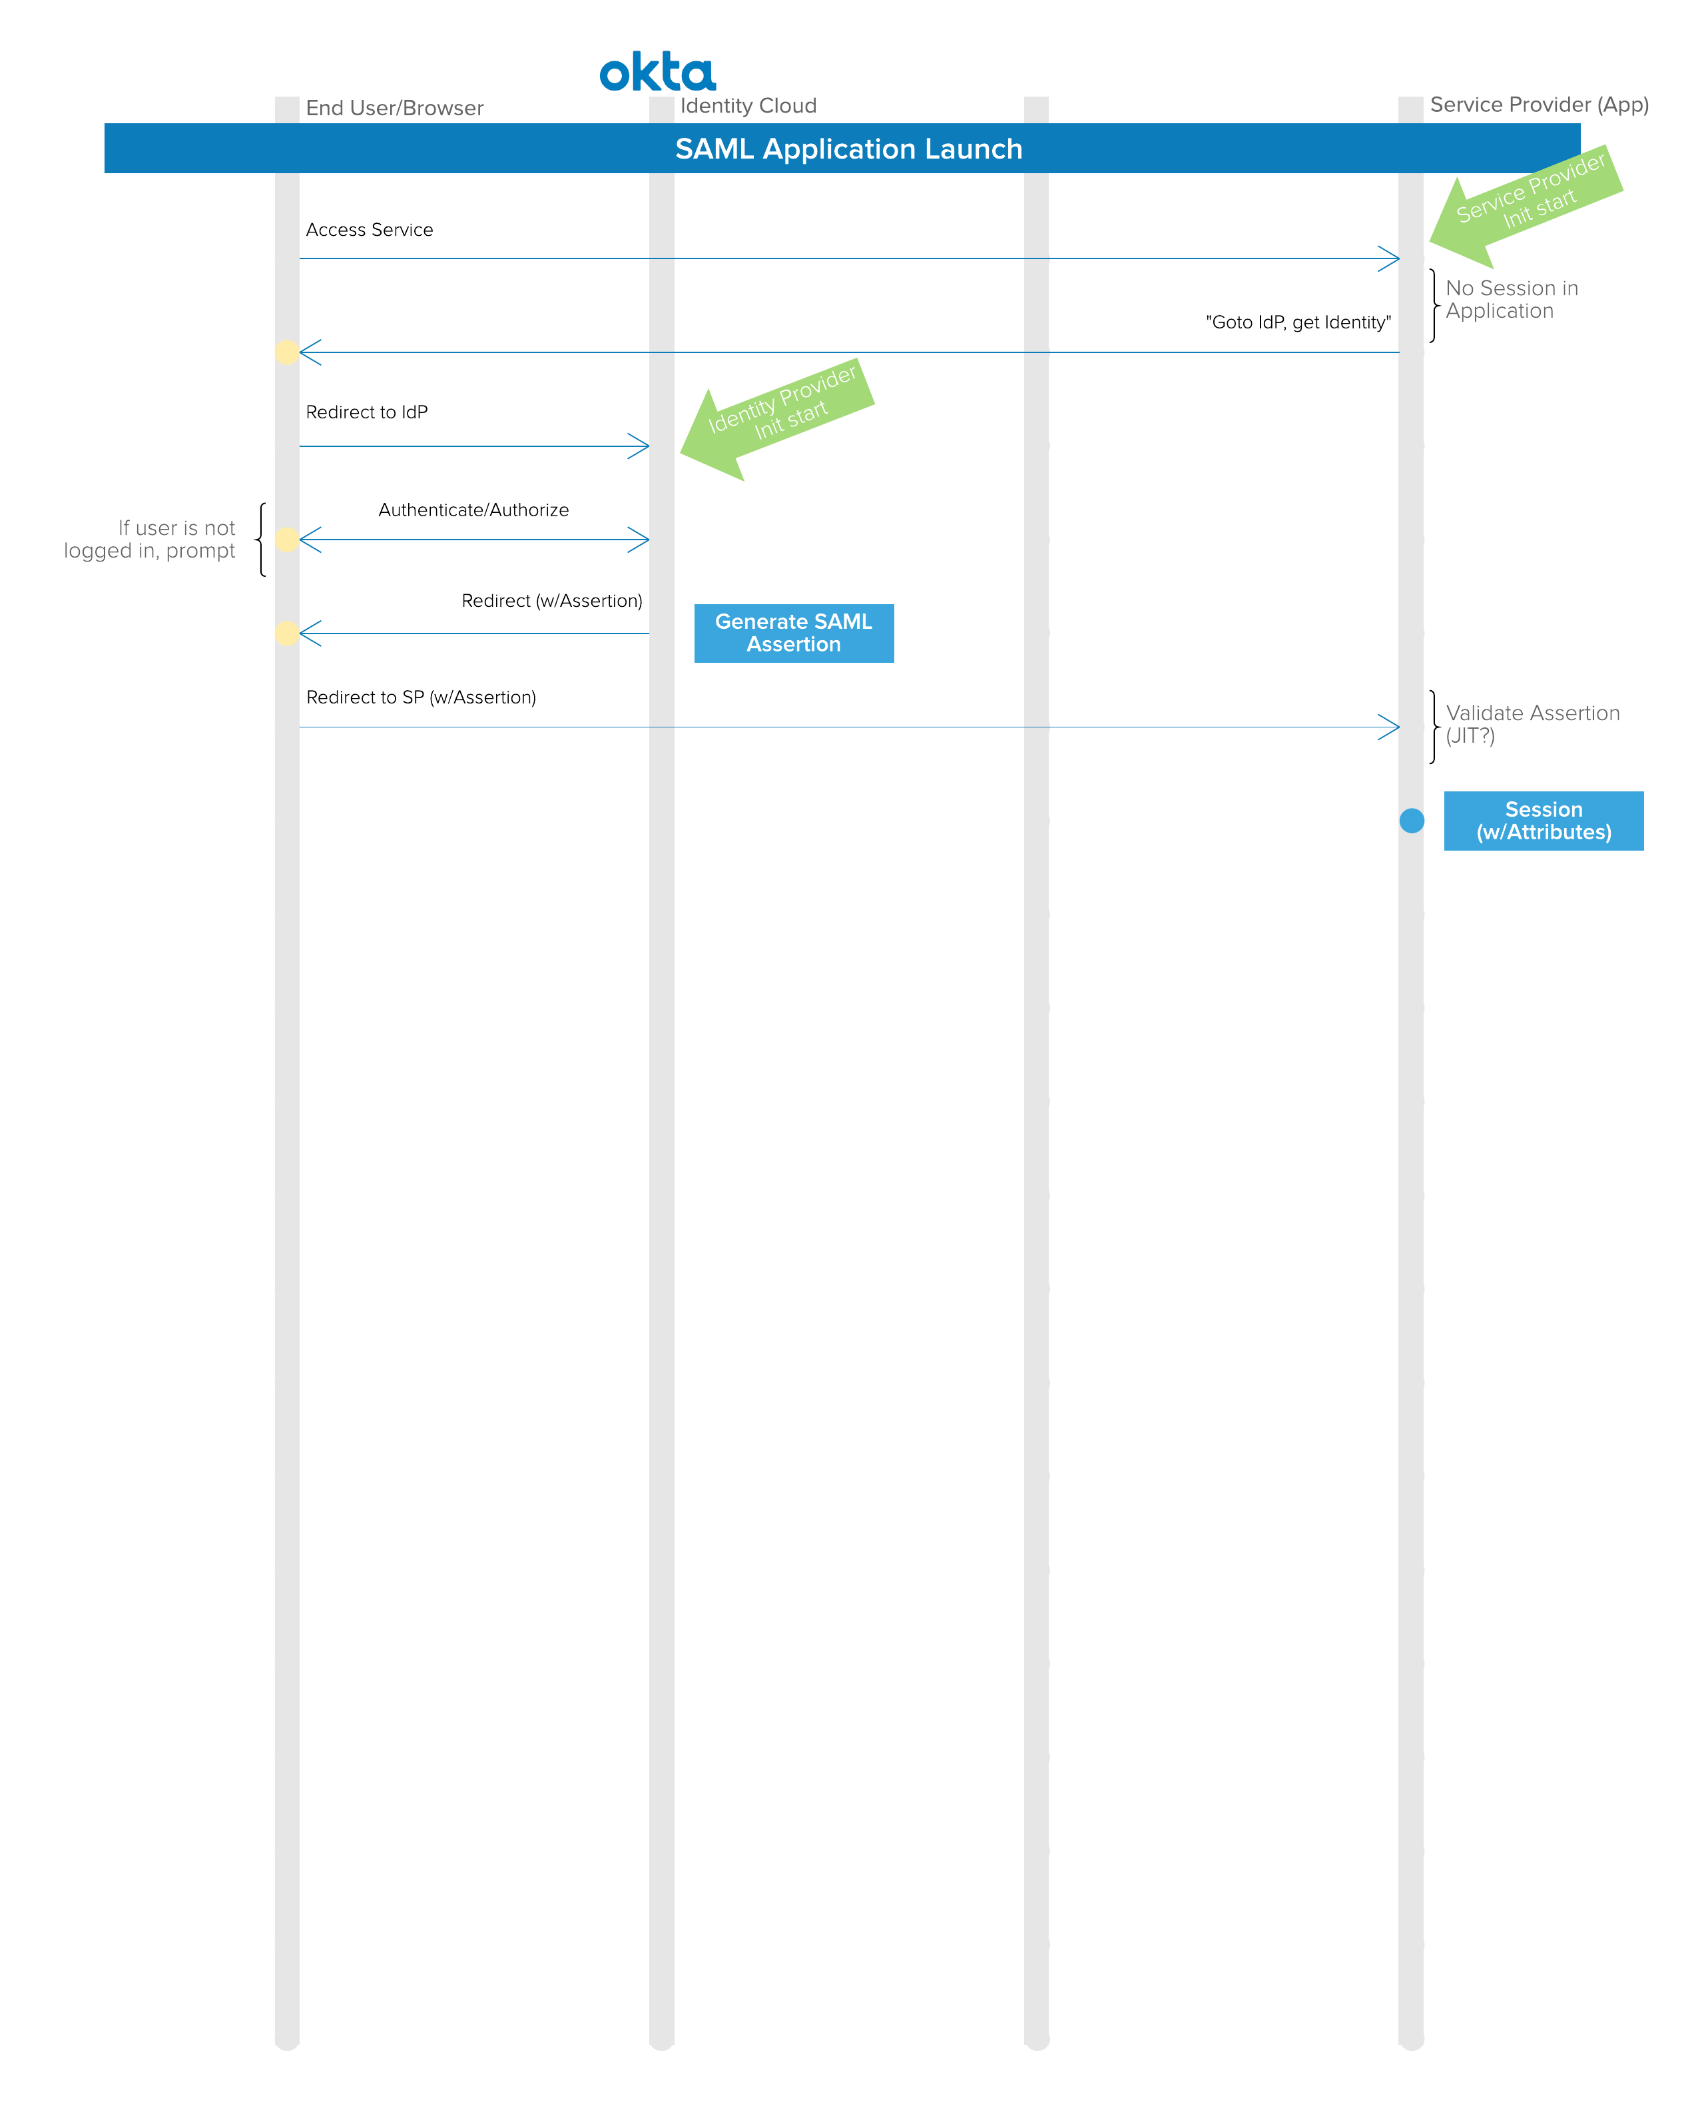

Ref: <http://developer.okta.com/standards/SAML/>

# Security

## Multiple Factor Authentication

Note: MFA will not be used at this time for external users. MFA is supported and may be added at a later date.

## Password Policy

All Passwords, either created in Okta, or used by the members’ IdPs should comply with the University of California security policy.

### 

### Self-Serve Password Management (for Local Accounts)

Password management is configurable by group driven policies. This includes complexity, history, or self-serve functions. The self-serve methods and recovery token duration are configurable.

The steps below represent a typical forgotten password flow for Okta local users:

* Present form to acquire username
* Check user state
  + Should be ACTIVE
  + If DEACTIVATED OR SUSPENDED, return message to call for assistance
* Generate a local recovery token
* Store recovery token locally or in Okta profile for user
* Send recovery token and Okta user ID in link to user in custom branded email
* Receive link
* Verify recovery token
  + Valid duration has not expired
  + Token matches stored data
* Present form to get new password and confirm
* Use Okta API to set password

Note: For inbound federated users, no passwords are associated locally with these users. Any locally created Okta users would have Smarter Balanced password policies applied to them (e.g. SBAC staff and non-federated users).

## Session Policy

The session inactivity timeout is set to 2 hours.

# User Attributes

The asterisked items in section 6.1 are the Okta required attributes. All other attributes are not required by Okta but represent common data and are available by default.

## Attribute Mapping

Normalized data avoids duplication, simplifies integration and aids in maintenance and troubleshooting.

Data available or required at the source needs to be identified. Sources include;

* CSV import applications
* registration applications
* profile update applications

Data required for the applications needs to be identified. Any transformations from the Okta org level attributes for a specific application needs to be identified.

* Indicates field is required

*\*\*sbacUUID is required if an organization has a proprietary ID that they would like to use to track user account information)*

|  |  |  |  |  |  |
| --- | --- | --- | --- | --- | --- |
| Attribute | Source | Description | Data Type | Destination 1 | Destination 2 |
| Login* |  |  |  |  |  |
| Email* |  |  |  |  |  |
| secondEmail |  |  |  |  |  |
| firstName* |  |  |  |  |  |
| lastName* |  |  |  |  |  |
| middleName |  |  |  |  |  |
| honorificPrefix |  |  |  |  |  |
| honorificSuffix |  |  |  |  |  |
| title |  |  |  |  |  |
| displayName |  |  |  |  |  |
| nickName |  |  |  |  |  |
| profileUrl |  |  |  |  |  |
| primaryPhone |  |  |  |  |  |
| mobilePhone |  |  |  |  |  |
| streetAddress |  |  |  |  |  |
| city |  |  |  |  |  |
| state |  |  |  |  |  |
| zipCode |  |  |  |  |  |
| countryCode |  |  |  |  |  |
| postalAddress |  |  |  |  |  |
| preferredLanguage |  |  |  |  |  |
| locale |  |  |  |  |  |
| timezone |  |  |  |  |  |
| userType |  |  |  |  |  |
| employeeNumber |  |  |  |  |  |
| costCenter |  |  |  |  |  |
| organization |  |  |  |  |  |
| division |  |  |  |  |  |
| department |  |  |  |  |  |
| managerId |  |  |  |  |  |
| manager |  |  |  |  |  |
| sbacUUID** |  |  |  |  |  |
| sbacTenancyChain* |  |  |  |  |  |
| Custom3 (TBD) |  |  |  |  |  |
| Custom4 (TBD) |  |  |  |  |  |
|  |  |  |  |  |  |

## Role and Tenancy Chain Information

### Role Information

Note: For information and access to Smarter Balanced APIs, please contact the Smarter Balanced support ([support@smarterbalanced.org](mailto:support@smarterbalanced.org)) .

The roles used by the **RDW** are provided in the table below:

|  |  |
| --- | --- |
| **Role** | **Description** |
| Custom Aggregate Reporter | Allows an administrator to generate aggregate reports of student assessment results within the institution to which the user is. |
| Embargo Admin | Allows an administrator to control the release of summative test results within the institution to which the user is assigned. |
| GROUP_ADMIN | Allows a school or district administrator to create/manage groups within the school or district to which they are assigned. |
| Instructional Resource Admin | Allows a state, district, or school administrator to create/manage links to instructional resources within the institution to which the user is assigned. |
| PII | Allows access to reports and personally identifiable information (PII) for the students in institutions (school, district, state) to which the user is assigned. This role is intended for administrators and others responsible for reporting at the institutional level. |
| PII_GROUP | Allows access to reports and personally identifiable information (PII) for the students in groups to which the user was assigned. This role is intended for teachers. |

An additional conceptual understanding of ‘Organziation Information’ is necessary when assigning access to data within the RDW. Access is hierarchical with the top-most level receiving access to records existing in child records:

Organization hierarchy. 
Lists from top to bottom: State, District, Institution. 


Note: Not pictured in this example are groups of disticts or groups of institutions.

Access is restricted by organization-level permissions passed via the tenancy chain for each rolename; a user at the institution level cannot access information at the district level. Alternatively, a district level assignment will provide access to institution level information if the institution exists in that district.

The role necessary for accessing **Tools for Teachers**

|  |  |
| --- | --- |
| **Role** | **Description** |
| DL_EndUser | Allows access to Tools for Teachers. |

The ‘state’ attribute passed via the tenancy chain is used to assign access to landing pages intended for each individual state.

The role necessary for accessing **Interim Assessment Item Portal**

|  |  |
| --- | --- |
| **Role** | **Description** |
| SB_IAIP_User | Allows access to the Interim Assessment Item Portal (IAIP). |

### Tenancy Chain Information

The Tenancy Chain is a multi-value string attribute that is used to provide authorization to, and control access to specific data within Smarter Balanced applications. The specifications for the sbacTenancyChain are available on GitHub in the OpenDJ repository:

<https://github.com/SmarterApp/IM_OpenDJ/blob/master/SBAC_SSO_Design.pdf>

Page 13 of the PDF lists the data elements that go into the pipe delimited string. A user may have many entries in this attribute, but the entire SAML assertion cannot exceed 1MB in size.

Below are examples of how a tenancy chain may look.

Note: Attributes are **case-sensitive**.

For providing access to *Tools for Teachers*, an example tenancy chain may be constructed like:

|NV|DL_EndUser|STATE|1000|ART_DL|||NV|NEVADA|||||||||

This example would grant the user access to the Tools for Teachers application.

For *Reporting Data Warehouse* and access to PII for an entire state, see the below example:  
|NV|PII|STATE|1000|ART_DL|||NV|NEVADA|||||||||

This example would provide state-wide access to Nevada student PII data and reports.

Reporting access at the district level:

|02|PII|DISTRICT|1000|ART_DL|||NV|NEVADA|||02|Clark|||||

This example would provide district-wide access to Clark District (County) student PII data and reports.

Reporting at a school level:  
|19687336819087|PII|INSTITUTION|1000|ART_DL|||NV|NEVADA|||19647830000000|Whoville Unified School District|||19647386019087|Whoville Elementary|

This example would provide institution (school) access to Whoville Elementary student PII data and reports.

The following provides tenancy chain position names with some samples and contextual notes:

|  |  |  |  |
| --- | --- | --- | --- |
| **Chain position** | **Position name** | **Sample Value** | **Notes** |
| 1 | RoleID (May also be referenced as Org ID) | 31750853130150 | This value is typically identical to the ID code for which the role is assigned. For example, if a user is assigned the role at the District level, the attribute for RoleID value should equal DistrictID value. |
| 2 | Rolename | PII | Smarter Balanced role (ex: PII, PII_GROUP, GROUP_ADMIN, Custom Aggregate Reporter) |
| 3 | Level | INSTITUTION | Level in which the role is assigned. Allowed values are ‘INSTITUTION’, ‘DISTRICT’, ‘STATE’ (Note: DISTRICT_GROUP and INSTITUTION_GROUP are also valid, yet aggregate reporting features may be limited) |
| 4 | ClientID | 1000 | Code of the system generating the tenancy chain. For Smarter Balanced systems, the value of ‘1000’ is an acceptable default. |
| 5 | Client | ART_DL | Name of the system generating the tenancy chain. For Smarter Balanced systems, the value of ‘ART_DL’ is an acceptable default. |
| 6 | GroupOfStatesID | 1 | ID of the group of states. |
| 7 | GroupOfStates | Western US | Name of the group of states. |
| 8 | StateID | NV | ID of the state. Should be the two-character state code. If the permission level is at the state, this value should appear in the RoleID position. |
| 9 | State | NEVADA | Name of the state. Should be in upper case |
| 10 | GroupOfDistrictsID |  | ID of the group of districts. |
| 11 | GroupOfDistricts |  | Name of the group of districts. |
| 12 | DistrictID | 31750850000000 | ID of the district. If the permission level is at the district, this value should appear in the RoleID position. If the permission level is State, this value should be blank. |
| 13 | District | Whoville Unified School District | Name of the district. If the permission level is State, this value should be blank. |
| 14 | GroupOfInstitutionsID | 54879 | ID of the group of institutions. |
| 15 | GroupOfInstitution | East Whoville Schools | Name of the group of institutions. |
| 16 | InstitutionID | 31750853130150 | ID of the school. If the permission level is at the institution, this value should appear in the RoleID position. If the permission level is State or District, this value should be blank. |
| 17 | Institution | Whoville High | Name of the school. If the permission level is at the institution, this value should appear in the RoleID position. If the permission level is State or District, this value should be blank. |

### Role-Mapping Examples

This section provides an example mapping that may be performed by a service provider when forming their tenancy chains for providing access to Smarter Balanced applications. This is intended to be only an example that could assist service provider authentication teams.

**A sample Teacher:**

|  |  |  |
| --- | --- | --- |
| **Element** | **Data** | **Comments/Notes** |
| Email | Teacher1@school.edu |  |
| User Location | Example Elementary School | May be school name. |
| Institution ID Value | 12345 | ID value for the school/institution |
| District ID | 9999912345 |  |
| District Description | EXAMPLE DISTRICT |  |
| State Abbreviation | ST |  |
| State Description | STATE |  |
| Service Provider’s Rolename | “Teacher” | This may be a proprietary role name that provides access to Service Provider’s applications. |
| Access Need(s) | * Access to Tools for Teachers * Access to interim test items * Reporting access to their student’s test results |  |

An example Tenancy Chain sequence for above user may look like (line-breaks and comments added at comma separator for clarity):

[|12345|DL_EndUser|INSTITUTION|1000|ART_DL|||ST|STATE|||||||12345|Example Elementary School|, -- represents typical access to Tools for Teachers --

|12345|SB_IAIP_User|INSTITUTION|1000|ART_DL|||ST|STATE|||||||12345|Example Elementary School|, -- represents typical access to Interim Assessment Item Portal --

|12345|PII_GROUP|INSTITUTION|1000|ART_DL|||ST|STATE |||||||12345| Example Elementary School|] -- represents typical access to the Smarter Reporting System for a teacher at a specific institution --

**A sample District Level Administrator:**

|  |  |  |
| --- | --- | --- |
| **Element** | **Data** | **Comments/Notes** |
| Email | Adminstrator1@district.edu |  |
| User Location | District Office | May be school name. |
| Institution ID Value | N/A | May only be necessary if user requires access to an institution that does not exist, hierarchically, under the district to be assigned. |
| District ID | 9999912345 |  |
| District Description | Example District 1 |  |
| State Abbreviation | ST |  |
| State Description | STATE |  |
| Service Provider’s Rolename | “District Administrator” | This may be a proprietary role name that provides access to Service Provider’s applications. |
| Access Need(s) | * Access to Tools for Teachers * Access to interim test items * Reporting access to test results for student within their assigned district * Assigning Student Groups to teachers |  |

Example Tenancy Chain for above user may look like (line-breaks and comments added at comma separator for clarity):

[|9999912345|DL_EndUser|DISTRICT|1000|ART_DL|||ST|STATE|||9999912345|Example District 1|||||, -- represents typical access to Tools for Teachers --

|9999912345|SB_IAIP_User|DISTRICT|1000|ART_DL|||ST| STATE|||9999912345|Example District 1|||||, -- represents typical access to Interim Assessment Item Portal --

|9999912345|PII|DISTRICT|1000|ART_DL|||ST| STATE|||9999912345|Example District 1|||||, -- represents typical access to student results within a District within the Smarter Reporting System --

|9999912345|GROUP_ADMIN|DISTRICT|1000|ART_DL|||ST|STATE|||9999912345|Example District 1|||||] -- represents typical access to assign Student Groups in a specific district within the Smarter Reporting System --

# Establishing Federation with Smarter Balanced

This section is intended to provide a general set of information related to the necessary information and steps that will need to be communicated and set up between Smarter Balanced and the Service Provider interested in establishing federation.

## Process Steps

The process will begin in a non-production environment and upon successful tests and a review of roles and their mapping (refer to section 6), production will then be set up and tested.

Initial setup requires the Smarter Balanced Team to receive from the Service Provider establishing Federation:

* Issuer URI
* Single Sign-On URL
* Signature Certificate

During this time, the Smarter Balanced Team will also provide the metadata for our Okta setup. Note: The Smarter Balanced Team will not make a recommendation for how a Service Provider will set up and allow authentication from Smarter Balanced, as it is an unknown what identity management platform or systems will be in use.

Depending on the applications that are supported by the Service Provider, the Smarter Team will also provide URLs (application embed links, see section 4.5.2) for direct authentication to Smarter Balanced applications (e.g. Tools for Teachers, Smarter Reporting System, etc.). These URLs are useful for a Member’s user portals (where user access tools and applications may be located) and will authorize an authenticated user into the specific Smarter Balanced application. In the case of a non-authenticated user, they will be directed to the Service Provider’s authentication system.

After production has been approved, this concludes federation setup.

# Appendix

## SBAC Tenancy Chain Example:

<saml:Attribute Name="sbacTenancyChain">

<saml:AttributeValue xmlns:xs="http://www.w3.org/2001/XMLSchema"

xmlns:xsi="http://www.w3.org/2001/XMLSchema-instance"

xsi:type="xs:string"

>|NV|PII|STATE|1000|ART_DL|||NV|NEVADA|||||||||</saml:AttributeValue>

<saml:AttributeValue xmlns:xs="http://www.w3.org/2001/XMLSchema"

xmlns:xsi="http://www.w3.org/2001/XMLSchema-instance"

xsi:type="xs:string"

>|02|GROUP_ADMIN|DISTRICT|1000|ART_DL|||NV|NEVADA|||02|Clark|||||</saml:AttributeValue>

<saml:AttributeValue xmlns:xs="http://www.w3.org/2001/XMLSchema"

xmlns:xsi="http://www.w3.org/2001/XMLSchema-instance"

xsi:type="xs:string"

>|MI|PII|STATE|1000|ART_DL|||MI|MICHIGAN|||||||||</saml:AttributeValue>

<saml:AttributeValue xmlns:xs="http://www.w3.org/2001/XMLSchema"

xmlns:xsi="http://www.w3.org/2001/XMLSchema-instance"

xsi:type="xs:string"

>|CA|DL_EndUser|STATE|1000|ART_DL|||CA|CALIFORNIA|||||||||</saml:AttributeValue>

<saml:AttributeValue xmlns:xs="http://www.w3.org/2001/XMLSchema"

xmlns:xsi="http://www.w3.org/2001/XMLSchema-instance"

xsi:type="xs:string"

>|CA|PII|STATE|1000|ART_DL|||CA|CALIFORNIA|||||||||</saml:AttributeValue>

</saml:Attribute>