Implementation Readiness Package

Overview Document

Contents

[Version History 1](bookmark://_Toc43883674#_Toc43883674)

[Purpose 1](bookmark://_Toc43883675#_Toc43883675)

[Revisions 1](bookmark://_Toc43883676#_Toc43883676)

[Understanding Smarter Balanced Assessments 1](bookmark://_Toc43883677#_Toc43883677)

[Assessment Delivery Design 2](bookmark://_Toc43883678#_Toc43883678)

[Test Delivery System 3](bookmark://_Toc43883679#_Toc43883679)

[Implementation Resources 3](bookmark://_Toc43883680#_Toc43883680)

[IRP Resource List 3](bookmark://_Toc43883681#_Toc43883681)

# Version History

|  |  |  |  |
| --- | --- | --- | --- |
| Date | Version | Updated By | Description of Document Edit(s) |
| 7/1/2020 | 0.1 | Peter Flores | Initial Draft Released |
|  |  |  |  |

# Purpose

The Implementation Readiness Package (IRP) provides a public and centralized listing of key technical documentation to support the implementation of Smarter Balanced Assessments.

Please note that the IRP resources will not perform a validation for external test delivery platforms or provide approval of implementation readiness for Smarter Balanced Assessments.

## Revisions

Beginning July 1, 2020 revisions will be noted in the version history and maintained for at minimum the prior 2 years. Content changes to existing documentation will be tracked within the documents.

# Understanding Smarter Balanced Assessments

Technical assessment teams should build a foundational understanding of Smarter Balanced Assessments. For additional details on Smarter Balanced Assessments, we recommend viewing additional resources available on the [assessment section of the Smarter Balanced website](https://www.smarterbalanced.org/assessments/).

## Assessment Delivery Design

The Smarter Balanced Assessment process is designed to enable Members to add or substitute their own component(s) (or vendor-supplied component(s)) as they deem necessary. The concept of interoperability is a factor in all design and development. Beyond component-level replace-ability, the system also provides integration into other systems, such as state data systems and Student Information Systems (SIS).

Once items are authored and an assessment is designed, it will enter the Test Administration process. Below is a visualization that provides **an example** of how a Smarter Balanced Assessment and its delivery may be performed:

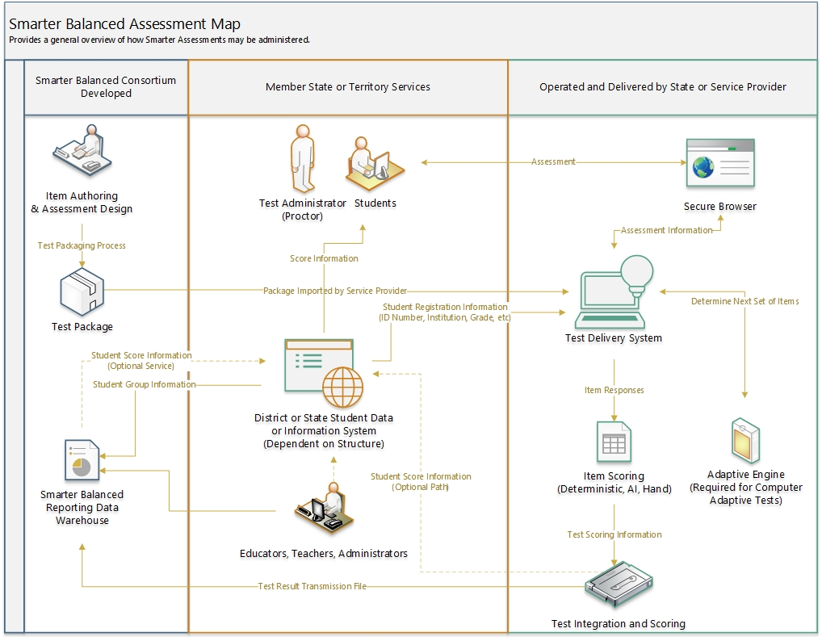

# Smarter Balanced Test Delivery System

As of April 1, 2020 the Smarter Balanced Test Delivery System (TDS) is no longer supported. The code base and documentation for the TDS is available within the [Smarter Balanced GitHub repository](https://github.com/SmarterApp?utf8=%E2%9C%93&q=TDS_).

# Implementation Resources

## IRP Resource List

|  |  |  |
| --- | --- | --- |
| **Resource Item** | **Description** | **Element**  **Supported** |
| [Overview document (This document)](http://www.smarterapp.org/) | This document serves as a guide to outline the importance of the documents utilized within the IRP. | General Understanding |
| [Smarter App Assessment Item Format (SAAIF)](http://www.smarterapp.org/documents/SmarterApp_Assessment_Item_Format_Specification.pdf)  Supporting Resource(s):   * [Item Types and Features](http://www.smarterapp.org/documents/Item_Types_And_Features.pdf) * [Item Metadata Specifications](http://www.smarterapp.org/documents/Item_Metadata_Specification.pdf) | The SmarterApp Assessment Item Format (SAAIF) specification defines an XML document structure for the encoding and representation of assessment items.  Item Types and Features document lists how each type of Smarter Balanced items are constructed (also referenced in the Accessibility Features section).  Item Metadata Specifications provides the specifications for the metadata that are used within Smarter Balanced items and stimuli. | Test Delivery |
| [QTI Information](http://www.imsglobal.org/activity/qtiapip) | While Smarter Balanced Items are currently issued in SAAIF, Smarter Balanced will be adopting a QTI 3.0 format beginning in the 2021 academic year. Please review this resource (contacting IMS Global may be required) to better understand QTI 3.0 and how it may impact test items.  For draft-versions of items in this format, please feel free to contact Smarter Balanced at [sb@smarterbalanced.org](mailto:sb@smarterbalanced.org). | Test Delivery |
| [Test Package Format 1.0](http://www.smarterapp.org/documents/AdministrationTestPackageFormat.pdf) | Provides the format specification that defines the test and guidance in how to load the test into a Test Delivery System. May be used to inform when using a proprietary system. | Test Delivery |
| IRP Test Package  Includes:  Test Administration Packages:   * [Interim Assessment Block (IAB) Package](http://www.smarterapp.org/documents/IRP-AssessmentBlocks.zip) * [Interim Comprehensive Assessment (ICA) Package](http://www.smarterapp.org/documents/IRP-ComprehensiveAssessments.zip)   and  [Content Package](http://download.smarterbalanced.org/IRP/IRP-ContentPackage.zip) | Fixed-form test administration and content packages designed to provide a comprehensive demonstration of the different types of questions from each claim type for different grades.  The IAB and ICA packages contain the administrative information necessary for issuing these tests. The administration packages must be used in accord with the Content Package.  The Content package contains the test items for both the Interim Assessment Block and the Interim Comprehensive Assessment. They are machine scored items with scoring rubrics. The items are drawn from publicly available test items. Organizations are permitted and encouraged to use this content package for development, testing, and demo purposes.  Note: Smarter Balanced Summative Assessments should be administered via a Computer Adaptive Test (CAT) format. For more information on the development and design of summative assessments please visit <http://www.smarterbalanced.org/assessments/development/> or contact Smarter Balanced at [sb@smarterbalanced.org](mailto:sb@smarterbalanced.org). | Test Delivery, Test Administration |
| [Item Rendering Information](http://www.smarterapp.org/documents/IRP-Item_Rendering_w_URLs.xlsx) | Provides a list of the items that comprise the test packages and links to how the variety of items and rendering examples of each via the [Smarter Balanced Sample Items Website](http://sampleitems.smarterbalanced.org/). | Test Delivery |
| [Accessibility Features](http://www.smarterbalanced.org/assessments/accessibility-and-accommodations/)  Supporting Resource(s):   * [ISAAP Accessibility Feature Codes](http://www.smarterapp.org/documents/ISAAP-AccessibilityFeatureCodes.pdf) * [Item Types and Features](http://www.smarterapp.org/documents/Item_Types_And_Features.pdf) * [Illustration Glossary](http://www.smarterapp.org/irp/IRP-Illustration-Glossary-TestPackage.html) * [Braille Transcripts](http://www.smarterapp.org/irp/IR-Braille-Transcripts.html) | Smarter Balanced Items require accessibility features per our Member’s requirements. Resources provided here are the:  Individual Student Assessment Accessibility Profile (ISAAP) process which describes the approach to addressing student access needs for Smarter Balanced assessments.  Item Types and Features document which lists how each of type of Smarter Balanced items are constructed (same as what is referenced in the SAAIF section).  Illustration Glossary which details the necessary requirements for how illustration glossary content is displayed.  Braille Transcripts which details the necessary steps in providing tests which require the use of Braille in the test administration process. | Test Delivery, Student Support |
| [Secure Browser](http://www.smarterapp.org/securebrowsers.html)  Supporting Resource(s):   * [Browser Implementation Readiness Test (BIRT)](https://birt.smarterbalanced.org/) | Information with details in how secure browsers should function and be able to provide assessment questions.  BIRT is a tool that may be used to preliminarily review browser compatibility to the Smarter Balanced Open Specification for Secure Browsers (OSSB) for communication with educational software. | Test Delivery, Test Administration |
| [Item Response Samples](http://www.smarterapp.org/documents/ItemResponseSamples.20200330.zip) | These samples can be used to test response scoring and rendering systems to gain insight into the format in which item responses are stored. | Item Scoring, Test Reporting |
| [Item Scoring Custom Operators](http://www.smarterapp.org/documents/Item_Scoring_Custom_Operators.pdf) | Assessment items are scored using rubrics encoded in IMS QTI Response Processing format. Custom operators support advanced item types such as Equations and Graphic Response items. | Item Scoring, Test Reporting |
| [Test Result Transmission (TRT) File Format](http://www.smarterapp.org/specs/TestResultsTransmissionFormat.html)  Supporting Resource(s):   * [Test Result Data Dictionary and Logical Data Model](http://www.smarterapp.org/documents/TestResults-DataModel.pdf) | TRT document details how information needs to be communicated to the Smarter Balanced Reporting Data Warehouse in order for a Member that is using the Smarter Balanced Reporting Data Warehouse.  Test Result Data Dictionary and Logical Data Model details information and definitions for data transmission formats. | Test Reporting |
| [Federated SSO Overview](http://www.smarterapp.org/documents/Federated_SSO_Documentation_v1.0.pdf) | Details the way educators authenticate with Smarter Balanced resources utilizing the same username and password issued for accessing their assessment system. Includes hi-level information related to role information and designing a tenancy chain. | Test Reporting, Smarter Balanced Application Access |