Student Group Upload Utilizing AWS Cognito Authorization

# Version History

|  |  |  |  |
| --- | --- | --- | --- |
| Version | Date | Author | Description |
| 1.0 | 2/22/2020 | Peter Flores | * Initial version for production support of solution. |
| 1.1 | 3/14/2022 | Peter Flores | * Fixed deprecated links to the Student Group and API documentation. |

# Overview of Process Steps

The information below should be used as a foundation for an SIS Vendor developed solution that, in accord with Districts, allows the vendor to be able to automate Student Group information updates to the California Educator Reporting System (CERS). The following information assumes a usage of [Postman](https://www.postman.com/) and is intended only as a suggestion to demonstrate and verify authorization and connectivity to the API and not the final developed solution.

1. Obtain AWS Cognito user account information for the AWS Cognito service
2. Get AWS Cognito Authorization Token
3. Compile the Roster Information for upload in the correct format
4. Submit an API request, attaching the data and token information
5. Confirm submission

# Step Information

Steps 1 and 2 are the steps that are used to obtain a token for the student score report. Complete documentation for that process can be obtained at in the [CAASPP.Application-Program-Interface-to-Electronic-Score-Reports.2020-21](http://www.caaspp.org/administration/reporting/student-score-report-option-A.html)

## Step 1

### Get Username and Password

Please see the documentation located at: <http://www.caaspp.org/administration/reporting/student-score-report-option-A.html>.

## Step 2

### Get Authorization Token

Please see documentation provided at: <https://www.caaspp.org/rsc/pdfs/CAASPP.ELPAC.Application-Program-Interface-to-Electronic-Score-Reports.2019-20.docx>

## Step 3

### Compile Roster

Compile the roster information from your SIS to align with the specifications that are located on the Student Group documentation.

Note: It is suggested that SIS Vendors consult with CDE to verify the District and School ID values that are utilized within the Reporting Data Warehouse as they may differ from the format that SIS vendors typically use.

## Step 4

### Submit via the API

Submit an API request using the Cognito-Authorized token and the roster information to the API. The URL for the request should be:

***Production URL Endpoint -***https://groups.import.smarterbalanced.org/groups/imports/

* Documentation for Uploading Using the API can be found in the [RDW API repo](https://www.smarterapp.org/documents/API.html#authentication-and-authorization)
* Additional documentation related to ingest service can be found at: <https://github.com/SmarterApp/RDW_Ingest>

## Step 5

Confirmation of a successful transmission should be received. Log and note any errors. Troubleshooting will need to be performed locally.

### Example Successful Submission Result Screen

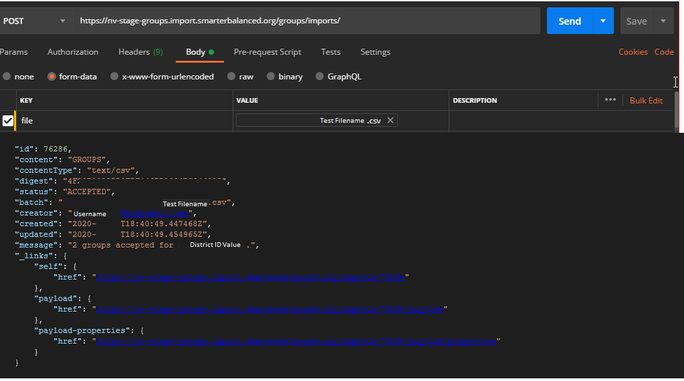

**Note:** The ability to check the status via the Payload URL is for Smarter Administrators only at this time.

## Troubleshooting and Help information

### Contact for Assistance

For access and authentication issues, please contact the ETS Service Desk.

Additional issues should be relayed to CDE.

### Frequently Asked Questions

Below are frequently asked questions and answers that may assist when developing a solution to utilize the Student Group API via Cognito Authorization.

**Question:** How many students can be uploaded in a single file at a time?

**Answer:** A **maximum of 1 million rows of student data** will be accepted. Smarter Balanced recommends to allow for approximately 20 minutes for processing for a file this size. Please contact CDE if you anticipate or are interested in exploring files that may be larger than 1 million rows.

**Question:** If 1 million students is the upload limit, does that mean that is also the limit to the number of students assigned to a student group?

**Answer:** No. A **maximum** of **200 students** **per Student Group** assignment

**Question:** Can Student Groups be named anything?

**Answer:** Student Group names must be composed of alpha-numeric characters (underscores and hyphens are also accepted, but not spaces) and no greater than 100 characters in length.

**Question:** Do groups all need to be sent grouped by school?  
**Answer:** All schools must be grouped. For example, the system would incorrectly assign students if a submission had students assigned to a group for SchoolA and then a group for SchoolB then returned sequentially to a group for SchoolA.  All students in SchoolA should be grouped within a file submission.

**Question:** Will the API process the same file over and over?

**Answer:** Regardless of if a file submission is successful or fails, if the same file is utilized without alteration the service will not process the file. It will assume it is the same file and to avoid an accidental repeat it is not processed. The data in the file is examined prior to ingestion and assigned a metatag that allows the system to identify if it has attempted to upload the file before. Filenames will not make a difference. Alteration of a single field will trigger the import to run as it identifies updated data.

**Question:** If a data exists in the file submission, does the entire submission fail or just the section where the error exists?  
**Answer:** An error will cause the entire submission to fail.

**Question:** Is it possible to upload only new students added for a particular Student Group?

**Answer:** The Student Group upload is a delete and replace solution, per Student Group. For example, if a set of students is uploaded using a pre-existing Student Group name, the new students will replace any existing students assigned to that Student Group. However, it is possible to update an individual Student Group for an individual school.

### Verify Authorizations

If you are receiving authorization issues, please attempt to verify your authorization by inserting the Bearer token information via a ‘GET’ at the following URL. Supply this information in your support request ticket.

Verify Access URL: <https://groups.import.smarterbalanced.org/imports/user>