LAB 3

Aim: Installation of HortonWorks Sandbox on Virtual Machine
Procedure:
1. Start the HortonWorks it shows the IP address of machine.
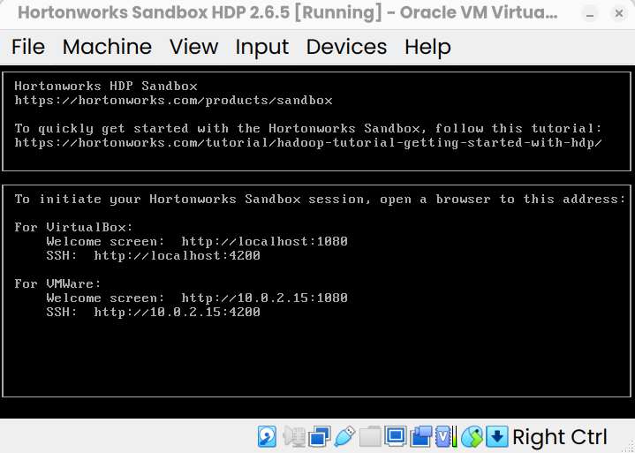
9. Navigate to http://localhost:4200
10. Use the username and password: maria_dev to login.
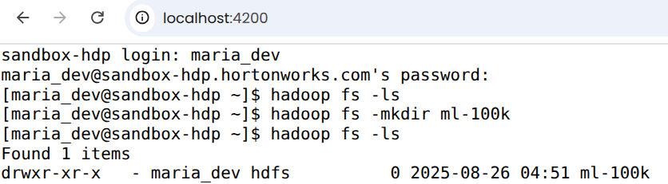
11. Execute the following commands one-by-one:

 hadoop fs -ls
The command hadoop fs -ls is used to list files and directories stored in Hadoop Distributed File System (HDFS) or other supported file systems (like local FS, S3, etc., depending on configuration).
It also shows the metadata:
- File permissions
- Replication factor
- Owner & group
- File size (in bytes)
- Last modification date & time
- Path


 hadoop fs -mkdir ml-100k
The hadoop fs -mkdir command is used to create new directories in Hadoop Distributed File System (HDFS) (or any other file system supported by Hadoop, like S3, local FS, etc., depending on your configuration)
We will give the command for creating a directory for a movielens dataset
 wget http://media.sundog-soft.com/hadoop/ml-100k/u.data
The above command is used to copy the data from web server to the Hadoop file system
 ls
Give the command ls to see whether the data is downloaded
Once it is downloaded, you will see the name as u.data
 ls -la
In Linux, ls -la lists all files including hidden ones (those starting with .), with detailed information (long format).
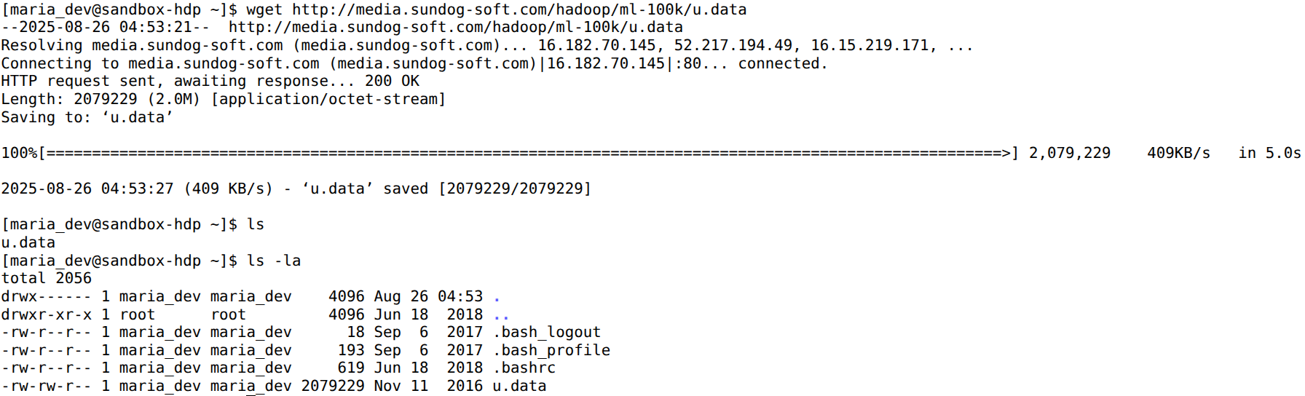
 hadoop fs -copyFromLocal u.data ml-100k/u.data
The file will get copied from local file system to the Hadoop named as u.data
 hadoop fs -ls
The hadoop fs -ls command is used to list files and directories in Hadoop Distributed File System (HDFS) or in any other file system supported by Hadoop (like local FS, S3, etc., depending on configuration)
 hadoop fs -rm ml-100k/u.data
📌 Purpose
- To remove (delete) files from HDFS.
- Works similar to Linux rm, but operates on HDFS.
 hadoop fs -rmdir ml-100k
The hadoop fs -rmdir command is used to remove (delete) empty directories from HDFS.
📌 Purpose
- To delete empty directories in Hadoop Distributed File System (HDFS).
- It is similar to the Linux rmdir command.
- ⚠️ Unlike -rm -r, it cannot delete directories that contain files or subdirectories.

 hadoop fs -ls
The commands checks where the directory is removed from the hadoop

