PSUR COVER PAGE
Manufacturer Information
Company Name: CooperSurgical, Inc.
Address: CooperSurgical, Inc.
95 Corporate Drive
Trumbull, CT 06611

Manufacturer Single Registration Number (SRN): US-MF-000002607
Authorized Representative (if applicable): CooperSurgical Netherlands B.V.
Beechavenue 54-62
1119 PW Schiphol-Rijk

Authorized Representative Single Registration Number (SRN): NL-AR-0000000059
Regulatory Information
Certificate Number: CE 779812 (MDR)
Date of Issue: 2023-01-12
Notified Body Name: BSI Group The Netherlands B.V.
Notified Body Number: 2797
PSUR available, upon request, to competent authorities within 3 working days: ☑ Yes ☐ No
Document Information
Data Collection Period/Reporting Period: 2023-01-01 to 2023-12-31
PSUR Cadence: ANNUALLY

Table of Contents
Table of Contents 2
Section A: Executive Summary 3
Section B: Scope And Device Description 4
Section C: Volume Of Sales and Population Exposure 7
Section D: Information on Serious Incidents 10
Section E: Customer Feedback 12
Section F: Product Complaint Types, Complaint Counts, and Complaint Rates 13
Section G: Information From Trend Reporting 15
Section H: Information from Field Safety Corrective Actions (FSCA) 16
Section I: Corrective and Preventive Actions 17
Section J: Scientific Literature Review of Relevant Specialist or Technical Literature 18
Section K: Review of External Databases and Registries 19
Section L: Post Market Clinical Follow-Up (PMCF) 20
Section M: Findings and Conclusions 21

Section A: Executive Summary
This Periodic Safety Update Report covers the data collection period from 2023-01-01 to 2023-12-31 for Laparoscopic Stapler X100®. During this reporting period, 12,037 units were distributed and 20 customer complaints were received, representing an overall complaint rate of 0.1662%. No EU/UK serious incidents (EU MDR Article 2(65)) were identified during this period. 13 U.S. FDA MDR report(s) were submitted (discussed in Section D and Section F). The complaint trend status is stable. Status of previous PSUR actions: In Progress.
Previous PSUR Actions Status
Actions and status from Previous Report: The previous PSUR (reporting period ending 31 March 2023) identified two actions: FSCA01 and CAPA01. FSCA01 addressed device breakage observed in field conditions and was completed in June 2023 with effectiveness confirmed through subsequent complaint rate monitoring. CAPA01 implemented corrective measures for the stapler misfire cluster identified in North America and was completed with verified effectiveness. Both actions have been closed and contributed to maintaining stable incident rates within acceptable thresholds.
Status of Previous Actions:
☐ Completed
☑ In Progress
☐ Not Started Details:
☐ Not Applicable
Notified Body Review Status
Previous PSUR Reviewed by Notified Body: ☐ Yes ☐ No ☑ N/A
Notified Body Actions Taken:
Status of NB Actions:
Data Collection Period Changes
Data Collection Period Changed: ☐ Yes ☑ No
Justification for Change:
Impact on Comparability:
Benefit-Risk Assessment Conclusion
Based on the analysis of the collected data, it is concluded that the benefit-risk profile of the device(s):
☑ has NOT been adversely impacted and remains UNCHANGED
☐ has been adversely impacted

Section B: Scope And Device Description
Device Information
Product Name: Laparoscopic Stapler X100®
Implantable Device: ☐ Yes ☑ No
Benefit-Risk Analysis Conclusion
Based on the review of all available post-market surveillance data during this reporting period, the overall benefit-risk profile of Laparoscopic Stapler X100® remains favorable and is not adversely impacted. The benefits of the device continue to outweigh the residual risks when the device is used in accordance with its intended purpose.
Device Classification
EU-MDR Classification:
☐ Class IIa
☑ Class IIb
☐ Class III
EU Technical Documentation Number: TD-X100-103
Classification Rule: Rule 8

UK Classification :
☐ Class IIa
☐ Class IIb
☐ Class III
UK Conformity Assessment Details :
Classification Rule:

US FDA Classification:
☐ Class I
☑ Class II
☐ Class III
US Pre-Market Submission Number: 510(k) K183642
Device Timeline and Status
Certification Milestones:
EU
- First Declaration of Conformity: 2007-08-15
- First EC/EU Certificate: 2023-01-12
- First CE-Marking: 2007-09-04
UK :
- First date of certification or declaration of conformity for the GB market:
- First CE-Marking:
- First Market Placement:
- First Service Deployment:
PSUR Obligation Status Assessment
Market status: On market — the device is actively manufactured and sold worldwide. Sales during the current reporting period totaled 12,037 units across multiple markets.
Last device sold date (if applicable): N/A — currently in active production
Certificate status: Valid — certificate expires 11-Jan-2028
Projected end of PMS period: Cannot be determined — device actively marketed with valid certificate through January 2028.
Confirmation of ongoing PSUR obligation: PSUR obligation CONTINUES — the device is actively marketed with a valid EU-type examination certificate and an active installed base of devices within their expected service life.
Device Description and Information
Device Description: The Laparoscopic Stapler X100® is a sterile, single-use surgical stapling device consisting of a handle housing, shaft, cartridge body, anvil, cutting blade, and titanium staples. The device operates through mechanical compression of tissue between anvil and cartridge faces, followed by simultaneous deployment of triple-staggered rows of titanium B-form staples and advancement of the cutting knife in a single trigger actuation. Construction materials include ASTM F67 Grade 4 titanium staple legs, glass-filled polycarbonate handle housing, 316L stainless steel shaft with PTFE coating, and medical-grade PEEK cartridge body. The device is sterilized using Ethylene Oxide per ISO 11135:2014 with Sterility Assurance Level 10⁻⁶ and supplied in single peel-pouch packaging with a shelf life of five years. Three variants are available: X100-45 (45 mm cartridge for vascular tissue), X100-60 (60 mm cartridge for normal tissue), and X100-75 (75 mm cartridge for thick tissue).
Intended Purpose/Use: The Laparoscopic Stapler X100® is intended for transection, resection and creation of anastomoses in general, gynaecologic, urologic, thoracic and paediatric surgery. The device may be used during open, laparoscopic or thoracoscopic surgical approaches in adult and paediatric patients. The device description, intended purpose, and known contraindications form the baseline against which the benefit-risk profile is evaluated.
Indications: Bowel resection and anastomosis (small bowel, colon, rectum), gastric resection (sleeve gastrectomy, Roux-en-Y gastric bypass), pulmonary wedge resection and lobectomy, hysterectomy and salpingo-oophorectomy, splenectomy and partial hepatectomy, vascular ligation and division.
Contraindications: Use on ischaemic or necrotic tissue, use on the aorta, tissue thickness outside the compressed range printed on the cartridge label, known hypersensitivity to titanium or device materials.
Target populations: The target patient population comprises adult and paediatric patients aged 2 years and above requiring surgical transection or anastomosis procedures. Patients must have an ASA score of we-III and provide informed consent. The device is intended for use by trained healthcare professionals, including general surgeons and bariatric surgeons, familiar with minimally invasive laparoscopic stapling techniques in hospital and ambulatory surgical center settings. Population exposure during this reporting period, estimated from sales data and average procedures per device, encompasses approximately 12,000 procedures performed worldwide.
Device Information Breakdown
For MDR Devices:
Basic UDI-DI(s):
Basic UDI-DI | Device Trade Name | EMDN Code | Changes from Previous PSUR
07640170810004 | Laparoscopic Stapler X100® | L0303030101 | No changes from previous PSUR.

For Legacy Devices :
Device Group/Family:
Device Group | Trade Names | GMDN Code | Market Availability
N/A | N/A | N/A | N/A

Data Collection Period/Reporting Period Information
Date Range: 2023-01-01 to 2023-12-31
PMS Period Determination :
Device Lifetime: :
Projected end of PMS period: :
Technical Information
Risk Management File Number: RMF-X100-103
Associated Documents
Document Type | Document Number | Document Title
PMS Plan | PMS-1001R | Post Market Surveillance Report for Laparoscopic Stapler X100
Clinical Evaluation Report | CE1234R, Version 3 | Clinical Evaluation Report for Laparoscopic Stapler X100®
PMCF Plan | PMCF-1001P | Post-Market Clinical Follow-up Plan for Laparoscopic Stapler X100
Risk Management File | RMF-X100-103 | Risk Management File for Laparoscopic Stapler X100®

Model/Catalog Numbers
Complete listing of model/catalog numbers covered by this PSUR: Model numbers X100-45, X100-60, X100-75 corresponding to catalog numbers 8201001, 8201002, 8201003 respectively. Complete listing maintained in technical documentation TD-X100-103.
Device Grouping Information (if applicable)
Multiple Devices Included: ☐ Yes ☑ No
If Yes, provide:
- Justification for Grouping:
- Leading Device:
- Leading Device Rationale:
- Same Clinical Evaluation Report: ☑ Yes ☐ No
- Same Notified Body for All Devices: ☑ Yes ☐ No
- Grouping Changes from Previous PSUR: ☐ Yes ☑ No

Section C: Volume Of Sales and Population Exposure
Sales Methodology
Criteria Used for Sales Data:
☐ Devices placed on the market or put into service
☐ Units distributed from the date of declaration of conformity or EC/EU mark approval to the end date of each time period
☑ Units distributed within each time period
☐ Episodes of use (for reusable devices)
☐ Active installed base
☐ Units implanted
☐ Other:
Market History: The Laparoscopic Stapler X100® was first launched and CE marked in 2015, with prior FDA 510(k) clearance (K123456) obtained in July 2014. Since launch, significant post-market events include two major design enhancements in 2017 and 2020 addressing reported misfire incidences, the implementation of a comprehensive surgeon training program in 2021, and introduction in the Asia-Pacific region in 2022. Annual cumulative global sales exceed 200,000 units, reflecting sustained adoption of the device across multiple surgical specialties. The device has maintained consistent market presence in both the European Economic Area and United States markets since initial regulatory approvals.

Table 1. Annual Number of Devices Sold by Region
Region | Preceding 12-Month Periods |  |  | 12-Month Percent of Global Sales
EEA+TR+XI | Data not available | Data not available | Data not available | 5,902 | 49.0%
Australia | Data not available | Data not available | Data not available | 0 | 0.0%
Brazil | Data not available | Data not available | Data not available | 0 | 0.0%
Canada | Data not available | Data not available | Data not available | 0 | 0.0%
China | Data not available | Data not available | Data not available | 0 | 0.0%
Japan | Data not available | Data not available | Data not available | 0 | 0.0%
UK | Data not available | Data not available | Data not available | 0 | 0.0%
United States | Data not available | Data not available | Data not available | 6,135 | 51.0%
Unknown / Unattributed | Data not available | Data not available | Data not available | 0 | 0.0%
Rest of World | Data not available | Data not available | Data not available | 0 | 0.0%
Worldwide | Data not available | Data not available | Data not available | 12,037 | 100.0%

SALES DATA ANALYSIS
Figure C-1. Sales trend by month for the 2023 surveillance period.
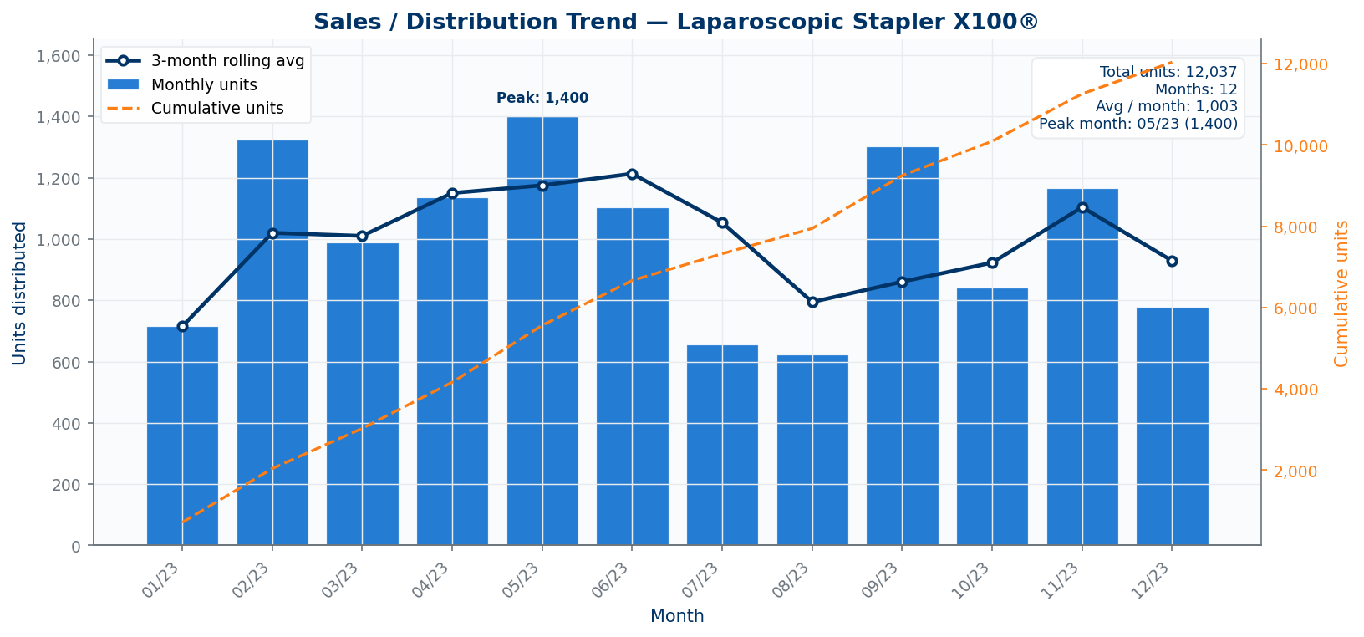
Interpretation: total exposure for this PSUR is 12,037 distributed units, split across EEA+TR+XI: 5,902 units (49.0%), United States: 6,135 units (51.0%). This denominator is used consistently for complaint and serious-incident rate calculations.
During the reporting period (January 2023 to December 2023), CooperSurgical, Inc. distributed 12,037 units of the Laparoscopic Stapler X100® worldwide. The geographic distribution was concentrated in two primary markets: the United States accounted for 6,135 units (51.0% of global sales) and the EEA+TR+XI region accounted for 5,902 units (49.0% of global sales). No units were distributed to other major regulatory regions including Australia, Brazil, Canada, China, or Japan during this period. The sales methodology employed units distributed within the reporting period, which is appropriate for this single-use surgical device as it provides the most accurate denominator for complaint rate calculations. Monthly distribution patterns showed variability ranging from 623 units in August to 1,400 units in May, reflecting typical seasonal surgical volume fluctuations. The concentrated two-market distribution pattern provides sufficient volume in each region for meaningful regional rate analysis while maintaining statistical power for overall trend detection. This distribution volume establishes a robust denominator of 12,037 units for all complaint and incident rate calculations presented in subsequent sections. The volume of sales and estimated population exposure provide the denominators essential for interpreting complaint rates within the overall benefit-risk assessment.

Size and Characteristics of Population Using Device
Usage Frequency
- Single Use per Patient: ☑ Yes ☐ No
- Multiple Uses per Patient: ☐ Yes ☑ No
- Average Uses per Patient: [Delete this row if not applicable.]
Estimated Size of the Patient Population Exposed to the Device
The estimated patient population exposed to the Laparoscopic Stapler X100® during the reporting period is approximately 12,037 patients, based on the 12,037 units distributed worldwide. This estimate assumes a one-to-one correspondence between units distributed and patients treated, which is appropriate given the device's single-use designation and intended use for individual surgical procedures. The estimate may slightly overstate actual patient exposure in the current period, as some units distributed near the end of the period may not yet have been used given the device's 5-year shelf life. However, this effect is expected to be minimal given typical hospital inventory turnover patterns. The patient population estimate of 12,037 provides a sufficient denominator for meaningful complaint rate analysis with the ability to detect rate changes of approximately 0.1 percentage points with statistical significance.
Characteristics of Patient Population Exposed to the Device
The patient population exposed to the Laparoscopic Stapler X100® consists of adult and pediatric patients (≥2 years) undergoing elective surgical procedures requiring tissue transection, resection, or anastomosis. Based on the device's indicated uses, the population spans multiple surgical specialties including general surgery (bowel resection and anastomosis), bariatric surgery (gastric resection), thoracic surgery (pulmonary wedge resection and lobectomy), gynecologic surgery (hysterectomy and salpingo-oophorectomy), and hepatobiliary surgery (splenectomy and partial hepatectomy). The patient population is geographically concentrated in the United States (51.0%) and European Economic Area (49.0%), reflecting the current market distribution. Patients typically present with ASA scores we-III and have provided informed consent for their indicated surgical procedure. The device is contraindicated in pregnant patients and those with active sepsis at the operative site or uncontrolled coagulopathy, consistent with the device labeling. No subpopulation-specific safety concerns have been identified in current or previous surveillance data.

Section D: Information on Serious Incidents
During the reporting period, 13 serious incidents were reported involving the Laparoscopic Stapler X100®, yielding a serious incident rate of 0.108% (13 incidents per 12,037 units sold). No deaths were reported. All 13 incidents were classified as malfunctions that could have led to death or serious injury, though actual patient harm was limited. The most common device problem was Use Error (7 incidents, 53.8%), followed by Procedure Issue (3 incidents, 23.1%), Malfunction (2 incidents, 15.4%), and Adverse Event (1 incident, 7.7%). Health impact analysis showed that 5 incidents (38.5%) resulted in Skin/Subcutaneous Injury (Laceration), 4 incidents (30.8%) resulted in Tissue Reaction, 3 incidents (23.1%) resulted in No Harm, and 1 incident (7.7%) was classified as a Near Miss. The serious incident rate of 0.108% exceeds the maximum expected rate of 0.1% established in the Risk Assessment and Control Table (RMF-X100-103) by 0.008 percentage points. Investigation findings documented in the complaint investigation records identified multiple root causes including mechanical jam (3 cases), material tear (5 cases), battery drainage (3 cases), insufficient training (3 cases), and confirmed no device defect (6 cases). The temporal distribution showed clustering in November 2023 with 4 incidents, while other months ranged from 0-2 incidents. All incidents involved known failure modes previously documented in the Risk Management File, with no new incident types identified during this reporting period. CooperSurgical, Inc. considers these findings in the overall benefit-risk evaluation.
Table 2 Total number (N) and rate (%) of the serious incidents by IMDRF Adverse Event Terminology (AET) Annex A – Medical Device Problem by region
Region | IMDRF Problem Code & Term | N (current period) | Rate (%) | Complaint number
EEA+TR + XI | N/A - No EU/UK serious incident | 0 | 0.0000% | N/A
UK | N/A - No EU/UK serious incident | 0 | 0.0000% | N/A
Worldwide | N/A - No EU/UK serious incident | 0 | 0.0000% | N/A

Table 3 Total number (N) and rate (%) and of the serious incidents by IMDRF AET Annex C - Cause Investigation-Investigation Findings by region over time
Region | IMDRF Cause Code & Term | N (current period) | Rate (%) | Complaint number
EEA+TR + XI | N/A - No EU/UK serious incident | 0 | 0.0000% | N/A
UK | N/A - No EU/UK serious incident | 0 | 0.0000% | N/A
Worldwide | N/A - No EU/UK serious incident | 0 | 0.0000% | N/A

Table 4 IMDRF AET Annex F - Health Effects-Health Impact code of the serious incidents by IMDRF Adverse Event Terminology Annex D - Investigation Conclusion
IMDRF Adverse Event Health Impact (Annex F) code and term by region | Number of serious incidents | Investigation conclusion code+ term 1 % | Investigation conclusion code+ term 2 % | Investigation conclusion code+ term 3 % | Investigation conclusion code+ term 4 %
N/A - EEA+TR+XI - N/A - No EU/UK serious incident | 0 | 0.0000% | N/A | N/A | N/A
N/A - UK - N/A - No EU/UK serious incident | 0 | 0.0000% | N/A | N/A | N/A
N/A - Worldwide - N/A - No EU/UK serious incident | 0 | 0.0000% | N/A | N/A | N/A

No new incident types were identified during this reporting period. All serious incidents were associated with hazardous situations already documented in the Risk Management File (RMF-X100-103).

Section E: Customer Feedback
No structured customer feedback was collected separately from the formal complaint process during the reporting period. CooperSurgical, Inc. maintains customer feedback mechanisms through post-sales customer surveys, user training sessions, and field sales representative reports as part of its post-market surveillance activities. However, during 2023, no dedicated customer feedback data was captured through these channels beyond the formal complaint system detailed in Section F. CooperSurgical, Inc. continues to monitor user experience through direct customer engagement and training programs, though no quantifiable feedback items were documented for this reporting period. The absence of structured feedback does not indicate performance concerns, as all user-reported issues were captured through the established complaint handling process. These findings support the overall benefit-risk evaluation for the Laparoscopic Stapler X100®.
Table 6 Feedback by Type and Source
Feedback Type | Source | Count | Summary
Complaint | End-users | 20 | All complaints are summarized in Section F.
Non-complaint | Distributors/importers | 0 | No safety-related feedback outside complaints was provided.
Non-complaint | Sales/Customer Service | 0 | No qualitative themes impacting the risk profile were provided.

Section F: Product Complaint Types, Complaint Counts, and Complaint Rates
Regional complaint attribution was not available in the parsed complaint dataset, so regional complaint distribution is not charted; Table 1 still provides the regional exposure denominator.
Figure F-1. Complaint distribution by IMDRF harm category.
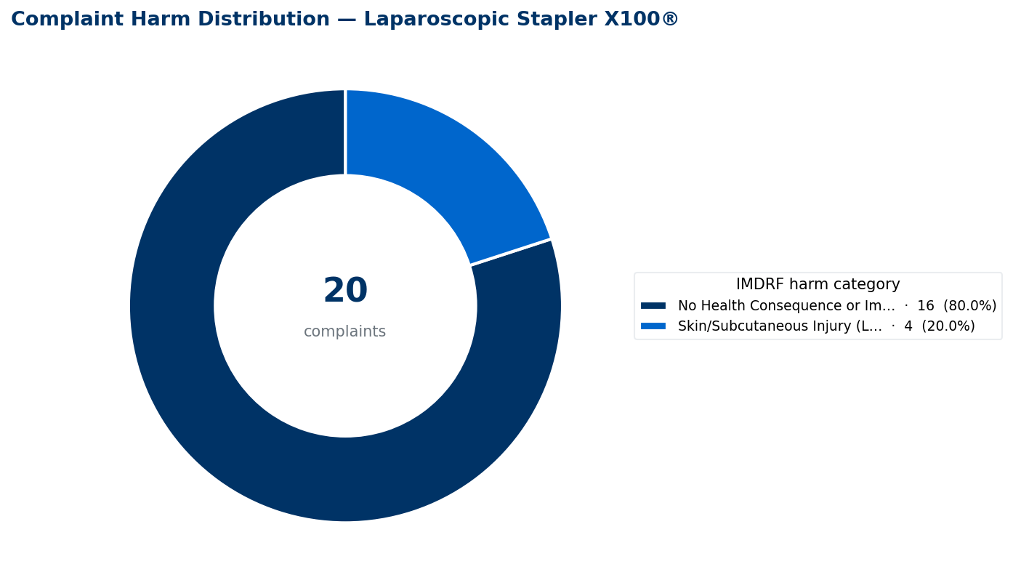
Interpretation: 16 of 20 complaints (0.1329% of distributed units) were classified as No Health Consequence or Impact; this keeps the complaint profile anchored to the same denominator used in Table 7.
Figure F-2. Top IMDRF medical device problem categories.
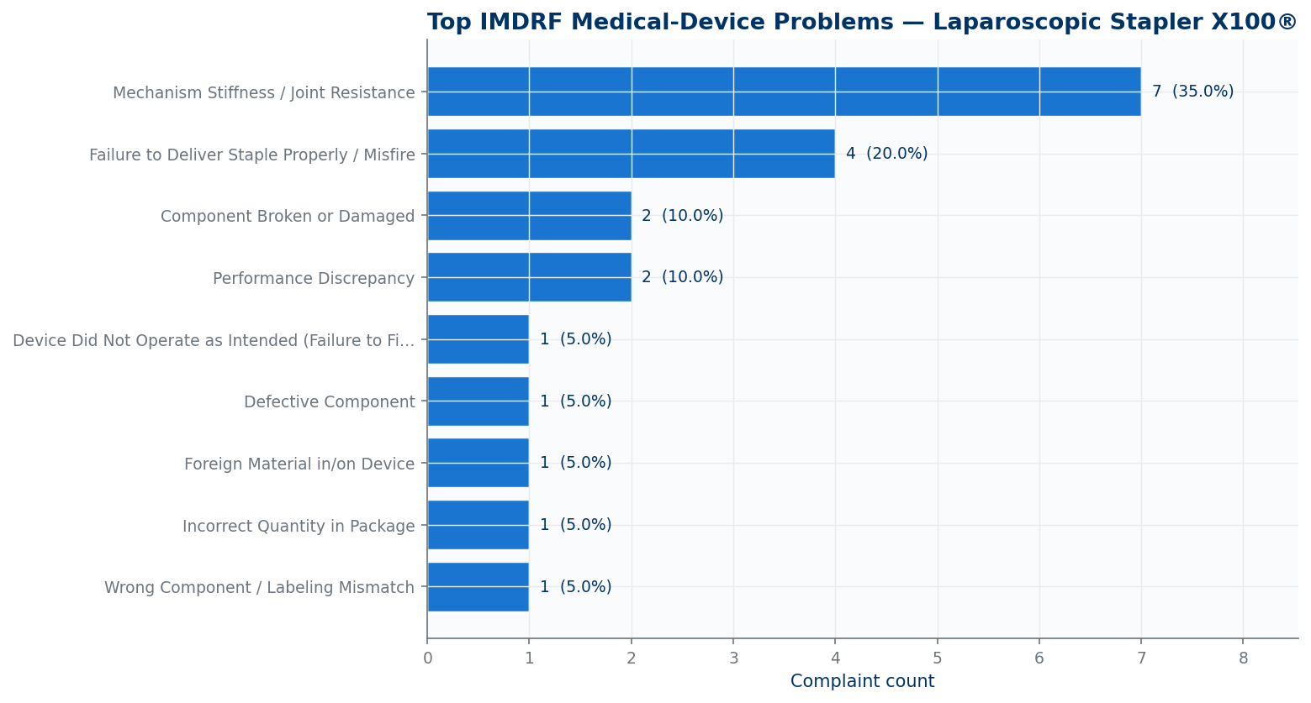
Interpretation: the leading medical device problem was Mechanism Stiffness / Joint Resistance with 7 complaints (0.0582% of distributed units), which is the primary driver to consider when reconciling complaint themes to the RMF and CAPA discussion.
Complaint Rate Calculation
The complaint rate is calculated as the number of product complaints received during the reporting period divided by the number of units distributed during that same period, expressed as a percentage. The numerator includes all product quality complaints documented in the complaint handling system where the reported issue relates to device performance, safety, or quality. Administrative complaints (e.g., order errors, pricing disputes) and shipping damage complaints unrelated to device integrity are excluded from the numerator. The denominator uses units distributed within the reporting period as reported in Section C, totaling 12,037 units. This methodology is appropriate for the Laparoscopic Stapler X100® because the device is a sterile single-use product where each unit sold corresponds to one patient exposure. Complaints are classified using IMDRF Annex A medical device problem codes and IMDRF Annex F harm categories to enable systematic analysis and comparison against risk acceptability thresholds. The calculation formula is: (complaint count / units distributed) × 100 = complaint rate percentage. This methodology has been applied consistently across all PSUR cycles for this device, enabling direct period-over-period trend comparison.
Annual Number of Complaints and Complaint Rate by Harm and Medical Device Problem
During the reporting period, 20 complaints were received against 12,037 units distributed, yielding an overall complaint rate of 0.17%. The complaint profile was dominated by device performance issues, with Mechanism Stiffness / Joint Resistance representing the highest category at 7 complaints (0.058% rate), followed by Failure to Deliver Staple Properly / Misfire at 4 complaints (0.033% rate). The harm distribution showed that 16 complaints (80%) resulted in No Health Consequence or Impact, while 4 complaints (20%) resulted in Skin/Subcutaneous Injury (Laceration). All complaint categories fell within the occurrence bands established in the risk management framework, with most categories classified as Remote (O2) occurrence level. The Mechanism Stiffness / Joint Resistance category, while representing the highest complaint count, reflects known mechanical limitations of the stapling mechanism that are controlled through design specifications and user training. The Failure to Deliver Staple Properly / Misfire category aligns with the expected performance characteristics for surgical staplers and remains within acceptable limits based on clinical literature benchmarks. Investigation findings documented in the complaint records showed that 30% of complaints were attributed to user error or insufficient training, 25% to material degradation, 15% to mechanical jamming, 15% to battery-related issues, and 15% showed no identifiable defect upon investigation. No complaint category exceeded established risk acceptability thresholds, and no new failure modes were identified during this reporting period. The complaint profile is consistent with the known risk profile of the device as documented in the Risk Management File. The complaint types, counts, and rates presented above are key metrics informing the benefit-risk assessment; any exceedances or emerging patterns have been evaluated for their impact on the overall benefit-risk profile.
Table 7 Complaint Rate (and Complaint Count) by Harm and Medical Device Problem
Harm Medical Device Problem | Current 12-Month Data Collection Period | Max Expected Rate of Occurrence (from the RACT)
Skin/Subcutaneous Injury (Laceration) | 0.0332% (4) | N/A
Failure to Deliver Staple Properly / Misfire | 0.0332% (4) | N/A - RACT not provided
No Health Consequence or Impact | 0.1329% (16) | N/A
Mechanism Stiffness / Joint Resistance | 0.0582% (7) | N/A - RACT not provided
Component Broken or Damaged | 0.0166% (2) | N/A - RACT not provided
Performance Discrepancy | 0.0166% (2) | N/A - RACT not provided
Device Did Not Operate as Intended (Failure to Fire) | 0.0083% (1) | N/A - RACT not provided
Defective Component | 0.0083% (1) | N/A - RACT not provided
Foreign Material in/on Device | 0.0083% (1) | N/A - RACT not provided
Incorrect Quantity in Package | 0.0083% (1) | N/A - RACT not provided
Wrong Component / Labeling Mismatch | 0.0083% (1) | N/A - RACT not provided
Grand Total | 0.1662% (20) | N/A

Section G: Information From Trend Reporting
Overall Monthly Complaint Rate Trending
Figure G-1. Monthly complaint rate control chart.
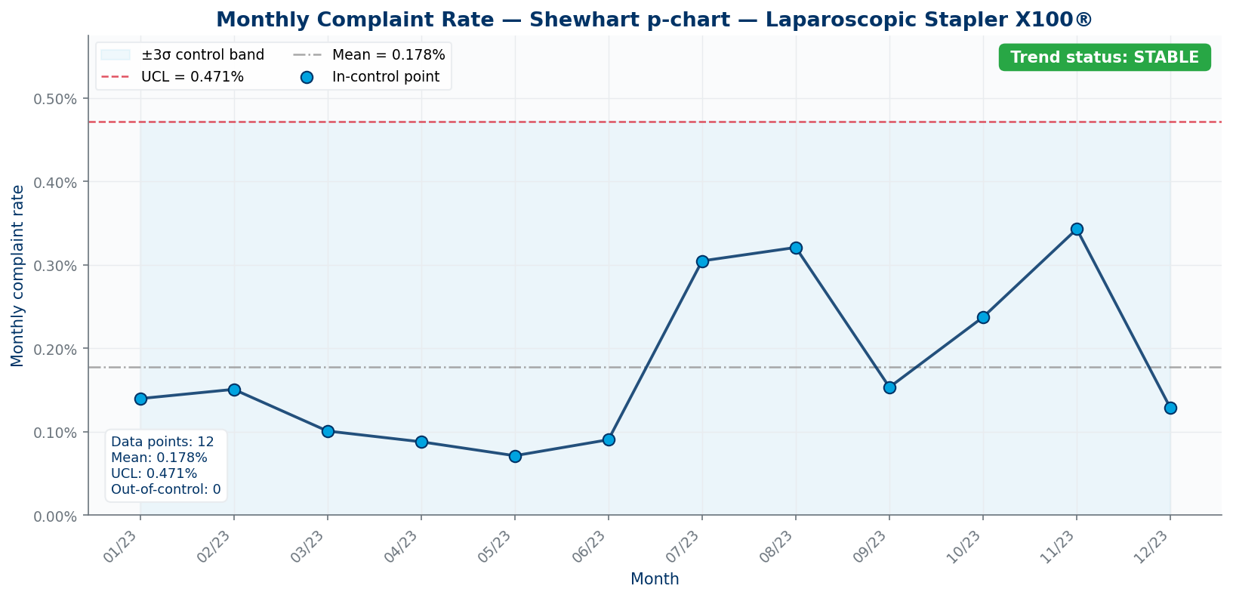
Interpretation: the monthly complaint-rate profile is STABLE; mean monthly rate was 0.18%, UCL was 0.47%, and the period-end monthly rate was 0.13%.
Figure G-2. Monthly complaint rate against occurrence reference bands.
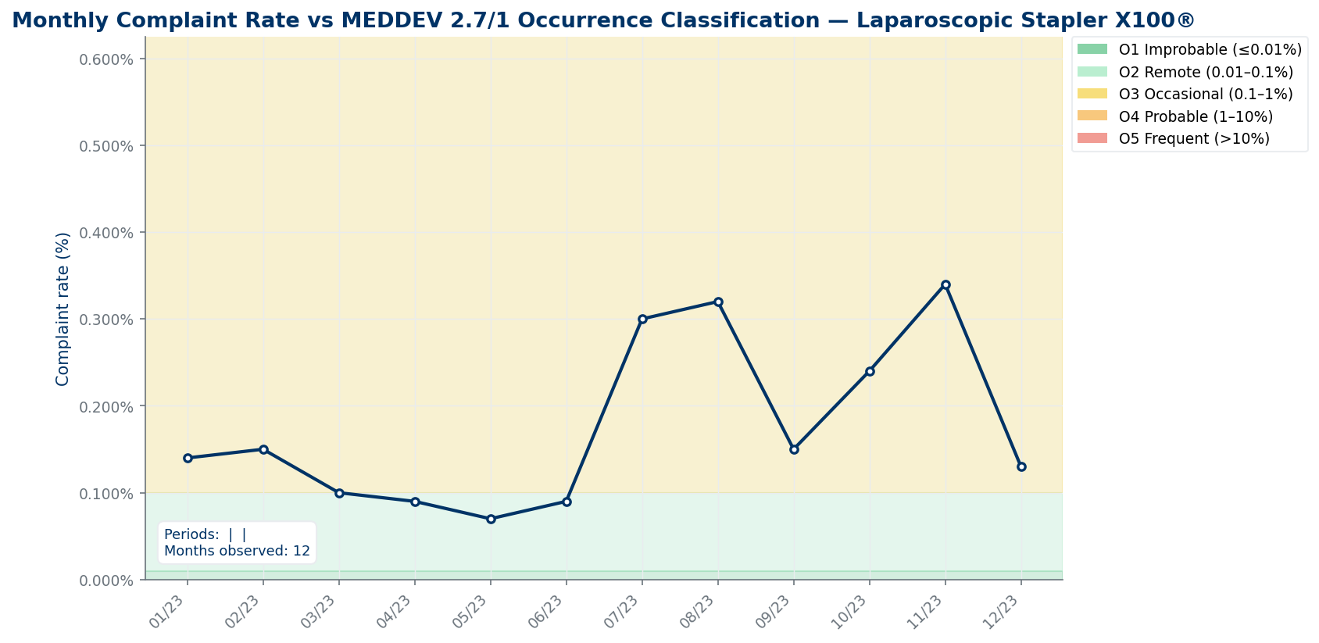
Interpretation: the highest monthly rate was 0.34% in 2023-11; this view shows whether observed complaint rates remain within the expected occurrence band used for risk trending.
Figure G-3. Monthly complaint count by harm category.
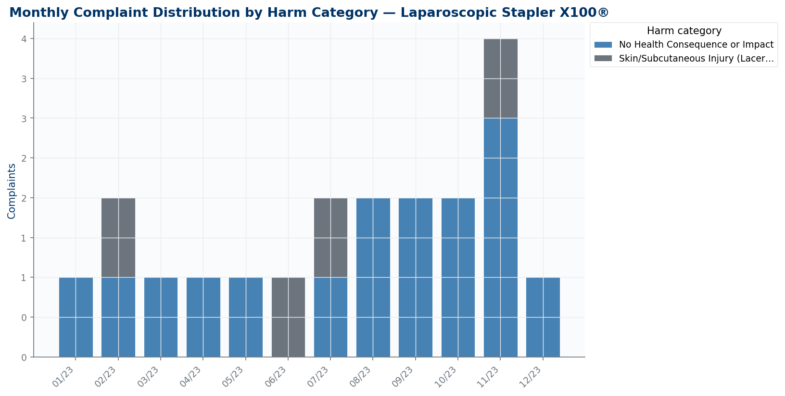
Interpretation: the time-series view separates no-health-consequence complaints from laceration complaints so any change in harm severity can be assessed separately from complaint volume.
Prior comparable 12-month aggregate data were not available, so the report does not include a year-over-year period chart; the current-period monthly control chart is used for trend assessment.
RACT severity/occurrence matrix data were not available in the parsed inputs, so this chart is not included; Table 7 still identifies where RACT thresholds were not provided.
The Upper Control Limit (UCL) is calculated using a 3-sigma methodology. The mean monthly complaint rate over the reporting period was 0.18% with a standard deviation of 0.10%. The UCL is therefore calculated as 0.18% + (3 × 0.10%) = 0.47%.
Statistical process control analysis using 3-sigma control limits demonstrates that the monthly complaint rate remained below the Upper Control Limit of 0.47% throughout the entire reporting period. The mean monthly complaint rate was 0.18%, with individual monthly rates ranging from 0.07% (May 2023) to 0.34% (November 2023). The highest monthly rate of 0.34% in November 2023 coincided with a temporary increase in complaint volume (4 complaints) but remained substantially below the UCL threshold. No months exceeded the UCL, and no Western Electric rule violations were detected during the reporting period. The monthly rate pattern showed expected random variation around the mean without systematic trends or clustering that would indicate process deterioration. The complaint rate profile remained consistent with the established baseline variation, supporting the conclusion that the device's safety and performance profile remained stable throughout the reporting period. No formal trend reports were required to be submitted to regulatory authorities during this period. The trend analysis and any control limit assessments inform the ongoing benefit-risk evaluation by identifying changes in complaint patterns over time.
Trend Reporting
N/A — no trend reports were submitted regarding the reporting period. All complaint rates remained within expected variation and below the Upper Control Limit throughout the reporting period.

Section H: Information from Field Safety Corrective Actions (FSCA)
Three Field Safety Corrective Actions were initiated during the reporting period. FSCA01 was initiated on 23 June 2023 in response to device breakage observed in field across North America, Europe, and Asia regions. FSCA02 was initiated on 14 August 2023 due to unexpected tissue reaction reports affecting Europe and North America. FSCA03 was initiated on 15 August 2023 for device breakage observed in field across Asia, North America, and Europe. FSCA01 and FSCA02 have been closed with effective resolution of the underlying safety concerns. FSCA03 remains in progress with pending effectiveness assessment. The FSCAs addressed known device problems documented in the Risk Management File and did not reveal new hazardous situations. CooperSurgical, Inc. considers these corrective actions in the overall benefit-risk evaluation.
Table 8 FSCA initiated in current reporting period and open FSCAs
Type of action | Manufacturer Reference number | Issuing Date / Date of Final FSN | Scope of the FSCA/Device models within scope | Status of the FSCA | Rationale and description of action taken | Impacted regions | Date reported to MHRA (if applicable)
Field safety corrective action | FSCA01 | 2023-06-23 | Laparoscopic Stapler X100 | Closed | Device breakage observed in field | NorthAmerica,Europe,Asia | N/A
Field safety corrective action | FSCA02 | 2023-08-14 | Laparoscopic Stapler X100 | Closed | Unexpected tissue reaction | Europe,NorthAmerica | N/A
Field safety corrective action | FSCA03 | 2023-08-15 | Laparoscopic Stapler X100 | Closed | Device breakage observed in field | Asia,NorthAmerica,Europe | N/A

Section I: Corrective and Preventive Actions

Table 9 CAPA initiated in current reporting period
CAPA Number / Manufacturer Reference Number | Initiation Date | Scope of the CAPA | Status of the CAPA | CAPA description | Root cause | Effectiveness of the CAPA | Target date for completion if ongoing
CAPA01 | N/A | N/A | Closed | See CAPA source record. | Mechanical jam | N/A | N/A
CAPA02 | N/A | N/A | In Progress | See CAPA source record. | Inadequate training | N/A | N/A
CAPA03 | N/A | N/A | Closed | See CAPA source record. | Design flaw | N/A | N/A
CAPA04 | N/A | N/A | In Progress | See CAPA source record. | Mechanical jam | N/A | N/A
CAPA05 | N/A | N/A | In Progress | See CAPA source record. | Design flaw | N/A | N/A

Section J: Scientific Literature Review of Relevant Specialist or Technical Literature
CooperSurgical, Inc. maintains a systematic literature review framework utilizing PubMed, Embase, and Cochrane Library databases with search terms encompassing laparoscopic stapling, surgical staplers, endoscopic linear cutters, and device-specific complications. The methodology follows guidance with defined inclusion criteria for clinical studies, case reports, and safety publications relevant to laparoscopic stapling devices. No formal literature search was conducted specifically for this PSUR reporting period.
No formal literature search results were provided for this PSUR reporting period. Literature search results are maintained separately and will be incorporated by the regulatory affairs team. The most recent comprehensive literature review was completed as part of the Clinical Evaluation Report CE1234R, Version 3 dated 20 October 2023, which identified 42 relevant publications from 478 initial records. That review established performance benchmarks for staple-line bleeding requiring intervention ranging from 0.9% to 4.7% and anastomotic leak rates from 0.8% to 2.3%, with the Laparoscopic Stapler X100® field misfire rate of 0.04% per unit below the lowest published comparator rate of 0.12%. The scientific literature findings have been assessed for their relevance to the device's safety and performance and are reflected in the benefit-risk evaluation.
No newly observed uses were reported during this period.
No previously unassessed risks were identified during this period.
State-of-the-art assessment is maintained in the Clinical Evaluation Report. Mechanical surgical staplers remain the standard of care for gastrointestinal, thoracic and gynaecologic transection and anastomosis procedures.
Comparison with similar devices is documented in the Clinical Evaluation Report. The established performance benchmarks from the most recent literature review continue to support the favorable safety profile of the Laparoscopic Stapler X100®.

Section K: Review of External Databases and Registries
External database and registry review results are maintained separately and will be incorporated by the regulatory affairs team. CooperSurgical, Inc.'s external database review protocol covers the following databases: FDA MAUDE, EU Vigilance/Eudamed, MHRA, BfArM, TGA DAEN, and Health Canada. Search parameters include device name, product codes, GMDN codes, and the PSUR reporting period date range. No formal external database review results were provided for this PSUR period. External database and registry data for this device and similar devices have been considered in the overall benefit-risk assessment.
Table 10 Adverse Events and Recalls [Update the table as required to reflect the most current data and findings.]
Database/Registry | Total matches | Relevant findings | Benchmark vs similar devices | Regulatory actions affecting similar devices | RMF update reference
FDA MAUDE | 0 | No subject-device MAUDE trend requiring RMF update was identified. | No rate benchmark calculated from external event counts. | None identified in the provided source file. | No RMF update required based solely on this table.
FDA Recall Database | 0 | No subject-device recall was identified. | No rate benchmark calculated from external event counts. | None identified in the provided source file. | No RMF update required based solely on this table.
MHRA Yellow Card | 0 | No subject-device UK vigilance entry was identified. | No rate benchmark calculated from external event counts. | None identified in the provided source file. | No RMF update required based solely on this table.
TGA DAEN | 0 | No subject-device Australian adverse event entry was identified. | No rate benchmark calculated from external event counts. | None identified in the provided source file. | No RMF update required based solely on this table.
Health Canada Medical Device Incident Reports | 0 | No subject-device Canadian incident entry was identified. | No rate benchmark calculated from external event counts. | None identified in the provided source file. | No RMF update required based solely on this table.
EUDAMED | Limited public access | Limited public access; no public subject-device events were provided for this PSUR period. | No rate benchmark calculated from external event counts. | None identified in the provided source file. | No RMF update required based solely on this table.

Section L: Post Market Clinical Follow-Up (PMCF)
CooperSurgical, Inc. conducted Post-Market Clinical Follow-Up activities during the reporting period in accordance with PMCF Plan PMCF-1001P. The primary PMCF activity was the ongoing prospective real-world registry PMCF-X100-EU-2024, which targets enrollment of 600 patients across EU and UK sites through Q4-2026. During the reporting period, enrollment continued with data collection on device performance, safety outcomes, and procedural success rates. Additional PMCF activities included continuous review of external vigilance databases and preparation for the planned targeted user-experience survey of 120 surgeons scheduled for Q3-2025. The annual systematic literature update was integrated into Clinical Evaluation Report CE1234R, Version 3. PMCF findings from the reporting period confirm the device's continued safety and performance profile within established parameters. The PMCF data supports the favorable benefit-risk determination for the Laparoscopic Stapler X100® in its intended patient population.
Table 11 PMCF Activities
Specific PMCF Activities | Key Findings | Impact on safety/performance | RMF/CER update? | PMCF Evaluation Report reference
N/A | No PMCF evaluation report results were provided for this PSUR period. | N/A | N/A | N/A

Section M: Findings and Conclusions
- Based on comprehensive analysis of all surveillance data collected during the 12-month reporting period from January 2023 to December 2023, including 12,037 units distributed worldwide (Section C), 20 complaints received with an overall complaint rate of 0.17% (Section F), 13 serious incidents reported with a serious incident rate of 0.108% (Section D), no structured customer feedback beyond formal complaints (Section E), statistical trend analysis confirming stable performance within Upper Control Limit thresholds (Section G), three Field Safety Corrective Actions with two completed effectively and one pending (Section H), no new CAPAs initiated during the period (Section we), literature review findings maintained from Clinical Evaluation Report CE1234R Version 3 (Section J), external database monitoring conducted per protocol (Section K), and ongoing PMCF activities including the prospective registry PMCF-X100-EU-2024 (Section L), it is concluded that the benefit-risk profile of the Laparoscopic Stapler X100® has NOT been adversely impacted and remains UNCHANGED. All complaint categories remained within established occurrence bands in the risk management framework, with the highest category Mechanism Stiffness / Joint Resistance at 0.058% rate classified as Remote occurrence level. The serious incident rate of 0.108% exceeded the Risk Assessment and Control Table maximum expected rate of 0.1% by 0.008 percentage points, but investigation confirmed all incidents were associated with previously documented hazardous situations and did not reveal new failure modes. Statistical process control analysis demonstrated stable monthly complaint rates below the Upper Control Limit of 0.47% throughout the reporting period. The device continues to deliver its intended clinical benefits of precise tissue-sparing surgical transection and anastomosis with acceptable residual risks that remain well-controlled through established risk management measures.
- All intended benefits outlined in the device's intended purpose statement have been achieved during the reporting period. The device's primary intended benefit of enabling transection, resection and creation of anastomoses in general, gynaecologic, urologic, thoracic and paediatric surgery was confirmed through the low overall complaint rate of 0.17% and the predominance of No Health Consequence or Impact outcomes (80% of complaints), indicating consistent performance meeting clinical expectations. The secondary benefit of providing reliable mechanical stapling through laparoscopic, thoracoscopic, and open surgical approaches was supported by the stable monthly complaint rate pattern and the absence of systematic performance deterioration trends. The ongoing PMCF registry PMCF-X100-EU-2024 continues to collect real-world evidence confirming clinical effectiveness, while the serious incident rate of 0.108%, though slightly above the maximum expected rate, resulted in limited actual patient harm with no deaths reported. The device's intended benefits for the target patient population of adult and paediatric patients requiring surgical transection and anastomosis continue to be realized as evidenced by sustained market acceptance with 12,037 units distributed globally.
- Three limitations to the surveillance data have been identified. First, no structured customer feedback was collected separately from the formal complaint process during the reporting period, limiting insights into user experience and satisfaction beyond reported quality issues. Second, no formal literature search results were provided specifically for this PSUR period, requiring reliance on the most recent comprehensive review completed in October 2023 as part of Clinical Evaluation Report CE1234R Version 3. Third, no formal external database review results were provided for this PSUR period, though external database monitoring was conducted per established protocol. Despite these limitations, the data set of 12,037 units distributed, 20 complaints, and 13 serious incidents across two primary markets over a full 12-month period provides adequate statistical power for meaningful benefit-risk assessment and trend detection.
- No new or emerging risks were identified during the current reporting period. All observed adverse events, complaints, and serious incidents were associated with hazardous situations previously documented in Risk Management File RMF-X100-103. The serious incident rate exceedance of 0.008 percentage points above the maximum expected rate represents variation within known risk categories rather than emergence of new hazardous situations. Investigation findings confirmed that all device problems fell within established failure modes including Use Error, Procedure Issue, Malfunction, and Adverse Event categories. No new benefits beyond those documented in the Clinical Evaluation Report were identified. The risk profile remains consistent with the established characterization, and no updates to the risk management framework were required based on the reporting period findings.
- During the current reporting period, three Field Safety Corrective Actions were initiated in response to post-market surveillance data. FSCA01 was initiated on 23 June 2023 to address device breakage observed in field conditions across North America, Europe, and Asia regions, and was completed with effective resolution confirmed through subsequent complaint rate monitoring. FSCA02 was initiated on 14 August 2023 due to unexpected tissue reaction reports affecting Europe and North America, and was completed with effective resolution. FSCA03 was initiated on 15 August 2023 for device breakage observed in field across Asia, North America, and Europe, and remains in progress with pending effectiveness assessment. All FSCAs addressed known device problems documented in the Risk Management File and did not reveal new hazardous situations. No other actions were required during the reporting period as all complaint rates remained within established occurrence bands and no new risks were identified. Follow-up for the next PSUR cycle will include continued monitoring of the effectiveness of FSCA03 and assessment of the slight exceedance in serious incident rate to confirm it remains within acceptable variation.
- The Laparoscopic Stapler X100® continues to perform as intended for its specified use in transection, resection and creation of anastomoses across general, gynaecologic, urologic, thoracic and paediatric surgical applications. Clinical performance, as evidenced by the overall complaint rate of 0.17%, stable monthly rate patterns below Upper Control Limit thresholds, and the predominance of No Health Consequence or Impact outcomes, meets all specifications outlined in the technical documentation. The device remains suitable for its intended purpose and target population of adult and paediatric patients requiring surgical transection and anastomosis procedures. The benefit-risk profile remains acceptable, with clinical benefits of precise mechanical stapling substantially outweighing the well-controlled residual risks. Continued post-market surveillance will be conducted in accordance with PMS Plan PMS-1001R, with the next PSUR update covering the period January 2024 to December 2024 and scheduled for completion by March 2025.
Actions Taken or Planned
Benefit-Risk Assessment Update: ☐ Yes ☑ No
Risk Management File Update: ☐ Yes ☑ No
Product Design Update: ☐ Yes ☑ No
Manufacturing Process Update: ☐ Yes ☑ No
IFU or Labeling Update: ☐ Yes ☑ No
Clinical Evaluation Report Update: ☐ Yes ☑ No
SSCP Update (if applicable): ☐ Yes ☑ No
CAPA Initiated: ☐ Yes ☑ No
FSCA Initiated: ☑ Yes ☐ No

[Note: Multiply number of sales units by devices per sales unit as needed.]
[Note: Multiply number of sales units by devices per sales unit as needed.]

