

**Early Prediction for Chronic Kidney Disease Detection: A Progressive Approach to Health Management**

**1. Introduction**

**1.1 Project Overview**

Chronic Kidney Disease (CKD) is a progressive condition that affects kidney function over time and can lead to serious health complications if not detected and treated early. In many cases, CKD remains undiagnosed until it reaches advanced stages, reducing treatment effectiveness and increasing the burden on healthcare systems. With the rapid growth of healthcare data and advancements in artificial intelligence, there is a significant opportunity to leverage machine learning techniques for early disease detection.

This project, titled **“Early Prediction for Chronic Kidney Disease Detection: A Progressive Approach to Health Management”**, presents a machine learning-based solution aimed at predicting CKD at an early stage using clinical and laboratory parameters. The system is trained on a publicly available dataset and is designed to provide timely, accurate predictions through a user-friendly web application interface. The primary goal is to assist medical professionals and patients in proactive health management, enabling early interventions and better prognosis.

**1.2 Objectives**

The key objectives of this project are:

* To develop an efficient and accurate machine learning model for the early detection of Chronic Kidney Disease.
* To preprocess and analyze clinical datasets effectively for meaningful model training.
* To evaluate different classification algorithms and select the one that yields the best performance.
* To deploy the model into a web-based interface using Flask, ensuring accessibility and ease of use.
* To provide a functional, interactive UI that allows users to input clinical values and receive instant prediction results.
* To promote early intervention and awareness in CKD management by integrating technology into routine healthcare practices.

**Milestone 1: Project Initialization and Planning Phase**

The "Project Initialization and Planning Phase" marks the project's outset, defining goals, scope, and stakeholders. This crucial phase establishes project parameters, identifies key team members, allocates resources, and outlines a realistic timeline. It also involves risk assessment and mitigation planning. Successful initiation sets the foundation for a well-organized and efficiently executed machine learning project, ensuring clarity, alignment, and proactive measures for potential challenges.

**Activity 1: Define Problem Statement**

Problem Statement: A 45-year-old patient with no visible symptoms and limited access to specialist care visits a clinic for a routine checkup. Despite showing early signs of kidney function deterioration in lab results, the condition remains undiagnosed due to the absence of immediate symptoms and lack of analytical support. This highlights a critical gap in early detection of Chronic Kidney Disease, especially in resource-constrained environments, where delayed diagnosis can lead to severe complications, emphasizing the need for an intelligent, automated CKD prediction system.

**Problem Statement Report:** [**link**](https://github.com/SmartinternzprojectCKD/Early-Prediction-for-Chronic-Kidney-Disease-Detection-A-Progressive-Approach-to-Health-Management/blob/main/1.%20Project%20Initialization%20and%20Planning%20Phase/Define%20Problem%20Statements.pdf)

**Activity 2: Project Proposal (Proposed Solution)**

The proposed project, *"Early Prediction for Chronic Kidney Disease Detection: A Progressive Approach to Health Management,"* aims to leverage machine learning for accurate and early identification of CKD in patients. Utilizing a comprehensive clinical dataset including blood pressure, serum creatinine, hemoglobin levels, and other key medical indicators, the project seeks to develop a predictive model capable of identifying potential CKD cases at an early stage. This initiative aligns with the goal of enhancing preventive healthcare by enabling timely medical intervention, reducing disease progression, and improving patient outcomes through an accessible, web-based diagnostic tool.

**Project Proposal Report:** [**link**](https://github.com/SmartinternzprojectCKD/Early-Prediction-for-Chronic-Kidney-Disease-Detection-A-Progressive-Approach-to-Health-Management/blob/main/1.%20Project%20Initialization%20and%20Planning%20Phase/Project%20Proposal.pdf)

**Activity 3: Initial Project Planning**

Initial Project Planning for the "Early Prediction for Chronic Kidney Disease Detection" project involves defining key objectives, outlining the project scope, and identifying stakeholders such as healthcare professionals, patients, and developers. This phase includes establishing a clear timeline, allocating resources, and formulating a strategic approach for data analysis and model development. The team begins by thoroughly understanding the clinical dataset, setting measurable goals for prediction accuracy, and designing a structured workflow for data preprocessing, model training, and deployment. Effective initial planning ensures a focused, scalable, and well-coordinated execution, laying the groundwork for impactful results in the early detection of CKD.

**Project Planning Report:** [**link**](https://github.com/SmartinternzprojectCKD/Early-Prediction-for-Chronic-Kidney-Disease-Detection-A-Progressive-Approach-to-Health-Management/blob/main/1.%20Project%20Initialization%20and%20Planning%20Phase/Project%20Planning.pdf)

**Milestone 2: Data Collection and Preprocessing Phase**

The Data Collection and Preprocessing Phase involves sourcing a reliable Chronic Kidney Disease dataset from the UCI Machine Learning Repository. The dataset includes key clinical attributes such as blood pressure, serum creatinine, hemoglobin, and albumin levels. To ensure data quality, this phase addresses missing values through imputation, handles categorical variables via encoding, and normalizes numerical features. Preprocessing tasks also involve data cleaning and reformatting to prepare the dataset for exploratory data analysis and machine learning model development, ensuring accuracy and consistency throughout the pipeline.

**Activity 1: Data Collection Plan, Raw Data Sources Identified, Data Quality**

**Report**

The dataset for “Early Prediction for Chronic Kidney Disease Detection” is sourced from the UCI Machine Learning Repository. It contains 400 patient records with clinical and physiological attributes such as blood pressure, serum creatinine, hemoglobin, and albumin levels. Data quality is ensured through detailed inspection, addressing missing and inconsistent values using imputation techniques, and standardizing categorical entries. Ethical data handling practices are followed throughout the process, ensuring a reliable and accurate foundation for building effective predictive

models.

**Data Collection Report:** [**link**](https://github.com/SmartinternzprojectCKD/Early-Prediction-for-Chronic-Kidney-Disease-Detection-A-Progressive-Approach-to-Health-Management/blob/main/2.%20Data%20Collection%20and%20Preprocessing%20Phase_/Raw%20Data%20Sources%20And%20Data%20Quality%20Report.pdf)

**Activity 2: Data Quality Report**

The dataset for “Early Prediction for Chronic Kidney Disease Detection” is sourced from the UCI Machine Learning Repository. It comprises clinical records of patients, including attributes such as age, blood pressure, specific gravity, albumin, sugar, and serum creatinine. Data quality was maintained through systematic verification, handling of missing values via mean/mode imputation and logical substitution, and normalization of data formats. Categorical inconsistencies were resolved through standard encoding practices, ensuring consistency across features. Ethical guidelines for health data handling were strictly followed, providing a robust and clean dataset suitable for accurate predictive modeling.

**Data Quality Report:** [**link**](https://github.com/SmartinternzprojectCKD/Early-Prediction-for-Chronic-Kidney-Disease-Detection-A-Progressive-Approach-to-Health-Management/blob/main/2.%20Data%20Collection%20and%20Preprocessing%20Phase_/Data%20Quality%20Report.pdf)

**Activity 3: Data Exploration and Preprocessing**

Data Exploration involves analyzing the Chronic Kidney Disease dataset to uncover patterns, detect anomalies, and understand the distribution of clinical features such as blood pressure, albumin levels, and serum creatinine. Key trends and correlations were visualized to guide feature selection and model choice. Preprocessing includes addressing missing values through appropriate imputation, scaling numerical variables for uniformity, and encoding categorical values such as red blood cell type and hypertension status. These critical steps improve data quality and integrity, ensuring the reliability and accuracy of subsequent machine learning analyses.

**Data Exploration and Preprocessing Report:** [**link**](https://github.com/SmartinternzprojectCKD/Early-Prediction-for-Chronic-Kidney-Disease-Detection-A-Progressive-Approach-to-Health-Management/blob/main/2.%20Data%20Collection%20and%20Preprocessing%20Phase_/Data%20Exploration%20and%20Preprocessing.pdf)

**Milestone 3: Model Development Phase**

The Model Development Phase focuses on building a reliable predictive model for early CKD detection. It involves strategic feature selection based on clinical relevance and correlation analysis. Multiple machine learning algorithms—including Logistic Regression, Decision Tree, Random Forest, and Gradient Boosting—are evaluated for performance. The selected model undergoes training using structured clinical data, followed by rigorous validation using metrics such as accuracy, precision, recall, and F1-score. This phase ensures the model’s robustness and reliability, forming the core of the system’s decision-support capability in healthcare diagnostics.

**Activity 1: Feature Selection Report**

The Feature Selection Report highlights the rationale behind selecting specific clinical features (e.g., blood pressure, albumin, serum creatinine, hemoglobin, and sugar levels) for the CKD prediction model. These features were chosen based on medical significance, correlation with the target outcome, and contribution to the model’s predictive accuracy. Statistical methods and domain knowledge guided the exclusion of redundant or weakly correlated variables, ensuring the model is both efficient and interpretable. The inclusion of these key features enhances the model's ability to accurately identify early signs of Chronic Kidney Disease.

**Feature Selection Report:** [**link**](https://github.com/SmartinternzprojectCKD/Early-Prediction-for-Chronic-Kidney-Disease-Detection-A-Progressive-Approach-to-Health-Management/blob/main/3.%20Model%20Development%20Phase/Feature_Selection_Report.pdf)

**Activity 2: Model Selection Report**

The Model Selection Report outlines the rationale behind choosing Logistic Regression, Decision Tree, Random Forest, and Gradient Boosting (XGBoost) for predicting Chronic Kidney Disease. These models were selected based on their proven ability to handle medical data, manage nonlinear relationships, and deliver high accuracy with interpretability. Logistic Regression offers simplicity and transparency, while Decision Tree and Random Forest models excel in capturing complex feature interactions. Gradient Boosting enhances predictive performance through iterative learning. The selection aligns with the project's goal of achieving reliable, explainable, and early-stage CKD detection suitable for real-world healthcare deployment.

**Model Selection Report:** [**link**](https://github.com/SmartinternzprojectCKD/Early-Prediction-for-Chronic-Kidney-Disease-Detection-A-Progressive-Approach-to-Health-Management/blob/main/3.%20Model%20Development%20Phase/Model%20Selection%20Report.pdf)

**Activity 3: Initial Model Training Code, Model Validation and Evaluation**

**Report**

The Initial Model Training Code applies selected machine learning algorithms—including Logistic Regression, Decision Tree, Random Forest, and Gradient Boosting—on the Chronic Kidney Disease dataset, establishing the foundation for reliable prediction. Data is split into training and testing sets to ensure unbiased evaluation. The Model Validation and Evaluation Report rigorously assesses each model's performance using key metrics such as accuracy, precision, recall, and F1-score. Confusion matrices and ROC curves are analyzed to validate the model's effectiveness, ensuring it meets the criteria for dependable early-stage CKD detection in clinical settings.

**Model Development Phase Template:** [**link**](https://github.com/SmartinternzprojectCKD/Early-Prediction-for-Chronic-Kidney-Disease-Detection-A-Progressive-Approach-to-Health-Management/blob/main/3.%20Model%20Development%20Phase/Model_Training_Code%2C_Model_Validation_and_Evaluation.pdf)

**Milestone 4: Model Optimization and Tuning Phase**

The Model Optimization and Tuning Phase focuses on refining machine learning models to achieve optimal predictive performance for early CKD detection. This stage includes implementing optimized model code, performing systematic hyperparameter tuning, comparing evaluation metrics across models, and justifying the selection of the most effective algorithm. These steps are critical in ensuring the model's robustness, generalizability, and clinical reliability.

**Activity 1: Hyperparameter Tuning Documentation**

The Gradient Boosting model was chosen for its consistently high performance across various clinical features. Through hyperparameter tuning—adjusting parameters such as learning rate, number of estimators, and max depth—the model achieved significant improvements in accuracy and generalization. Its ability to capture complex interactions between medical variables, resist overfitting, and maintain stability in predictions supports its use as the final model for CKD detection, aligning well with the project’s health-oriented objectives.

**Activity 2: Performance Metrics Comparison Report**

The Performance Metrics Comparison Report presents a comprehensive evaluation of baseline and tuned performance across multiple models. Gradient Boosting exhibited the highest improvement, with accuracy rising from baseline values (~94%) to optimized levels (~97%), alongside notable gains in precision and recall. This comparison illustrates the effectiveness of hyperparameter tuning and reinforces the decision to adopt Gradient Boosting as the core predictive engine in the system.

**Activity 3: Final Model Selection Justification**

The Final Model Selection Justification outlines the reasoning behind selecting **Gradient Boosting** as the final model for Chronic Kidney Disease prediction. Gradient Boosting demonstrated superior accuracy, strong generalization capability, and resilience to overfitting when compared to other algorithms. Its ability to effectively manage complex clinical relationships and improve performance through hyperparameter tuning aligns seamlessly with the project’s healthcare objective of early and accurate CKD detection. This makes it the most reliable and impactful choice for deployment in a real-world diagnostic environment.

**Model Optimization and Tuning Phase Report:** [**link**](https://github.com/SmartinternzprojectCKD/Early-Prediction-for-Chronic-Kidney-Disease-Detection-A-Progressive-Approach-to-Health-Management/blob/main/4.%20Model%20Optimization%20and%20Tuning%20Phase/Model%20Optimization%20and%20Tuning%20Phase.pdf)

Results

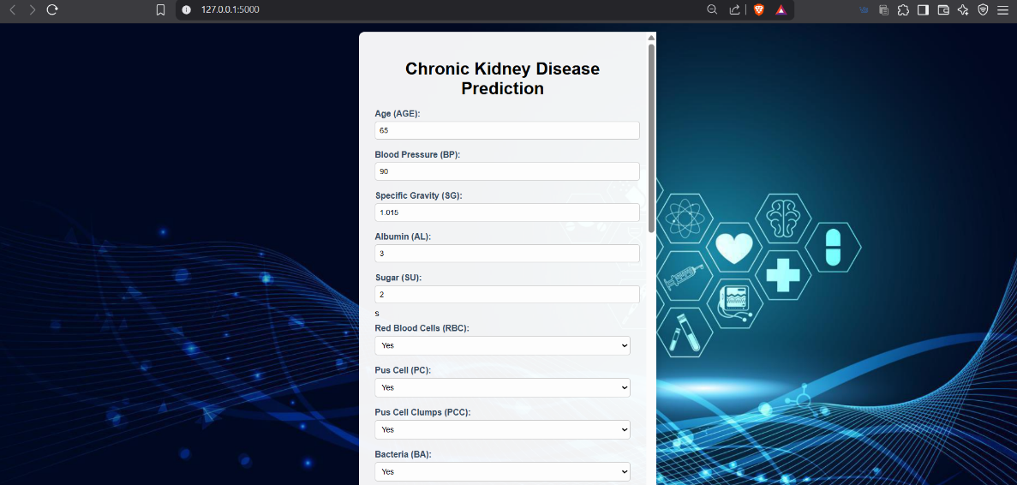

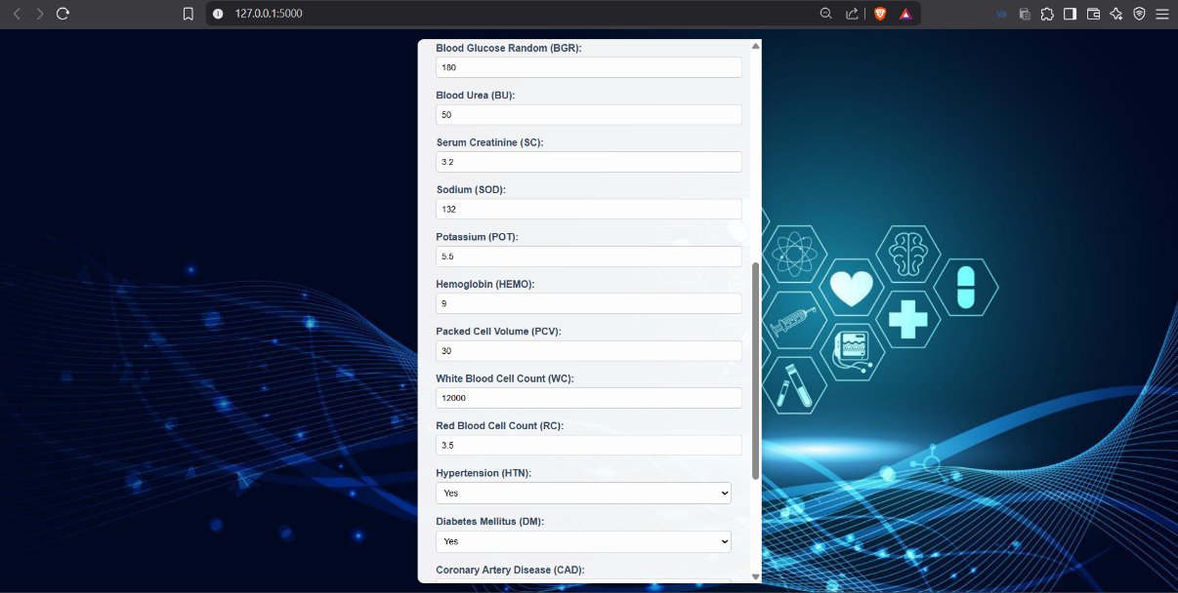

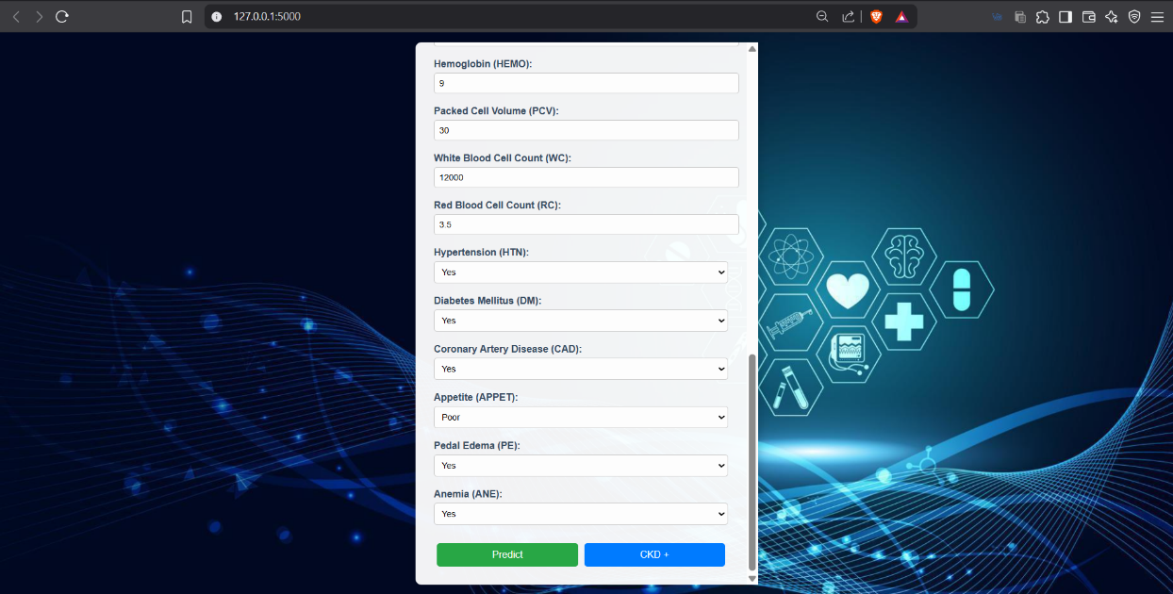

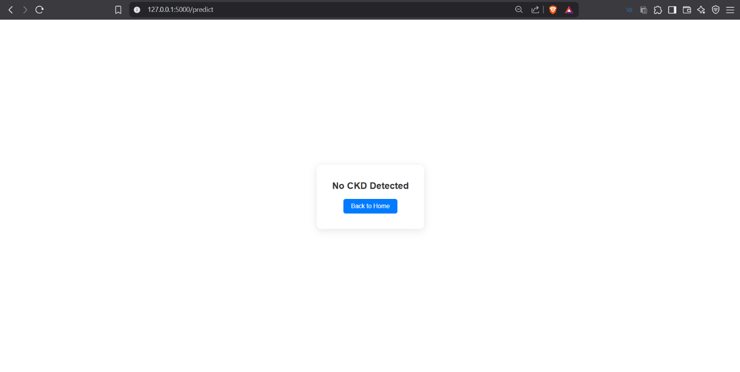

**Advantages & Disadvantages**

**Advantages**

* **High Predictive Accuracy:** Gradient Boosting consistently delivers superior accuracy in classification tasks, making it ideal for early CKD detection.
* **Handles Complex Relationships:** It effectively captures nonlinear patterns and interactions between multiple clinical features.
* **Feature Importance Analysis:** The model provides insights into which medical parameters most influence predictions, aiding clinical interpretation.
* **Reduced Overfitting (with tuning):** When properly tuned, Gradient Boosting models generalize well to unseen data.
* **Scalability:** Suitable for both small and moderately large healthcare datasets, offering flexibility in real-world applications.

**Disadvantages**

* **Computationally Intensive:** Training Gradient Boosting models, especially with hyperparameter tuning, can be time-consuming and resource-demanding.
* **Less Interpretable:** Compared to simpler models like Decision Trees or Logistic Regression, it can be more difficult to interpret without visualization tools.
* **Sensitive to Noisy Data:** Gradient Boosting can overfit on noisy datasets if not carefully regularized.
* **Hyperparameter Tuning Required:** Performance heavily depends on finding the right combination of parameters, requiring time and experimentation.

### ****Conclusion****

The project “Early Prediction for Chronic Kidney Disease Detection: A Progressive Approach to Health Management” successfully demonstrates how machine learning can be leveraged to address critical challenges in healthcare diagnostics. By training and deploying a predictive model using clinical data, the system provides early identification of CKD, enabling timely medical intervention and improving patient outcomes.

Among the models evaluated, **Gradient Boosting** emerged as the most effective due to its high accuracy, robustness, and ability to model complex clinical relationships. The development of a responsive and user-friendly web application further enhances accessibility, allowing both patients and healthcare providers to benefit from intelligent diagnostic support.

This initiative not only supports the goal of preventive healthcare but also sets the stage for broader AI-driven health applications that can improve quality of care, especially in resource-limited settings.

### ****Future Scope****

The project lays the groundwork for further advancements in AI-driven healthcare solutions, with several opportunities for future development:

* **Multi-Disease Prediction:** Expanding the system to predict other chronic conditions such as diabetes, liver disease, or cardiovascular disorders using integrated datasets.
* **Larger and Real-Time Datasets:** Incorporating real-time patient data from electronic health records (EHRs) and integrating larger, diverse datasets to enhance model accuracy and generalizability.
* **Mobile Application Integration:** Developing a mobile-friendly version of the application for greater accessibility, especially in rural or remote areas.
* **Clinical Decision Support:** Enhancing the system with recommendation features to assist doctors with treatment suggestions based on prediction outcomes.
* **User Authentication and Data Storage:** Adding login functionality and patient history tracking to make the tool more personalized and secure.
* **Explainable AI (XAI):** Integrating explainability tools (like SHAP or LIME) to provide transparency and help healthcare professionals understand how predictions are made.

**Appendix**

Source Code

<https://github.com/SmartinternzprojectCKD/Early-Prediction-for-Chronic-Kidney-Disease-Detection-A-Progressive-Approach-to-Health-Management/tree/main/5.%20Project%20Executable%20Files>

[click here](https://github.com/SmartinternzprojectCKD/Early-Prediction-for-Chronic-Kidney-Disease-Detection-A-Progressive-Approach-to-Health-Management/tree/main/5.%20Project%20Executable%20Files)

GitHub & Project Demo Link

<https://github.com/SmartinternzprojectCKD/Early-Prediction-for-Chronic-Kidney-Disease-Detection-A-Progressive-Approach-to-Health-Management>

[click here](https://github.com/SmartinternzprojectCKD/Early-Prediction-for-Chronic-Kidney-Disease-Detection-A-Progressive-Approach-to-Health-Management/tree/main)

<https://youtu.be/fzedLXeo3Ro>

[click here](https://www.youtube.com/watch?v=fzedLXeo3Ro)