SMART SPORTZ - EXTERNAL API INTEGRATION BLUEPRINT
Provider List, Where Needed, Credentials, Backend Usage, Security Rules, and Implementation Priority

Document | External API Integration Blueprint
Project | Smart Sportz - Enterprise Sports Tournament Management Platform
Purpose | List every external API needed for production, where it is used in the frontend/backend, where to get credentials, and how backend should integrate it.
Frontend Reference | Public website, tournament registration, payment receipt, live score hub, user portal, management portal, super admin, CMS, reports, logs, and settings pages.
Backend Rule | Frontend must call Smart Sportz internal APIs only. External provider secrets must stay inside backend environment variables and secure secret storage.
Date | July 23, 2026
Version | 1.0

Core Integration Rule
Do not call payment, email, SMS, WhatsApp, push, media storage, bot protection verification, maps server APIs, or AI APIs directly from frontend pages with secret keys.
The React frontend should call /api/v1 internal endpoints. The backend should validate permissions, call the external provider through an adapter service, save results to DB-1, mirror/backup where needed, and write DB-3 logs.

1. External API Ecosystem
Smart Sportz needs external providers for payment, communication, media storage, maps, bot protection, monitoring, and optional AI intelligence. These integrations should be wrapped inside backend services so providers can be changed later without rewriting frontend pages.
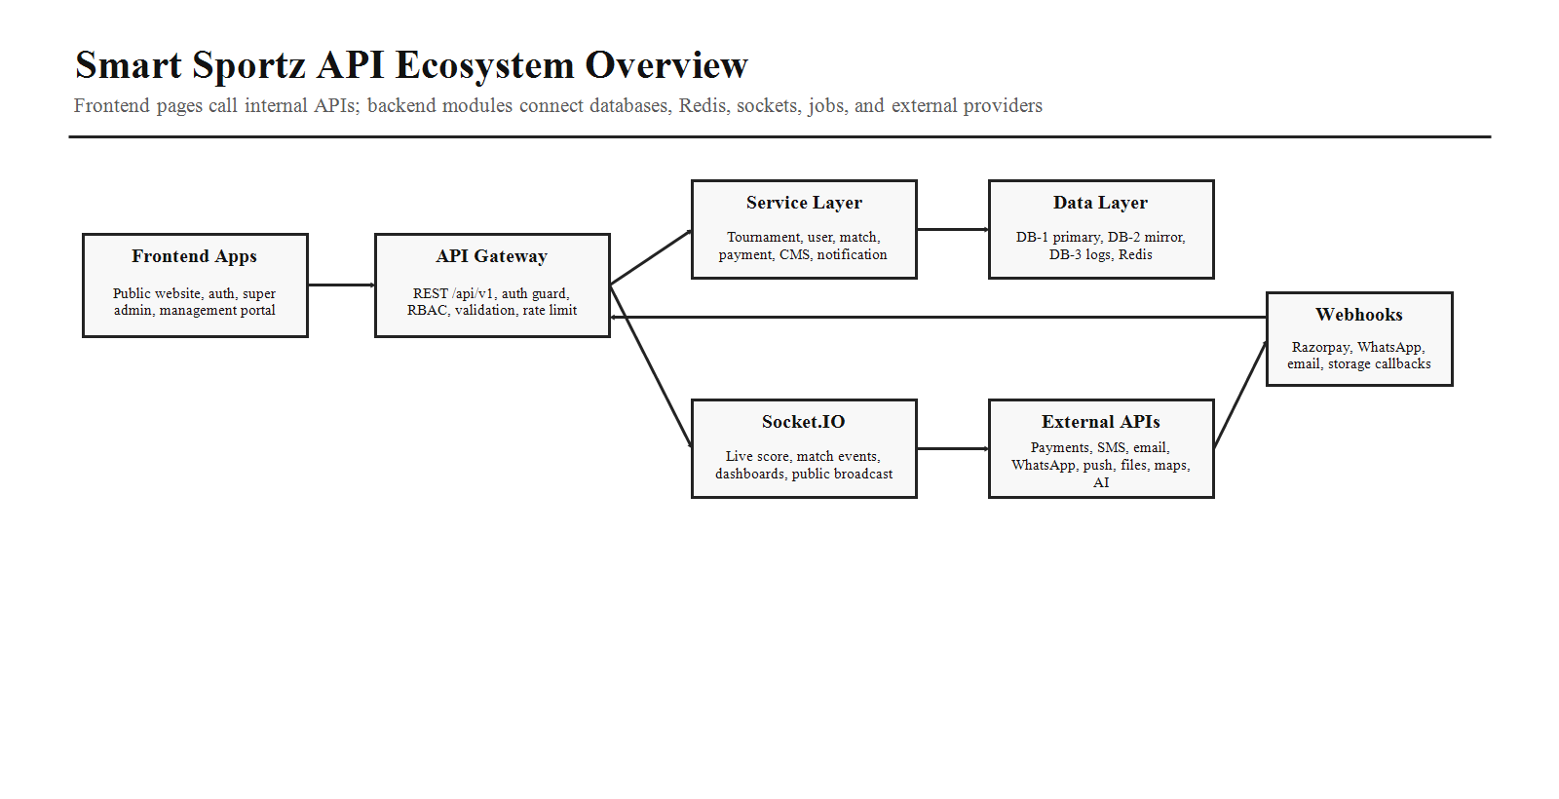

2. Required External APIs
Priority | External API | Where Needed in Smart Sportz | Credentials / Where to Get
Must Have | Razorpay Payment Gateway | Registration payment, payment receipt page, admin payment operations, refunds, invoices, finance reports, webhook audit logs. | Create Razorpay account, complete KYC, use Razorpay Dashboard to create Test/Live Key ID and Key Secret. Configure webhook URL and webhook secret.
Must Have | Transactional Email Provider - Resend or SendGrid | Login OTP, forgot password, registration confirmation, payment receipt, approval/rejection, match schedule updates, report export delivery, admin alerts. | Resend: verify sending domain and create API key in Resend dashboard. SendGrid: verify sender/domain and create API key in SendGrid settings.
Must Have | SMS Provider - Twilio, MSG91, or Fast2SMS | OTP, registration status, urgent match reminders, payment alerts, venue change alerts, admin/security alerts. | Twilio: Account SID, Auth Token or API Key, sender number/messaging service. MSG91/Fast2SMS: account auth key and approved sender/template details.
Must Have | Media and Document Storage - Cloudinary or AWS S3 | Tournament banners, gallery, sponsor logos, team logos, player photos, verification documents, reports, receipts, invoices, certificates. | Cloudinary: cloud name, API key, API secret. AWS S3: access key, secret key, region, bucket, IAM policy.
Must Have | Bot Protection - Cloudflare Turnstile or Google reCAPTCHA | Login, forgot password, OTP request, public registration, contact form, high-risk public forms. | Turnstile: create widget to get sitekey and secret key. reCAPTCHA: create site key and secret key from Google Cloud/reCAPTCHA console.
Recommended | WhatsApp Business Platform Cloud API | Registration updates, payment success, approval/rejection, fixture reminders, match-day alerts, announcements, support messages. | Meta Developer app, WhatsApp Business Account, phone number ID, access token, app secret, webhook verify token, approved message templates.
Recommended | Firebase Cloud Messaging | Browser/mobile push notifications for live match updates, tournament reminders, admin alerts, announcement delivery, user portal notifications. | Firebase project, web app config, VAPID key for web push, service account credentials for backend send operations.
Recommended | Google Maps Platform | Venue location, tournament detail map, address autocomplete, geocoding, directions, venue administration. | Google Cloud project, billing, Maps JavaScript API key, Places API, Geocoding API, restricted frontend and backend keys.
Recommended | Monitoring and Error Tracking - Sentry or similar | Production API errors, frontend errors, release health, stack traces, live score failures, webhook failures. | Sentry project DSN, auth token for release upload, environment-specific project settings.
Optional | OpenAI API | AI report summaries, match insight generation, CMS suggestions, support assistant, admin analytics explanation. | OpenAI Platform project API key and project settings. Keep key server-side only.
Optional | Analytics - Google Analytics or Plausible | Public website traffic, registration funnel, marketing pages, content performance, conversion tracking. | Analytics property/site ID and frontend tracking key. Keep privacy settings aligned with policy.
Optional | CDN/WAF - Cloudflare | Domain DNS, CDN caching, WAF protection, SSL, Turnstile, security rules, public site performance. | Cloudflare account, domain zone, DNS records, API token if deployment automation is needed.

3. Provider Flow
All external provider communication should pass through backend adapter services. The adapter receives a normalized request from service logic, calls the provider, stores the response, handles retries, and logs the result.
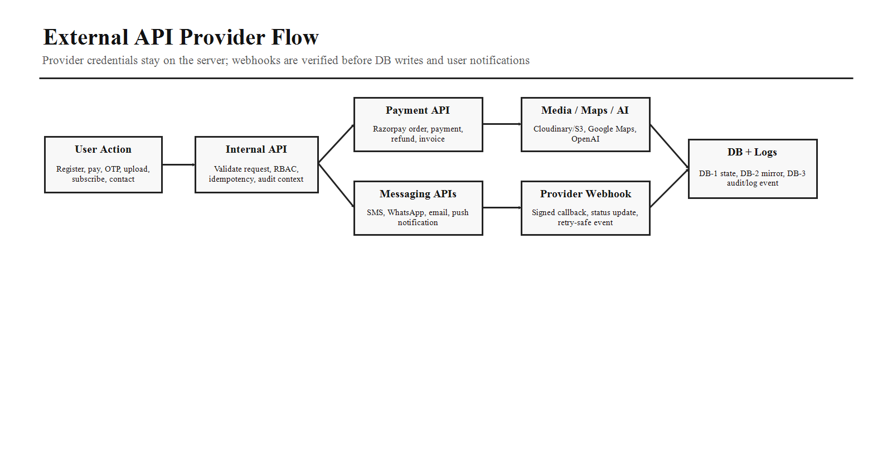
- Frontend page submits a user action to Smart Sportz backend.
- Backend validates JWT, RBAC, scope, request body, rate limit, and idempotency key.
- Backend service writes pending state to DB-1 and calls provider adapter.
- Provider response is stored with safe metadata only; secrets are never returned to frontend.
- Provider webhook is signature-verified and processed idempotently.
- DB-1 is updated, DB-2 mirror/backup is triggered where required, DB-3 log/event record is written, and notifications are queued.

4. Frontend Page to External API Need
Frontend Area | External APIs Needed | Backend Internal API Boundary
Home / Tournaments / Sports / Teams | Media storage, optional analytics, optional maps for venues. | /api/v1/public/tournaments, /sports, /teams, /cms, /media
Tournament Detail | Media storage, Google Maps, analytics. | /api/v1/public/tournaments/:slug, /venues/:id/map
Registration Page | Razorpay, media/document storage, Turnstile/reCAPTCHA, email, SMS, WhatsApp. | /api/v1/registrations, /payments/orders, /files/upload-policy, /captcha/verify
Payment Receipt Page | Razorpay, email, PDF/file storage. | /api/v1/payments/:id/status, /receipts/:id, /invoices/:id
Login / Forgot Password / OTP | Email, SMS, Turnstile/reCAPTCHA. | /api/v1/auth/login, /forgot-password, /otp, /reset-password, /captcha/verify
Live Hub / Live Match | Socket.IO, Firebase push, optional notification providers. | /api/v1/live/* and Socket.IO rooms
User Portal | Email, SMS, WhatsApp, push, file storage. | /api/v1/user/profile, /registrations, /payments, /certificates
Management Portal | Push, WhatsApp/SMS announcements, file storage. | /api/v1/management/* and Socket.IO control events
Super Admin Payments | Razorpay, email, PDF/file storage, monitoring. | /api/v1/admin/payments, /refunds, /webhook-events
Super Admin CMS | Media storage, optional AI content suggestions, analytics. | /api/v1/admin/cms, /media, /ai/content-suggestions
Reports / Logs | Email delivery, file storage, optional OpenAI summaries, monitoring. | /api/v1/admin/reports, /exports, /logs

5. Payment API - Razorpay
Item | Planning Detail
Where used | Registration payment, team entry fee, receipt, invoice, refund, admin finance dashboard, webhook audit.
Backend services | PaymentService, RazorpayProvider, InvoiceService, ReceiptService, RefundService, PaymentWebhookService, AuditService.
Credentials | RAZORPAY_KEY_ID, RAZORPAY_KEY_SECRET, RAZORPAY_WEBHOOK_SECRET.
Backend endpoints | POST /api/v1/payments/orders, GET /api/v1/payments/:id/status, POST /api/v1/payments/webhooks/razorpay, POST /api/v1/admin/payments/:id/refund.
Security | Verify webhook signature, check amount and currency, use idempotency, do not trust frontend payment success alone, restrict refund permission.
Database records | Payment, PaymentEvent, Invoice, Receipt, Refund, AuditLog, NotificationJob.

6. Communication APIs
Channel | Where Needed | Provider Details | Backend Rules
Email | OTP, password reset, registration, payment receipt, approval/rejection, reports, admin alerts. | Resend or SendGrid. | Use templates, queue sending, record delivery status, never block payment flow on email delay.
SMS | OTP, urgent alerts, payment status, venue changes. | Twilio, MSG91, or Fast2SMS. | Rate-limit OTP, use approved templates where required, store provider status.
WhatsApp | Registration status, reminders, announcements, support. | Meta WhatsApp Cloud API or Twilio WhatsApp. | Use approved templates, opt-in rules, webhook delivery status, queue retries.
Push | Live score, match reminders, user/admin alerts. | Firebase Cloud Messaging. | Store FCM tokens per device, support topic subscriptions, remove invalid tokens.
In-app | Portal notifications. | Internal DB/Redis, no external provider required. | Store unread/read state, link to entity, broadcast through Socket.IO if active.

7. Media, Maps, Bot Protection, and AI
Area | Provider | Where Needed | Important Backend Logic
Media and documents | Cloudinary or AWS S3 | Banners, gallery, logos, player photos, documents, reports, invoices, certificates. | Validate file type/size, private vs public buckets, signed URLs, virus scan option, metadata, audit downloads.
Maps | Google Maps Platform | Venue pages, tournament detail, admin venue setup. | Use restricted keys, server-side geocoding if needed, never expose unrestricted backend key.
Bot protection | Cloudflare Turnstile or reCAPTCHA | Login, OTP, public registration, contact. | Verify token server-side before expensive or risky operations.
AI optional | OpenAI API | Report summaries, match insights, support assistant, CMS suggestions. | Admin-only features first, redact sensitive data, log usage, limit cost.
Monitoring | Sentry or similar | Frontend/backend production errors. | Use environment-specific DSNs and do not send secrets or private documents in error payloads.

8. Environment Variable Checklist
Provider | Environment Variables
Razorpay | RAZORPAY_KEY_ID, RAZORPAY_KEY_SECRET, RAZORPAY_WEBHOOK_SECRET
Email | EMAIL_PROVIDER, RESEND_API_KEY or SENDGRID_API_KEY, EMAIL_FROM_ADDRESS, EMAIL_REPLY_TO
SMS | SMS_PROVIDER, TWILIO_ACCOUNT_SID, TWILIO_AUTH_TOKEN, TWILIO_MESSAGING_SERVICE_SID or MSG91_AUTH_KEY / FAST2SMS_AUTH_KEY
WhatsApp | WHATSAPP_PROVIDER, META_WHATSAPP_ACCESS_TOKEN, META_WHATSAPP_PHONE_NUMBER_ID, META_WHATSAPP_BUSINESS_ACCOUNT_ID, META_WHATSAPP_WEBHOOK_VERIFY_TOKEN, META_WHATSAPP_APP_SECRET
Firebase Push | FIREBASE_PROJECT_ID, FIREBASE_CLIENT_EMAIL, FIREBASE_PRIVATE_KEY, FCM_WEB_VAPID_KEY
Cloudinary | CLOUDINARY_CLOUD_NAME, CLOUDINARY_API_KEY, CLOUDINARY_API_SECRET
AWS S3 Alternative | AWS_ACCESS_KEY_ID, AWS_SECRET_ACCESS_KEY, AWS_REGION, S3_BUCKET_NAME
Google Maps | GOOGLE_MAPS_BROWSER_KEY, GOOGLE_MAPS_SERVER_KEY
Bot Protection | TURNSTILE_SITE_KEY, TURNSTILE_SECRET_KEY or RECAPTCHA_SITE_KEY, RECAPTCHA_SECRET_KEY
OpenAI Optional | OPENAI_API_KEY, OPENAI_PROJECT_ID
Sentry Optional | SENTRY_DSN, SENTRY_AUTH_TOKEN, SENTRY_ORG, SENTRY_PROJECT

9. Security and Compliance Rules
- Provider secrets must stay in backend environment variables or a production secret manager.
- Use separate development, staging, and production credentials for every provider.
- Restrict frontend public keys by domain where possible, especially Google Maps, Firebase web config, analytics, and Turnstile sitekey usage.
- Webhook endpoints must verify provider signatures and store raw event IDs for idempotency.
- All provider calls must use structured logs with correlation ID, but logs must not contain card data, OTP values, passwords, access tokens, or private documents.
- Use queues for slow provider calls such as email, WhatsApp, SMS, push, PDF generation, and report delivery.
- Record DB-3 logs for payment webhook, refund, notification failure, provider outage, suspicious login, OTP abuse, media upload rejection, and API key rotation.

10. Implementation Priority
Phase | Integrations to Configure | Reason
MVP 1 | Razorpay, Email, Media Storage, Turnstile/reCAPTCHA | Needed for secure registration, payment, receipt, login, and document upload.
MVP 2 | SMS, WhatsApp, Firebase Cloud Messaging | Needed for real tournament communications and live alerts.
MVP 3 | Google Maps, Sentry, Analytics | Needed for venue UX, production monitoring, and conversion tracking.
Future | OpenAI API, advanced CDN/WAF automation | Useful after core workflows are stable.

11. Official Reference Links
- Razorpay API: https://razorpay.com/docs/api/
- Razorpay Webhooks: https://razorpay.com/docs/webhooks/
- Resend Email API: https://resend.com/docs/api-reference/introduction
- Twilio Programmable Messaging: https://www.twilio.com/docs/messaging/api
- Meta WhatsApp Business Platform: https://developers.facebook.com/documentation/business-messaging/whatsapp/about-the-platform
- Firebase Cloud Messaging: https://firebase.google.com/docs/cloud-messaging
- Cloudinary Upload API: https://cloudinary.com/documentation/image_upload_api_reference
- Google Maps API Key: https://developers.google.com/maps/documentation/javascript/get-api-key
- Cloudflare Turnstile: https://developers.cloudflare.com/turnstile/get-started/
- OpenAI API Reference: https://platform.openai.com/docs/api-reference
Final Recommendation
Start with Razorpay, Resend, Cloudinary or S3, and Turnstile because those unblock registration, payment, receipt, media upload, login safety, and production readiness.
Add SMS, WhatsApp, and Firebase Cloud Messaging next so tournament participants and admins receive reliable real-time communication.

