PHASE 10 - FRONTEND ARCHITECTURE & REACT APPLICATION DESIGN

Enterprise AI Coding Master Prompt

Smart Sportz - React Frontend Engineering Blueprint

Document | Phase 10 Frontend Architecture and React Application Design
Project | Smart Sportz
Focus | React, Vite, TypeScript, Tailwind, reusable component system, nested routing, portals, forms, server state, client state, Socket.IO, accessibility, performance, theming, and testing
Reference Style | Same compact spacing, alignment, borders, margins, and black document treatment as the approved Phase documents
Date | July 5, 2026
Version | 1.0

Phase 10 Intent
This document converts the frontend prompt into a production-ready React application architecture for the public website, authentication flow, Super Admin Portal, Management User Portal, and live score experience.
The frontend must be fast, responsive, accessible, modular, reusable, SEO-friendly for public pages, and optimized for real-time tournament operations.

1. Module Objective
Build a modern frontend using React, Vite, and TypeScript that powers the Smart Sportz public website, Super Admin Portal, Management User Portal, authentication screens, and live score interfaces.
- Keep public pages SEO-friendly and portal pages workflow-focused.
- Use feature-based organization while centralizing shared UI, services, types, assets, hooks, providers, and utilities.
- Support loading, empty, success, error, forbidden, unauthorized, and retry states across all user journeys.
- Optimize real-time score updates without mixing live server data into permanent client state.

2. Technology Stack
Layer | Technology
Framework | React 19 with Vite.
Language | TypeScript with strict typing and no any usage.
Styling and Motion | Tailwind CSS, reusable design tokens, Framer Motion.
Routing | React Router with nested route layouts and permission guards.
State | Redux Toolkit for cross-cutting client state; TanStack Query for server state.
Forms and Validation | React Hook Form and Zod.
UI Utilities | Lucide React, Recharts, React Big Calendar, TanStack Table, Sonner, dnd-kit.
Real Time | Socket.IO Client through a reusable provider and hooks.

3. React Frontend Application Architecture
The frontend should be composed around layout shells, shared UI modules, providers, service modules, and feature pages. Each portal should feel dedicated to its workflow while sharing the same design system and engineering foundations.
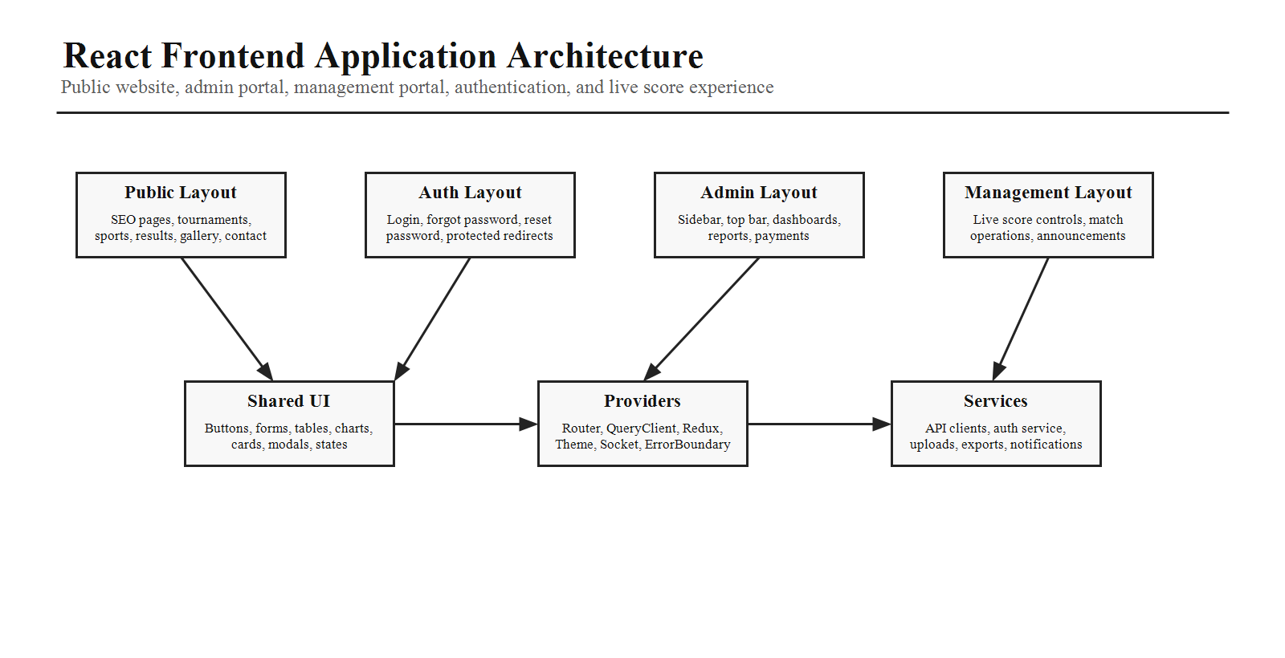

4. Application Structure
Folder | Responsibility
src/app | Application bootstrap, provider composition, global configuration, app-level boundaries.
src/assets | Images, icons, fonts, and illustrations.
src/components | Shared common, form, table, chart, card, layout, live-score, and UI components.
src/layouts | Public, auth, admin, and management layout shells.
src/pages | Public, admin, management, and auth pages.
src/routes | Route objects, lazy imports, guards, layout nesting, route metadata.
src/hooks | Reusable hooks for UI, auth, data access, sockets, and responsive behavior.
src/services and src/api | Typed HTTP clients, resource service modules, upload and export services.
src/store | Redux slices for authentication, profile, theme, notifications, command palette, and live match selection.
src/providers and src/contexts | QueryClient, Redux, theme, sockets, toasts, error boundaries, and app contexts.
src/sockets | Socket client setup, event contracts, room subscription helpers, and live hooks.
src/constants, src/types, src/utils, src/styles | Shared configuration, TypeScript contracts, helpers, and global CSS.

5. Routing Strategy
Use nested routing so layouts own navigation, chrome, and shared context while pages stay focused on feature behavior. Public routes should remain crawlable and fast; portal routes should enforce authentication and permissions.
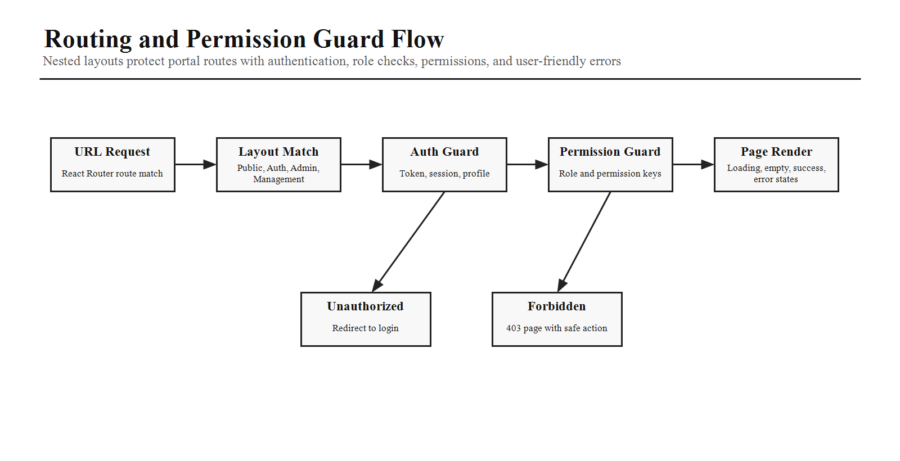
Route Group | Pages
Public Layout | /, /live, /tournaments, /sports, /results, /contact.
Auth Layout | /login, /forgot-password, /reset-password.
Admin Layout | /admin/dashboard, /admin/tournaments, /admin/matches, /admin/payments, /admin/reports.
Management Layout | /management/dashboard, /management/live-score, /management/results.

6. Layouts
Layout | Required Experience
Public Layout | Sticky navigation, footer, newsletter, global search, public page polish, SEO-friendly metadata.
Authentication Layout | Login, forgot password, reset password, minimal distraction, clear validation, safe redirects.
Admin Layout | Sidebar, top bar, breadcrumbs, notifications, command palette, dense dashboard workflows.
Management Layout | Operational shell with quick access to live matches, score controls, results, and announcements.

7. Design System Implementation
Expose reusable design tokens through Tailwind configuration and utility classes. The system should define colors, typography, spacing, border radius, shadows, animations, breakpoints, dark mode behavior, and component variants.
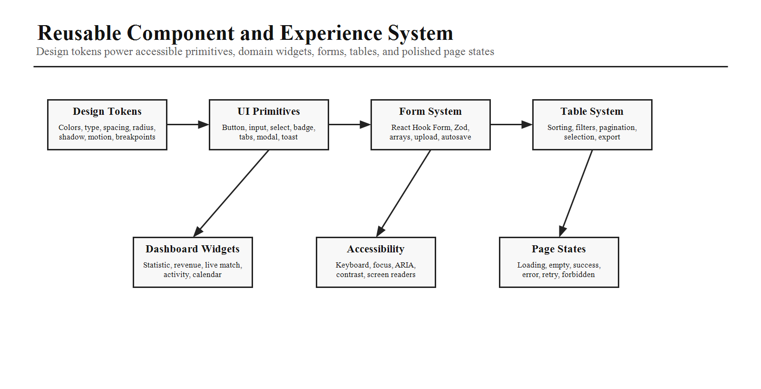

8. Shared Component Library
Component Group | Components
Inputs | Input, TextArea, Select, MultiSelect, Checkbox, Radio, Switch, Date Picker, Time Picker, File Upload.
Actions and Feedback | Button, Tooltip, Dropdown, Modal, Drawer, Toast Notifications, Loading Spinner.
Navigation | Tabs, Accordion, Pagination, Breadcrumb, Command Palette.
Display | Avatar, Badge, Chip, Skeleton Loader, Empty State, Error State.
Quality Requirements | Variants, sizes, disabled state, loading state, keyboard navigation, dark mode, accessibility.

9. Dashboard Widgets
- Statistic Card, Revenue Card, Tournament Card, Live Match Card, Activity Feed, Recent Registrations.
- Upcoming Matches, Calendar Widget, Notifications Widget, and Leaderboard Widget.
- Widgets must accept data through props, avoid hidden data fetching, and remain presentation-focused.

10. Form Architecture
Form Concern | Requirement
Form Engine | React Hook Form for state, submission, and field registration.
Validation | Zod schemas with inline error messages and typed payloads.
Shared Fields | Reusable field wrappers for labels, help text, errors, disabled states, and layout.
Advanced Flows | Async validation, autosave for long forms, dynamic arrays such as player lists, and file uploads.

11. Data Fetching
Use TanStack Query for all server interactions. API calls should live in dedicated service modules and expose typed request and response contracts.
- Use caching, background refetch, pagination, infinite scrolling, mutations, and optimistic updates.
- Keep server data in TanStack Query rather than Redux.
- Use query keys consistently by resource, tenant scope, tournament scope, filters, and pagination cursor.

12. Global State
Use Redux Toolkit only for cross-cutting client state such as authentication, user profile, theme, notifications, command palette, and live match selection. Avoid storing server resources in Redux.
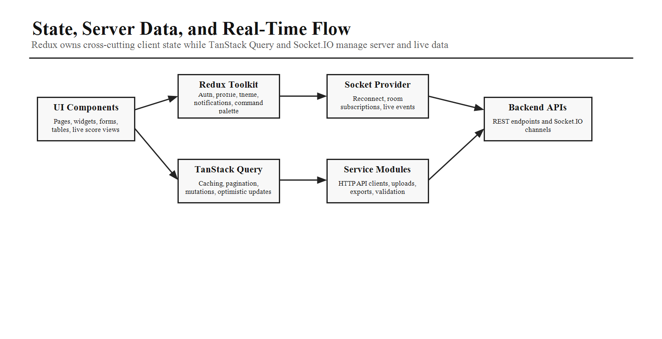

13. Socket.IO Client
Responsibility | Requirement
Connection | Central provider owns connection management and connection status.
Recovery | Automatic reconnect and safe re-subscription to active rooms.
Rooms | Tournament feed, live match, notifications, and operational event rooms.
Hooks | Expose useLiveMatch, useTournamentFeed, and useNotifications.
Boundary | Socket events update live UI and TanStack Query cache where appropriate; they should not bypass typed service contracts.

14. Table System
Build a generic data table used across admin and management modules. It must support server-side pagination, sorting, filtering, search, column visibility, row selection, bulk actions, export, responsive layout, and reusable empty/error/loading states.

15. File Management
Capability | Requirement
Upload | Drag-and-drop upload components for images, PDFs, and documents.
Preview | Image previews, selected file metadata, validation errors, and retry states.
Progress | Progress indicator, cancellation where practical, remove action, and upload status.
Validation | File type, file size, count limits, and feature-specific requirements.

16. Accessibility
- Use semantic HTML and keyboard-accessible interactions.
- Manage focus for modals, drawers, menus, command palette, and route transitions.
- Use ARIA attributes only where semantic HTML is insufficient.
- Maintain color contrast compliance and screen reader support.
- Ensure all custom interactive components are fully accessible.

17. Performance
Performance Area | Implementation
Code Splitting | Lazy load route groups, portal sections, heavy charts, calendars, and tables.
Assets | Optimize images and avoid loading noncritical media on first paint.
Large Lists | Virtualize long lists and tables where needed.
Rendering | Use memoization where appropriate and avoid unnecessary re-renders.
Delivery | Run bundle analysis, prefetch critical routes, and keep shared chunks intentional.

18. Error Handling
Provide error boundaries, retry UI, network error pages, unauthorized pages, forbidden pages, and not found pages. User-facing copy should be clear while technical details are logged through the application logging strategy.

19. Theme Support
Support light mode and dark mode. Persist user preference and allow theme switching from top navigation or user settings while keeping system preference as a sensible fallback.

20. Testing Strategy
Test Level | Focus
Unit | Reusable components, hooks, validators, utilities, and reducers.
Integration | Feature flows such as authentication, registration, payment, live score update, and admin actions.
End-to-End | Critical user journeys across public, admin, management, and live score experiences.
Regression Focus | Authentication, registration, payments, live score updates, permission guards, and major dashboard flows.

21. AI Coding Instructions
- Create reusable component library modules rather than page-specific one-off components.
- Use feature-based organization with shared UI modules.
- Keep business logic out of presentation components.
- Build forms with React Hook Form and Zod.
- Use TanStack Query for all server interactions.
- Integrate Socket.IO through a dedicated provider and custom hooks.
- Implement responsive layouts for mobile, tablet, desktop, and large displays.
- Optimize bundle size using lazy loading and code splitting.
- Follow strict TypeScript typing and avoid any.
- Ensure every page includes loading, empty, success, and error states.
Phase 10 Completion Criteria
Phase 10 is complete when the frontend objective, technology stack, folder structure, route strategy, layout shells, design system, shared component library, dashboard widgets, forms, data fetching, global state, Socket.IO integration, table system, file management, accessibility, performance, error handling, theme support, testing strategy, and coding rules are clear enough for implementation planning.

