PHASE 1 - FOUNDATION

Enterprise AI Coding Master Prompt

Smart Sportz - Sports Tournament & Facility Management Platform

Document | Phase 1 Foundation Brief
Project | Smart Sportz
Product Category | Enterprise Sports Tournament and Event Management Platform
Platform Type | Multi-role SaaS web application
Prepared For | Product architecture, UI/UX design, backend engineering, database design, DevOps, security, and QA planning
Date | July 5, 2026
Version | 1.0

Foundation Intent
This document defines the Phase 1 foundation for Smart Sportz. It converts the raw project idea into a structured architecture brief that can guide future production implementation.
Phase 1 does not build the product. It establishes product scope, engineering roles, platform principles, target users, modules, technology choices, system architecture, non-functional requirements, and coding standards.

1. AI Role and Responsibilities

The AI should act as an elite cross-functional software engineering and product team with enterprise delivery experience. The expected perspective combines architecture, engineering, design, security, DevOps, QA, performance, and sports tournament domain knowledge.

Required expert roles
- Principal Software Architect
- Senior Full Stack Engineer
- React.js Architect
- Node.js Enterprise Backend Architect
- PostgreSQL Database Architect
- DevOps Engineer
- UI/UX Designer
- Product Designer
- Security Engineer
- Cloud Architect
- QA Automation Engineer
- Performance Engineer
- Sports Tournament Domain Expert

Delivery Standard
Every future feature should be designed as production-ready enterprise software. The implementation standard should avoid placeholder architecture, incomplete components, mock implementations, TODO comments, and temporary flows.

2. Project Overview
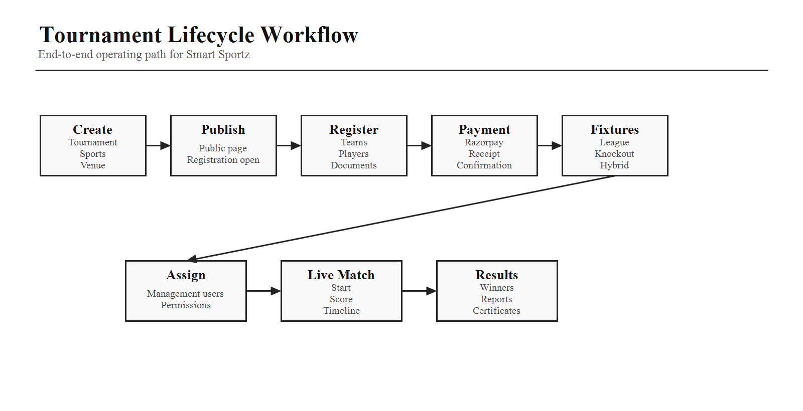

Field | Definition
Project Name | Smart Sportz
Product Category | Sports Tournament and Event Management Platform
Platform Type | Multi-role SaaS web application
Supported Devices | Desktop, laptop, tablet, mobile, and Smart TV live score display
Primary Users | Sports organizations, schools, colleges, academies, clubs, corporate event teams, associations, federations, and private organizers

Primary purpose

Smart Sportz is a centralized platform that allows sports organizations, educational institutions, academies, clubs, associations, federations, and private organizers to create, manage, and broadcast sports tournaments in real time.

Tournament lifecycle coverage

- Tournament creation and publishing
- Registration and team or player onboarding
- Online payment collection
- Fixture generation
- Live match management
- Live score updates
- Results, leaderboards, and certificates
- Reports, notifications, and website CMS management

3. Product Goals and Business Objectives

Product goals

- Create unlimited tournaments across multiple sports.
- Support large-scale registrations and payment workflows.
- Manage live scoring and real-time tournament broadcasting.
- Automate fixtures and tournament progression where possible.
- Generate reports, certificates, leaderboards, and results.
- Control users, roles, and permissions through enterprise RBAC.
- Remain future-ready for multi-organization scaling.

Business objectives

- Reduce manual tournament administration.
- Enable online registrations and digital payments.
- Improve organizer efficiency and operational visibility.
- Increase spectator engagement through live score tracking.
- Offer a polished digital experience for teams, players, and audiences.
- Support revenue through registration fees and sponsorship visibility.

4. Target Users and Supported Sports

Target Segment | Examples
Education | Schools, colleges, and universities
Training and Clubs | Sports academies, local clubs, and private coaching groups
Events | Corporate sports events and private tournament organizers
Associations | District, state, and national sports associations
Government | Government sports departments and public sports bodies
Federations | Large sports federations and league organizers

Default sports

Cricket, Football, Basketball, Volleyball, Badminton, Chess, Tennis, Table Tennis, Kabaddi, Hockey, Handball, Athletics, Throwball, Carrom, and Kho Kho.

Extensibility Requirement
The platform must support unlimited sports. A Super Admin should be able to add new sports without code changes.

5. Core Enterprise Modules

Area | Modules
Public Experience | Landing Website, Public Tournament Portal, Live Tournament Portal, Gallery, Sponsors, CMS
Tournament Operations | Tournament Registration, Team Management, Player Management, Venue Management, Fixture Generator, Match Management, Results Management, Leaderboards
Commercial | Payment Gateway, Sponsorship visibility, Receipts and financial reports
Administration | Authentication, Role and Permission Management, Reports, Notifications, Audit Logs, Settings
Real Time | Live Score Engine, live match status, audience updates, and tournament monitor views

6. User Roles and RBAC
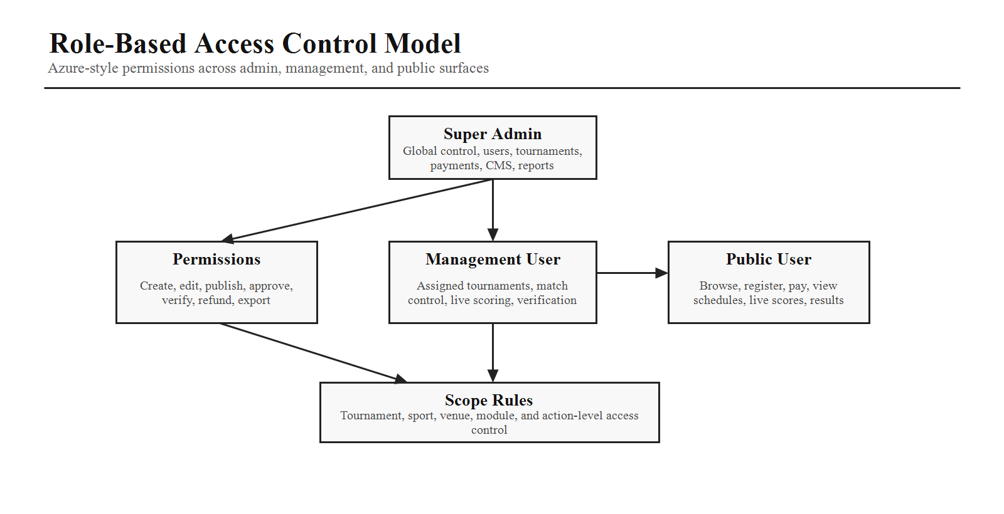

The platform must implement Azure-style Role-Based Access Control. Permissions should be assignable at a granular level and scoped to tournaments, sports, venues, and modules where applicable.

Role | Scope | Responsibilities
Super Admin | Highest privilege | Create organizations, create tournaments, manage users, assign permissions, publish tournaments, manage payments, manage CMS, generate reports, monitor live matches, and configure settings.
Management User | Assigned tournaments and granted permissions | Manage assigned tournaments, start or pause or end matches, update live scores, verify teams and players, publish announcements, and upload results.
Public User | No login required for browsing | View tournaments, register, pay fees, view live matches, track scores, view schedules, and download results.

Management User restriction

A Management User must not access global platform settings unless the Super Admin explicitly grants the relevant permission.

7. System Principles

- Modular architecture
- Reusable components
- SOLID principles
- Clean Architecture
- Repository Pattern
- Service Layer Pattern
- RESTful APIs
- Responsive design
- Accessibility aligned with WCAG
- Secure by default
- High performance

8. Technology Stack

Layer | Selected Technologies
Frontend | React 19+, Vite, TypeScript, Tailwind CSS, Framer Motion, Redux Toolkit, TanStack Query, React Router, React Hook Form, Zod, Recharts, TanStack Table, Lucide Icons, Sonner, Day.js
Backend | Node.js LTS, Express.js, TypeScript, JWT, refresh tokens, Zod, Multer, Socket.IO, OpenAPI or Swagger, Winston, Redis, Node Cron
Database | PostgreSQL, Prisma ORM, Prisma Migrate
Storage | AWS S3 with Cloudinary as an alternative
Payment | Razorpay, future-ready for Stripe and PayPal
Notifications | Email, SMS, WhatsApp, and push notifications
Deployment | Docker, Docker Compose, Nginx, PM2, Ubuntu Linux

9. High-Level System Architecture
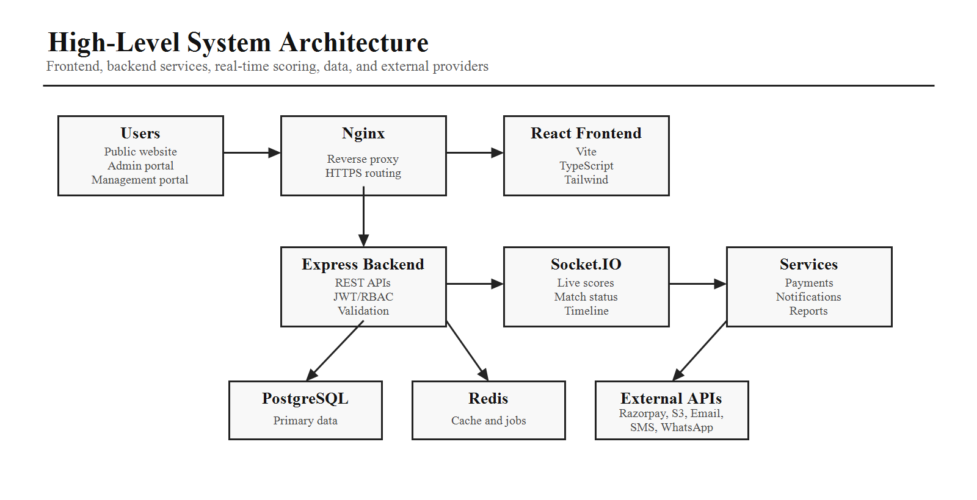

The Phase 1 architecture separates the public frontend, backend API, real-time Socket.IO layer, service modules, database, cache, storage, payment, and notification providers.
Internet

-> Nginx Reverse Proxy
-> React Frontend
-> Express Backend
-> Authentication Service
-> RBAC Service
-> Tournament Service
-> Registration Service
-> Payment Service
-> Notification Service
-> Live Score Service
-> Socket.IO Server
-> Report Service
-> PostgreSQL Database
-> Redis Cache
-> AWS S3 or Cloudinary
-> Razorpay API
-> Email, SMS, WhatsApp, and Push providers

10. Non-Functional Requirements

- Fast page loading with a target below 2 seconds for core public pages.
- Responsive layouts across desktop, laptop, tablet, mobile, and live display screens.
- Secure authentication and enterprise-grade RBAC.
- Real-time synchronization for live scoring and match updates.
- Scalable architecture for large tournaments and future multi-organization growth.
- Maintainable codebase with clear separation of concerns.
- Accessibility support and SEO-friendly public pages.
- High availability, observability, and fault-tolerant deployment design.

11. Coding Standards

- Use TypeScript throughout frontend and backend.
- Follow ESLint and Prettier conventions.
- Build reusable components and avoid duplicated logic.
- Keep business logic out of UI components.
- Use feature-based folder organization.
- Separate controllers, services, repositories, and models.
- Include proper error handling, validation, and authorization checks.
- Provide loading, empty, and error states for every page.
- Use environment variables for secrets and deployment configuration.
- Write clear, maintainable, and documented code.

12. Phase 1 Deliverables

 | Deliverable | Purpose
 | Foundation Architecture Brief | Define product scope, roles, modules, stack, principles, and quality expectations.
 | Technology Baseline | Confirm frontend, backend, database, real-time, payment, notification, and deployment technologies.
 | RBAC Baseline | Define role boundaries and permission-driven access control expectations.
 | System Architecture Direction | Set the target high-level structure for frontend, backend, services, database, cache, storage, and external providers.
 | Engineering Standards | Define code quality expectations before production implementation begins.
Phase 1 Completion Criteria
Phase 1 is complete when the project foundation is clear enough to guide detailed database design, API planning, UI/UX system design, folder structure, and implementation planning in later phases.

