PHASE 5 - SUPER ADMIN PORTAL

Enterprise AI Coding Master Prompt

Smart Sportz - Super Admin Control Center

Document | Phase 5 Super Admin Portal (Part 1)
Project | Smart Sportz
Focus | Enterprise administration portal, dashboard, navigation shell, user management, Azure-style RBAC, tournaments, master data, finance, CMS, notifications, reports, audit logs, and system settings
Reference Style | Same spacing, alignment, borders, margins, and black document treatment as the approved Phase 1 document
Date | July 5, 2026
Version | 1.0

Phase 5 Intent
This document defines Part 1 of the Smart Sportz Super Admin Portal. It converts the raw administration prompt into a structured control-center specification for future frontend, backend, database, RBAC, audit, and reporting implementation.
The Super Admin portal should feel like a modern cloud management console: fast, searchable, permission-aware, table-driven, audit-friendly, and ready for future multi-tenant SaaS expansion.

1. Portal Objective
Build the highest-privilege administration portal for Smart Sportz. The Super Admin must be able to control organizations, tournaments, users, permissions, payments, sports, venues, live matches, reports, website CMS, notifications, security, and settings from one unified interface.
- Provide an executive view of the complete platform.
- Support operational management through searchable tables, filters, drawers, forms, modals, and bulk actions.
- Enforce granular RBAC for every sensitive action.
- Log every important administrative change for audit and security review.
- Prepare the system for future SaaS mode with organization switching and scoped permissions.

2. Global Admin Layout
The admin layout should use a clean sidebar, sticky top navigation, dynamic main content region, command palette, dashboard widgets, and table-first operational views.
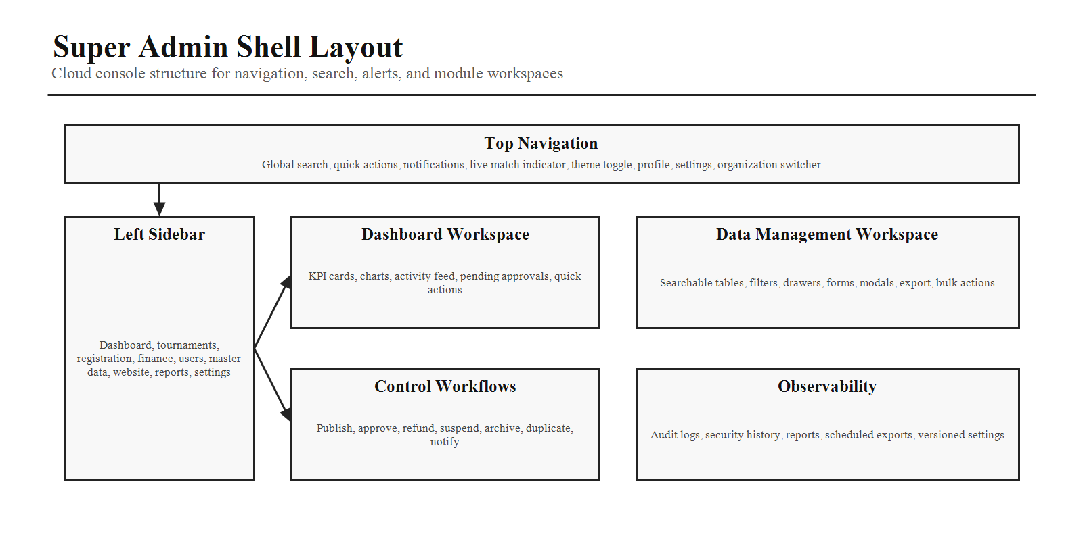

3. Top Navigation
Navigation Item | Purpose
Global Search | Search tournaments, teams, players, organizations, payments, users, reports, and CMS content.
Quick Actions | Create tournament, add sport, add venue, create user, send announcement, and other shortcut actions.
Notifications | Show operational alerts, failed payments, pending approvals, live match events, and system warnings.
Live Match Indicator | Display active live matches and provide fast navigation into live match control.
Theme Toggle | Switch between light and dark mode where supported by the app design system.
Profile and Settings | Access account profile, security, settings shortcut, and logout.
Organization Switcher | Future-ready control for SaaS and multi-organization operation.

4. Sidebar Information Architecture
Group | Pages
Dashboard | Overview, Analytics, Activity Feed
Tournament Management | All Tournaments, Create Tournament, Fixtures, Matches, Live Matches, Results
Registration | Registrations, Teams, Players, Waitlist
Finance | Payments, Refunds, Coupons, Revenue
User Management | Management Users, Roles, Permissions, Audit Logs
Master Data | Sports, Venues, Categories, Age Groups, Organizations
Website | Homepage CMS, Gallery, Sponsors, Blogs, FAQs, Contact Requests
Reports | Tournament Reports, Financial Reports, Participation Reports, Custom Reports
Settings | General, Branding, Payment Gateway, Notifications, Email Templates, Integrations, Security

5. Dashboard Page
The dashboard provides an executive overview of the whole platform and should support fast drill-down into operational queues.
Dashboard Area | Required Content
KPI Widgets | Active tournaments, live matches, upcoming events, teams registered, players registered, revenue, pending approvals, payments today, refund requests, active management users.
Charts | Registrations over time, revenue trend, sport-wise participation, and live match distribution.
Activity Feed | Tournament created, payment received, match started, match completed, user created, and other key events.
Quick Actions | Create tournament, add sport, add venue, create user, and send announcement.

6. Super Admin Module Map
The Super Admin module map organizes the portal around domain ownership areas. Each area should be implemented as an independent React route with nested layouts and reusable CRUD primitives.
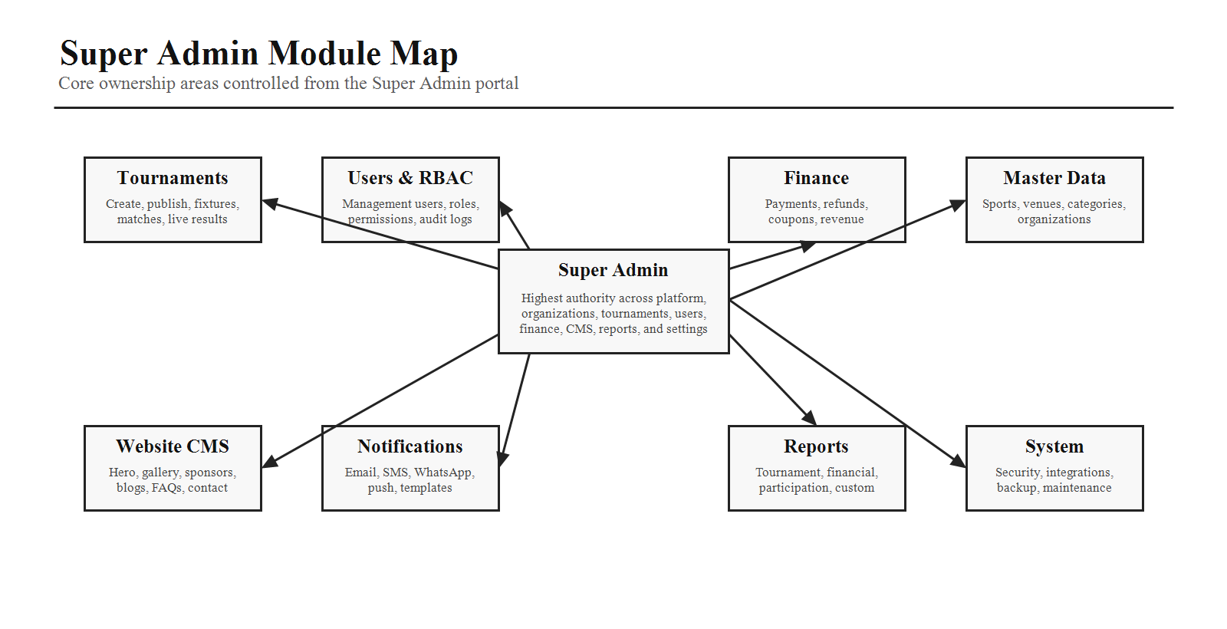

7. Management User Page
This page allows the Super Admin to create, manage, suspend, activate, delete, and permission operational users.
Area | Specification
Table Columns | Name, email, mobile, role, assigned tournaments, status, last login, actions.
Row Actions | View, edit, reset password, assign permissions, suspend, activate, delete.
Bulk Actions | Activate, suspend, export, delete.
Expected States | Loading, empty, filtered empty, error, permission denied, confirmation, success, and destructive-action confirmation.

8. Create Management User
Form Group | Fields
Identity | First name, last name, email, mobile number, username, profile photo.
Security | Password, confirm password, password policy validation, reset invitation option.
Employment | Role, department, employee ID, status.
Assignments | Tournaments, sports, venues.
Permission Templates | Tournament Manager, Live Score Manager, Registration Officer, Finance Officer, Read Only, Custom.

9. Azure-Style RBAC
Every permission should be individually assignable. Permissions should support inheritance, reusable groups, and scoped assignment by tournament, sport, venue, organization, module, or global platform level.
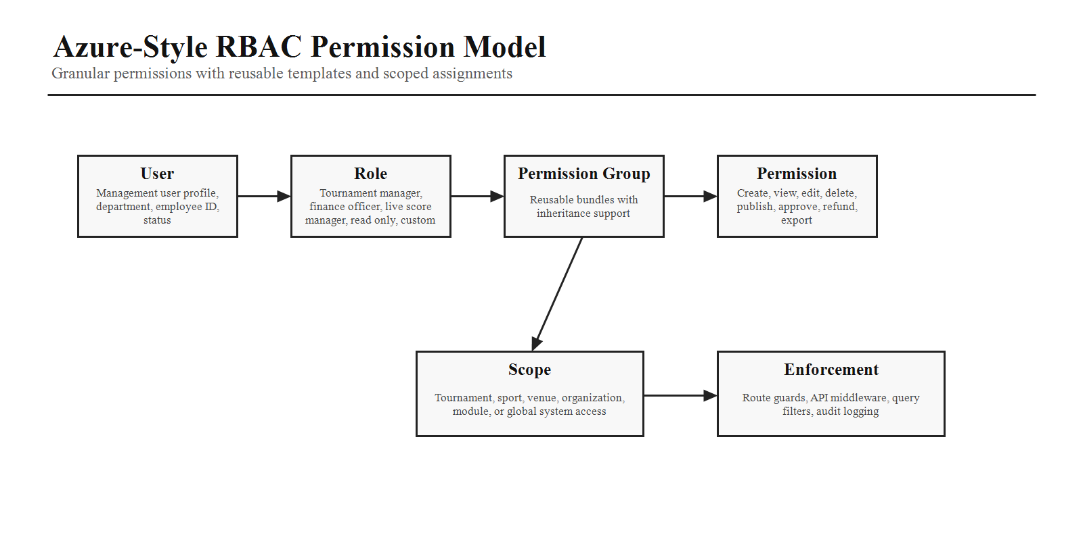
Domain | Permissions
Tournament | Create, view, edit, delete, publish, archive.
Matches | Create, start, pause, resume, end, edit, delete.
Live Scores | View, update, override, reset.
Teams | Create, edit, delete, import, export.
Players | Create, edit, delete, verify.
Registrations | View, approve, reject, waitlist.
Payments | View, verify, refund, export.
Reports | View, export, schedule.
CMS | Edit homepage, manage gallery, manage sponsors, publish blogs.
System | Settings, integrations, audit logs, API keys.

10. Tournament Management
Capability | Details
Core Actions | Create tournament, edit tournament, publish, unpublish, duplicate, archive, delete.
Filters | Sport, status, date, venue, organizer.
Tournament Detail Tabs | Overview, registration, fixtures, teams, players, payments, live matches, reports.
Controls | Use confirmation dialogs for destructive actions and publish/unpublish workflows.

11. Sports, Venues, and Organizations
Module | Fields and Features
Sports Management | Sport name, icon, banner, description, rules, status, add, edit, disable, delete.
Venue Management | Venue name, address, city, state, country, capacity, number of courts/grounds, GPS coordinates, photos, availability calendar, maintenance status, venue map.
Organization Management | Organization name, type, logo, contact person, email, phone, address, subscription plan, status. Supports future multi-tenant SaaS mode.

12. Payment and Coupon Management
Area | Specification
Payment Dashboard | Today's revenue, total revenue, pending payments, failed payments, and refunds.
Payment Table | Transaction ID, tournament, participant, amount, method, status, date, and actions.
Payment Actions | View, verify, refund, export.
Coupon Fields | Coupon code, discount type, discount value, valid from, valid to, usage limit, applicable tournaments, status.

13. Notification Center
The notification center should let Super Admin users create, schedule, preview, and send Email, SMS, WhatsApp, and push notifications.
- Targets: all users, specific tournament, selected teams, selected players, and management users.
- Support templates for recurring notifications.
- Track delivery status, failures, retries, and sender identity.
- Require confirmation for high-volume sends.

14. Website CMS
CMS Area | Managed Content
Homepage | Hero, live banner, featured tournaments, testimonials, FAQs, about us, contact details, footer links.
Media | Gallery, sponsor logos, banners, and published images.
Content | Blogs, FAQs, contact requests, footer links, privacy and policy references where applicable.
Publishing | Changes should support preview before publishing and maintain a publish history.

15. Reports
Report Type | Purpose
Tournament Performance | Tournament status, participation, outcomes, match activity, and operational health.
Team Participation | Team counts, category breakdowns, registrations, approvals, and participation trend.
Player Participation | Player count, demographics, category participation, and verification status.
Revenue and Payments | Collected revenue, pending payments, failed payments, refunds, coupon usage, and reconciliation.
Live Match Statistics | Live status, match timelines, results, and sport-specific scoring indicators.
Export Options | PDF, Excel, CSV, and scheduled email delivery.

16. Audit Logs and System Settings
Every administrative action must be searchable, exportable, and traceable. Settings should be versioned so configuration changes can be reviewed and audited.
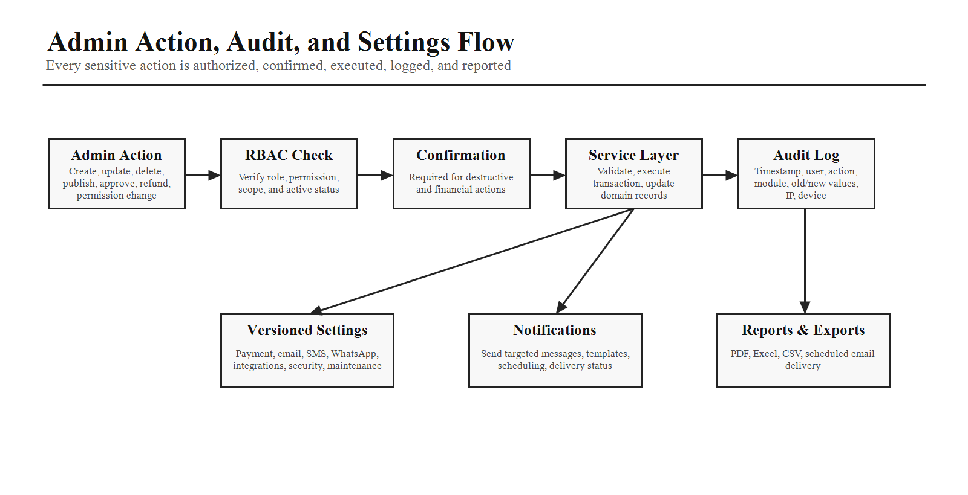
Audit Field | Description
Timestamp | Exact time the action occurred.
User | Admin or management user who performed the action.
Action and Module | The action type and module affected.
Previous and New Value | Before/after values for meaningful changes.
IP Address and Device | Security metadata for investigation and compliance.
Settings Category | Scope
General and Branding | Platform identity, logos, colors, public identity, and basic configuration.
Payment Gateway | Razorpay keys, webhook settings, payment modes, refund rules, and reconciliation preferences.
Email, SMS, WhatsApp | Provider credentials, templates, sender identities, delivery preferences.
Security | Password policy, session policy, token configuration, API keys, and access controls.
Integrations, Backup, Maintenance | External service settings, backup policy, and maintenance mode control.

17. AI Coding Instructions
- Build each module as an independent React route with nested layouts.
- Use reusable CRUD components for tables, forms, filters, drawers, and modals.
- Implement Azure-style RBAC with granular permissions and scope-aware enforcement.
- Use optimistic UI updates where appropriate.
- Require confirmation dialogs for all destructive, financial, publishing, approval, refund, and permission actions.
- Provide audit logging for create, update, delete, publish, approve, refund, and permission changes.
- Implement server-side pagination, filtering, and sorting.
- Design the portal for future multi-tenant SaaS expansion without major architectural changes.
- Include loading, empty, error, success, permission-denied, and retry states in every operational page.
Phase 5 Completion Criteria
Phase 5 Part 1 is complete when the Super Admin portal objective, navigation shell, sidebar structure, dashboard, management-user workflow, granular RBAC, tournament controls, master data, finance, notifications, CMS, reports, audit logs, settings, and implementation rules are clear enough for production planning.

