PHASE 6 - MANAGEMENT USER PORTAL

Enterprise AI Coding Master Prompt

Smart Sportz - Tournament Operations Dashboard

Document | Phase 6 Management User Portal
Project | Smart Sportz
Focus | Role-based operations dashboard, assigned tournaments, match management, live scoring, team/player verification, announcements, results, reports, offline-ready scoring, activity logs, and profile management
Reference Style | Same spacing, alignment, borders, margins, and black document treatment as the approved Phase 1 document
Date | July 5, 2026
Version | 1.0

Phase 6 Intent
This document defines the Smart Sportz Management User Portal. It turns the operations prompt into a structured specification for assigned tournament workflows, live match control, live scoring, verification, results, reports, and future offline operation.
Every route, widget, table, form, button, API call, and real-time action must respect permissions granted by the Super Admin.

1. Module Objective
Build a role-based operational dashboard for Management Users. The portal should let assigned users manage assigned tournaments, verify teams and players, control live matches, update scores, publish announcements, upload results, and generate reports when permitted.
- Only show assigned tournament, venue, sport, module, and action data.
- Use permission-aware navigation and immediate revocation handling.
- Optimize live match and score screens for tablets and mobile devices used at venues.
- Synchronize score and match updates instantly to public pages through Socket.IO.
- Maintain detailed audit logs for every operational change.

2. Access Control Scope
Management Users can access only assigned tournaments, assigned venues, assigned sports, granted modules, and granted actions. Revoked permissions must immediately block frontend UI and backend API access.
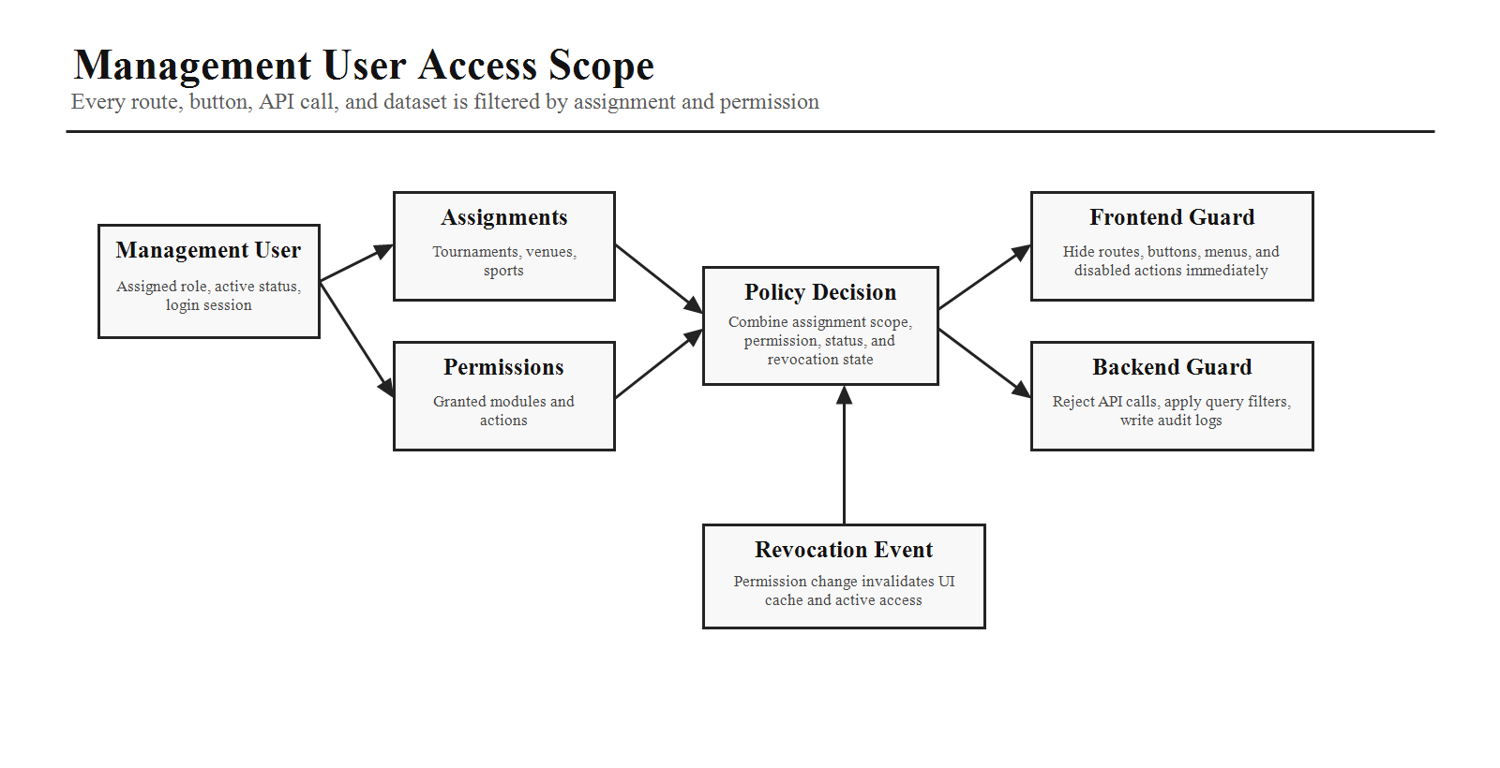

3. Portal Layout
The portal should use a role-scoped top navigation, collapsible sidebar, and main content area tuned for fast tournament operations.
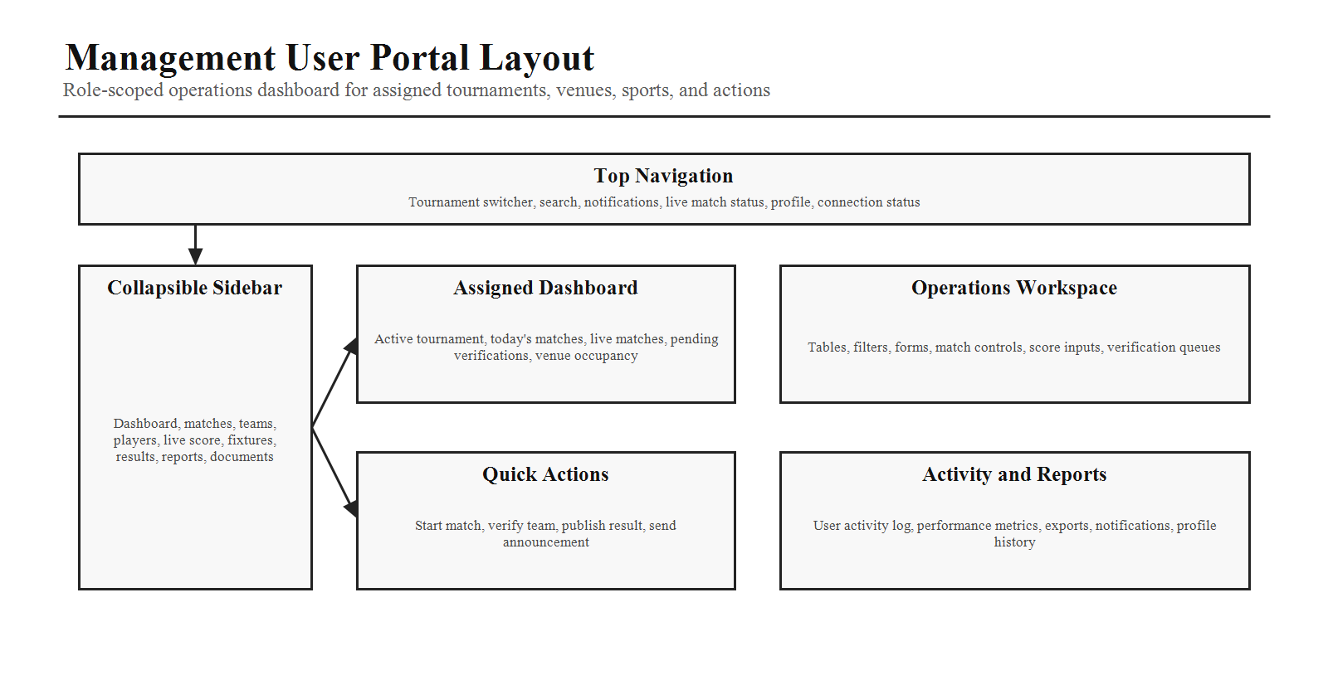
Layout Area | Required Behavior
Top Navigation | Tournament switcher, search, notifications, live match status, profile, connection status, and quick context switching.
Sidebar | Dashboard, matches, teams, players, live score, fixtures, results, reports, documents, profile. Sidebar collapses on smaller screens.
Main Content | Widgets, live data, tables, forms, statistics, operational queues, and reports.
Permission Awareness | Hidden or disabled navigation items when access is not granted.

4. Dashboard
The dashboard must display only assigned tournament data and should prioritize pending actions and live operations.
Dashboard Area | Required Content
Widgets | Active tournament, today's matches, live matches, pending team verifications, pending player verifications, pending announcements, match completion percentage, and venue occupancy.
Quick Actions | Start match, verify team, publish result, and send announcement. Each action appears only if permitted.
Operational Context | Current assignment, sport, venue, upcoming match, and active alerts.
States | Loading, empty assignment, permission denied, offline, sync pending, and error states.

5. Assigned Tournaments
Area | Specification
Columns | Tournament name, sport, venue, status, registration status, live match count, actions.
Actions | View, manage, open dashboard.
Filtering | Status, sport, venue, registration state, live match presence, date.
Security | Dataset must be server-filtered by assigned tournament IDs and scoped permissions.

6. Match Management
Capability | Details
Filters | Date, sport, round, venue, and match status.
Actions | Start match, pause match, resume match, end match, edit match, reschedule if permitted.
Controls | Confirmation dialogs for destructive or state-changing actions.
Audit | Record match state changes with user, tournament, match, timestamp, device, and previous/new values.

7. Live Match Control
Display Area | Fields
Match Context | Team A, Team B, timer, current score, match status, officials, venue, and match events.
Controls | Start, pause, resume, end, cancel, and emergency stop.
Sync Requirement | Changes sync instantly to the public website using Socket.IO.
Safety | Emergency stop and cancellation require confirmation and audit logging.

8. Live Score Management
Live scoring must support sport-specific scoring models. Every score change must be timestamped and reversible when the user has permission.
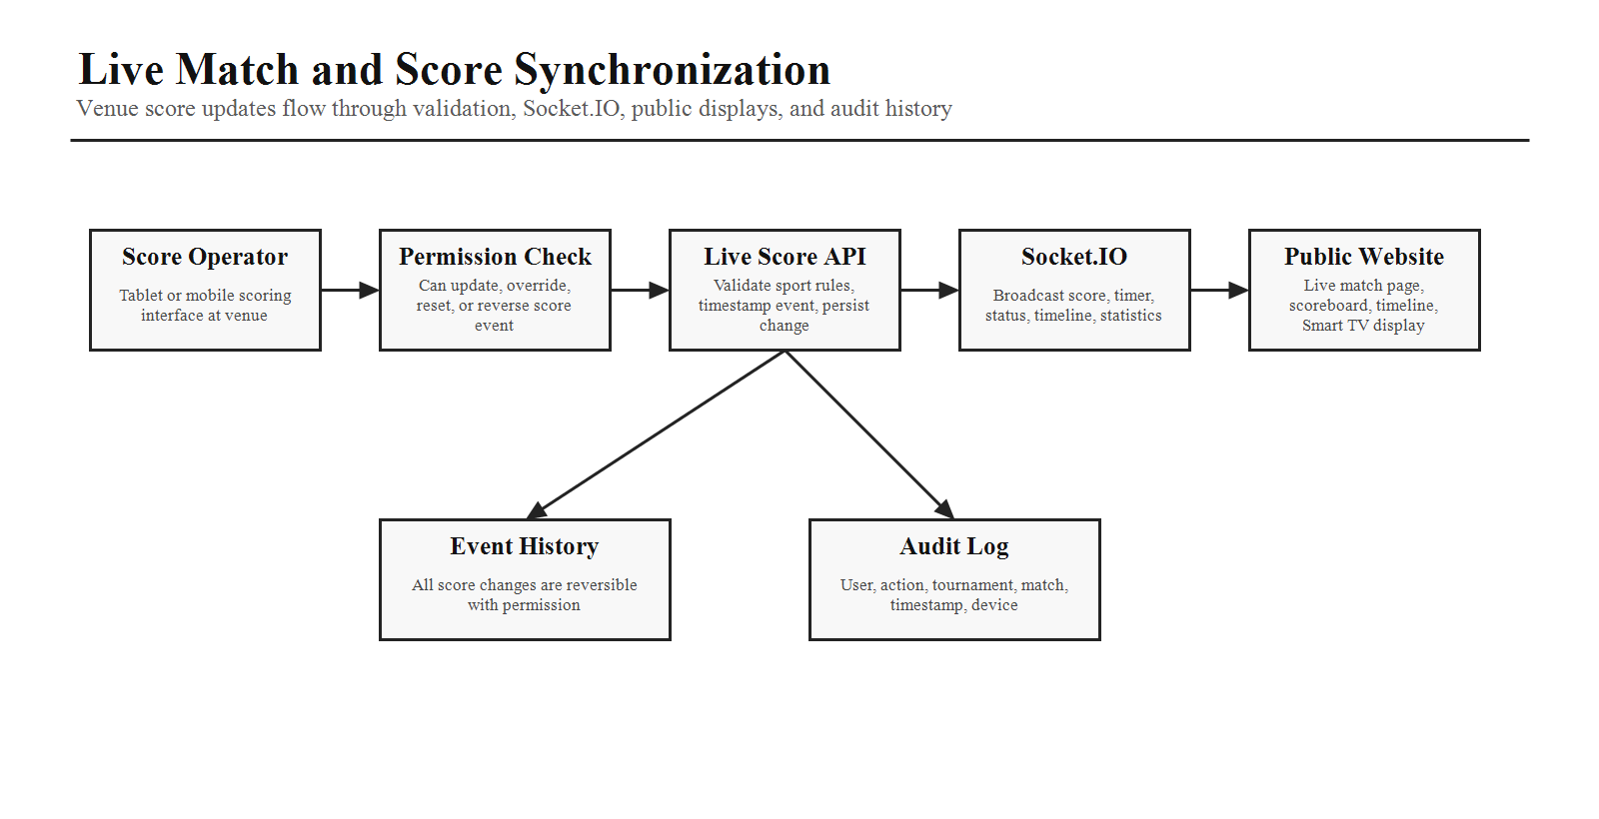
Sport | Supported Scoring Events
Cricket | Runs, wickets, overs, extras, partnerships.
Football | Goals, assists, yellow cards, red cards, substitutions.
Basketball | 2-point score, 3-point score, free throws, fouls, timeouts.
Volleyball | Points, sets, timeouts.

9. Team and Player Verification
Verification Queue | Checks and Actions
Team Verification | Verify team details, documents, entry fee, eligibility, team size. Actions: approve, reject, request changes.
Player Verification | Verify identity, age, documents, eligibility, and team assignment. Actions: approve, reject, request additional documents.
Audit Requirement | Capture reviewer, timestamp, decision, reason, previous state, and new state.

10. Officials Management
Area | Specification
Assigned People | Referees, assistant referees, scorers, volunteers.
Actions | Assign, reassign, mark attendance, contact.
Visibility | Only show officials for assigned tournaments, venues, or matches.

11. Announcements
Management Users can create tournament-specific announcements when permitted.
- Types: general, schedule change, venue change, emergency, results published.
- Delivery: website, email, SMS, WhatsApp, and future push notification.
- Support preview, scheduling, audience targeting, confirmation, and delivery status.

12. Results Management
Capture Field | Purpose
Final Score | Record the official match result after completion.
Winner and MVP | Identify winning side and key performer.
Match Duration | Record start, end, and total duration.
Match Summary and Remarks | Operational notes and public-facing summary where permitted.
Actions | Save draft, publish, edit if permitted. Publishing updates leaderboards automatically.

13. Fixture View
View | Behavior
Calendar View | Show matches by date, venue, status, and assigned tournament.
Bracket View | Show knockout or hybrid structure where supported.
List View | Searchable table of fixtures with filters and actions.
Highlights | Current match, upcoming match, completed match.

14. Venue Management and Participant Check-In
Module | Specification
Venue Monitoring | View assigned venues, occupancy, current match, upcoming matches, and maintenance alerts.
Venue Permissions | Cannot modify venue settings unless permission is granted.
Participant Check-In | Support QR code or manual check-in for team arrival, player arrival, and official arrival.
Check-In Status | Checked in, late, absent.

15. Document Center
Document Type | Access Rules
Rule Book | View/download based on tournament assignment and document permission.
Fixtures | View/download generated fixtures for assigned tournaments.
Team Lists | View assigned teams and approved participant lists.
Certificates | Access generated certificates when permitted.
Venue Maps | Download or view maps for assigned venues.

16. Reports
Report | Scope
Match Report | Match details, score events, officials, timeline, final result.
Team Report | Team verification, eligibility, attendance, tournament participation.
Player Report | Player verification, age, documents, eligibility, participation.
Attendance Report | Team, player, and official check-in status.
Live Score Summary | Score events, reversals, timestamps, operator activity.
Exports | PDF, Excel, CSV where permitted.

17. Notifications and Profile
Area | Specification
Inbox Alerts | New assignment, match start reminder, registration approval needed, payment issue, schedule change, emergency announcement.
Notification State | Read and unread status with filtering.
Profile Management | Profile photo, name, contact details, password, notification preferences.
Profile Visibility | Assigned roles, assigned tournaments, last login, activity history.

18. Offline Mode
The live scoring interface should be future-ready for intermittent connectivity at outdoor venues and tournament grounds.
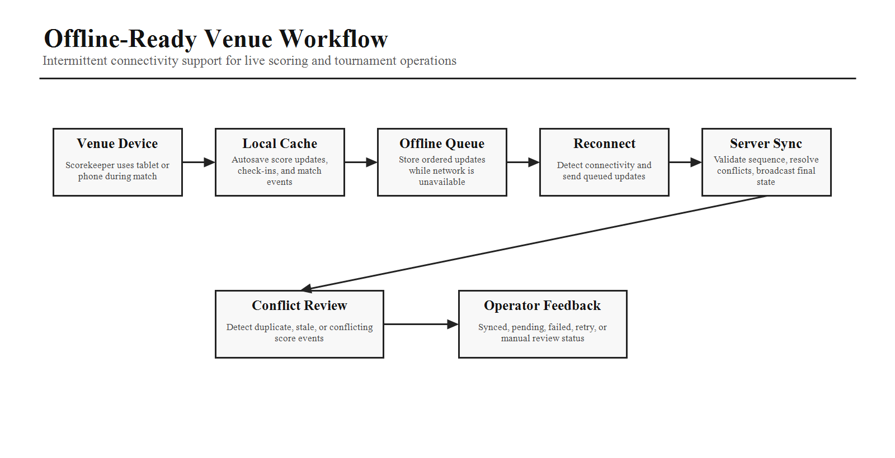
- Cache score updates locally.
- Queue updates while offline.
- Synchronize automatically when the connection is restored.
- Detect and resolve synchronization conflicts.
- Show clear operator feedback for synced, pending, failed, retry, and manual review states.

19. Activity Log and Performance Dashboard
Feature | Required Data
Activity Log | Timestamp, action, tournament, device, and examples such as match started, score updated, team approved, result published.
Performance Metrics | Matches managed, scores updated, teams verified, players verified, average update time.
Visibility | Performance dashboard visible only to the user and Super Admin.

20. AI Coding Instructions
- Build a modular dashboard using reusable widgets.
- Enforce RBAC checks in both frontend and backend.
- Use Socket.IO for real-time score synchronization.
- Optimize the live score interface for tablets and mobile devices used at venues.
- Implement autosave for score updates where appropriate.
- Provide confirmation dialogs for destructive actions.
- Maintain detailed audit logs for every operational change.
- Ensure the UI remains responsive and usable in outdoor tournament environments with varying network conditions.
- Use server-side filtering for assignment-scoped data and never trust client-side filtering alone.
Phase 6 Completion Criteria
Phase 6 is complete when the Management User portal objective, permission scope, layout, dashboard, assigned tournaments, match control, live scoring, verification workflows, officials, announcements, results, fixtures, venue monitoring, check-in, documents, reports, notifications, profile, offline readiness, activity log, performance dashboard, and implementation rules are clear enough for production planning.

