# ICD2 - HLS Central West ICD10 Bot

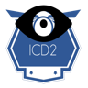

# Overview

# Components

## ICD2DB

This is a [Microsoft SQL Server](https://azure.microsoft.com/en-us/services/sql-database/) database with a single table (ICD10Codes). Each row in the table contains an ICD10 code, and its associated text description. A [full-text index](https://docs.microsoft.com/en-us/sql/relational-databases/search/full-text-search?view=sql-server-2017) on the table allows for ICD10 codes to be looked up using natural text search.

## ICD2-BOT

A bot built using the [Microsoft Bot Framework](https://dev.botframework.com/), [NodeJS](https://nodejs.org/en/), and [TypeScript](https://www.typescriptlang.org/) that handles user input for searching ICD10 codes.

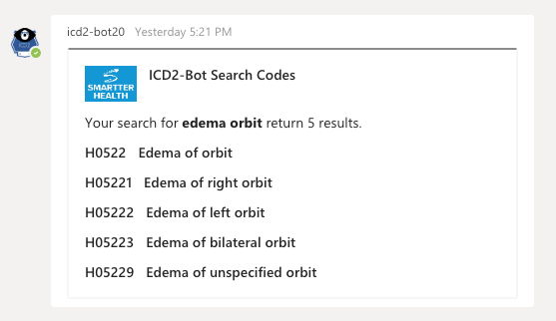

Figure : ICD2-Bot in Action

# Deployment

## Tools Needed

* An [Azure](https://azure.microsoft.com/en-us/) Subscription that will host the ICD2 components.
* [SQL Server Management Studio](https://docs.microsoft.com/en-us/sql/ssms/download-sql-server-management-studio-ssms?view=sql-server-2017) for deploying the ICDDB database to Azure.
* (Optional) [Visual Studio Code](https://code.visualstudio.com/) for local development.
* (Optional) [NGrok](https://ngrok.com/) for local development and debugging.