**Assignment 2**

**Name:** Shubham Kulkarni

**Roll No:** 321039

**Gr No:** 21910316

**Batch:** TY-A2

**Title:** LED Blinking assignment using Arduino / Raspberry pi

**Objective:** To learn interfacing LED’s with Arduino **Methodology:**

**1. Material Required:**

1. **3 X LEDS**
2. **3 X 220 OHM RESISTOR**
3. **ARDUINO UNO R3**
4. **CONNECTING WIRES**
5. **LAPTOP/PC FOR CODING**

**2.**

**SCHEMATIC DIAGRAM:**

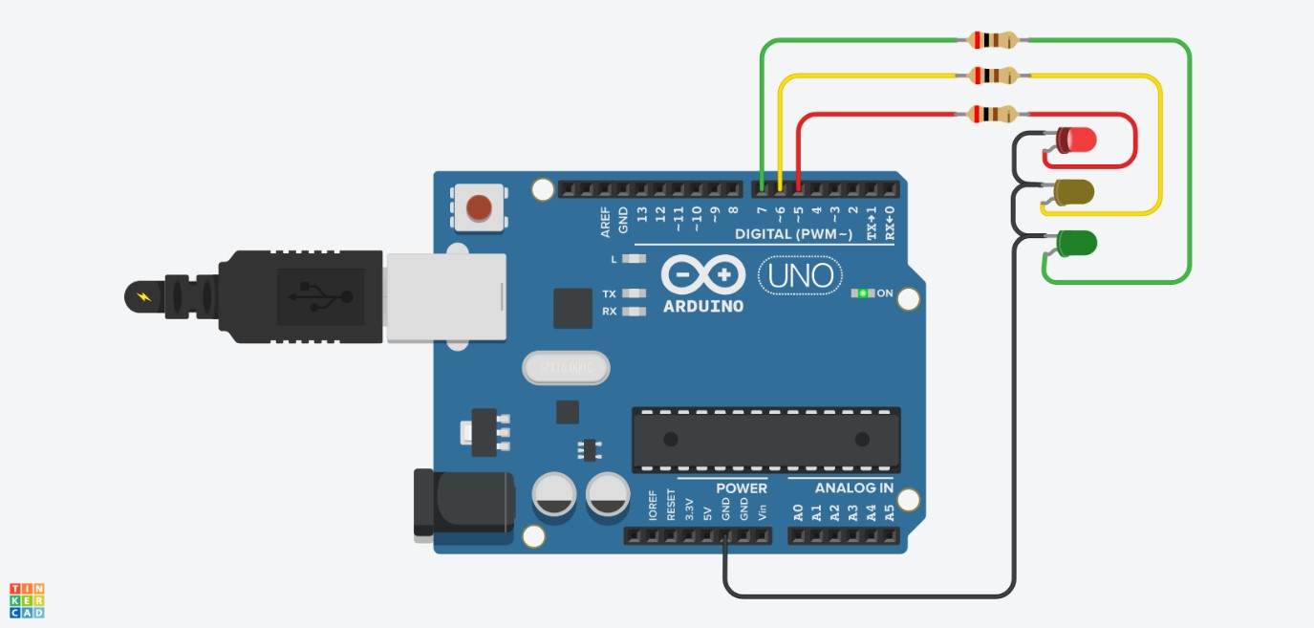

**3. CODE:**

int red = 11; int yellow = 12; int green = 13; void setup(){ pinMode(red, OUTPUT); pinMode(yellow, OUTPUT);

pinMode(green, OUTPUT);

}

void loop()

{

changeLights();

delay(15000);

}

void changeLights()

{

// green off, yellow on for 3 seconds digitalWrite(green, LOW); digitalWrite(yellow, HIGH); delay(3000);

// turn off yellow, then turn red on for 5 seconds digitalWrite(yellow, LOW); digitalWrite(red, HIGH); delay(5000);

// red and yellow on for 2 seconds (red is already on though) digitalWrite(yellow, HIGH); delay(2000);

// turn off red and yellow, then turn on green digitalWrite(yellow, LOW); digitalWrite(red, LOW); digitalWrite(green, HIGH); delay(3000);

}

**Output :**

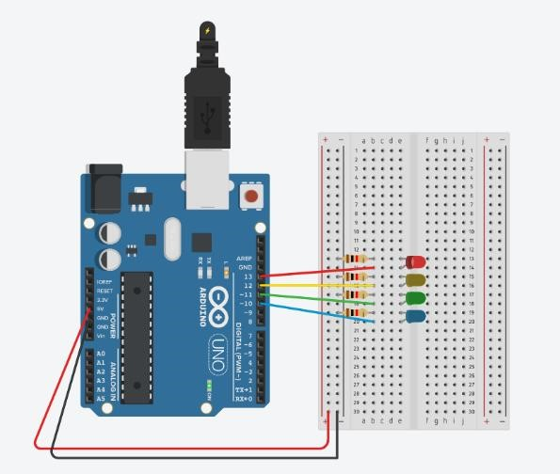

# **Conclusion:** We have learnt about interfacing and programming LED’s with Arduino