**TY B.Tech Computer Engineering**

**Internet of Things Lab**



**SUBMITTED TO:**

**PROF. VIDULA MESHARAM**

**VISHWAKARMA INSTITUTE OF INFORMATION TECHNOLOGY, PUNE**

**COMPUTER ENGINEERING DEPARTMENT**

**NAME: Rohit Bharti**

**G.R NO.: 21910374**

**ROLL NO.: 322055**

**CLASS: TY COMP B**

**BATCH: B3**

**Aim:** To Interface Ultrasonic sensor with Arduino.

**Objective:** To understand the working of a Ultrasonic sensor and how it can be connected to Arduino.

**Theory:**

An [Ultrasonic](https://www.learnelectronicsindia.com/blogs-1/hashtags/Ultrasonic) Sensor is an electronic device that measures the distance of an object or obstacle via Ultrasonic sound waves (that travel faster than the speed of audible sound), and it converts the reflected ultrasonic waved into electric signals. It is one of the most reliable and accurate proximity sensors.

The [sensor](https://www.learnelectronicsindia.com/blogs-1/hashtags/sensor) is based on the measurement of the time of flight of an ultrasonic pulse, which is reflected by the ground, it sends out Ultrasonic waves that has a range of frequency above human hearing. Ultrasonic Sensor is commonly used in obstacle avoiding robots and automation projects.

**Components:**

* Ultrasonic Distance Sensor
* Arduino Uno R3

1. HCSR04: is the Ultrasonic Sensor used. An ultrasonic sensor contains two circular structures: one is the[**transmitter**](https://www.learnelectronicsindia.com/blogs-1/hashtags/transmitter) and the other is a [**receiver**](https://www.learnelectronicsindia.com/blogs-1/hashtags/receiver). The transmitter transmits the ultrasonic sound while the receiver receives the reflected signal.



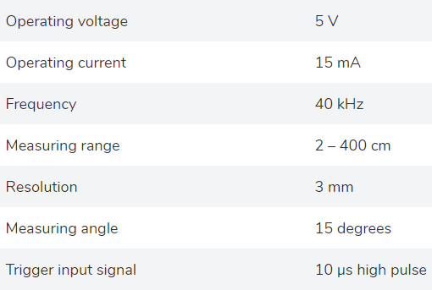

1. Arduino Uno R3: The [Arduino](https://www.learnelectronicsindia.com/blogs-1/hashtags/Arduino) is a micro-controller board that is based on the ATmega328P, it consists of digital and analog input/output pins that are interfaced with the ultrasonic sensor (used to send and receive data). the Arduino Uno IDE consists of a Serial Monitor that displays the output.



**CIRCUIT:**

Circuit connections:

Ultrasonic sensor has 4 pins:

1. **Vcc**: connected to the 5V in Arduino

2. **TRIG (trigger)**: connected to PIN 10 of the Arduino

[Trigger](https://www.learnelectronicsindia.com/blogs-1/hashtags/Trigger) is used as Transmitter, this pin is used to transmit the sound from the Ultrasonic sensor. Trigger should be high. It is connected to the digital pin of the Arduino and used as output pin.

3. **ECHO:** connected to PIN 9 of Arduino.

Echo is used as a Receiver, it receives the sound. It is connected to the digital pin of the Arduino and used as input pin. In this diagram, we have connected Echo to pin 9.

4. **GND (ground)**: connected to the GND of Arduino

**Circuit diagram:**

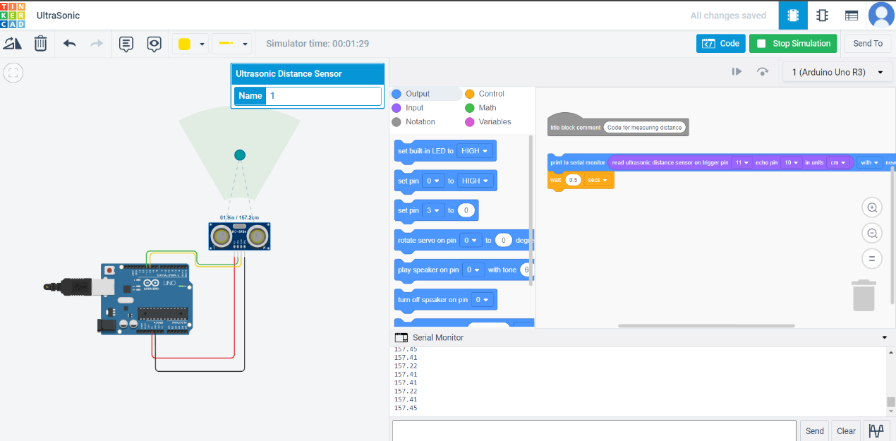

**How to calculate distance:**

An Ultrasonic Sensor measures the time of flight of an Ultrasonic wave and by measuring the time, it measures the distance of the object.

When an object is placed in front of an ultrasonic sensor, ultrasonic waves are emitted on the object which is reflected towards the receiver. When the waves are transmitted and received, the total time taken for the Ultrasonic waves the hit the object and reflect back is calculated. Distance is calculated through time.

General formula for distance= [T x C](https://www.arrow.com/en/research-and-events/articles/ultrasonic-sensors-how-they-work-and-how-to-use-them-with-arduino)

To calculate object distance: [D = ½ T x C](https://www.arrow.com/en/research-and-events/articles/ultrasonic-sensors-how-they-work-and-how-to-use-them-with-arduino)

D= distance of the object or obstacle

C= speed of sound in air = 0.034 microseconds

We divide the time of flight by 2 as we do not want to measure the total distance i.e., the distance taken for the pulse to hit the object and the distance is taken for it to reflect the receiver. We only want to calculate the proximity of the object.

This gives the distance of the object from the sensor. Thus, we have to divide the time by 2.

**Distance (cm) = Speed of sound (cm/µs) × Time (µs) / 2**

**Code:**

//variables and pins declared and initialised

int trigPin = 10; //TRIG connected to pin 10 of Arduino

int echoPin = 9; //ECHO connected to pin 9 of Arduino

long time;

int distance;

void setup()

//this loop repeats only once

{

pinMode(10, OUTPUT); //TRIG pin set as output

pinMode(9, INPUT); //ECHO pin set as input

**Serial**.begin(9600); //begin communication

}

void loop()

//this loop repeats continously

{

digitalWrite(10, LOW); //TRIG pin set low (cleared)

delayMicroseconds(2); //delay of 2 microseconds given

digitalWrite(10, HIGH); //TRIG pin set high (signal transmitted)

delayMicroseconds(10); //delay of 10 microseconds given

digitalWrite(10, LOW); //TRIG pin set as low again

//calculating the distance

time = pulseIn(9, HIGH); //to calculate time of flight

distance = time*0.034/2; //to calculate distance of object

//printing the distance

**Serial**.print("Distance: ");

**Serial**.println(distance);

}

**Serial Monitor:** Output can be seen on the Serial Monitor after we start the simulation.

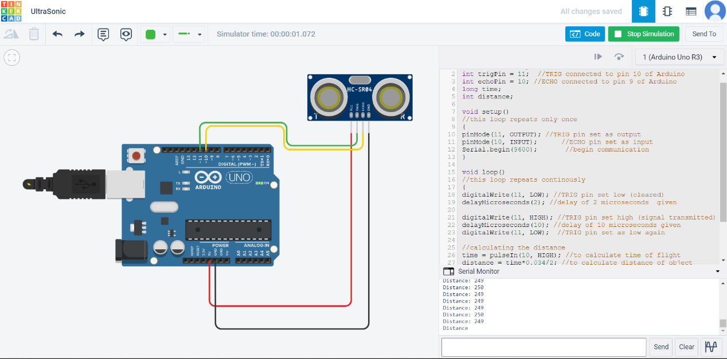

**Conclusion:** We have successfully interfaced a Ultrasonic sensor with Arduino and calculated the distance of the object.