**Documentation : TalentFlow – A mini Hiring Platform**

**1. Project Description**

**TalentFlow** is a modern single-page application (SPA) built to address the inefficiencies of manual and fragmented hiring processes. The platform serves as a centralized solution for human resources professionals and recruiters to manage the entire talent acquisition lifecycle, from initial job posting to candidate hiring. The application's intuitive user interface and streamlined workflow are designed to save time, reduce administrative overhead, and provide a clear overview of the recruitment pipeline.

The application is composed of three core modules:

* **Jobs Page:** This module allows recruiters to view all open job requisitions. Each job is represented as a card, providing a quick summary of the role, location, and status. The interface is designed to provide quick access to job details and an organized view of all available positions.
* **Candidates Page:** The heart of the platform, this module provides a comprehensive overview of all applicants. It features a responsive layout to view candidate cards, each containing essential information such as their name, contact details, and current application status. This page is central to tracking and managing all candidates in one place.
* **Assessments Page:** This section of the platform is dedicated to managing and building technical assessments for candidates. It allows for the creation of new assessments and linking them to specific job roles, enabling a standardized and objective evaluation process.

**2. Tools and Technologies**

The technical stack for **TalentFlow** was carefully selected to ensure a balance of robust performance, developer productivity, and maintainability. Each tool plays a crucial role in the application's overall functionality and structure.

| Category | Tools & Libraries | Justification |
| --- | --- | --- |
| **Frontend** | React.js, React Router DOM, React-DND | **React.js** was chosen for its component-based architecture, which allows for the creation of reusable UI elements and simplifies the development of complex interfaces. **React Router DOM** was used to manage client-side routing, enabling seamless navigation between different pages without full-page reloads. **React-DND** was specifically integrated to enable a future kanban-style drag-and-drop feature for managing candidate stages. |
| **State Management** | React Hooks (useState, useEffect) | For a project of this scale, the built-in React Hooks provide a powerful and lightweight solution for state management. useState handles all local component states, while useEffect is essential for managing side effects like data fetching and API call simulations. This approach avoids the overhead of larger state management libraries. |
| **Styling** | Inline CSS (JSX) | Inline CSS was used for styling to keep component code co-located, making it highly modular and easy to manage. This approach prevents CSS class name collisions and simplifies the styling of individual components. |
| **Data Handling** | Mock Service Worker (MSW) | **MSW** was a critical choice during development. It's a powerful API mocking library that intercepts network requests at the service worker level. This allowed us to build the entire front end as if it were communicating with a real backend, without needing a server to be physically running. |
| **Version Control** | Git & GitHub | **Git** is the industry standard for version control, enabling collaborative development and tracking of all code changes. **GitHub** was used as the remote repository to store the project, manage collaboration, and act as the source for deployment. |
| **Deployment** | Vercel | **Vercel** was chosen for its seamless integration with GitHub. It automates the deployment process, providing a continuous deployment workflow where every push to the main branch triggers a new build and deploy to the live server. |

**3. Future Enhancements**

The current version of TalentFlow provides a strong foundation. The following enhancements would elevate the platform to a production-ready and fully-featured application:

* **User Authentication and Authorization:** The most critical enhancement is adding a secure authentication system. This would involve a login page, user sessions, and a backend service to manage user data. Furthermore, implementing authorization would allow for different user roles (e.g., administrator, recruiter) to have varying levels of access to sensitive data and functionality.
* **Transition to a Real Backend and Database:** The application's data is currently served via a mock API. To make the platform truly functional and persistent, a real backend (e.g., using Node.js, Express, or Python with Django) and a database (e.g., PostgreSQL, MongoDB) are required. This would allow for dynamic data updates, storing information permanently, and handling complex business logic.
* **Advanced Analytics and Reporting:** Adding a dashboard with data visualization would provide valuable insights into the hiring funnel. Metrics such as time-to-hire, candidate source tracking, and pipeline velocity could be displayed, empowering recruiters with data-driven decision-making.
* **Automated Communication:** Integration with email or other communication APIs would allow for automated notifications. This could include sending interview invitations to candidates, notifying hiring managers of new applicants, and sending stage-change alerts.
* **Enhanced UX:** Implementing a true kanban board for the Candidates page would allow for a more intuitive drag-and-drop workflow for moving candidates between different stages (e.g., Applied, Interview, Offer).

**4. Project Folder Structure**

The project's modular folder structure is a key element of its maintainability. It follows the principle of separation of concerns, ensuring that related code is grouped logically.

**Core Directories Explanation:**

* **src/api**: This directory is central to the mock data architecture. It contains the db.js file for mock data, server.js to set up the MSW, and handlers to define the mock API endpoints.
* **src/components**: Houses all reusable UI components. This is divided into sub-directories like candidates, jobs, and assessments to group related components and make them easy to find.
* **src/hooks**: Dedicated to custom React Hooks (useJobs, useCandidates, etc.). This promotes code reusability by abstracting complex data-fetching and state-management logic away from the main components.
* **src/pages**: Contains the top-level components that correspond to each route in the application (e.g., JobsPage, CandidatesPage). This structure keeps the routing logic clean and organized.
* **src/utils**: Stores utility functions and global constants that are used across multiple parts of the application.

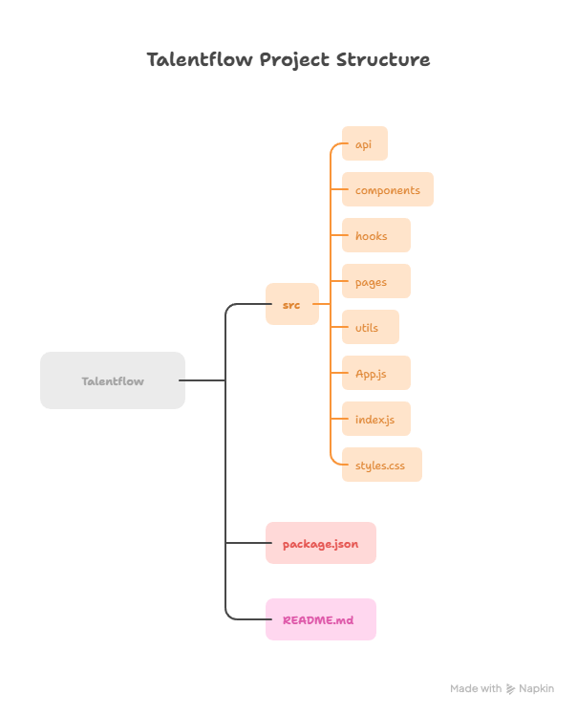

**5. System Architecture**

The system is architected as a **static-site front end with a simulated API layer**. It does not rely on a traditional client-server model for development.

1. **Client-Side Rendering:** The entire user interface, built with React, is rendered on the client side (in the user's browser). This makes the application highly responsive and reduces server load.
2. **Mock API Communication:** During development, the application makes API calls to URLs (e.g., /api/candidates). These calls are intercepted by the **Mock Service Worker (MSW)**. The MSW then returns a mock JSON response from our db.js file, simulating a real backend without any network requests leaving the user's machine.
3. **Deployment Model:** When deployed to Vercel, the entire application is bundled into a set of static files (HTML, CSS, JS). Vercel serves these static files directly from its global CDN (Content Delivery Network) for fast load times. The public/mockServiceWorker.js file is also deployed with these files.

This architecture is ideal for front-end development as it decouples the front end from the backend, allowing development to proceed in parallel.

**6. Tools Explanation (Elaborated)**

* **React.js:** A powerful and flexible library for building modern user interfaces. Its component-based approach allows developers to think in terms of small, self-contained pieces of UI logic that can be easily composed. React's virtual DOM efficiently updates the UI, leading to high-performance applications.
* **React Router DOM:** An essential library for building single-page applications. It provides the core functionality for managing the application's URL and displaying the correct components based on the current path, ensuring a seamless navigation experience without page reloads.
* **Mock Service Worker (MSW):** MSW is a revolutionary tool that allows developers to mock API responses in a declarative way. By setting up handlers, we can simulate GET, POST, PUT, and DELETE requests, providing a realistic development environment that mirrors a real backend and API. This significantly speeds up front-end development.
* **Vercel:** A premier cloud platform optimized for front-end frameworks. Its key features include serverless functions, automatic scaling, and a global CDN. Vercel automatically detects the framework and configures the build settings, making the deployment process as simple as a single git push.

**7. State Management (Elaborated)**

State management in this project is handled primarily through **React Hooks**, a modern feature introduced in React 16.8.

* useState: This hook is used to manage local state within a functional component. For example, on the CandidatesPage, useState is used to track the search term, the filter status, and which candidate is currently selected for the modal. It allows components to manage their own internal data and re-render only when that data changes.
* useEffect: This hook is used to handle "side effects" that occur outside the normal React render cycle. In our custom hooks, useEffect is used to trigger data fetching from the mock API. The dependency array ([query, status]) ensures that the data is refetched only when the search query or status filter changes.
* **Custom Hooks (useJobs, useCandidates):** These hooks were created to abstract and encapsulate the data-fetching and filtering logic. By moving this logic into a custom hook, we can reuse it across different components. For example, the useCandidates hook fetches and filters candidate data, and its results can be used by both the CandidatesPage and other components that might need access to candidate data. This prevents code duplication and keeps our components focused on rendering the UI.

**8. Deployment and Live Status**

The project has been successfully deployed and is hosted on Vercel at the following URL:

[talent-flow-a-hiring-platform-i376gx4ph-smathaf09s-projects.vercel.app](https://www.google.com/search?q=https://talent-flow-a-hiring-platform-i376gx4ph-smathaf09s-projects.vercel.app/)

**NOTE:** **On the live Vercel environment, the Jobs and Candidates pages do not display content.**

**Explanation:** The deployed application is a static site. It cannot run the **Mock Service Worker (MSW)** on the server-side to intercept API calls. In the local development environment, the MSW is active in the browser, allowing the application to simulate API requests and get a response from the mock data. However, on the live server, there is no mock server running. When the deployed app tries to fetch data from /api/jobs or /api/candidates, it results in a **404 Not Found** error, as these endpoints do not actually exist. The server then returns an HTML error page, which causes the Unexpected token '<' error when the client-side code tries to parse it as JSON. The codebase itself is correct, but it requires a real backend to be fully functional in a production environment.