SF16Functional Testing: Final Test

|  |  |
| --- | --- |
| Your name: Tatiana Smatova | Date: 25.06.2018 |

## Introduction to the project.

Imagine that you were assigned to a new project as a tester where domain area – finances. You and your test team lead Victor is located in Minsk. The rest team – in India, China (development) and USA (business analyst, customers and supervisors).

This is a small mobile project developed for Blackberry platform. After login to the application you are redirected to the Home screen (please see the screenshot of the Home screen below):

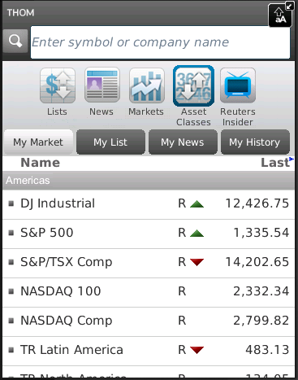

Financial content of the Home screen

Search bar

Main horizontal menu with icons

Customer of the project (named Brian) wants to implement a new feature for this project. Brian was working with business analyst John on requirements for this feature.

So, your task is:

1. Review the requirements for the new feature provided by John.
2. In case of any questions you need to write email to John with request to clarify your questions.
3. Provide estimations for test activities for this feature by email to your test lead Victor.
4. Write test cases for the feature for smoke test.
5. Review provided screens with the implemented feature.
6. Find and submit bugs in case of any.
7. (*optional task) Send test results and your decisions about quality of the feature to Victor.

**Below you will find requirements for the feature and templates for emails, test cases, bug reports and so on, please fill in only those templates that you think reasonable in scope of this feature. Also you can write any additional information that you want.**

## Requirements for the new feature

**User story #045**

**Summary**: As a user I want to access my Profile from the Home screen

**Priority**: Major

**Description**:

* Profile menu icon exists in the Home screen.
* Profile menu icon is positioned on the list of menu icons in the Home screen between Lists and News icons.
* Profile view is displayed when Profile icon is selected.
* The Profile view must have header section (with name, company, location, thought of the day and photo).
* If photo is not available then default image is used.
* The rest of the person’s detail fields can be scrolled, only lines where user has added information are shown.
* Text size must not be too small.

## Clarification letter for business analyst regarding the feature #045:

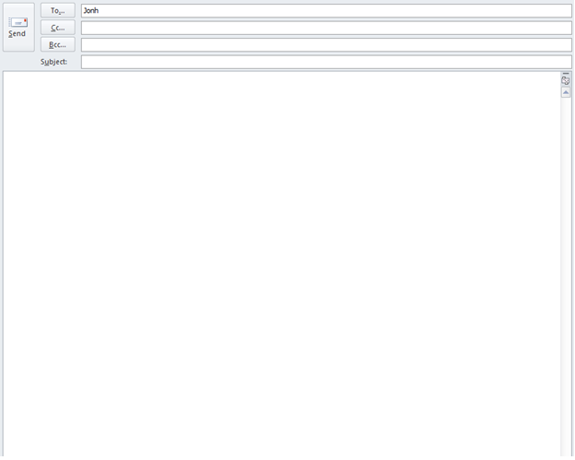

Team

User story #045. Clarification of the requirements for the function

Hello, Jonh!

Our team is working on the development of the profile view function of the THOM application (User story #045).

I would like to clarify some questions about the requirements for this function.

1. What is the username and password can be used to login to the app? Without login and password it is impossible to start testing.
2. In what browsers and devices the application will be used?
3. If there access the profile view without an Internet connection?
4. Are there default values for required fields before the user fills them in.
5. At what moment does the required profile attributes have to be filled in (name, company, location, thought of the day and photo)? During registration or from profile page?
6. What is exactly the size of the text necessary?
7. What should be the default image if the user's photo is not added?
8. What is the maximum size and what format (jpg, png) of a photo that can be added by the user?
9. Who fills in the thought of the day field - the user or the application?

Thank you.

Best regards,

Tatiana Smatova

Cell: +375-29-685-60-26

Skype: smatova.tatiana

Email: [smatova.tatiana@gmail.com](mailto:smatova.tatiana@gmail.com)

## Test estimations for the feature #045 to the test team lead Victor:

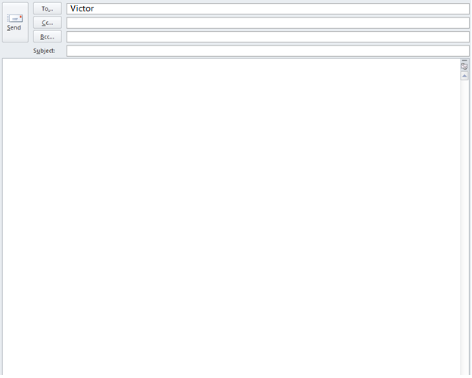;

User story #045. Testing estimations Tatiana Smatova

Виктор, привет!

Ниже я привела свои расчеты на тестирование feature #045.

Здесь я учла тесты на одном браузере и одном девайсе.

Если будет утвержден список нескольких браузеров или девайсов, нужно будет пересчитать.

Если в рамках всей группы я буду отставать или опережать сроки, сообщи, я пересмотрю и откорректирую.

Checking the existence of profile menu Icon on the home screen - 3

Checking the position of profile menu Icon on the home screen - 3

Checking the profile login by clicking the profile icon on the home screen - 4

Checking of mandatory information in the header section of the profile view (name, company, location, thought of the day and photo) – 10

Checking the display of lines with added information - 10

Checking the display rows with blank data – 6

Checking the scrolling of person’s detail fields - 6

Test Cases: 42

Test Cases creation: 15 min

Total TC creation: 42*15 min = 630 min

Test execution: 7 min

1 browses on 1 device

Total TC execution: 42*7 min = 294 min

Other activities (Bug reporting, verification, Troubleshooting, Reports, Emails, Meetings (discussion of issues in the team)): 30%

Risks (illness, build failed, some tests not counted, etc.): 20%

 ((630 min + 294 min)+30%)+20% = 1441 min /60min = 24 h / 8h = 3 days.

Estimation: 3 days

Best regards,

Tatiana Smatova

Cell: +375-29-685-60-26

Skype: smatova.tatiana

Email: [smatova.tatiana@gmail.com](mailto:smatova.tatiana@gmail.com)

## Test cases for the feature #045:

|  |  |  |  |  |  |  |
| --- | --- | --- | --- | --- | --- | --- |
| **No** | **Req. No.** | **Module** | **Test Description** | **Expected Results** | **Passed /Failed** | **Comments** |
| **1** |  | Profile Icon on home screen | **Checking the existence of profile menu Icon on the home screen**  **Precondition:**  Run THOM application  Login to the application (login=””, password =””)  **Steps**:   1. Verify that a profile menu Icon exists on the home screen | 1. The profile menu Icon exists on the home screen | Passed | Login and password must provide Jonh |
| **No** | **Req. No.** | **Module** | **Test Description** | **Expected Results** | **Passed /Failed** | **Comments** |
| **2** |  | Profile Icon on home screen | **Checking the position of profile menu Icon on the home screen**  **Precondition:**  Run THOM application  Login to the application (login=””, password =””)  **Steps**:   1. Verify that a menu icon is positioned on the list of menu icons in the Home screen between Lists and News icons | 1. The profile menu Icon is positioned on the list of menu icons in the Home screen between Lists and News icons | Failed | Login and password must provide Jonh  **profile icon.png** |
| **No** | **Req. No.** | **Module** | **Test Description** | **Expected Results** | **Passed /Failed** | **Comments** |
| **3** |  | Profile view | **Checking the opening of profile view by clicking the profile icon on the home screen**  **Precondition:**  Run THOM application  Login to the application (login=””, password =””)  **Steps**:   1. Click on the profile icon in the Home screen | 1. The profile view is displayed on the screen | Failed | Login and password must provide Jonh |
| **No** | **Req. No.** | **Module** | **Test Description** | **Expected Results** | **Passed /Failed** | **Comments** |
| **4** |  | Profile view | **Checking of mandatory information in the header section of the profile view (name, company, location, thought of the day and photo)**  **Precondition:**  Run THOM application  Click on the profile icon in the Home screen  **Steps**:   1. Verify that the Profile view have in header section Users name, company, location, thought of the day and photo | 1. The Users name, company, location, thought of the day and photo are displayed in the header | Failed | **Cannot be tested because of the inability to open the profile by clicking the Profile icon on Home screen** |

## The feature #045 is ready for testing:

So, developers have finished implementation the feature #045. You received notification that the build with feature #045 was released and ready for testing. The build was successfully installed. Victor asked you to test the feature. You open the application -> login -> and see the Home screen provided below:

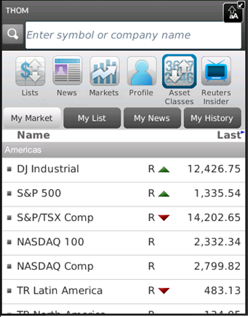

Upon clicking Profile icon in the main horizontal menu the next screen is opened:

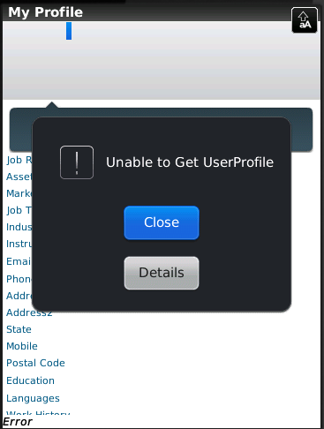

**If you see any bugs in these two screens you can post them below:**

## Templates for bug reports:

|  |  |
| --- | --- |
| **Bug ID** | **#1** |
| **Summary** | **Profile view is not displayed when Profile icon is selected** |
| **Description** | It is impossible to open the profile clicking on the Profile icon on the Home screen  **Actual result:** The message "Unable to get user profile" appeared by clicking on Profile icon.  **Expected result:** The profile menu Icon is positioned on the list of menu icons between Lists and News icons  **Reproduced on:**  **Reproducibility:**  **Workaround:** |
| **Severity** | **Major** |
| **Steps to reproduce** | 1. Run THOM application 2. Login to the application (login=””, password =””) 3. Click on the profile icon in the Home screen |
| **Bug ID** | **#2** |
| **Summary** | **The menu icon is located between the “Markets” and “Asset Classes” icons** |
| **Description** | The profile menu icon is positioned in the list of menu icons on the home screen between the “Markets” and “Asset Classes” icons.  **Actual result:** The profile menu icon is positioned between the “Markets” and “Asset Classes” icons.  **Expected result:** The profile menu Icon is positioned on the list of menu icons between Lists and News icons  **Reproduced on:**  **Reproducibility:**  **Workaround:** |
| **Severity** | **Minor** |
| **Steps to reproduce** | 1. Run THOM application 2. Login to the application (login=””, password =””) 3. See the profile menu icon is positioned between the “Markets” and “Asset Classes” icons   **profile icon.png** |
| **Bug ID** | **#3** |
| **Summary** |  |
| **Description** |  |
| **Severity** |  |
| **Steps to reproduce** |  |

## Test results to the test team lead:

Team

User story #045 Test result report Tatiana Smatova

Hi Viktor.

Please find my report below

**Test result report**

**User story #045**

**25.06.2018**

**Test team:**

|  |  |  |
| --- | --- | --- |
| **Name** | **Position** | **Role in the project** |
| Tatiana Smatova | Tester | Manual testing |

**Testing process description:**

**Platform used:** Blackberry platform. For creation Test Cases used MS Office Excel. For creation Bug Report used MS Office Excel.

Test cases were created to check the existence of Profile menu icon in the Home screen, open the Profile view when Profile icon is selected and the correct display of person’s detail in the profile. There was a manual, black box test.

**Summary:** Red. As a result of the smoke tests, it was found 2 bug. One of which makes it impossible to do most of the tests. The quality of application is not good. The developed function cannot be used in this form.

**Testing timetable:**

|  |  |  |  |
| --- | --- | --- | --- |
| Tester | Date | Description | Duration |
| Tatiana Smatova | 25.06.2018 | Creating smoke test case  Testing  Creating Bug Report | 2 h |

**Recommendations**:

It should be fixed a bug that interferes with the running tests. Also It should be fixed the icon position bug in accordance with the customer's requirement.

**New bugs found:**

|  |  |  |
| --- | --- | --- |
| 1 | major | Profile view is not displayed when Profile icon is selected |
| 2 | minor | The menu icon is located between the “Markets” and “Asset Classes” icons |

**All bugs statistics:**

|  |  |  |  |  |  |
| --- | --- | --- | --- | --- | --- |
| **Status** | **Quantity** | **Severity** | | | |
| **Critical** | **Major** | **Medium** | **Minor** |
| Submitted | 2 | 0 | 1 |  | 1 |

Best regards,

Tatiana Smatova

Cell:

Skype: smatova.tatiana

Email: [smatova.tatiana@gmail.com](mailto:smatova.tatiana@gmail.com)

**Thank you for passing the test and good luck**

**☺SFT16**