**CSCI/MATH 3180**

**Lab Assignment #5**

# Name:_____________________________

**Maple Worksheet: Use Maple** to do the following and your Maple worksheet as **YourLastName5.mw.**

1. Create the divided difference table for the data points, {(0, 0), (1, 1), (2, 0), (3,1), (4,0)}.
2. Find the Newton interpolant for the data set.
3. Draw/Plot the Newton interpolant.

**Part I.**

**1.** Consider constructing a quadratic spline for the data points, {(0, 0), (1, 1), (2, 0), (3,1), (4,0)}.

1. Give a linear system of the coefficients of the quadratic spline function. Write the system as 12 by 13 augmented matrix.  ***Show all work.***

Step 1

S1(x)=a1(x)2+b1(x)+c1

S2(x)=a2(x)2+b2(x)+c2

S3(x)=a3(x)2+b3(x)+c3

S4(x)=a4(x)2+b4(x)+c4

S1(0)=a1(0)2+b1(0)+c1=0

S1(1)=a1(1)2+b1(1)+c1=1

S2(1)=a2(1)2+b2(1)+c2 =1

S2(2)=a2(2)2+b2(2)+c2=0

S3(2)=a3(2)2+b3(2)+c3=0

S3(3)=a3(3)2+b3(3)+c3=1

S4(3)=a4(3)2+b4(3)+c3=1

S4(4)=a4(4)2+b4(4)+c4=0

Step 2

S1’(x)=2a1(x)+b1

S2’(x)=2a2(x)+b2

S3’(x)=2a3(x)+b3

S4’(x)=2a4(x)+b4

S1’(1)= S2’(1)=>2a1(1)+b1-2a2(1)-b2=0

S2’(2)= S3’(2)=> 2a2(2)+b2-2a3(2)-b3=0

S3’(4)= S4’(4)=> 2a3(3)+b3-2a4(3)+b4=0

Step 3

0 0 1 0 0 0 0 0 0 0 0 0 0

1 1 1 0 0 0 0 0 0 0 0 0 1

0 0 0 1 1 1 0 0 0 0 0 0 1

0 0 0 4 2 1 0 0 0 0 0 0 0

0 0 0 0 0 0 4 2 1 0 0 0 0

0 0 0 0 0 0 9 3 1 0 0 0 1

0 0 0 0 0 0 0 0 0 9 3 1 1

0 0 0 0 0 0 0 0 0 16 4 1 0

2 1 0 -2 -1 0 0 0 0 0 0 0 0

0 0 0 4 1 0 -4 1 0 0 0 0 0

0 0 0 0 0 0 6 1 0 -6 1 0 0

0 1 0 0 0 0 0 0 0 0 0 0 0

S1’(0)=2a1(0)+b1=0

B1=0

1. Use **Maple** to do the following and add the Maple commands toyour Maple worksheet that you have created. i) What is the solution for the linear system in a)?

[1, 0, 0, -3, 8, -4, 5, -24, 28, -7, 48, -80]

Write down the spline function based on the solution from i).

S1(x)=x2

S2(x)=-3x2+8x-4

S3(x)=5x2-24x+28

1. S4(x)=-7x2+48x-80

* 1. **Plot the spline function in Maple worksheet.**



1. Verify the spline function in b) is indeed a quadratic spline for the data given in a) by checking its requirements.
2. Is the spline function **interpolating** the data and **continuous**? Yes

S1(0)=1(0)2+0*(0)+0=0

S1(1)=1(1)2+0*(1)+0=0

S2(1)=-3(1)2+8(1)-4 =1

S2(2)=-3(2)2+8(2)-4=0

S3(2)=5(2)2-24(2)+28=0

S3(3)=5(3)2-24(3)+28=1

S4(3)=-7(3)2+48(3)-80=1

S4(4)=-7(4)2+48(4)-80=0

ii) Is the first derivative of the spline function continuous? yes

S1’(1)= S2’(1)=>2(1)(1)-2(-3)(1)-(8)=0

S2’(2)= S3’(2)=> 2(-3)(2)+8-2(5)(2)-(-24)=0

S3’(4)= S4’(4)=> 2(5)(3)-24-2(-7)(3)-48=0

**2.** Consider constructing a natural cubic spline using the following data points: (-1, 1), (0, 2), (1, -1), (2, 0)

1. Give a linear system of the coefficients of the natural cubic spline functions. ***Show all work here*** *and* write the system as **12 by 13 augmented matrix**.

Step 1

S1(x)=a1(x)3+b1(x)2+c1x+d1

S2(x)=a2(x)3+b2(x)2+c2x+d2

S3(x)=a3(x)3+b3(x)2+c3x+d3

S1(-1)=a1(-1)3+b1(-1)2+c1(-1)+d1=1

S1(0)=a1(0)3+b1(0)2+c1(0)+d1=2

S2(0)=a2(0)3+b2(0)2+c2(0)+d2=2

S2(1)=a2(1)3+b2(1)2+c2(1)+d2=-1

S3(1)=a3(1)3+b3(1)2+c3(1)+d3=-1

S3(2)=a3(2)3+b3(2)2+c3(2)+d3=0

Step 2

S1(0)= S2(0) continious

Step 2

S1’(x)= 3a1(x)2+2b1(x)+c1

S2’(x)= 3a2(x)2+2b2(x)+c2

S1’(0)= S2’(0)=> 3a1(0)2+2b1(0)+c1 - 3a2(0)2-2b2(0)2-c2=0

S2’(1)= S3’(1)=> 3a2(1)2+2b2(1)2+c2-3a3(1)2-2b3(1)2-c3=0

Step 3

S1’’(0)= S2’(0)=> 6a1(0)+2b1- 6a2(0)-2b2 =0

S2’’(1)= S3’(1)=> 6a2(1)+2b2 -6a3(1)-2b3 =0

-1 1 -1 1 0 0 0 0 0 0 0 0 1

0 0 0 1 0 0 0 0 0 0 0 0 2

0 0 0 0 0 0 0 1 0 0 0 0 2

0 0 0 0 1 1 1 1 0 0 0 0 -1

0 0 0 0 0 0 0 0 1 1 1 1 -1

0 0 0 0 0 0 0 0 8 4 2 1 0

0 0 1 0 0 0 -1 0 0 0 0 0 0

0 0 0 0 3 2 1 0 -3 -2-1 0 0

0 2 0 0 0 -2 0 0 0 0 0 0 0

0 0 0 0 6 2 0 0 -6 -2 0 0 0

-6 2 0 0 0 0 0 0 0 0 0 0 0

0 0 0 0 0 0 0 0 12 2 0 0 0

S1’’(-1)= 6a1(-1)+2b1=0

S2’’(2)= 6a2(2)+2b2

1. Use **Maple** to do the following and add the Maple commands toyour Maple worksheet that you have created.
   * 1. Enter the linear system of 12 equations obtained in a). What is the solution (vector) for the linear system in a) from Maple?

[-4/3, -4, -5/3, 2, 8/3, -4, -5/3, 2, -4/3, 8, -41/3, 6])

Write down the spline function based on the solution from i).

S1(x)=-4/3x3-4 x2-5/3x+2

S2(x)=-8/3x3-4 x2 -5/3x+2

S3(x)=-4/3x3+8 x2 -4/3+6

* + 1. **Plot** the spline function in Maple worksheet.



1. Now verify the spline function in b) is indeed a natural cubic spline for the data given in a) by checking the requirements for a natural cubic spline.

Check the following:

* + 1. S interpolates, i.e. S(ti) = yi and is continuous. Note: If S(ti) = yi,

then S is continuous.

* + 1. S is continuous
    2. S is continuous

iv) S is natural cubic spline, i.e. S(t0) = 0 and S(tn) = 0

**Show all work.**

* + 1. S interpolates ( S(ti) = yi ) and is continuous.

Note: If S(ti) = yi, then S is continuous.

Write S(x) first and then verify.

S1(x)=-4/3x3-4 x2-5/3x+2

S2(x)=-8/3x3-4 x2 -5/3x+2

S3(x)=-4/3x3+8 x2 -4/3+6

S1(-1)=-4/3(-1)3-4(-1)2+-5/3(-1)+2=1yes

S1(0)=-4/3(0)3-4(0)2-5/3(0)+2=2yes

S2(0)=-8/3(0)3-4(0)2-5/3(0)+2=2 yes

S2(1)=-8/3(1)3-4(1)2+-5/3(1)+2≠-1no

S3(1)=-4/3(1)3+8(1)2-4/3(1)+6≠-1no

S3(2)=-4/3(2)3+8(2)2-4/3(2)+6≠0 no

* + 1. S is continuous

Compute/Write S first and then verify.

S1’(0)= S2’(0)=> 3(-4/3)(0)2+2(-4)(0)-5/3 – 3(-8/3)(0)2-2(-4)(0)2-(-5/3)=0 yes

S2’(1)= S3’(1)=> 3(-8/3)(1)2+2(-4) (1)2-5/3-3(-4/3)(1)2-2(8)(1)2-(-4/3)=-28.333 no

* + 1. S is continuous

Compute/Write S first and then verify.

S1’’(-1)= 6(-4/3)(-1)+2(-4)=0 yes

S2’’(2)= 6(-8/3)(2)+2(-4)=-40 not continious

* + 1. S is natural cubic spline, i.e. S(t0) = 0 and S(tn) = 0

No, S is not cubic spline S1’’(-1)=0 but S2’’(2)≠0

**Example:**

Newton form of the interpolating polynomial of degree 3 for the data points (0,0),(1,1)(2,0),(3,1)

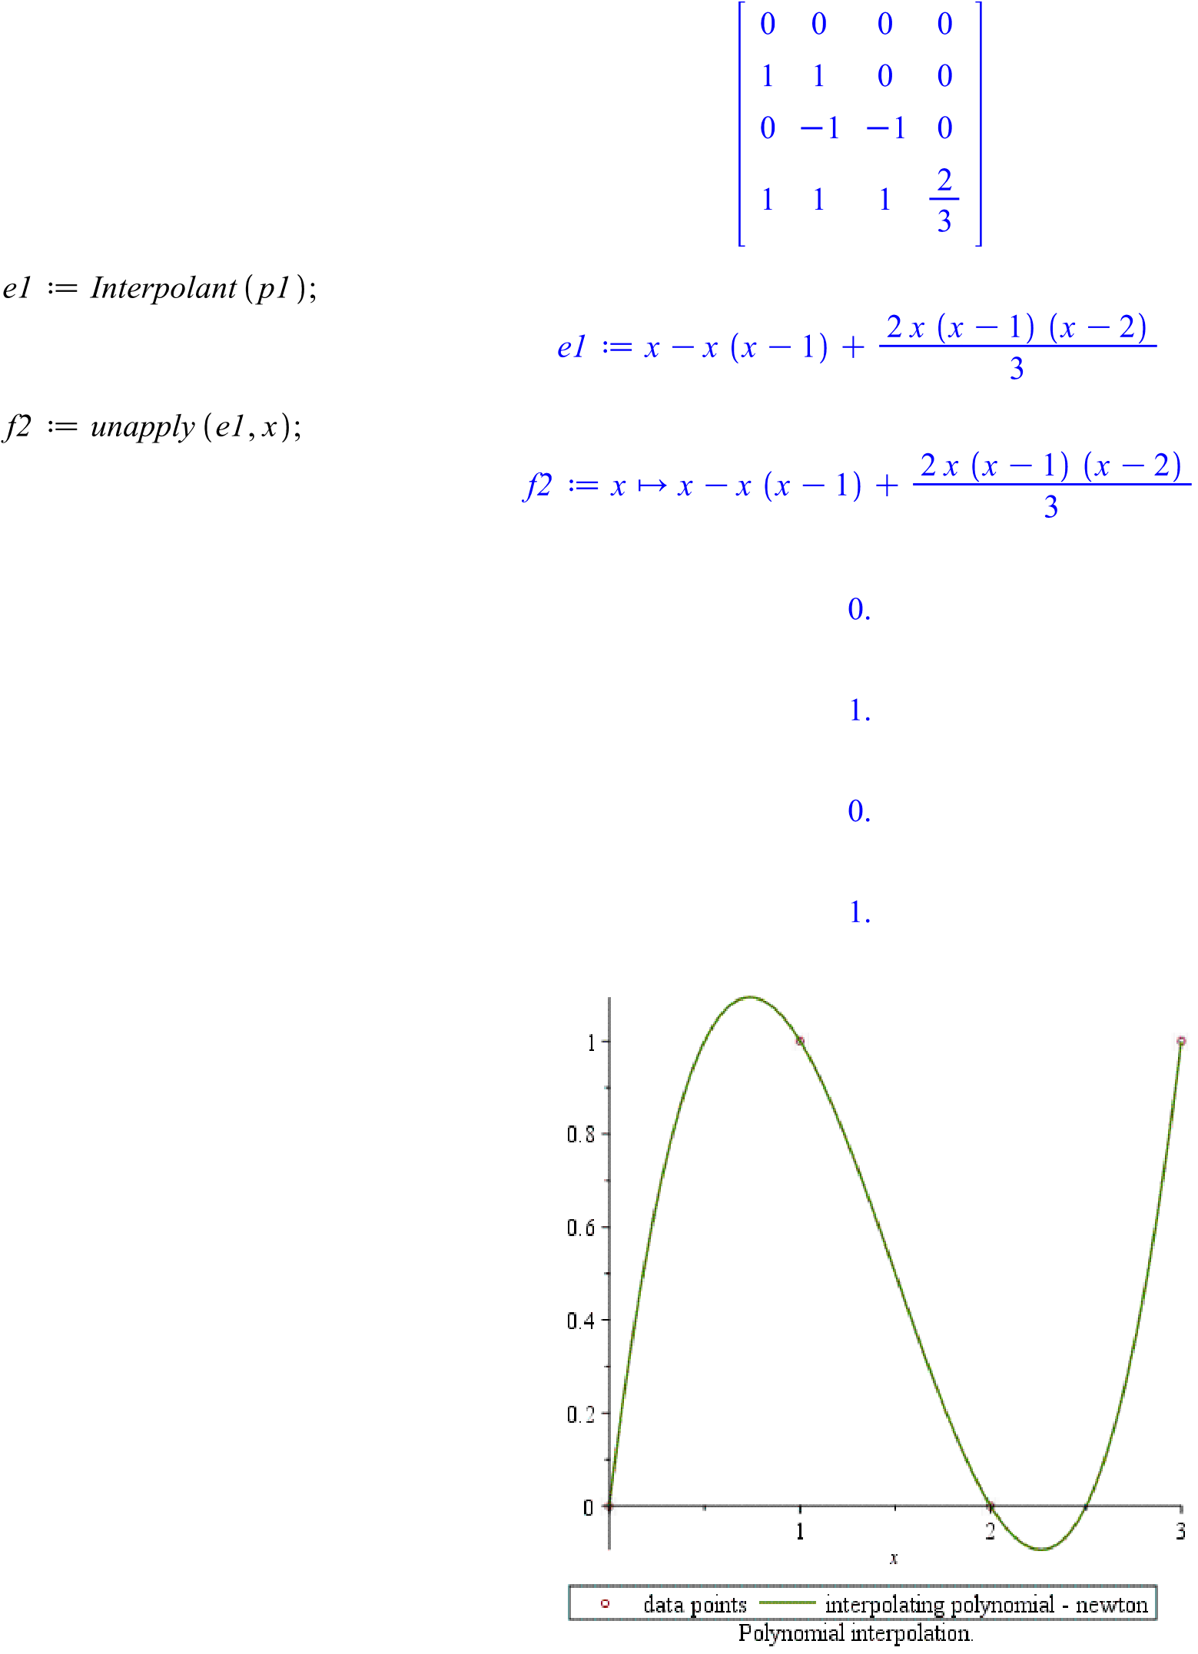------------------------------------------------------------------------------

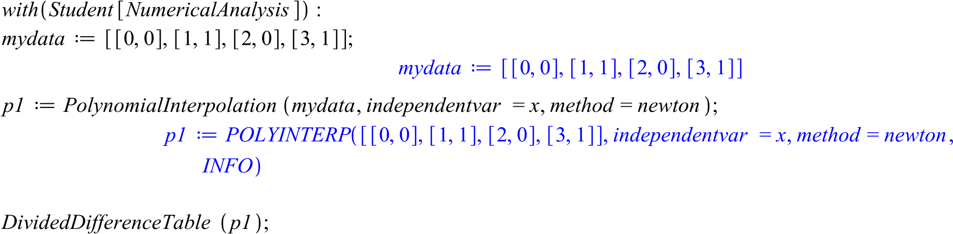

Quadratic spline for (0,0),(1,1)(2,0),(3,1)

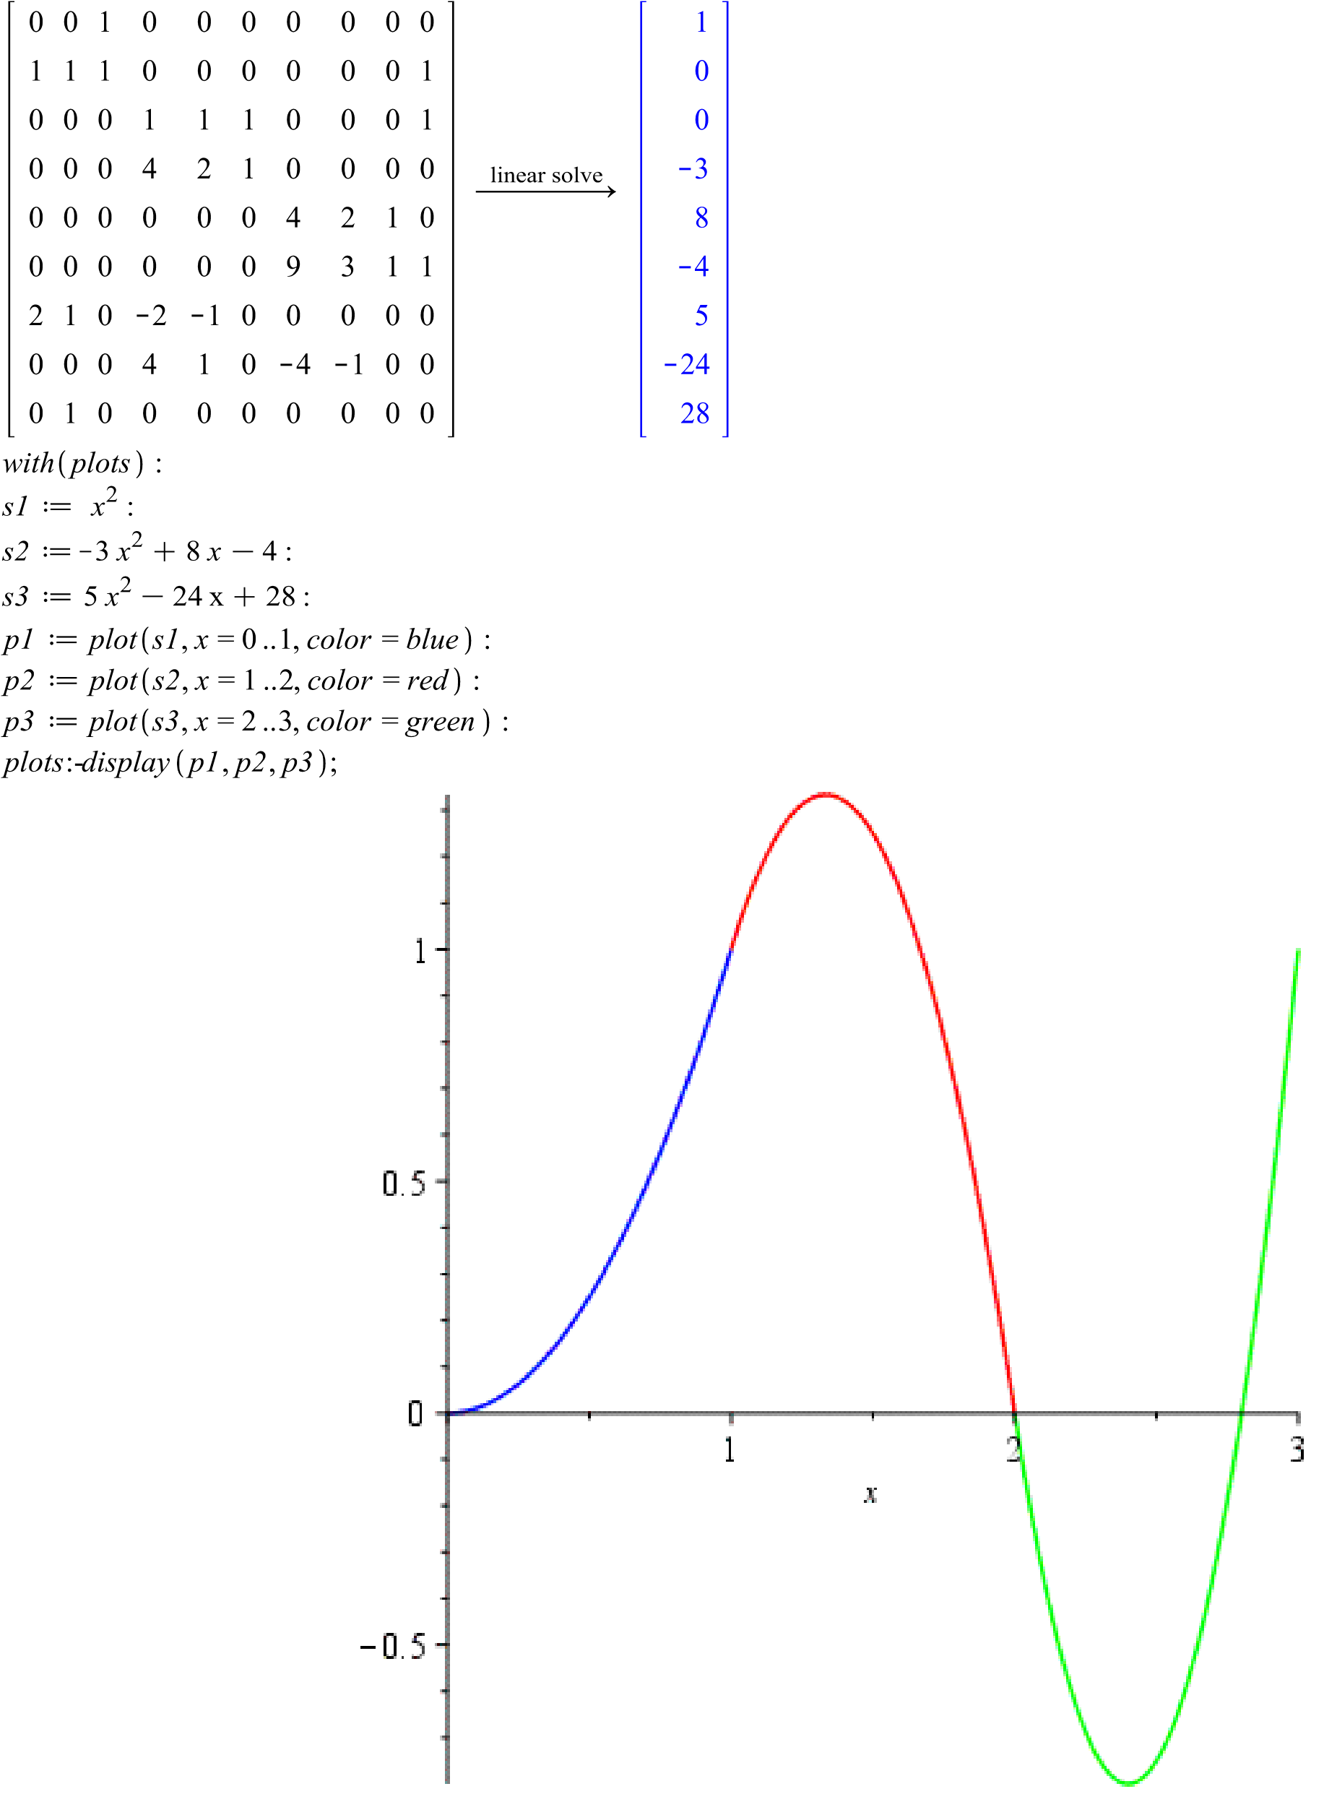

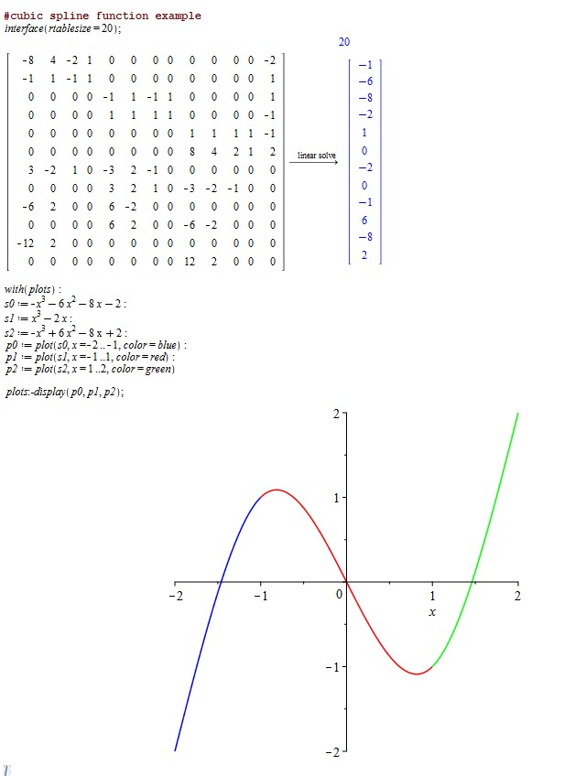

**Part II.**

1-3. Given the following augmented matrix representing a linear system,

|  |  |  |  |  |  |  |  |
| --- | --- | --- | --- | --- | --- | --- | --- |
| *a*11 | *a*12 | *a*13 | . | . | . | *a*1n | *b*1 |
| *a*21 | *a*22 | *a*23 | . | . | . | *a*2n | *b*2 |
| *a*31 | *a*32 | *a*33 | . | . | . | *a*3n | *b*3 |
| . | . | . |  |  |  | . | . |
| . | . | . |  |  |  | . | *.* |
| . | . | . |  |  |  | *.* | *.* |
| *a*n1 | *a*n2 | *a*n3 | . | . | . | *a*nn | *b*n |

1. Write pseudo-code for the forward elimination phase of the 2. Write pseudo-code for the back substitution phase of

Naïve Gaussian Elimination Method. the Naïve Gaussian Elimination Method.

|  |  |
| --- | --- |
| For each step k=1 to n-1  For each row i=k+1 to n-1  Multiplier=a[i][k]/a[k]a[k]  For each column j=0 to n  a[i][j]-=multiplier*a[k][j]  End For  b[i]=b[i]-multiplier*b[k]  End For  End For | For each row i=n to 1  Sum[i]=a[i][n]  For each column j=i+1 to n  Sum[i]=sum[i]-a[i][j]*sum[j]  End For  Sum[i]=sum[i]/a[i][i]  End For |

1. Write pseudo-code for the forward elimination phase of the Gaussian Elimination with Partial Pivoting Method.

For each step k=1 to n-1

temp=a[k][k]

a[k][k]=a[k+1][k]

a[k+1][k]=temp

For each row i=k+1 to n-1

Multiplier=a[i][k]/a[k]a[k]

For each column j=0 to n

a[i][j]-=multiplier*a[k][j]

End For

Update b value

End For

End For

4-5. Given the following system of equations: 2*x*+3*y* = 8

-*x*+2*y*-*z* = 0

3*x*+2*z* = 9 4. Apply the naïve Gaussian Elimination Method to solve the system.

* + - 1. Show all work for the forward elimination phase and circle the upper triangle matrix obtained.
      2. Show all work for the back substitution phase.
      3. What is the solution obtained?
      4. Verify your solution.

2 3 0 8

-1 2 -1 0

3 0 2 94

N=3

1. steps

step 1

update New Row 2 -> Row2-Row1*muntiplier

multiplier= a[2][1]/a[1][1]=-1/2

NewRow2=-1 2 -1 0 – (-1/2)(2 3 0 8)

= -1 2 -1 0 –(-1 -3/2 0 -4) =(0 7/2 -1 4)

2 3 0 8

0 7/2 -1 4

0 -9/2 2 82

update New Row 3 -> Row3-Row1*muntiplier

multiplier= a[3][1]/a[1][1]=3/2

NewRow3= 3 0 2 94 –(3/2)(2 3 0 8)

=3 0 2 94 –(3 9/2 0 12)= 0 -9/2 2 82

Step 2

update New Row 3 -> Row3-Row2*muntiplier

multiplier= a[3][2]/a[2][2]=-9/2/7/2

2 3 0 8

0 7/2 -1 4

0 0 5/7 610/7

= NewRow3= 0 -9/2 2 82 –(-9/7)(0 7/2 -1 4)

=0 -9/2 2 82 –(0 -9/2 9/7 -36/7)=0 0 5/7 610/7



Back ward substitution

X3=610/7*7/5=122

X2=(4- (-1)(122))(2/7) =36

x1=(8-0(605/7)-3(36))*1/2=-50

**5**. Apply the Gaussian Elimination with Partial Pivoting Method to solve the system.

* + - 1. Show all work for the forward elimination phase and circle the upper triangle matrix obtained.

3 0 2 94

-1 2 -1 0

2 3 0 8

2 3 0 8

-1 2 -1 0

3 0 2 94

swap R3 with R1

update New Row 2 -> Row2-Row1*muntiplier

multiplier= a[2][1]/a[1][1]=-1/3

NewRow2=-1 2 -1 0 – (-1/3)( 3 0 2 94)

= -1 2 -1 0 –(-1 0 -2/3 -94/3) =(0 2 -1/3 94/3)

3 0 2 94

0 2 -1/3 94/3

0 3 -4/3 -164/3

update New Row 3 -> Row3-Row1*muntiplier

multiplier= a[3][1]/a[1][1]=2/3

NewRow3= 2 3 0 8 –(2/3)( 3 0 2 94)

=2 3 0 8 –(2 0 4/3 188/3)= 0 3 -4/3 -164/3

3 0 2 94

0 3 -4/3 -164/3

0 2 -1/3 94/3



3 0 2 94

0 2 -1/3 94/3

0 3 -4/3 -164/3



Swap row 3 row 2

update New Row 3 -> Row3-Row2*muntiplier

multiplier= a[3][2]/a[2][2]=2/3

NewRow3= 0 2 -1/3 94/3–(2/3)( 0 3 -4/3 -164/3)=(0 0 5/9 610/9)

3 0 2 94

0 3 -4/3 -164/3

0 0 5/9 610/9



* + - 1. Show all work for the back substitution phase.

X3=610/9*9/5=122

X2=(-164/3+ (4/3)(122))(1/3) =36

x1=(94-2(122)-0(36))*1/3=-50

* + - 1. What is the solution obtained?

[122,36,-50]

* + - 1. Verify your solution.

It is correct

**Part III.** Write a C++ program that implements the Naïve Gaussian Elimination and Gaussian Elimination with Partial Pivoting (See class notes.) for linear systems.

* + 1. Name your source file **YourLastName5.cpp**.
    2. All floating point arithmetic will be double precision.
    3. Input to the main program
       - data file name
       - sequence of augmented matrices each of which represents a linear system

1. Program output: For each linear system
   * + - Original augmented matrix
       - Upper triangular matrix obtained by the Naïve Gaussian Elimination
       - Solution from the Naïve Gaussian Elimination
       - Upper triangular matrix obtained by the Gaussian Elimination with Partial Pivoting
       - Solution from the Gaussian Elimination with Partial Pivoting See sample output below.
2. Analyze your output and write a short report (**YourLastName5_Report.pdf**) including the following
   * + - Description of your experiment
       - Description of Program input
       - Description of Program output
       - Your conclusion/ what you have learned from doing this lab.

Original Augmented Matrix for System 1

1. 0 1 0 0 0 0 0 0 0 0 0 0
2. 1 1 0 0 0 0 0 0 0 0 0 1

0 0 0 1 1 1 0 0 0 0 0 0 1

0 0 0 4 2 1 0 0 0 0 0 0 0

0 0 0 0 0 0 4 2 1 0 0 0 0

0 0 0 0 0 0 9 3 1 0 0 0 1

0 0 0 0 0 0 0 0 0 9 3 1 1

0 0 0 0 0 0 0 0 0 16 4 1 0

2 1 0 -2 -1 0 0 0 0 0 0 0 0

0 0 0 4 1 0 -4 -1 0 0 0 0 0

0 0 0 0 0 0 6 1 0 -6 -1 0 0

1. 1 0 0 0 0 0 0 0 0 0 0 0

Upper triangular Augmented Matrix from N.G.E.

0.0 0.0 1.0 0.0 0.0 0.0 0.0 0.0 0.0 0.0 0.0 0.0 0.0 -nan -nan -inf-nan -nan -nan -nan -nan -nan -nan -nan -nan -nan

-nan -nan -nan -nan -nan -nan -nan -nan -nan -nan -nan -nan -nan

-nan -nan -nan -nan -nan -nan -nan -nan -nan -nan -nan -nan -nan

-nan -nan -nan -nan -nan -nan -nan -nan -nan -nan -nan -nan -nan

-nan -nan -nan -nan -nan -nan -nan -nan -nan -nan -nan -nan -nan

-nan -nan -nan -nan -nan -nan -nan -nan -nan -nan -nan -nan -nan

-nan -nan -nan -nan -nan -nan -nan -nan -nan -nan -nan -nan -nan

-nan -nan -nan -nan -nan -nan -nan -nan -nan -nan -nan -nan -nan

-nan -nan -nan -nan -nan -nan -nan -nan -nan -nan -nan -nan -nan

-nan -nan -nan -nan -nan -nan -nan -nan -nan -nan -nan -nan -nan

-nan -nan -nan -nan -nan -nan -nan -nan -nan -nan -nan -nan -nan

Solution from N.G.E x1:-nan(ind) x2:-nan(ind) x3:-nan(ind) x4:-nan(ind) x5:-nan(ind) x6:-nan(ind) x7:-nan(ind) x8:-nan(ind) x9:-nan(ind) x10:-nan(ind) x11:-nan(ind) x12:-nan(ind)

Upper triangular Augmented Matrix from G.E.P.P.

2.0 1.0 0.0 -2.0 -1.0 0.0 0.0 0.0 0.0 0.0 0.0 0.0 0.0 0.0 1.0 0.0 0.0 0.0 0.0 0.0 0.0 0.0 0.0 0.0 0.0 0.0 0.0 0.0 1.0 0.0 0.0 0.0 0.0 0.0 0.0 0.0 0.0 0.0 0.0 0.0 0.0 0.0 4.0 2.0 1.0 0.0 0.0 0.0 0.0 0.0 0.0 0.0 0.0 0.0 0.0 0.0 -1.0 -1.0 -4.0 -1.0 0.0 0.0 0.0 0.0 0.0 0.0 0.0 0.0 0.0 0.0 0.3 -2.0 -0.5 0.0 0.0 0.0 0.0 1.0 0.0 0.0 0.0 0.0 0.0 0.0 9.0 3.0 1.0 0.0 0.0 0.0 1.0 0.0 0.0 0.0 0.0 0.0 0.0 0.0 -1.0 -0.7 -6.0 -1.0 0.0 -0.7 0.0 0.0 0.0 0.0 0.0 0.0 0.0 0.0 0.1 -1.0 -0.2 0.0 2.1 0.0 0.0 0.0 0.0 0.0 0.0 0.0 0.0 0.0 16.0 4.0 1.0 0.0 0.0 0.0 0.0 0.0 0.0 0.0 0.0 0.0 0.0 0.0 0.8 0.4 1.0

0.0 0.0 0.0 0.0 0.0 0.0 0.0 0.0 0.0 0.0 0.0 0.0 -3.3

Solution from G.E.P.P. x1: 1.0 x2: 0.0 x3: 0.0 x4: -3.0 x5: 8.0 x6: -4.0 x7: 5.0 x8:-24.0 x9: 28.0 x10: -7.0 x11: 48.0 x12:-80.0

**Submission**

1. Save the following in a compressed (zipped) folder.

**YourLastName5_Part_I.pdf**

**YourLastName5_Part_II.pdf**

**YourLastName5.mw**

**YourLastName5.cpp**

**YourLastName5_Report.pdf**

1. Submit the compressed folder to D2L.

1. **Confirm** your submission.

➢ **Download** the zipped folder which you have submitted and **check the contents**. ➢ Multiple submissions are allowed, but the last submission will be graded.

***NOTE: LABS MUST BE YOUR ORIGINAL AND INDEPENDENT WORK.***

EVALUATION RUBRIC

|  |  |  |
| --- | --- | --- |
| Maple worksheet | | __/2 |
| Part I | | __/7 |
| Part II | | __/6 |
| Part III: C++ Programming Project | |  |
| 1 | Solve the assigned problem using methods described in program description. |  |
| The program input meets the requirements. Program output meets the requirements. | __/2 |
| 2 | Compilation/Execution   * Compile without errors. * Execute without crashing. | __/2 |
| 3 | Produce correct answers. | __/3 |
| 4 | The program output well formatted and properly labeled and identified. | __/1 |
| 5 | Main Comment Block includes the following.  file name due date author course # program description input output | __/0.5 |
| 6 | Documentation, indentation, and white space usage   * Meaning variable names are used and they are briefly described. * Each section of statements in the program is well documented. * Proper INDENTATION is used to make the program easier to read. * WHITE SPACES are used in appropriate places for readability. |
| 7 | Report meets the requirements. | __/1 |
| 8 | Contents of zipped folder  ✓ Zip folder contains the five items described above. | __/0.5 |
|  | TOTAL | __/25 |