Department of Computer Science and Engineering (Data Science)
S.Y. B.Tech. Sem: IV Subject: Statistics for Data Science
Experiment 0
Name: Yati Rathod SAP ID: 60009230026
Date: | Experiment Title: Visualizing descriptive statistics
Aim | To visualize descriptive statistics on data
Software | Google Colab
Implementation | 1. Load the Dataset for Visualization (Kaggle Retail Dataset for Data visualization)  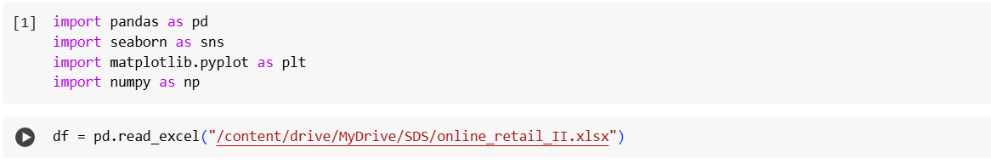  2. Understand the dataset using methods like head, tail, describe, etc.  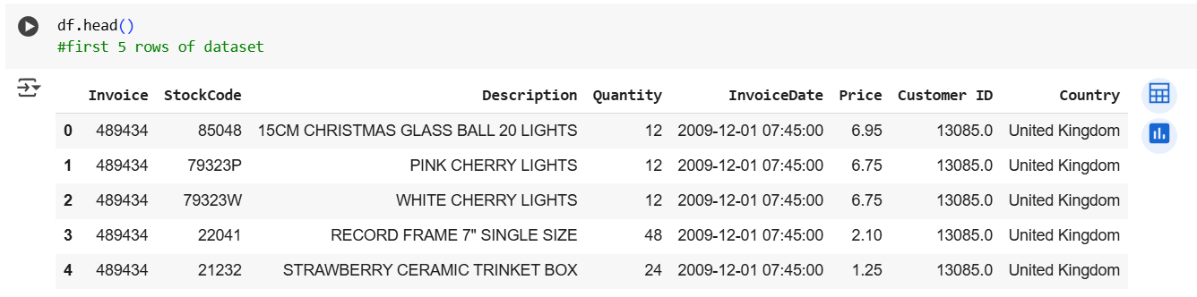  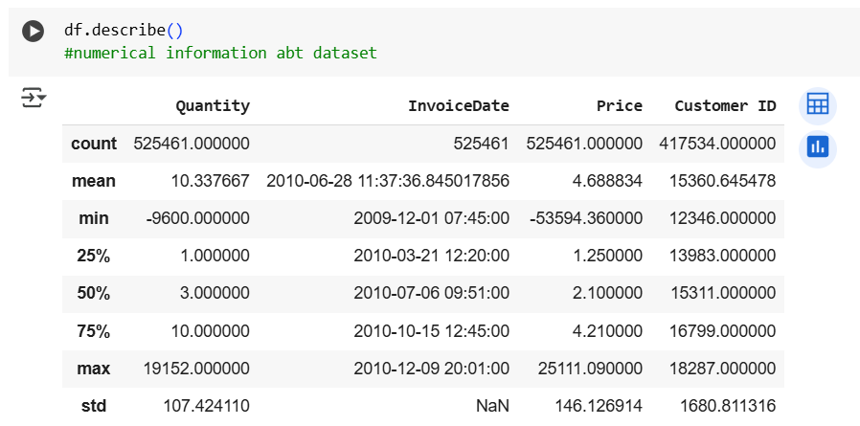  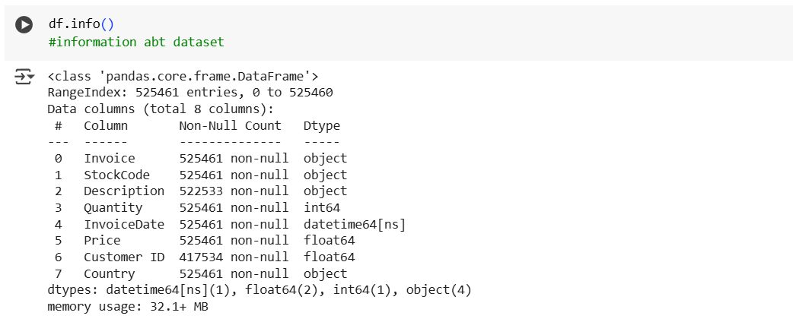  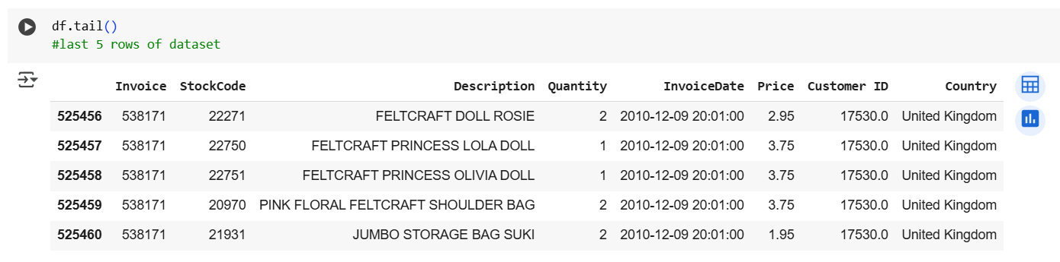  3. Find out and plot Null values in the dataset  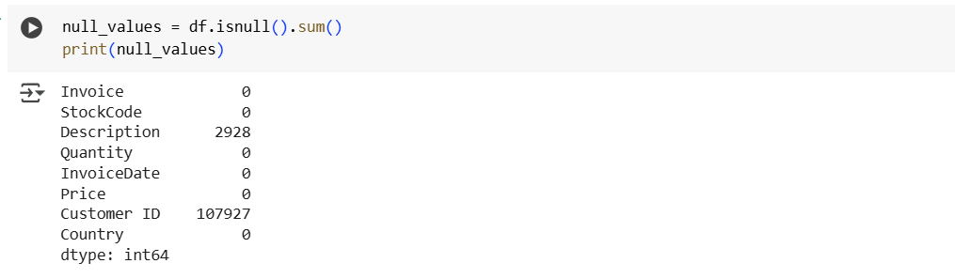  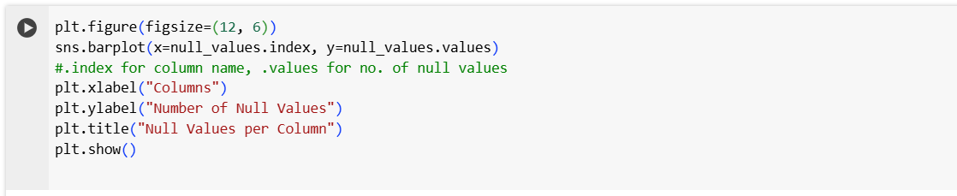  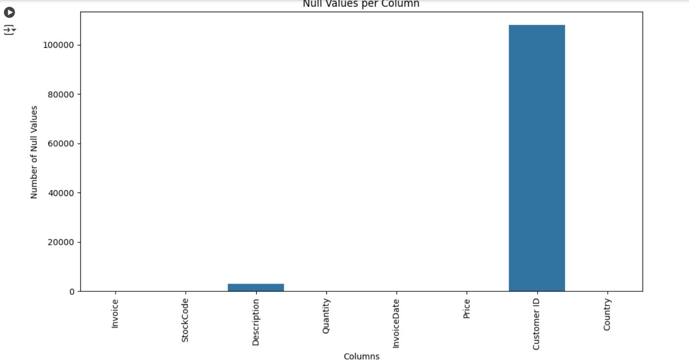  4. Plot counts (Bar plots) for categorical variables  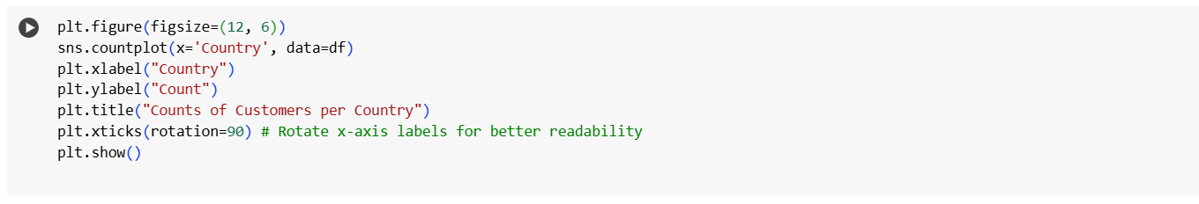  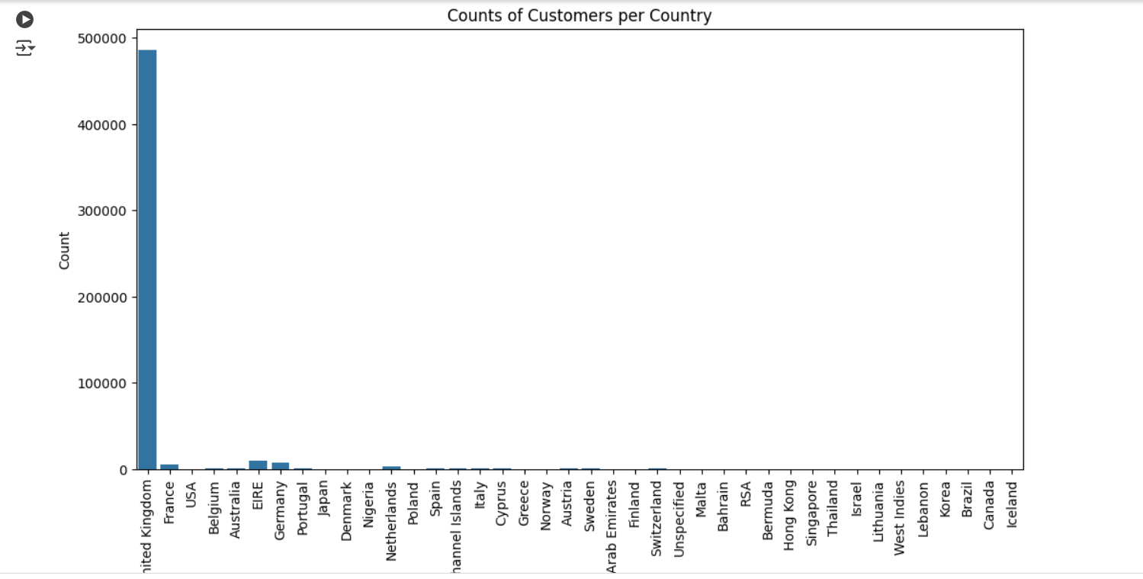  5. Plot Histograms or Density Plots  For numerical column, histograms or density plots would help to visualize the distribution of data. This gives an idea of the data spread, central tendency, and skewness.  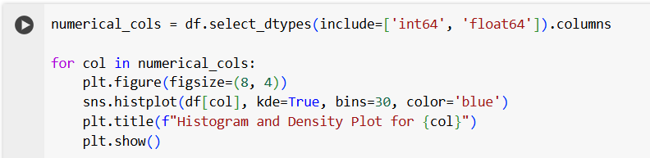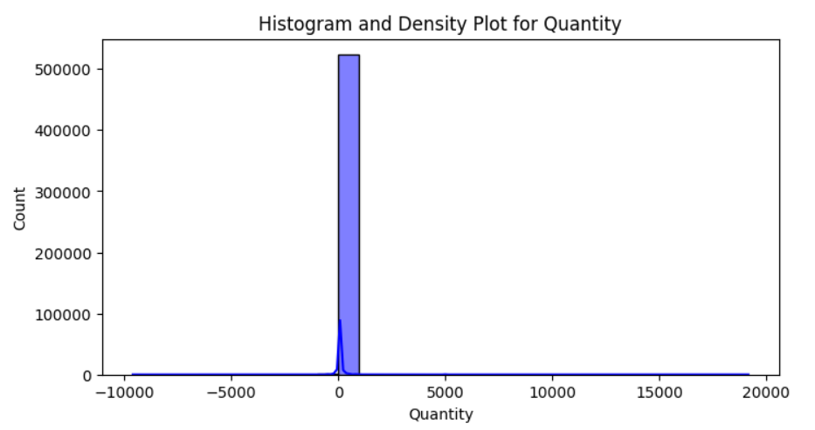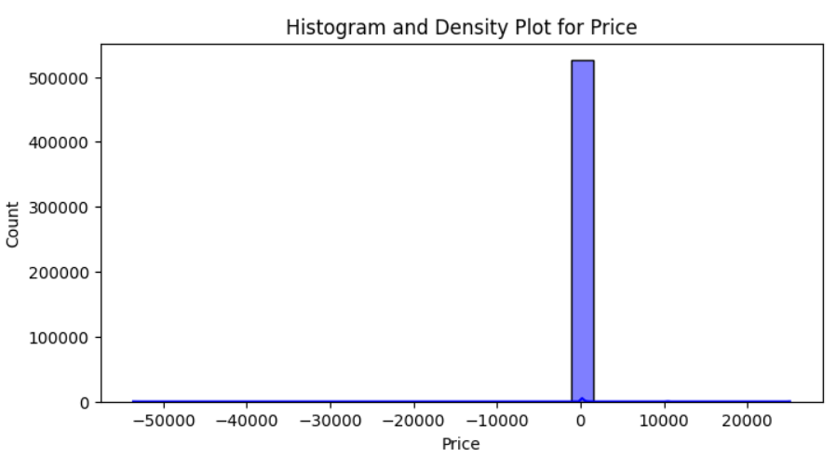  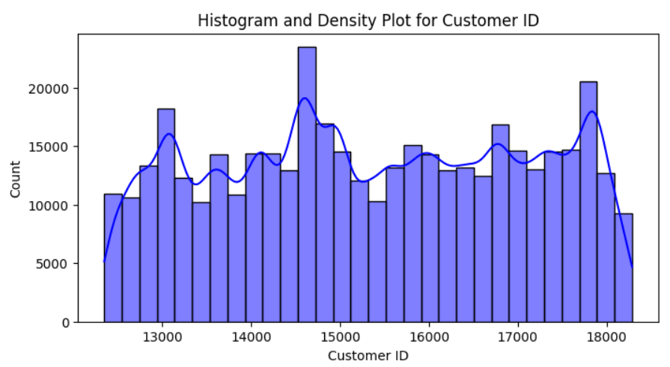  6. Boxplots- for visualizing the distribution of data in terms of quartiles. To identify outliers and compare distributions across different groups.  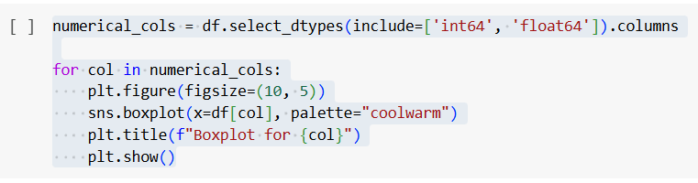  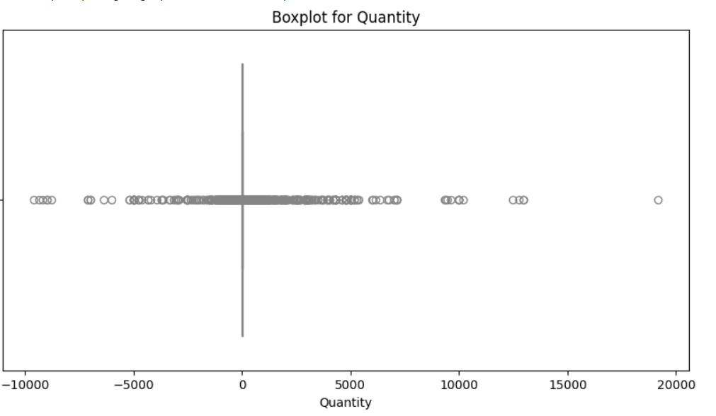  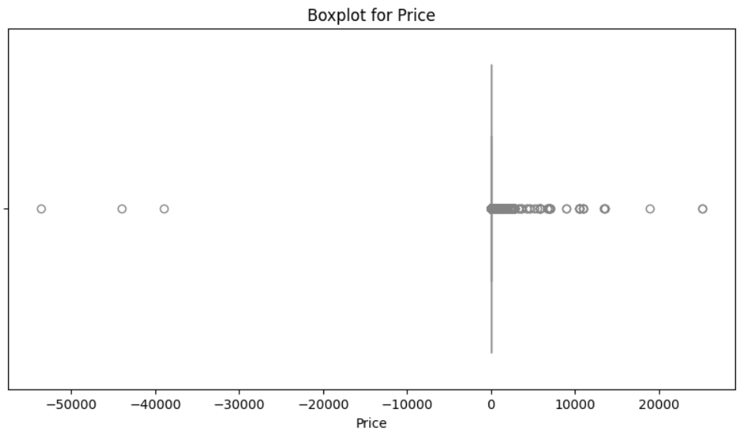  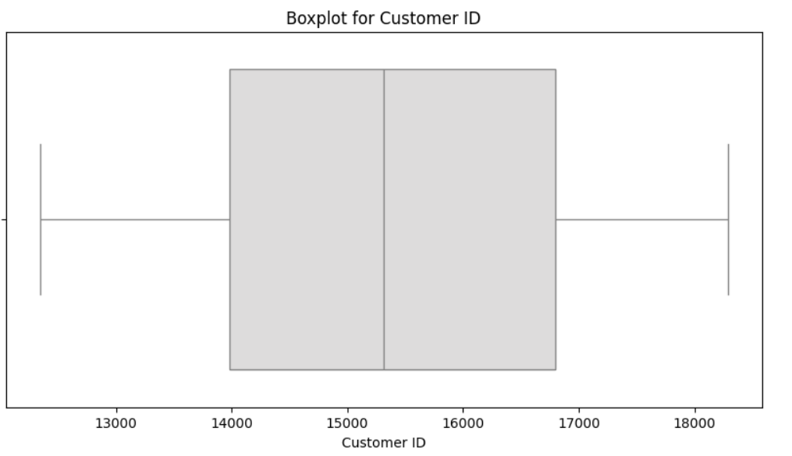  7. Time Series Plots: If your Data contains time series data, plot the time series and observe any trend.  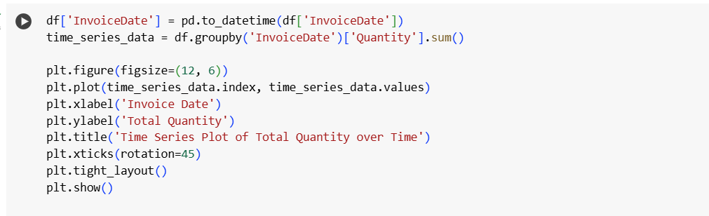  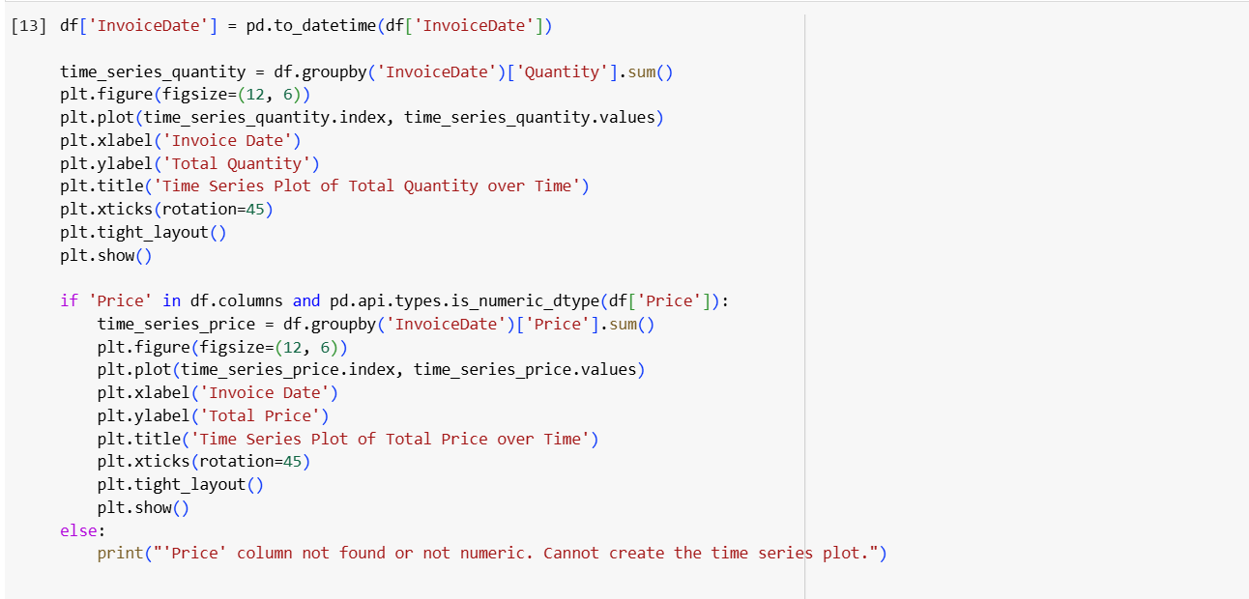  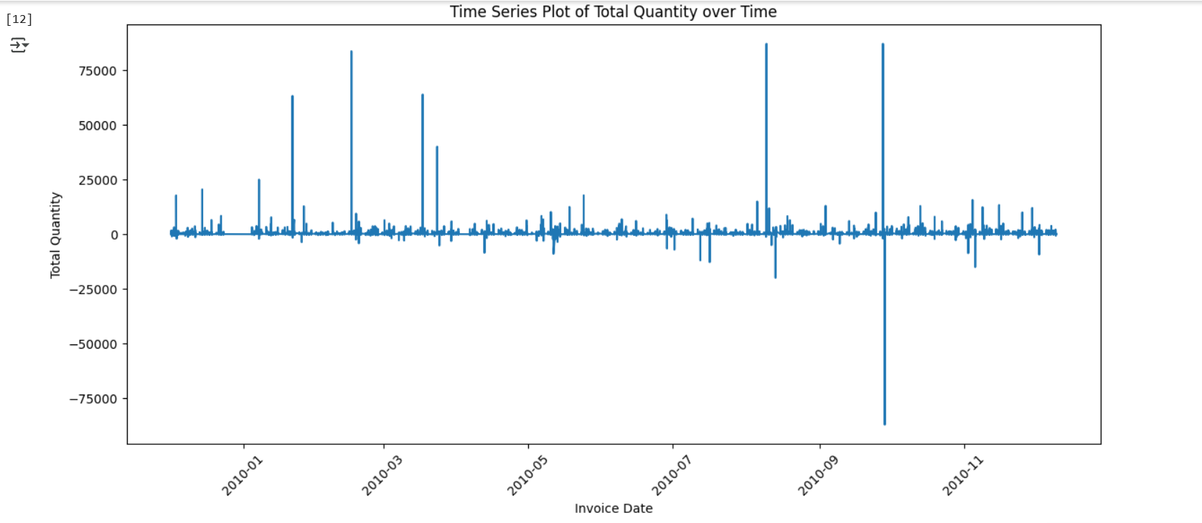  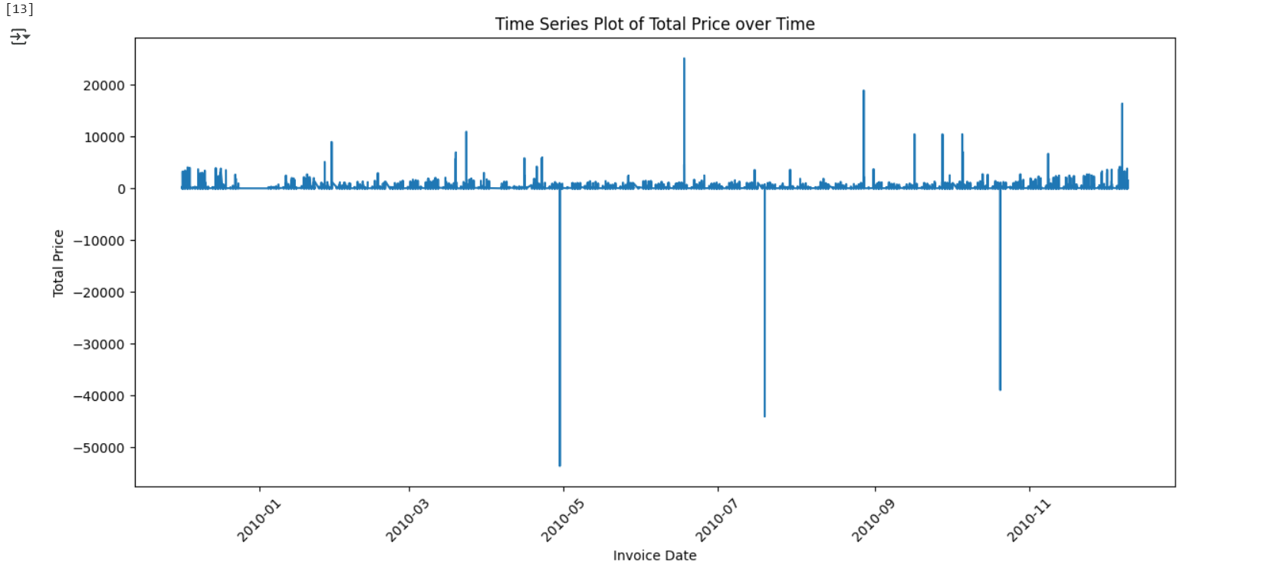  8. Plot skewness values for numerical columns using skew() function.  The skew() function can be used to calculate skewness in data. It represents the shape of the distribution. Skewness can be quantified to define the extent to which a distribution differs from a normal distribution.  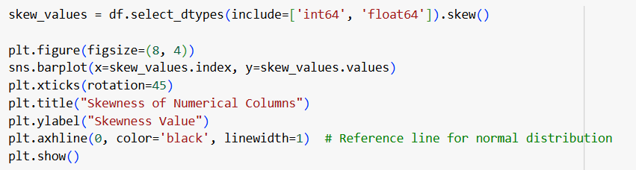  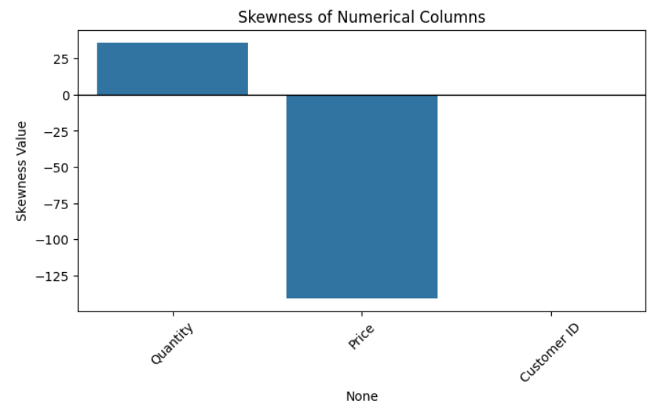  9. Plot kurtosis values for numerical columns using kurt() function.  The kurt() function can be used to calculate kurtosis in data. Kurtosis is the measure of thickness or heaviness of the distribution. It represents the height of the distribution.  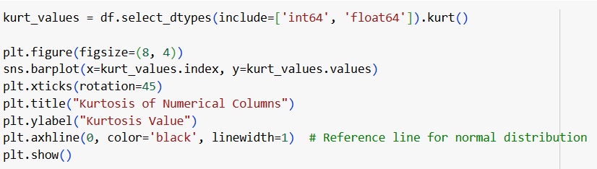  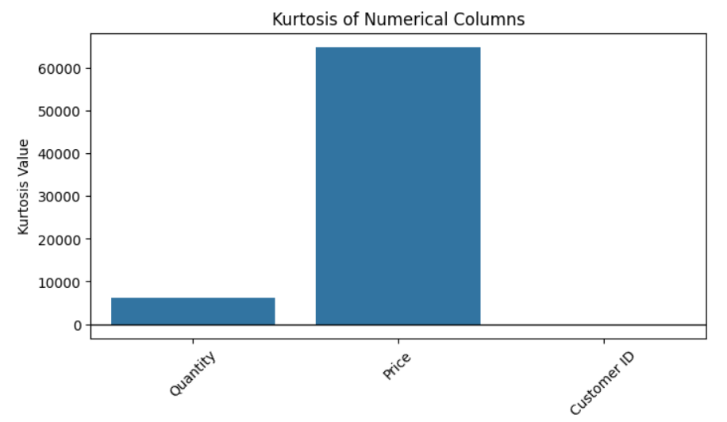  10. Plot the corr() function using heatmap(): Perform on glue Dataset,l  The corr() used to find the pairwise correlation of all columns in the dataframe. Missing values excluded in the calculation. Correlation uncovers the complex and unknown relationships between the variables in the dataset. The most common and default correlation coefficient is Pearson’s correlation coefficient.  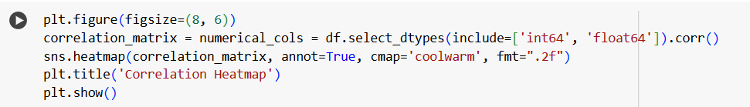  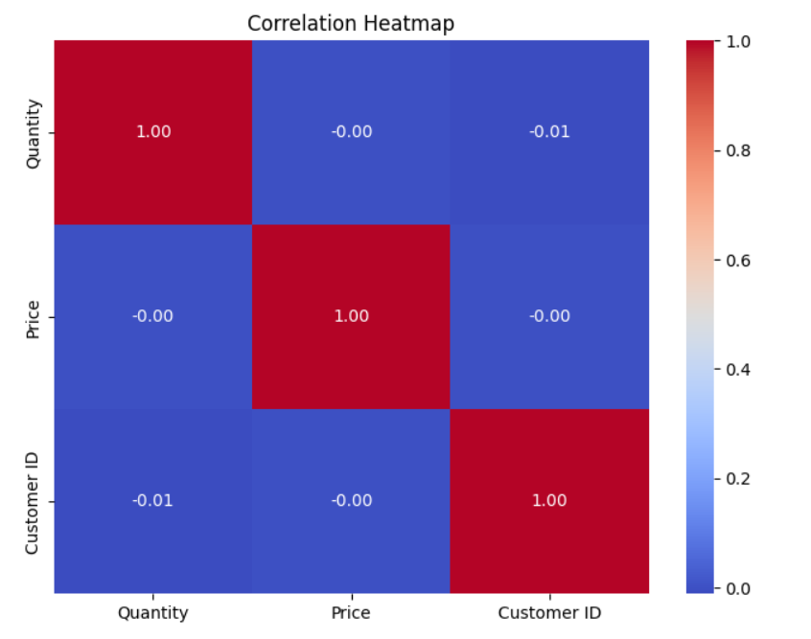  11.factorplot():Seaborn is an amazing visualization library for statistical graphics plotting in Python. It provides beautiful default styles and color palettes to make statistical plots more attractive.This method returns the FacetGrid object with the plot on it for further tweaking.  12. Countplot(): Perform operation on tips.csv file from seaborn library  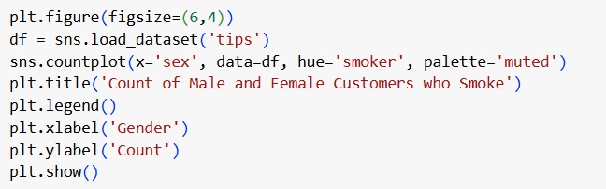  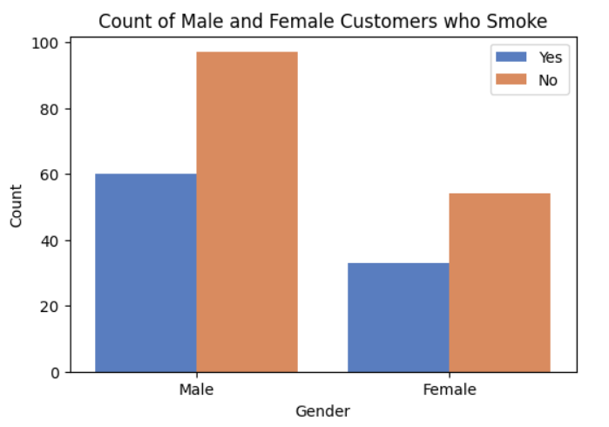  13 pairplot():This function helps you make a grid of plots where each row shares the same y-axis and each column shares the same x-axis. The plots on the diagonal (where the row and column are the same) show the distribution of just one variable. It is also possible to show a subset of variables or plot different variables on the rows and columns.  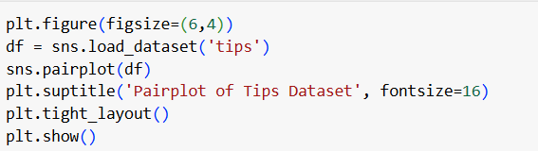  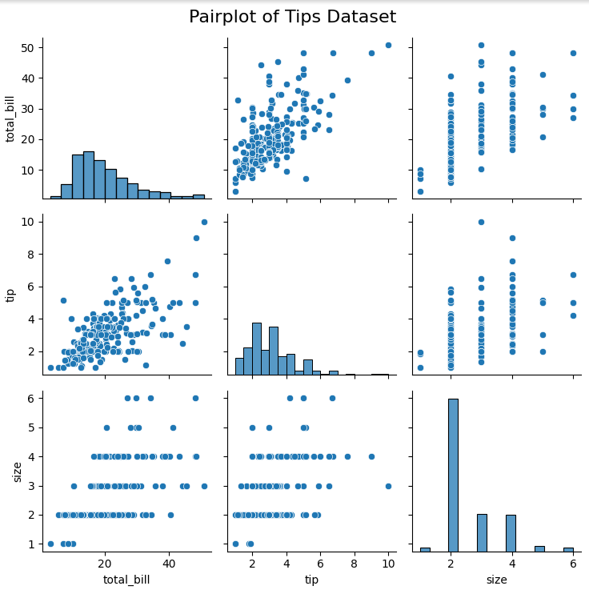  14. Kdeplot(): perform on Iris Dataset and geyser dataset  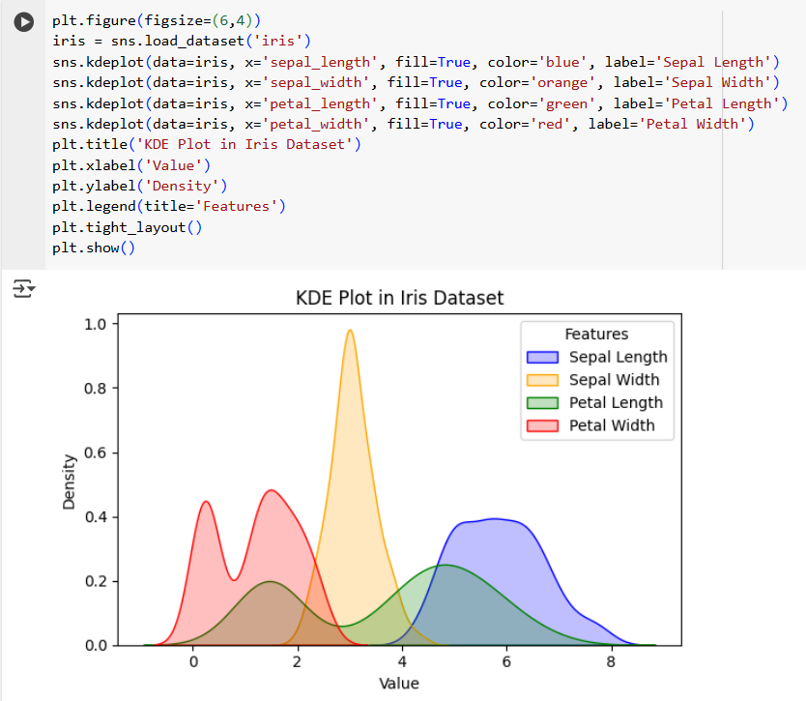  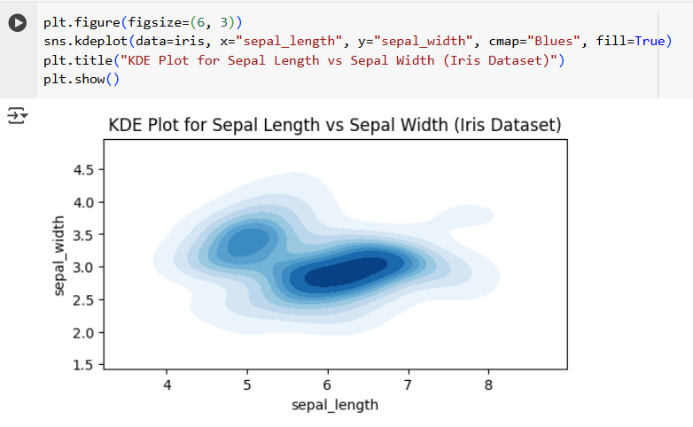  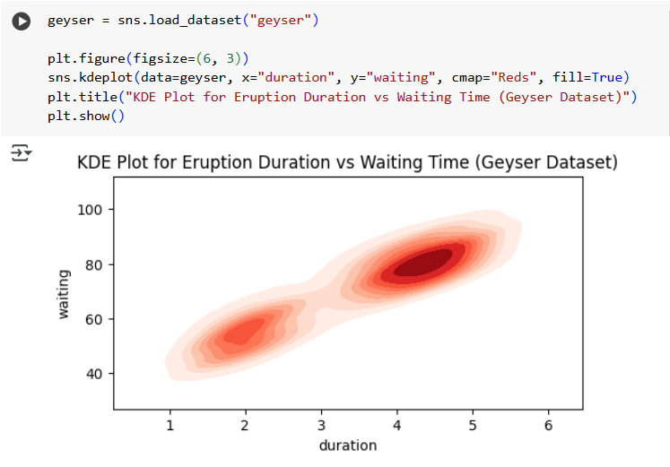  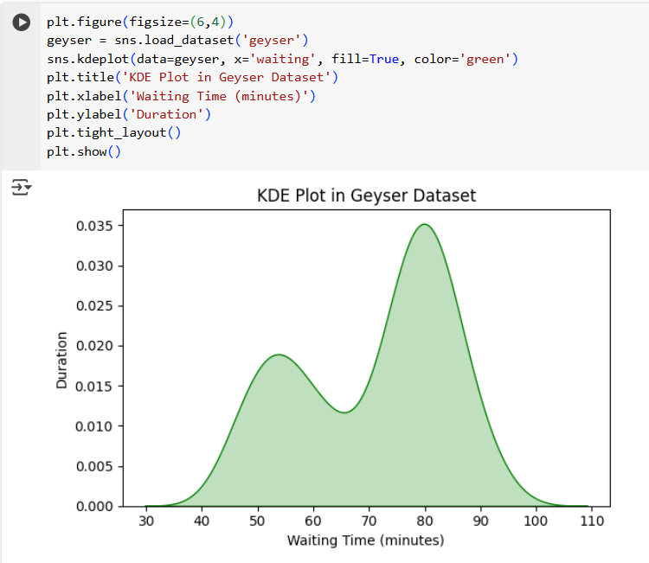  15. FacetGrid():This class maps a dataset onto multiple axes arrayed in a grid of rows and columns that correspond to levels of variables in the dataset. The plots it produces are often called “lattice”, “trellis”, or “small-multiple” graphics.  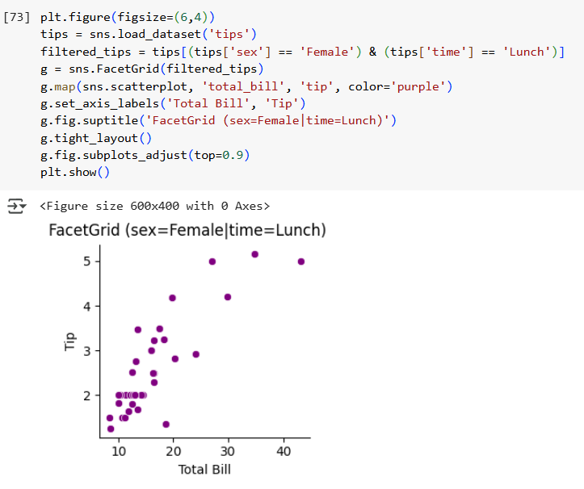
Conclusion | Descriptive Statistics, combined with Python’s powerful libraries, provides a foundational understanding of data. By mastering these measures and tools, you can effectively summarize, visualize, and draw valuable insights from your datasets.

Colab link:
https://colab.research.google.com/github/SmayanKulkarni/AI-and-ML-Course/blob/master/SDS/Descriptive.ipynb

Signature of Faculty

