**Question 1**

Installation of VS Code:

Describe the steps to download and install Visual Studio Code on Windows 11 operating system. Include any prerequisites that might be needed.

1. Open Google and type **Visual Studio Code download** in the search bar.



1. Click on the link below.

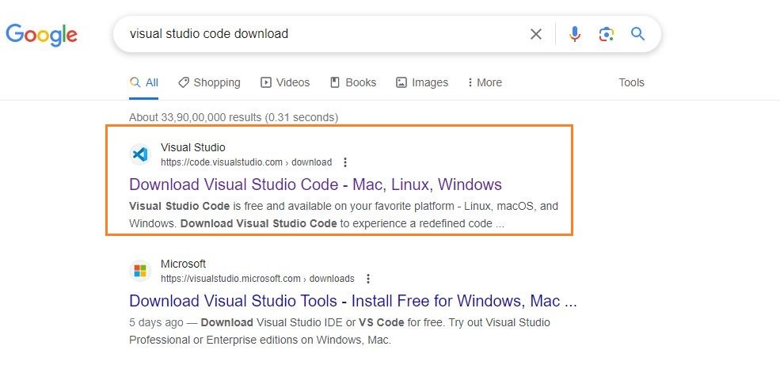

1. In this case we are selecting Windows.

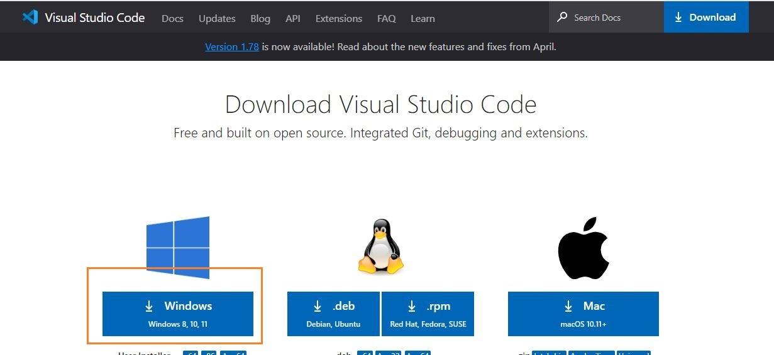

1. The file will be downloaded onto your system. Open the file and then click on **Install**. After downloading the VS Code file, the official site will display a Thanks message for downloading the file.
2. Now accept the license agreement
3. Then it prompts for the file location, where you want to save the VS Code file. Browse the location and then click on **Next**.

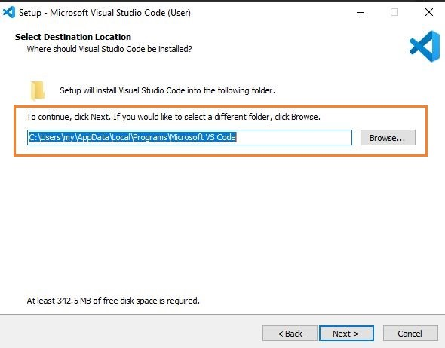

1. Next, you see the prompt for the additional task which we want the VS Code to perform. At this step, choose the default settings and then click on **next**.

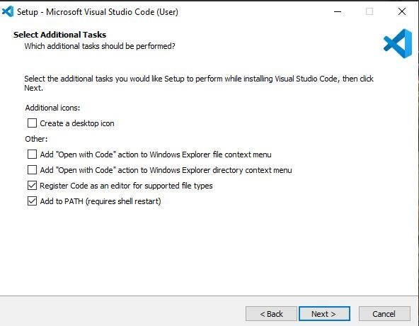

1. The next prompt is how you want the VS Code on your startup. Change according to your convenience and click on **Next**.

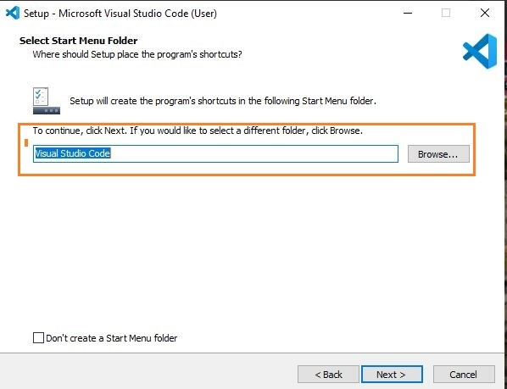

1. The installation of VS Code will now begin.
2. At this step, we have completed installing VS Code, click on **Finish**.

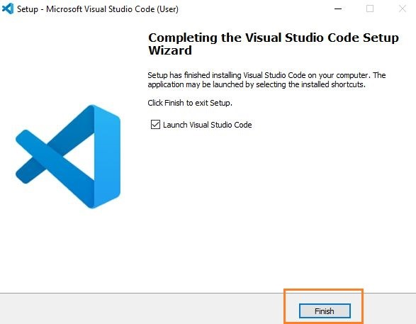

**Explore Extensions:**

* Open Visual Studio Code.
* Click on view then extensions or press Ctrl+Shift+X.
* Search for and install extensions based on your preferences and project requirements eg. Python, Flutter,

**Question 2**

First-time Setup:

After installing VS Code, what initial configurations and settings should be adjusted for an optimal coding environment? Mention any important settings or extensions.

After installing Visual Studio Code (VS Code), there are the initial configurations and settings to adjust for an optimal coding environment:

1. Install Essential Extensions:

- Example Extensions:

- GitLens: Provides powerful Git integration.

- ESLint: Linting tool for JavaScript and TypeScript.

- Python: Adds support for Python development.

2. Set Default Theme:

- Choose a theme (`Ctrl+K Ctrl+T`) for syntax highlighting and UI preferences.

3. Adjust Font Size:

- Change font size (`Ctrl+` or `Cmd+`) to suit readability.

4. Configure File Associations:

- Associate specific file types with appropriate extensions for syntax highlighting.

5. Customize Keybindings:

- Modify keybindings (`Ctrl+K Ctrl+S`) to match personal preferences or workflow.

6. Review Editor Settings:

- Explore settings (`Ctrl+,`) for additional customization options like tab size and line wrapping.

These adjustments help personalize VS Code for efficient coding, debugging, and version

control workflows based on individual needs and project requirements.

**Question 3**

User Interface Overview:

Explain the main components of the VS Code user interface. Identify and describe the purpose of the Activity Bar, Side Bar, Editor Group, and Status Bar.

The main components of the VS Code user interface are:

1. Activity Bar:

- Purpose: Provides quick access to different views like Explorer (file navigation), Search, Source Control (Git), and Extensions.

2. Side Bar:

- Purpose: Houses specific views like Explorer (file navigation), Search, Git (version control), and Extensions.

3. Editor Group:

- Purpose: Displays open files in tabs for editing and allows users to work on multiple files simultaneously.

4. Status Bar:

- Purpose: Shows information such as Git branch, file encoding, and language mode. It also includes indicators for problems (errors, warnings), and allows quick settings toggles (e.g., line endings).

These components collectively provide navigation, editing, version control, and status information within VS Code, enhancing productivity and workflow management.

**Question 4**

Command Palette:

What is the Command Palette in VS Code, and how can it be accessed? Provide examples of common tasks that can be performed using the Command Palette.

The Command Palette in VS Code is a powerful tool that allows you to execute various commands quickly. You can access it by pressing `Ctrl+Shift+P` (Windows). Here are examples of tasks you can perform using the Command Palette:

1. Opening Files: Open any file by typing its name.

2. Switching between Views: Toggle between different panels like Explorer, Source Control, and Debug.

3. Running Tasks: Execute tasks defined in your project, such as build scripts or test runners.

4. Changing Settings: Modify editor settings or extensions configurations.

5. Searching for Commands: Discover and run any command available in VS Code, including those from installed extensions.

The Command Palette is a versatile tool that helps streamline your workflow by providing quick access to various commands and operations within VS Code.

**Question 5**

Extensions in VS Code:

Discuss the role of extensions in VS Code. How can users find, install, and manage extensions? Provide examples of essential extensions for web development.

Extensions in VS Code add extra features and capabilities to the editor. They can help with coding in different languages, debugging, formatting code, and more. Users can find and install extensions by clicking on the Extensions icon in the Activity Bar or using the shortcut `Ctrl+Shift+X`. From there, they can search for extensions in the Marketplace, install them with a click, and manage them by enabling, disabling, or removing as needed.

Examples of essential extensions for web development:

1. Live Server: Launches a local development server with live reload capability.

2. ESLint: Linter for JavaScript and TypeScript to catch errors and enforce coding standards.

3. Prettier: Code formatter to ensure consistent code style across your project.

4. Debugger for Chrome: Enables debugging JavaScript code directly from VS Code using Chrome's debugging protocol.

5. HTML CSS Support: Provides autocompletion, syntax highlighting, and other enhancements for HTML and CSS files.

These extensions enhance productivity and make VS Code more powerful for web development tasks.

**Question 6**

Integrated Terminal:

Describe how to open and use the integrated terminal in VS Code. What are the advantages of using the integrated terminal compared to an external terminal?

Opening and using the integrated terminal in VS Code is easy. You can open it by pressing `Ctrl+`` (backtick) or by going to the menu and selecting `View` > `Terminal`. Once open, you can type commands just like you would in an external terminal.

Advantages of using the integrated terminal compared to an external terminal:

1. Convenience: It's right inside VS Code, so you don't need to switch between different windows.

2. Contextual Awareness: It automatically opens to the folder of your current project, making it easier to run commands related to your code.

3. Integration: You can directly interact with VS Code features, like running tasks defined in your `tasks.json` file or debugging commands.

4. Customization: You can customize the terminal's appearance and behavior to suit your preferences and workflow.

Using the integrated terminal in VS Code streamlines your development process by keeping everything you need in one place.

**Question 7**

File and Folder Management:

Explain how to create, open, and manage files and folders in VS Code. How can users navigate between different files and directories efficiently?

Creating, opening, and managing files and folders in VS Code is straightforward:

Creating Files and Folders:

1. Create a New File:

- Click on the Explorer icon in the Side Bar (`Ctrl+Shift+E`).

- Right-click in the Explorer area and choose `New File`.

- Enter the file name and press `Enter`.

2. Create a New Folder:

- Similarly, right-click in the Explorer area and choose `New Folder`.

- Enter the folder name and press `Enter`.

Opening Files and Folders:

1. Open a File:

- Double-click on a file in the Explorer to open it in the Editor.

- Alternatively, use the `File` > `Open File...` menu (`Ctrl+O`) to browse and select a file to open.

2. Open a Folder:

- Use `File` > `Open Folder...` to open an entire folder in VS Code.

Managing Files and Folders:

1. Rename or Move:

- Right-click on a file or folder in the Explorer and choose `Rename` or `Move...`.

2. Delete:

- Right-click and select `Delete` to remove a file or folder. Confirm deletion when prompted.

Navigating Between Files and Directories Efficiently:

1. File Navigation:

- Use `Ctrl+P` to open the Quick Open bar and type the file name to quickly navigate to it.

- Use `Ctrl+Tab` to cycle through open files.

2. Directory Navigation:

- In the Explorer, click on folder names to expand or collapse directory structures.

- Use breadcrumbs at the top of the Editor to navigate up through parent directories.

These methods allow users to efficiently create, open, and manage files and folders within VS Code, enhancing productivity and organization while coding.

**Question 8**

Settings and Preferences:

Where can users find and customize settings in VS Code? Provide examples of how to change the theme, font size, and keybindings.

In VS Code, users can find and customize settings to tailor their coding environment:

Finding Settings:

1. Using the Settings UI:

- Click on `File` > `Preferences` > `Settings` (or press `Ctrl+,`).

- This opens the Settings tab where you can search for and adjust various settings.

2. Editing `settings.json`:

- Click on the `{}` icon in the top-right corner of the Settings tab to open `settings.json`.

- This file allows direct editing of VS Code settings in JSON format.

Customizing Settings:

Example Changes:

1. Changing the Theme:

- Navigate to the Settings UI.

- Search for "Color Theme" and select a new theme from the dropdown list.

2. Adjusting Font Size:

- Search for "Font Size" in the Settings UI.

- Modify the value for "Editor: Font Size" to increase or decrease the font size.

3. Modifying Keybindings:

- Open the Settings UI.

- Search for "Keybindings" and click on `Open Keyboard Shortcuts (JSON)` to edit keybindings directly in `keybindings.json`.

Benefits:

- Personalization: Customize VS Code to match your preferences and improve readability.

- Efficiency: Access and modify settings quickly to optimize your coding experience.

By utilizing these settings customization options, users can create a more comfortable and efficient environment for coding in VS Code.

**Question 9**

Debugging in VS Code:

Outline the steps to set up and start debugging a simple program in VS Code. What are some key debugging features available in VS Code?

Setting up and starting debugging in VS Code involves a few straightforward steps:

Steps to Set Up and Start Debugging:

1. Install Required Extensions:

- If necessary, install extensions specific to your programming language or framework that support debugging.

2. Create or Open Your Project:

- Open your project folder in VS Code (`File` > `Open Folder...`).

3. Configure Launch Settings:

- Navigate to the Debug view by clicking on the bug icon in the Activity Bar (or press `Ctrl+Shift+D`).

- Click on the gear icon (`create a launch.json file`) and select your debugging environment (e.g., Node.js, Python).

- VS Code may auto-generate a `launch.json` file with default configurations.

4. Set Breakpoints:

- In your source code, click in the gutter next to the line numbers to set breakpoints. A red circle indicates a breakpoint.

5. Start Debugging:

- Press `F5` or click on the green play button (`Start Debugging`) in the Debug view.

Key Debugging Features in VS Code:

- Breakpoints: Pause execution at specific lines to inspect variables and state.

- Watch: Monitor variables and expressions in real-time during debugging sessions.

- Call Stack: View the chain of function calls that led to the current point in execution.

- Debug Console: Interact with your code and execute commands while debugging.

- Variable Highlighting: Hover over variables to see their current values in the editor.

- Step Controls: Step through code line-by-line (`F10` for step over, `F11` for step into, `Shift+F11` for step out).

These features help developers diagnose and fix issues in their code effectively, making debugging in VS Code intuitive and powerful.

**Question 10**

Using Source Control:

How can users integrate Git with VS Code for version control? Describe the process of initializing a repository, making commits, and pushing changes to GitHub.

Integrating Git with VS Code for version control involves several steps:

Initializing a Git Repository:

1. Open Your Project:

- Open your project folder in VS Code (`File` > `Open Folder...`).

2. Initialize Git:

- Open the integrated terminal in VS Code (`Ctrl+``) and run:

git init

- This initializes a new Git repository in your project folder.

Making Commits:

1. Stage Changes:

- In VS Code, open the Source Control view by clicking on the source control icon (usually looks like a branch or a list).

- You'll see a list of changed files. Click the `+` button next to each file to stage them for commit.

2. Commit Changes:

- Enter a commit message in the text box at the top of the Source Control view.

- Click the checkmark icon (`Commit`) to commit your changes.

Pushing Changes to GitHub:

1. Create a GitHub Repository:

- Go to GitHub and create a new repository if you haven't already done so.

2. Add Remote Repository:

- In the integrated terminal in VS Code, add the remote repository URL:

git remote add origin <repository-url>

- Replace `<repository-url>` with the URL of your GitHub repository.

3. Push Changes:

- Push your committed changes to GitHub:

git push -u origin main

- This command pushes changes from your local `main` branch to the `main` branch on GitHub.

- If you're working with a different branch, replace `main` with your branch name.

Summary:

By following these steps, users can effectively manage version control using Git within VS Code. It simplifies the process of tracking changes, collaborating with others, and maintaining code history on platforms like GitHub.