Smeet Dedhia 200968236 Week8

Demonstrate the built in functions using Scala by creating an array, perform the following functions:

val a1 = Array(10,20,30,40,50)

val a2 = Array(1,2,3,4,5)

i)Non Parameterized Function

a1.max



ii) Parameterized Function

Array.concat(a1,a2)



iii) Recursion Function

def fact(n: Int): Int =

{

if (n == 0)

return 1

else

return n * fact(n-1)

}

fact(a1.min)

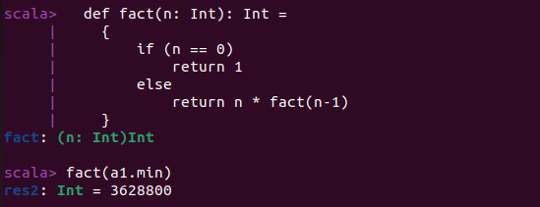

iv) Function Parameter with Default Value

def myAdd(x: Int, y: Int=10) = x + y;

myAdd(a1.max)

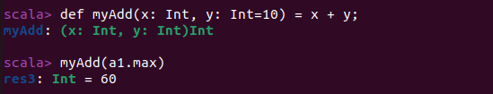

v) Anonymous Functions

var myMul = (x:Int, y:Int) => x*y

myMul(a1.min, a2.max)

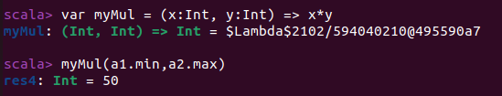

vi) Functions with Map Method

val a2_sqr = a2.map(x => x*x)



vii) Currying Functions

def myAdd(x: Int, y: Int) = x + y;

myAdd(a1.max,a2.max)

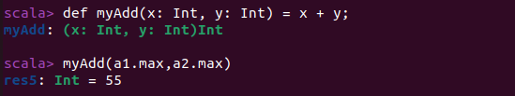

viii) Nested Functions

def factorial(i: Int): Int = {

def fact(i: Int, accumulator: Int): Int = {

if (i <= 1)

accumulator

else

fact(i - 1, i * accumulator)

}

fact(i, 1)

}

factorial(10)

