Smeet 200968236

a)

df = LOAD '/home/hdoop/Downloads/Telco_customer_churn.csv' USING PigStorage(',') AS (CustomerID:chararray,Country:chararray,State:chararray,City:chararray,Zip_Code:int,Gender:chararray,Partner:chararray,Dependents:chararray,Tenure_Months:int,Payment_Method:chararray,Monthly_Charges:int,Total_Charges:int);

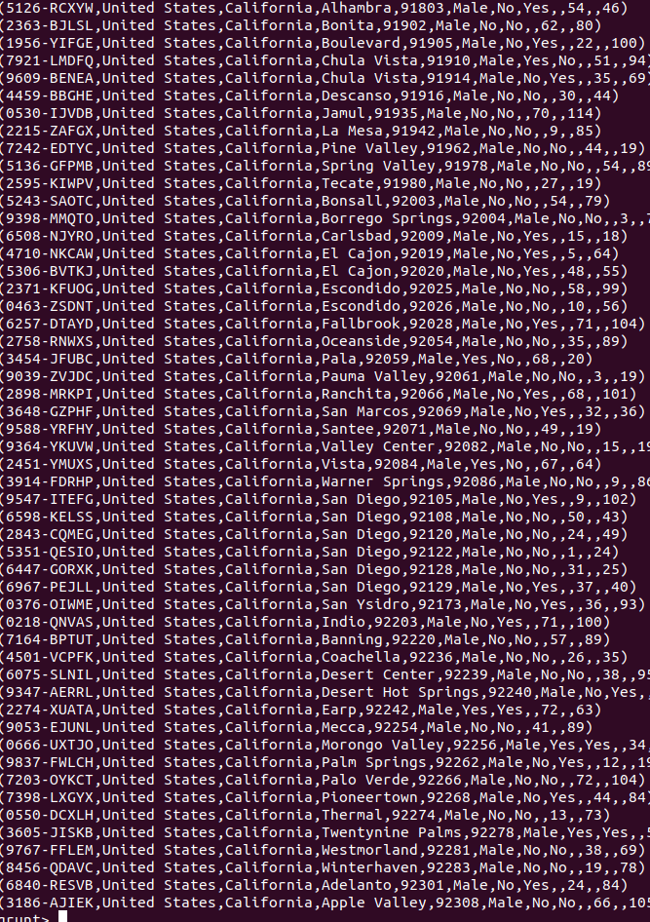
b)

c)
