Project Title:
PhishScan Detection

TEAM NO.: 72
NAMES OF THE STUDENTS PARTICIPATED IN THE TEAM:
SMEET SADHU, PARSHAV SHAH, MAHI H. PANCHAL

COLLEGE: GLS UNIVERSITY
SEMESTER: 6
DEPARTMENT: COMPUTER SCIENCE AND ENGINEERING
CITY: AHMEDABAD
STATE: GUJARAT
PROJECT MENTOR NAME: MS. SHIVANGI GANDHI



Project Details:

PhishScan is a browser extension designed to protect users from phishing and malicious websites by performing real-time URL analysis and threat detection. The system integrates external threat intelligence services and intelligent detection techniques to warn users before they interact with harmful links.

Problem Statement:

Phishing attacks are rapidly increasing and have become one of the most common cyber threats. Attackers create fake websites and malicious links that closely resemble legitimate platforms to steal sensitive user information such as usernames, passwords, banking details, and personal data. Traditional security solutions often fail to detect newly generated phishing URLs in real time, leaving users vulnerable during every day web browsing.

Need of Project:
Increasing number of phishing attacks targeting common users. Lack of real-time, browser-level protection for suspicious links. Users often click links without verifying authenticity. Existing solutions are complex or not user-friendly. Need for a lightweight, fast, and privacy-focused security tool.
Who are the End Users:
- General internet users
- Students and working professionals
- Online banking and e-commerce users
- Organizations requiring basic phishing protection

Proposed Solution:

PhishScan provides a browser-native security solution that automatically scans website URLs during browsing. The system verifies links using the VirusTotal API and AI-assisted analysis to detect malicious behavior. If a link is suspicious, it is highlighted visually, and the user is warned before interacting with it.

Technology Used:

Frontend: HTML, CSS, JavaScript

Browser Platform: Google Chrome Extension APIs

Backend / API: VirusTotal API

AI Components: URL pattern analysis and heuristic-based detection

Version Control: Git & GitHub

Testing: Demo phishing pages

Project Outcomes:
The project demonstrates an effective and practical solution to enhance user security during web browsing.

1



Modelling:
The system follows a modular detection model:
- URL Capture Module – Captures active webpage links
- Preprocessing Module – Normalizes and validates URLs
- Threat Analysis Module – Checks URLs using VirusTotal and AI rules
- Decision Engine – Classifies URLs as safe or suspicious
- User Interface Module – Displays warnings and scan results
The steps can we visualized by seeing the below diagram
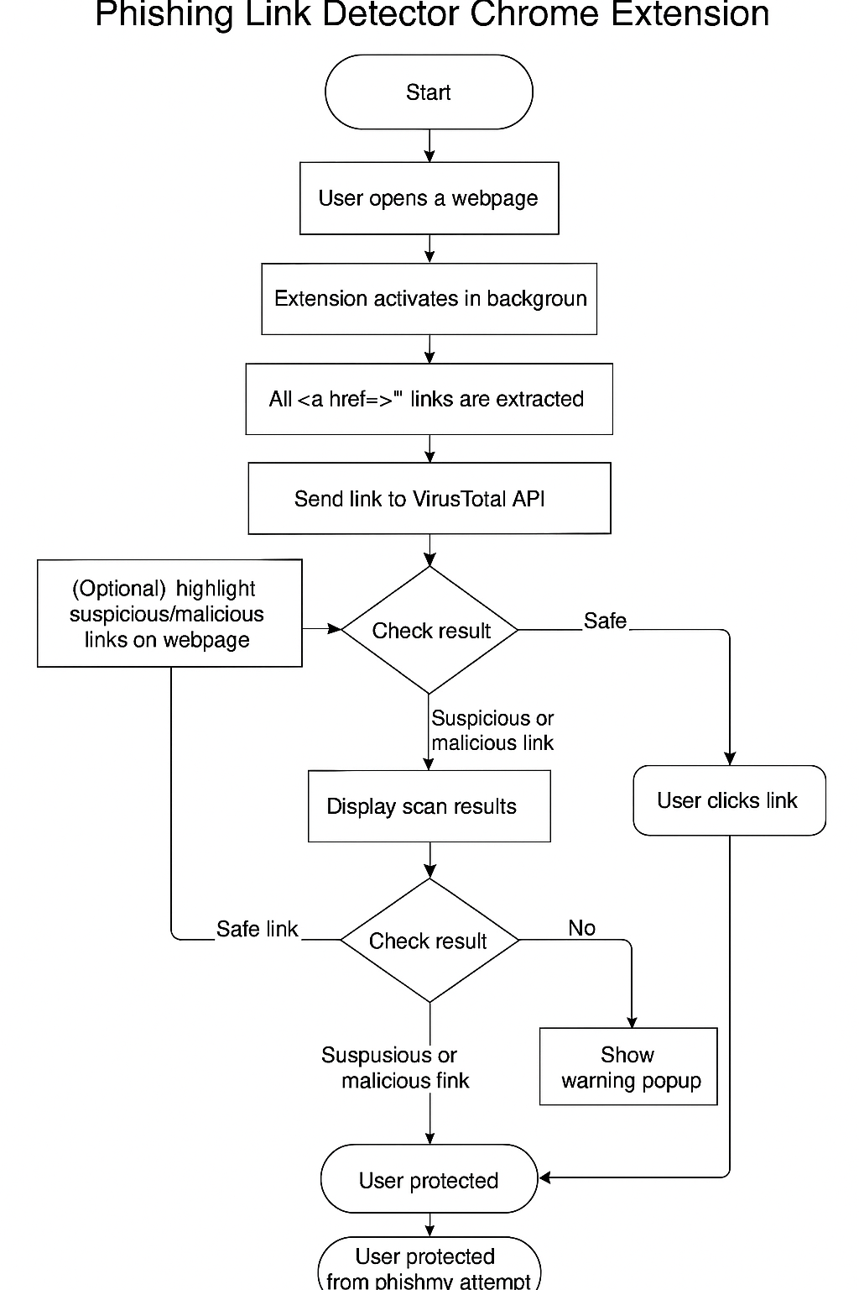

Results:
- Graphical User Interface (GUI):




- Real-Time Prediction Output:
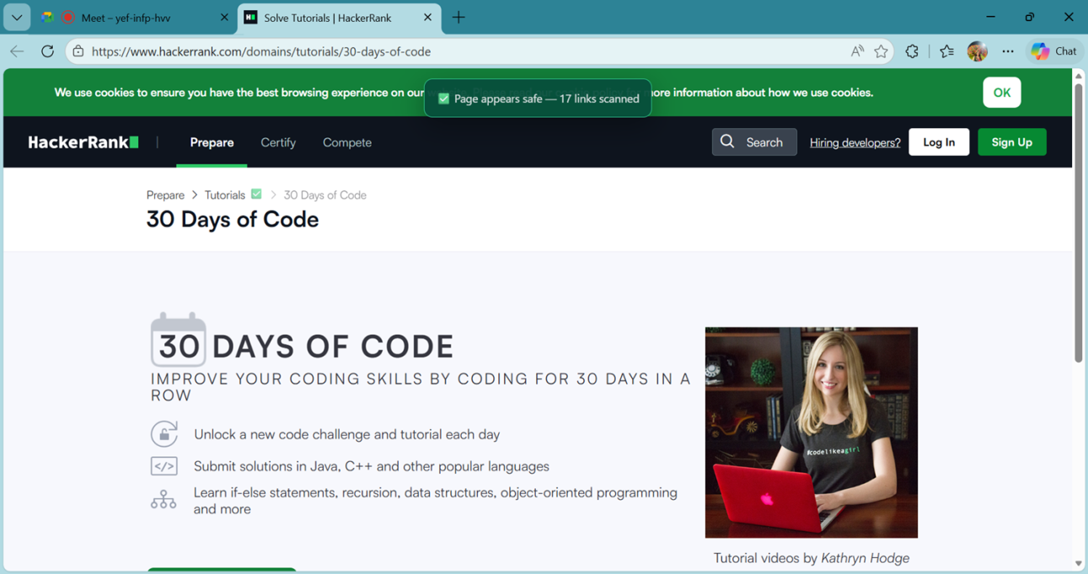

Future scope for project enhancement:

- Machine learning–based predictive phishing detection
- Support for multiple browsers (Firefox, Edge, Safari)
- Custom whitelist and blacklist management
- Cloud-based threat intelligence sharing
- Mobile browser extension versions
- Enterprise-level dashboard and analytics
- Community-driven real-time threat updates

3

