EDA Service
Exploratory Data Analysis Platform

Technical Documentation & Project Report

1. Problem Statement

In modeling lifecycles (development, back-testing, pre-deployment, and production), Analytic Base Tables (ABTs) evolve constantly as new dataset versions are ingested. Without a systematic tool to track dataset health, detect population/schema drift, and flag compliance risks, modeling teams face critical problems.

1.1 The Core Challenge
Organizations that deploy machine learning models at scale face three interlocking problems:

- Population Drift — Borrower profiles, customer behaviors, or transaction patterns evolve over time due to macroeconomic shifts, product changes, or demographic movements. A model trained on last year's data may be scoring a materially different population today.
- Pipeline Failures — Upstream data engineering changes (schema modifications, ETL regressions, missing value spikes) corrupt incoming data silently. No error is thrown. Scores continue to be produced. The degradation is invisible until a performance review cycle.
- The Raw Data Constraint — In regulated industries, raw datasets containing personal or financial records cannot be freely transferred or loaded into diagnostic tools without violating privacy regulations. This severely limits the standard approaches to drift monitoring.

1.2 Why Existing Solutions Fall Short
Most drift detection frameworks require access to raw data. They compute CDF-based statistics, run chi-square tests, and sample from full distributions. In regulated modeling contexts, this creates an inherent conflict between monitoring quality and data governance compliance.

Additionally, raw metrics like PSI=0.31 or KS=0.18 are meaningless to business stakeholders and risk committees. Translating numerical drift signals into actionable business language requires expert domain knowledge, which cannot always be applied manually at scale and frequency.

The Gap This Platform Addresses
A production-ready system that performs rigorous statistical drift monitoring using only pre-computed metadata — no raw data access required — and automatically synthesizes those findings into human-readable, governance-compliant business decisions.

2. Business Impact

EDA delivers measurable business value across four dimensions, applicable to any organization operating predictive models at scale.

2.1 Model Performance Preservation
Every deployed model has a performance lifecycle. Silent drift shortens that lifecycle without warning. EDA extends effective model longevity by:
- Detecting distribution shifts before they translate to measurable KS/Gini decay, enabling proactive retraining rather than reactive firefighting.
- Distinguishing organic population change from pipeline failures — preventing unnecessary and expensive retraining cycles triggered by data engineering regressions rather than real behavioral shifts.
- Providing drift velocity metrics (PSI slope per version) that give teams a forward-looking signal: how fast is this population moving, and how many versions remain before action is mandatory.

2.2 Operational Efficiency
Manual exploratory data analysis for model validation is resource-intensive and typically requires a senior data scientist to:
- Write custom scripts per dataset and version
- Interpret statistical outputs and produce narrative reports
- Present findings to non-technical stakeholders in business language

EDA compresses this multi-day process to seconds. A single comparison run produces a fully narrated, validated 7-card decision view ready for risk committee presentation.

2.3 Regulatory & Governance Compliance
The platform is designed with regulatory requirements as a first-class concern:
- Data Minimization — operates exclusively on pre-computed metadata, never accessing raw personal or financial records. This eliminates PII exposure risk entirely.
- Audit Trail — generates formatted XLSX compliance reports with complete rule logs, severity evidence, and recommended actions for external regulators and internal audit functions.
- Governance Guardrails — automatically identifies columns flagged as informationPrivacy=private in the metadata catalog and escalates them to a dedicated governance slot, prompting sign-off workflows before model promotion.
- Anti-Bias Alerting — monitors distribution drift in protected or sensitive attributes, enabling compliance officers to detect potential adverse impact before it becomes a regulatory issue.

2.4 Financial Risk Mitigation
Across all modeling domains, undetected drift directly translates to financial exposure:

Domain | Drift Consequence | EDA Intervention
Credit / PD Models | Underestimated default risk — write-offs; overestimated risk — lost originations | PSI flags stale bins before scoring errors compound
Fraud Detection | Concept drift in fraud patterns — rising false negatives and chargebacks | Velocity and FSI metrics identify accelerating instability
Customer Churn | Stale propensity scores — misdirected retention spend | Target event-rate monitoring catches outcome definition drift
Marketing Propensity | Wrong audience targeting — wasted campaign budget | Population shift scope (broad/narrow) guides campaign refresh timing
Insurance Underwriting | Incorrect loss ratio estimates — inadequate premium pricing | Boundary expansion flags extreme value extrapolation risk

3. Solution Overview

EDA is a metadata-driven decision intelligence platform. It ingests pre-computed statistical column profiles from upstream data catalogs (such as SAS Information Catalog), runs a layered analysis and comparison pipeline, and synthesizes findings into validated, human-readable business decisions.

3.1 Core Design Principles
- No Raw Data Access — the system works exclusively from statistical summaries: quantile distributions, completeness percentages, cardinality counts, skewness, and privacy flags.
- Additive Architecture — every new capability is added as an independent module. Existing interfaces are never broken or modified.
- LLM Narrates, Rules Decide — deterministic rule engines set all thresholds and actions. The LLM is used only to translate those decisions into business language.
- Graceful Degradation — every LLM call has a hard-coded rule-based fallback. LLM unavailability never breaks the application.
- Domain Agnostic — the platform works for any modeling domain (credit, fraud, churn, insurance, marketing) with domain context adjusting language framing only, not logic.

3.2 Platform Capabilities

Capability | Description
Metadata Ingestion | Accepts SAS IC column profiles or raw JSON payloads. Automatic hash-based versioning — same metadata updates the timestamp; changed metadata creates a new version.
Single-Version Health | 10-section analysis (S0-S9): overall readiness score, blockers, quality warnings, governance risks, target variable analysis, distribution health, column-level health scores, and a prioritized action list.
Multi-Version Comparison | 11-section comparison (C0-C10): schema changes, completeness drift patterns, distribution drift, target event-rate shift, PSI matrix (union-boundary method), cardinality explosions, and health score trend.
Advanced Drift Suite | 10 additional drift metrics: CV drift, std deviation drift, quantile shift, boundary drift, kurtosis drift, entropy drift, Feature Stability Index (FSI), drift velocity, baseline drift, and approximate KS statistic.
Interpretation Engine | Three-tier interpretation: Tier A (deterministic rules I4-I9), Tier B (LLM-enriched narrative), Tier C (hybrid corrections). Covers population shift, target stability, feature drift impact, model action, pipeline break risks, and pipeline health.
Decision View | 7-card executive dashboard. Drift stories with root-cause diagnosis (center shift, boundary expansion, spread change), target behavior, pipeline quality, model scoring risk, and governance. Validated by rule-based guardrails + optional LLM review.
Compliance Export | Formatted XLSX audit report with full rule logs, severity evidence, and action recommendations for regulatory review.
Threshold Configuration | UI-configurable thresholds for PSI, completeness, target drift, column health weights, and imbalance ratios. Persisted in Flask session and propagated via hidden form fields.

3.3 Technology Stack

Layer | Technology | Purpose
Web Server | Flask (Python) | REST endpoints, session management, Jinja2 template rendering
UI | HTML5 / CSS / Vanilla JS | Dark-mode responsive dashboard, Chart.js visualizations, PSI heatmaps
AI Integration | Azure OpenAI (GPT-4o) | Drift narration, triage ranking, meta-narrative synthesis, validator review
LLM HTTP Client | urllib (stdlib) | Custom wrapper: timeouts, proxy support, provider switching (Anthropic / OpenAI / Azure)
Data Storage | Local JSON flat files | Metadata snapshots under datadump/ — no database dependency
Audit Export | openpyxl | Formatted Excel compliance reports
Drift Metrics | Python (pure) | PSI, KS approx, FSI, velocity, boundary drift, CV drift — all metadata-only

4. Algorithms & Mathematical Models

EDA implements a comprehensive set of statistical metrics, all derived exclusively from pre-computed metadata. Each metric serves a distinct diagnostic purpose in the drift detection pipeline.

4.1 Population Stability Index (PSI)
PSI is the primary metric for quantifying distribution shift between a baseline version (B) and a new version (N). EDA uses union boundaries — the combined range across both versions — to prevent artificial PSI inflation when value ranges differ:

PSI = Sigma ( P_i(N) - P_i(B) ) x ln( P_i(N) / P_i(B) )

Bucket boundaries defined as: [ union_min, Q1_base, Median_base, Q3_base, union_max ]

PSI Range | Label | Recommended Action
< 0.10 | Stable | No action — monitor at next cycle
0.10 to 0.25 | Monitor | Review WoE bins and feature scaling; recalibrate decision threshold
> 0.25 | Significant Shift | Back-test model performance; rebin features or retrain model

4.2 Approximate Kolmogorov-Smirnov Statistic
True KS requires raw data. EDA approximates it by reconstructing CDFs at five known quantile points (min, Q1, Median, Q3, max) using linear interpolation, then finding the maximum CDF deviation:

D = max_x | F_base(x) - F_new(x) | (evaluated at 5 quantile points)

KS serves as a secondary confirmation signal. When both PSI and KS flag the same column, confidence in the drift finding is high.

4.3 Quantile Shift Analysis
Tracks displacement at Q1, Median, and Q3 independently, normalized by the base IQR. This locates where in the distribution the shift is occurring — lower tail, center, or upper tail — which directly informs whether WoE bin boundaries need adjustment:

Quantile Shift = ( q_new - q_base ) / IQR_base

4.4 Coefficient of Variation (CV) Drift
CV drift measures relative dispersion change, independent of scale. It flags noise level instability that would invalidate feature scaling or WoE bin boundaries even when the mean appears stable:

CV = std / |mean|

Relative Change = |CV_new - CV_base| / CV_base

4.5 Feature Stability Index (FSI)
FSI provides a longitudinal stability score across all observed version pairs — the single trustworthiness rating for a feature across its entire monitored history. Used in Basel model monitoring guidelines and SAS Model Manager:

FSI = max( 0, 1 - Mean_PSI / PSI_Monitor_Threshold )

FSI >= 0.70: Stable. FSI 0.40-0.70: Monitor. FSI < 0.40: Chronically unstable — consider feature replacement.

4.6 Drift Velocity
Drift velocity quantifies acceleration — how fast PSI is changing per version. It distinguishes gradual, manageable drift from rapid deterioration requiring immediate action. Computed as the least-squares slope of pairwise PSI values over time:

Velocity = B1 = ( N*Sum(xi*yi) - Sum(xi)*Sum(yi) ) / ( N*Sum(xi^2) - (Sum(xi))^2 ) [PSI units per version]

4.7 Column Health Score
A composite 0-100 score per column, aggregating five dimensions with domain-optimized weights. Used to compute an overall Dataset Readiness Score (0-100) that serves as the top-level health indicator:

Dimension | Weight | Rationale
Completeness | 35% | Missing data is the leading cause of model failure
Variance | 20% | Zero or near-zero variance features add noise, not signal
Format Quality | 20% | Mismatches and blank strings corrupt encoders silently
Governance | 15% | Leakage and PII exposure introduce regulatory and performance risk
Distribution | 10% | Severe skewness and outliers degrade linear model performance

Health Score >= 80: Good. 55-79: Fair. 30-54: Poor. < 30: Critical. Dataset Readiness Score averages column scores weighted by readiness status (drop = 0.0 weight, caution = 0.5, ready = 1.0).

5. System Architecture & Data Flow

EDA follows a six-layer architecture, flowing from raw metadata ingestion through statistical computation, deterministic interpretation, AI narration, safety validation, and final UI presentation.

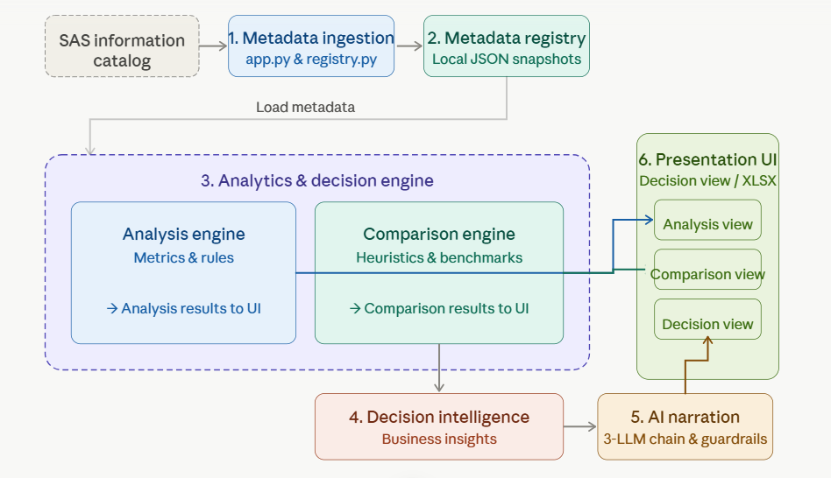
Fig. Component diagram

5.1 Architecture Layers

Layer 1: Ingestion & Registry
Files: app.py, abt/registry.py
Receives metadata payloads. Computes SHA-256 hashes for deterministic versioning. Stores snapshots as local JSON under datadump/.

Layer 2: Data Representation
Files: abt/columnProfile.py
Maps JSON payloads into ABTProfile and ColumnProfile Python objects. All downstream modules work exclusively with these typed objects — never raw dicts.

Layer 3: Computational Engines
Files: abt/analyze.py, abt/compare.py, abt/drift_metrics.py
Executes S0-S9 single-version health checks and C0-C10 comparison sections. Advanced drift suite computes 10 additional metrics including FSI, velocity, and baseline drift.

Layer 4: Interpretation Engine
Files: abt/interpretations.py
Three-tier decision engine. Tier A: deterministic heuristics (I4-I9). Tier B: LLM-enriched narrative. Tier C: hybrid multi-signal corrections. Each tier stored independently in the results dict.

Layer 5: Business Insight Director
Files: abt/business_insights.py, abt/signal_collector.py, abt/llm_drift_narratives.py
Groups column signals into drift themes. Executes 3-call LLM chain (Triage => Card Synthesis => Meta Narrative). Maps findings to 7 structured business slots.

Layer 6: Safety Validation & UI
Files: abt/insight_validator.py
Two-pass guardrail layer. Pass 1: 6 deterministic hard rules. Pass 2: Optional LLM review with strict JSON parsing. Prevents nonsensical or non-compliant recommendations. Displays the results on the UI.

5.2 Analysis Flow (Single Version)
Triggered by POST to /analyze/run. The run_analysis() function executes 10 sections sequentially, each building on the previous:

- S0 — Dataset Readiness Score (weighted average of S8 health scores)
- S1 — Health Summary (column counts, completeness summary, zero-variance count)
- S2 — Blockers (completeness < 50%, zero variance, mismatch rate > 15%)
- S3 — Quality Warnings (partial missing, blank strings, format mismatches)
- S4 — Governance, Privacy & Leakage Risks (informationPrivacy=private, identifier detection, probability score heuristic)
- S5 — Column Readiness Classification (ready / caution / drop)
- S6 — Target Variable Analysis (event rate, imbalance ratio, balance classification)
- S7 — Distribution Health (skewness labels, outlier detection, transformation recommendations)
- S8 — Column Health Scores (0-100 composite per column)
- S9 — Prioritized Action List (severity x impact ranking)
- I1/I2/I3 — Feature usability verdicts, training readiness strategy, preprocessing checklist

5.3 Comparison Flow (Multi-Version)
Triggered by POST to /compare/run with N >= 2 selected versions. The run_comparison() function executes all C and I sections, then optionally triggers the 3-LLM chain:

- C0-C10: All comparison sections computed first (PSI matrix, schema changes, completeness drift, distribution drift, target drift, cardinality drift)
- Drift Suite: 10-metric suite computed for all column pairs (FSI, velocity, baseline, KS, CV, std, quantile, boundary, kurtosis, entropy)
- I4-I9 Tier A: Rule-based interpretations (population shift, target stability, feature drift impact, model action, pipeline break risks, pipeline health)
- I4c-I9c Tier C: Hybrid corrections refining Tier A outputs using multi-signal evidence
- I4b-I9b Tier B: Enhanced interpretations that consume Tier C outputs and add narrative placeholders
- LLM Enrichment (optional): 3-call chain synthesizes drift themes into business cards; llm_insights.py enriches C0, C8, and version story

5.4 The 3-Call LLM Chain (Decision Intelligence)
The AI narrative synthesis is deliberately broken into three focused calls, each with a single well-defined job. This reduces hallucination risk and keeps each call within a tight token budget:

Call | Name | Input | Output (max tokens)
Call 1 | Triage | All column drift themes + domain + purpose | Ranked theme IDs + triage reason (200 tokens)
Call 2 | Card Synthesis | One theme's composite facts + fixed anchors | Headline + evidence + action per card (250 tokens)
Call 3 | Meta Narrative | All completed card headlines + I7 decision + verdict | Single connecting portfolio sentence (60 tokens)

5.5 Validation Guardrail Rules
All insight cards pass through a two-pass validation layer before reaching the UI. Pass 1 applies six deterministic hard rules:

Rule | Condition & Override
Rule 1: Private Drop Blocked | Prevents any recommendation to drop a private/protected attribute; replaces with governance review requirement
Rule 2: Data-Loss Action Blocked | If drift is caused by pipeline data loss, all model action recommendations are removed; only pipeline fix is permitted
Rule 3: Drift Story Ceiling | Individual drift card actions cannot exceed the overall I7 model decision level
Rule 4: Verdict Ceiling | No card action may be stronger than the C0 verdict ceiling (CLEAR: hold only; BLOCK: pipeline fix only)
Rule 5: Governance Sign-off | All governance slot actions must contain regulatory sign-off language
Rule 6: BLOCK Override | BLOCK verdict strips all model actions from every card; only data quality fixes are permitted

Pass 2 (optional, active when use_llm=on): If any hard rule fires, the structured facts and the rule that triggered are formatted into a minimal LLM prompt. The response is strictly parsed as JSON {is_correct, replacement}. Free-text responses are rejected.

6. What Is Implemented

The following capabilities are fully implemented and production-ready in the current codebase.

6.1 Core Analysis Engine:
- 10-section single-version analysis (S0-S9) with full threshold configuration support
- Column health score (0-100) with 5-dimension composite weighting
- Dataset readiness score with blocked column penalty weighting
- Prioritized action list with severity x impact ranking
- Target variable analysis: event rate, imbalance ratio classification, SMOTE guidance
- Distribution health: skewness classification, outlier detection, transformation recommendations
- Governance detection: privacy flags, identifier detection, probability leakage heuristic

6.2 Comparison & Drift Detection Engine:
- 11-section multi-version comparison (C0-C10) scaling to N >= 2 versions without structural changes
- PSI matrix with union boundary approach (eliminates range-mismatch inflation)
- C0 verdict engine: CLEAR / MONITOR / BACK_TEST_REQUIRED / BLOCK with configurable thresholds
- Cardinality explosion detection (C10) with severity classification
- Missingness pattern classification: complete / stable_missing / growing_missing / newly_missing / sparse / recovering / fluctuating
- Health score trend with least-squares slope, direction classification, and trend note
- 10-metric advanced drift suite: CV drift, std drift, quantile shift, boundary drift, kurtosis drift, entropy drift, FSI, drift velocity, baseline drift, approximate KS

6.3 Interpretation Engine:
- Tier A heuristics (I4-I9): population shift scope and cause, target stability classification (organic_gradual / organic_jump / label_change / data_loss), feature drift root cause (center_shift / boundary_expansion / spread_change), model action decision (retrain / rebin / recalibrate / hold), pipeline break risk detection, pipeline health classification with escalation flag
- Tier C hybrid corrections (I4c-I9c): multi-signal refined cause detection, velocity-based decision escalation, FSI-informed feature retention logic
- Tier B enhanced interpretations (I4b-I9b): full PSI trajectory series, event-rate series, dataset score history — all structured for LLM prompt consumption

6.4 Decision Intelligence Layer:
- Signal collection pipeline (v1 and v2) with column-wise metric aggregation and PSI-anchored magnitude scoring
- Theme grouping: drift signals clustered into 7 business themes (center_shift_down, center_shift_up, boundary_expansion, spread_change, new_segments, pipeline_failure, volatility)
- 3-call LLM prompt chain with composite fact sheet generation from raw drift metrics
- 7-slot business insight layout with dynamic reordering (critical target/pipeline cards promoted to front)
- 6-rule validation guardrail with Pass 2 LLM JSON-schema review
- synthesise_drift_insights() (v1 single-call) and synthesise_drift_insights_v2() (3-call chain) both available

6.5 Infrastructure & UI:
- Flask web application with all routes: ingest, fetch-IC, analyze, compare, decision view, config, XLSX export
- SAS Information Catalog integration (fetch_ic.html + services/ic_client.py)
- Threshold configuration system with session persistence and hidden form field propagation
- Dark-mode UI with PSI heatmap (CSS grid), Chart.js health score bars, readiness trend lines, target drift timeline
- XLSX audit export via openpyxl
- LLM provider switching: Anthropic / OpenAI / Azure OpenAI via llm_config.py ACTIVE_PROVIDER flag

7. Usage Instructions

7.1 Prerequisites
- Python 3.10 or later installed and on the system PATH
- Node.js 18+ (required for XLSX export functionality only)
- An API key for Azure OpenAI, OpenAI, or Anthropic (optional — required only for AI narration features)
- Access to the SAS Information Catalog API endpoint (optional — manual JSON ingestion always works)

7.2 Installation & Startup

- Clone or download the repository to a local directory
- Copy .env.example to .env and configure the following variables:

Variable | Value
OPENAI_API_KEY or ANTHROPIC_API_KEY | Your LLM provider API key
ACTIVE_PROVIDER | openai | anthropic | azure_openai
AZURE_OPENAI_ENDPOINT | Full Azure deployment URL (Azure only)
AZURE_OPENAI_KEY | Azure deployment key (Azure only)
IC_BASE_URL | SAS Information Catalog base URL (optional)
IC_API_KEY | SAS IC API key (optional)

- Run the startup script from the project root:

# Windows
run.bat

# Linux / macOS
python -m venv venv && source venv/bin/activate
pip install -r requirements.txt
python app.py

- Open http://localhost:5000 in your browser

7.3 Ingesting Metadata
EDA accepts metadata in two ways:

Option A — Manual Paste
- Navigate to Ingest in the top navigation bar
- Enter a table name (this becomes the dataset identifier across all versions)
- Paste the SAS column catalog JSON payload into the textarea
- Click Ingest to register the dataset. The system will version it automatically

Option B — Fetch from SAS Information Catalog
- Navigate to Fetch IC
- Enter the CAS table name and optionally the CASlib
- The system queries the IC API, retrieves the metadata, and ingests it automatically

7.4 Running a Single-Version Analysis
- Navigate to Analyze
- Select the registered table name and version from the dropdowns
- Optionally specify the target column name if it is not auto-detected
- Toggle Enrich with AI narrative to activate LLM enrichment (requires API key)
- Click Run Analysis to view the S0-S9 results with interpretation layer

7.5 Running a Multi-Version Comparison
- Navigate to Compare
- Select the table name — this loads the version list
- Hold Ctrl/Cmd and select two or more versions to compare
- Set the Business Domain and Model Purpose (affects AI framing language only, not logic)
- Toggle Enrich with AI narrative and click Run Comparison
- On the results page, click Decision View to open the executive 7-card summary

7.6 Threshold Configuration
All analysis thresholds can be customised via Additional Configuration on the Analyze or Compare selection pages:
- PSI thresholds (stable < 0.10, shift > 0.25 by default)
- Completeness blocker threshold (default: 50%)
- Target drift notable/critical thresholds
- Imbalance ratio thresholds for moderate and severe classification
- Column health score dimension weights (must sum to 1.0; auto-normalised)

Custom thresholds are stored in the Flask session and propagated via hidden form fields, surviving page navigation within a session.

8. Results

8.1 Data Ingestion

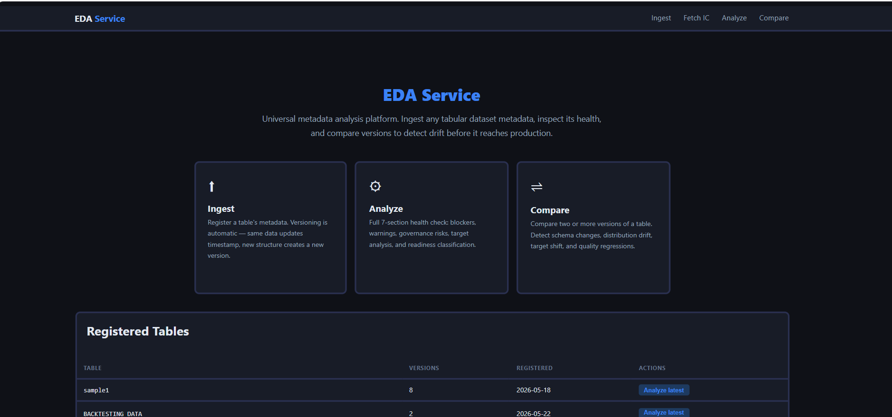

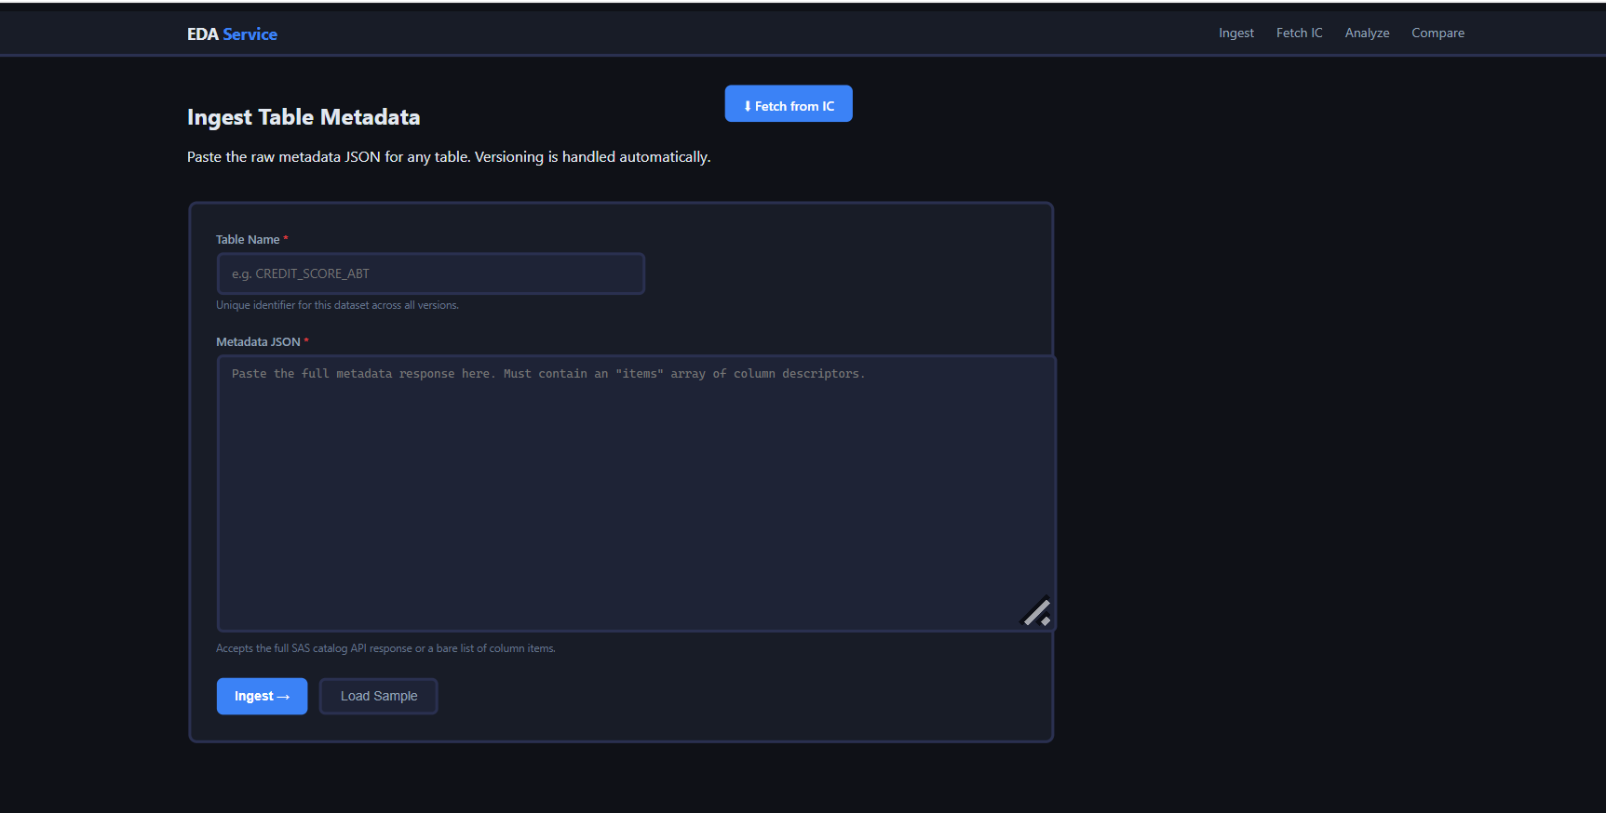

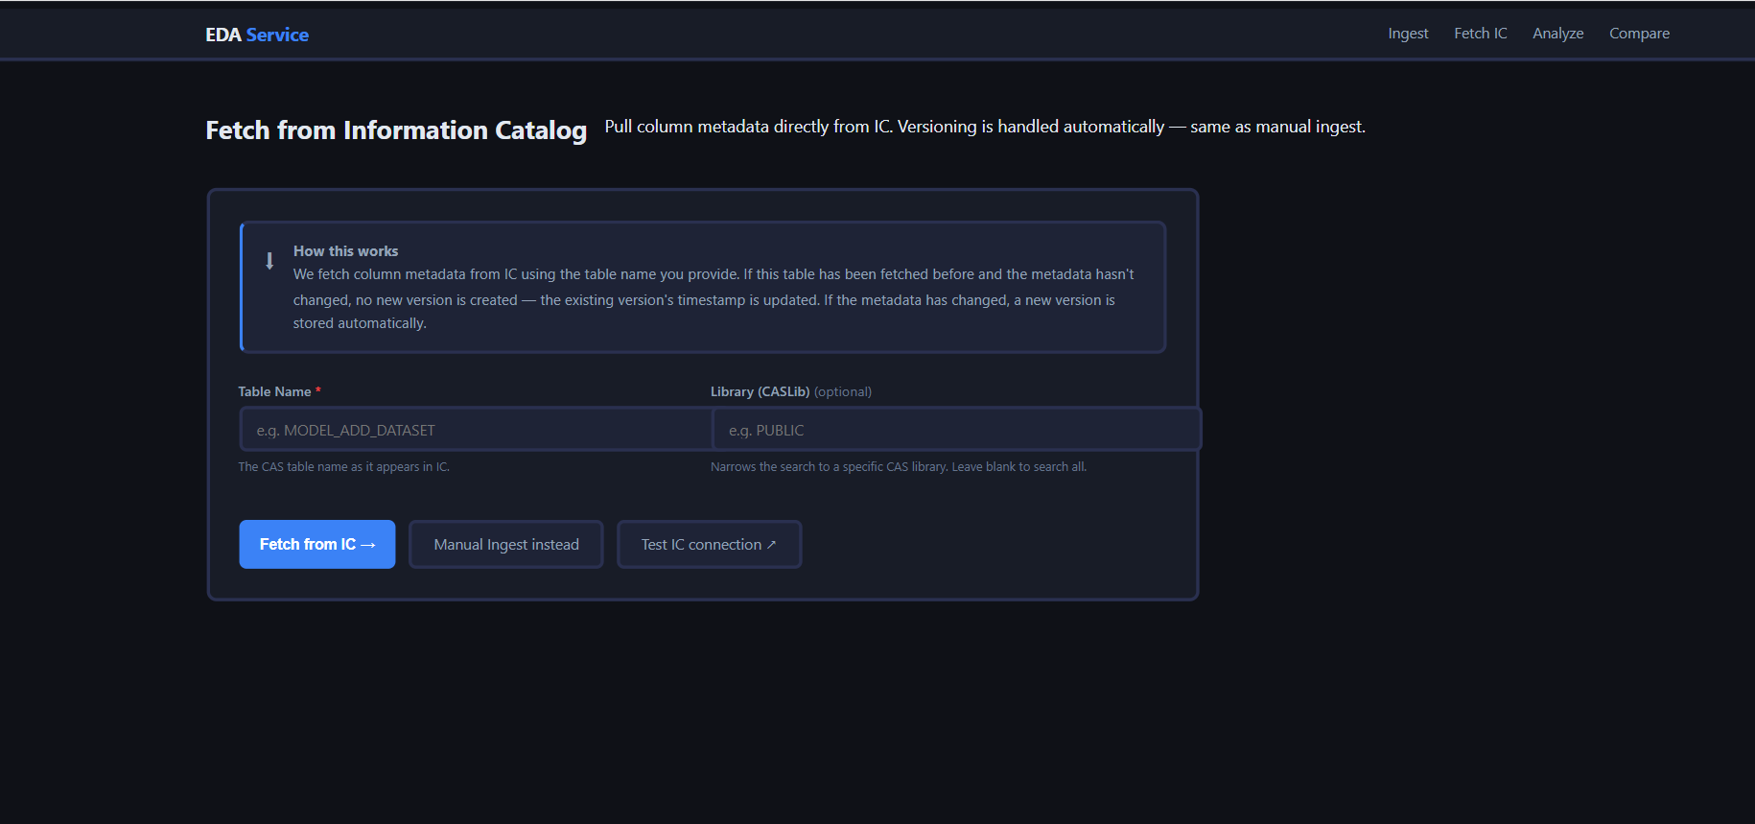

8.2 Analysis (Single-version analysis):

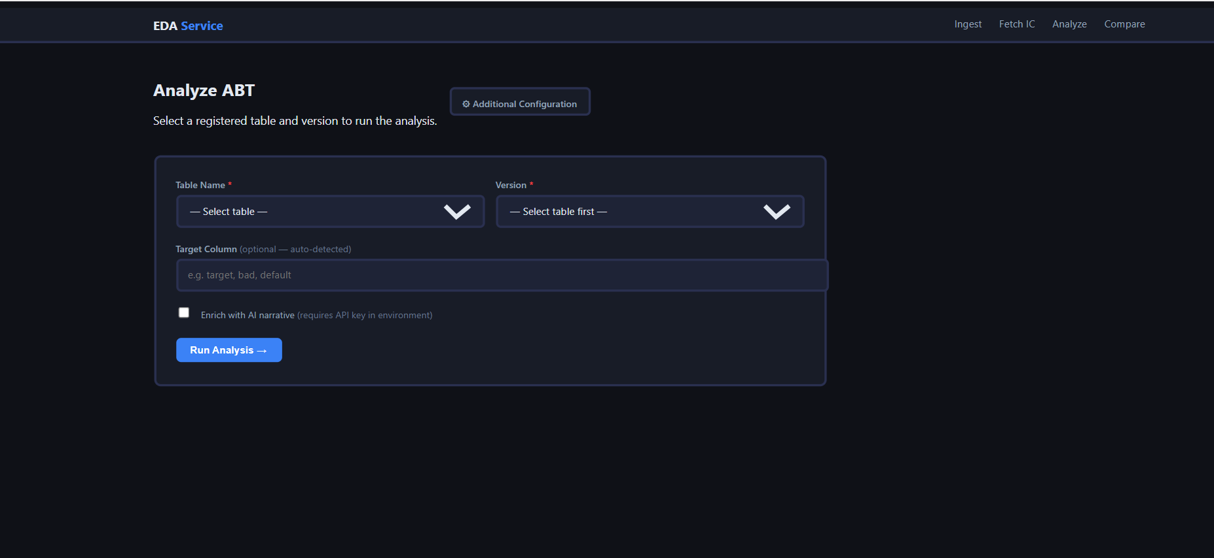

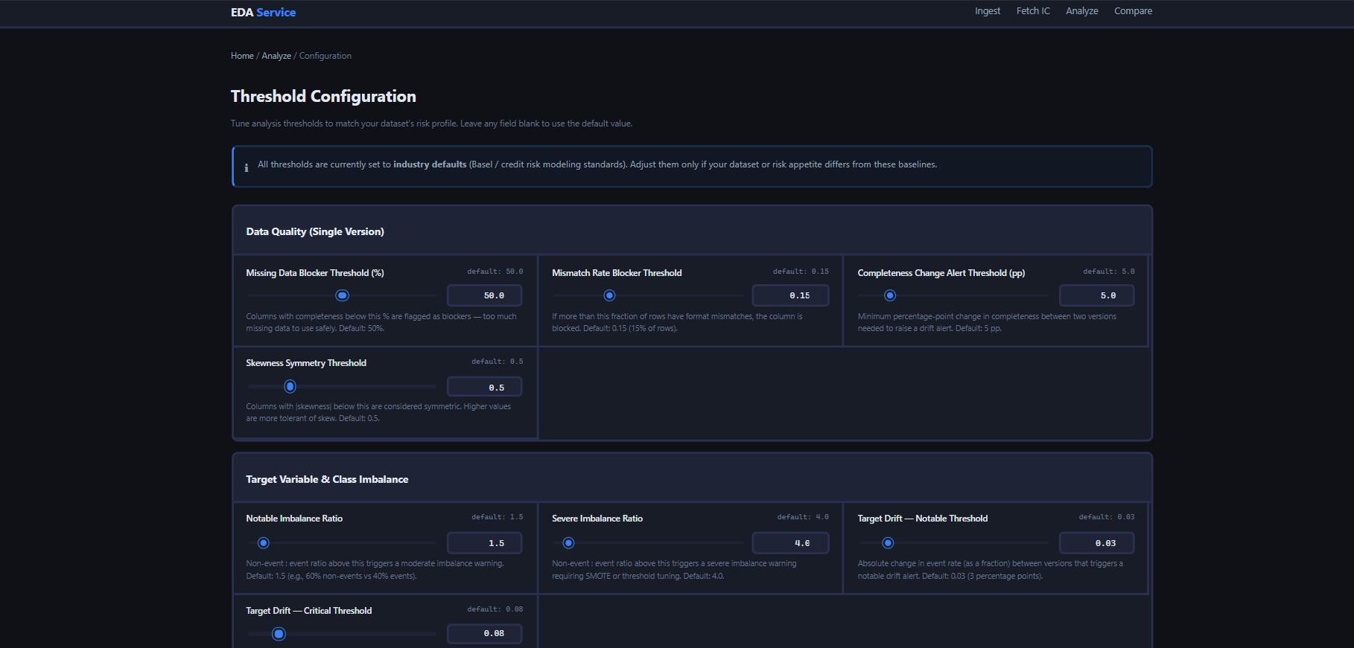

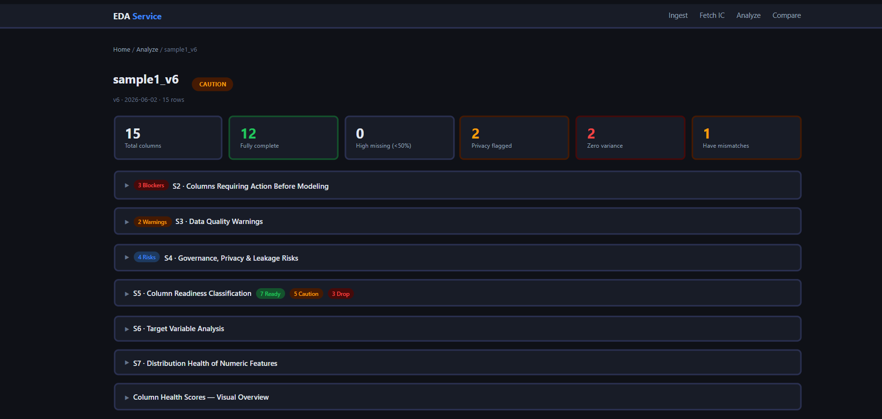

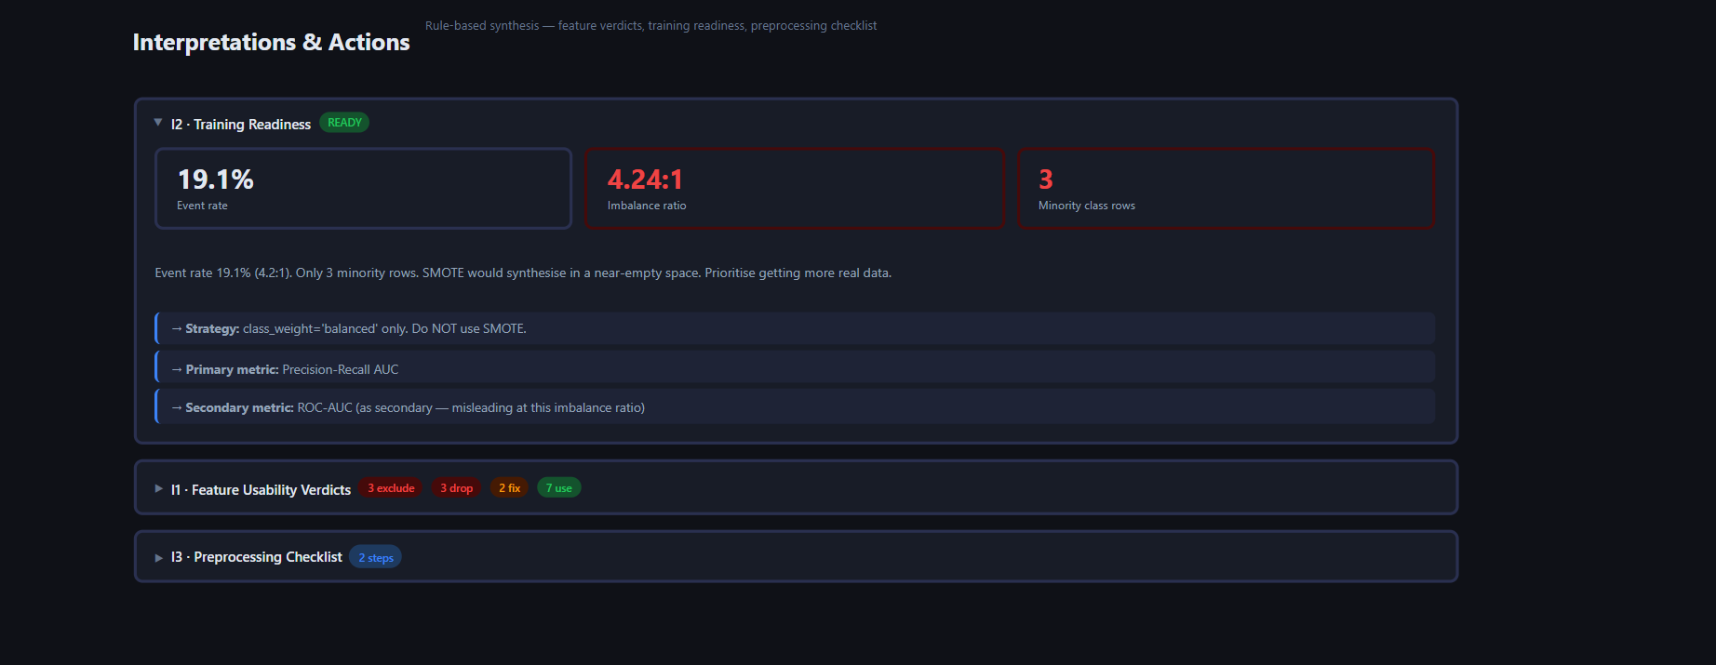

8.3 Comparison (Multi-version comparison):

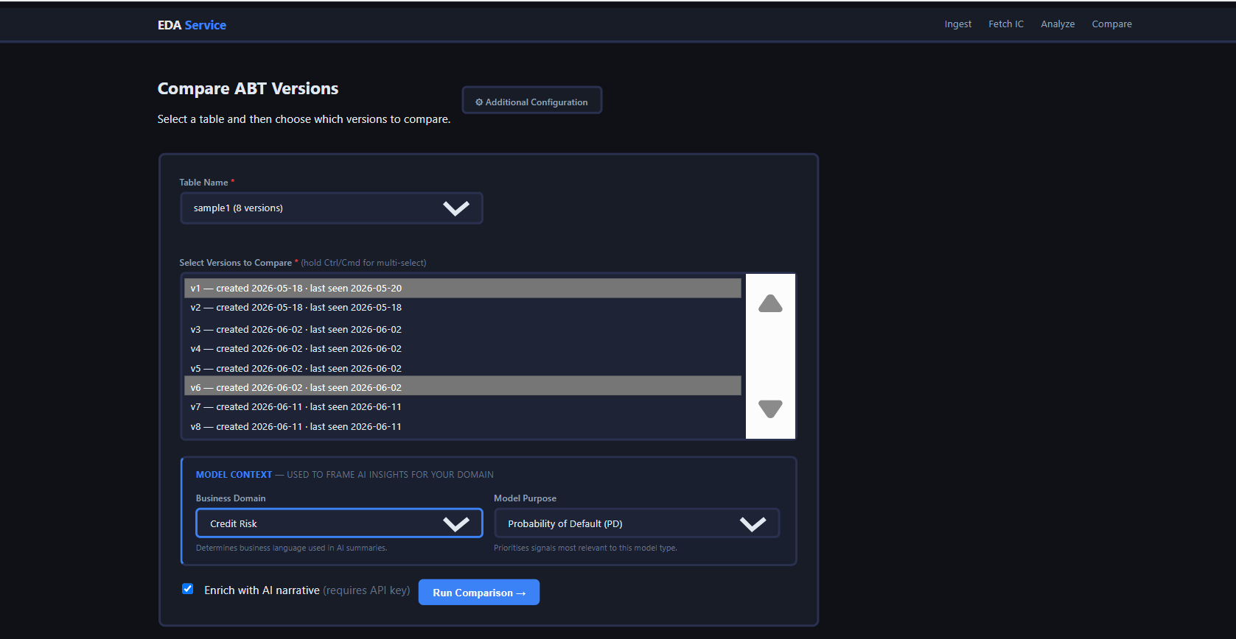

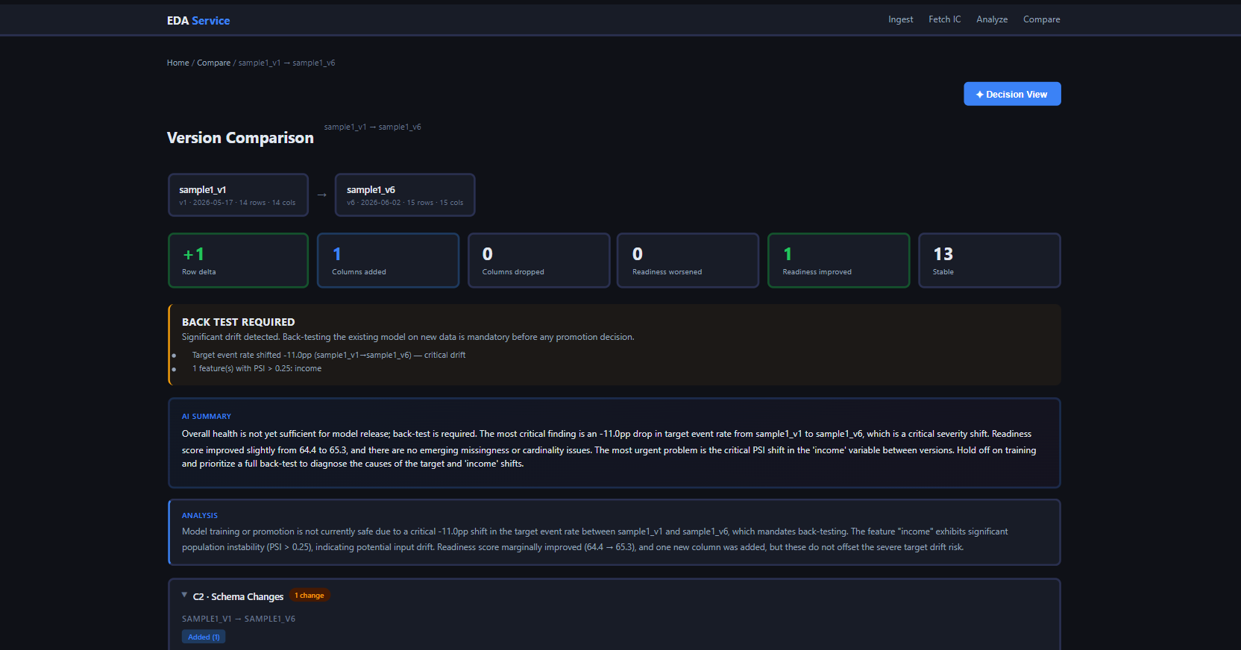

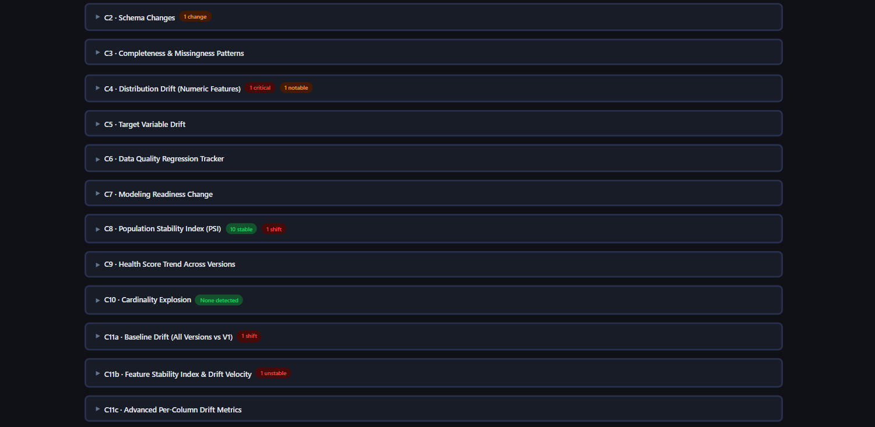

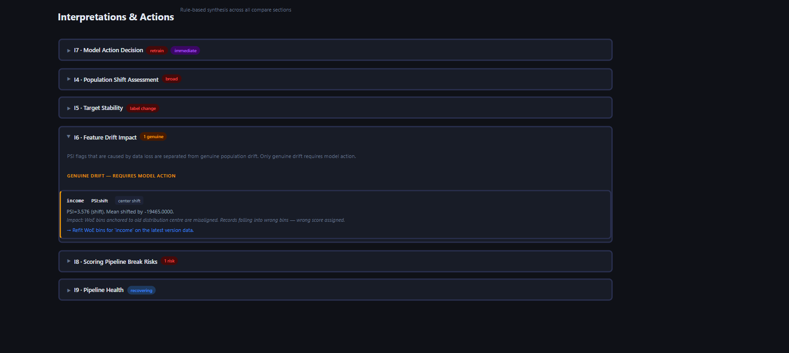

8.4 Decision View:

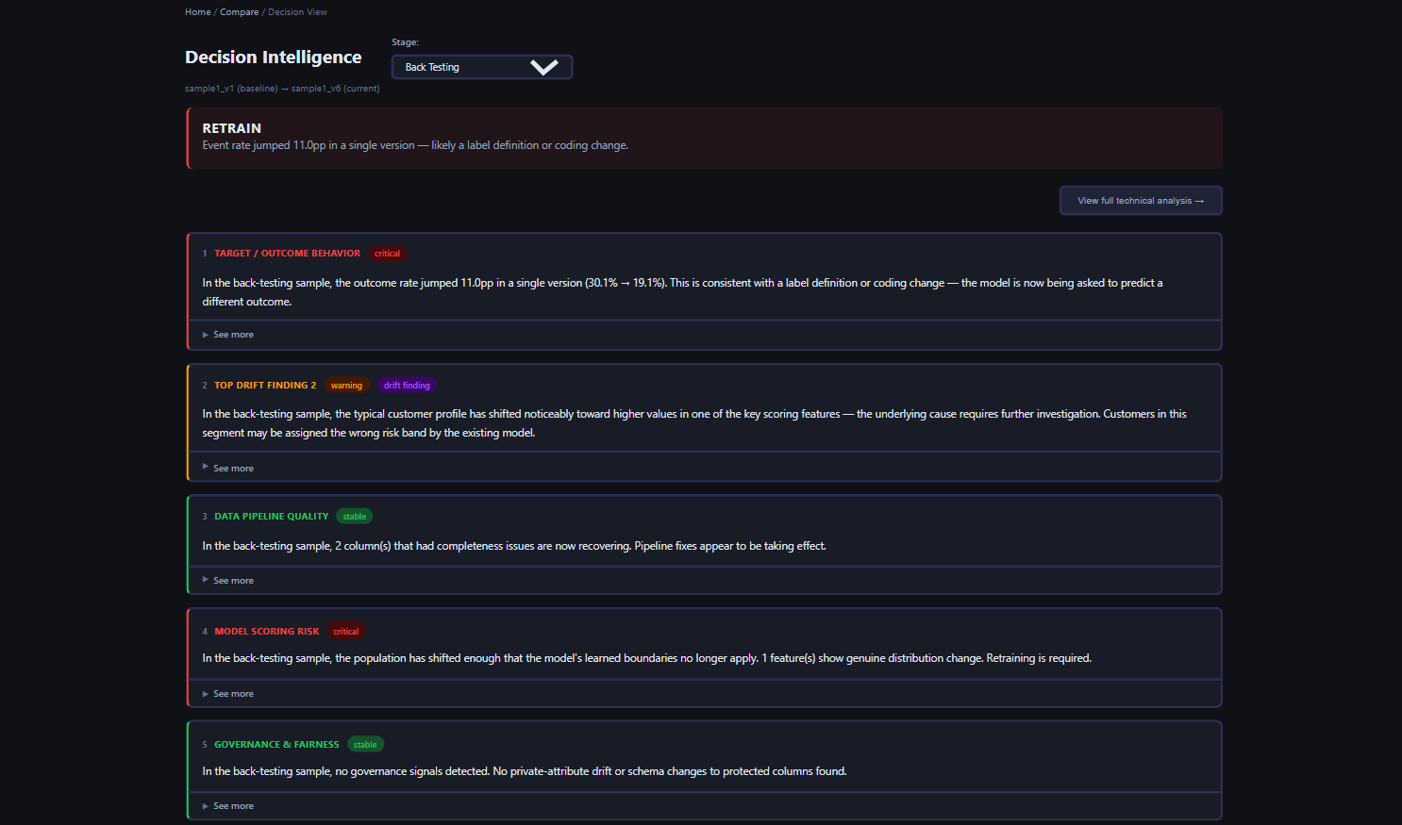

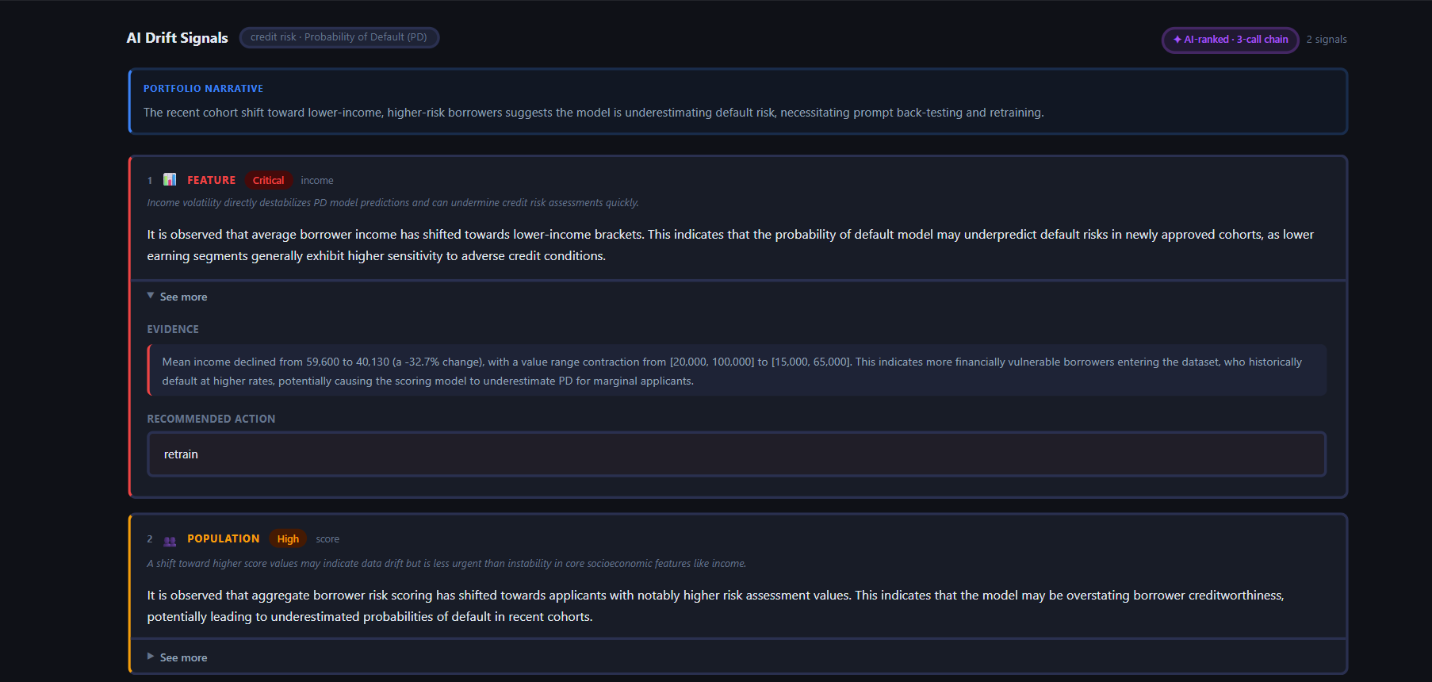

9. Future Enhancements

9.1 Enhancements to the Metadata-Only Pipeline

These improvements can be implemented directly on the current catalog metadata ingestion structure.

A. Headless/Offline AI via Local LLM Integrations (Ollama)

Objective: Replace external OpenAI APIs with self-contained, zero-cost local runners for headless enterprise deployments.

Details: Update abt/llm/llm_client.py and abt/llm/llm_config.py to support an offline model host (e.g., http://localhost:11434/api/chat running Llama 3 or Mistral). This secures sensitive information catalog metadata locally and ensures consistent service uptime.

B. Feature Importance Integration vs. Derived Urgency Metrics

Objective: Prevent irrelevant or highly volatile variables from pushing critical predictors out of the Decision View cards.

Details: Expand the metadata ingestion schema to accept true model coefficients or feature importances (e.g., SHAP values, Gini importances, or Permutation importances from training). These actual predictor weights will be used to rank drift signals, ensuring major changes in high-impact features (like income or DTI) are prioritized first.

C. In-Context Learning (ICL) few-shot prompts

Objective: Refine LLM narration, boundaries evidence, and action recommendations.

Details: Embed 2–3 concrete input/output examples inside the _CARD_SYSTEM system prompts in abt/llm/llm_prompts.py for target domains like Fraud or Churn. This acts as a guide to teach the model domain-specific terminology (e.g., chargeback rates vs. customer retention metrics) and ensure style consistency.

D. Segment-Conditioned Metadata Ingestion

Objective: Enable segment-specific diagnostic recommendations.

Details: Allow the catalog ingestion engine to accept column profiles grouped by categorical variables (e.g., segment or risk_band). The comparison engine can then track sub-population drift trajectories (e.g. "DTI increased by 8% specifically within the High Risk segment"), enabling targeted recommendations instead of global refit instructions.

9.2 Advanced Capabilities Unlocked by Raw Dataset Access

If the platform is integrated with raw data lakes or database access, the following features can be added.

A. Dynamic WoE Binning & Information Value (IV) Calculations

Objective: Calculate proposed binning updates automatically.

Details: Analyze the raw dataset to compute new Weight of Evidence (WoE) boundaries and quantify the performance gain. The UI can display a comparison of the feature's Information Value (IV) before and after re-binning (e.g., "Refitting bin boundaries for income restores its IV from 0.12 back to 0.28"), giving the validation team clear quantitative evidence to proceed.

B. Multivariate Drift Detection (Joint Distribution Shift)

Objective: Identify correlation shifts across columns that univariate PSI checks miss.

Details: Compute multivariate statistics (such as Mahalanobis Distance, Covariance matrix differences, or the reconstruction error of a simple Autoencoder) on the raw dataset. This will flag joint distribution shifts (e.g., when age and income distributions appear stable individually, but their correlation flips).

C. Real-Time Model Performance Back-Testing (Gini & KS Decay)

Objective: Measure exact performance degradation on consecutive version datasets.

Details: Align raw features with true target labels and deployed model score predictions. Calculate exact validation metrics (such as ROC-AUC, Gini coefficient, and Kolmogorov-Smirnov KS scores) to monitor predictive power decay over time.

D. Cross-Column Conditional Quality Rules

Objective: Identify record-level logical contradictions.

Details: Validate cross-feature logical constraints on raw rows (e.g., "If loan_status is 'defaulted', days_past_due must be > 90"). This flags silent data corruption and pipeline issues that single-column completeness checks cannot detect.

9.3 Known Issues
- The compare flow does not pass cfg (ThresholdConfig) to run_comparison() — custom thresholds only affect single-version analysis, not comparison metrics.
- The decision view route currently re-runs the full comparison on every GET request. For large datasets with many columns, this adds latency. Caching the results dict in the Flask session would address this.

10. References & Technical Resources
1) Download instances | downloadInstances | SAS Developer Portal
get/instances
Use this API for fetching the ABT metadata from the Information Catalog.
Note: Need to ensure that the metadata is present in the I
Downloads resulting metadata for instances. The level query parameter indicates the level or degree of complexity of the metadata to return in the response. Each of the levels provides the returned metadata in different tabular structures. The properties that can be used as filter and sort criteria are:
- id,
- name,
- label,
- description,
- type,
- createdBy,
- creationTimeStamp,
- modifiedBy,
- modifiedTimeStamp,
- definition,
- resourceId,
- endpoint1Id, and
- endpoint2Id

Sample response:

{
"abt_snapshot": {
"name": "sample1_v1",
"table_name": "sample1",
"version": 1,
"row_count": 14,
"snapshot_date": " "
},
"items": [
{
"creationTimeStamp": " ",
"createdBy": " ",
"modifiedTimeStamp": " ",
"modifiedBy": " ",
"id": " ",
"links": [ ]
"version": 1,
"instanceType": "entity",
"definition": "",
"definitionId": " ",
"name": "column_name",
"type": " ",
"attributes": {
"analysisTimeStamp": " ",
"bestChartType": "",
"cardinalityCount": 1000,
"casDataType": "double",
"completenessPercent": 100,
"dataType": "num",
"hasOutliers": false,
"hasUniqueField": true,
"kurtosis": -1.2,
"leastCommonValue": 1,
"max": 1000,
"mean": 500.5,
"median": 500.5,
"min": 1,
"missingCount": 0,
"mode": 1000,
"mostCommonValue": 1000,
"nOutliers": 0,
"ordinalPosition": 8,
"quantiles25": 250.5,
"quantiles50": 500.5,
"quantiles75": 750.5,
"rawLength": 8,
"sasDataType": "num",
"semanticTypeId": " ",
"semanticTypeScore": ,
"skewness": -6.20361e-19,
"standardDeviation": ,
"statisticalScale": " ",
"uniquenessPercent":
}
}

