1) Comparison results: Experimentation
In this, I have took 3 different ABTs and tried to compare their basic stats.
This is done in order to check whether we can really provide some meaningful information to the user from the ABTs.

Flow:
1) Already have 3 ABTs with me
2) Comparing these 3 ABTs and tried to calculate the data drifts in them. The findings and the approach are trivial for now. Need inputs on what insights a user can expect.
3)_LLM integrated to explain the findings and the visuals.

Limitation: This is not done using API. This is simply an experiment on what we can do using the data we have.

Results:
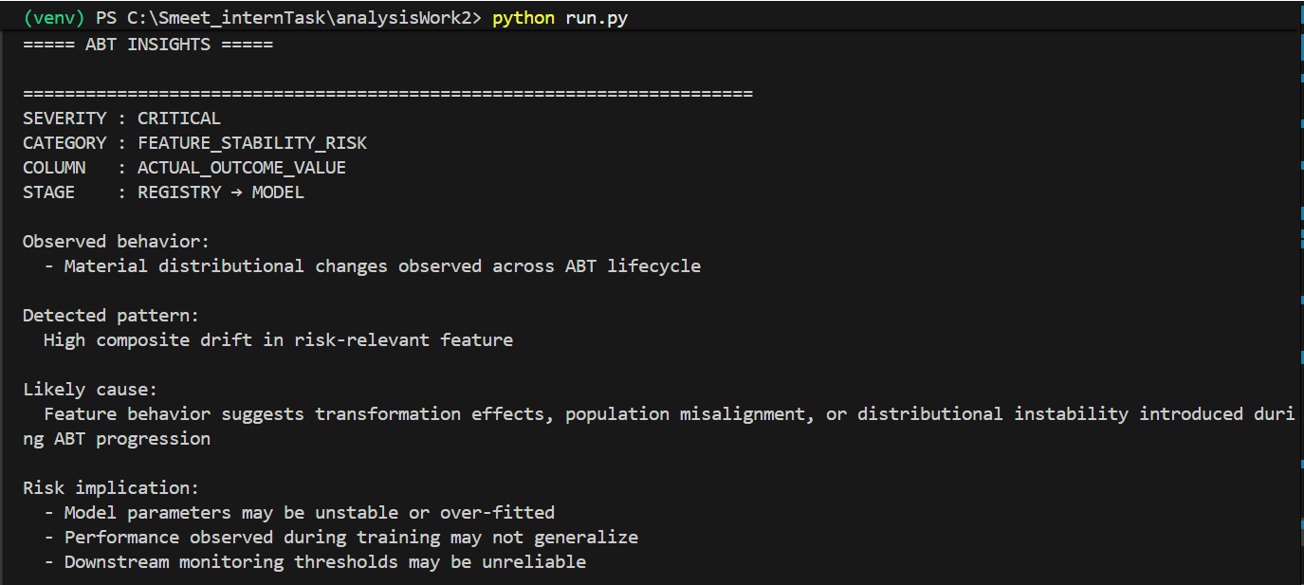
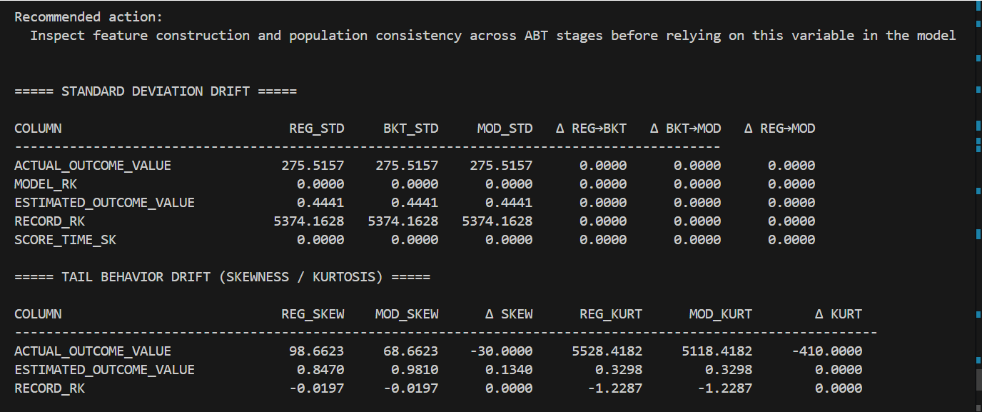
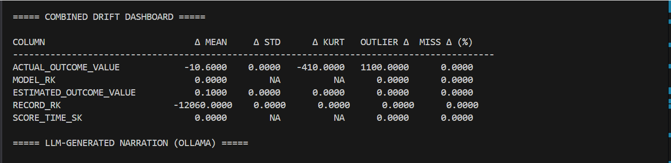
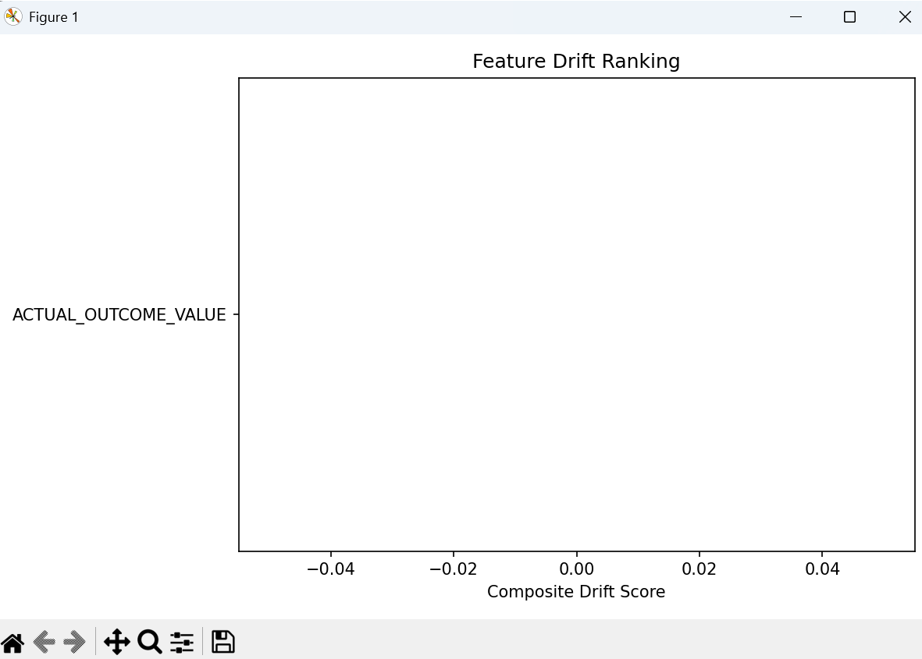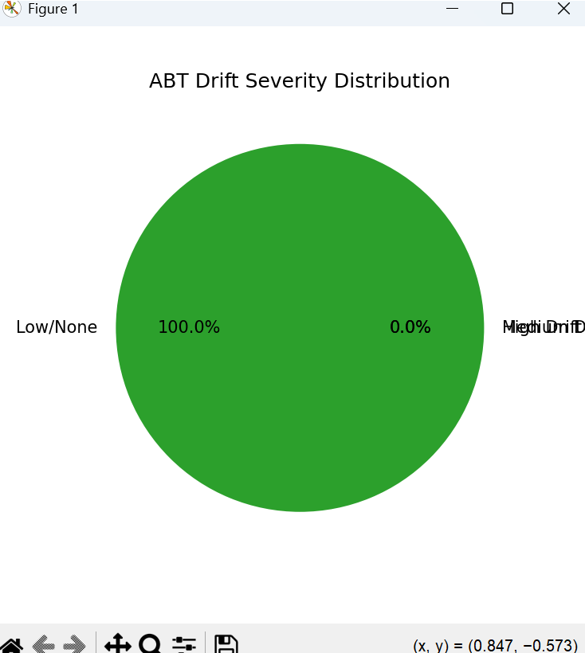

The graphs do not provide any actual insights to the user. Will try to see if we can derive anything out of these graphs, else will not use them.

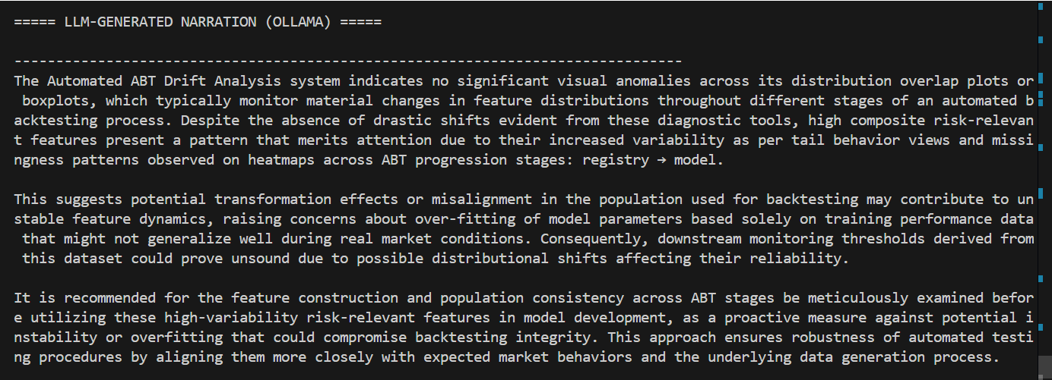

The LLM insights should be shorter and to the point. Need to put it in simple and non-technical terms.

==================================================================================================================================================

Started with Implementation:
1) Through a Flask application:
Flow:
1) Inputs: table name and library name
2) Then we have 2 options:
a. Analyze:
i. The download API will fetch the information from the Information Catalog and store it in our data-dump.
ii. This will analyze and provide insights about that specific ABT only.
iii. Insights will be displayed on the UI.

b. Compare:
i. Requires the input name of the tables to be compared
ii. It checks whether the table is present in the data-dump or not.
If yes, move to comparison. If no, download API is used to fetch the details for that table and stored in data-dump.
iii. Comparison logic will then run on the selected ABTs and insights like data-drifts and trends will be calculated and displayed on the UI.
Results:
1)
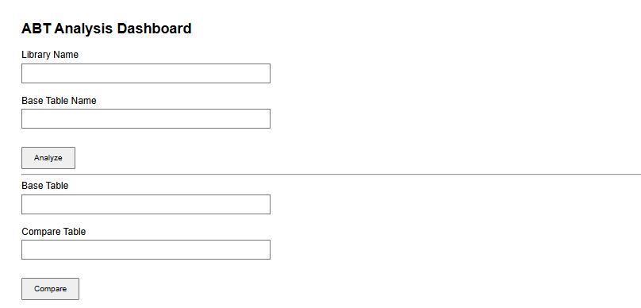

2)
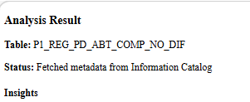
Analysis logic is not implemented yet. EDA insights about a specific ABT will be provided on this action.
3)
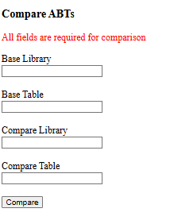

4)
Terminal: sanity check
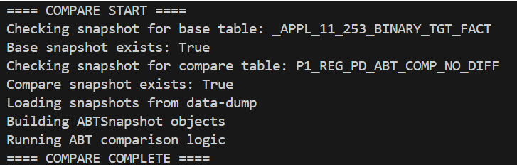

5) Note: The ABTs are not related here, hence the results are not up to the mark. Also, the comparison experimentation codes will be added here.
5.1
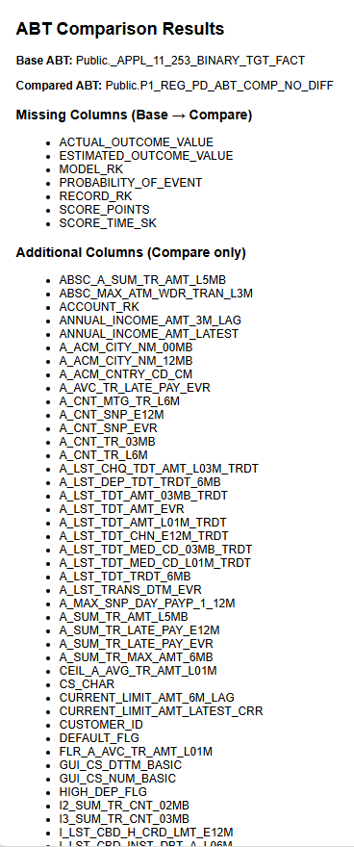

5.2
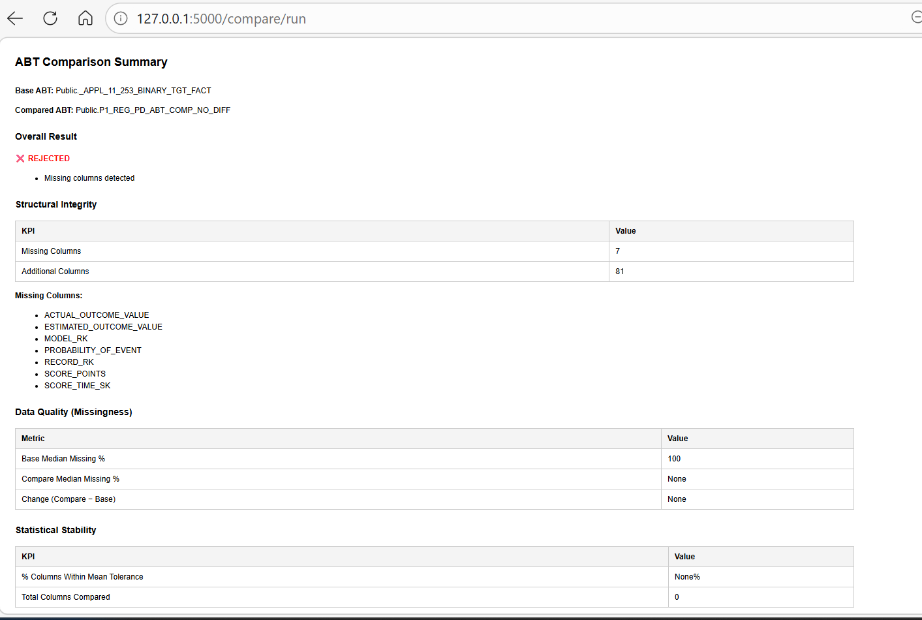

6) Data-dump:
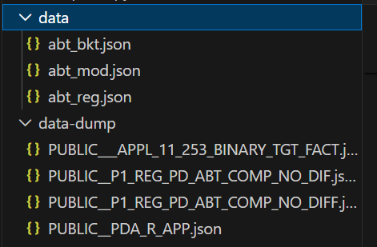
Final Expected outcome for comparison:

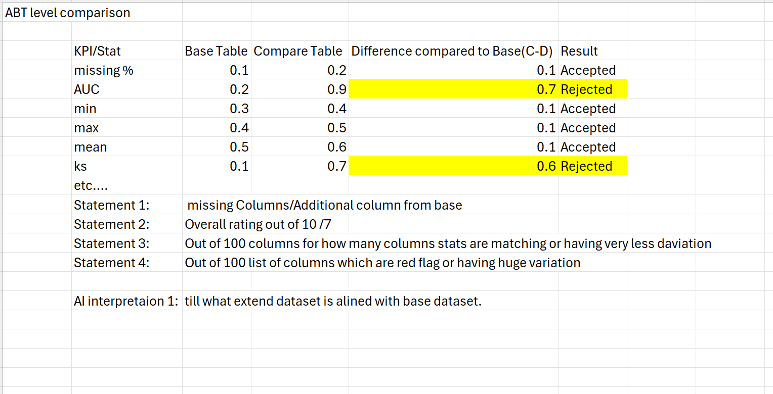

Current Limitations:
- Implicit ABT versioning is not supported
- Availability of the required info in the IC is not guaranteed, which might lead to inconsistencies in the results. Discovery agent can be an option.
- The current implementation contains comparisons for 2 tables. This needs to be extended for a multi-table comparison logic to analyze trends in the data.
- The calculations may take time and might not be available at the required instant.

Next Steps:
- Finalizing the comparison logic implementation
- Analyze action implementation for each ABT (if required)
- ABT analysis using discovery agent as a fallback if not available in the IC already.

