**SHARMIDHA SOUNDARARAJAN**

**APPLIED PROGRAMMING - ASSIGNMENT 3**

**PROGRAM 1:**

**Birth_tree = {1:"Apple",2:"Willow",3:"Maple",4:"Elm",5:"Fig",6:"Cherry",7:"Walnut",8:"Oak",9:"Palm",10:"Olive",11:"Citrus",12:"Sprouts"}**

**def getBirthTree(month):**

**month = int(month)**

**index = month %12**

**return Birth_tree[index]**

**month = input("Enter a month: ")**

**out = getBirthTree(month)**

**print("Birth tree is: ",out)**

**OUTPUT1:**

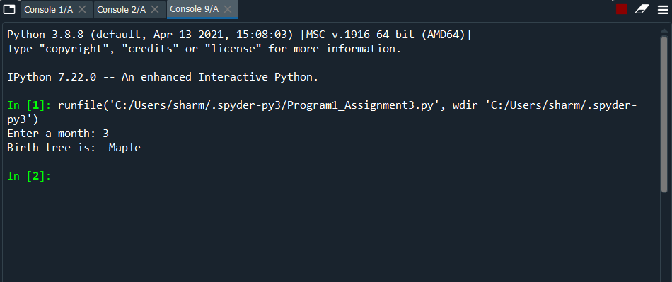

**PROGRAM 2:**

**infileName = "countryLists.txt"**

**infile = open(infileName,"r")**

**outfileName = "helloworld.txt"**

**outfile = open(outfileName,"w")**

**for line in infile:**

**greeting = ("Hello "+line)**

**outfile.write(greeting)**

**infile.close()**

**outfile.close()**

**print("Result saved in output file")**

**OUTPUT2**

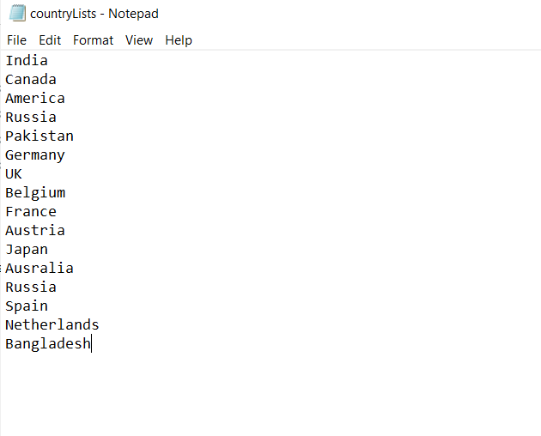

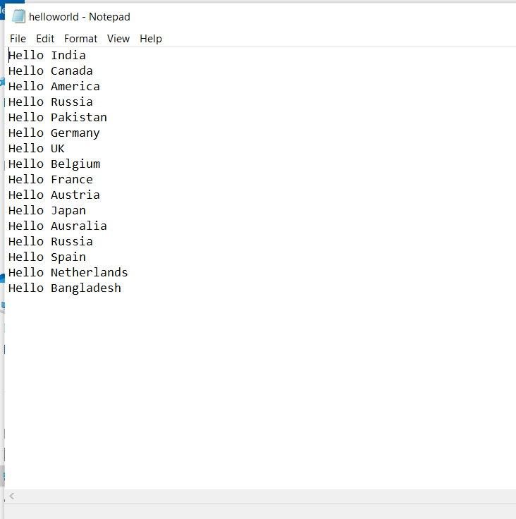

**PROGRAM 3:**

**def main():**

**print("This program will calculate average word length!")**

**infile = open("word.txt","r")**

**for line in infile:**

**words = line.split()**

**wordCount = len(words)**

**ch = 0**

**for word in words:**

**ch+= len(word)**

**avg = ch / wordCount**

**print("Average word length is:", avg)**

**infile.close()**

**main()**

**OUTPUT3:**

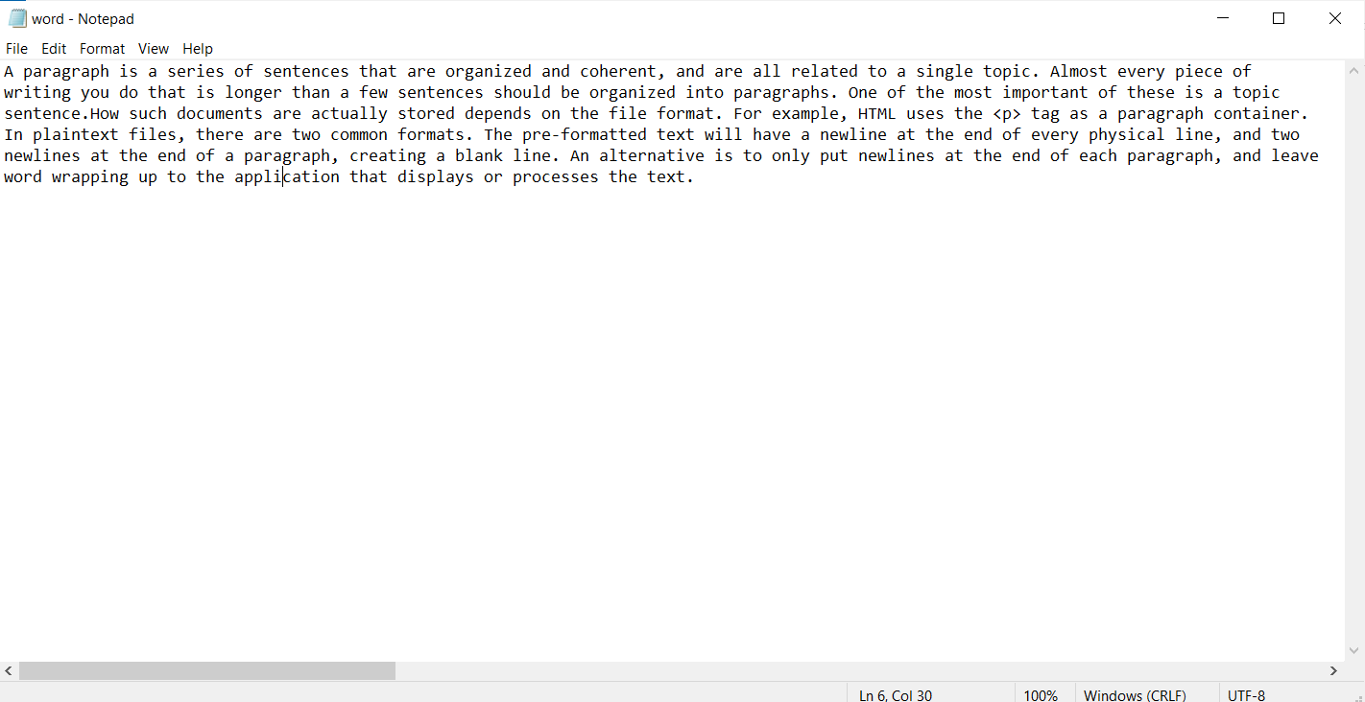

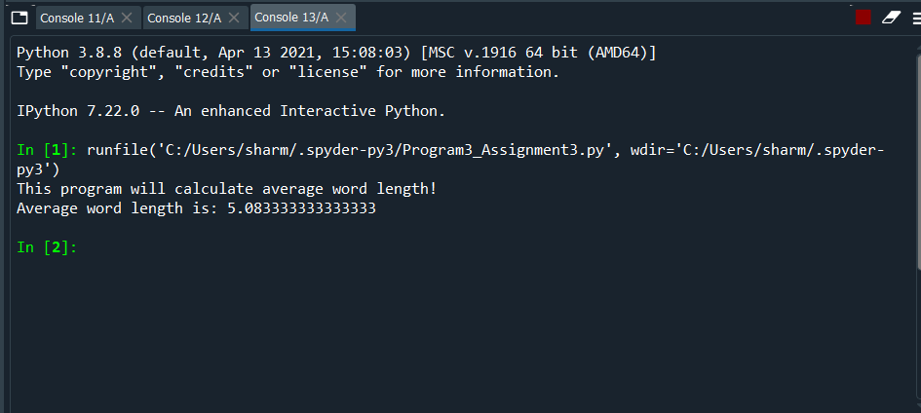

**PROGRAM4:**

**import random**

**import string**

**def get_random_string():**

**# choose from all lowercase letter**

**lower_letters = string.ascii_lowercase**

**upper_letters = string.ascii_uppercase**

**character = lower_letters + upper_letters + "0123456789" + "!@#$%^&*"**

**result_str = ''.join(random.choice(character) for i in range(10))**

**return result_str**

**def generate_password():**

**outfileName = "passwords.txt"**

**outfile = open(outfileName,"w")**

**for i in range(0,101):**

**outfile.write(get_random_string())**

**outfile. write("\n")**

**outfile.close()**

**result_str = get_random_string()**

**print("Random password is: ",result_str)**

**generate_password()**

**OUTPUT 4:**

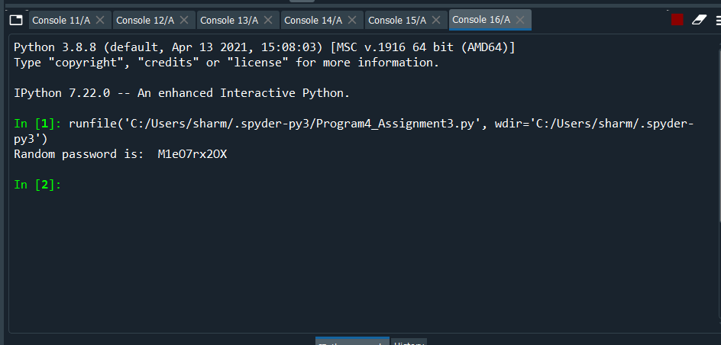

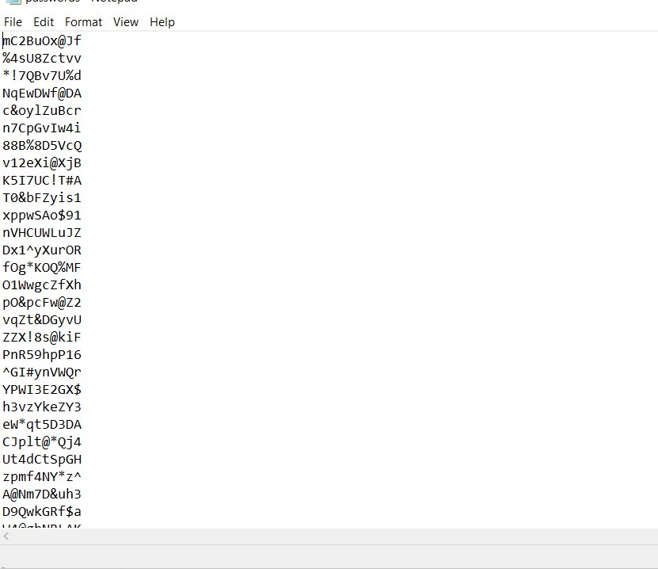

**PROGRAM 5a:**

**t = input("Enter a message: ")**

**key = 2**

**encryption = ""**

**text = t.replace(" ","")**

**for letter in text:**

**letter_unicode = ord(letter)**

**letter_index = ord(letter)-ord("A")**

**print(letter_index)**

**new_index = (letter_index+key)%26**

**print(new_index)**

**new_unicode = new_index+ord("A")**

**print(new_unicode)**

**new_char = chr(new_unicode)**

**print(new_char)**

**encryption = encryption+new_char**

**print(encryption)**

**OUTPUT5a:**

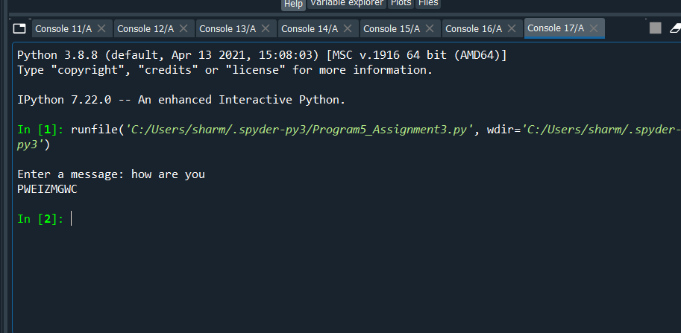

**5b:**

**Used frequency analysis method. Find the maximum occurring character and match it with “E” which is the highest occurring character in english language.**

**PROGRAM5c**

**ASCII_SIZE = 256**

**def getMaxOccuringChar(str):**

**encryption = ""**

**count = [0] * ASCII_SIZE**

**max = -1**

**c = ''**

**for i in str:**

**count[ord(i)]+=1;**

**for i in str:**

**if max < count[ord(i)]:**

**max = count[ord(i)]**

**c = i**

**key = ord(c)-ord("E")**

**for letter in str:**

**letter_unicode = ord(letter)**

**letter_index = ord(letter)-ord("A")**

**new_index = (letter_index-key)%26**

**new_unicode = new_index+ord("A")**

**new_char = chr(new_unicode)**

**encryption = encryption+new_char**

**print("key is: ",key)**

**print("Result is ",encryption)**

**return c**

**str = "SIOBUPYWLUWEYXNBYWIXY"**

**getMaxOccuringChar(str)**

**OUTPUT 5c:**

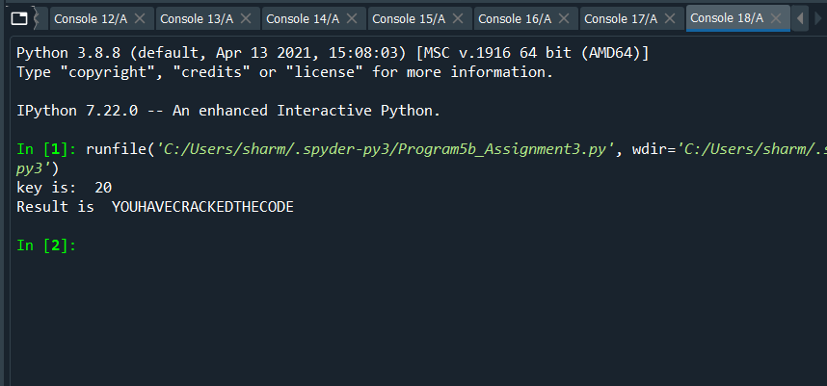

**PROGRAM 6:**

**from operator import itemgetter**

**def main():**

**count = 0**

**max = -1**

**c = ''**

**freq = {}**

**end_letter = {}**

**infile = open("caesers.txt","r")**

**for line in infile:**

**for character in line:**

**if character in freq:**

**freq[character] +=1**

**else:**

**freq[character] =1**

**frequencies= dict(sorted(freq.items(), key=lambda item: item[1]))**

**print("Frequency of each letters is ")**

**print(frequencies)**

**infiles = open("caesers.txt","r")**

**for line in infiles:**

**for i in line.split():**

**if i[-1] in end_letter:**

**end_letter[i[-1]] += 1**

**else:**

**end_letter[i[-1]] = 1**

**endletter_freq= dict(sorted(end_letter.items(), key=lambda item: item[1]))**

**print("End frequencies is :")**

**print(endletter_freq)**

**main()**

**OUTPUT6:**

