**SHARMIDHA SOUNDARARAJAN**

**APPLIED PROGRAMMING - ASSIGNMENT 2**

**PROGRAM 1:**

**import math**

**def main():**

**standard_potential = 1.25**

**temperature = 273**

**ion_charge = 2**

**q = 0.077**

**r = 8.3145**

**f = 96485.33**

**reduction_potential = standard_potential - ((r*temperature)/(ion_charge*f)) * math.log(q)**

**print("Reduction potential is",round(reduction_potential,2))**

**main()**

**OUTPUT1:**

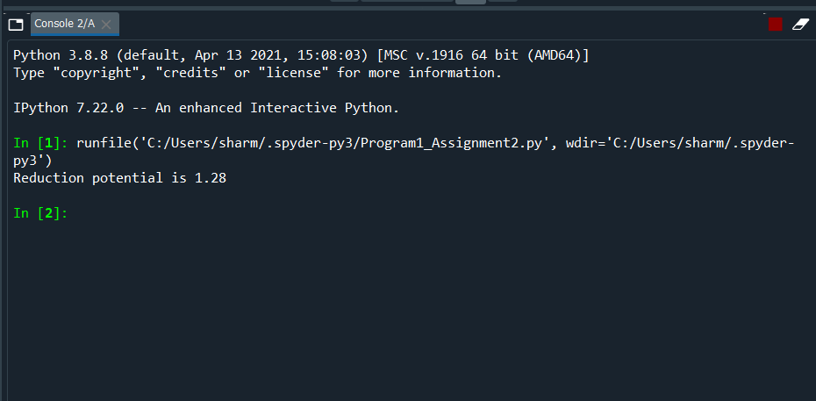

**PROGRAM 2:**

import numpy as np

import matplotlib.pyplot as plt

g=9.8

y = np.arange(10,201)

root = np.sqrt(y/g)

t = 2*np.pi*root

plt.plot(y,t)

plt.xlabel("length of the pendulum string (cm) ")

plt.ylabel("pendulum period")

**OUTPUT2:**

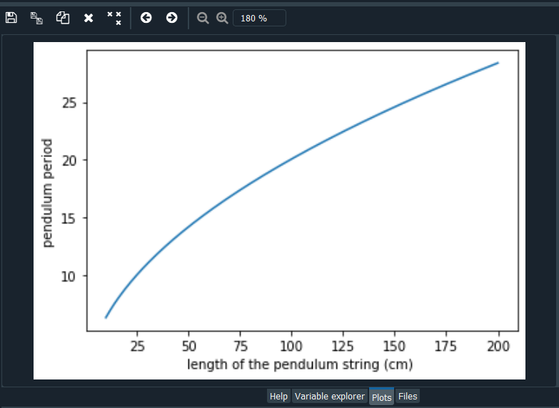

**PROGRAM3:**

**import numpy as np**

**import matplotlib.pyplot as plt**

**price = np.arange(0,21)**

**demand = 20 - (2*price)**

**supply = -10 + (2*price)**

**plt.plot(price,demand)**

**plt.plot(price,supply)**

**plt.title("Supply and Demand")**

**plt.xlabel("Price")**

**plt.ylabel("Quantity")**

**plt.legend(["Demand","Supply"])**

**print("Equilibrium price is 7.5$")**

**OUTPUT3:**

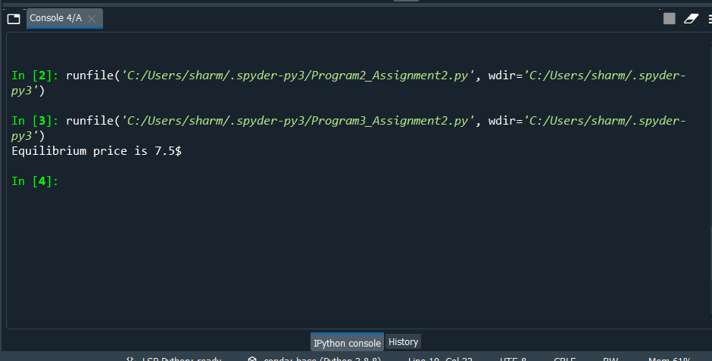

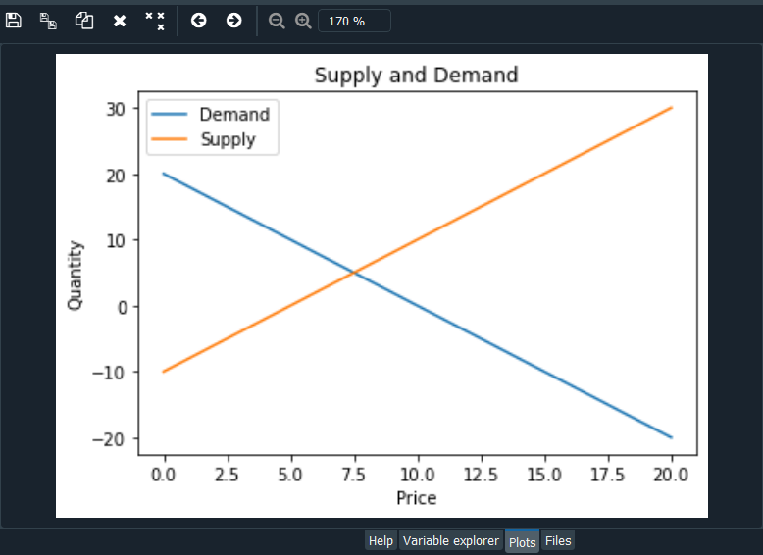

**PROGRAM4:**

**from graphics import \***

**def stripe(window,stripe,color):**

**stripe.setFill(color)**

**stripe.setOutline(color)**

**stripe.draw(window)**

**def iceland_flag():**

**flag_length = 600**

**flag_height = 18 / 25 * flag_length**

**win = GraphWin('Icelandflag',flag_length,flag_height)**

**#RGB values of blue,red and white**

**blue = color_rgb(2,85,156)**

**red = color_rgb(220, 30, 53)**

**white = color_rgb(255, 255, 255)**

**stripe_colors = [blue,red,white]**

**#set background colour with given rgb values for white**

**win.setBackground(stripe_colors[2])**

**# Blue rectangles**

**blue_topleft = Rectangle(Point(0,0),Point(150,160))**

**stripe(win,blue_topleft,stripe_colors[0])**

**blue_bottomleft = Rectangle(Point(0,flag_height),Point(150,270))**

**stripe(win,blue_bottomleft,stripe_colors[0])**

**blue_topright = Rectangle(Point(flag_length,0),Point(260,160))**

**stripe(win,blue_topright,stripe_colors[0])**

**blue_bottomright = Rectangle(Point(flag_length,flag_height),Point(260,270))**

**stripe(win,blue_bottomright,stripe_colors[0])**

**#red stripe**

**red_horizontal = Rectangle(Point(0,240),Point(flag_length,190))**

**stripe(win,red_horizontal,stripe_colors[1])**

**red_vertical = Rectangle(Point(230,0),Point(180,flag_length))**

**stripe(win,red_vertical,stripe_colors[1])**

**input('Press ENTER to close the window')**

**win.close()**

**iceland_flag()**

**OUTPUT4:**

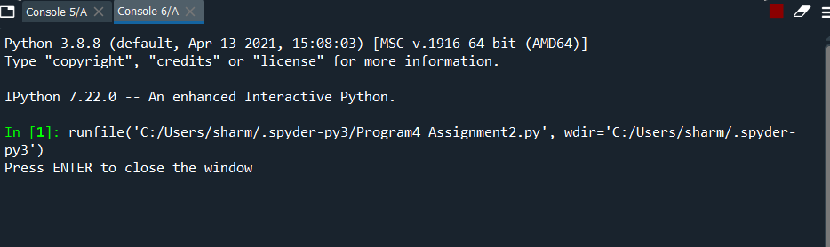

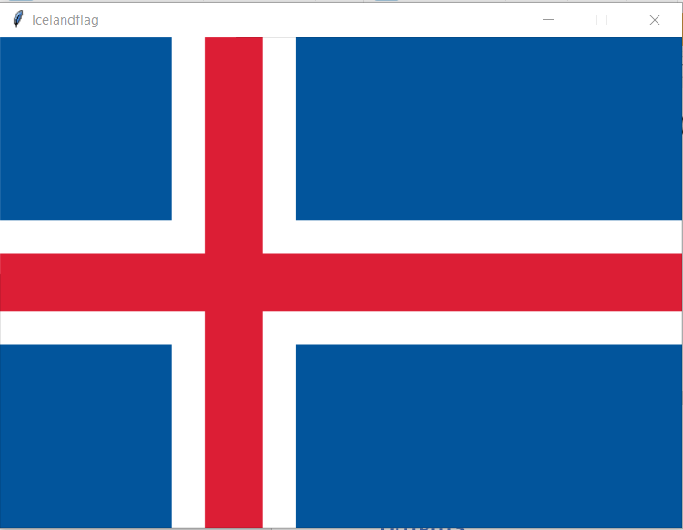

**PROGRAM5:**

**from graphics import \***

**def main():**

**win = GraphWin('Pentagon',300,300)**

**print("Click five times in the window to draw the pentagon")**

**point1 = win.getMouse()**

**point2 = win.getMouse()**

**point3 = win.getMouse()**

**point4 = win.getMouse()**

**point5 = win.getMouse()**

**pentagon = Polygon(point1,point2,point3,point4,point5)**

**pentagon.setFill("green")**

**pentagon.setOutline("green")**

**pentagon.draw(win)**

**input('Press ENTER to close the window')**

**win.close()**

**main()**

**OUTPUT5:**

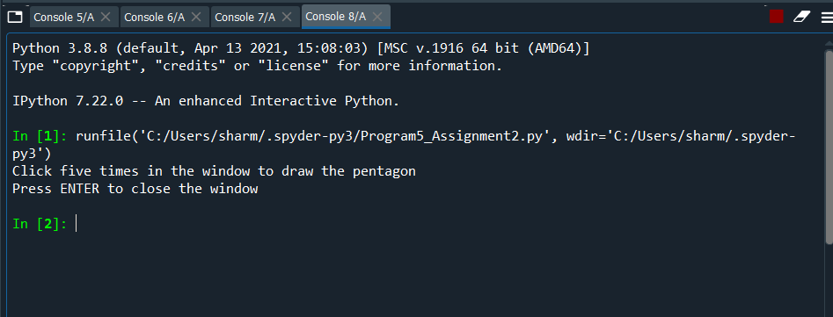

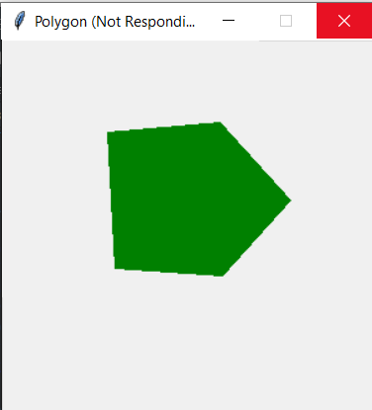

**PROGRAM6:**

**import graphics**

**from graphics import \***

**def main():**

**win = GraphWin('polygon',600,600)**

**p1 = Point(100,500)**

**p2 = Point(250,300)**

**p3 = Point(100,100)**

**p4 = Point(400,100)**

**p5 = Point(550,300)**

**p6 = Point(400,500)**

**polygon = Polygon(p1,p2,p3,p4,p5,p6)**

**colour = input("Enter your favourite colour: ")**

**polygon.setFill(colour)**

**polygon.setOutline(colour)**

**polygon.draw(win)**

**input('Press ENTER to close the window')**

**win.close()**

**main()**

**OUTPUT6:**

