- Introduction
This project required the development of a small web application running on a virtual machine in Microsoft Azure. The main objective was to create a user authorization system and then display their personal profile, which displays basic information such as name, email, department, and user photo. A Microsoft SQL Server database was used to store the information, and the application itself was implemented in Flask.
During the work, I had to deploy a virtual machine, set up an SSH connection, install all the necessary dependencies, prepare the project structure, and configure the web part to interact with the database.

- Azure Infrastructure Setup
First, a resource group named "Project" was created. A resource group in Azure serves as a container for all resources used within a project, including virtual machines, networks, and their services. All necessary utilities and services for working on the project will be added to this group.
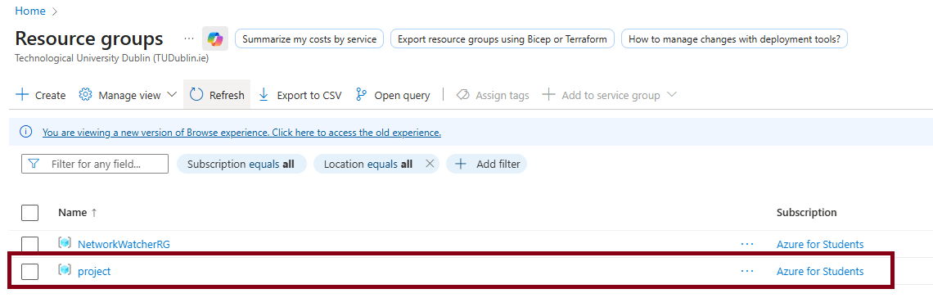
After creating the "Project" resource group, a Network Security Group (NSG) was created and added to this resource group. Three inbound traffic rules were configured within the NSG: SSH (port 22), HTTP (port 80), and HTTPS (port 443).

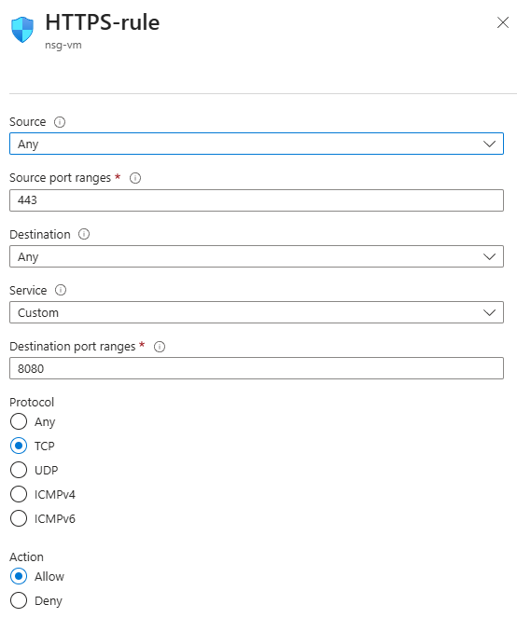
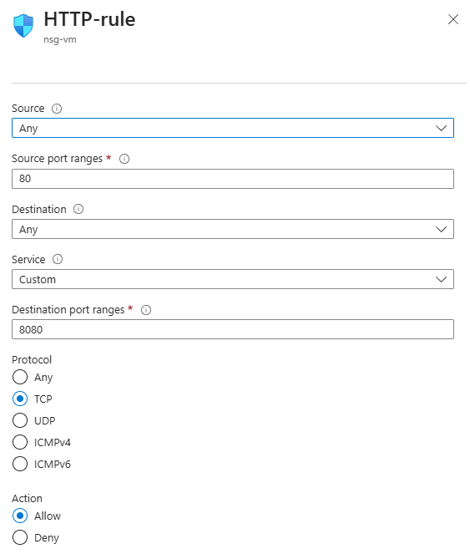
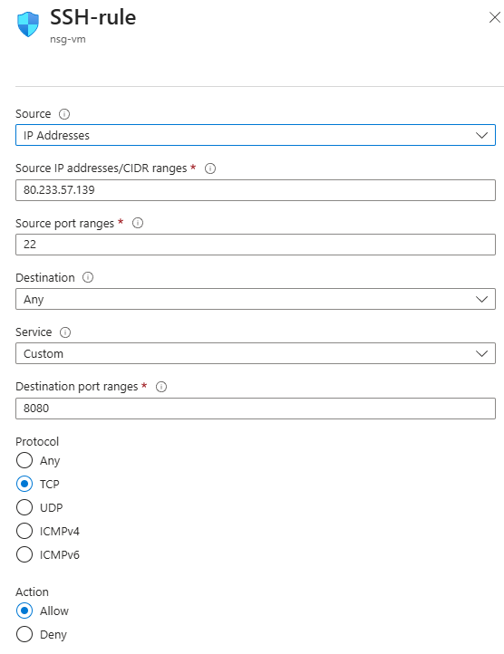

The next step was to create a virtual network (VNet), which was also added to the "Project" resource group. Two subnets were created within the virtual network:
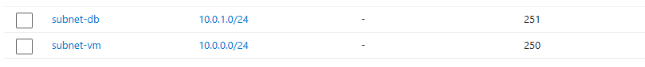
And a virtual machine (VM) was created, which was connected to the network through the Network security group settings.
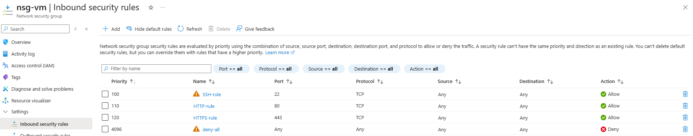
To implement the required architecture, a cloud database was deployed in Azure SQL Database. This database serves as the web application's primary data storage and is completely isolated from public access.
To comply with the requirement, public access to the database was completely disabled.
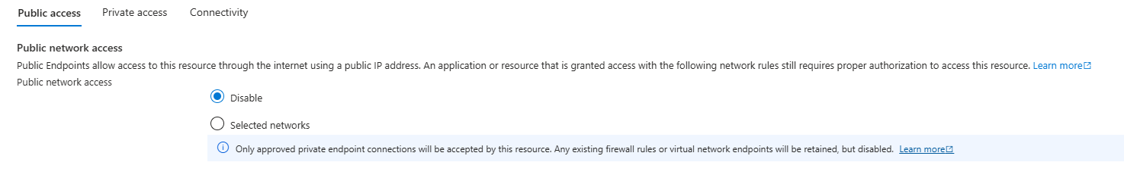
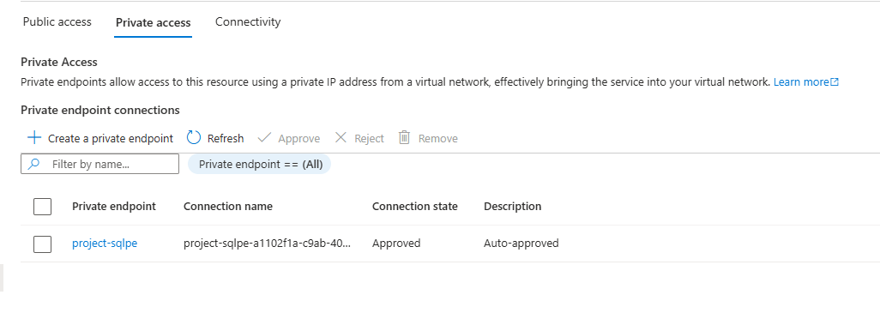
After creating all the necessary components, the following resources appeared in the Project resource group

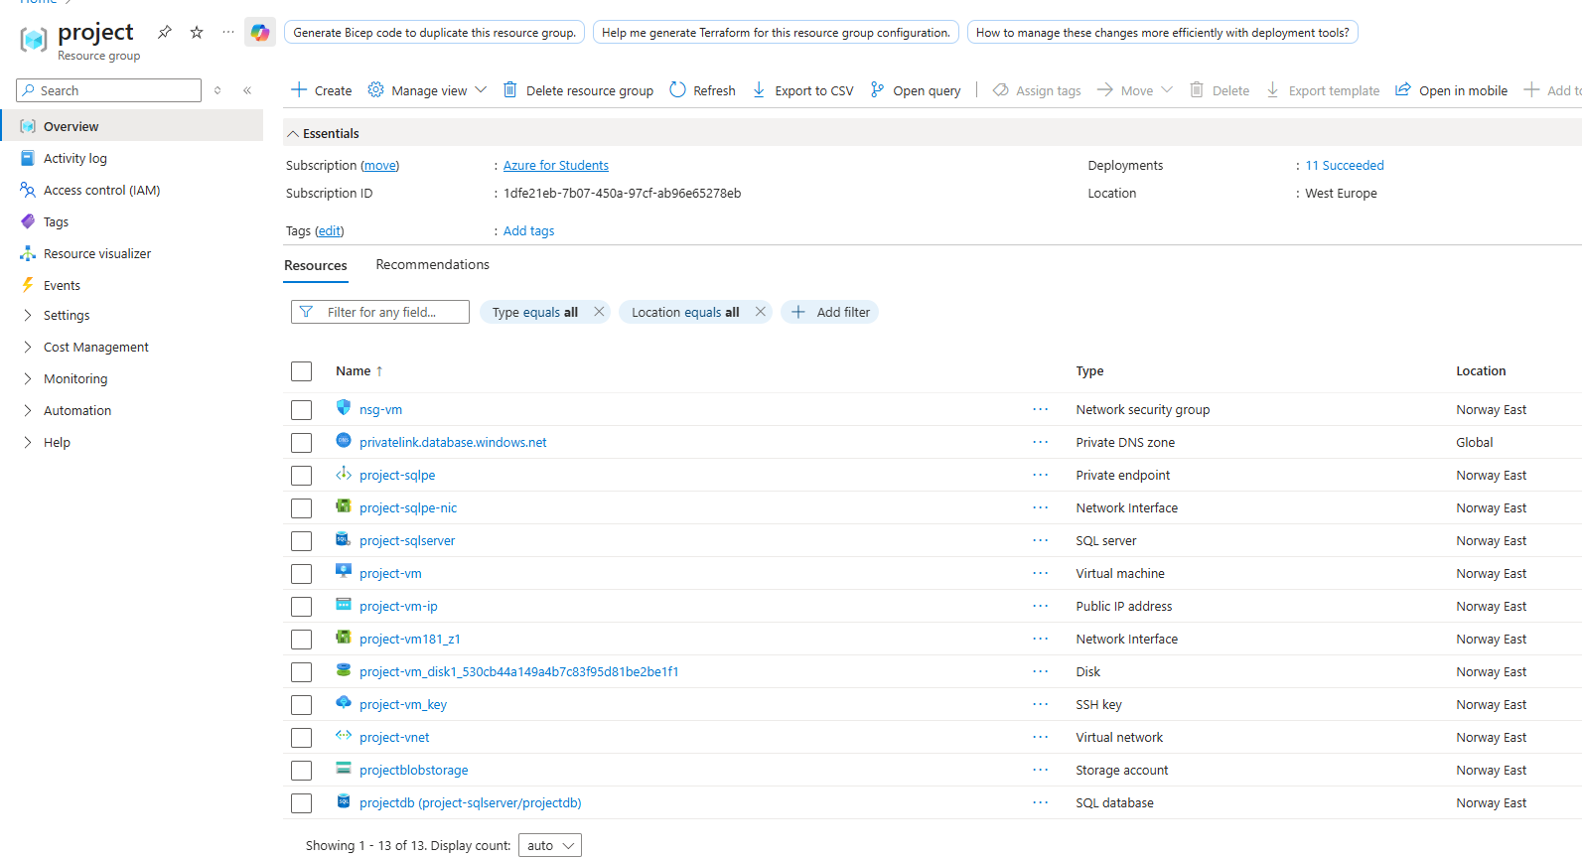
In total
A Resource Group is like a folder for all project resources.
I put all the main elements there: the virtual machine, database, network, and firewall. This is convenient because you can manage the entire infrastructure in one place and easily delete it if something goes wrong.
A Virtual Network is a private network in Azure, like a local network in an office. I created it so that the VMs and database could communicate securely with each other. I also divided the resources within the network into separate subnets to logically isolate the database and VMs.
Subnets are used to separate the network.
subnet-vm — for a virtual machine running a web application.
subnet-db — for a database, so it's isolated and inaccessible directly from the internet.
This separation helps improve security and control who can connect and from where.
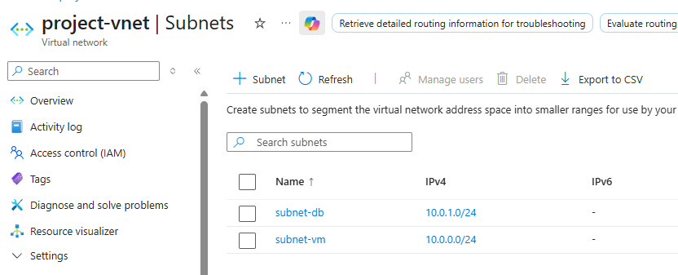
NSG (Network Security Group) is Azure's built-in firewall, which allows you to define rules for allowing and blocking traffic at the subnet or network interface level. For the VM, only the necessary ports were allowed: SSH (22) for server administration and HTTP/HTTPS (80/443) for web traffic. All other ports were blocked.
A VM is an Ubuntu Linux server running a web application.
It acts as an "intermediate layer": users access the VM, and the VM then connects to the database via a private network.
SQL Database - The database stores all application data: users, roles, information for CRUD operations.
Additionally, a Private Endpoint was used to ensure a secure connection to the database. Private Endpoint allows connection to Azure SQL Database via an internal virtual network IP address, eliminating the need for public access to the database. This enhances security and aligns with corporate data protection principles. This way, the database is completely isolated while still running the application. I made the container completely private so no one could access the files directly over the internet.
All these measures ensure that the web application can operate securely, and the database remains protected from potential external attacks. This architecture meets modern requirements for building secure cloud solutions and provides the ability to scale the project in the future without major infrastructure changes.
- Virtual Machine Configuration
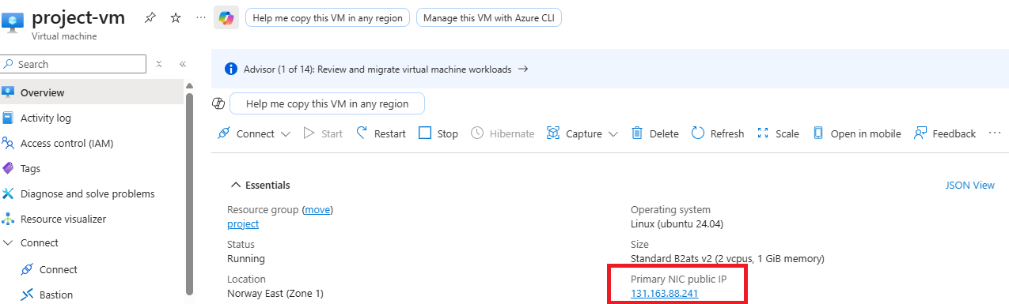
After successfully connecting to the Ubuntu virtual machine, we updated the system to the latest versions to ensure the latest security patches.
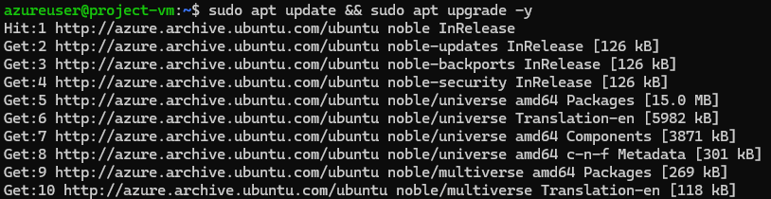
For security, we configured a firewall (UFW). All incoming connections are blocked by default, except for SSH (port 22), HTTP (port 80), and HTTPS (port 443). The remaining ports are blocked with deny-all.
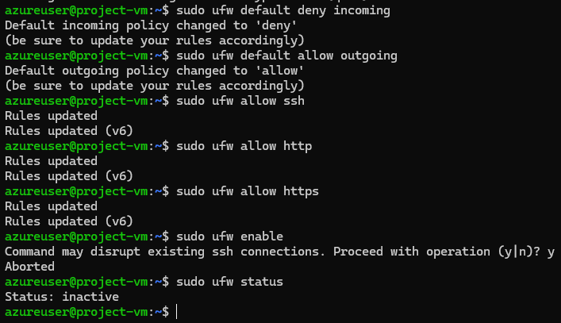
After the first attempt to connect to the database via a private endpoint from a virtual machine, a port connection test showed that the connection was not established. This occurred because the database subnet (subnet-db) initially did not have an assigned network security group (NSG), which controls access to network resources. 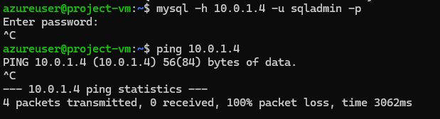
To remedy this, we created a new Network Security Group, named it nsg-db, and configured the following rules:
Allow incoming connections to port 1433 TCP (for SQL Database) only from the VM subnet (subnet-vm) and Deny all other connections. 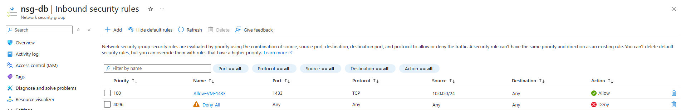
We then assigned nsg-db to the subnet-db subnet. A connection test from the virtual machine on port 1433 showed a successful connection.

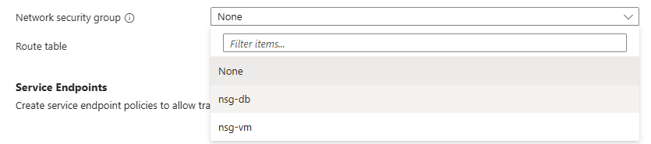
- SQL Database Setup and Integration
At this point, we connected to our projectdb database via a private endpoint from the virtual machine and began creating test tables for the web application.
First, we tested the existing databases.
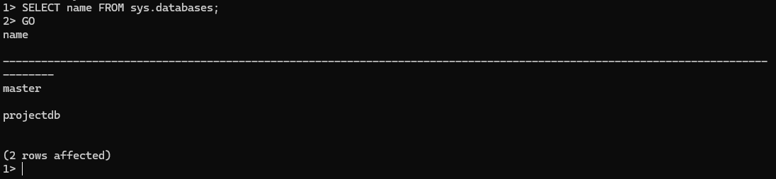
Initially, access to the projectdb database was denied due to insufficient permissions and an incorrect connection. After configuring network rules, assigning the correct role to the administrator user, and installing the necessary tools on the VM, the connection was successful.
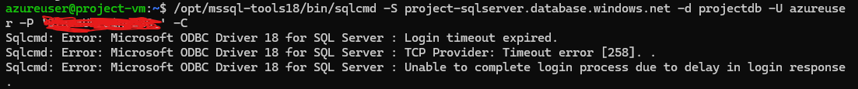(I blurred out the password because I used my own from Brightspace.)
To grant privileges, the user was assigned the dbmanager role, which allows creating databases, assigning users, and managing them.
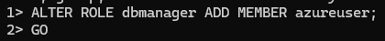
Next, I was able to go directly to the required database and perform a check:
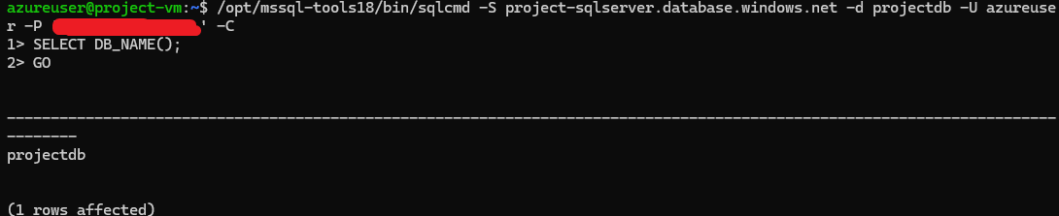
Using sqlcmd on the virtual machine, we created the Users table in the projectdb database. A check through information_schema.tables confirmed the table was created successfully.
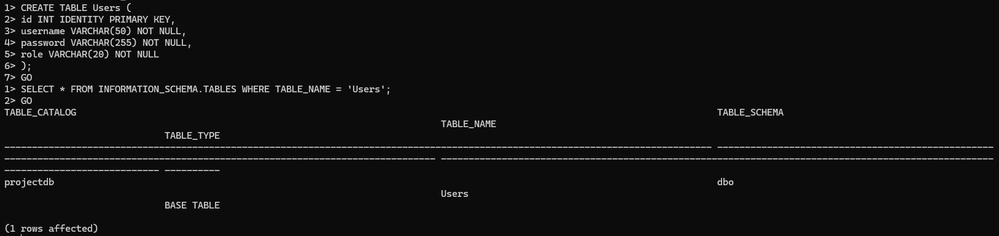
- Web Application Deployment
We need to prepare a working environment to run a Python web application.
First, update packages and install Python 3 using the commands: sudo apt update, sudo apt install python3 -y, pip install flask pyodbc (I close My CMD by accident, so no screenshots for this.)
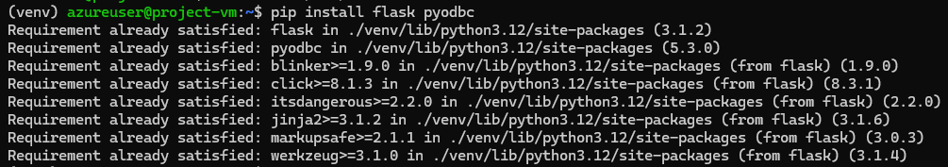
Installing packages via pip is blocked. Therefore, to ensure proper operation, a virtual environment was created using python3 -m venv, after which everything was installed into it.
On the VM, in the azureuser user's home folder, we created a folder for the project:
We created an app.py file at the root of the project. We added the minimal code to launch the web server:
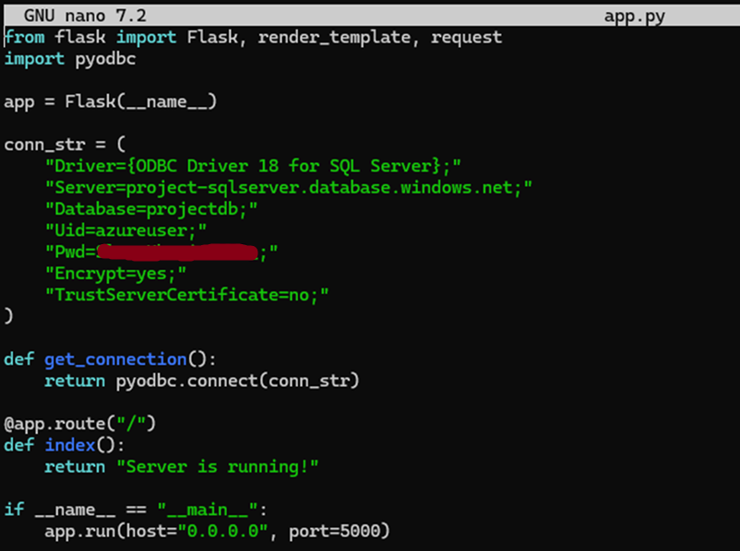
And launch the application with the command:
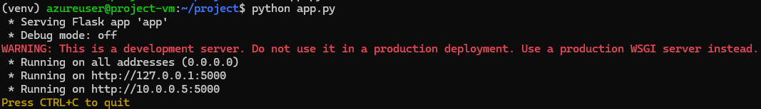The Flask server became accessible via the VM's internal IP and port 5000, and it was possible to verify that everything was working.

To make our Flask application accessible externally, we enabled the firewall on the VM and allowed incoming connections on port 5000:
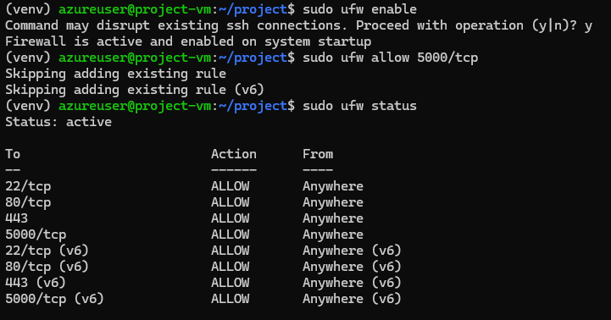
After this, a check revealed that port 5000 was open along with other standard ports. This allows users to connect to the application through a browser using the virtual machine's public IP and port 5000.
Before this, we created a rule in the Network security group
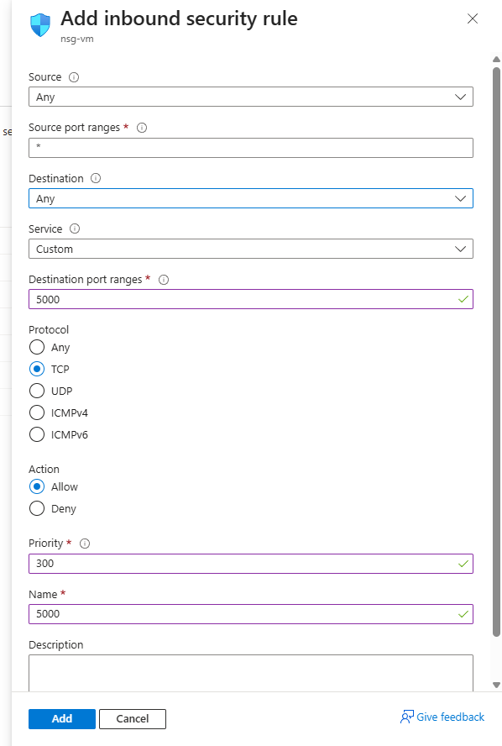
After that, we launched the application and checked through the browser - when switching to the IP of the virtual machine with port 5000, the message "Server is running!" is displayed.
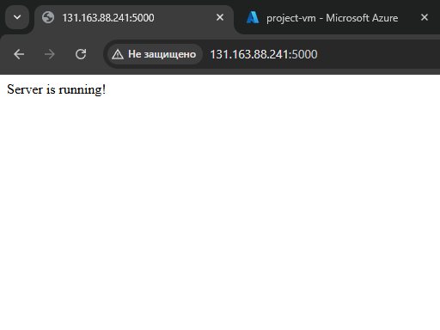

Thus, we have verified that the web server is running, ready to accept connections, and can be used for further integration with the database.
Using the sqlcmd command, we connected to the SQL server.
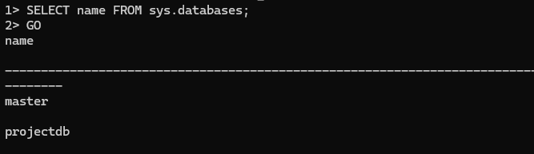
The output shows the master and projectdb databases, which confirms a successful connection and the presence of a target database for the project.
After creating the Users and Projects tables, we tested their functionality by adding a few records manually.
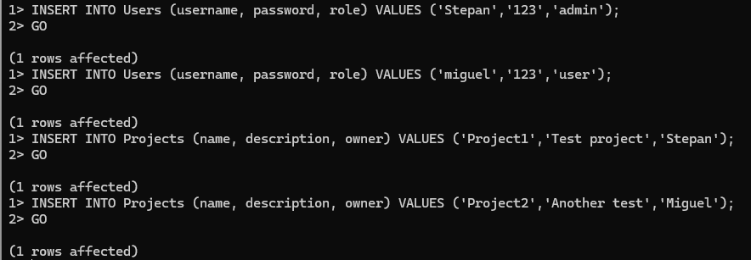
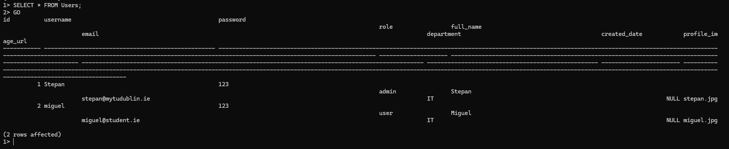
Initially, the application had a minimal HTML output without any design—only standard Flask forms. To add a full-fledged graphical interface, it was decided to adapt the project to the existing HTML templates (login.html and profile.html) used in labs.
As a result, the app received a fully functional user interface: a modern login form, a structured profile page, and a properly functioning data display, including photos. This made the app more user-friendly and visually understandable.
After integrating the new HTML templates, an error occurred due to the profile page expecting additional user fields. These columns weren't present in the original database, causing the application to return SQL errors when loading the profile. To resolve the issue, we updated the user table: we added the missing columns and populated them with test values.
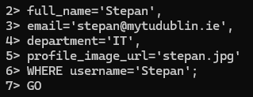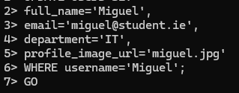

To upload custom images to the Azure VM, I used the built-in PowerShell scp command, which allows you to copy files over an SSH connection.
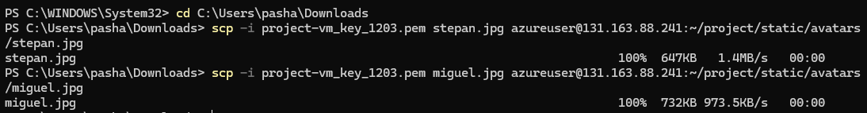
Where:
scp — command for secure file transfer over SSH
-i — flag for recursive folder upload
avatars — local folder with images
azureuser@131.163.88.241 — username and IP address of the virtual machine
/project/statjc/avatars/stepan(or Miguel).jpg/ — target path on the server

After completing all the settings, server configuration, database connection, and integration of new HTML templates, the web application now has a fully designed graphical interface. Now, when launching the site, a modern and user-friendly login page is displayed, and after logging in, a stylized user profile page with an avatar and personal information is displayed.
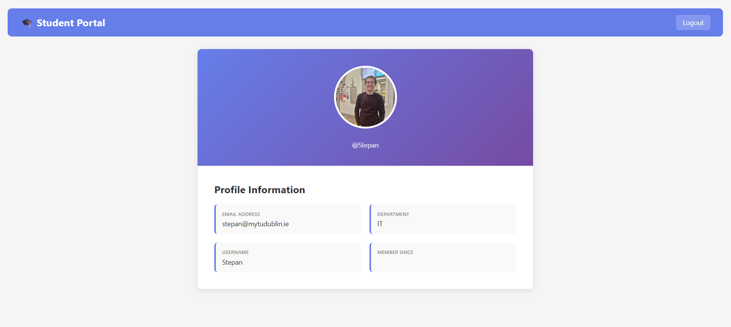

- Additional settings
To protect the server from brute-force attacks and unauthorized access, SSH was configured to prohibit password authentication and only allow key-based login. And minimize the risk of control access hijacking, remote login as the root user has been disabled.
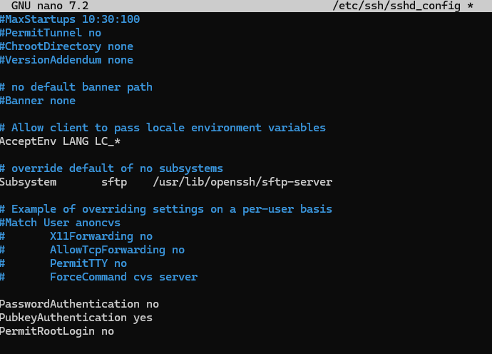
PasswordAuthentication no — Disables password login.
PubkeyAuthentication yes — Allows login only with SSH keys.
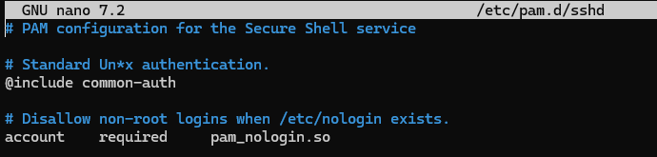
@include common-auth includes standard modules, including password restrictions.

The full OS security policy has been configured. This includes:
disabling weak passwords,
restricting repeated passwords,
password expiration,
locking out after multiple incorrect attempts.
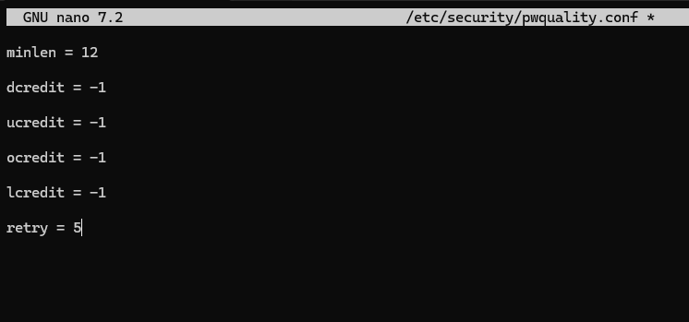
minlen = 12 — minimum password length
dcredit — digit requirements -1 Means the password must contain at least 1 digit
ucredit — uppercase letter requirements
lcredit — lowercase letter requirements
ocredit — special character requirements
In Azure, data encryption is enabled by default for nearly all core services, including Azure SQL Database, Azure Blob Storage, and virtual machine virtual disks. This is achieved through Transparent Data Encryption technology, which automatically encrypts all database files, transaction logs, and backups. The advantage of TDE is that the developer does not need to manually change the application logic—encryption occurs at the platform level, transparently and continuously, without impacting performance.
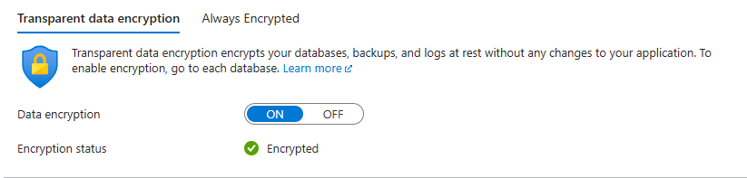
To ensure data encryption between the user and the web server, an HTTPS connection was configured. This ensures that logins, passwords, and other transmitted data are not transmitted in cleartext, as is the case with a standard HTTP connection. HTTPS uses the TLS protocol, which prevents third parties from intercepting or spoofing traffic.
To enable HTTPS on the Flask application, a self-signed SSL certificate was created. This certificate is not issued by an official certificate authority, but is perfectly suitable for educational purposes and testbeds, providing full traffic encryption.
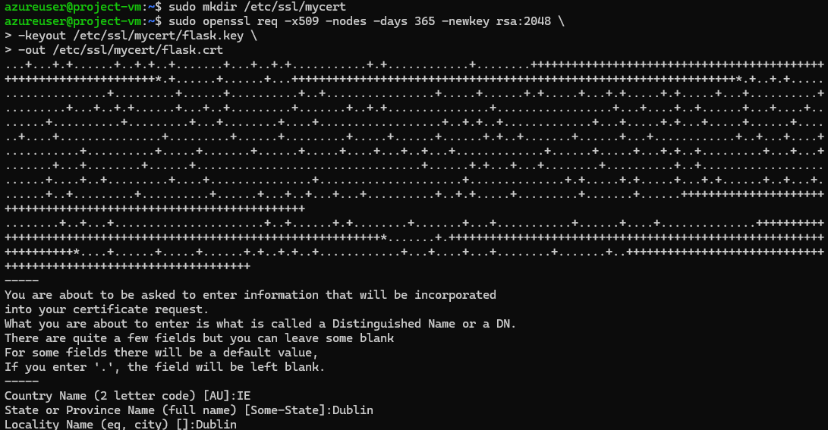
To improve the system's resilience to automated password guessing (brute-force attacks), the Fail2Ban utility was installed and configured on the server. It analyzes login logs and automatically blocks IP addresses that generate too many failed authentication attempts.
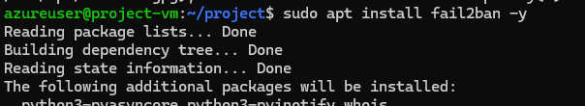
After installation, Fail2Ban begins monitoring SSH logs and, if suspicious activity is detected, temporarily blocks the intruder via built-in filters and iptables/ufw rules. This is especially important after disabling password authentication, as if password authentication is accidentally enabled or configuration errors occur, fail2ban will continue to protect the server.

One of the key elements of a secure server infrastructure is timely software updates. Security updates patch discovered vulnerabilities and prevent known attacks from being exploited by attackers. To ensure that all critical patches are installed automatically, an auto-update system was configured on the server.
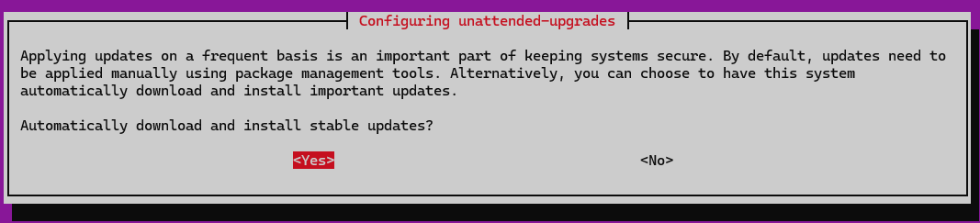
Once activated, the unattended-upgrades package automatically downloads and applies security updates without user intervention.

To ensure control over the system's state, promptly detect errors, and track suspicious activity, log monitoring was configured and tested. Log monitoring is a necessary element of any secure infrastructure, as it allows for the timely detection of attacks or technical failures.
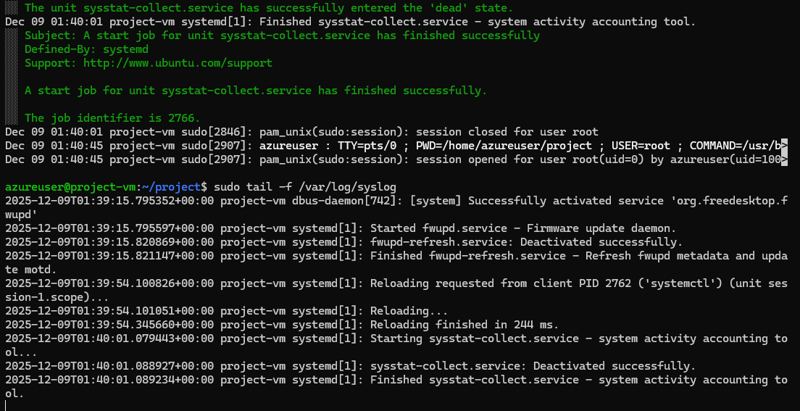
To prevent logs from growing uncontrollably and taking up all available disk space, log rotation was configured on the server using the built-in logrotate tool. It automatically archives old log files, deletes obsolete entries, and creates new log files.
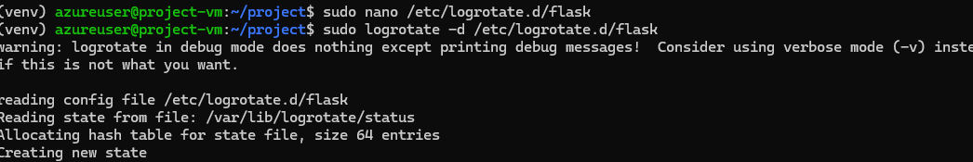

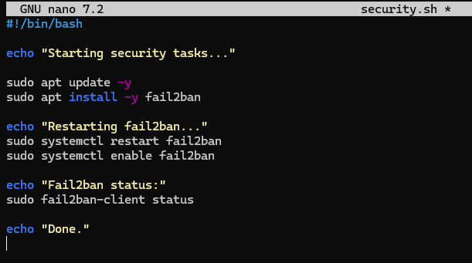
Perform the basic automation of security processes by creating a simple Bash script for installing and configuring the Fail2ban tool. The following script rapidly deploys basic protection against brute-force attacks on a server.
First, apt update is run to refresh the list of available packages and then make sure that the newest versions are installed. Then Fail2ban package installation will be automated. A popular log-based intrusion prevention and detection security tool, able to monitor log files and block IP addresses that show signs of malicious activities—repeated login attempt failures via SSH, for instance.
After the installation, the script restarts the Fail2ban service to correctly initialize it with its default settings. Further, it runs the command systemctl enable fail2ban, which sets up Fail2ban to start at system boot. This means protection will be turned on after every reboot of the server and is an important element in maintaining security over time.
Finally, the script displays the current status of Fail2ban by using the fail2ban-client status command so that you can be sure that fail2ban is up and running.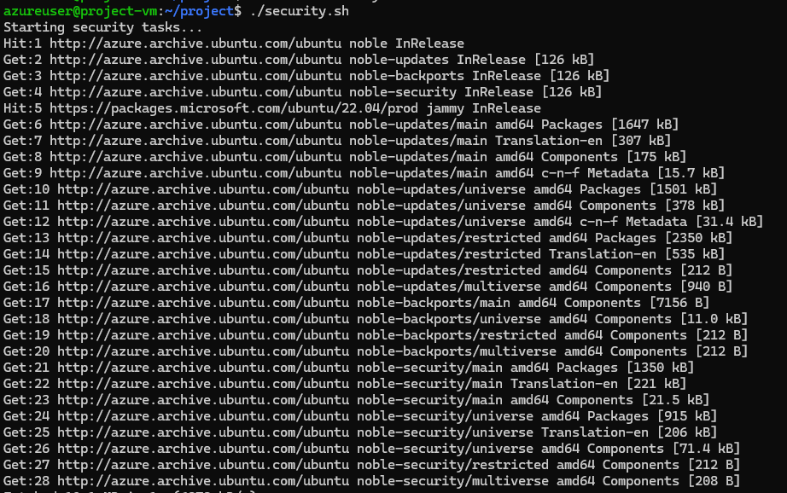
- Conclusion
It resulted in a fully functional web application that supported user authentication and integration with a cloud SQL database, using a modern graphical interface. The work involved different components and covered several important areas: from setting up the virtual machine, installing needed dependencies, to setting up the server environment, developing, and debugging of the Flask backend, creation of tables and data structures in Azure SQL Server, connection of HTML templates, and work with static files.
Therefore, the given project can be regarded as successfully completed. It let us not only meet the formal requirements but also acquire precious experience: from working with cloud infrastructure to integrating a web application with a database and developing a user interface. Knowledge and skills acquired will be helpful both in further training and in the course of creating more complex projects in a real-world setting.and developing a user interface. The knowledge and skills gained will be useful both in further training and when creating more complex projects in a real-world setting.

