TECHNICAL SEMINAR REPORT

THE BITCOIN NETWORK AND PROTOCOL

SAWAN SINGH MAHARA
1PE14EC128

VISVESVARAYA TECHNOLOGICAL UNIVERSITY

Belgaum-590014

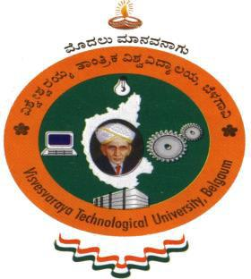

Seminar Report
On

“THE BITCOIN NETWORK AND PROTOCOL”
Submitted in partial fulfilment of the requirements for the VIII Semester

Bachelor of Engineering
IN
ELECTRONICS AND COMMUNICATION ENGINEERING

For the Academic year

2017-2018

BY

SAWAN SINGH MAHARA
(1PE14EC128)

UNDER THE GUIDANCE OF
CHIRANJEEVI G.N

Dept. of ECE, PESIT, BSC.



Department of Electronics and communication Engineering

PESIT, Bangalore South Campus

HOSUR ROAD BANGALORE-56010

PESIT, Bangalore South Campus
HOSUR ROAD

BANGALORE-560100

DEPARTMENT OF ELECTRONICS AND COMMUNICATION
ENGINEERING

CERTIFICATE

This is to certify that the seminar entitled “BITCOIN NETWORK AND PROTOCOL” is a bonafide work carried out by SAWAN SINGH MAHARA bearing register number 1PE14EC128. in partial fulfilment for the award of Degree of Bachelors (Bachelors of Engineering) in Electronics and communication Engineering of Visvesvaraya Technological University, Belgaum during the year 2017-2018.

Signatures:

Seminar Guide Head of the Department

Dr. Subhash Kulkarni

Asst. Professor Chiranjeevi G.N

HOD, ECE

PESIT, BSC
Bangalore-100

Examiners:

1.

2.

