**Базы данных**

**РК №1**

**Лумбунов Д.В. ИУ7-54Б**

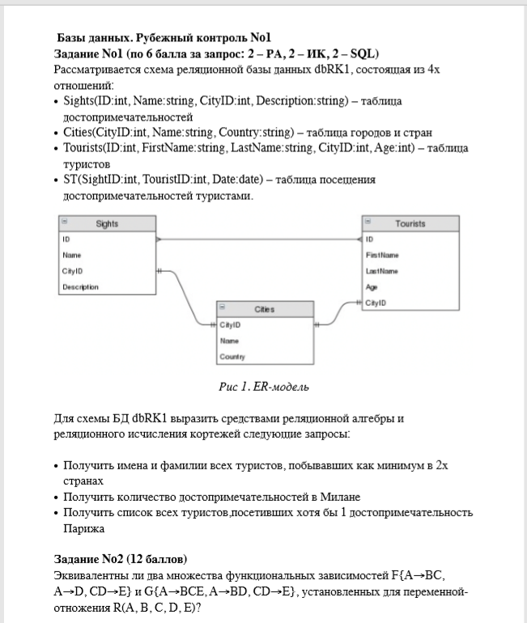

-- ЗАДАНИЕ 1

-- 1)

select ID, FirstName, LastName from (

select T.ID, T.FirstName, T.LastName, Country from

Sights S join Cities C on S.CityID = C.CityID as SC

join ST on ST.SightID = SC.ID as STSC

join Tourists T on STSC.TouristID = T.ID

group by T.ID, T.FirstName, T.LastName, Country)

group by T.ID, T.FirstName, T.LastName having count(*) > 1

-- 2)

select ammount from (

select C.CityID, C.Name, count(*) as amount from

Cities C join Sights S on C.CityID = S.CityID

group by C.CityID, C.Name) as CS

where CS.Name = 'Milan'

-- 3)

select T.ID, T.FirstName, T.LastName from (

select * from

Sights S join Cities C on S.CityID = C.CityID

where C.Name = 'Paris') as P

join ST on P.ID = ST.SightID as PST

join Tourists T on PST.TouristID = T.ID

-- ЗАДАНИЕ 2

/*

F{A->BC, A->D, CD->E}

G{A->BCE, A->BD, CD->E}

R{A,B,C,D,E}

1){A}+ = {A,B,C,D,E} A -> BCE, A -> BD

{CD}+ = {C,D,E} CD -> E

2){A}+ = {A,B,C,D,E} A -> BC, A -> D, CD -> E

{CD}+ = {C,D,E} CD -> E

НЕ ЭКВИВАЛЕНТНЫ

*/