Short term soil biotic assemblages are affected by harvesting, disc-trenching and blading with no additional effects of higher biomass utilization treatments.

* Emily Smenderovac (corresponding author), Great Lakes Forestry Centre, Natural Resources Canada, [emily.smenderovac@nrcan-rncan.gc.ca](mailto:emily.smenderovac@nrcan-rncan.gc.ca)

Jesse Hoage, Laurentian University, Natural Resources Canada, [Jesse.hoage@gmail.com](mailto:Jesse.hoage@gmail.com)

Teresita M. Porter, Centre for Biodiversity Genomics and Department of Integrative Biology, University of Guelph [terrimporter@gmail.com](mailto:terrimporter@gmail.com)

Rob Fleming, Great Lakes Forestry Centre, Natural Resources Canada, [rob.fleming@nrcan-rncan.gc.ca](mailto:rob.fleming@nrcan-rncan.gc.ca)

Nathan Basiliko, Laurentian University, [nbasiliko@laurentian.ca](mailto:nbasiliko@laurentian.ca)

Dave Morris, Centre for Northern Forest Ecosystem Research, Ontario Ministry of Northern Development, Mines, Natural Resources and Forestry, Thunder Bay CA P7E 2V6, [Dave.M.Morris@ontario.ca](mailto:Dave.M.Morris@ontario.ca)

Lisa Venier, Great Lakes Forestry Centre, Natural Resources Canada, [lisa.venier@nrcan-rncan.gc.ca](mailto:lisa.venier@nrcan-rncan.gc.ca)

2022-06-10

# Highlights

* Harvesting and forest floor removal alter Arthropod, Bacterial and Fungal Communities

# Abstract

# Key Words

Key words:

# 1 Introduction

Forest harvesting in Canada has continued to focus on traditional forest products (i.e., lumber, pulp and paper), with only a minor consideration in the bioenergy stream. While bioenergy has been part of the operational mix in forestry operations in the past (e.g., co-generation feedstock, small - to medium scale commercial and domestic pellet production facilities, some small-scale, community-based heat and power facilities) this market has remained small. The displacement of fossil fuels, and associated financial incentives, and associated financial incentives, may increase the demand for bioenergy products (Berch et al., 2011). One possible feedstock source of this additional wood biomass would likely be through intensification (i.e., high utilization of forest biomass in combination with the harvesting of feedstocks for traditional wood forest products) of existing harvesting operations, utilizing forest biomass that would otherwise be left on site or at roadside. This could be detrimental by removing biomass that would otherwise provide resources to the site, in a stump harvesting versus full tree harvesting, for example. Choosing forestry operations that responsibly increase yields requires evaluation of the ecosystem-level impacts of these high utilization practices.

Soil communities are becoming more widely considered as indicators of ecosystem change. Arthropods, bacteria and, fungi are represent components, and bottom up drivers, of well-functioning forest ecosystems, but have the potential to be strongly influenced by changes in the amount of woody residues remaining after disturbance. While all three of these groups have direct connections with woody substrates, each group also reflect ecosystem-level changes that are related to structural or physical changes that are linked to different biomass retention strategies. In terms of sensitive taxa, arthropod, bacteria, fungi and their functional responses are known to be responsive to moisture and oxygen availability within soil. The addition of woody biomass can result in increased shading, changes in albedo, reduced compaction and provide key habitat features (Venier et al., 2017). All of these factors, individually or collectively, can influence community composition, but generally, any ecological effects should first be detected in the smaller, lower trophic level groups. Small, lower trophic level organisms tend to respond more quickly to change because of fast generation times when conditions and resources selectively enrich from a vast diversity of quiescent taxa and larger populations: e.g., it is estimated that there are up to 1010 bacteria in a small sample of soil, comprising up to 106 distinct taxa (Torsvik and Øvreås, 2002; Whitman et al., 1998).

While clearcut harvesting can affect microbial community composition, past studies examining gradients of biomass removals have reported minimal additional effects on community composition or function (Smenderovac et al., 2017). It seems reasonable to assume that the effects of clearcut harvesting, when compared to the uncut forest are so large, that additional biomass removal or retention does not buffer or intensify any biotic community response in the short term.

The disturbances caused by to clearcut harvesting are not only restricted to biomass removal effects. Greater disturbance footprints can also result in changes to hydrology, soil upheaval and changes to the microtopography of the land (e.g. soil turned over into ‘piles’ or patchy distributions of woody debris) (Löf et al., 2012). Often, in managed forests, site preparation is used to reduce vegetation competition for planted seedlings (e.g., Disc trenching is a site preparation technique commonly applied in Canada)(Sutherland and Foreman, 1995). These techniques introduce distinct topographic features to sites, and disturb existing soil structure. These microtopographic features can result in measurable changes in nutrient distribution (Johansson, 1994), which could result in community structures, and the specific changes in these features can be lost in site-level assessments (Levy-Booth et al., 2016; Schmidtl et al., 1996).

In respect to the microtopographic impacts of forest site preparation, soil biotic responses have been less studied than larger overall responses to silvicultural activities. There are expectations that there would be biodiversity impacts from site preparation, as various soil horizons are known to harbour different soil communities (Chaves Cardoso et al., 2020; Frey et al., 2021). These mechanisms of disturbance can also result in differences in localized microclimate conditions and nutrient reserves; e.g., removal of organic horizons may reduce the water holding capacity, rendering soils more susceptible to water loss during drought conditions and, altering decomposition rates (Jiménez Esquilín et al., 2008; Löf et al., 2012; Webster et al., 2016). It is important to represent these mechanisms to ensure that the results of treatment-level studies are considered in the appropriate context given the selected sampling season and topographic features included in the overall sampling design.

Advancements in high throughput DNA sequencing technology have greatly increased the sensitivity of these techniques, and increased their affordability, and they are being increasingly applied to forest systems as a result. Even today, most soil samples remain dominated by unknown bacteria, fungi and soil invertebrates, which have not been detected or documented through traditional techniques (Mishra et al., 2022). However, through the use of DNA DNA metabarcoding and high-throughput sequencing, we can evaluate whether soil organisms are responding to direct or indirect effects of intensification. Of particular relevance, these technologies may assist in the detection of subtle community responses in early-stage studies that were not possible using traditional techniques. Used alongside enzyme activities to assess functional response, these techniques provide enhanced insights into short-term responses.

Our overall goal was to assess whether forest harvesting intensity results in soil biota change, and whether our sampling design influenced the interpreted results of the study. First, we assessed whether five different harvesting intensities/soil disturbance levels resulted in different community compositions and functional responses. Secondly, we assessed whether the choice of topographic features included in our sampling design had an influence in the interpretation of our results to the extent of altering our conclusions. Thirdly, we assessed whether the timing of our sampling was the best option for capturing the changes in temperature and moisture sensitive community members.

## 1.1 Hypotheses

1. Compared to Full-tree harvesting, further increased biomass removal (i.e., Stump removal or Blading) has impacts on soil communities, whereas reduced biomass removal (i.e., Tree-length harvesting) results in a shift closer to uncut conditions.
2. Disc trenching affects community structure related to the resulting microtopographic features and the redistribution of organic soil results has different impacts than complete removal of organic components (i.e. Blading).
3. Seasonal effects are important, and influence the interpretation of results.

# 2 Methods

## 2.1 Site description

This study was conducted at the Island Lake Biomass Trials in Chapleau, Ontario, which are previously well described(Kwiaton et al., 2014; Venier et al., 2017). In brief, the study site is located near Chapleau, Ontario and was established on a 40 year old second growth jack pine stand. Plots (70 m by 35 m) were harvested in the winters of 2010-2011 with four increasing levels of biomass removal 1) stem-only (leaving the crowns of harvested trees), 2) full-tree (removing the above ground tree biomass), 3) full-tree biomass with stump removal, 4) blading (removal of all biomass including stumps, downed woody debris and forest floor). All treatments had five replicate plots, and nearby forest was kept in-tact, and uncut control plots were established (2.1). All plots (excluding bladed plots) were prepared using disc-trenching. Plots were split and planted with jack pine and black spruce in May 2012.

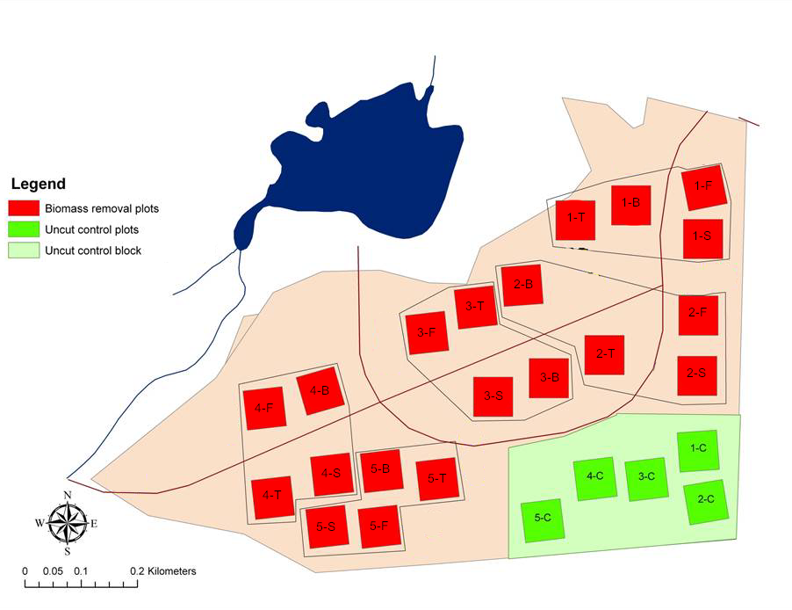

Figure 2.1: Map of the Island Lake Biomass Harvest Research and Demonstration Area, modified from Kwiaton et al, (2014) Figure 2.4. For the biomass removal plots, the numbers indicate the block number and the letters indicate the harvest treatment: T = Tree Length, F = Full-tree, S = Stump removal, B = Bladed, C = Uncut Control.

## 2.2 Soil sampling

The organic horizons (i.e., Litter and fermentation-humus horizons) and upper mineral soil were sampled during the 2016 growing season. Each soil sample was collected in a 5cm diameter PVC pipe to a depth of 10 cm. PVC pipes were sanitized with bleach before sampling was performed. All sampling was completed with gloves to reduce cross-contamination. Samples were immediately frozen at -20˚C after sampling and held at that temperature until analysis. All samples were shipped to the Great Lakes Forestry Centre (Sault Ste. Marie) where soils were split into organic and mineral horizons and homogenized according to the experimental design (see below), and subsamples were taken for enzyme and metabarcoding analyses.

Sampling for three separate hypotheses were conducted on the biomass harvesting sites. Harvesting samples were collected from soils in August 2016 from unharvested sites and from the flats of four harvesting treatments: stem only, where only the stem of the tree were removed from site; full tree, where all of the above-ground biomass including branches were removed; stumped, where stumps were removed from the ground with a back-hoe in addition to full-tree harvest; and, bladed, where all organic material was scraped from the surface of the soil. Topographic samples were collected in June 2016 from full tree sites, from three topographic features: flats, where the soil horizons were not disturbed by disc trenching; piles, the mixed organic and mineral horizon created from the digging of trenches; and, trenches, which consisted of troughs of exposed mineral soil. Seasonal sampling was conducted on the flats of full tree and on the soils of unharvested plots in June, August and October 2016.

## 2.3 Sample Processing

One homogenized soil core was taken for each treatment at each block of each site. Soil cores from all samples were split into organic and mineral fractions and homogenized separately. For biomass harvesting treatments, and for temporal analysis, an organic/mineral soil composite was made by combining 2.5g of both organic and mineral homogenized soils in a clean bag. For microtopography flat samples, the proportion of organic and mineral soils in the sample core were recorded before separation, and re-combined by weight in proportions matching the original proportions in the soil core to a total sample weight of 1g into a clean sample bag. Microtopography pile and trench samples did not have any distinguishable soil horizons in the top 10 cm, 1g of each soil core was sampled into a clean sample bag.

## 2.4 Enzyme Analyses

Enzyme analyses were performed for the ecologically important enzymes N-acetylglucosaminidase (NAG), phosphatase (PHOS) and xylosidase (XY). All enzyme activities were performed in 96-well plates under controlled conditions using 4-methylumbelliferone-fluorescence tagged substrates (pH 5 and room temperature) and measured with a BioTek Synergy H1 Hybrid spectrophotometer/fluorometer. Incubation times were based on time-trials conducted on a subset of samples. Samples were stored at -20˚C prior to analysis via existing protocols (Findlay, 2007; Saiya-Cork et al., 2002).

## 2.5 Metabarcoding

DNA extractions were performed using 0.25g of homogenized bulk soil samples using Qiagen DNEasy Powersoil extraction kits. Extracted DNA was then amplified using primers targeted for specific groups of organisms (Supplemental Materials, Tables S1.1, S1.2). Paired-end sequencing for Arthropods (F230), Fungi (ITS), general Eukaryotes (18S) and Bacteria (16S) were performed on the Illumina MiSeq platform in the Hajibabaei lab at the Centre for Biodiversity Genomics, University of Guelph. A total of ~113 million paired-end reads were generated from 4 amplicons (Supplemental Materials, Table S1.3). Data was processed into ESVs (Exact Sequence Variants) using the MetaWorks pipeline v1.4.0 (Porter and Hajibabaei, 2020). Sequence retention details are provided in Tables S1.3 and S1.4 of the Supplemental Materials. Samples with less than 1000 reads were removed. Taxonomic assignments with at least 80% accuracy were retained using the bootstrap cutoff values for the ITS, COI and 18S classifiers genus level for 300 bp reads. We used a cut off value of 80% for the 16S region as recommended by the RDP classifier documentation. Taxonomy of 16S data was assigned using the RDP 2.1.3 database included with MetaWorksv1.4.0. Taxonomic assignment of 18S sequences was completed with SILVA 138 SSURef Nr99 trained to work with the RDP 2.13 classifier (Wang et al., 2007). F230 sequences were classified using the CO1 Classifier v4 (Porter and Hajibabaei, 2018). ITS sequences were classified with the UNITE v8.2 ITS reference set database(Kõljalg et al., 2019; Porter, 2020). Functional guilds were assigned through FAPROTAX (16S), FUNGuild (ITS) or using the BETSI database (F230) (Hedde et al., 2012; Louca et al., 2016; Nguyen et al., 2016). A summary of the percent of ESVs identified to Genus using the appropriate cut-off values are provided in Table S1.5 of the Supplemental Materials.

## 2.6 Statistical analysis

All statistical analyses were performed in R, with graphics construction in ggplot2 and ggpubr Kassambara (2020).

The following were performed on each metabarcoding dataset before subsequent analysis: Shannon, Inverse Simpsons, and richness diversity metrics were calculated using the diversity and specnumber functions in the vegan package (Oksanen et al., 2020), on relative abundance (Bacterial 16S) or presence-absence data (Fungal ITS, Arthropod F230, Eukaryote 18S); Centred-log-ratio values were computed for each experimental set of samples for compositional PCA and RDA analyses by subtracting the log of the mean relative abundance (with zeros replaced with 0.5) for each sample from the log of the relative abundance of each ESV in each sample (Aitchison et al., 2000). In order to assess if this approach introduced biases RDA, and PCA analyses were also performed on clr transformed datasets rarefied to the 15th percentile of sample counts, and on Bray Curtis distances of relative abundance (Bacterial 16S) or Jaccard distances of presence-absence data (Fungal ITS, Arthropod F230, Eukaryote 18S) (Supplemental Rarefied Analyses, Supplemental Traditional Analyses). Diversity metrics were also assessed on the rarefied datasets (Supplemental Rarefied Analyses).

Enzyme activities were assessed with ANOVA using harvesting intensity as a predictor with the orthogonal contrasts outlined in Table 2.1. Bladed samples were included in the analysis of topographic features as a comparison to trench disturbance. The diversity metrics for each metabarcoding target (i.e., 16S, 18S, ITS, or F230) were assessed using the orthogonal contrasts outlined in Tables 2.1 and 2.2, while seasonal trends were assessed with a mixed-model anova which included a harvest and seasonal interaction term.

Table 2.1: Orthogonal contrasts used to test effects of harvest intensity.

| Code | Contrast | Tests |
| --- | --- | --- |
| H.UC | Stem-Only, Full tree and Stumped vs Uncut control | Effect of tree removal |
| FFR | Bladed vs Stem-Only, Full tree and Stumped | Effect of forest floor removal |
| BGBR | Stumped vs Stem-Only and Full tree | Effect of below-ground woody biomass removal |
| FT.SO | Full tree vs Stem-Only | Effect of fine and coarse woody debris retention vs only coarse wood |

Table 2.2: Orthogonal contrasts used to test differences between topographic features.

| Code | Contrast | Tests |
| --- | --- | --- |
| T.B | Trench vs Bladed | Are effects of forest floor removal buffered in trenches |
| Ex.Mix | Trench vs Piles and Flats | Effect exposing mineral soil via relocation of organic layer to piles |
| Mix.St | Pile vs Flats | Effect of mixing of soil layers in piles |

PCA was performed on compositional data for harvesting samples, topographic or seasonal samples and graphed for visual examination. Pairwise PERMANOVA and betadispersion of the compositional community structures were calculated via the adonis and betadisper functions in vegan, using the comparisons outlined in Table 2.1 and 2.2 or PERMANOVA with a harvest-season interaction term followed by pairwise PERMANOVA. RDA with harvesting, topography or season as a constraining variable was used to confirm PERMANOVA results. ALDEx2 glm modelling was also performed, using the comparisons outlined in Table 2.1 and 2.2 or with a model including a harvest-season interaction term. ESVs with significant differences in response to treatments were visualized as heatmaps, for seasonal analyses, sites were clustered using wards agglomerative hierarchical clustering.

# 3 Results

## 3.1 Harvest Intensity

### 3.1.1 Enzyme Activity

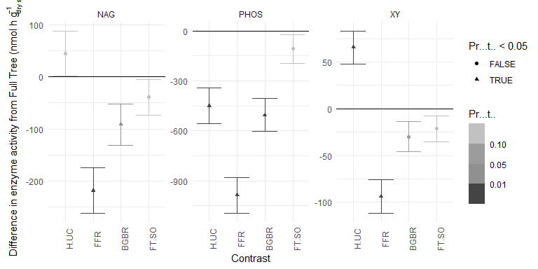

Figure 3.1: Difference in enzyme activity based on orthogonal contrasts defined in Table 2.1. Significance is indicated with colour (darker are more significant) and shape (triangles are significant at p < 0.05 and circles are not significant at p < 0.05. Values higher than zero indicate there was an increase in activity from the treatment, values lower than zero indicate there was a decrease in activity from the treatment.

NAG activity was significantly decreased by forest floor removal and below-ground biomass removal. PHOS activity was significantly decreased by harvesting, forest floor removal and below ground biomass removal. XY activity was significantly decreased by forest floor removal, but significantly increased by harvesting alone. No enzyme activity had a significant response to fine woody biomass retention in stem-only plots (Fig 3.1).

### 3.1.2 Diversity and Community Structure

Largely, diversity metrics did not have significant responses to the harvesting disturbance. Harvesting significantly (p < 0.05) decreased arthropod (F230) diversity metrics compared to unharvested treatments, and increased fungal (ITS) richness and inverse Simpsons diversity. Forest floor removal significantly decreased eukaryotic (18S) and arthropod (F230) diversity metrics and Fungal (ITS) richness and inverse Simpson’s diversity, but increased bacterial (16S) richness. There were no significant responses of any diversity metrics to below-ground biomass removal or retention of fine woody debris (Stump or Tree-length treatments) (Supplemental Materials, Fig 2.3).

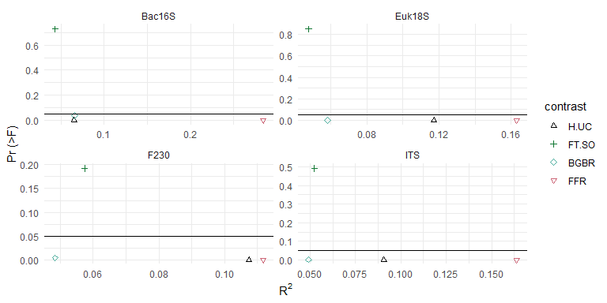

Figure 3.2: Results of community structure PERMANOVA tests performed with the orthogonal contrasts described in Table 2.1. The variance explained by each comparison (R2) is shown on the x axis, and the probability of the effect is ahown on the y axis (Pr (>F)). A black line is used to display p = 0.05.

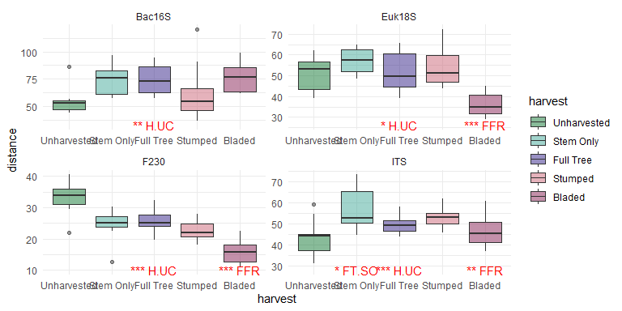

Figure 3.3: Results of betadispersion tests comparing community structures of the different harvesting treatments. The betadispersion of each treatment is shown on the y axis, and the treatment is shown along the x axis. Significant contrast tests as outlined in Table 2.1 harvesting are indicated in red (* = p < 0.05, ** = p < 0.01, *** = p < 0.001).

Intensification of harvesting from full tree harvesting resulted in significant changes to community compositional structure in all metabarcoding communities. While both below-ground biomass removal and forest floor removal resulted in significant changes, the amount of variance explained by forest floor removal was much greater (below-ground biomass removal explained ~0.1 or less of the variance) (Fig 3.2). Some of this variance was due to differences in dispersion, but the average composition of the bladed treatments was different from that of the other harvested treatments, (i.e., in 18S and F230 communities, where bladed community compositions were more consistent, and had a different average composition than full tree treatments) (Fig 3.3, Supplemental Materials 2.1.2, 2.1.3). The average compositional structure and betadispersion of the unharvested forest was also significantly different from that of the harvested treatments. The amount of variance explained by harvesting were lower, generally less than 0.15, in each of the communities assessed.

### 3.1.3 Differences in specific organisms

The ESVs that had significant compositional differences were responding to harvesting or forest floor removal. There were no ESVs that differed between full-tree and stem only removal, and only one Eukaryotic (18S) ESV that responded to below-ground biomass removal (Supplemental Materials 2.1.4). There was only one arthropod ESV that had any significant compositional change. The bacterial genii that were a higher compositional component after forest floor removal had characteristics indicative of nutrient limitation, low oxygen, and high temperatures (e.g., *Chloracidobacterium* and *Blastochloris* are photoheterotrophs; *Aggregicoccus* and *Fimbriiglobus* have chitinolytic or microbial lytic capabilities; *Thermoanaerothrix* and *Thermoflexus* can be moderately thermophilic; *Anaeromyxobacter*, *Thermanaerothrix*, *Syntrophaceticus* all have anaerobic or facultatively anaerobic metabolism)(Dedysh, 2020; Imhoff, 2020; Reichenbach, 2015; Schnürer et al., 2018; Sood et al., 2015; Tank et al., 2018; Watanabe et al., 2015; Yamada and Sekiguchi, 2018). Bacterial genii that were lower in bladed sites were typically chemoheterotrophic (e.g., *Acidipila*, *Edaphobacter*, *Povalibacter*) and most were aerophilic(Hiraishi, 2019; Nogi et al., 2014; Thrash and Coates, 2015). Fungal ESVs lower after forest floor removal were generally saprotrophic, with a notable increase in species associated with decay of fruits (i.e. *Geminibasidium*, *Collophora*) while the ESVs that were decreased in bladed treatments were wood saprotrophs or plant pathogens (e.g., *Auriculariales*, *Agaricomycetes*, **Trametes*,* Trechispora*,* Mortierella*)(Ainsworth, 2008). Unharvested sites had increased dominance of the mycorrhizal fungi* Tricholoma*,* Cortinarius* and *Hygrophorus* compared to harvested sites. Eukaryotic (18S) ESVs that decreased with forest floor removal were generally associated with aquatic or high-moisture environments (e.g., the algae and bacteriovorus organisms *Limnognathia*, *Orciraptor* and *Viridiraptor*; the aquatic invertebrate *Rotaria*) (Hess and Melkonian, 2013). ESVs identified as mosses (i.e., *Pohlia*, *Pottia* and *Rosulabryum*) were a higher compositional dominance after forest floor removal (Klips, 2017).

## 3.2 Topographic differences

### 3.2.1 Diversity and Community Structure

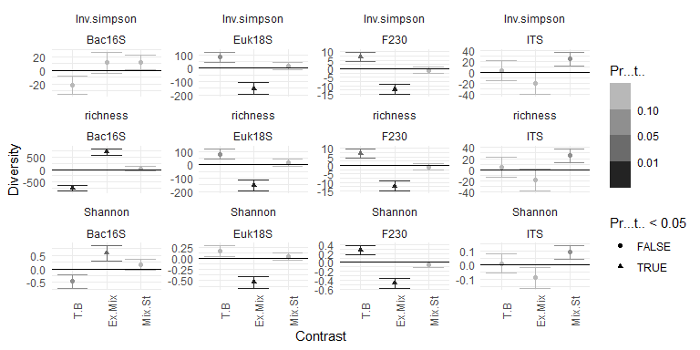

Figure 3.4: Orthogonal contrasts between microtopography features as described in Table 2.2. Values lower than zero indicate the effect is a decrease in diversity, values higher than zero indicate increased diversity as an effect.

Bladed and trench features were not significantly different aside from lower bacterial richness, and higher arthropod diversity for all metrics in trench features. There were lower eukaryotic and arthropod diversity and richness for all metrics, but increased bacterial richness and Shannon diversity in the trenches as opposed to flat areas and piles following disc scarification. There were no significant differences for any fungal (ITS) diversity metrics, or between flat and pile features for any metabarcoding group (Fig 3.4).

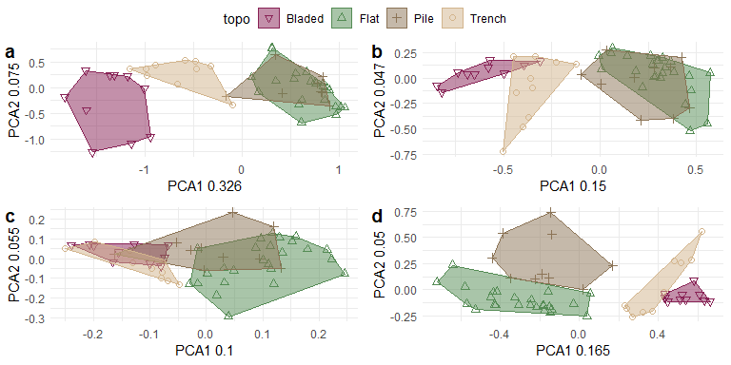

Figure 3.5: Principal Components Analysis of metabarcoding compositional community structure for a) Bacterial 16S, b) Fungal ITS, c) Arthropod F230 d) Eukaryotic 18S. Bladed sites are displayed in maroon as downward facing triangles, Flats are displayed in green with upwards facing triangles, piles are displayed in brown as + symbols, trench communities are displayed as tan circles. Hulls encompass all the observed communities of each microsite type.

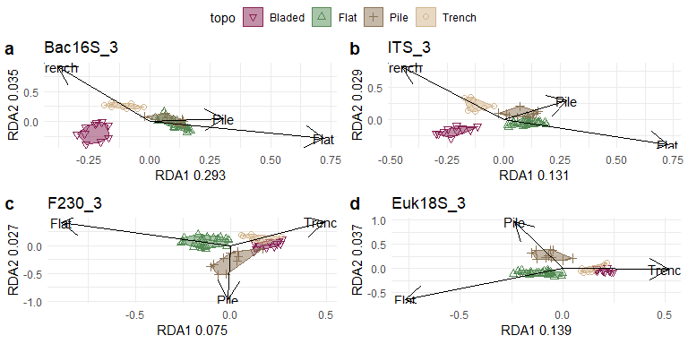

Figure 3.6: Redundancy Analysis of metabarcoding compositional community structure for a) Bacterial 16S, b) Fungal ITS, c) Arthropod F230 d) Eukaryotic 18S. Bladed sites are displayed in maroon as downward facing triangles, Flats are displayed in green with upwards facing triangles, piles are displayed in brown as + symbols, trench communities are displayed as tan circles. Hulls encompass all the observed communities of each microsite type. Black arrows represent the direction associated to particular features.

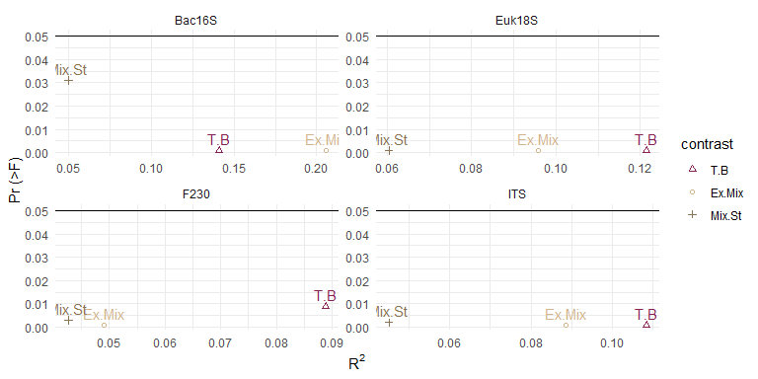

Figure 3.7: Results of orthogonal PERMANOVA tests comparing community structures of the different microtopography features and Bladed sites,orthogonal contrasts are outlined in Table 2.2. The variance explained by each comparison (R2) is shown on the x axis, and the probability of the effect is along the y axis (Pr (>F)). A black line is used to display p = 0.05.

PCA of Aitchison distances showed community compositions that were mostly distinct between microtopography features. There were some instances of overlaps between microtopographic features: Bacterial 16S and Fungal ITS pile and flat communities and, Eukaryotic 18S trench and bladed features (Fig 3.5). Across all metabarcoding communities, the RDA axes associated with the most explainable variance were associated with trench features. The bacterial community showed the greatest differences between the trench and flat features, with 20% of the community variance explained by the trench axis (Fig 3.6).

Comparisons of community compositions from features between trench soils to soils with organic components (piles and flats) generally explained between 9 - 20 % of variance. Trench-Bladed differences were also, generally, larger. The bacterial (16S) community was the most responsive, with ~ 20% of the community variance explained by mineral soil exposure in trenches, and greater than 10% of community variance explained by the bladed comparisons to trench features (Fig 3.7). The smallest amount of explained variance was associated with the arthropod (F230) community. Much of the difference in variance in these communities was due to differences in average community composition, but some of the difference in arthropod (F230) and eukaryotic (18S) communities was attributed to lower betadispersion in trench and bladed features (Supplemental Materials 2.2.2).

### 3.2.2 Differences in specific organisms

ESVs were only significantly different in Trench-Bladed comparisons and exposure of mineral soil in trenches compared to pile and flat features. Most of the bacteria and fungi that were associated with exposure of mineral soil were increased in compositional abundance. In contrast, eukaryotic organisms generally had decreased compositional abundance in the exposed mineral soil in trenched and arthropods only had one ESV that was significantly associated with (Supplemental Materials 2.2.4). The organisms that had changes in compositional abundance in trenches compared to flats and piles were largely consistent with those that were decreased due to forest floor removal (e.g, *Acidibacter*, *Anaeromyxobacter*, *Thermanaerothrix*, *Rhizoclasmatium*, *Collophora*, *Rhizoscyphus*, *Orciraptor*, *Viridiraptor*). There were some generalist soil bacteria that were of decreased compositional dominance in the trench microenvironments compared to bladed (i.e., *Spartobacteria*, *Gemmatimonas*, *Aliidongia*) as well as one mycorrhizal fungi *Cortinarius*.

## 3.3 Seasonal Patterns

### 3.3.1 Diversity and Community Structure

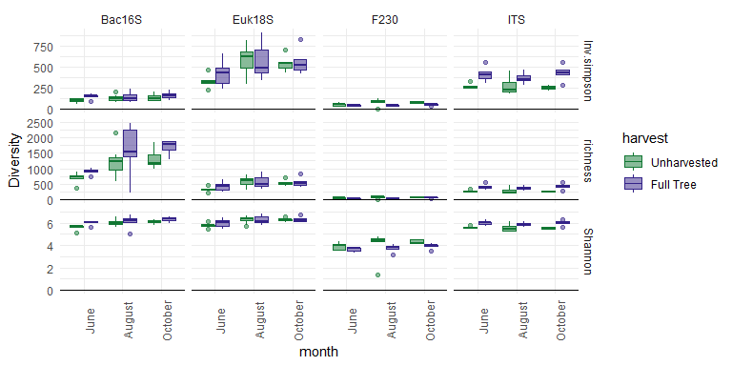

Figure 3.8: Diversity (Shannon, Inverse Simpsons, and ESV richness) for each metabarcoding target (Bacterial 16S and Fungal ITS2) across three months of sampling for full tree and unharvested treaments. Unharvested is shown in green, and full tree is displayed in blue.

There was a significantly higher fungal (ITS) inverse Simpsons diversity, Shannon diversity and, richness and, bacterial (16S) Shannon diversity and richness in Full-tree harvest compared to unharvested controls. Harvesting also resulted in significantly lower eukaryotic inverse Simpsons diversity and Shannon diversity, and, arthropod (F230) richness (Supplemental Materials 2.3.1). There were seasonal changes in the different metabarcoding communities. Eukaryotic (18S) diversity metrics were generally elevated in the month of August. Bacterial diversity increased as the season progressed from June to October. Arthropod and fungal diversity were generally stable through the months sampled. Harvesting changed the seasonal patterns in the eukaryotic (18S) community Simpson’s diversity; harvesting resulted in a relatively stable diversity across the seasons, compared with the elevated diversity in the uncut forest in August (Fig 3.8).

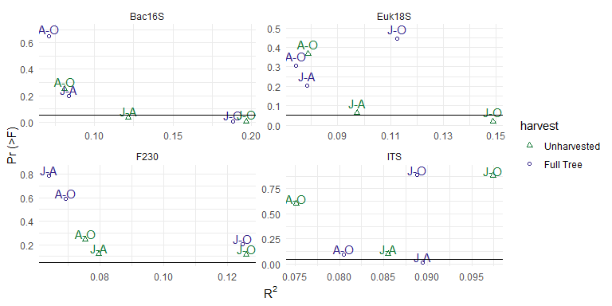

Figure 3.9: Results of pairwise PERMANOVA tests comparing community structures of months (J = June, A = August, O = October) within full tree and unharvested treatments. The variance explained by each comparison (R2) is shown on the x axis, and the probability of the effect is along the y axis (Pr (>F)). A black line is used to represent p = 0.05.

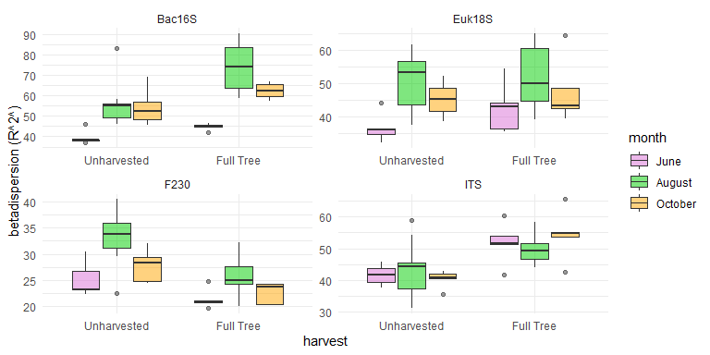

Figure 3.10: Results of pairwise betadispersion tests comparing community structures of months within full tree and unharvested treatments. The betadispersion of each treatment (R2) is shown on the y axis, and the treatment is shown along the x-axis. Significant differences are indicated in red text.

## 

While there were significant (p<0.05) impacts of harvesting or season on each of the datasets, there was no effect of the interaction of harvesting and season on any diversity metric for any targeted group. There were community compositional changes between months that were different between full-tree and unharvested treatments, but there were no significant (p < 0.05) interaction effects of season and harvesting found from PERMANOVA for any targeted group. Fungal composition was different between June and August Full-tree treatments. Eukaryotic compositions (18S) only differed in unharvested sites with June being significantly different from the other sampled months. Bacterial (16S) compositional changes occurred within both full-Tree and unharvested treatments, with higher variances between June and October. In each dataset, June-October comparisons had the most variance between months, though this was not always significant (Fig 3.9). The differences in composition were driven by differences in average composition, though there were differences in beta dispersion as well (i.e., lower betadispersion in June compared to other months in Full-Tree and unharvested treatments for bacterial (16S), eukaryotic (18S) and arthropod (F230) community composition) (Fig 3.10). In general, the compositional variance between months in all metabarcoding targets, in both treatments were lower than 20% of the total variance (Fig 3.9).

Partial RDA with month as constraining variables, and treatment as control variables showed that seasonal variation, in general, represented a small amount of community composition variance (less than 10%) for any metabarcoding target. There were some indications that there were larger seasonal differences introduced by harvesting in arthropod and eukaryotic communities. The distances along the axes associated with the month gradients were slightly larger in harvested eukaryote (18S) communities and, slightly smaller in the harvested arthropod (F230) communities compared to unharvested treatments, but represented a miniscule amount of variance (Supplemental Materials 2.3.3).

While there were some differences in response between harvested and unharvested treatments for some seasonally impacted bacteria, the patterns in the fungal (ITS), arthropod (F230) and Eukaryotic (18S) communities were less clear, and of less statistical significance (larger p-values). While some bacterial (16S) ESVs had decreases or increases consistent across most samples from given months, fungal (ITS), arthropod (F230) and Eukaryotic (18S) compositional abundance were less consistent, and resulted in the months of these treatments being much less clearly separated with hierarchical clustering (i.e., June, August and October often fell into the same clusters). In general, changes to seasonal trends were small. There were no ESVs from any metabarcoding target that had clear, significant changes across the seasons (Supplemental Materials 2.3.4).

## 3.4 Rarefied and Traditional Analyses

Rarefied and traditional analyses had some subtle differences from the main compositional analyses performed in this paper (Supplemental Rarefied Analyses, Supplemental Traditional Analyses), but generally confirmed the conclusions about community shifts and diversity metrics.

# 4 Discussion

## 4.1 Does biomass removal intensity have additional impacts on soil communities?

Current practices in Canada generally utilize full-tree harvesting in clear cut operations (Thiffault et al., 2011). While de-intensification to stem only harvesting is an attractive concept, results suggest that de-intensification would not result in any additional benefits to the soil ecology of harvested sites in the short term. The multiple metabarcoding targets along with enzyme analyses allow for increased robustness in the evaluation of soil biodiversity and functional responses to harvest intensification, as the changes in each taxonomic group can confirm or add context to the results. There was little difference between community structures, diversity or enzyme activities between stem only and full tree harvesting in any of the targeted groups. Conversely, intensification of biomass removal past full-tree harvest did cause response differences from full-tree harvest, and full-tree harvest was different from unharvested sites. These consisted of community changes, enzyme activity differences, and decreases in diversity as harvesting intensified. It is likely that the additional disturbances are related to the physical disturbances involved in intensification past full-tree harvest. Stump removal involves additional soil upheaval and exposure of mineral horizons, while blading is an extreme treatment that removes all organic horizons from the surface of the soil. Our analysis compared the average composition of communities in organic horizons and mineral horizons in the same analysis due to the sample homogenization applied, and so the results were biased towards finding differences from sites with forest floor and bladed sites, which did not have organic horizon to sample. Despite this limitation in our study design, the strong signal is still valid, as it is driven by many of the organisms lost through the lack of organic layers.

These results are consistent with previous studies conducted on these plots, in that harvesting and forest floor removal had significant effects on community compositions. Smenderovac et al., (2017) found that fire and unharvested sites were dissimilar from harvested plots and bladed plots, but that there was little additional difference introduced by intensification of biomass removals. Venier et al. (2017) found the same pattern in arthropod communities, where there was little additional effect of stump removal compared to the typical clear cut harvesting, but a significant effect of blading. This was also found in mesofauna communities (Rousseau et al., 2019). These earlier studies were sampled at 1-3 years after harvest and there was little decomposition or incorporation of wood materials into soils. We have found small community structure, and significant phosphatase responses to below-ground biomass removal 5 years after harvest, after some vegetation recovery and tree growth, and using much more sensitive techniques, but this effect still remains small enough that we could not distinguish any significant changes to specific groups.

Other studies have also reported a lack of response to biomass removal intensification to key groups such as ectomycorrhizae (Huusko et al., 2015). The responses to forest floor removal (i.e., increases in enzymatic activity and wood saprotrophs, increases in acidophiles and extremophiles, decreased arthropod diversity) are consistent with existing knowledge of harvesting impacts. Studies of arthropod and microbial communities on this site consistently found that bladed plots were significantly different from full-tree harvesting (Rousseau et al., 2019; Smenderovac et al., 2017; Venier et al., 2017). Soil disturbance during harvesting results in increased aeration and mixing of soils, which can increase decomposition of existing organic matter (Jiménez Esquilín et al., 2008), but can also decrease water holding capacity, which in turn can result in more acidity and changes in the soil community structure. We saw these impacts in the effect of harvesting, the community structure of unharvested plots was different from those in harvested, and the xylosidase activity was lower in unharvested treatments (Fig 3.1, Fig 3.2, Fig 3.3). ). It may be that the in-tact organic layer of these soils have carbon sources that are preferable to the xylose polysaccharide hemicellulose (e.g., glucose and fructose from plant roots or small organic molecules from fresh litter), resulting in reduced xylose activity. These processes are exacerbated in the extreme soil disturbance of blading (Thiffault et al., 2011). The complete removal of woody biomass in bladed plots had the expected result of decreasing wood saprotroph abundance as well. What was more surprising was that there were not detectable increases of wood saprotrophy with the fine-woody debris retention in stem-only harvesting. This suggests that the biodiversity of soils could be fairly resistant to biomass removal intensification, however the reduction in phosphatase activity in plots with below-ground biomass removal suggest that there could be nutrient limitations introduced by intensification beyond full-tree harvest (Fig 3.1. Conversely, the lack of differences between stem only and full tree harvesting suggest that there are few short-term benefits to switching from full-tree to stem only harvesting practices. There was some evidence, when communities were analyzed after rarefaction, that stem-only harvest could cause some decreases in fungal diversity, suggesting that there is less diversity of abundant organisms in the treatment.

That a xylosidase activity increase was not also detected in stem-only harvesting suggests that the conditions in unharvested plots are not stimulated or recovered quickly by the retention of biomass. It is possible the additional biomass removals don’t have large impacts on soil nutrients that control the soil biodiversity. Morris et al. (2019) found little response in soil carbon, nitrogen or potassium in soil after 20 years, long after most of the initial woody debris would have decomposed. It could also be that the location of sampling minimized observed effect; Organisms that colonize wood from soils, and the biogeochemical cycles they are involved in, could be protected by the preserved biodiversity in the soils of the less disturbed flat micro-topography features. The different harvested and unharvested communities along with the reduced enzymatic activity in harvested treatments, show that there could be key decomposition and mutualistic fungi missing from harvested plots, at least in early regenerative stages. This pattern of biodiversity loss was also observed in arthropod communities (Rousseau et al., 2019; Venier et al., 2017). Varenius et al. (2017) found that ectomycorrhizal fungi were significantly altered by harvesting, though they appeared to be recovering over time. They suggested that retention of in-tact forest patches may expedite the recolonization process. While these losses could have large implications for overall ecosystem-level productivity, long-term site productivity, in terms of tree growth and soil nutrient availability over the first 20 years, has not been improved in stem-only harvest compared to full-tree harvest (Fleming et al., 2018; Hazlett et al., 2021; Morris et al., 2019).

## 4.2 Are there large differences in community composition in the topographic features introduce by harvesting?

Disc-trenching results in exposed mineral layer (trench), mixed mineral and organic layer (pile) and somewhat “in-tact” areas of soils (flat). This soil disturbance is extensive, which was observed by the different community structures in the different topographic features of full-tree harvested plots (Fig ??, Fig 3.7, Fig ??). It has been demonstrated in other studies that this disturbance is significant, and potentially long-lasting and potentially very large, given that the area of ground disturbed is estimated to be within 20-50% (Chaves Cardoso et al., 2020; Jiménez Esquilín et al., 2008). The different moisture retention in these topographic features are so great they are the basis of planting decisions (Boateng et al., 2011; Chaves Cardoso et al., 2020; Nesdoly and Vanrees, 1998). It is well known that different soil horizons support different community structures (Paul, 2014; Porter et al., 2019). Organic horizons are nutrient rich and have better water holding capacity, while mineral soils are typically inhabited by organisms adapted to harsher conditions (Paul, 2014). The different proportions of mineral and organic horizons in each topographic feature may partially explain these differences. However, there are other physical characteristics related to these topographic features that could be influencing community composition (i.e., aeration, water holding capacity, surface temperature) (Löf et al., 2012). The few diversity impacts observed indicated that diversity in trench features have decreased diversity compared to flats and piles (Fig Fig 3.4). The flat and pile plots had more organisms associated with well developed soils, (e.g., *Mortierella*, *Cantherelles*) while trenches contained more organisms that can be associated with young soils (e.g., bryophytes, extremophile bacteria, “free-living” bacteria). Thornton and Matlack (2002) had also found that nematode diversity is impacted by site preparation, and could take up to 50 years to recover.

Focusing on impacts to topographic features where there is more potential for biomass interactions (i.e., Flats) is a valid approach to assess whether biomass residuals themselves provide reservoirs of diversity, or provide nutrients to soils. However, it is possible that biomass residues could influence the other topographic features associated with site preparation. That trench features had different community structures than bladed, though both were essentially exposed mineral soils, shows that there may be benefits to having ‘islands’ of in-tact soil on the landscape. Much like pockets of mature trees are left in harvested areas to serve as a source of new trees, these biodiversity-retaining features may be critical sources of organisms important in geochemical cycling, which was demonstrated by the importance of retaining in-tact forest floor by Webster et al. (2021; 2016). While trenches are not in direct contact with wood residues or well-developed organic horizons, they may benefit from organic materials and nutrients leached or transported from flats and piles, which could be why certain bacterial species were a smaller community component in trench communities compared to bladed treatments. Trenches could also be more protected from environmental stresses than bladed plots by being recessed into the ground, the reduced wind exposure would limit erosion and potentially provide some buffer for evapotranspiration. Levy-Booth et al, (2016) found that the changes in moisture and physical disruptions can change bacterial and fungal soil community structure. These physical changes could be enhanced or altered by the retention of biomass (e.g., wind could be dispersed by piles of branches, biomass could provide additional shading). There is very little research on the interactions of micro-topographic features of soil preparation, and instead, most research focuses on the large-scale effects of these activities (Jiménez Esquilín et al., 2008; Löf et al., 2012). The effects introduced could have long term implications, and by only sampling on the features with the most potential direct biomass influence (flats), we could be under-representing shifts to soil biota communities.

There could be ecological implications to this finding (i.e., changes to nutrient cycling or trophic dynamics). Site preparation has been observed to have long-term impacts. Jiménez Esquilín (2008) found scarification impacts on microbial community biomass and composition were detectable up to 20 years after the disturbance. However, these changes may not be detrimental to tree growth. Fleming et al, (2018) did not find detrimental impacts of disc-trenching on Jack Pine growth in 20 year old stands, instead, they actually found either no impact or some survival and growth benefits when it was used. (2021) also found negligible effects of disc-trenching on soil nitrogen and phosphorus balances in 20 years, but there are suggestions these systems may diverge with time and repeated silvicultural cycles. The growth and survival benefits of site preparation are well known in the forestry context, but there may be alternatives to disruption of soil layers that might better replicate natural conditions. Weber et al, (1995) found that sites treated with prescribed burn and disc trenching experienced similar survival and nutrient use benefits. There are reports in the literature of site preparation leading to decreases to amphibian populations, and nematode diversity, fungal biomass and ectomycorrhizal communities (Hartley, 2002; Kwaśna et al., 2019; Thornton and Matlack, 2002). Studies have also indicated there are potential additional advantages to this form of site preparation (e.g., increased total carbon stocks, enhanced vegetation recovery by providing a greater diversity of micro-environments (Haeussler et al., 2021; Mjöfors et al., 2017)). Generally, the literature is fairly sparse on this topic, as it is complex to assess the impacts of these activities when it is difficult to find natural disturbance comparisons within the same temporal context (Haeussler et al., 2021). This makes it difficult to gauge the ecological trade-offs of site preparation.

## 4.3 What time of year are communities most responsive to harvesting stresses?

In general, diversity metrics, and community composition differences supported that sampling in the late summer/fall is the best time to detect treatment differences. There were no strong indications that there was increased sensitivity to seasonal changes in harvested plots compared with uncut plots. Generally, the community composition was fairly stable across months in a given year and the direction of difference between harvested and unharvested plots was consistent across diversity metrics (Fig 3.8, Fig 3.9, Fig 3.10). While investigation of partial RDAs showed slight increases in the variance between months in harvested plots, the variance associated with seasonal change was very small. The lack of seasonal response could be due to the assay used. Metabarcoding uses environmental DNA, so we are likely picking up dormant cells in the shoulder seasons, and more active community members in August, where there is more diversity and warmer temperatures. There are many studies that have demonstrated that functional microbial community characteristics, soil respiration or phospholipid profiles vary with season (Koranda et al., 2013; Webster et al., 2016; Zhao et al., 2021). This study shows, however, that similar patterns are not detected with a DNA-based analysis. Siles et al. (2017) found that microbial responses to seasonal changes were limited to functional responses, but not present in amplicon sequencing. This finding has implications for the use of DNA studies in ecological contexts. In some ways, this loosens logistical constraints and concerns around incompatibility of samples that were distributed across the season. In other respects, it showcases the limitations of applying DNA based techniques to estimate functional activities. In summary, DNA-based analyses appear to be quite stable over temporal gradients within a growing season, but are not reliable indicators of short-term seasonal fluctuations in conditions.

## 4.4 How do our interpretations of harvesting treatment response change with the added information about topographic and seasonal response patterns?

We often have to make sampling decisions, in the interests of efficiency, that can limit our interpretation of site-wide effects. Here we argue that there are likely minimal changes introduced by shifts to stem only or stump removal from full tree-harvesting, and that the results we observed are representative of stable community shifts. However, our microtopography assessment raises questions of whether sampling only on flats represents and captures the impacts of harvesting intensity and soil disturbance on soils, especially when comparing to unharvested forests that do not have these features. With our current sampling, it is possible that responses to biomass removal intensification existed in topographic features that we did not assess. Future studies should look to assess whether the recovery of specific topographic features are effected by the amount of biomass removal or retention, as effects could be through indirect, physical mechanisms that are not captured on flats. These topographic insights also provide a new context to our results, that the observed shifts (or lack thereof), of physical disturbances are likely greater than those of intensified biomass removal.

## 4.5 Conclusion

We found little evidence that de-intensification of biomass removals from full tree harvesting provides benefits to arthropod, bacterial or fungal soil biodiversity. Clearcut harvesting as a disturbance was a large effect, and further intensification to stumping had minimal impacts on arthropod, bacterial or fungal communities in the short term. Soil organic matter removal, in bladed treatments and trench features, resulted in large community shifts and communities adapted for low nutrient conditions. Topographic features which retained organic matter maintained communities with more heterotrophy and potential plant associates, suggesting that site-preparation techniques that retain in-tact organic soil are preferable to those where organic material are removed. However, harvesting has a large effect on soil communities, and we found that harvested plots have not recovered fully in the short term. Future studies should include natural analogues to the disturbances of interest, mainly fire comparisons, to ensure that these changes are within the range of natural disturbance, and that the topographic features from site preparation provide similar habitats and services to naturally disturbed sites. Our results support that our conclusions were not heavily influenced by the timing of sampling, and suggest that DNA-based analyses are robust to seasonal fluctuations. This could allow for a wider window of sampling when using these techniques. However, DNA-based analyses may not be suitable for studying the sensitivity of communities to short-term climate shifts and RNA-based and/or functional assays may be required to assess these impacts.

# 5 Acknowldegements

We would like to thank the Hajibabei lab at the University of Guelph for performing sequenceing for this project as well as Paul Hazlett for his part in establishing the Island Lake Biomass Study plots, as well as all the scientists, students and staff involved in monitoring and sampling.

# References

Ainsworth, G.C., 2008. Ainsworth & Bisby’s Dictionary of the Fungi. CABI.

Aitchison, J., Barcelo-Vidal, C., Martın-Fernandez, J.A., Pawlowsky-Glahn, V., 2000. Logratio Analysis and Compositional Distance. Mathematical Geology 5.

Berch, S., Morris, D., Malcolm, J., 2011. Intensive forest biomass harvesting and biodiversity in Canada: A summary of relevant issues. The Forestry Chronicle 87, 478–487. <https://doi.org/10.5558/tfc2011-046>

Boateng, J.O., Heineman, J.L., Bedford, L., Nemec, A.F.L., 2011. Soil Characteristics and Lodgepole Pine (Pinus contorta var. latifolia) Performance Two Decades after Disk Trenching of Unburned and Broadcast-Burned Plots in Subboreal British Columbia. International Journal of Forestry Research 2011, e752359. <https://doi.org/10.1155/2011/752359>

Chaves Cardoso, J., Burton, P.J., Elkin, C.M., 2020. A Disturbance Ecology Perspective on Silvicultural Site Preparation. Forests 11, 1278. <https://doi.org/10.3390/f11121278>

Dedysh, S.N., 2020. [Fimbriiglobus](https://onlinelibrary.wiley.com/doi/abs/10.1002/9781118960608.gbm01971), in: Bergey’s Manual of Systematics of Archaea and Bacteria. John Wiley & Sons, Ltd, pp. 1–6.

Findlay, S., 2007. CHAPTER 11 - Dissolved Organic Matter, in: Hauer, F.R., Lamberti, G.A. (Eds.), Methods in Stream Ecology (Second Edition). Academic Press, San Diego, pp. 239–248. <https://doi.org/10.1016/B978-012332908-0.50013-9>

Fleming, R.L., Leblanc, J.-D., Weldon, T., Hazlett, P.W., Mossa, D.S., Irwin, R., Primavera, M.J., Wilson, S.A., 2018. Effect of vegetation control, harvest intensity, and soil disturbance on 20-year jack pine stand development. Can. J. For. Res. 48, 371–387. <https://doi.org/10.1139/cjfr-2017-0331>

Fleming, R.L., Morris, D.M., Hazlett, P.W., 2021. Assessing temporal response to biomass removal: A framework for investigating evolving constraints on boreal stand development. Forest Ecology and Management 497, 119518. <https://doi.org/10.1016/j.foreco.2021.119518>

Frey, B., Walthert, L., Perez-Mon, C., Stierli, B., Köchli, R., Dharmarajah, A., Brunner, I., 2021. [Deep Soil Layers of Drought-Exposed Forests Harbor Poorly Known Bacterial and Fungal Communities](https://www.frontiersin.org/article/10.3389/fmicb.2021.674160). Frontiers in Microbiology 12.

Haeussler, S., Kabzems, R., McClarnon, J., Bedford, L., 2021. Successional change, restoration success, and resilience in boreal mixedwood vegetation communities over three decades. Can. J. For. Res. 51, 766–780. <https://doi.org/10.1139/cjfr-2020-0024>

Hartley, M.J., 2002. Rationale and methods for conserving biodiversity in plantation forests. Forest Ecology and Management, Forest Ecology in the next Millennium : Putting the long view into Practice 155, 81–95. <https://doi.org/10.1016/S0378-1127(01)00549-7>

Hazlett, P.W., Emilson, C.E., Morris, D.M., Fleming, R.L., Hawdon, L.A., Leblanc, J.-D., Primavera, M.J., Weldon, T.P., Kwiaton, M.M., Hoepting, M.K., 2021. Effects of harvesting intensity, vegetation control and fertilization on 5–20 year post-harvest N availability in boreal jack pine and black spruce forest soils in northern Ontario, Canada. Forest Ecology and Management 497, 119483. <https://doi.org/10.1016/j.foreco.2021.119483>

Hedde, M., Pey, B., Auclerc, A., Capowiez, Y., Cluzeau, D., Cortet, J., Decaëns, T., Deharveng, L., Dubs, F., Joimel, S., Guernion, M., Grumiaux, F., Laporte, M.-A., Nahmani, J., Pasquet, A., Pelosi, C., Pernin, C., Ponge, J.-F., Salmon, S., Santorufo, L., 2012. BETSI, a complete framework for studying soil invertebrate functional traits. <https://doi.org/10.13140/2.1.1286.6888>

Hess, S., Melkonian, M., 2013. The Mystery of Clade X: Orciraptor gen. nov. and Viridiraptor gen. nov. are Highly Specialised, Algivorous Amoeboflagellates (Glissomonadida, Cercozoa). Protist 164, 706–747. <https://doi.org/10.1016/j.protis.2013.07.003>

Hiraishi, A., 2019. [Acidipila](https://onlinelibrary.wiley.com/doi/abs/10.1002/9781118960608.gbm01666), in: Bergey’s Manual of Systematics of Archaea and Bacteria. John Wiley & Sons, Ltd, pp. 1–7.

Huusko, K., Tarvainen, O., Saravesi, K., Pennanen, T., Fritze, H., Kubin, E., Markkola, A., 2015. Short-term impacts of energy wood harvesting on ectomycorrhizal fungal communities of Norway spruce saplings. ISME J 9, 581–591. <https://doi.org/10.1038/ismej.2014.154>

Imhoff, J.F., 2020. [Blastochloris](https://onlinelibrary.wiley.com/doi/abs/10.1002/9781118960608.gbm00815.pub2), in: Bergey’s Manual of Systematics of Archaea and Bacteria. John Wiley & Sons, Ltd, pp. 1–8.

Jiménez Esquilín, A.E., Stromberger, M.E., Shepperd, W.D., 2008. Soil Scarification and Wildfire Interactions and Effects on Microbial Communities and Carbon. Soil Sci. Soc. Am. j. 72, 111–118. <https://doi.org/10.2136/sssaj2006.0292>

Johansson, M., 1994. The influence of soil scarification on the turn‐over rate of slash needles and nutrient release. null 9, 170–179. <https://doi.org/10.1080/02827589409382828>

Kassambara, A., 2020. [ggpubr: ggplot2 based publication ready plots](https://rpkgs.datanovia.com/ggpubr/) (manual).

Klips, R., 2017. Mosses, Liverworts and Hornworts: A Field Guide to Common Bryophytes of the Northeast. cast 82, 169–170. <https://doi.org/10.2179/17-BR001>

Kõljalg, U., Abarenkov, K., Nilsson, R.H., Larsson, K., Taylor, A.F.S., 2019. The UNITE Database for Molecular Identification and for Communicating Fungal Species. <https://doi.org/10.3897/BISS.3.37402>

Koranda, M., Kaiser, C., Fuchslueger, L., Kitzler, B., Sessitsch, A., Zechmeister-Boltenstern, S., Richter, A., 2013. Seasonal variation in functional properties of microbial communities in beech forest soil. Soil Biology and Biochemistry 60, 95–104. <https://doi.org/10.1016/j.soilbio.2013.01.025>

Kwaśna, H., Behnke-Borowczyk, J., Gornowicz, R., Łakomy, P., 2019. Effects of preparation of clear-cut forest sites on the soil mycobiota with consequences for Scots pine growth and health. Forest Pathology 49, e12494. <https://doi.org/10.1111/efp.12494>

Kwiaton, M., Hazle, P., Morris, D., Fleming, R., Webster, K., Venier, L., Aubin, I., 2014. Island Lake Biomass Harvest Research and Demonstra on Area: Establishment Report 82.

Levy-Booth, D., Prescott, C., Christiansen, J., Grayston, S., 2016. Site preparation and fertilization of wet forests alter soil bacterial and fungal abundance, community profiles and CO2 fluxes. Forest Ecology and Management 375, 159–171. <https://doi.org/10.1016/j.foreco.2016.05.033>

Löf, M., Dey, D.C., Navarro, R.M., Jacobs, D.F., 2012. Mechanical site preparation for forest restoration. New Forests 43, 825–848. <https://doi.org/10.1007/s11056-012-9332-x>

Louca, S., Parfrey, L.W., Doebeli, M., 2016. Decoupling function and taxonomy in the global ocean microbiome. Science 353, 1272–1277. <https://doi.org/10.1126/science.aaf4507>

Mishra, A., Singh, L., Singh, D., 2022. Unboxing the black box—one step forward to understand the soil microbiome: A systematic review. Microb Ecol. <https://doi.org/10.1007/s00248-022-01962-5>

Mjöfors, K., Strömgren, M., Nohrstedt, H.-Ö., Johansson, M.-B., Gärdenäs, A., 2017. Indications that Site Preparation increases Forest Ecosystem Carbon Stocks in the Long-Term. Scandinavian Journal of Forest Research 32, 1–34. <https://doi.org/10.1080/02827581.2017.1293152>

Morris, D.M., Hazlett, P.W., Fleming, R.L., Kwiaton, M.M., Hawdon, L.A., Leblanc, J.-D., Primavera, M.j., Weldon, T.P., 2019. Effects of Biomass Removal Levels on Soil Carbon and Nutrient Reserves in Conifer-Dominated, Coarse-Textured Sites in Northern Ontario: 20-Year Results. Soil Science Society of America Journal 83, S116–S132. <https://doi.org/10.2136/sssaj2018.08.0306>

Nesdoly, R.G., Vanrees, K.C.J., 1998. Redistribution of extractable nutrients following disc trenching on Luvisols and Brunisols in Saskatchewan. Can. J. Soil. Sci. 78, 367–376. <https://doi.org/10.4141/S97-057>

Nguyen, N.H., Song, Z., Bates, S.T., Branco, S., Tedersoo, L., Menke, J., Schilling, J.S., Kennedy, P.G., 2016. FUNGuild: An open annotation tool for parsing fungal community datasets by ecological guild. Fungal Ecology 20, 241–248. <https://doi.org/10.1016/j.funeco.2015.06.006>

Nogi, Y., Yoshizumi, M., Hamana, K., Miyazaki, M., Horikoshi, K., 2014. Povalibacter uvarum gen. nov., sp. nov., a polyvinyl-alcohol-degrading bacterium isolated from grapes. Int J Syst Evol Microbiol 64, 2712–2717. <https://doi.org/10.1099/ijs.0.062620-0>

Oksanen, J., Blanchet, F.G., Friendly, M., Kindt, R., Legendre, P., McGlinn, D., Minchin, P.R., O’Hara, R.B., Simpson, G.L., Solymos, P., Stevens, M.H.H., Szoecs, E., Wagner, H., 2020. [vegan: Community ecology package](https://CRAN.R-project.org/package=vegan) (manual).

Paul, E., 2014. Soil Microbiology, Ecology and Biochemistry. Academic Press.

Porter, T.M., 2020. [UNITE ITS Classifier](https://github.com/terrimporter/UNITE_ITSClassifier).

Porter, T.M., Hajibabaei, M., 2020. METAWORKS: A flexible, scalable bioinformatic pipeline for multi-marker biodiversity assessments. bioRxiv 2020.07.14.202960. <https://doi.org/10.1101/2020.07.14.202960>

Porter, T.M., Hajibabaei, M., 2018. Automated high throughput animal CO1 metabarcode classification. Scientific Reports 8, 4226. <https://doi.org/10.1038/s41598-018-22505-4>

Porter, T.M., Morris, D.M., Basiliko, N., Hajibabaei, M., Doucet, D., Bowman, S., Emilson, E.J.S., Emilson, C.E., Chartrand, D., Wainio-Keizer, K., Séguin, A., Venier, L., 2019. Variations in terrestrial arthropod DNA metabarcoding methods recovers robust beta diversity but variable richness and site indicators. Sci Rep 9, 18218. <https://doi.org/10.1038/s41598-019-54532-0>

R Core Team, 2021. [R: A Language and Environment for Statistical Computing](https://www.R-project.org/). R Foundation for Statistical Computing, Vienna, Austria.

Reichenbach, H., 2015. [Myxococcales](https://onlinelibrary.wiley.com/doi/abs/10.1002/9781118960608.obm00088), in: Bergey’s Manual of Systematics of Archaea and Bacteria. John Wiley & Sons, Ltd, pp. 1–31.

Rousseau, L., Venier, L., Aubin, I., Gendreau-Berthiaume, B., Moretti, M., Salmon, S., Handa, I.T., 2019. Woody biomass removal in harvested boreal forest leads to a partial functional homogenization of soil mesofaunal communities relative to unharvested forest. Soil Biology and Biochemistry 133, 129–136. <https://doi.org/10.1016/j.soilbio.2019.02.021>

Saiya-Cork, K.R., Sinsabaugh, R.L., Zak, D.R., 2002. The effects of long term nitrogen deposition on extracellular enzyme activity in an Acer saccharum forest soil. Soil Biology and Biochemistry 34, 1309–1315. <https://doi.org/10.1016/S0038-0717(02)00074-3>

Schmidtl, M., Macdonald, S., rothwel, R., 1996. Impacts of harvesting and mechanical site preparation on soil chemical properties of mixed-wood boreal forest sites in Alberta. Canadian Journal of Soil Science 76, 531–540. <https://doi.org/10.4141/cjss96-066>

Schnürer, A., Müller, B., Westerholm, M., 2018. [Syntrophaceticus](https://onlinelibrary.wiley.com/doi/10.1002/9781118960608.gbm01452), in: Bergey’s Manual of Systematics of Archaea and Bacteria. John Wiley & Sons, Ltd.

Siles, J.A., Margesin, R., 2017. Seasonal soil microbial responses are limited to changes in functionality at two Alpine forest sites differing in altitude and vegetation. Sci Rep 7, 2204. <https://doi.org/10.1038/s41598-017-02363-2>

Smenderovac, E.E., Webster, K., Caspersen, J., Morris, D., Hazlett, P., Basiliko, N., 2017. Does intensified boreal forest harvesting impact soil microbial community structure and function? Can. J. For. Res. 47, 916–925. <https://doi.org/10.1139/cjfr-2016-0468>

Sood, S., Awal, R.P., Wink, J., Mohr, K.I., Rohde, M., Stadler, M., Kämpfer, P., Glaeser, S.P., Schumann, P., Garcia, R., Müller, R., 2015. Aggregicoccus edonensis gen. nov., sp. nov., an unusually aggregating myxobacterium isolated from a soil sample. Int J Syst Evol Microbiol 65, 745–753. <https://doi.org/10.1099/ijs.0.061176-0>

Sutherland, B.J., Foreman, F.F., 1995. Guide to the use of mechanical site preparation equipment in northwestern Ontario. Great Lakes Forestry Centre, Canadian Forest Service, Natural Resources Canada, Sault Ste. Marie, Ontario.

Tank, M., Costas, A.M.G., Bryant, D.A., 2018. [Chloracidobacterium](https://onlinelibrary.wiley.com/doi/abs/10.1002/9781118960608.gbm01534), in: Bergey’s Manual of Systematics of Archaea and Bacteria. John Wiley & Sons, Ltd, pp. 1–9.

Thiffault, E., Hannam, K.D., Paré, D., Titus, B.D., Hazlett, P.W., Maynard, D.G., Brais, S., 2011. Effects of forest biomass harvesting on soil productivity in boreal and temperate forests — A review. Environ. Rev. 19, 278–309. <https://doi.org/10.1139/a11-009>

Thornton, C.W., Matlack, G.R., 2002. [Long-term disturbance effects in the nematode communities of south Mississippi woodlands](https://www.ncbi.nlm.nih.gov/pmc/articles/PMC2620545). J Nematol 34, 88–97.

Thrash, J.C., Coates, J.D., 2015. [Edaphobacter](https://onlinelibrary.wiley.com/doi/abs/10.1002/9781118960608.gbm00002), in: Bergey’s Manual of Systematics of Archaea and Bacteria. John Wiley & Sons, Ltd, pp. 1–3.

Torsvik, V., Øvreås, L., 2002. Microbial diversity and function in soil: from genes to ecosystems. Current Opinion in Microbiology 5, 240–245. <https://doi.org/10.1016/S1369-5274(02)00324-7>

Varenius, K., Lindahl, B.D., Dahlberg, A., 2017. Retention of seed trees fails to lifeboat ectomycorrhizal fungal diversity in harvested Scots pine forests. FEMS Microbiology Ecology 93, fix105. <https://doi.org/10.1093/femsec/fix105>

Venier, L.A., Work, T.T., Klimaszewski, J., Morris, D.M., Bowden, J.J., Kwiaton, M.M., Webster, K., Hazlett, P., 2017. Ground-dwelling arthropod response to fire and clearcutting in jack pine: implications for ecosystem management. Can. J. For. Res. 47, 1614–1631. <https://doi.org/10.1139/cjfr-2017-0145>

Wang, Q., Garrity, G.M., Tiedje, J.M., Cole, J.R., 2007. Naïve Bayesian Classifier for Rapid Assignment of rRNA Sequences into the New Bacterial Taxonomy. Appl. Environ. Microbiol. 73, 5261–5267. <https://doi.org/10.1128/AEM.00062-07>

Watanabe, M., Kojima, H., Fukui, M., 2015. Limnochorda pilosa gen. nov., sp. nov., a moderately thermophilic, facultatively anaerobic, pleomorphic bacterium and proposal of Limnochordaceae fam. nov., Limnochordales ord. nov. and Limnochordia classis nov. in the phylum Firmicutes. Int J Syst Evol Microbiol 65, 2378–2384. <https://doi.org/10.1099/ijs.0.000267>

Weber, M.G., McAlpine, R.S., Wotton, B.M., Donnelly, J.G., Hobbs, M.W., 1995. Prescribed burning and disk trenching effects on early plantation performance in eastern Ontario, Canada. Forest Ecology and Management 78, 159–171. <https://doi.org/10.1016/0378-1127(95)03587-0>

Webster, K.L., 2021. The effect of boreal jack pine harvest residue retention on soil environment and processes. Forest Ecology and Management 13.

Webster, K.L., Wilson, S.A., Hazlett, P.W., Fleming, R.L., Morris, D.M., 2016. Soil CO2 efflux and net ecosystem exchange following biomass harvesting: Impacts of harvest intensity, residue retention and vegetation control. Forest Ecology and Management, Special Section: Forest Management for Climate Change 360, 181–194. <https://doi.org/10.1016/j.foreco.2015.10.032>

Whitman, W.B., Coleman, D.C., Wiebe, W.J., 1998. [Prokaryotes: The unseen majority](https://www.ncbi.nlm.nih.gov/pmc/articles/PMC33863). Proc Natl Acad Sci U S A 95, 6578–6583.

Wickham, H., 2016. [ggplot2: Elegant graphics for data analysis](https://ggplot2.tidyverse.org). Springer-Verlag New York.

Yamada, T., Sekiguchi, Y., 2018. [Anaerolineaceae](https://onlinelibrary.wiley.com/doi/abs/10.1002/9781118960608.fbm00301), in: Bergey’s Manual of Systematics of Archaea and Bacteria. John Wiley & Sons, Ltd, pp. 1–5.

Zhao, C., Wang, Y., Zhang, N., Liang, J., Li, D., Yin, C., Liu, Q., 2021. Seasonal shifts in the soil microbial community responded differently to in situ experimental warming in a natural forest and a plantation. European Journal of Soil Science n/a. <https://doi.org/10.1111/ejss.13135>