TASK EKALAVYA

# DATABASE TASKS

* Create an ER diagram for Hospital management system.

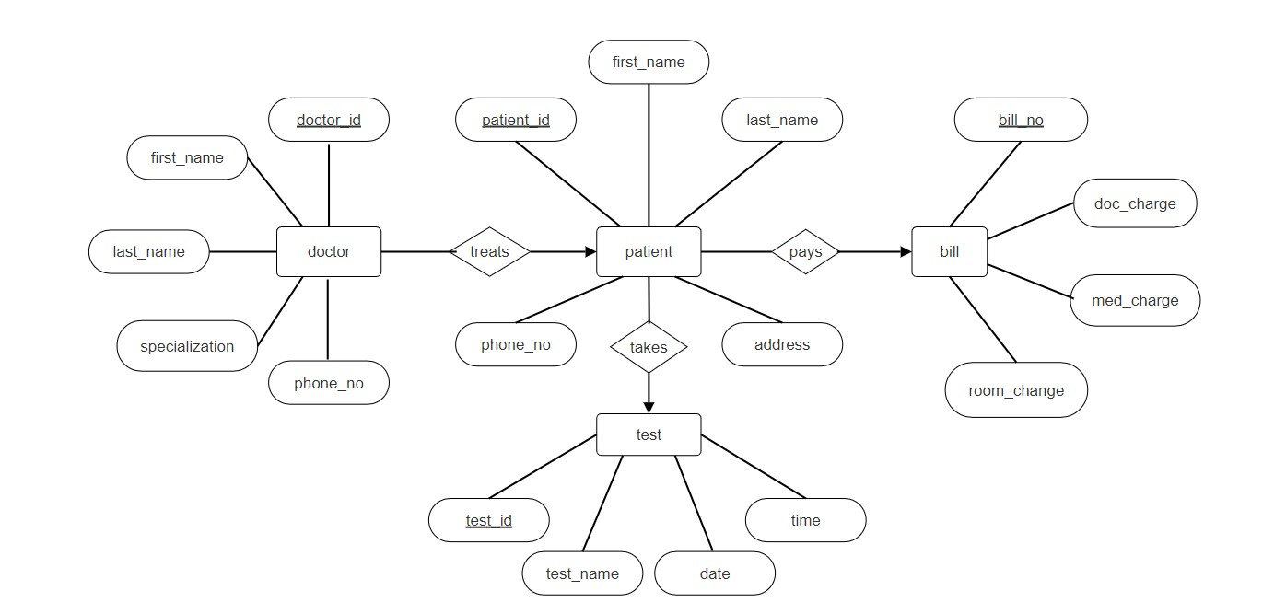

* Setup the Postgre on your machine and create a DB.

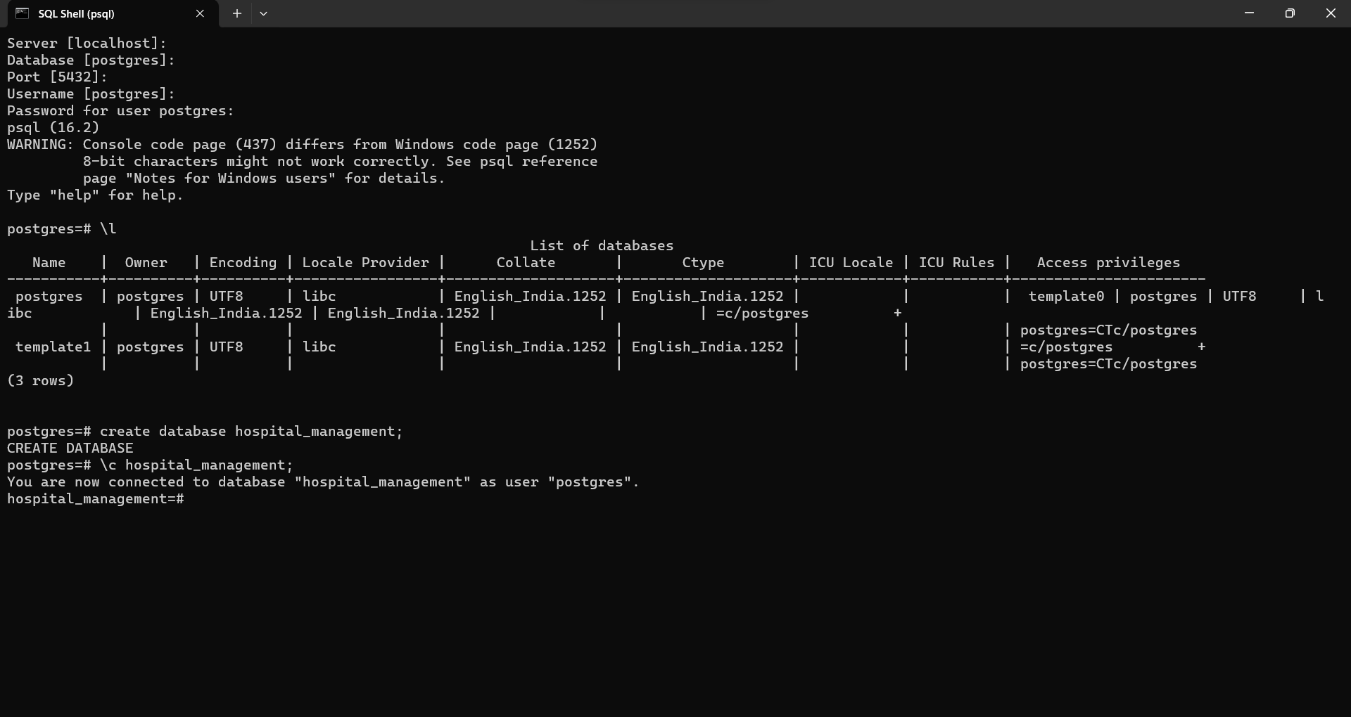

* Add tables respective to ER diagrams .
* Add data to each table with minimum of 100 rows.

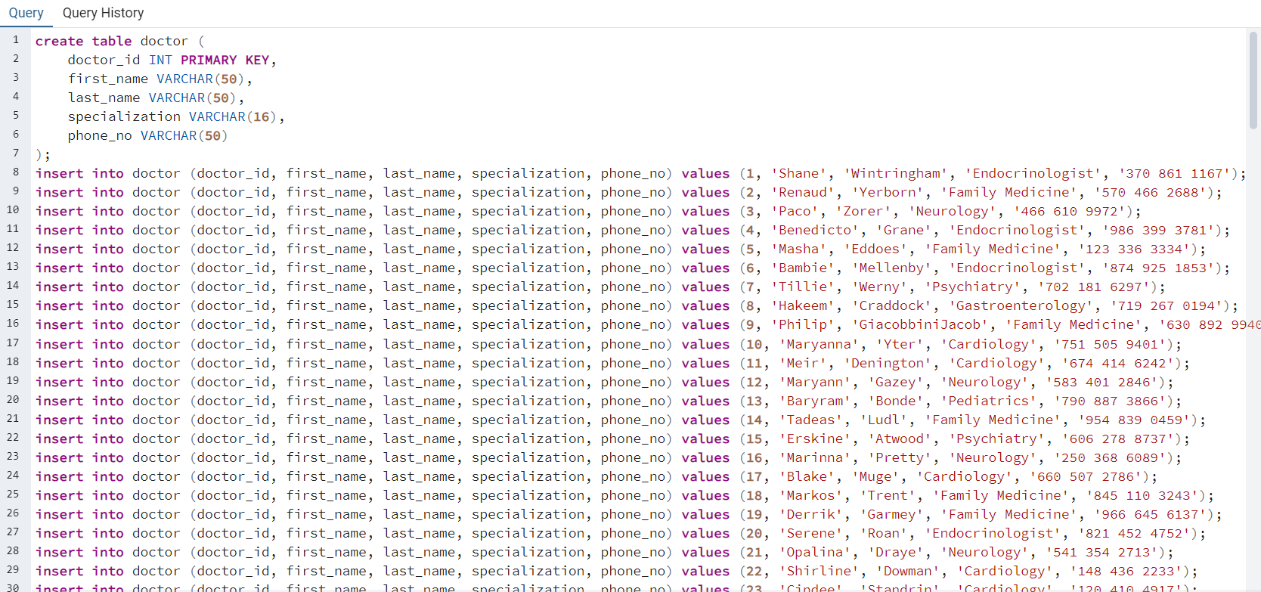

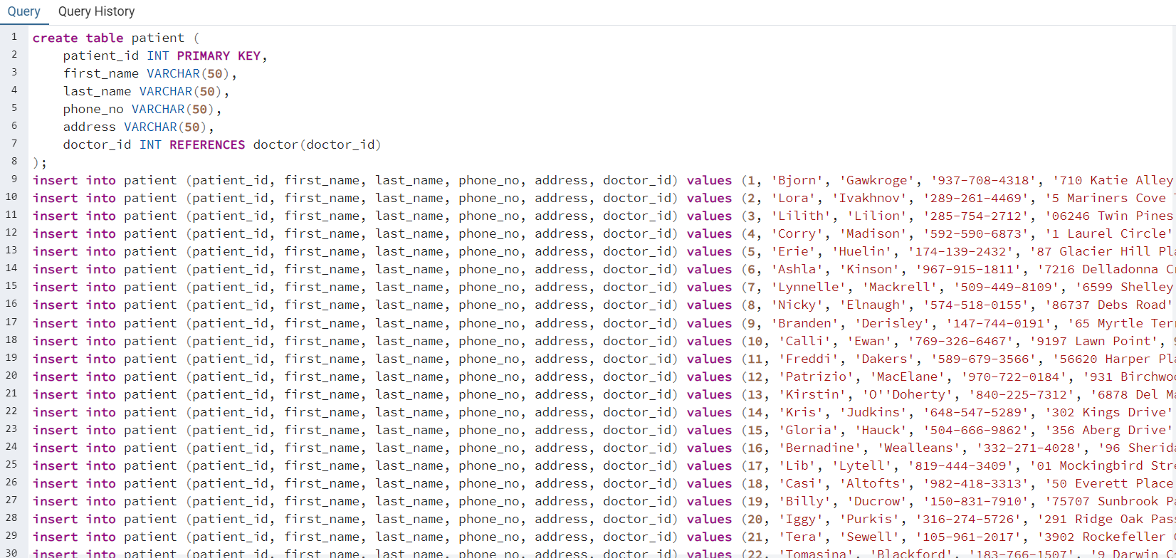

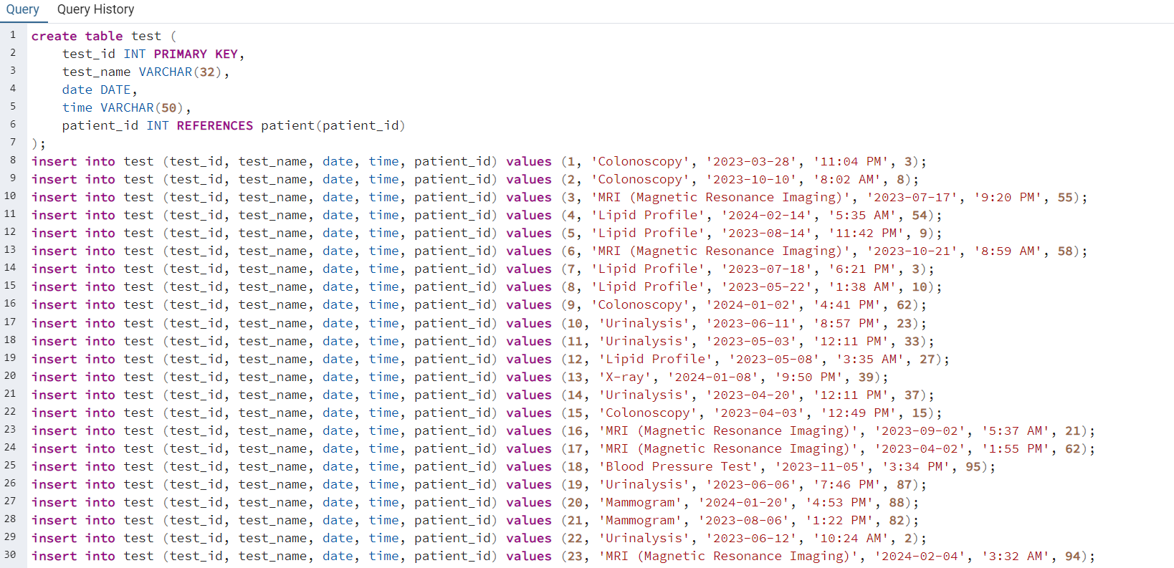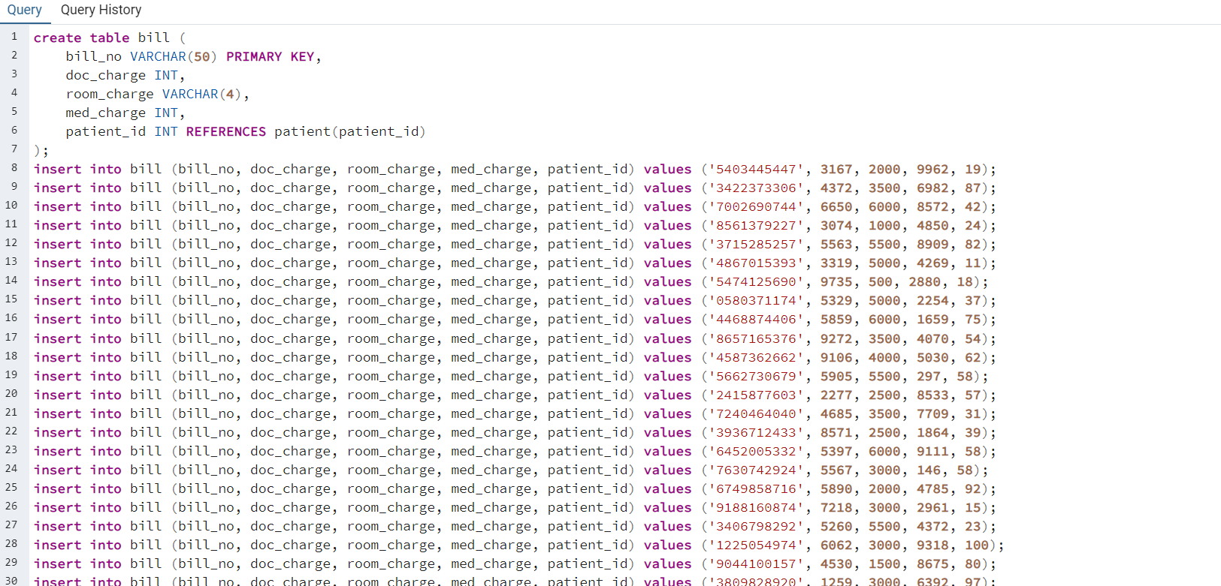

* Write a Select query without conditions

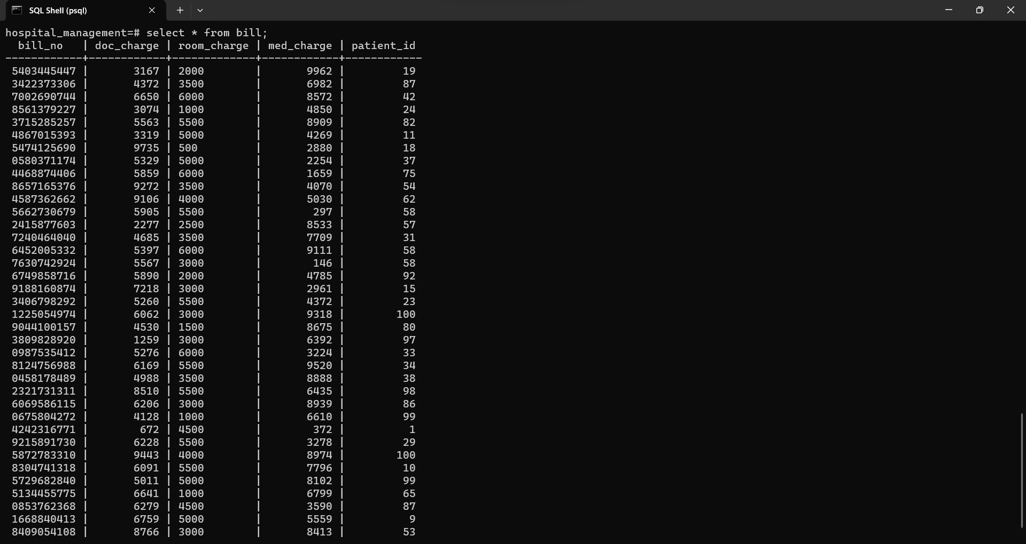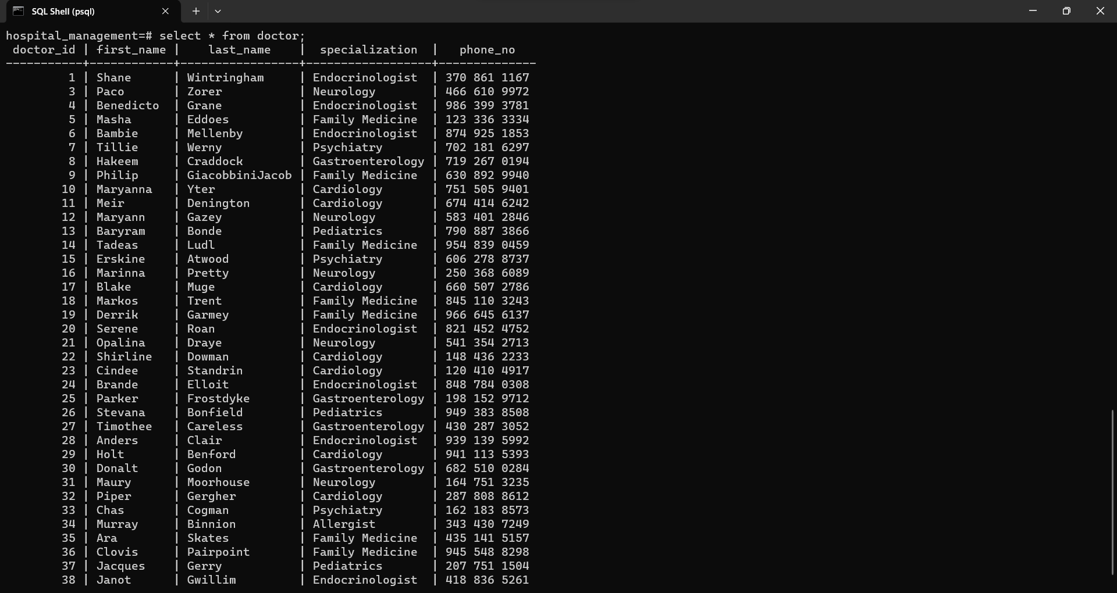

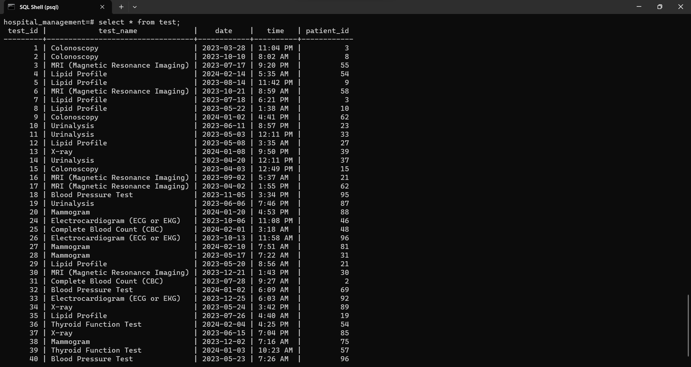

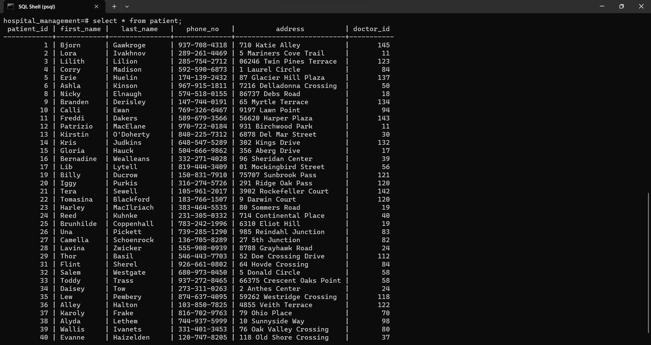

* Write a Select query with conditions.

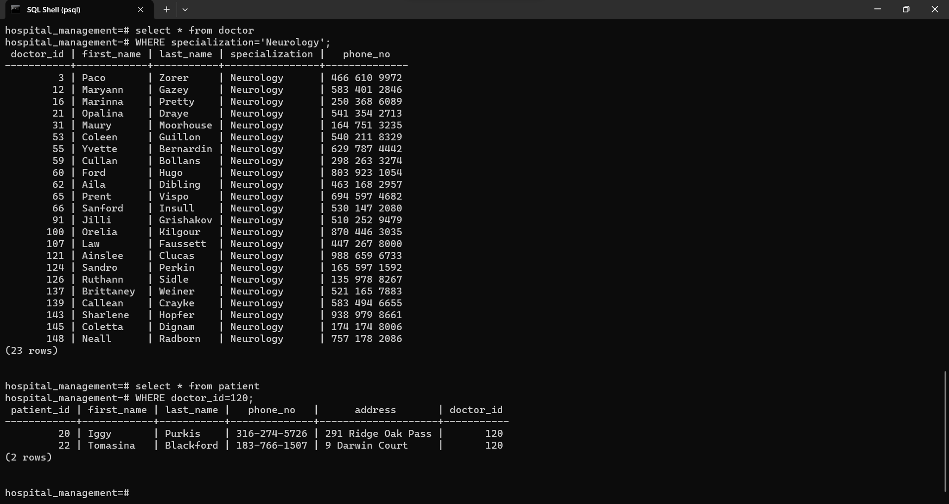

* Write an insert query to add new data for all the tables

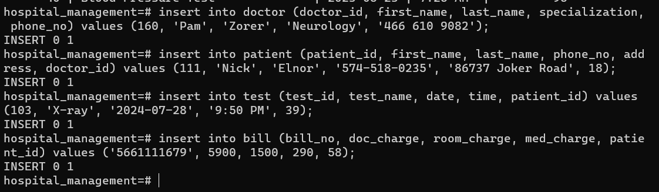

* Write an Delete query to delete any existing data for all the tables.

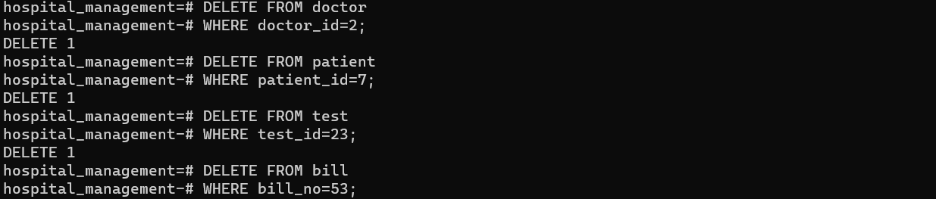

* Write an Update query to update any existing data for all the tables.

